SUPPORTING INFORMATION

Integrative Multi-Omics Analysis Unravels the Host Response Landscape and Reveals a Serum Protein Panel for Early Prognosis Prediction for ARDS
Mengna Lin^{1,2†}, Feixiang Xu^{2†}, Jian Sun², Jianfeng Song³, Yao Shen⁴, Su Lu², Hailin Ding², Lulu Lan², Chen Chen², Wen Ma⁵, Xueling Wu^{6,*}, Zhenju Song^{2,1,7*}, Weibing Wang^{1,5*}
¹Shanghai Institute of Infectious Disease and Biosecurity，Fudan University, Shanghai, China;
²Department of Emergency Medicine, Zhongshan Hospital, Fudan University, Shanghai, China;
³Department of Emergency Medicine, Minhang Hospital, Fudan University, Shanghai, China;
⁴Department of Respiratory Medicine, Pudong Hospital, Fudan University, Shanghai, China;
⁵School of Public Health, Fudan University, Shanghai, China;
⁶Department of Respiratory Medicine, Renji Hospital, Shanghai Jiaotong University School of Medicine, Shanghai, China;
⁷Institute of Emergency Rescue and Critical Care, Fudan University, Shanghai, China

†Mengna Lin and Feixiang Xu contributed equally.
*Correspondence: wwb@fudan.edu.cn; song.zhenju@zs-hospital.sh.cn; wuxueling76@126.com

Metabolomics sequencing and data preprocessing
The extracted data was processed by removing any peaks with a missing value (ion intensity = 0) in more than 50% of groups, by replacing the zero value with half of the minimum value, and by screening according to the qualitative results of the compound. Compounds with resulting scores below 36 (out of 60) points were also deemed to be inaccurate and removed. A data matrix was combined from the positive and negative ion data. Partial Least-Squares-Discriminant Analysis (PLS-DA) was utilized to distinguish the metabolites that differ between groups. To prevent overfitting, 7-fold cross-validation and 200 Response Permutation Testing (RPT) were used to evaluate the quality of the model.
Variable Importance of Projection (VIP) values obtained from the OPLS-DA model were used to rank the overall contribution of each variable to group discrimination. A two-tailed Student’s T-test was further used to verify whether the metabolites of difference between groups were significant. Differential metabolites were selected with VIP values greater than 1.0 and p-values less than 0.05.
PRM assay
To evaluate the candidate biomarkers of prognosis, a unique PRM assay was generated, incorporating as many candidate proteins as possible. For the proteome profiling samples, the peptide was examined utilizing a Q Exactive HF-X Hybrid Quadrupole-Orbitrap Mass Spectrometer (Thermo Fisher Scientific), integrated with a state-of-the-art high-performance liquid chromatography system (EASY nLC 1200, Thermo Fisher Scientific). The peptide samples, once dried, were reconstituted in Solvent A (0.1% formic acid in water). These reconstituted samples were then loaded onto a 2-cm, self-packed trapping column (with an inner diameter of 100 μm and packed with 3 μm ReproSil-Pur C18-AQ beads from Dr. Maisch GmbH) using Solvent A. Subsequently, separation was achieved on a column of 150 μm in inner diameter and 15 cm in length (1.9 μm ReproSil-Pur C18-AQ beads from Dr. Maisch GmbH). This separation process spanned 150 minutes, utilizing a gradient composed of Solvent A and Solvent B (0.1% formic acid in 80% ACN) at a constant flow rate of 600 nL/min (0–30 min, 0 min, 8% B; 0–4 min, 8–15% B; 4–19 min, 15–30% B; 19–22 min, 30–50% B; 23–24 min, 50–100% B; 24–30 min, 100% B). Ionization of the eluted peptides was achieved at 2 kV, after which they were introduced into the mass spectrometer. The instrument operated in a Parallel Reaction Monitoring acquisition mode, capturing full scan MS1 spectra of ions with a mass-to-charge ratio (m/z) ranging from 300 to 1400, utilizing the Orbitrap mass analyzer set to a high resolution of 60,000. The automatic gain control (AGC) target was established at 3E+06, with a maximum ion injection time of 80 ms. A selection of 20 precursor ions was made for fragmentation in the HCD cell, employing a normalized collision energy of 27%. The resultant fragment ions were analyzed by the Orbitrap at a resolution of 15,000, with the AGC for MS/MS set to 1e6 and the maximum ion injection time maintained at 80 ms.

Fig. S1 (A-C) The PCA plots across ARDS, DC and HC groups. (D) The volcano plot of differentially abundant proteins when DC group compared with HC group.

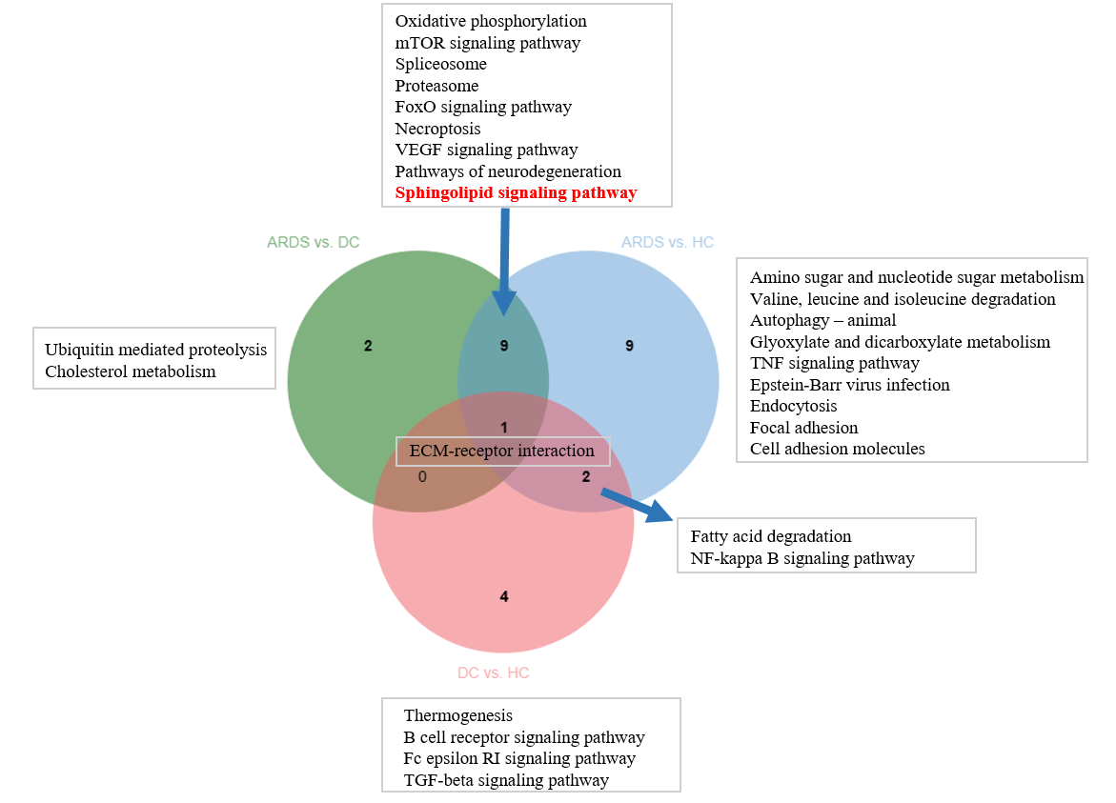
Fig. S2 The Venn plot for pathways.
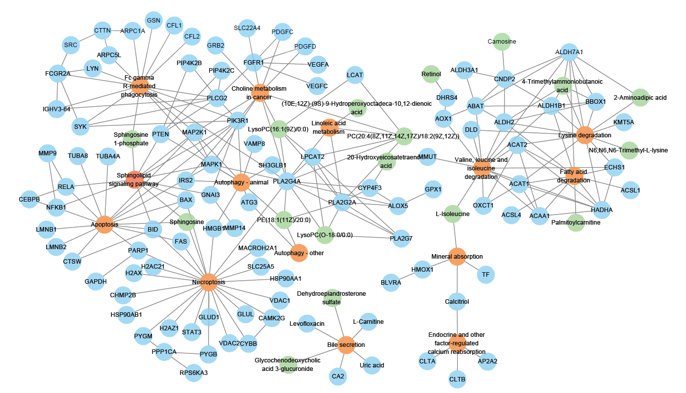
Fig. S3 The cross-talk network in ARDS compared HC group.

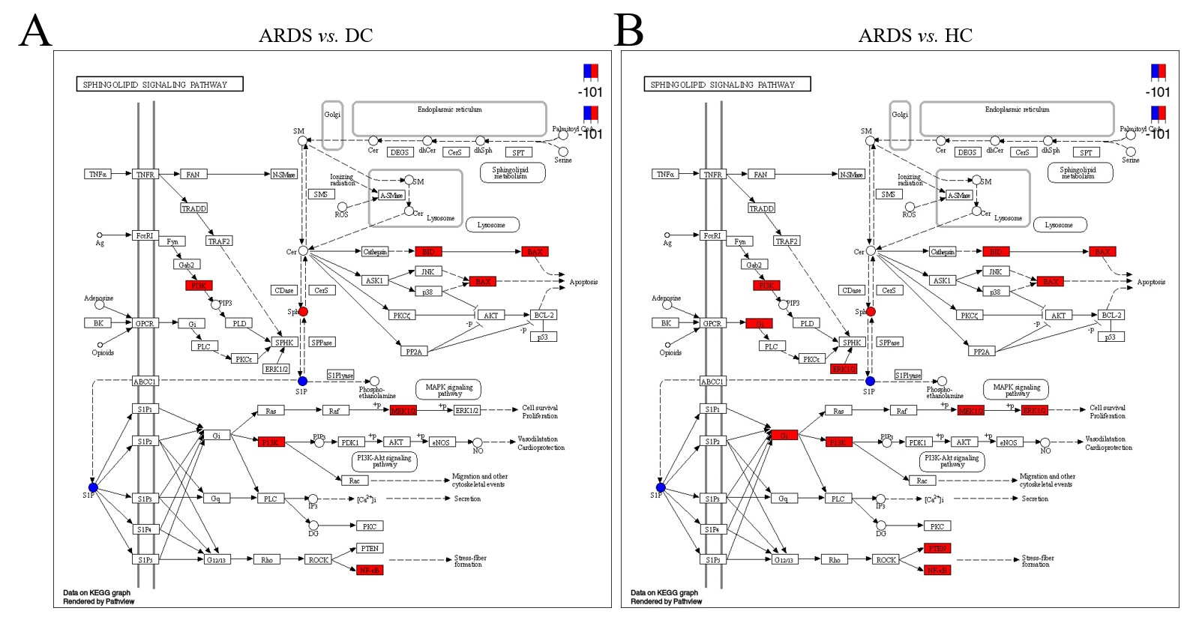
Fig. S4 The protein-metabolite network in ARDS vs. DC (A) and ARDS vs. HC (B).

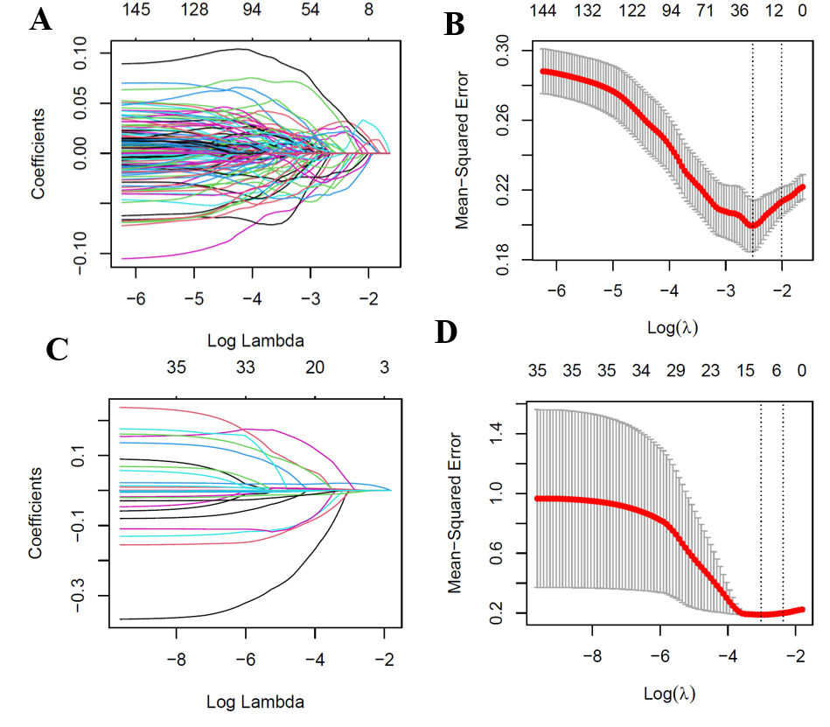
Fig. S5 (A-B) The feature selection to screen the candidate protein biomarkers based on the proteomics. (C-D) The feature selection to screen the candidate parameters in the clinical prognosis model. (A, C) LASSO regression coefficient selection and variable screening. The lower horizontal axis represents lambda value, and the upper horizontal axis scale represents the number of variables in the LASSO regression model. (B, D) Cross-validation in the LASSO regression model to select the tuning parameter. The horizontal axis represents the log (lambda) value, and the vertical axis represents partial likelihood deviance. Error bars represent the means ± SD (by 10-fold cross-validation). The minimum mean 10-fold cross-validated error of λ is selected.

Table S1. The baseline characteristics of the validation cohort.
P: Comparison between survived ARDS and deceased ARDS. *P < 0.05, **P < 0.01, ***P < 0.001.

 | ARDS (n=183) | survived ARDS (n=98) | deceased ARDS (n=85) | P value
Age (mean, SD) | 72.6 (14.3) | 71.9 (14.6) | 73.9 (12.7) | 0.233
Male (n, %) | 134 (73.2) | 76 (77.6) | 58 (68.2) | 0.157
SOFA | 4 [3-7] | 3 [2-6] | 5 [5-8] | <0.001***
P/F ratio | 150.0 [90.0-239.0] | 186.5 [117.9-265.5] | 100.0 [68.5-210.0] | <0.001***
RBC (*10¹²/L) | 3.91 [3.28-4.28] | 3.92 [3.27-4.47] | 3.91 [3.36-4.39] | 0.338
Hb (g/L) | 115.0 [96.0-131.0] | 119.0 [97.0-135.8] | 111.0 [95.0-130.0] | 0.143
WBC (*10⁹/L) | 10.51 [7.36-14.50] | 10.62 [7.23-14.03] | 10.34 [7.41-15.22] | 0.911
NEU (*10⁹/L) | 9.0 [6.2-13.0] | 8.8 [6.0-11.8] | 9.9 [6.5-15.8] | 0.076
LYM (*10⁹/L) | 0.6 [0.4-1.0] | 0.7 [0.5-1.1] | 0.6 [0.4-0.9] | 0.060
PLT (*10⁹/L) | 155.0 [110.0-222.0] | 178.5 [134.0-232.3] | 135.0 [79.0-192.0] | <0.001***
ALT (U/L) | 30.0 [18.0-53.0] | 30.5 [18.0-58.5] | 29.0 [18.0-41.0] | 0.654
AST (U/L) | 34.0 [21.0-53.0] | 31.0 [20.0-51.5] | 37.0 [25.0-53.0] | 0.152
STB (µmol/L) | 11.10 [8.60-20.60] | 10.95 [7.80-17.90] | 11.30 [9.15-22.80] | 0.069
CB (µmol/L) | 4.10 [3.00-6.70] | 4.05 [2.58-5.98] | 4.20 [2.89-8.40] | 0.231
BUN (mmol/L) | 9.30 [6.10-15.00] | 8.45 [5.86-12.25] | 10.40 [6.80-19.40] | 0.003**
Cr (µmol/L) | 79.0 [63.0-113.0] | 74.5 [62.3-98.3] | 83.0 [67.0-134.5] | 0.029*
Alb (g/L) | 32.0 [29.0-35.0] | 33.0 [29.0-35.3] | 31.0 [28.5-34.0] | 0.057
CRP (mg/L) | 64.0 [23.4-145.1] | 52.6 [18.05-132.3] | 79.9 [29.0-148.1] | 0.148
PCT (ng/mL) | 0.26 [0.11-1.22] | 0.21 [0.07-0.88] | 0.27 [0.14-1.27] | 0.514
Fg (mg/dL) | 448.0 [212.0-526.0] | 448.0 [281.5-539.3] | 451.0 [207.0-516.0] | 0.102
PT (second) | 13.5 [12.6-15.1] | 13.1 [12.3-14.2] | 14.0 [12.9-15.6] | 0.153
APTT (second) | 29.2 [26.8-35.5] | 28.75 [25.6-32.7] | 29.8 [26.3-33.9] | 0.798
D-dimer (mg/L) | 2.86 [1.28-8.06] | 3.00 [1.19-8.52] | 2.50 [1.31-6.92] | 0.753
Hypertension (n, %) | 90 (49.2) | 49 (50.0) | 41 (48.2) | 0.812
Coronary heart disease (n, %) | 36 (19.7) | 14 (14.3) | 22 (25.9) | 0.050
Diabetes (n, %) | 57 (31.1) | 32 (32.7) | 25 (29.4) | 0.638
Cerebrovascular disease (n, %) | 30 (16.4) | 13 (13.3) | 17 (20.0) | 0.221
Immunosuppression (n, %) | 20 (10.9) | 12 (12.2) | 8 (9.4) | 0.541

Table S2. The pathway enrichment in metabolomics.
group | Annotation | count | FDR | RichFactor
ARDS vs. DC | Sphingolipid signaling pathway | 2 | 0.001076 | 0.133333333
ARDS vs. DC | Sphingolipid metabolism | 2 | 0.003516 | 0.074074074
ARDS vs. DC | Porphyrin metabolism | 3 | 0.011874 | 0.02027027
ARDS vs. DC | Apoptosis | 1 | 0.013473 | 0.25
ARDS vs. DC | Lysine degradation | 2 | 0.014609 | 0.035714286
ARDS vs. DC | Fc gamma R-mediated phagocytosis | 1 | 0.02678 | 0.125
ARDS vs. DC | Endocrine and other factor-regulated calcium reabsorption | 1 | 0.02678 | 0.125
ARDS vs. DC | Apelin signaling pathway | 1 | 0.030081 | 0.111111111
ARDS vs. DC | Necroptosis | 1 | 0.033372 | 0.1
ARDS vs. DC | Parathyroid hormone synthesis, secretion and action | 1 | 0.033372 | 0.1
ARDS vs. DC | Calcium signaling pathway | 1 | 0.036652 | 0.090909091
ARDS vs. DC | Phospholipase D signaling pathway | 1 | 0.036652 | 0.090909091
ARDS vs. DC | Choline metabolism in cancer | 1 | 0.036652 | 0.090909091
ARDS vs. HC | Choline metabolism in cancer | 2 | 0.002944 | 0.181818182
ARDS vs. HC | Sphingolipid signaling pathway | 2 | 0.005516 | 0.133333333
ARDS vs. HC | Lysine degradation | 3 | 0.008344 | 0.053571429
ARDS vs. HC | Glycerophospholipid metabolism | 3 | 0.008344 | 0.053571429
ARDS vs. HC | Sphingolipid metabolism | 2 | 0.017432 | 0.074074074
ARDS vs. HC | Linoleic acid metabolism | 2 | 0.018686 | 0.071428571
ARDS vs. HC | Mineral absorption | 2 | 0.019976 | 0.068965517
ARDS vs. HC | Autophagy - other | 1 | 0.022675 | 0.333333333
ARDS vs. HC | Apoptosis | 1 | 0.030123 | 0.25
ARDS vs. HC | Bile secretion | 4 | 0.040632 | 0.022988506
ARDS vs. HC | Autophagy - animal | 1 | 0.044855 | 0.166666667
ARDS vs. HC | Fc gamma R-mediated phagocytosis | 1 | 0.059372 | 0.125
ARDS vs. HC | Endocrine and other factor-regulated calcium reabsorption | 1 | 0.059372 | 0.125
DC vs. HC | Choline metabolism in cancer | 2 | 0.002731 | 0.181818182
DC vs. HC | Lysine degradation | 3 | 0.0075 | 0.053571429
DC vs. HC | Glycerophospholipid metabolism | 3 | 0.0075 | 0.053571429
DC vs. HC | Bile secretion | 5 | 0.007619 | 0.028735632
DC vs. HC | Mineral absorption | 2 | 0.01859 | 0.068965517
DC vs. HC | Autophagy - other | 1 | 0.021842 | 0.333333333
DC vs. HC | Apoptosis | 1 | 0.02902 | 0.25
DC vs. HC | Autophagy - animal | 1 | 0.043225 | 0.166666667

Table S3. The DAP between deceased and survived ARDS.
Gene | logFC | AveExpr | P.Value | adj.P.Val | Compare
TBCB | -0.6719282 | -0.2291773 | 0.00011709 | 0.02100244 | deceased-survived
TMED2 | -0.6671753 | 0.0218195 | 0.00029617 | 0.03436854 | deceased-survived
TAGLN2 | -0.6439316 | -0.2399998 | 0.00028031 | 0.03436854 | deceased-survived
HSDL2 | -0.6211779 | -0.2693525 | 0.00025766 | 0.03436854 | deceased-survived
SYK | -0.6197709 | -0.3415852 | 0.00011693 | 0.02100244 | deceased-survived
EPX | -0.6071317 | -0.1342443 | 0.00068158 | 0.04664486 | deceased-survived
ASAP2 | -0.5891296 | -0.2500608 | 0.00076285 | 0.04837122 | deceased-survived
ACIN1 | 0.58575861 | 0.42698586 | 0.00021336 | 0.03436854 | deceased-survived
PPP1R7 | 0.58814633 | 0.34767383 | 0.00047191 | 0.0393603 | deceased-survived
PTMA | 0.6045931 | 0.39667824 | 0.00025496 | 0.03436854 | deceased-survived
HRNR | 0.61518606 | -0.0516892 | 0.00079743 | 0.04837122 | deceased-survived
TBCA | 0.61561094 | 0.18626459 | 0.00039052 | 0.03529722 | deceased-survived
NACA | 0.61658488 | 0.28188036 | 0.00034666 | 0.03516728 | deceased-survived
CAPN2 | 0.618448 | 0.14428018 | 0.00028681 | 0.03436854 | deceased-survived
FLG2 | 0.61912563 | -0.0521589 | 0.0008417 | 0.04992245 | deceased-survived
LBP | 0.62097518 | 0.11844295 | 0.00062092 | 0.0460344 | deceased-survived
SPON1 | 0.62418812 | 0.18608899 | 0.00070632 | 0.04712951 | deceased-survived
RANGAP1 | 0.6277671 | 0.08016607 | 0.00054207 | 0.04255228 | deceased-survived
WDR44 | 0.63040208 | 0.18540633 | 0.00060125 | 0.04584937 | deceased-survived
LDHB | 0.63210231 | 0.317993 | 0.00034889 | 0.03516728 | deceased-survived
MYL4 | 0.63240925 | 0.10408419 | 0.0006629 | 0.04655991 | deceased-survived
PDIA4 | 0.65622246 | 0.19475527 | 0.00039675 | 0.03529722 | deceased-survived
PSMA1 | 0.66251461 | 0.08951768 | 0.00025714 | 0.03436854 | deceased-survived
KRT1 | 0.66352305 | -0.0131546 | 0.00035576 | 0.03516728 | deceased-survived
CTSL | 0.67223585 | -0.0108752 | 0.0004274 | 0.03679789 | deceased-survived
HTRA1 | 0.67997647 | 0.07855264 | 0.00031773 | 0.03516728 | deceased-survived
EEF2 | 0.68456994 | 0.24878709 | 5.4273E-05 | 0.01448552 | deceased-survived
SPP1 | 0.68684432 | 0.24480926 | 8.1352E-05 | 0.01885677 | deceased-survived
KRT9 | 0.68903696 | 0.0070054 | 0.0002254 | 0.03436854 | deceased-survived
PTMS | 0.71103215 | 0.25342387 | 8.4781E-05 | 0.01885677 | deceased-survived
NUCB1 | 0.71190102 | 0.18607182 | 0.00011804 | 0.02100244 | deceased-survived
CAND1 | 0.74384901 | 0.20208132 | 3.9031E-05 | 0.011575 | deceased-survived
PSME1 | 0.77162955 | 0.17392586 | 7.7378E-06 | 0.00295032 | deceased-survived
EZR | 0.78369871 | 0.28873514 | 1.0193E-05 | 0.0034005 | deceased-survived
PSME2 | 0.78386074 | 0.09393115 | 6.9509E-06 | 0.00295032 | deceased-survived
CAPNS1 | 0.79289945 | 0.26926305 | 4.2208E-06 | 0.00225308 | deceased-survived
LMNA | 0.8143974 | 0.2250422 | 3.4629E-06 | 0.00225308 | deceased-survived
NUDC | 0.86362674 | 0.16892193 | 1.0683E-06 | 0.00126698 | deceased-survived
MSN | 0.88650524 | 0.23241071 | 1.4241E-06 | 0.00126698 | deceased-survived
RDX | 0.91389513 | 0.22085216 | 5.4519E-07 | 0.00126698 | deceased-survived

