Graphical Abstract
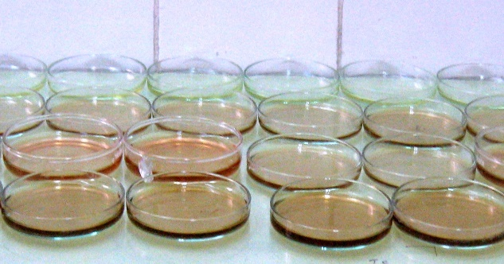  Membrane casting in glass Petri dishes | 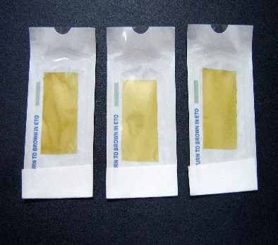  Sterilized membrane for GTR studies
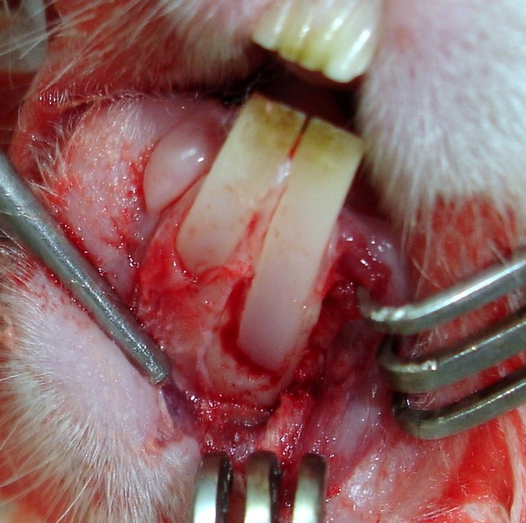  Defects creation in control rabbits | 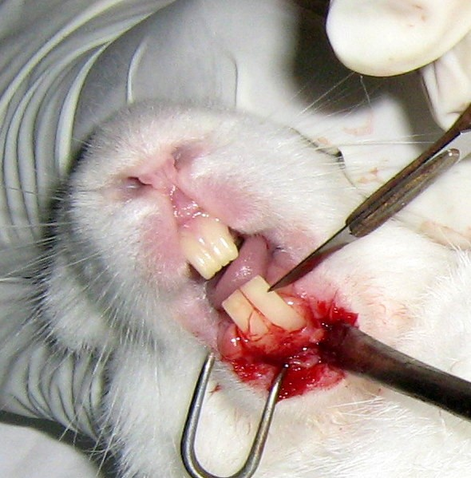  Tissue healed & biomembrane resorbed  Tissue has grown

