Original image for checking
Figure 6E
TGFβR1 (53kd)

β-actin (43kd)
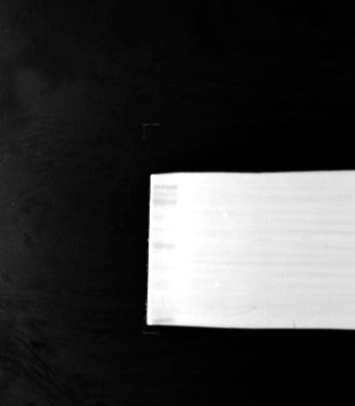
Figure 6F
TGFβR1 (53kd)
β-actin (43kd)
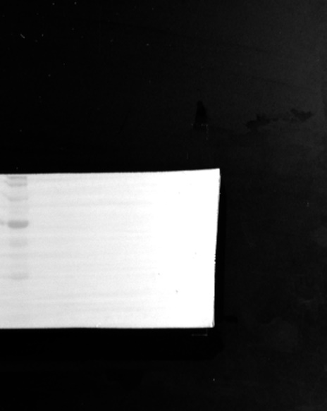
Figure 6G
α-SMA (42kd)
CD31 (130kd)
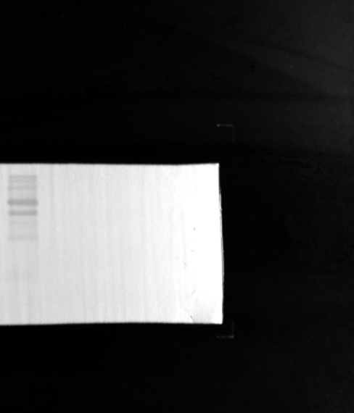
Vimentin (57kd)
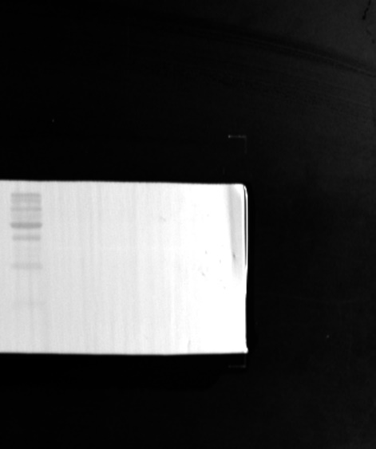
β-actin (43kd)
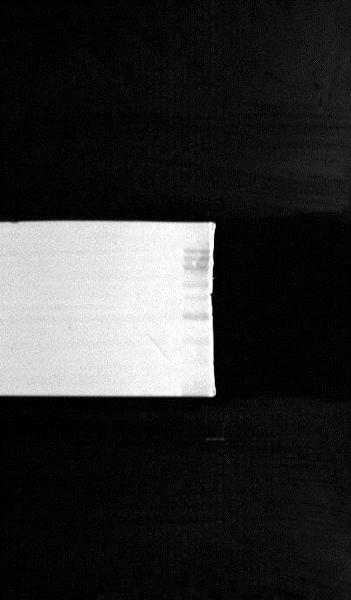
Figure 7C
TGFβR1 (53kd)
β-actin (43kd)
