Supplementary Materials
Table S1 Chemotaxis of 32 antagonistic endophytic bacteria associated with root-rot disease of Panax notoginseng to 5 organic acids
Table S2 Chemotaxis of the genus Bacillus of antagonistic endophytic bacteria associated with root-rot disease of Panax notoginseng to 5 organic acids
Figure S1. Chemotactic response of 32 antagonistic endophytic bacteria associated with root-rot disease of Panax notoginseng to aspartic acid as analyzed by the drop assay.
Figure S2. Chemotactic response of 32 antagonistic endophytic bacteria associated with root-rot disease of Panax notoginseng to citric acid as analyzed by the drop assay.
Figure S3. Chemotactic response of 32 antagonistic endophytic bacteria associated with root-rot disease of Panax notoginseng to fumaric acid as analyzed by the drop assay.
Figure S4. Chemotactic response of 32 antagonistic endophytic bacteria associated with root-rot disease of Panax notoginseng to malic acid as analyzed by the drop assay.
Figure S5. Chemotactic response of 32 antagonistic endophytic bacteria associated with root-rot disease of Panax notoginseng to oxalic acid as analyzed by the drop assay.
Figure S6. Chemotactic response of 32 antagonistic endophytic bacteria associated with root-rot disease of Panax notoginseng to succinic acid as analyzed by the drop assay.
Figure S7. Chemotactic response of the genus Bacillus of antagonistic endophytic bacteria associated with root-rot disease of Panax notoginseng to 5 organic acids as analyzed by the drop assay.

Table S1 Chemotaxis of 32 antagonistic endophytic bacteria associated with root-rot disease of Panax notoginseng to 5 organic acids
 | Isolates |  |  |  |  |  | Compounds
 |  |  | AS |  | CA |  | FA |  | MA |  | OA |  | SA
NR1(Alcaligenes faecalis subsp. faecalis ) |  | 26.2 |  | 16.0 |  | 34.4 |  | 27.9 |  | 8.0 |  | 2.0
L22 (Acinetobacter calcoaceticus ) |  | 27.0 |  | 70.0 |  | 37.0 |  | 24.3 |  | 9.0 |  | 71.3
KL1 (Bacillus aerophilus) |  | 54.1 |  | 70.0 |  | 40.0 |  | 61.4 |  | 73.0 |  | 56.1
KR2 (Bacillus aerophilus) |  | 70.0 |  | 63.0 |  | 50.0 |  | 5.0 |  | 70.0 |  | 6.0
NL2 (Bacillus aerophilus) |  | 34.0 |  | 77.0 |  | 48.2 |  | 59.6 |  | 4.0 |  | 56.0
YL1 (Bacillus amyloliquefaciens subsp. plantarum ) |  | 30.5 |  | 40.0 |  | 40.0 |  | 50.1 |  | 75.0 |  | 21.0
YP1 (Bacillus amyloliquefaciens subsp. plantarum ) |  | 72.0 |  | 72.0 |  | 70.0 |  | 65.7 |  | 50.0 |  | 55.0
YR3 (Bacillus amyloliquefaciens subsp. plantarum) |  | 75.0 |  | 69.0 |  | 53.0 |  | 36.6 |  | 66.0 |  | 54.3
L9 (Bacillus amyloliquefaciens subsp. plantarum) |  | 39.2 |  | 9.0 |  | 50.0 |  | 2.0 |  | 74.0 |  | 56.2
R7 (Bacillus amyloliquefaciens subsp. plantarum) |  | 50.0 |  | 3.0 |  | 54.0 |  | 42.6 |  | 5.0 |  | 4.0
L14 (Bacillus aryabhattai) |  | 73.0 |  | 76.0 |  | 45.2 |  | 62.4 |  | 30.0 |  | -
KL2 (Bacillus cereus) |  | 30.7 |  | 21.1 |  | 33.3 |  | 50.7 |  | 8.0 |  | 53.0
R18 (Bacillus methylotrophicus) |  | 30.0 |  | 59.8 |  | 37.5 |  | 66.1 |  | 67.0 |  | 59.4
YR7 (Bacillus mycoides) |  | 70.0 |  | 58.0 |  | 34.5 |  | 64.7 |  | 70.0 |  | 18.0
NR6 (Bacillus simplex) |  | 69.0 |  | 70.0 |  | 38.1 |  | 43.3 |  | 73.0 |  | 12.0
YR5 (Bacillus tequilensis) |  | 74.0 |  | 53.0 |  | 64.0 |  | 2.0 |  | 67.0 |  | 69.6
KS2 (Bacillus xiamenensis ) |  | 74.0 |  | 72.0 |  | 46.7 |  | 38.1 |  | 71.0 |  | 48.4
YR4 (Brevibacillus borstelensis) |  | 26.0 |  | 46.0 |  | 32.5 |  | 19.0 |  | 54.0 |  | 16.1
YR8 (Brevibacillus borstelensis) |  | 35.0 |  | 33.0 |  | 63.0 |  | 35.8 |  | 6.0 |  | 4.0
NS4 (Enhydrobacter aerosaccus) |  | 46.8 |  | 62.8 |  | 40.0 |  | 67.0 |  | 43.0 |  | 59.5
YS3 (Kytococcus sedentarius) |  | 27.6 |  | 5.0 |  | 35.5 |  | 54.0 |  | - |  | 5.0
P17 (Lysinibacillus sphaericus) |  | 32.2 |  | 66.0 |  | 62.0 |  | 67.6 |  | 58.0 |  | 64.7
Table S1 Continued

Isolates |  |  | Compounds
Isolates | AS | CA | FA | MA | OA | SA
NR5 (Paenibacillus taiwanensis) | 28.7 | 58.3 | 37.5 | 65.3 | 4.0 | 54.0
NL1 (Pantoea brenneri) | 50.3 | 58.0 | 34.5 | 25.7 | 5.0 | 25.1
KS1 (Pantoea vagans) | 51.2 | 8.0 | 70.5 | 70.0 | 43.3 | 73.6
KR4 (Pseudomonas chlororaphis subsp. aurantiaca) | 53.0 | 61.6 | 52.0 | 36.0 | 60.0 | 72.0
NR3 (Pseudomonas chlororaphis subsp. aurantiaca) | 10.0 | 67.3 | 31.4 | 61.7 | 7.0 | 45.0
NR2 (Pseudomonas helmanticensis) | 28.9 | 58.2 | 41.5 | 59.0 | 12.0 | 74.2
KR1 (Pseudomonas moraviensis) | 71.0 | 56.0 | 57.0 | 27.1 | 76.0 | 6.0
NP3 (Sphingomonas dokdonensis) | 31.4 | 51.0 | 41.0 | 17.3 | - | -
NS2 (Staphylococcus arlettae) | 25.0 | 55.7 | 35.5 | 61.6 | 4.0 | 52.0
NS5 (Staphylococcus hominis subsp. hominis) | 37.1 | 51.0 | 43.0 | 69.0 | 15 | 58.2
Note: The strength of the chemotaxis was quantified by measuring the diameter of the chemotactic ring and scored on a scale from very strong response (>51 mm), stronger response (31-50 mm), strong response (21-30 mm), weak response (1-20 mm), and “-” no response, as described previously [49]. For tested organic acids included: CA, citric acid; FA, fumaric acid; MA, malic acid; OA, oxalic acid; SA, succinic acid.

Table S2 Chemotaxis of the genus Bacillus of antagonistic endophytic bacteria associated with root-rot disease complex of Panax notoginseng to 5 organic acids
Isolates |  |  | Compounds
Isolates | AS | CA | FA | MA | OA | SA
KL1 (Bacillus aerophilus) | 54.1 | 70.0 | 40.0 | 61.4 | 73.0 | 56.1
KR2 (Bacillus aerophilus) | 70.0 | 63.0 | 50.0 | 5.0 | 70.0 | 6.0
NL2 (Bacillus aerophilus) | 34.0 | 77.0 | 48.2 | 59.6 | 4.0 | 56.0
YL1 (Bacillus amyloliquefaciens subsp. plantarum ) | 30.5 | 40.0 | 40.0 | 50.1 | 75.0 | 21.0
YP1 (Bacillus amyloliquefaciens subsp. plantarum ) | 72.0 | 72.0 | 50.0 | 65.7 | 72.0 | 55.0
YR3 (Bacillus amyloliquefaciens subsp. plantarum) | 75.0 | 69.0 | 53.0 | 36.6 | 66.0 | 54.3
L9 (Bacillus amyloliquefaciens subsp. plantarum) | 39.2 | 9.0 | 50.0 | 2.0 | 74.0 | 56.2
R7 (Bacillus amyloliquefaciens subsp. plantarum) | 50.0 | 3.0 | 54.0 | 42.6 | 5.0 | 4.0
L14 (Bacillus aryabhattai) | 73.0 | 76.0 | 45.2 | 62.4 | 30.0 | -
KL2 (Bacillus cereus) | 30.7 | 21.1 | 33.3 | 50.7 | 8.0 | 53.0
R18 (Bacillus methylotrophicus) | 30.0 | 59.8 | 37.5 | 66.1 | 67.0 | 59.4
YR7 (Bacillus mycoides) | 70.0 | 58.0 | 34.5 | 64.7 | 70.0 | 18.0
NR6 (Bacillus simplex) | 69.0 | 70.0 | 38.1 | 43.3 | 73.0 | 12.0
YR5 (Bacillus tequilensis) | 74.0 | 53.0 | 64.0 | 2.0 | 67.0 | 69.6
KS2 (Bacillus xiamenensis ) | 74.0 | 72.0 | 46.7 | 38.1 | 71.0 | 48.4
Note: The strength of the chemotaxis was quantified by measuring the diameter of the chemotactic ring and scored on a scale from very strong response (>51 mm), stronger response (31-50 mm), strong response (21-30 mm), weak response (1-20 mm), and “-” no response, as described previously [49]. For tested organic acids included: CA, citric acid; FA, fumaric acid; MA, malic acid; OA, oxalic acid; SA, succinic acid.

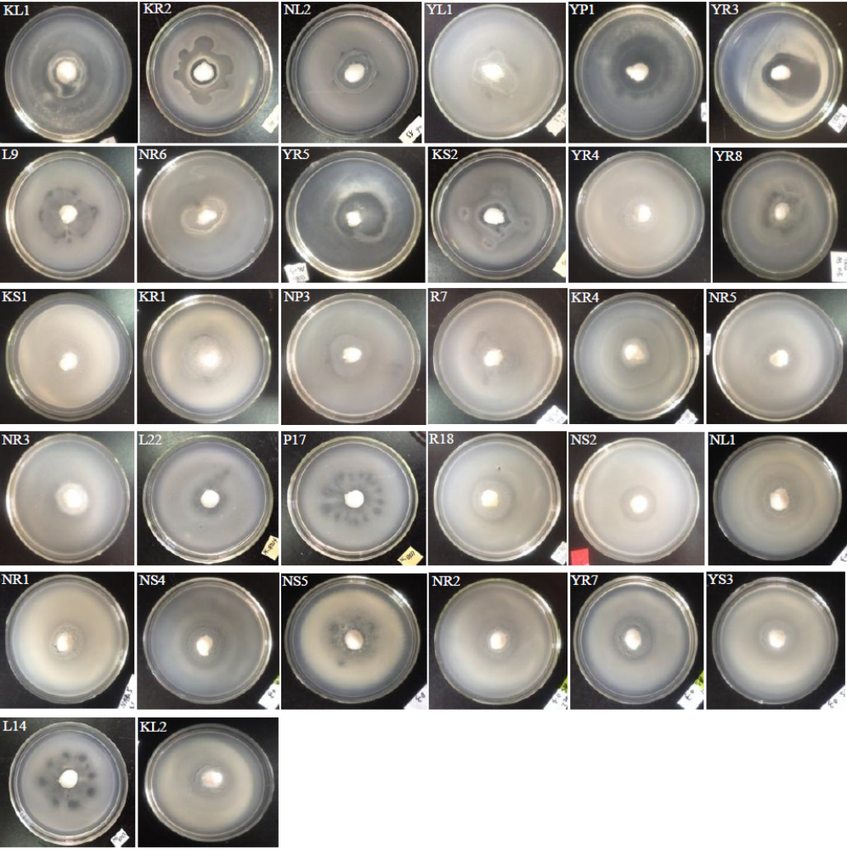

Fig. S1

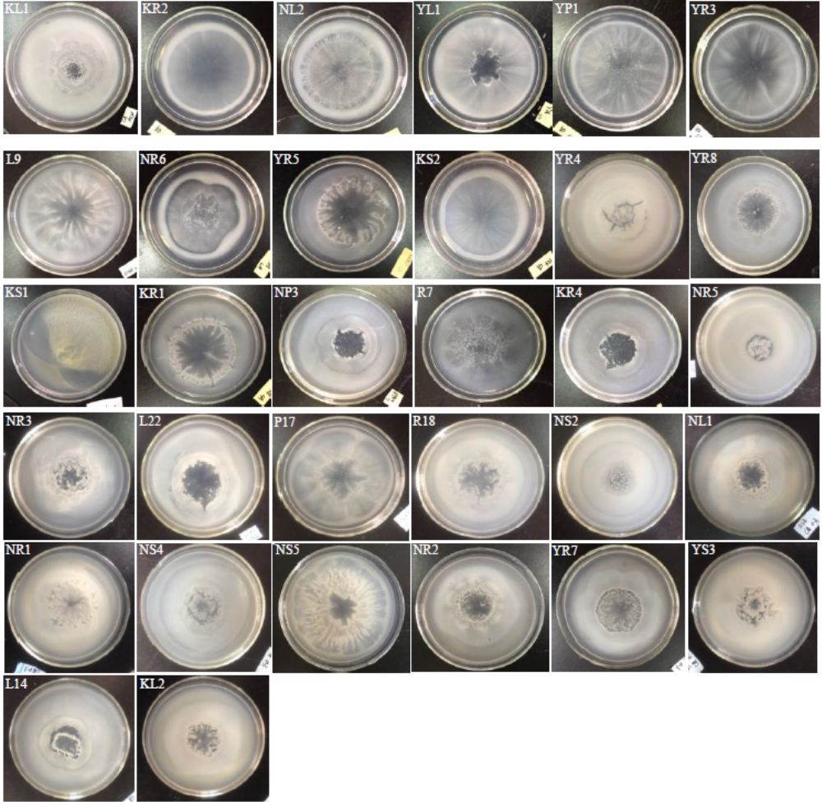

Fig. S2

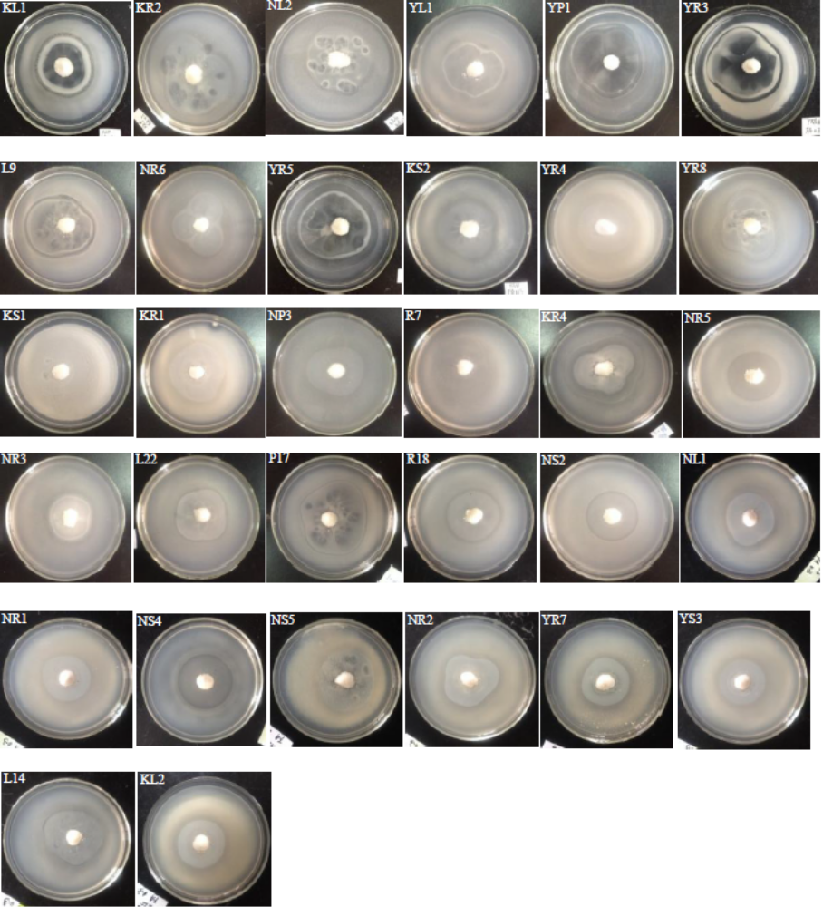

Fig. S3

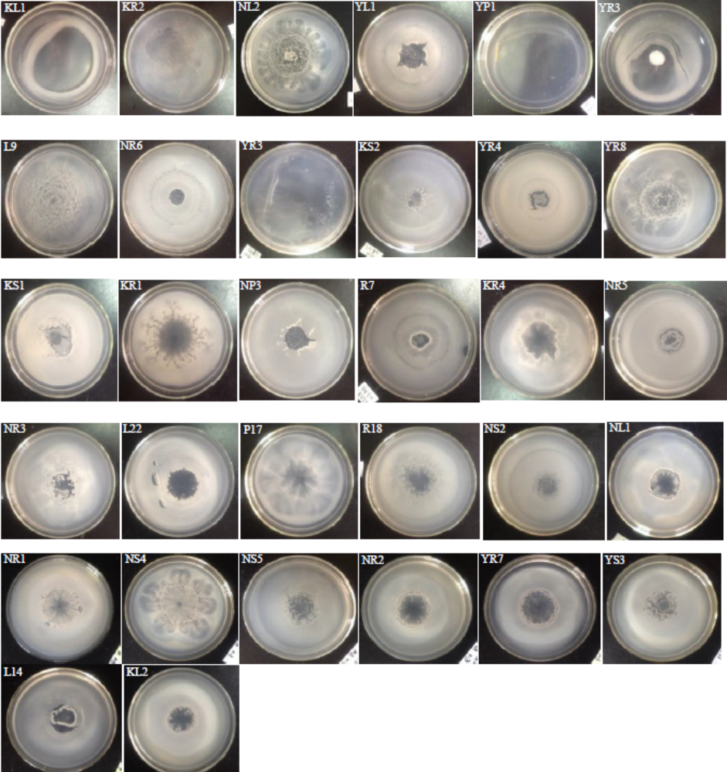

Fig. S4

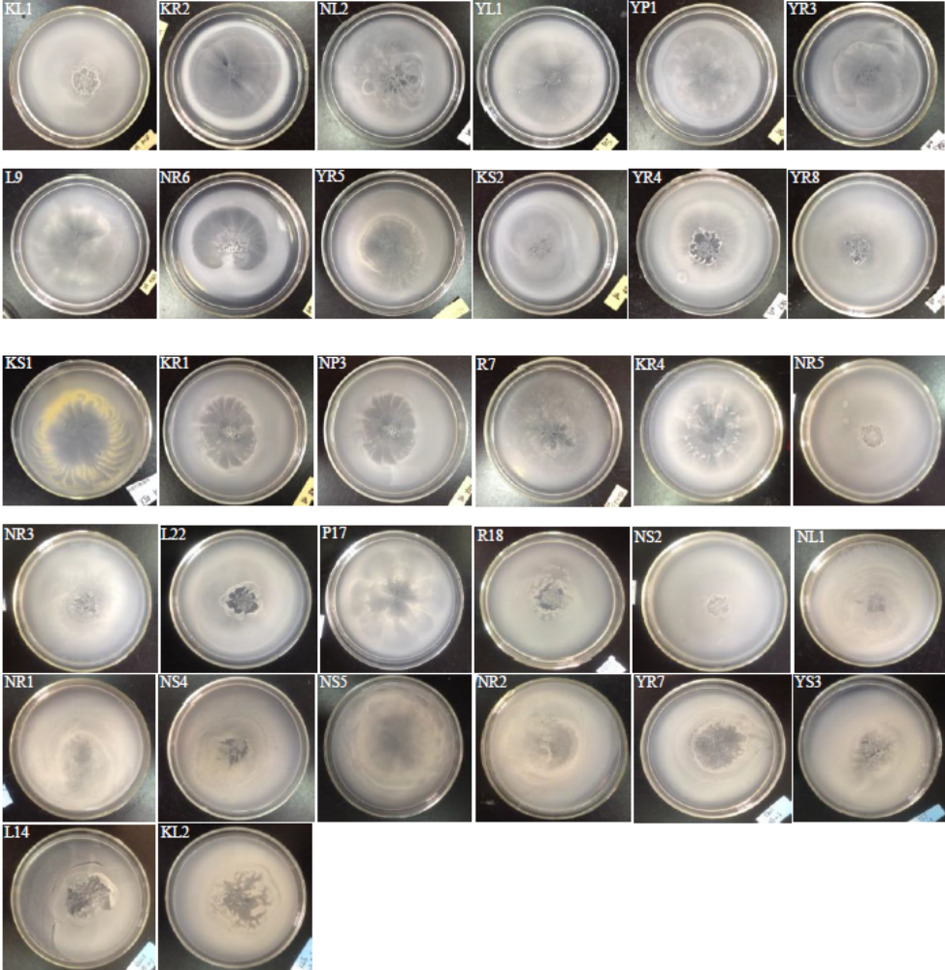

Fig. S5

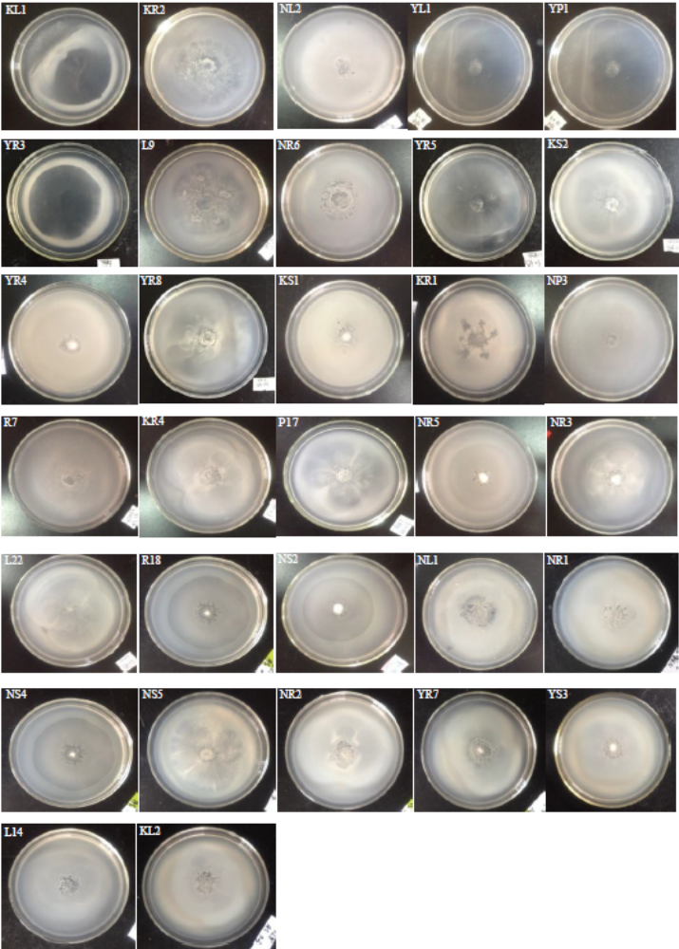

Fig. S6

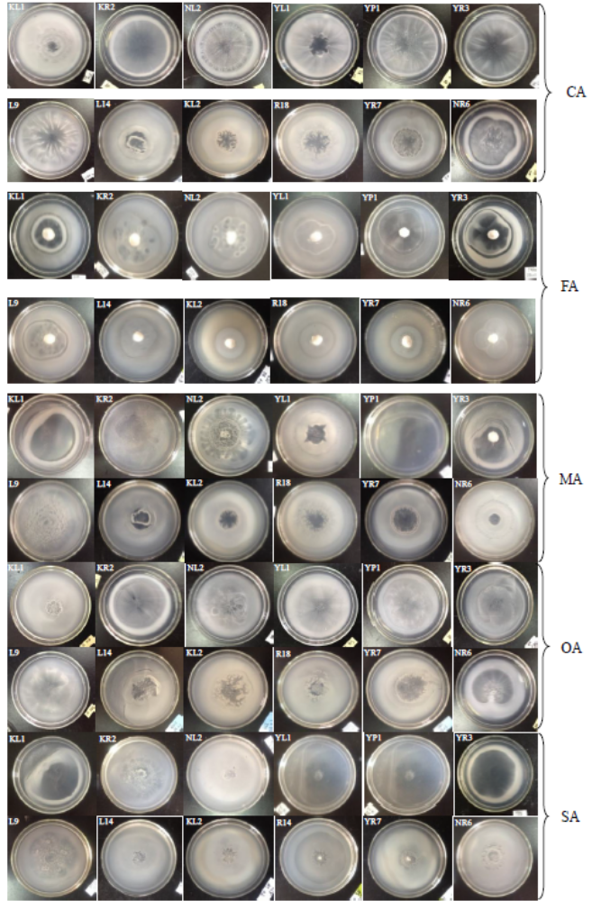
Fig. S7

