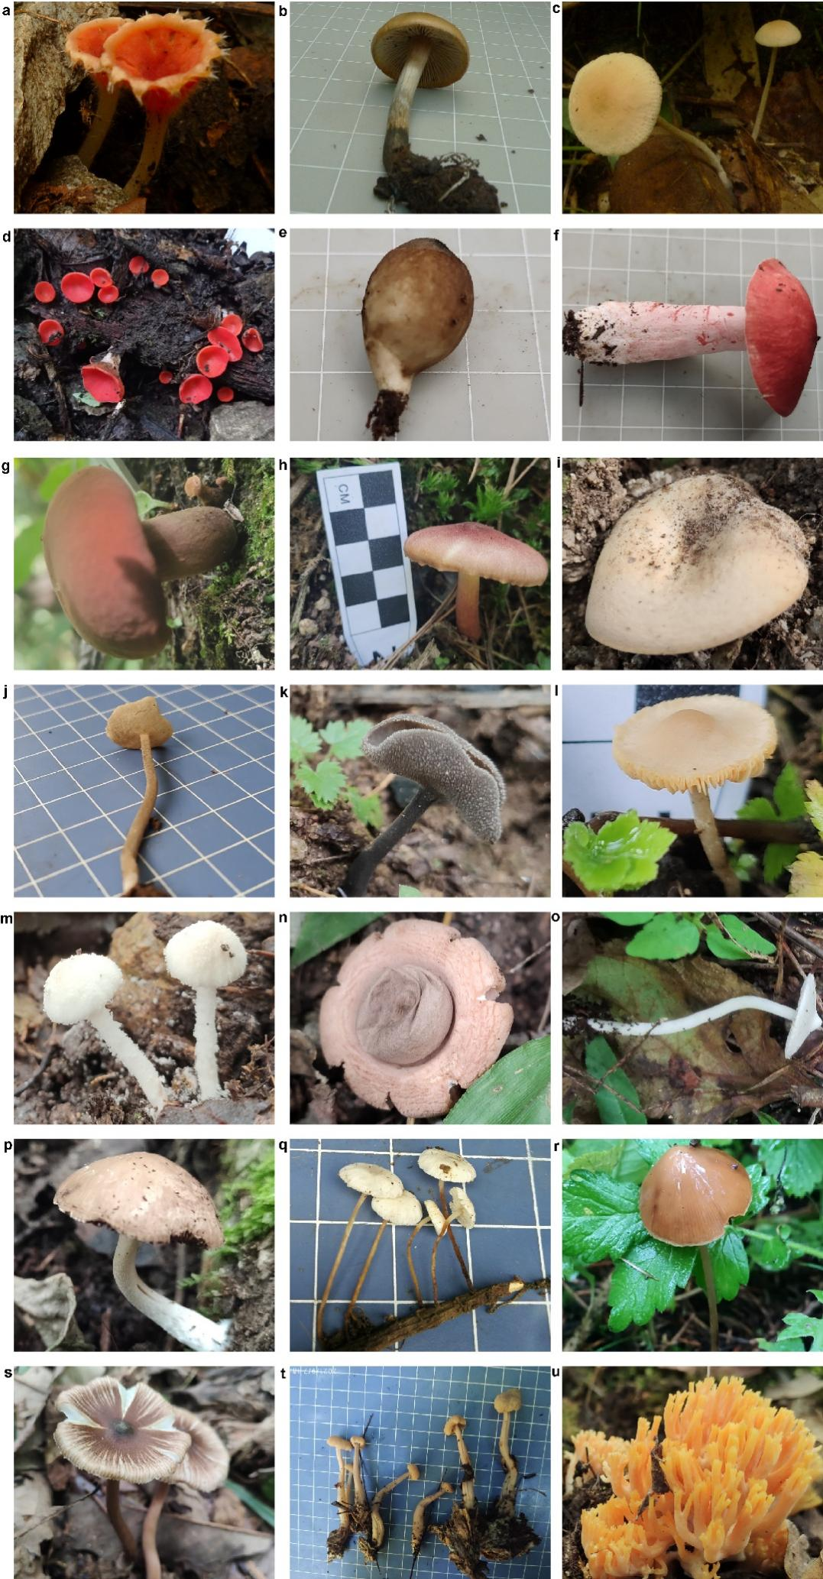
Figure S1. Novel and potential novel fungal species identified in this study. Novel species of Microstoma (a), Psilocybe (b), and Helvella (j, k). Potential novel species of Marasmius (c), Sarcoscypha (d), Lycoperdon (e), Russula (f), Boletaceae (g), Tricholomopsis (h), Lactifluus (i), Tubaria (l), Cystolepiota (m), Geastrum (n), Inocybe (o, s), Psathyrella (p), Marasmiellus (q), Conocybe (r), Cudonia (t), and Ramaria (u).

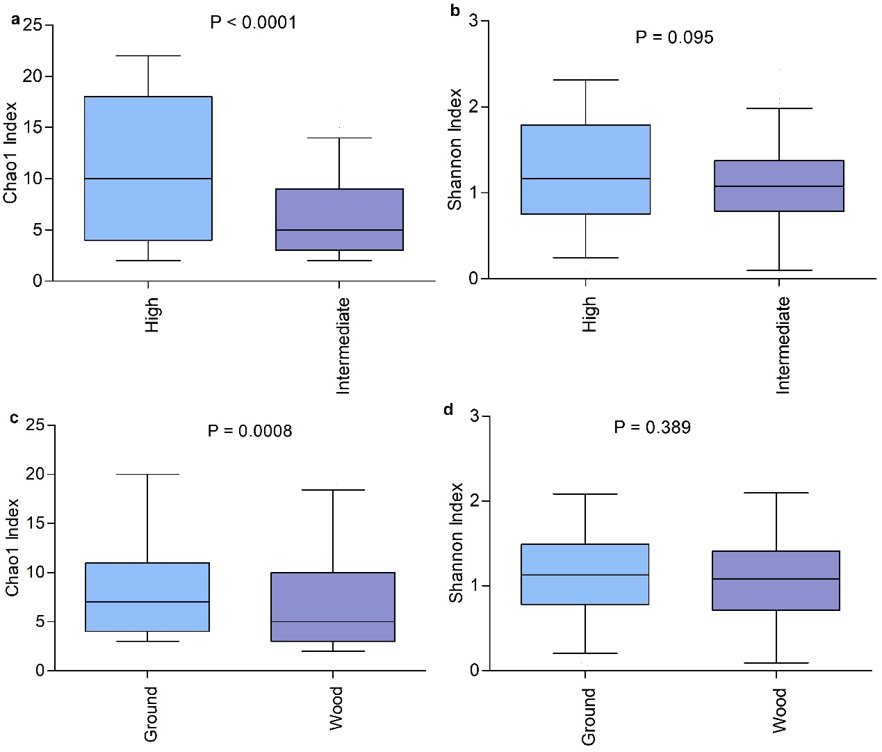
Figure S2. Alpha diversity of fungicolous fungal communities. Box plots show variation in Chao1 (a, c) and Shannon diversity (b, d) indices of fungicolous fungal communities from sporocarps collected from different altitude areas (a, b) and growth substrates (c, d). Medians are indicated by dark lines. Statistical differences between the different categories were evaluated using Student’s t-tests. Source data are provided as a source data ﬁle.

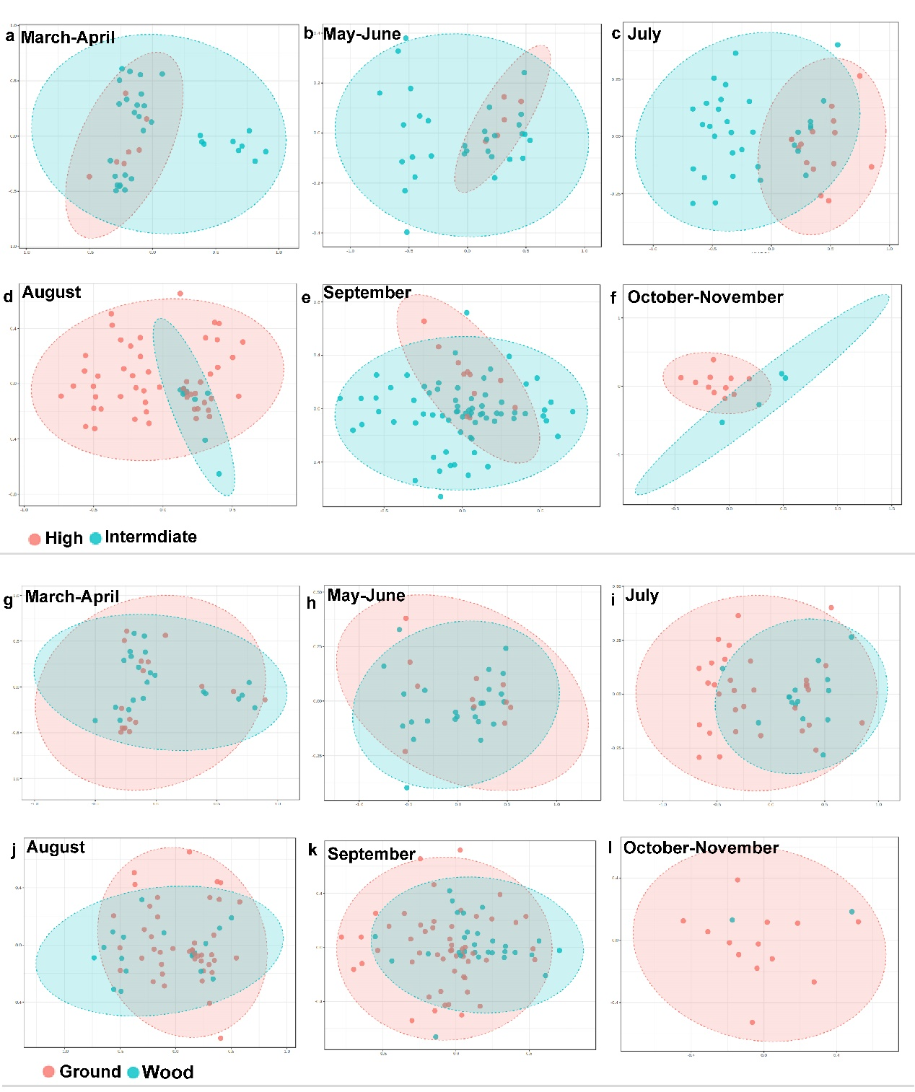
Figure S3. Non-metric multidimensional scaling plots based on Bray–Curtis dissimilarities of fungicolous fungal community composition in sporocarps. These sporocarps were from different altitude areas, growth substrates, and collection times from March to November. Statistical significance was analyzed using PERMANOVA tests. The stress and p values are shown in Table S5. Source data are provided as a source data ﬁle.

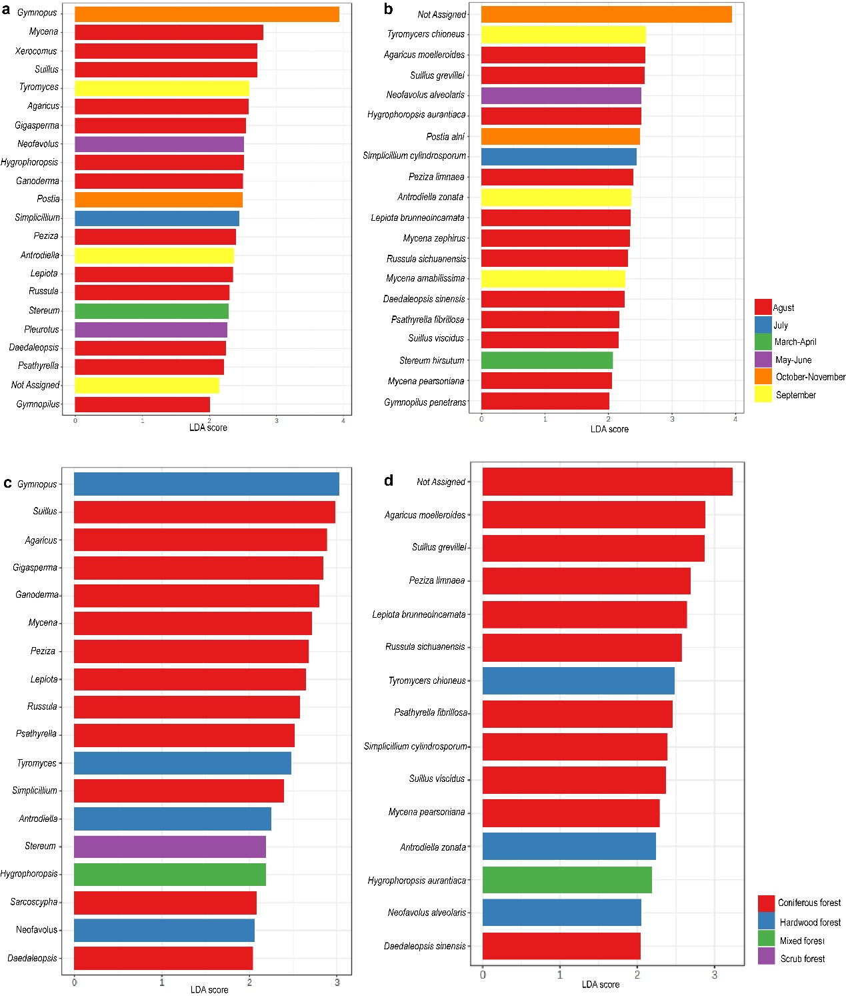
Figure S4. Enrichment of fungicolous fungal taxa in sporocarps. These sporocarps were sampled collected in different months (a and b) and from different habitats (c and d) based on LEfSe analyses. Histograms show linear discriminant analysis (LDA) scores calculated for ASVs at the genus (a and c) and species (b and d) levels. Source data are provided as a source data ﬁle.

Table S1. Novel species identified in this study.
Samples number | Maximum value of percent identity （%）ª | Notes
20200016 | 87.72 | Novel species of Microstoma 1
20200025 | 94.10 | Novel species of Psilocybe 2
20200053 | 93.52 | Potential novel species of Marasmius
20200118 | 96.79 | Potential novel species of Sarcoscypha
20200143 | 95.58 | Potential novel species of Lycoperdon
20200155 | 96.09 | Potential novel species of Russula
20200161 | 81.62 | Potential novel species of Boletaceae
20200162 | 95.20 | Potential novel species of Tricholomopsis
20200180 | 91.63 | Potential novel species of Lactifluus
20200210 | 81.96 | Novel species of Helvella 3
20200232 | 81.39 | Novel species of Helvella 3
20200244 | 91.24 | Potential novel species of Tubaria
20200273 | 93.67 | Potential novel species of Cystolepiota
20200276 | 93.89 | Potential novel species of Geastrum
20200300 | 91.87 | Potential novel species of Inocybe
20210402 | 94.14 | Potential novel species of Psathyrella
20210441 | 93.89 | Potential novel species of Marasmiellus
20210447 | 80.81 | Potential novel species of Conocybe
20210462 | 86.64 | Potential novel species of Inocybe
20210485 | 91.87 | Potential novel species of Cudonia
20210498 | 85.61 | Potential novel species of Ramaria
ª Maximum value of percent identity refers to the maximum nucleotide similarity identity value from BLASTn searches using the ITS1 ASV sequences.

References
- Huo WY et al. MicrostomaNingshanica, a new species of Microstoma based on molecular, light and scanning electron microscopy analyses from Shaanxi Province, China. All Life. 2022;15(1):901-907. DOI: 10.1080/26895293.2022.2114551.
- He XL, et al. Psilocybe ningshanensis (Hymenogastraceae, Agaricales), a new species from China. Phytotaxa. 2022; 545(2):175-185. DOI: 10.11646/phytotaxa.545.2.6.
- He XL, et al. Two New Species of Helvella (Pezizales, Ascomycota) in the Qinling Mountains, China. J Fungal Res. 2023.

Table S2. Samples Information
Sample number | Species identification | Notes
20200001 | Psathyrella mammifera
20200004 | Psathyrella mammifera
20200005 | Psathyrella longicauda
20200008 | Tubaria furfuracea
20200010 | Sarcoscypha austriaca
20200013 | Entoloma vernum
20200016 | Microstoma ningshanica | Novel species
20200017 | Lentinula edodes
20200021 | Sarcoscypha austriaca
20200022 | Psathyrella cf. bipellis
20200025 | Psilocybe ningshanica | Novel species
20200026 | Fulvoderma scaurum
20200028 | Psathyrella mammifera
20200029 | Psathyrella mammifera
20200036 | Neofavolus alveolaris
20200037 | Psilocybe ningshanica
20200040 | Xylaria sp.
20200042 | Mycena galericulata
20200043 | Mycena maculate
20200044 | Simocybe centunculus
20200046 | Scutellinia crinite
20200049 | Russula sp.
20200051 | Marasmiellus candidus
20200052 | Russula sp.
20200053 | Marasmius sp. | Potential novel species
20200055 | Chaetocalathus galeatus
20200056 | Mycena abramsii
20200057 | Mycena abramsii
20200058 | Laccaria laccata
20200063 | Coprinellus radians
20200065 | Gymnopus ocior
20200067 | Coprinellus disseminatus
20200070 | Tyromyces chioneus
20200071 | Gymnopus densilamellatus
20200072 | Entoloma llimonae
20200073 | Gymnopus densilamellatus
20200076 | Ganoderma applanatum
20200078 | Laccaria laccata
20200081 | Russula sp.
20200082 | Amanita molliuscula
20200083 | Amanita incarnatifolia
20200084 | Russula sp.
20200085 | Scleroderma cepa
20200086 | Tricholomopsis sp.
20200087 | Russula sp.
20200088 | Entoloma rivulare
20200089 | Entoloma rivulare
20200090 | Inocybe stellata
20200092 | Inocybe malenconii
20200093 | Amanita subglobosa
20200094 | Russula sp.
20200095 | Russula insignis
20200096 | Cortinarius epipurrus
20200097 | Scleroderma cepa
20200098 | Russula sp.
20200100 | Russula sp.
20200101 | Strobilomyces sp.
20200102 | Lactifluus pilosus
20200103 | Boletus reticulatus
20200105 | Tyromyces kmetii
20200114 | Ophiocordyceps nutans
20200115 | Trichaleurina tenuispora
20200116 | Ganoderma applanatum
20200117 | Psathyrella incondita
20200118 | Sarcoscypha sp. | Potential novel species
20200119 | Polyporus tuberaster
20200120 | Psathyrella microrhiza
20200121 | Suillus viscidus
20200122 | Suillus viscidus
20200123 | Psathyrella amarescens
20200124 | Tremiscus helvelloides
20200125 | Mycena pura
20200126 | Mycena pearsoniana
20200127 | Suillus grevillea
20200128 | Lepiota sp.
20200129 | Cystoderma arcticum
20200130 | Inocybe cincinnata
20200131 | Gymnopilus picreus
20200132 | Peziza badia
20200134 | Humaria hemisphaerica
20200136 | Tephrocybe confusa
20200137 | Singerocybe umbilicata
20200138 | Tremiscus helvelloides
20200139 | Amanita glarea
20200140 | Gymnopilus sp.
20200141 | Mycena subulate
20200142 | Mycena subulate
20200143 | Lycoperdon sp. | Potential novel species
20200145 | Leotia lubrica
20200146 | Tricholomopsis sp.
20200147 | Hygrophoropsis ningshanica
20200148 | Daedaleopsis confragosa
20200151 | Suillus grevillea
20200152 | Xerocomus magniporus
20200154 | Lactarius deliciosus
20200155 | Russula sp. | Potential novel species
20200157 | Marasmius occultatiformis
20200158 | Marasmius occultatiformis
20200159 | Mycena sp.
20200161 | Boletaceae sp. | Potential novel species
20200162 | Tricholomopsis sp. | Potential novel species
20200164 | Strobilomyces sp.
20200165 | Gyroporus sp.
20200170 | Amanita pallidorosea
20200172 | Lactarius ambiguus
20200173 | Hymenochaete xerantica
20200174 | Suillus luteus
20200175 | Amanita griseofolia
20200176 | Gymnopus dryophilus
20200177 | Hydnellum brunneorubrum
20200179 | Hydnum berkeleyanum
20200180 | Lactifluus sp. | Potential novel species
20200181 | Laetiporus cremeiporus
20200182 | Stropharia lignicola
20200183 | Laccaria negrimarginata
20200184 | Leotia lubrica
20200187 | Hydnum albopallidum
20200188 | Hydnum albopallidum
20200189 | Mycena pura
20200191 | Marasmius occultatiformis
20200193 | Stropharia rugosoannulata
20200197 | Cortinarius scaurus
20200199 | Pseudosperma rimosum
20200201 | Lactarius subatlanticus
20200202 | Mycena pearsoniana
20200204 | Mycena galericulata
20200205 | Lycoperdon caudatum
20200206 | Clavulina sp.
20200209 | Inocybe sp.
20200210 | Helvella sp. | Novel species
20200211 | Hypomyces cervinus
20200212 | Hypomyces cervinus
20200214 | Polyporus sp.
20200215 | Cortinarius helvolus
20200216 | Stropharia lignicola
20200218 | Singerocybe alboinfundibuliformis
20200220 | Mycena citrinomarginata
20200222 | Inocybe lilacina
20200224 | Mycena floridula
20200225 | Lyophyllum leucophaeatum
20200226 | Inocybe sp.
20200232 | Helvella sp. | Novel species
20200234 | Pleurotus pulmonarius
20200235 | Psathyrella candolleana
20200237 | Pluteus nanus
20200240 | Psathyrella microrhiza
20200241 | Mucidula mucida
20200242 | Coprinopsis lagopus
20200243 | Kuehneromyces mutabilis
20200244 | Tubaria sp. | Potential novel species
20200247 | Cortinarius hinnuleus
20200249 | Gymnopus erythropus
20200253 | Pleurotus pulmonarius
20200256 | Mycena galopus var. candida
20200258 | Crepidotus sphaerosporus
20200263 | Phillipsia chinensis
20200266 | Gymnopus erythropus
20200268 | Mycena haematopus
20200272 | Antrodiella zonata
20200273 | Cystolepiota sp. | Potential novel species
20200276 | Geastrum sp. | Potential novel species
20200277 | Cyclocybe erebia
20200283 | Hypholoma lateritium
20200284 | Cyanosporus coeruleivirens
20200285 | Agrocybe firma
20200290 | Flammulina cephalariae
20200292 | Mycena pura
20200293 | Suillus luteus
20200294 | Suillus luteus
20200295 | Leratiomyces sp.
20200296 | Laccaria laccata
20200299 | Cuphophyllus virgineus
20200300 | Inocybe sp. | Potential novel species
20200301 | Gymnopus dryophilus
20200302 | Hebeloma cavipes
20200303 | Hypholoma fasciculare
20200304 | Laccaria versiforma
20200323 | Tulostoma squamosum
20200324 | Geastrum sp.
20200325 | Hebeloma dunense
20200326 | Phellinus orientoasiaticus
20210003 | Tubaria furfuracea
20210004 | Strobilurus luchuensis
20210007 | Galerina marginata
20210009 | Strobilurus luchuensis
20210011 | Panaeolus papilionaceus
20210013 | Trametes sanguinea
20210014 | Tubaria furfuracea
20210015 | Trametes junipericola
20210016 | Hypholoma fasciculare
20210017 | Mycena laevigata
20210018 | Psathyrella phegophila
20210019 | Strobilurus luchuensis
20210020 | Auriscalpium microsporum
20210026 | Psathyrella phegophila
20210029 | Neofavolus alveolaris
20210031 | Galerina marginata
20210058 | Coprinellus radians
20210060 | Daedalea dickinsii
20210062 | Neofavolus alveolaris
20210063 | Psathyrella senex
20210064 | Psathyrella longicauda
20210065 | Psathyrella mammifera
20210067 | Psathyrella bipellis
20210068 | Polyporus arcularius
20210069 | Volvariella gloiocephala
20210089 | Flammulina cephalariae
20210090 | Xylaria schweinitzii
20210091 | Neofavolus alveolaris
20210092 | Psathyrella amaura
20210093 | Cerioporus squamosus
20210094 | Agrocybe praecox
20210097 | Entoloma sepium
20210098 | Polyporus varius
20210099 | Coprinellus radians
20210100 | Entoloma llimonae
20210102 | Psathyrella phegophila
20210104 | Psathyrella bipellis
20210106 | Neofavolus alveolaris
20210115 | Mycena silvae-nigrae
20210118 | Psathyrella candolleana
20210121 | Mycena silvae-nigrae
20210122 | Turbinellus floccosus
20210125 | Artomyces pyxidatus
20210128 | Gymnopus dryophilus
20210138 | Daedalea dickinsii
20210140 | Hydnum berkeleyanum
20210141 | Agaricus xanthodermus
20210147 | Psathyrella candolleana
20210151 | Pluteus primus
20210175 | Paxillus involutus
20210182 | Strobilomyces confusus
20210198 | Russula sp.
20210205 | Cortinarius sp.
20210208 | Mycena pura
20210212 | Russula lakhanpalii
20210245 | Geastrum Velutinum
20210246 | Gymnopus dryophilus
20210251 | Marasmius oreades
20210258 | Stropharia ambigua
20210261 | Entoloma abortivum
20210273 | Trichoglossum sp.
20210274 | Lactarius torminosus
20210278 | Mucidula mucida
20210283 | Phillipsia chinensis
20210402 | Psathyrella sp. | Potential novel species
20210405 | Polyporus tuberaster
20210409 | Coprinellus disseminatus
20210411 | Inocybe semifulva
20210414 | Boletus reticulatus
20210421 | Amanita incarnatifolia
20210423 | Humaria hemisphaerica
20210426 | Polyporus tuberaster
20210427 | Panaeolus fimicola
20210433 | Helvella elastica
20210434 | Suillus viscidus
20210435 | Suillus viscidus
20210441 | Marasmiellus sp. | Potential novel species
20210445 | Amanita brunneofuliginea
20210447 | Conocybe sp. | Potential novel species
20210451 | Piptoporellus soloniensis
20210453 | Laetiporus cremeiporus
20210457 | Amanita pallidorosea
20210458 | Russula persicina
20210462 | Inocybe sp. | Potential novel species
20210465 | Russula aurantioflava
20210466 | Gymnopilus penetrans
20210468 | Calocera viscosa
20210471 | Artomyces pyxidatus
20210475 | Hebeloma danicum
20210477 | Phillipsia chinensis
20210478 | Tricholoma argyraceum
20210479 | Lactarius ambiguus
20210485 | Cudonia sp. | Potential novel species
20210490 | Laccaria laccata
20210498 | Ramaria sp. | Potential novel species
20210499 | Amanita abrupta
20210504 | Suillus luteus
20210512 | Armillaria sp.
20210525 | Armillaria sp.

Table S3. The information of barcodes X
Sample nomber | Barcodes X
Sample nomber | Forward | Reverse
20200001 | ACACGCATGACACACT | AGTGTGTCATGCGTGT
20200004 | CATCACTACGCTAGAT | AGTGTGTCATGCGTGT
20200005 | TCTATGTCTCAGTAGT | AGTGTGTCATGCGTGT
20200008 | GCACATACACGCTCAC | AGTGTGTCATGCGTGT
20200010 | TGCTCTCGTGTACTGT | AGTGTGTCATGCGTGT
20200013 | GACAGCATCTGCGCTC | AGTGTGTCATGCGTGT
20200016 | ATGCTCACTACTACAT | AGTGTGTCATGCGTGT
20200017 | GACTGCACATGCACGA | AGTGTGTCATGCGTGT
20200021 | CGTGAGTAGTCAGACG | AGTGTGTCATGCGTGT
20200022 | ATCGCATCGCAGAGAC | AGTGTGTCATGCGTGT
20200025 | TATCAGCACGACATGC | AGTGTGTCATGCGTGT
20200026 | ATCGAGCAGCAGTCGT | AGTGTGTCATGCGTGT
20200028 | TGCATAGTAGTGCTCT | AGTGTGTCATGCGTGT
20200029 | CTACGATGCTATGTAT | AGTGTGTCATGCGTGT
20200036 | TACATCTCGCTGCGCA | AGTGTGTCATGCGTGT
20200037 | ACACGCATGACACACT | TCTGTAGTGCGTGCGC
20200040 | CATCACTACGCTAGAT | TCTGTAGTGCGTGCGC
20200042 | GTGCGTATGTCGCTAC | TCTGTAGTGCGTGCGC
20200043 | TACGCGTGTACGCAGA | TCTGTAGTGCGTGCGC
20200044 | GCACATACACGCTCAC | TCTGTAGTGCGTGCGC
20200046 | TGCTCTCGTGTACTGT | TCTGTAGTGCGTGCGC
20200049 | GACAGCATCTGCGCTC | TCTGTAGTGCGTGCGC
20200051 | CTGATGCGCGCTGTAC | TCTGTAGTGCGTGCGC
20200052 | ATGCTCACTACTACAT | TCTGTAGTGCGTGCGC
20200053 | GACTGCACATGCACGA | TCTGTAGTGCGTGCGC
20200055 | GACGTGTCGTAGATAT | TCTGTAGTGCGTGCGC
20200056 | ATCGCTGTGTCTATAG | TCTGTAGTGCGTGCGC
20200057 | CGTGAGTAGTCAGACG | TCTGTAGTGCGTGCGC
20200058 | ATCGCATCGCAGAGAC | TCTGTAGTGCGTGCGC
20200063 | CTAGACACGCAGTCAC | TCTGTAGTGCGTGCGC
20200065 | CTACGATGCTATGTAT | TCTGTAGTGCGTGCGC
20200067 | TCTACTGCATGATGTC | TCTGTAGTGCGTGCGC
20200070 | CATACATCGCGCAGTA | TCTGTAGTGCGTGCGC
20200071 | ACACGTGATAGCTACG | TCTGTAGTGCGTGCGC
20200072 | TACATCTCGCTGCGCA | TCTGTAGTGCGTGCGC
20200073 | ACACGCATGACACACT | AGCTCTGAGTCTCTAT
20200076 | CATCACTACGCTAGAT | AGCTCTGAGTCTCTAT
20200078 | GTGCGTATGTCGCTAC | AGCTCTGAGTCTCTAT
20200081 | ACAGTGCGCTGTCTAT | AGCTCTGAGTCTCTAT
20200082 | TGCTCTCGTGTACTGT | AGCTCTGAGTCTCTAT
20200083 | CTCAGTGTGACACATG | AGCTCTGAGTCTCTAT
20200084 | ATGCTGATGACGCGCT | AGCTCTGAGTCTCTAT
20200085 | GACAGCATCTGCGCTC | AGCTCTGAGTCTCTAT
20200086 | CGACTACGTACAGTAG | AGCTCTGAGTCTCTAT
20200087 | CTGATGCGCGCTGTAC | AGCTCTGAGTCTCTAT
20200088 | ATGCTCACTACTACAT | AGCTCTGAGTCTCTAT
20200089 | GACTGCACATGCACGA | AGCTCTGAGTCTCTAT
20200090 | TATGACTAGTGTACTA | AGCTCTGAGTCTCTAT
20200092 | ATCGCTGTGTCTATAG | AGCTCTGAGTCTCTAT
20200093 | CGTGAGTAGTCAGACG | AGCTCTGAGTCTCTAT
20200094 | ATCGCATCGCAGAGAC | AGCTCTGAGTCTCTAT
20200095 | TGCTATCTGAGATACT | AGCTCTGAGTCTCTAT
20200096 | CAGCAGATCATGTCGA | AGCTCTGAGTCTCTAT
20200097 | TATCAGCACGACATGC | AGCTCTGAGTCTCTAT
20200098 | ATCGAGCAGCAGTCGT | AGCTCTGAGTCTCTAT
20200100 | TGCATAGTAGTGCTCT | AGCTCTGAGTCTCTAT
20200101 | CTACGATGCTATGTAT | AGCTCTGAGTCTCTAT
20200102 | GTCACGATATAGTGAC | AGCTCTGAGTCTCTAT
20200103 | TCTACTGCATGATGTC | AGCTCTGAGTCTCTAT
20200105 | AGTCACACGCACGCTG | AGCTCTGAGTCTCTAT
20200114 | GTGCGTATGTCGCTAC | ATCTAGCGTAGTGATG
20200115 | TACGCGTGTACGCAGA | ATCTAGCGTAGTGATG
20200116 | GCACATACACGCTCAC | ATCTAGCGTAGTGATG
20200117 | ACAGTGCGCTGTCTAT | ATCTAGCGTAGTGATG
20200118 | TGCTCTCGTGTACTGT | ATCTAGCGTAGTGATG
20200119 | CTCAGTGTGACACATG | ATCTAGCGTAGTGATG
20200120 | ATGCTGATGACGCGCT | ATCTAGCGTAGTGATG
20200121 | GACAGCATCTGCGCTC | ATCTAGCGTAGTGATG
20200122 | CGACTACGTACAGTAG | ATCTAGCGTAGTGATG
20200123 | CTGATGCGCGCTGTAC | ATCTAGCGTAGTGATG
20200124 | ATGCTCACTACTACAT | ATCTAGCGTAGTGATG
20200125 | GACTGCACATGCACGA | ATCTAGCGTAGTGATG
20200126 | TATGACTAGTGTACTA | ATCTAGCGTAGTGATG
20200127 | GACGTGTCGTAGATAT | ATCTAGCGTAGTGATG
20200128 | ATCGCTGTGTCTATAG | ATCTAGCGTAGTGATG
20200129 | CGTGAGTAGTCAGACG | ATCTAGCGTAGTGATG
20200130 | ATCGCATCGCAGAGAC | ATCTAGCGTAGTGATG
20200131 | TGCTATCTGAGATACT | ATCTAGCGTAGTGATG
20200132 | CAGCAGATCATGTCGA | ATCTAGCGTAGTGATG
20200134 | ATCGAGCAGCAGTCGT | ATCTAGCGTAGTGATG
20200136 | TGCATAGTAGTGCTCT | ATCTAGCGTAGTGATG
20200137 | CTACGATGCTATGTAT | ATCTAGCGTAGTGATG
20200138 | GTCACGATATAGTGAC | ATCTAGCGTAGTGATG
20200139 | TCTACTGCATGATGTC | ATCTAGCGTAGTGATG
20200140 | TAGTGTGCGACTCTGA | ATCTAGCGTAGTGATG
20200141 | AGTCACACGCACGCTG | ATCTAGCGTAGTGATG
20200142 | CATACATCGCGCAGTA | ATCTAGCGTAGTGATG
20200143 | ACACGTGATAGCTACG | ATCTAGCGTAGTGATG
20200145 | ACACGCATGACACACT | ACTACTGAGACATAGA
20200146 | GCGCACGCACTACAGA | ACTACTGAGACATAGA
20200147 | ATAGAGACTCAGAGCT | ACTACTGAGACATAGA
20200148 | CATCACTACGCTAGAT | ACTACTGAGACATAGA
20200151 | TACGCGTGTACGCAGA | ACTACTGAGACATAGA
20200152 | GCACATACACGCTCAC | ACTACTGAGACATAGA
20200154 | TGCTCTCGTGTACTGT | ACTACTGAGACATAGA
20200155 | CTCAGTGTGACACATG | ACTACTGAGACATAGA
20200157 | GACAGCATCTGCGCTC | ACTACTGAGACATAGA
20200158 | CGACTACGTACAGTAG | ACTACTGAGACATAGA
20200159 | CTGATGCGCGCTGTAC | ACTACTGAGACATAGA
20200161 | GACTGCACATGCACGA | ACTACTGAGACATAGA
20200162 | TATGACTAGTGTACTA | ACTACTGAGACATAGA
20200164 | ATCGCTGTGTCTATAG | ACTACTGAGACATAGA
20200165 | CGTGAGTAGTCAGACG | ACTACTGAGACATAGA
20200170 | ATCGAGCAGCAGTCGT | ACTACTGAGACATAGA
20200172 | TGCATAGTAGTGCTCT | ACTACTGAGACATAGA
20200173 | CTACGATGCTATGTAT | ACTACTGAGACATAGA
20200174 | GTCACGATATAGTGAC | ACTACTGAGACATAGA
20200175 | TCTACTGCATGATGTC | ACTACTGAGACATAGA
20200176 | TAGTGTGCGACTCTGA | ACTACTGAGACATAGA
20200177 | AGTCACACGCACGCTG | ACTACTGAGACATAGA
20200179 | ACACGTGATAGCTACG | ACTACTGAGACATAGA
20200180 | TACATCTCGCTGCGCA | ACTACTGAGACATAGA
20200181 | ACACGCATGACACACT | GTAGCGACATACGCAC
20200182 | GCGCACGCACTACAGA | GTAGCGACATACGCAC
20200183 | ATAGAGACTCAGAGCT | GTAGCGACATACGCAC
20200184 | CATCACTACGCTAGAT | GTAGCGACATACGCAC
20200187 | TACGCGTGTACGCAGA | GTAGCGACATACGCAC
20200188 | GCACATACACGCTCAC | GTAGCGACATACGCAC
20200189 | ACAGTGCGCTGTCTAT | GTAGCGACATACGCAC
20200191 | CTCAGTGTGACACATG | GTAGCGACATACGCAC
20200193 | GACAGCATCTGCGCTC | GTAGCGACATACGCAC
20200197 | GACTGCACATGCACGA | GTAGCGACATACGCAC
20200199 | GACGTGTCGTAGATAT | GTAGCGACATACGCAC
20200201 | CGTGAGTAGTCAGACG | GTAGCGACATACGCAC
20200202 | ATCGCATCGCAGAGAC | GTAGCGACATACGCAC
20200204 | CAGCAGATCATGTCGA | GTAGCGACATACGCAC
20200205 | TATCAGCACGACATGC | GTAGCGACATACGCAC
20200206 | ATCGAGCAGCAGTCGT | GTAGCGACATACGCAC
20200209 | CTACGATGCTATGTAT | GTAGCGACATACGCAC
20200210 | GTCACGATATAGTGAC | GTAGCGACATACGCAC
20200211 | TCTACTGCATGATGTC | GTAGCGACATACGCAC
20200212 | TAGTGTGCGACTCTGA | GTAGCGACATACGCAC
20200214 | CATACATCGCGCAGTA | GTAGCGACATACGCAC
20200215 | ACACGTGATAGCTACG | GTAGCGACATACGCAC
20200216 | TACATCTCGCTGCGCA | GTAGCGACATACGCAC
20200218 | GCGCACGCACTACAGA | TCTGCGTACACGCGTA
20200220 | CATCACTACGCTAGAT | TCTGCGTACACGCGTA
20200222 | GTGCGTATGTCGCTAC | TCTGCGTACACGCGTA
20200224 | GCACATACACGCTCAC | TCTGCGTACACGCGTA
20200225 | ACAGTGCGCTGTCTAT | TCTGCGTACACGCGTA
20200226 | TGCTCTCGTGTACTGT | TCTGCGTACACGCGTA
20200232 | ATGCTCACTACTACAT | TCTGCGTACACGCGTA
20200234 | TATGACTAGTGTACTA | TCTGCGTACACGCGTA
20200235 | GACGTGTCGTAGATAT | TCTGCGTACACGCGTA
20200237 | CGTGAGTAGTCAGACG | TCTGCGTACACGCGTA
20200240 | CAGCAGATCATGTCGA | TCTGCGTACACGCGTA
20200241 | TATCAGCACGACATGC | TCTGCGTACACGCGTA
20200242 | ATCGAGCAGCAGTCGT | TCTGCGTACACGCGTA
20200243 | CTAGACACGCAGTCAC | TCTGCGTACACGCGTA
20200244 | TGCATAGTAGTGCTCT | TCTGCGTACACGCGTA
20200247 | TCTACTGCATGATGTC | TCTGCGTACACGCGTA
20200249 | AGTCACACGCACGCTG | TCTGCGTACACGCGTA
20200253 | ACACGCATGACACACT | GTGAGCGTGTATGTGC
20200256 | CATCACTACGCTAGAT | GTGAGCGTGTATGTGC
20200258 | GTGCGTATGTCGCTAC | GTGAGCGTGTATGTGC
20200263 | CTCAGTGTGACACATG | GTGAGCGTGTATGTGC
20200266 | CGACTACGTACAGTAG | GTGAGCGTGTATGTGC
20200268 | ATGCTCACTACTACAT | GTGAGCGTGTATGTGC
20200272 | ATCGCTGTGTCTATAG | GTGAGCGTGTATGTGC
20200273 | CGTGAGTAGTCAGACG | GTGAGCGTGTATGTGC
20200276 | CAGCAGATCATGTCGA | GTGAGCGTGTATGTGC
20200277 | TATCAGCACGACATGC | GTGAGCGTGTATGTGC
20200283 | TCTACTGCATGATGTC | GTGAGCGTGTATGTGC
20200284 | TAGTGTGCGACTCTGA | GTGAGCGTGTATGTGC
20200285 | AGTCACACGCACGCTG | GTGAGCGTGTATGTGC
20200290 | GCGCACGCACTACAGA | ATAGACAGCGCACTGT
20200292 | CATCACTACGCTAGAT | ATAGACAGCGCACTGT
20200293 | TCTATGTCTCAGTAGT | ATAGACAGCGCACTGT
20200294 | GTGCGTATGTCGCTAC | ATAGACAGCGCACTGT
20200295 | TACGCGTGTACGCAGA | ATAGACAGCGCACTGT
20200296 | GCACATACACGCTCAC | ATAGACAGCGCACTGT
20200299 | CTCAGTGTGACACATG | ATAGACAGCGCACTGT
20200300 | ATGCTGATGACGCGCT | ATAGACAGCGCACTGT
20200301 | GACAGCATCTGCGCTC | ATAGACAGCGCACTGT
20200302 | CGACTACGTACAGTAG | ATAGACAGCGCACTGT
20200303 | CTGATGCGCGCTGTAC | ATAGACAGCGCACTGT
20200304 | ATGCTCACTACTACAT | ATAGACAGCGCACTGT
20200323 | ACACGTGATAGCTACG | ATAGACAGCGCACTGT
20200324 | TACATCTCGCTGCGCA | ATAGACAGCGCACTGT
20200325 | ACACGCATGACACACT | ACAGTACACGAGAGCA
20200326 | GCGCACGCACTACAGA | ACAGTACACGAGAGCA
20210003 | TCTATGTCTCAGTAGT | ACAGTACACGAGAGCA
20210004 | GTGCGTATGTCGCTAC | ACAGTACACGAGAGCA
20210007 | ACAGTGCGCTGTCTAT | ACAGTACACGAGAGCA
20210009 | CTCAGTGTGACACATG | ACAGTACACGAGAGCA
20210011 | GACAGCATCTGCGCTC | ACAGTACACGAGAGCA
20210013 | CTGATGCGCGCTGTAC | ACAGTACACGAGAGCA
20210014 | ATGCTCACTACTACAT | ACAGTACACGAGAGCA
20210015 | GACTGCACATGCACGA | ACAGTACACGAGAGCA
20210016 | TATGACTAGTGTACTA | ACAGTACACGAGAGCA
20210017 | GACGTGTCGTAGATAT | ACAGTACACGAGAGCA
20210018 | ATCGCTGTGTCTATAG | ACAGTACACGAGAGCA
20210019 | CGTGAGTAGTCAGACG | ACAGTACACGAGAGCA
20210020 | ATCGCATCGCAGAGAC | ACAGTACACGAGAGCA
20210026 | TGCATAGTAGTGCTCT | ACAGTACACGAGAGCA
20210029 | TCTACTGCATGATGTC | ACAGTACACGAGAGCA
20210031 | AGTCACACGCACGCTG | ACAGTACACGAGAGCA
20210058 | CAGCAGATCATGTCGA | CATGTGTCACACTGAG
20210060 | ATCGAGCAGCAGTCGT | CATGTGTCACACTGAG
20210062 | TGCATAGTAGTGCTCT | CATGTGTCACACTGAG
20210063 | CTACGATGCTATGTAT | CATGTGTCACACTGAG
20210064 | GTCACGATATAGTGAC | CATGTGTCACACTGAG
20210065 | TCTACTGCATGATGTC | CATGTGTCACACTGAG
20210067 | AGTCACACGCACGCTG | CATGTGTCACACTGAG
20210068 | CATACATCGCGCAGTA | CATGTGTCACACTGAG
20210069 | ACACGTGATAGCTACG | CATGTGTCACACTGAG
20210089 | GACGTGTCGTAGATAT | AGCGCGTCATCAGCAT
20210090 | ATCGCTGTGTCTATAG | AGCGCGTCATCAGCAT
20210091 | CGTGAGTAGTCAGACG | AGCGCGTCATCAGCAT
20210092 | ATCGCATCGCAGAGAC | AGCGCGTCATCAGCAT
20210093 | TGCTATCTGAGATACT | AGCGCGTCATCAGCAT
20210094 | CAGCAGATCATGTCGA | AGCGCGTCATCAGCAT
20210097 | CTAGACACGCAGTCAC | AGCGCGTCATCAGCAT
20210098 | TGCATAGTAGTGCTCT | AGCGCGTCATCAGCAT
20210099 | CTACGATGCTATGTAT | AGCGCGTCATCAGCAT
20210100 | GTCACGATATAGTGAC | AGCGCGTCATCAGCAT
20210102 | TAGTGTGCGACTCTGA | AGCGCGTCATCAGCAT
20210104 | CATACATCGCGCAGTA | AGCGCGTCATCAGCAT
20210106 | TACATCTCGCTGCGCA | AGCGCGTCATCAGCAT
20210115 | ACACGCATGACACACT | AGTGTGTCATGCGTGT
20210118 | ATAGAGACTCAGAGCT | AGCTCTGAGTCTCTAT
20210121 | CATCACTACGCTAGAT | ATCTAGCGTAGTGATG
20210122 | TCTATGTCTCAGTAGT | ACTACTGAGACATAGA
20210125 | GTGCGTATGTCGCTAC | GTAGCGACATACGCAC
20210128 | TACGCGTGTACGCAGA | TCTGCGTACACGCGTA
20210138 | CTCAGTGTGACACATG | CATGTGTCACACTGAG
20210140 | ATGCTGATGACGCGCT | AGCGCGTCATCAGCAT
20210141 | GACAGCATCTGCGCTC | GAGCGCAGATGCTGTC
20210147 | GACTGCACATGCACGA | TCGTGCATGTGCAGTC
20210151 | TATGACTAGTGTACTA | TAGTACACTAGTCATA
20210175 | ATCGAGCAGCAGTCGT | ACGACTGCTGCTCGAT
20210182 | TGCATAGTAGTGCTCT | AGAGCACTACTATGCA
20210198 | CATACATCGCGCAGTA | TACTGCGCGATGTATG
20210205 | TACATCTCGCTGCGCA | TGCGCAGCGAGATGTA
20210208 | ACACGCATGACACACT | AGTGTGTCATGCGTGT
20210212 | GCGCACGCACTACAGA | TCTGTAGTGCGTGCGC
20210245 | GACAGCATCTGCGCTC | GAGCGCAGATGCTGTC
20210246 | CGACTACGTACAGTAG | CTACTGTACGTAGTCG
20210251 | ATGCTCACTACTACAT | ATGTAGTAGTGAGCAT
20210258 | GACTGCACATGCACGA | TCGTGCATGTGCAGTC
20210261 | TATGACTAGTGTACTA | TAGTACACTAGTCATA
20210273 | GACGTGTCGTAGATAT | ATATCTACGACACGTC
20210274 | ATCGCTGTGTCTATAG | CTATAGACACAGCGAT
20210278 | TGCTATCTGAGATACT | AGTATCTCAGATAGCA
20210283 | ATCGAGCAGCAGTCGT | ACGACTGCTGCTCGAT
20210402 | TGCATAGTAGTGCTCT | AGAGCACTACTATGCA
20210405 | CTACGATGCTATGTAT | ATACATAGCATCGTAG
20210409 | GTCACGATATAGTGAC | GTCACTATATCGTGAC
20210411 | TCTACTGCATGATGTC | GACATCATGCAGTAGA
20210414 | CATACATCGCGCAGTA | TACTGCGCGATGTATG
20210421 | TCTATGTCTCAGTAGT | ACTACTGAGACATAGA
20210423 | TACGCGTGTACGCAGA | TCTGCGTACACGCGTA
20210426 | TGCTCTCGTGTACTGT | ACAGTACACGAGAGCA
20210427 | CTCAGTGTGACACATG | CATGTGTCACACTGAG
20210433 | ATGCTCACTACTACAT | ATGTAGTAGTGAGCAT
20210434 | GACTGCACATGCACGA | TCGTGCATGTGCAGTC
20210435 | TATGACTAGTGTACTA | TAGTACACTAGTCATA
20210441 | CGTGAGTAGTCAGACG | CGTCTGACTACTCACG
20210445 | TGCTATCTGAGATACT | AGTATCTCAGATAGCA
20210447 | CAGCAGATCATGTCGA | TCGACATGATCTGCTG
20210451 | TATCAGCACGACATGC | GCATGTCGTGCTGATA
20210453 | ATCGAGCAGCAGTCGT | ACGACTGCTGCTCGAT
20210457 | CTACGATGCTATGTAT | ATACATAGCATCGTAG
20210458 | GTCACGATATAGTGAC | GTCACTATATCGTGAC
20210462 | TAGTGTGCGACTCTGA | TCAGAGTCGCACACTA
20210465 | AGTCACACGCACGCTG | CAGCGTGCGTGTGACT
20210466 | CATACATCGCGCAGTA | TACTGCGCGATGTATG
20210468 | ACACGTGATAGCTACG | CGTAGCTATCACGTGT
20210471 | ACACGCATGACACACT | AGTGTGTCATGCGTGT
20210475 | GCGCACGCACTACAGA | TCTGTAGTGCGTGCGC
20210477 | ATAGAGACTCAGAGCT | AGCTCTGAGTCTCTAT
20210478 | CATCACTACGCTAGAT | ATCTAGCGTAGTGATG
20210479 | TCTATGTCTCAGTAGT | ACTACTGAGACATAGA
20210485 | TACGCGTGTACGCAGA | TCTGCGTACACGCGTA
20210490 | ACAGTGCGCTGTCTAT | ATAGACAGCGCACTGT
20210498 | TGCTCTCGTGTACTGT | ACAGTACACGAGAGCA
20210499 | CTCAGTGTGACACATG | CATGTGTCACACTGAG
20210504 | GACAGCATCTGCGCTC | GAGCGCAGATGCTGTC
20210512 | CGACTACGTACAGTAG | CTACTGTACGTAGTCG
20210525 | GACTGCACATGCACGA | TCGTGCATGTGCAGTC

Table S4. ITS reference sequences of macrofungi from NCBI
Scientific name | Taxid | Accession number
Leotia lubrica | 39932 | AY144549
Leotia lubrica | 39932 | AY144556
Leotia lubrica | 39932 | MW862370
Leotia lubrica | 39932 | AY144552
Helvella elastica | 155154 | MW862351
Humaria hemisphaerica | 137252 | DQ200832
Humaria hemisphaerica | 137252 | MF926527
Humaria hemisphaerica | 137252 | MZ159485
Microstoma ningshanica | 2817420 | MW718686
Agaricus xanthodermus | 83518 | JX434654
Agaricus xanthodermus | 83518 | MW291095
Agaricus xanthodermus | 83518 | MW554214
Lepiota sp. | 1916367 | MK651640
Amanita brunneofuliginea | 67694 | MH508270
Amanita griseofolia | 576577 | ON794274
Amanita griseofolia | 576577 | MW192459
Amanita griseofolia | 576577 | FJ441043
Amanita cf. incarnatifolia | 2303078 | MH508296
Amanita cf. incarnatifolia | 2303078 | MH508294
Amanita cf. incarnatifolia | 2303078 | MH508293
Amanita subglobosa | 67732 | KF017947
Crepidotus sphaerosporus | 110233 | MN823140
Crepidotus sphaerosporus | 110233 | MK966515
Laccaria laccata | 36061 | MZ310485
Laccaria laccata | 36061 | MW488332
Laccaria laccata | 36061 | JF273528
Laccaria laccata | 36061 | MW554155
Laccaria negrimarginata | 1263844 | JX504120
Laccaria versiforma | 2053751 | MG519559
Laccaria versiforma | 2053751 | MG519555
Gymnopilus penetrans | 171471 | KY434169
Gymnopilus penetrans | 171471 | KT368685
Gymnopilus penetrans | 171471 | KR072502
Gymnopilus penetrans | 171471 | MW750186
Hebeloma cavipes | 91667 | KX773876
Hebeloma cavipes | 91667 | MH366769
Hebeloma danicum | 91669 | KX687198
Hebeloma danicum | 91669 | MT117090
Hebeloma danicum | 91669 | MT117084
Hebeloma danicum | 91669 | MT117079
Hebeloma dunense | 1715262 | KX687199
Hebeloma dunense | 1715262 | MW445666
Hebeloma dunense | 1715262 | MW445655
Hebeloma dunense | 1715262 | MW445650
Psilocybe ningshanica | 2828053 | MW939918
Cystoderma arcticum | 858864 | GU234028
Cystoderma arcticum | 858864 | GU234154
Panaeolus papilionaceus | 330517 | MK397571
Inocybe lilacina | 71955 | MG719772
Inocybe stellata | 1745701 | MW520962
Inocybe stellata | 1745701 | MW554024
Inocybe stellata | 1745701 | GQ893012
Pseudosperma rimosum | 217425 | OM801908
Pseudosperma rimosum | 217425 | JF908111
Lycoperdon caudatum | 341587 | MK239255
Tephrocybe confusa | 1611801 | KP192633
Tephrocybe confusa | 1611801 | KP192611
Marasmius oreades | 181124 | MN258668
Marasmius oreades | 181124 | FJ481042
Marasmius oreades | 181124 | HF546217
Mycena abramsii | 1033003 | MZ666430
Mycena pura | 153505 | MK966530
Gymnopus densilamellatus | 1689719 | MT023351
Gymnopus densilamellatus | 1689719 | MT023350
Gymnopus densilamellatus | 1689719 | MT023349
Gymnopus dryophilus | 206318 | MH589970
Gymnopus dryophilus | 206318 | MH589966
Gymnopus dryophilus | 206318 | MH589964
Gymnopus dryophilus | 206318 | MH589963
Gymnopus dryophilus | 206318 | MH589962
Gymnopus ocior | 206328 | KY026678
Gymnopus ocior | 206328 | DQ449960
Gymnopus ocior | 206328 | DQ449959
Gymnopus ocior | 206328 | DQ449958
Gymnopus ocior | 206328 | DQ449956
Gymnopus ocior | 206328 | DQ449955
Lentinula edodes | 5353 | MT252553
Lentinula edodes | 5353 | MT252542
Lentinula edodes | 5353 | MH859349
Pluteus primus | 71960 | HM562156
Pluteus primus | 71960 | MK028500
Pluteus primus | 71960 | KJ009781
Pluteus primus | 71960 | KJ009780
Coprinellus disseminatus | 71703 | MK077819
Coprinellus disseminatus | 71703 | KJ714005
Coprinellus disseminatus | 71703 | OL355048
Coprinellus radians | 71721 | OK165585
Coprinellus radians | 71721 | KU761146
Coprinellus radians | 71721 | OM212897
Coprinellus radians | 71721 | HQ847045
Coprinellus radians | 71721 | JN943117
Psathyrella bipellis | 373338 | FN430700
Psathyrella candolleana | 71730 | MF161235
Psathyrella candolleana | 71730 | AB470883
Psathyrella candolleana | 71730 | LT716063
Psathyrella candolleana | 71730 | KU761246
Psathyrella candolleana | 71730 | MF475996
Psathyrella candolleana | 71730 | MK214404
Psathyrella candolleana | 71730 | MK247863
Psathyrella candolleana | 71730 | MW554147
Psathyrella cf. bipellis | 1905670 | KX897437
Psathyrella incondita | 2022278 | MF325975
Psathyrella microrhiza | 443893 | MF966500
Psathyrella microrhiza | 443893 | MF966498
Psathyrella microrhiza | 443893 | MH856264
Psathyrella microrhiza | 443893 | ON738545
Psathyrella senex | 443888 | AM712274
Kuehneromyces mutabilis | 71948 | OM970912
Kuehneromyces mutabilis | 71948 | MH855189
Kuehneromyces mutabilis | 71948 | MZ005552
Tricholoma argyraceum | 76320 | MK607504
Tricholoma argyraceum | 76320 | LT000127
Tricholoma argyraceum | 76320 | LT000010
Cyclocybe erebia | 2545910 | MT994783
Tubaria furfuracea | 110255 | OK021584
Tubaria furfuracea | 110255 | KY706159
Tubaria furfuracea | 110255 | MZ159504
Tubaria furfuracea | 110255 | MF039266
Aureoboletus sp. | 1916345 | OM062576
Strobilomyces sp. LHH-2018c | 2078624 | MG832050
Strobilomyces sp. LHH-2018c | 2078624 | MG832051
Xerocomus magniporus | 1195726 | OM970933
Xerocomus magniporus | 1195726 | JQ678697
Xerocomus sp. | 459536 | KR149785
Hygrophoropsis ningshanica | 2817419 | MW718694
Paxillus involutus | 71150 | ON794296
Paxillus involutus | 71150 | ON794246
Paxillus involutus | 71150 | MT578067
Scleroderma cepa | 150798 | MN258685
Phellinus orientoasiaticus | 1825552 | MK404440
Phellinus orientoasiaticus | 1825552 | JQ828928
Phellinus orientoasiaticus | 1825552 | JQ828924
Clavulina sp. | 228201 | KY684382
Hydnum albopallidum | 2937976 | LC621809
Hydnum albopallidum | 2937976 | LC621808
Hydnum albopallidum | 2937976 | NR_176696
Hydnum albopallidum | 2937976 | LC621807
Cerioporus squamosus | 2829415 | MG712306
Cerioporus squamosus | 2829415 | LC096099
Cerioporus squamosus | 2829415 | KU189779
Cerioporus squamosus | 2829415 | AB587630
Cyanosporus coeruleivirens | 2782305 | MG137065
Cyanosporus coeruleivirens | 2782305 | MG137064
Echinochaete russiceps | 564642 | MH114648
Echinochaete russiceps | 564642 | MK268901
Echinochaete russiceps | 564642 | MK268900
Echinochaete russiceps | 564642 | MK268899
Polyporus arcularius | 5639 | MH856541
Polyporus arcularius | 5639 | KX548973
Polyporus arcularius | 5639 | LC415539
Polyporus arcularius | 5639 | LC415534
Polyporus arcularius | 5639 | LC415512
Polyporus arcularius | 5639 | KX899969
Polyporus arcularius | 5639 | KX899967
Trametes junipericola | 303692 | ON402813
Trametes junipericola | 303692 | ON402812
Trametes sanguinea | 158606 | MT340981
Trametes sanguinea | 158606 | MN416288
Trametes sanguinea | 158606 | MN258679
Trametes sanguinea | 158606 | MH857087
Auriscalpium microsporum | 2841979 | KY485957
Lactarius ambiguus | 2218193 | MH447588
Lactarius ambiguus | 2218193 | MH447583
Lactarius ambiguus | 2218193 | MH447582
Lactarius ambiguus | 2218193 | MH447587
Lactarius ambiguus | 2218193 | MH447586
Lactarius ambiguus | 2218193 | MH447584
Lactarius ambiguus | 2218193 | MH447585
Lactarius deliciosus | 55514 | MT325770
Lactarius torminosus | 152948 | MK167422
Lactarius torminosus | 152948 | MZ068193
Lactifluus pilosus | 1837261 | MG551736
Lactifluus pilosus | 1837261 | MZ157882
Lactifluus pilosus | 1837261 | MG551737
Lactifluus pilosus | 1837261 | MG551738
Russula aurantioflava | 2593032 | MN130071
Russula aurantioflava | 2593032 | MN130070
Russula aurantioflava | 2593032 | MN130069
Russula cf. decolorans B2 | 1271904 | JX434675
Gymnomyces fallax | 233977 | ON543713
Gymnomyces fallax | 233977 | KC152107
Gymnomyces fallax | 233977 | AY239349
Russula lakhanpalii | 2757793 | MW646983
Russula vinosobrunneola | 2316766 | MG719931
Russula vinosobrunneola | 2316766 | MG719930
Hydnellum brunneorubrum | 2810388 | NR_174068
Hydnellum brunneorubrum | 2810388 | MW579945
Hydnellum brunneorubrum | 2810388 | MW579944
Hydnellum brunneorubrum | 2810388 | MW579943

Table S5. The stresses and p values of NMDS plots of Figure S3.
NMDS plot | Stress | p values
a | 0.08009 | 0.039
b | 0.087392 | 0.059
c | 0.09035 | 0.001
d | 0.14873 | 0.001
e | 0.18674 | 0.037
f | 0.1295 | 0.001
g | 0.08009 | 0.063
h | 0.087392 | 0.648
i | 0.09035 | 0.001
j | 0.14873 | 0.027
k | 0.18674 | 0.001
l | 0.1295 | 0.111

