Associating serum testosterone levels with African ancestral prostate cancer health disparities
Maphuti Tebogo Lebelo, Naledi Mmekwa, Weerachai Jaratlerdsiri, Shingai B.A. Mutambirwa, Massimo Loda, Vanessa M. Hayes and M.S. Riana Bornman
SUPPLEMENTARY DATA

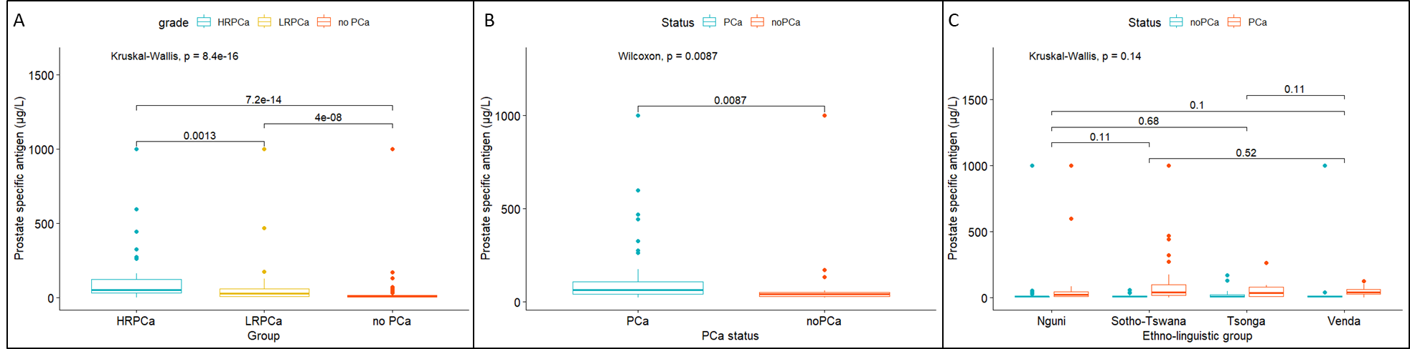
Figure S1. Boxplots of prostate specific antigen levels of men with- and without prostate cancer. (A) Prostate specific antigen levels (PSA) by PCa group including high-risk (HRPCa), low-risk (LRPCa) and no PCa. (B) PSA levels by PSA grouping of ≥20 µg/L. (C) PSA levels by ethnolinguistic group.

Figure S2: Boxplots of serum testosterone levels of men ≥65 years, according to prostate cancer (PCa) status in black South African men with (n=82) or without (n=75) prostate cancer, including high-risk (HRPCa) or low-risk (LRPCa) disease defined by pathology. Boxplot of PCa status and risk for total testosterone (A), bioavailable testosterone (B), and free testosterone (C).
Figure S3: LOESS curves representing PCa status by age for serum cholesterol (A) and triglycerides (B) levels. Boxplots representing cholesterol (C) and triglycerides (D) levels by clinicopathological presentation defined as high-risk (HRPCa), low-risk (LRPCa) or no prostate cancer (no PCa).
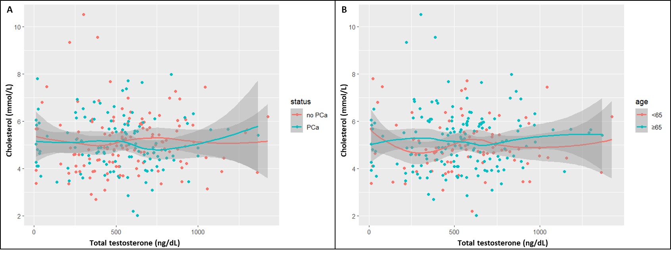
Figure S4: LOESS curves of correlation between serum cholesterol and total testosterone levels by PCa status (A) and age (B).

