Supplementary Table 1 Qualitative characteristics of parental lines of hot and bell pepper according to DUS characters
Parent code | Parental Line | LCVD status | Fruit bearing habbit | Color intensity red | Color intensity green | Fruit shape | Fruit sinuation | Fruit shape at apex | Fruit glossiness | Source†
P₁ | S-343 | Resistant | Solitary Pendant | Medium | Medium | Moderately Triangular | Weak | Acute | Medium | P.A.U.*
P₂ | PAU SM-1 | Susceptible | Solitary Pendant | Medium | Medium | Square | Medium | Depressed | Medium | P.A.U.
P₃ | PAU SM-2 | Susceptible | Solitary Pendant | Dark | Medium | Square | Medium | Depressed | Medium | P.A.U.
P₄ | PAU SM-8 | Susceptible | Solitary Pendant | Dark | Dark | Cordate | Weak | Depressed & Acute | Strong | P.A.U.
P₅ | PAU SM-4 | Susceptible | Solitary Pendant | Medium | Medium | Square | Medium | Depressed & Acute | Medium | P.A.U.
P₆ | PAU SM-17 | Susceptible | Solitary Pendant | Dark | Medium | Rectangular | Strong | Depressed | Strong | P.A.U.
P₇ | PAU SM-58 | Susceptible | Solitary Pendant | Medium (Yellow) | Medium | Square | Medium | Depressed | Medium | P.A.U.
†*P.A.U.: Punjab Agricultural University, Ludhiana

Supplementary Table 2 Comparisons of fruit traits among F₁, BC₁F₁ and BC₂F₁ generations and their parental lines
Individuals | TEN FRUIT WEIGHT (g) |  |  |  | FRUIT LENGTH (cm) |  |  |  | FRUIT WIDTH (cm)
Individuals | Parents | F₁ | BC₁ F₁ | BC₂ F₁ | Parents | F₁ | BC₁ F₁ | BC₂ F₁ | Parents | F₁ | BC₁ F₁ | BC₂ F₁
S-343 | 43.67e | - | - | - | 7.34^{ab} | - | - | - | 1.37^{d} | - | - | -
PAU SM-1 | 757.8^{b} | 237.18^{b} | 470.83ª | 707.73^{b} | 7.51ª | 9.51^{bc} | 7.22^{cd} | 8.04ª | 5.71^{b} | 2.75ª | 4.95ª | 5.58^{ab}
PAU SM-2 | 833.83ª | 276.37ª | 443.42^{ab} | 733.26^{b} | 7.64ª | 11.63ª | 7.83^{abc} | 7.01^{b} | 5.92^{b} | 2.5^{b} | 3.32^{bc} | 5.4^{ab}
PAU SM-8 | 340.5^{d} | 161.92^{c} | 255.07^{c} | 310.55e | 6.93^{b} | 8.68^{c} | 7.39^{bcd} | 6.73^{bc} | 3.42^{c} | 2.13^{c} | 2.93^{cd} | 3.28^{c}
PAU SM-4 | 540.02^{c} | 252.15^{b} | 385.64^{b} | 529.67^{c} | 5.58^{d} | 9.78^{b} | 6.99^{d} | 5.96^{c} | 5.68^{b} | 2.84ª | 3.32^{bc} | 5.01^{b}
PAU SM-17 | 343.33^{d} | 171.91^{c} | 251.1^{c} | 370.91^{d} | 6.82^{bc} | 8.62^{c} | 8.24ª | 6.81^{bc} | 3.99^{c} | 2.11^{c} | 2.44^{d} | 4^{c}
PAU SM-58 | 861.83ª | 257.47^{ab} | 478.43ª | 804.91ª | 6.26^{c} | 9.41^{bc} | 8.12^{ab} | 6.25^{bc} | 6.66ª | 2.76ª | 3.5^{b} | 5.85ª
Gen. Mean | 531.57 | 226.17 | 380.75 | 576.17 | 6.87 | 9.61 | 7.63 | 6.8 | 4.68 | 2.51 | 3.41 | 4.85
C.V. | 6.55 | 4.94 | 11.75 | 4.97 | 4.95 | 5.47 | 5.83 | 7.25 | 7.46 | 4.52 | 8.92 | 8.89
F Prob. | 0 | 0 | 0 | 0 | 0 | 0 | 0.03 | 0.01 | 0 | 0 | 0 | 0
S.E.M. | 21.73 | 6.45 | 25.83 | 16.54 | 0.19 | 0.3 | 0.26 | 0.28 | 0.22 | 0.07 | 0.18 | 0.25
C.D. 5% | 61.933 | 20.33 | 81.38 | 52.12 | 0.60 | 0.96 | 0.81 | 0.9 | 0.62 | 0.21 | 0.55 | 0.79
C.D. 1% | 97.38 | 28.92 | 115.75 | 74.14 | 0.87 | 1.36 | 1.15 | 1.28 | 0.99 | 0.29 | 0.79 | 1.12
Note: Values in columns with same letter are not significantly different at p < 0.05

Supplementary Table 2 (Cont’d.)
Individuals | FRUIT PERICARP THICKNESS (mm) |  |  |  | NO. OF LOCULES FRUIT⁻¹
Individuals | Parents | F₁ | BC₁ F₁ | BC₂ F₁ | Parents | F₁ | BC₁ F₁ | BC₂ F₁
S-343 | 1.18^{b} | - | - | - | 2^{b} | - | - | -
PAU SM-1 | 4.13ª | 1.89^{b} | 2.88^{ab} | 3.94^{ab} | 3.67ª | 2.33 | 2.67 | 3^{b}
PAU SM-2 | 3.75 ª | 2.16ª | 1.95^{d} | 3.21^{b} | 3.67ª | 2.33 | 2.67 | 3.33^{ab}
PAU SM-8 | 3.47 ª | 1.94^{b} | 2.53^{bc} | 3.46^{b} | 2^{b} | 1.67 | 1.67 | 2^{c}
PAU SM-4 | 3.68 ª | 2.27ª | 2.41^{bcd} | 3.45^{b} | 3.67ª | 3.00 | 3.33 | 3.67ª
PAU SM-17 | 3.8 ª | 1.78^{b} | 2.34^{cd} | 3.74^{b} | 3.33ª | 2.00 | 2.33 | 3^{b}
PAU SM-58 | 3.93 ª | 2.28ª | 3.25ª | 4.7ª | 3.67ª | 2.33 | 2.67 | 3.33^{ab}
Gen. Mean | 3.42 | 2.05 | 2.56 | 3.75 | 3.14 | 2.28 | 2.56 | 3.06
C.V. | 11.56 | 4.86 | 10.79 | 12.78 | 16.03 | 20.7 | 22.21 | 11.44
F Prob. | 0.57 | 0 | 0 | 0.04 | 0.02 | 0.09 | 0.08 | 0
S.E.M. | 0.25 | 0.06 | 0.16 | 0.28 | 0.32 | 0.27 | 0.33 | 0.2
C.D. 5% | 0.70 | 0.18 | 0.5 | 0.87 | 0.89 | _ | _ | 0.64
C.D. 1% | _ | 0.26 | 0.71 | 1.24 | 1.42 | _ | _ | 0.9
Note: Values in columns with same letter are not significantly different at p < 0.05

Supplementary Table 2 (Cont’d.)
Individuals | NUMBER OF FRUITS PLANT⁻¹ |  |  |  | FRUIT YIELD PLANT⁻¹ (g)
Individuals | Parents | F₁ | BC₁ F₁ | BC₂ F₁ | Parents | F₁ | BC₁ F₁ | BC₂ F₁
S-343 | 232.67ª | - | - | - | 1020.33^{bc} | - | - | -
PAU SM-1 | 19.33^{d} | 23.67^{b} | 13.33 | 18.33^{b} | 1465.67ª | 561.63^{c} | 622.75ª | 1298.35ª
PAU SM-2 | 14.67de | 24.67^{b} | 12.33 | 14.67^{bc} | 1223.67^{ab} | 680.4^{b} | 544.43^{b} | 1070.71^{b}
PAU SM-8 | 38.00^{b} | 19.33^{c} | 11.67 | 29.00ª | 905.22^{cd} | 421.23^{d} | 298.76^{d} | 900.85^{c}
PAU SM-4 | 15.00de | 31.67ª | 11.67 | 13.33^{c} | 802.29^{cd} | 799.15ª | 438.46^{c} | 706.25^{d}
PAU SM-17 | 22.00^{c} | 23.67^{b} | 11.00 | 18.33^{b} | 764.33^{d} | 407.58^{d} | 278.94^{d} | 678.18^{d}
PAU SM-58 | 9.33e | 22.67^{bc} | 11.33 | 9.33^{d} | 803.8^{cd} | 582.04^{bc} | 541.54^{b} | 749.66^{cd}
Gen. Mean | 50.14 | 24.28 | 11.89 | 17.17 | 997.90 | 575.34 | 454.15 | 900.67
C.V. | 8.75 | 8.95 | 11.86 | 12.36 | 14.08 | 10.63 | 8.97 | 10.18
F Prob. | 0 | 0 | 0.44 | 0 | 0 | 0 | 0 | 0
S.E.M. | 1.31 | 1.25 | 0.81 | 1.22 | 73.49 | 35.31 | 23.51 | 52.93
C.D. 5% | 7.80 | 3.95 | _ | 3.86 | 249.87 | 111.27 | 74.09 | 166.8
C.D. 1% | 5.86 | 5.62 | _ | 5.49 | 329.4 | 158.26 | 105.39 | 237.25
Note: Values in columns with same letter are not significantly different at p < 0.05

TRAITS* | PH | PW | NB | FPP | FL | FW | FPT | TFW | FYP | NL | DMG | DMR | VC | CC | CHA | CHB | CHT | SFW | SDW | SPF
PH | 1 | 0.05 | 0.07 | 0.69* | 0.29 | -0.76** | -0.45 | -0.81** | 0.02 | -0.42 | 0.61* | 0.82** | -0.609* | 0.08 | 0.40 | 0.48 | 0.47 | -0.44 | -0.66* | -0.19
PW | 0.05 | 1 | 0.30 | 0.65* | 0.07 | -0.22 | -0.26 | -0.15 | 0.21 | -0.52 | -0.08 | 0.08 | 0.28 | -0.10 | 0.45 | 0.66* | 0.61* | -0.30 | -0.13 | -0.36
NB | 0.07 | 0.30 | 1 | 0.26 | -0.48 | -0.26 | -0.29 | -0.38 | -0.13 | -0.21 | 0.29 | 0.34 | -0.08 | -0.91** | 0.64* | 0.36 | 0.47 | -0.53 | -0.44 | 0.41
FPP | 0.69* | 0.65* | 0.26 | 1 | 0.26 | -0.83** | -0.42 | -0.73** | 0.08 | -0.85** | 0.57 | 0.69* | -0.02 | -0.04 | 0.67* | 0.92** | 0.87** | -0.53 | -0.63* | -0.53
FL | 0.29 | 0.07 | -0.48 | 0.26 | 1 | -0.03 | 0.03 | 0.18 | 0.80** | -0.18 | 0.03 | -0.15 | -0.19 | 0.54 | -0.46 | -0.02 | -0.17 | 0.52 | 0.24 | -0.53
FW | -0.76** | -0.22 | -0.26 | -0.83** | -0.03 | 1 | 0.45 | 0.92** | 0.31 | 0.86** | -0.85** | -0.93** | 0.05 | 0.13 | -0.78** | -0.85** | -0.86** | 0.76** | 0.90** | 0.38
FPT | -0.45 | -0.26 | -0.29 | -0.42 | 0.03 | 0.45 | 1 | 0.46 | 0.08 | 0.31 | -0.49 | -0.50 | 0.22 | 0.19 | -0.49 | -0.42 | -0.46 | 0.54 | 0.58* | 0.16
TFW | -0.81** | -0.15 | -0.38 | -0.73** | 0.18 | 0.92** | 0.46 | 1 | 0.44 | 0.63* | -0.79** | -0.99** | 0.22 | 0.30 | -0.82** | -0.73** | -0.79** | 0.82** | 0.89** | 0.07
FYP | 0.02 | 0.21 | -0.13 | 0.08 | 0.80** | 0.31 | 0.08 | 0.44 | 1 | 0.10 | -0.33 | -0.44 | -0.27 | 0.28 | -0.53 | -0.19 | -0.32 | 0.66* | 0.48 | -0.26
NL | -0.42 | -0.52 | -0.21 | -0.85** | -0.18 | 0.81** | 0.31 | 0.63* | 0.10 | 1 | -0.69* | -0.612* | -0.41 | 0.09 | -0.66* | -0.91** | -0.86** | 0.55 | 0.64* | 0.67*
DMG | 0.61* | -0.08 | 0.29 | 0.57 | 0.03 | -0.85** | -0.49 | -0.79** | -0.33 | -0.69* | 1 | 0.83** | -0.01 | -0.32 | 0.64* | 0.62* | 0.65* | -0.64* | -0.83** | -0.21
DMR | 0.82** | 0.08 | 0.34 | 0.69* | -0.15 | -0.93** | -0.50 | -0.99** | -0.44 | -0.61* | 0.83** | 1 | -0.24 | -0.25 | 0.79** | 0.69* | 0.76** | -0.81** | -0.92** | -0.11
VC | -0.61* | 0.28 | -0.08 | -0.02 | -0.19 | 0.05 | 0.22 | 0.22 | -0.27 | -0.41 | -0.01 | -0.24 | 1 | -0.01 | 0.15 | 0.26 | 0.23 | -0.06 | 0.1 | -0.40
CC | 0.08 | -0.10 | -0.91** | -0.04 | 0.54 | 0.13 | 0.19 | 0.30 | 0.28 | 0.09 | -0.32 | -0.25 | -0.01 | 1 | -0.55 | -0.18 | -0.31 | 0.45 | 0.32 | -0.60*
CHA | 0.40 | 0.45 | 0.64* | 0.67* | -0.46 | -0.78** | -0.49 | -0.82** | -0.53 | -0.66* | 0.64* | 0.79** | 0.15 | -0.55 | 1 | 0.84** | 0.93** | -0.93** | -0.83** | -0.04
CHB | 0.48 | 0.66* | 0.36 | 0.92** | -0.02 | -0.85** | -0.42 | -0.73** | -0.19 | -0.91** | 0.62* | 0.69* | 0.26 | -0.18 | 0.84** | 1 | 0.98** | -0.71* | -0.72** | -0.51
CHT | 0.47 | 0.61* | 0.47 | 0.87** | -0.17 | -0.86** | -0.46 | -0.79** | -0.32 | -0.86** | 0.65* | 0.76** | 0.23 | -0.31 | 0.93** | 0.98** | 1 | -0.81** | -0.79** | -0.36
SFW | -0.44 | -0.30 | -0.53 | -0.53 | 0.52 | 0.75** | 0.54 | 0.82** | 0.66* | 0.55 | -0.64* | -0.81** | -0.06 | 0.45 | -0.93** | -0.71* | -0.81** | 1 | 0.91** | 0.00
SDW | -0.66* | -0.13 | -0.44 | -0.63* | 0.24 | 0.90** | 0.58* | 0.89** | 0.48 | 0.64* | -0.83** | -0.92** | 0.10 | 0.32 | -0.83** | -0.72** | -0.79** | 0.91** | 1 | 0.17
SPF | -0.19 | -0.36 | 0.41 | -0.53 | -0.53 | 0.38 | 0.16 | 0.07 | -0.26 | 0.66* | -0.21 | -0.11 | -0.40 | -0.60* | -0.04 | -0.51 | -0.36 | 0.00 | 0.17 | 1
Supplementary Table 3 Correlation coefficients between different studied characters based on Pearson correlation method
*See traits acronyms in Table 2, *Significant at 5% level of significance ** Significant at 1% level of significance, Blue colored values positively correlated while red are negatively correlated with each other

Supplementary Table 4 Eigen values and cumulative variability in per cent for all principal components
 | PC1 | PC2 | PC3 | PC4 | PC5 | PC6 | PC7 | PC8 | PC9 | PC10 | PC11 | PC12
Standard deviation | 3.205 | 1.896 | 1.569 | 1.290 | 0.909 | 0.849 | 0.454 | 0.340 | 0.271 | 0.217 | 0.135 | 0.000
Proportion of Variance | 0.514 | 0.180 | 0.123 | 0.083 | 0.041 | 0.036 | 0.010 | 0.006 | 0.004 | 0.002 | 0.001 | 0.000
Cumulative Proportion | 0.514 | 0.693 | 0.816 | 0.900 | 0.941 | 0.977 | 0.987 | 0.993 | 0.997 | 0.999 | 1.000 | 1.000

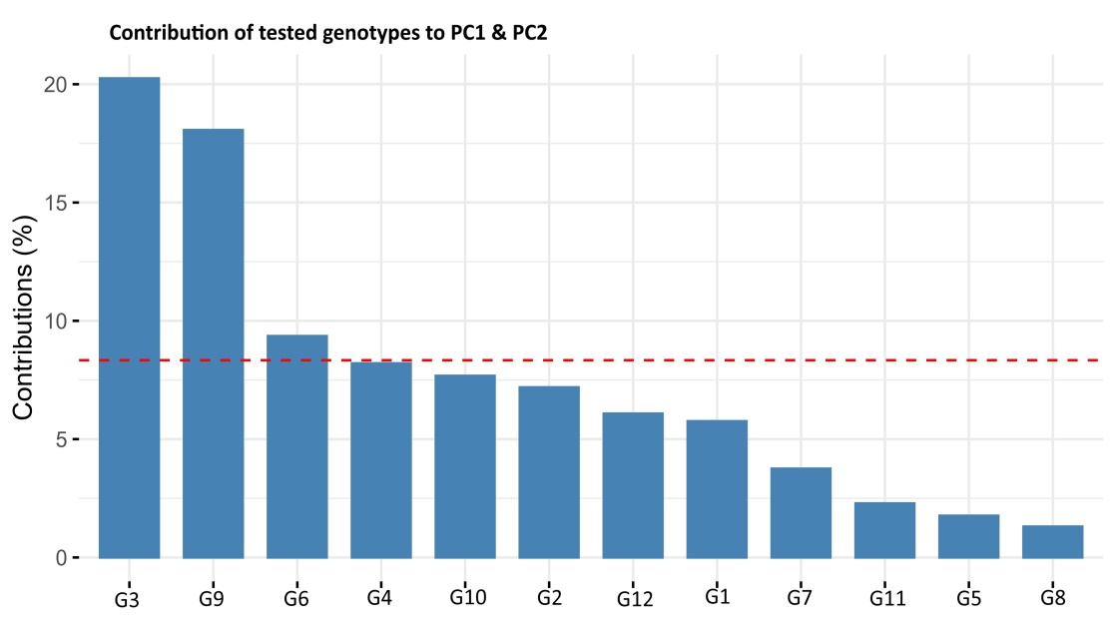

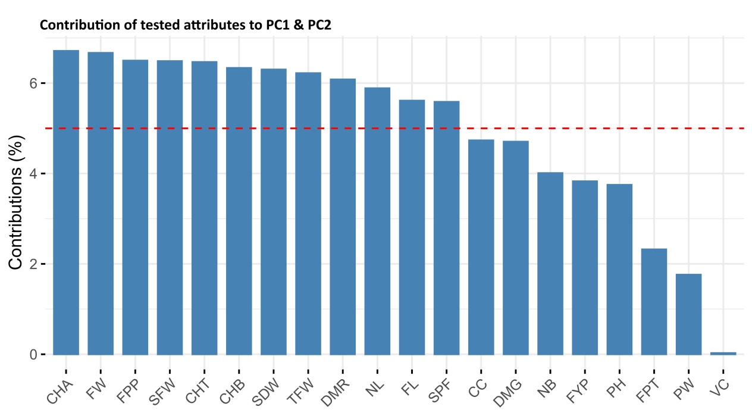
Supplementary Fig. 1 & 2 The contribution of tested attributes and genotypes to the per cent variation explained by principal components, the threshold (red line) define significant traits and genotypes majorly contributing to variation (For genotypes acronyms see Table 8 & for traits acronyms see Table 2)

