Layered gel emulsion-templated Janus porous composites for emulsified oil separation
Shixiang Zuo,^{a,b} Chunyu Wang,^{c,*} Nawaa Ali Husaykan Alshammari,^{d} Salah Mohamad El-Bahy,^{e} Rong Xu,ª Saijie Li,^{c} Lei Wang,^{c} Chao Yao,^{a,b} Zeinhom Mohamad El-Bahy,^{f} Haoguan Gui,^{a,b,*}
ª Advanced Catalysis and Green Manufacturing Collaborative Innovation Center, School of Petrochemical Engineering, Changzhou University, Changzhou 213164, China
^{b} R&D Center of Xuyi Attapulgite Applied Technology, Changzhou University, Xuyi 211700, China
^{c} State Key Laboratory of NBC Protection for Civilian, Beijing 102205, China
^{d} Department of Chemistry, Faculty of Science, Northern Border University, Arar 73222, Saudi Arabia
^{e} Department of Chemistry, Turabah University College, Taif University, P.O. Box 11099, Taif 21944, Saudi Arabia
^{f} Department of Chemistry, Faculty of Science, Al-Azhar University, Nasr City 11884, Cairo, Egypt

Corresponding authors:
wcy18@tsinghua.org.cn (C.W.)
guihaoguan@cczu.edu.cn (H.G.)

Supporting Information Includes:
Additional Data:
- Fig. S1. Morphology for GO-based HIPEs.
- Fig. S2. Rheological properties for GO-based HIPEs.
- Fig. S3. Morphology for PCL-based HIPEs.
- Fig. S4. Rheological properties for PCL-based HIPEs.
- Fig. S5. Cyclic compressive stress-strain curves of polyHIPEs
- Table S1. Formation of GO-based polyHIPEs.
- Table S2. Formation of PCL-based polyHIPEs.

Figures
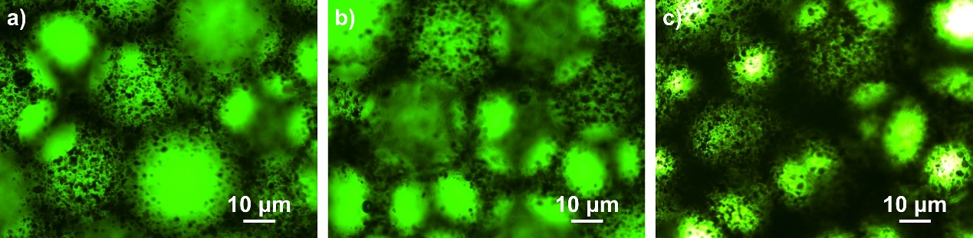
Fig. S1. Optical images for GO-based HIPEs: a) GO-2, b) GO-5 and c) GO-10

Fig. S2. Rheological properties of GO-based HIPEs: a) storage (G’) and loss (G’’) moduli, and b) complex viscosity (η*)

Fig. S3. Optical images for PCL-based HIPEs: a) PCL-2, b) PCL-5 and c) PCL-10

Fig. S4. Rheological properties for PCL-based HIPEs: a) storage (G’) and loss (G’’) moduli, and b) complex viscosity (η*)

Fig. S5. Cyclic compressive stress-strain curves of polyHIPEs: a) GO-2 and b) PCL-2

Tables
Table S1. Recipes of the GO-based polyHIPEs
 | GO-4 | GO-8 | GO-12
External continuous phase (wt%)
DMSO | 20.40 | 18.30 | 16.20
GO | 1.00 | 2.00 | 3.00
PolyMDI | 1.00 | 2.00 | 3.00
F-127 | 2.50 | 2.50 | 2.50
Total | 24.90 | 24.80 | 24.70
Internal dispersed phase (wt%)
Paraffin oil | 75.00 | 75.00 | 75.00
Catalyst (added after HIPEs formation, wt%)
DBTDL | 0.10 | 0.20 | 0.30

Table S2. Recipes of the PCL-based polyHIPEs
 | PCL-5 | PCL-10 | PCL-20
External continuous phase (wt%)
DMSO | 19.87 | 17.25 | 12.00
PCL-Triol | 1.25 | 2.50 | 5.00
PolyMDI | 1.25 | 2.50 | 5.00
F-127 | 2.50 | 2.50 | 2.50
Total | 24.87 | 24.75 | 24.50
Internal dispersed phase (wt%)
Paraffin oil | 75.00 | 75.00 | 75.00
Catalyst (added after HIPEs formation, wt%)
DBTDL | 0.13 | 0.25 | 0.50

