Supplementary Materials
Materials and Methods
Supplementary Text
Figs. S1 to S10
Tables S1 to S8
Table S9 in a separate file (a large table with all post-hoc comparison results)
References (##–##)
Movies S1

SUPPLEMENTARY MATERIALS

Fig. S1. Electrode coverage. (a) and (b) list the numbers of stimulating/recording channels having been tested in each participant, across ipsilateral (yellow) and contralateral (blue) hemispheres, respectively. (d) Counts of bipolar channels stimulated and recorded across two hemispheres (l: left, r: right), highlighted at the lower coverage (n < 10). Most of the examined causal connectivity instances have a sample size >= 10.

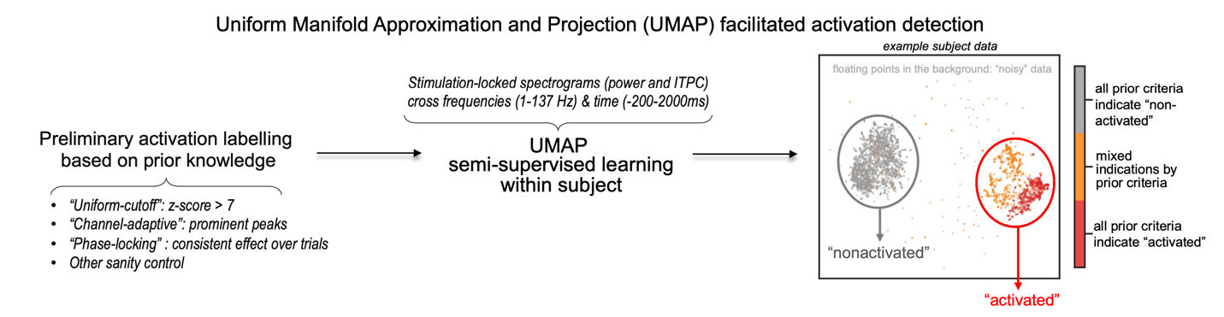
Fig. S2: Illustration of the activation detection pipeline using semi-supervised UMAP learning. The activation detection was conducted at the individual basis. The resulting clusters have been manually checked for meaningful representation of the data.

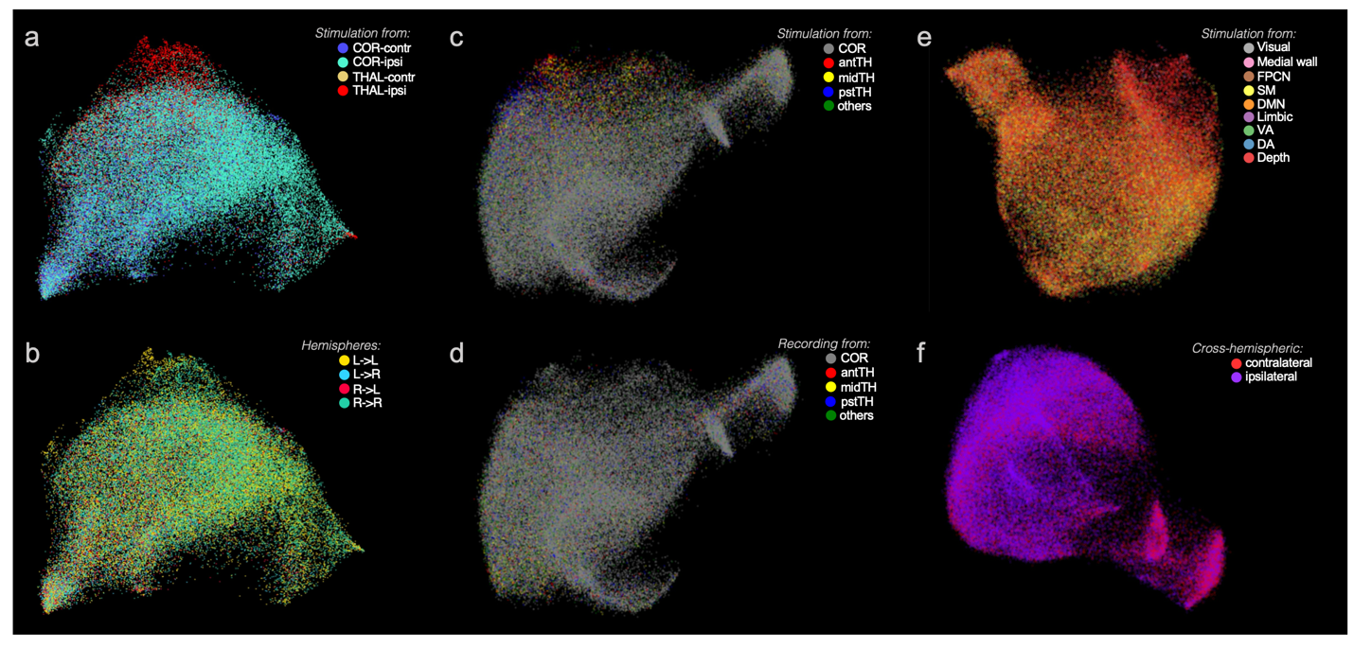
Fig. S3: Unsupervised UMAP embedding space exploration, presented to support the anatomical category that we chose to focus on in the study, i.e., shown in (a). The same embedding structure is rotated for the best visualization. Subplots (a), (b) present the same slice of the embedding space, colored depending on (a) where the EP is originated from (regardless of the recording site’s location), and (b) which hemisphere the SEP is stimulated and recorded from. Subplots (c) and (d) present the same slice of the embedding space, but they differ in their color correspondence to the stimulation sites’ location (COR: cortex, antTH: anterior thalamus, midTH: mid thalamus, pstTH: posterior thalamus, others: other subcortical areas including amygdala, basal ganglia, claustrum). Subplots (e) and (f) show the same embedding space, from different viewing angles, colored to (e) the large-scale intrinsic network identities of the stimulation sites, and (f) the cross-hemispheric condition of a SEP (i.e., ipsilateral SEPs are the pairs stimulated and recorded from the same hemisphere, regardless of the left or right hemisphere; and the contralateral SEPs are those stimulated and recorded from the other hemisphere) (DMN: default-mode network, FPCN: fronto-parietal control network, SM: sensori-motor network, VA: ventral attention network, DA: dorsal attention network). The examples show that the recording sites’ location, intrinsic network territories and hemisphere identity are not determining factors of the SEP’s spectral profiles; rather, whether the connectivity initiates from the thalamus or cortex andspreads to the ipsilateral or contralateral hemisphere, produces distinct spectral patterns of the EP.

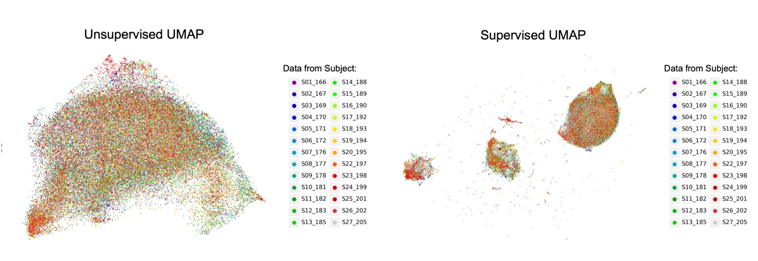

Fig. S4: Mapping between the UMAP embedding spaces with subject identity (with S21 excluded from the analyses due to excessive number of bad channels in this subject’s data). The unsupervised and supervised UMAP embedding spaces were the same as presented in the main article, but colored with subject ID, instead of anatomical labelling. The subject-ID distributions do not correspond to the embedding structures, suggesting that the embedding spaces and clustering are not dominated by the individual differences which may be suspected as a confounding factor.

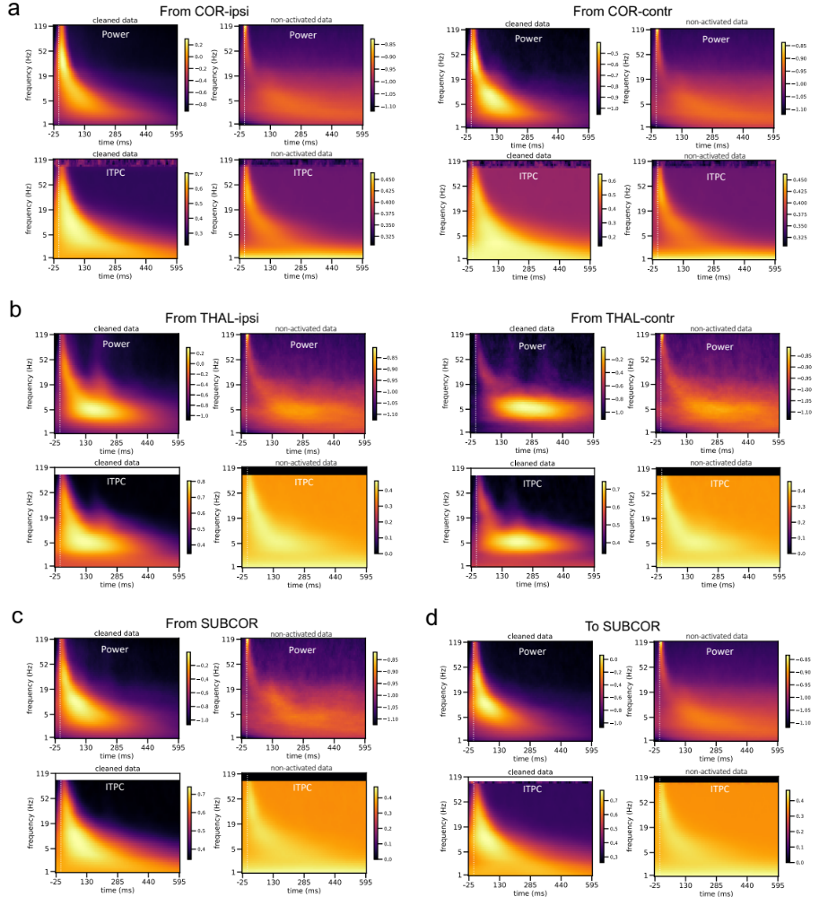
Fig. S5. Group-averaged power and ITPC, cleaned data (left) and noisy non-activated data (right) that is subtracted from the channel-matched spectrograms by which the cleaned data was obtained. To minimize the influence of electrical artifacts, we created a non-activated spectral information (power and ITPC) template for each stimulating channel by averaging all the non-activated pairs stimulating from this channel. This non-activated spectral template contains mostly the artifact of volume conduction, hallmarked by the high-frequency peak pixel immediately following the stimulation onset. We used the non-activated spectral template as a control and subtracted it from all the activated spectrograms from the same stimulation channel within the same participant. The remaining traces of the activated spectral information were considered cleaned data. The colorbars indicate the magnitudes for power and ITPC, which are log-transformed and z-scored for power and square-root transformed and z-scored for ITPC.
(a) Spectrograms averaged across all instances with stimulating channels from the ipsilateral (COR-ipsi) or contralateral (COR-contr) cortices. (b) Spectrograms averaged across all instances with stimulating channel from the ipsilateral (THAL-ipsi) or contralateral (THAL-contr) thalamus. (c) and (d) show spectrograms averaged across all instances with stimulating or recording channels, respectively, in the non-thalamic subcortical areas. We note that the F1 feature cannot be an artifact of volume conduction because i) electrical artifact appears to be a highlighted pixel at the high frequency (>100Hz) and immediately upon the stimulation (within 10 ms) on the power spectrogram (see non-activated data). It has a very different characteristic than F1. ii) All spectrograms for activated data have been subtracted with the non-activated data (containing the stimulation artifact feature) before statistical testing. iii) In terms of the feature decoding for individual connections, we relied on multi-variate pattern matching in the time-frequency domain which is not biased by the amplitude in the time domain.

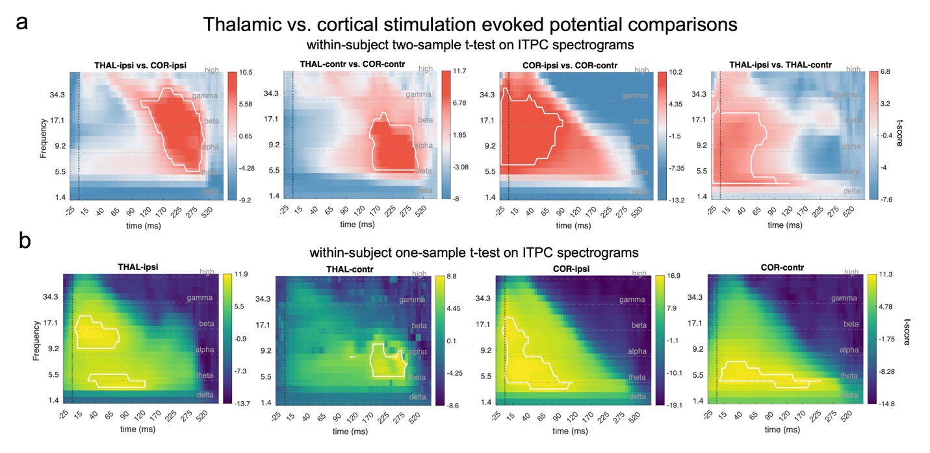
Fig. S6: Spectrograms of stimulation-evoked inter-trial phase coherence (ITPC) within and between anatomical categories (COR: cortex, THAL: thalamus, ipsi: ipsilateral, contr: contralateral, à: causal influence direction). Highlighted contours on the spectrograms indicate significant clusters (n-permutation = 5000, initial cluster forming threshold = 6 t-scores, P_{cluster} < 0.01). Dashed lines on the spectrograms denotes the segments of conventional frequency bands: [0.5, 5] Hz (delta), [5, 8] Hz (theta), [8, 15] Hz (alpha), [15, 30] Hz (beta), [30, 70] Hz (gamma) and > 70 Hz (high). (a) Thalamic vs. cortical evoked spectrogram comparison with within-subject two-sample t-tests (two-tailed) on the ITPC spectrograms, significance inference performed with cluster-based permutation testing. White contours highlight significant clusters of the contrast indicated on the subtitle. Reversed contrasts did not generate significant results. (b) Thalamic and cortical evoked ITPC spectrograms and significant clusters in either ipsilateral or contralateral hemispheres. Significance testing conducted with within-subject one-sample t-tests. Acronym example “THAL-ipsi” on the subtitle means recording from pairs of electrodes that were stimulated from the ipsilateral thalamus.

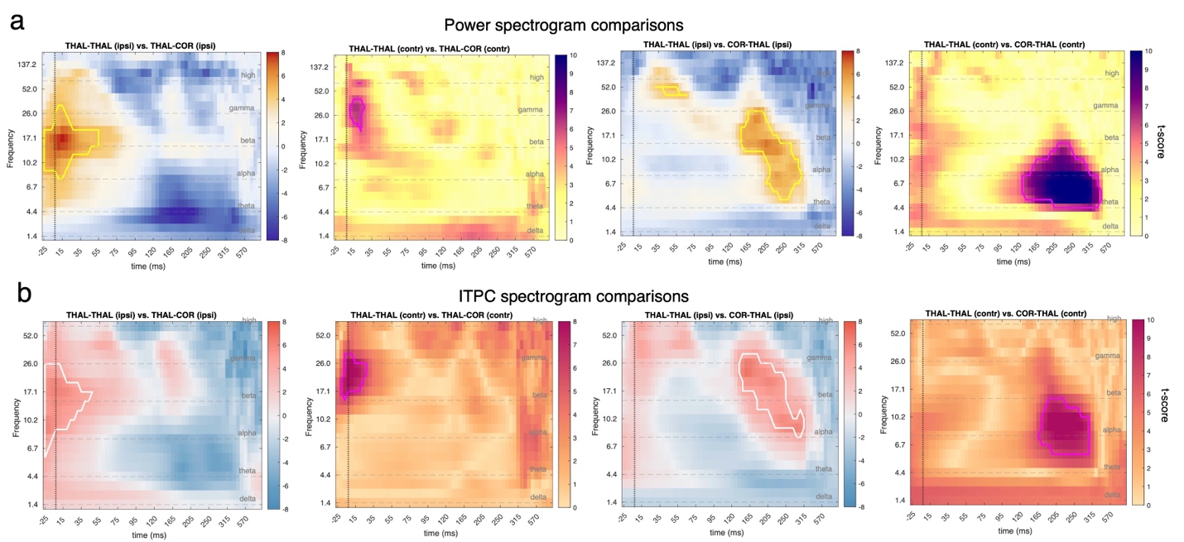
Fig. S7: Cluster-based permutation tests among different anatomical categories of thalamus-related connectivity. (a) Power spectrogram comparisons. (b) ITPC spectrogram comparisons. Tested contrasts are between THALà THAL vs. THALàCOR, and between THALàTHAL vs. CORàTHAL, in either ipsilateral or contralateral pairs. The tests were conducted within-subject by default, but the number of subjects with comparable contralateral THALà THAL instances were too few (<10) to generate reliable significance testing; therefore, the tests involving this condition were conducted with a between-subject design (i.e., two-sample t-test at the group level in the second and the fourth columns).

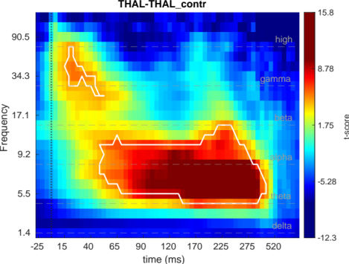
Fig. S8. Cluster-based permutation test on THAL->THAL (contra) connections (no mixed design). The test at the individual level could not be reliably estimated due to insufficient number of subjects (n-subject = 7). However, among the 7 individuals with bilateral thalamic stimulations and recordings, there was a sufficient sample size of electrode contacts (n-connections = 81) to estimate the effect at the group level. The color-bar represents a group-level t-score of a one-sample t-test. Significance clusters are marked by white contours.

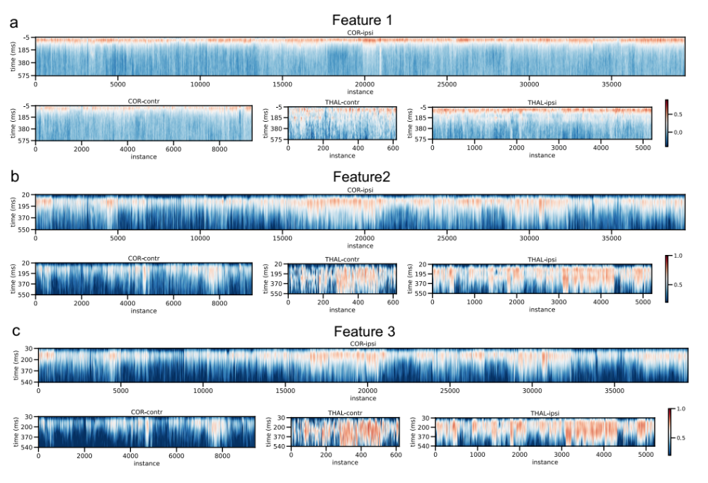
Fig. S9. Data overview of the feature representations for each anatomical category of the stimulation channel. (a)-(c) respectively show the F1-3 representations. For each heatmap, the x-axis shows the instance number of the whole cohort. An instance is a causal-connectivity case (with a complex spectral profile depicted by the power and ITPC spectrogram) that is established by a unique stimulation-recording channel pair. Instances with the same stimulation category are grouped here, including COR-ipsi, COR-contr, THAL-ipsi and THAL-contr. The y-axis shows the time upon stimulation onset. F2 and 3 have later starting times because their spectra-temporal window is long which renders an equally long window to estimate its representation at each timepoint, while the datapoints in the beginning of the trial (including the baseline) are not sufficient for an estimation of these features. However, the F2 and 3 have a late onset which permits this limitation to be irrelevant. The color bars show the Pearson-correlation coefficient. The hotter color indicates the rising of the feature.

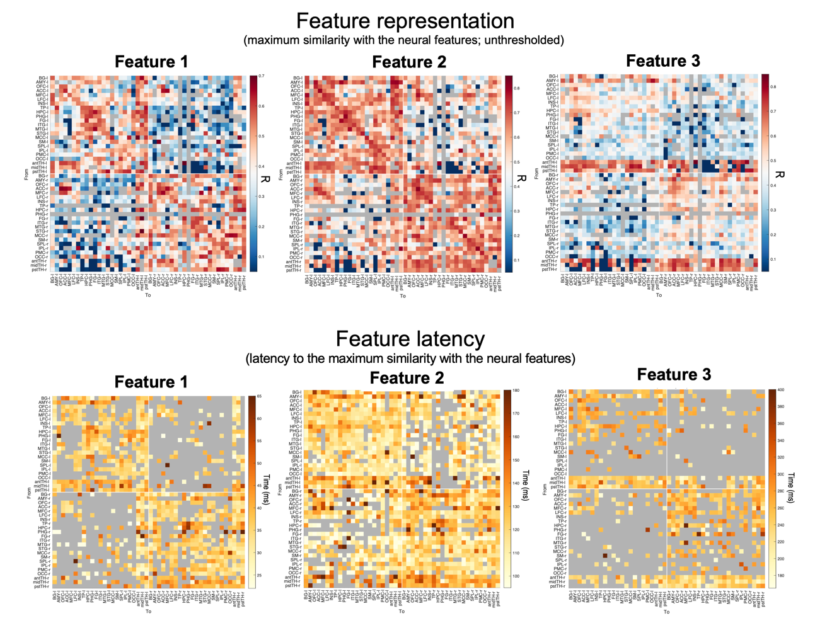
Fig. S10: Feature representation and latency for the three neural features. For R matrices, the grey entries indicate NaN values where the sample size for this connectivity is not bigger than 10 (Fig. S1c). Otherwise, the r* (maximum similarity reached during the feature window) of all incidences in this pair of anatomical regions are averaged: R = $\overline{r*}$. Feature latency is the time duration from the stimulation onset to the timepoint where the r* is reached. Instances with small r* (< 0.4 for Feature 1, 2 and < 0.5 for Feature 3) are neglected and counted as NaN in the grey entries in the latency matrices. Feature 2&3 generally have stronger r* because the two features persist longer and are concentrated at the lower frequencies: not only do longer time windows provide more timepoints to correlation which provides larger statistical power, but also the lower frequencies usually have bigger magnitude on the spectrograms. Both factors contribute to the higher correlation coefficients for the Feature 2&3. To address that, we did not directly compare the R values unless normalized. We also defined the cutoffs of the R values adaptively for each feature by visually inspecting the histograms of their distributions as well as the concerned anatomical patterns.

Supplementary Tables

Activation Criteria | Accuracy | Sensitivity | Precision | False Positive Rate | Correlation with UMAP learning
Uniform-Cutoff | 0.80 | 0.37 | 0.99 | 0.01 | 0.52
Channel-Adaptive | 0.84 | 0.53 | 0.95 | 0.01 | 0.63
Phase-Locking | 0.91 | 0.77 | 0.99 | 0.02 | 0.80

Table S1. Evaluation of the three preliminary labelling algorithms which are based on traditional methods, with the semi-supervised UMAP clustering as a reference. Peak detection at the temporal domain using a uniform threshold (i.e., “Uniform-Cutoff”) to determine a high amplitude is mostly often used in the previous literature. The results show that it has high precision but low sensitivity, i.e., tends to make Type-II errors. Stimulation and recording of non-neocortex such as subcortex and limbic areas often evoke potentials with relatively small peaks and unconventional waveforms, in which cases traditional peak-detection methods tend to fail.

ROI analysis

Between-thalamic comparisons

Area | NO. Observations | NO.  Random Groups (adjusted) | Estimate | t-value | p | p (FDR-corr.)
BG | 173 | elecID:34 | -0.08 | -2.61 | 0.01 | 0.03
AMY | 138 | elecID:24 | 0.01 | 0.47 | 0.64 | 0.70
OFC | 153 | elecID:42 | -0.13 | -4.74 | <<0.01 | <<0.01
ACC | 99 | elecID:20 | -0.18 | -5.79 | <<0.01 | <<0.01
MFC | 60 | elecID:11 | -0.15 | -3.36 | 0.00 | 0.01
LFC | 446 | elecID:98 | -0.09 | -5.41 | <<0.01 | <<0.01
INS | 446 | elecID:97 | -0.02 | -0.82 | 0.41 | 0.58
TP | 56 | elecID:13 | -0.02 | -0.51 | 0.60 | 0.70
HPC | 221 | elecID:42 | 0.03 | 1.42 | 0.16 | 0.28
PHG | 35 | elecID:7 | 0.09 | 1.82 | 0.07 | 0.16
FG | 46 | elecID:10 | 0.02 | 0.37 | 0.71 | 0.74
ITG | 114 | elecID:28 | 0.06 | 1.81 | 0.07 | 0.16
MTG | 228 | elecID:46 | 0.06 | 2.49 | 0.01 | 0.04
STG | 165 | elecID:38 | -0.02 | -0.64 | 0.52 | 0.65
MCC | 77 | elecID:12 | -0.10 | -2.62 | 0.01 | 0.03
SM | 227 | elecID:51 | 0.05 | 2.43 | 0.02 | 0.04
SPL | 22 | elecID:5 | 0.05 | 0.61 | 0.52 | 0.65
IPL | 103 | elecID:19 | 0.04 | 1.20 | 0.26 | 0.40
PMC | 286 | elecID:55 | 0.02 | 1.12 | 0.27 | 0.40
OCC | 64 | elecID:15 | 0.06 | 1.63 | 0.10 | 0.19
<<: far smaller than; Estimate “positive”: pstTH > antTH
Table S2. Comparison of F1 representations in the thalamic inflow pathways between antTH and pstTH. Here we tested all brain areas (of both hemispheres) that had sufficient electrode coverage, i.e., more than two electrodes covered in the area within-subject, and ten observations in total. The tested statistical model is a mixed linear model, with R as the dependent variable, predicated by (i) the fixed effect of “ROI” (i.e., pstTH minus antTH) and (ii) the random effect of the variability among the electrode contacts (i.e., the different electrode contacts to be stimulated, which are shared between the ROIs; similar to a paired t-test model). Using the toolbox of “lme4” ⁵⁶ (https://cran.r-project.org/web/packages/lme4/), the model and the compared null model are written as the following: ml: r ~ ROI+ (1|elecID); ml0: r ~ (1|elecID).

Area | NO. Observations | NO.  Random Groups (adjusted) | Estimate | t-value | p | p (FDR-corr.)
BG | 258 | elecID:57 | -0.04 | -1.54 | 0.12 | 0.17
AMY | 34 | elecID:10 | -0.07 | -1.18 | 0.25 | 0.29
OFC | 102 | elecID:35 | -0.17 | -4.60 | <<0.01 | <<0.01
ACC | 65 | elecID:17 | -0.24 | -6.91 | <<0.01 | <<0.01
MFC | 14 | elecID:6 | -0.05 | -0.34 | 0.71 | 0.75
LFC | 446 | elecID:130 | -0.13 | -7.91 | <<0.01 | <<0.01
INS | 299 | elecID:85 | 0.08 | 4.04 | <<0.01 | 0.00
HPC | 53 | elecID:19 | -0.03 | -0.65 | 0.51 | 0.57
FG | 19 | elecID:6 | -0.09 | -1.37 | 0.16 | 0.20
ITG | 62 | elecID:22 | 0.06 | 1.58 | 0.12 | 0.17
MTG | 200 | elecID:71 | 0.14 | 6.59 | <<0.01 | <<0.01
STG | 173 | elecID:50 | 0.22 | 9.63 | <<0.01 | <<0.01
MCC | 56 | elecID:18 | -0.10 | -2.50 | 0.01 | 0.02
SM | 155 | elecID:44 | 0.06 | 2.19 | 0.03 | 0.05
SPL | 25 | elecID:9 | 0.28 | 3.57 | 0.00 | 0.01
IPL | 159 | elecID:41 | 0.20 | 9.26 | <<0.01 | <<0.01
PMC | 308 | elecID:83 | 0.18 | 9.46 | <<0.01 | <<0.01
OCC | 19 | elecID:8 | 0.27 | 3.14 | 0.00 | 0.01
midTH | 30 | elecID:12 | -0.01 | -0.17 | 0.87 | 0.87
<<: far smaller than; Estimate “negative”: pstTH > antTH
Table S3. Comparison of F1 representations in the thalamic outflow pathways between antTH and pstTH. Again tested for all the brain areas (of both hemispheres) that have sufficient electrode coverage: more than two electrodes covered in this area within-subject, and ten observations in total. The tested statistical model is a mixed linear model, with R as the dependent variable, predicated by (i) the fixed effect of “ROI” (i.e., pstTH minus antTH) and (ii) the random effect of the variability among the electrode contacts (i.e., the different electrode contacts to be recorded from, which are shared between the ROIs; similar to a paired t-test model). Using the toolbox of “lme4” ⁵⁶ (https://cran.r-project.org/web/packages/lme4/), the model and the compared null model are written as the following: ml: r ~ ROI+ (1|elecID); ml0: r ~ (1|elecID).

Area | NO. Observations | NO.  Random Groups (adjusted) | Estimate | t-value | p | p (FDR-corr.)
BG | 173 | elecID:34 | -0.08 | -2.61 | 0.01 | 0.10
AMY | 138 | elecID:24 | -0.01 | -0.28 | 0.79 | 0.87
OFC | 153 | elecID:42 | -0.07 | -2.46 | 0.01 | 0.10
ACC | 99 | elecID:20 | -0.08 | -2.50 | 0.01 | 0.10
MFC | 60 | elecID:11 | 0.02 | 0.41 | 0.69 | 0.81
LFC | 446 | elecID:98 | -0.04 | -2.15 | 0.03 | 0.17
INS | 446 | elecID:97 | -0.04 | -2.01 | 0.04 | 0.19
TP | 56 | elecID:13 | 0.04 | 0.84 | 0.40 | 0.61
HPC | 221 | elecID:42 | 0.03 | 0.89 | 0.38 | 0.61
PHG | 35 | elecID:7 | 0.04 | 0.64 | 0.53 | 0.69
FG | 46 | elecID:10 | 0.01 | 0.16 | 0.88 | 0.92
ITG | 114 | elecID:28 | 0.04 | 1.09 | 0.27 | 0.61
MTG | 228 | elecID:46 | 0.02 | 0.77 | 0.44 | 0.61
STG | 165 | elecID:38 | -0.02 | -0.57 | 0.56 | 0.69
MCC | 77 | elecID:12 | -0.06 | -1.26 | 0.21 | 0.60
SM | 227 | elecID:51 | -0.03 | -1.21 | 0.23 | 0.60
SPL | 22 | elecID:5 | -0.09 | -0.89 | 0.35 | 0.61
IPL | 103 | elecID:19 | 0.06 | 1.27 | 0.21 | 0.60
PMC | 286 | elecID:55 | -0.02 | -0.82 | 0.41 | 0.61
OCC | 64 | elecID:15 | 0.00 | 0.03 | 0.97 | 0.97
midTH | 33 | elecID:11 | 0.03 | 0.86 | 0.38 | 0.61
Estimate “positive”: pstTH > antTH

Table S4. Comparison of F3 representations in the thalamic inflow pathways between antTH and pstTH. Again tested for all the brain areas (of both hemispheres) that have sufficient electrode coverage: more than two electrodes covered in this area within-subject, and ten observations in total. The tested statistical model is a mixed linear model, with R as the dependent variable, predicated by (i) the fixed effect of “ROI” (i.e., pstTH minus antTH) and (ii) the random effect of the variability among the electrode contacts (i.e., the different electrode contacts to be stimulated, which are shared between the ROIs; similar to a paired t-test model). Using the toolbox of “lme4” ⁵⁶ (https://cran.r-project.org/web/packages/lme4/), the model and the compared null model are written as the following: ml: r ~ ROI+ (1|elecID); ml0: r ~ (1|elecID).None of the comparisons were significant: it is expectable because F3 is not common in the thalamic inflow pathways, hence the comparison of cortex-evoked F3 signals in the thalamus between antTH and pstTH only show spurious differences.

Area | NO. Observations | NO.  Random Groups (adjusted) | Estimate | t-value | p | p (FDR-corr.)
BG | 258 | elecID:57 | -0.07 | -2.85 | 0.00 | 0.02
AMY | 34 | elecID:10 | -0.05 | -0.72 | 0.47 | 0.64
OFC | 102 | elecID:35 | -0.12 | -3.12 | 0.00 | 0.02
ACC | 65 | elecID:17 | -0.06 | -2.31 | 0.03 | 0.08
MFC | 14 | elecID:6 | -0.14 | -2.05 | 0.07 | 0.12
LFC | 446 | elecID:130 | -0.11 | -7.53 | <<0.01 | <<0.01
INS | 299 | elecID:85 | -0.05 | -2.21 | 0.03 | 0.08
HPC | 53 | elecID:19 | -0.11 | -2.47 | 0.02 | 0.07
FG | 19 | elecID:6 | -0.15 | -2.00 | 0.05 | 0.10
ITG | 62 | elecID:22 | -0.03 | -0.66 | 0.50 | 0.64
MTG | 200 | elecID:71 | -0.06 | -3.08 | 0.00 | 0.02
STG | 173 | elecID:50 | 0.00 | -0.09 | 0.93 | 0.97
MCC | 56 | elecID:18 | -0.08 | -2.02 | 0.05 | 0.10
SM | 155 | elecID:44 | -0.04 | -1.15 | 0.25 | 0.37
SPL | 25 | elecID:9 | 0.03 | 0.41 | 0.68 | 0.81
IPL | 159 | elecID:41 | 0.00 | 0.04 | 0.97 | 0.97
PMC | 308 | elecID:83 | -0.03 | -1.93 | 0.05 | 0.10
OCC | 19 | elecID:8 | -0.11 | -1.15 | 0.25 | 0.37
midTH | 30 | elecID:12 | -0.01 | -0.19 | 0.84 | 0.94
<<: far smaller than; Estimate “positive”: pstTH > antTH

Table S5. Comparison of F3 representations in the thalamic outflow pathways between antTH and pstTH. Again tested for all the brain areas (of both hemispheres) that have sufficient electrode coverage: more than two electrodes covered in this area within-subject, and ten observations in total. The tested statistical model is a mixed linear model, with R as the dependent variable, predicated by (i) the fixed effect of “ROI” (i.e., pstTH minus antTH) and (ii) the random effect of the variability among the electrode contacts (i.e., the different electrode contacts to be recorded from, which are shared between the ROIs; similar to a paired t-test model). Using the toolbox of “lme4” ⁵⁶ (https://cran.r-project.org/web/packages/lme4/), the model and the compared null model are written as the following: ml: r ~ ROI+ (1|elecID); ml0: r ~ (1|elecID).

ROI | Area | NO. Observations | NO.  Random Groups (adjusted) | Estimate |  | t-value | p | p (FDR-corr.)
antTH | BG | 320 | pairID:153, seed_elecID:48, subject:19 | 0.12 | 1.35 |  | 0.18 | 0.25
antTH | AMY | 68 | pairID:34, seed_elecID:23, subject:11 | 0.7 | 3.58 |  | <<0.01 | <<0.01
antTH | OFC | 464 | pairID:228, seed_elecID:40, subject:17 | 0.04 | 0.61 |  | 0.54 | 0.57
antTH | ACC | 226 | pairID:113, seed_elecID:25, subject:10 | 0.18 | 1.99 |  | 0.05 | 0.08
antTH | MFC | 66 | pairID:33, seed_elecID:13, subject:7 | 0.45 | 2.21 |  | 0.03 | 0.05
antTH | LFC | 1102 | pairID:550, seed_elecID:50, subject:22 | 0.2 | 4.22 |  | <<0.01 | <<0.01
antTH | INS | 498 | pairID:245, seed_elecID:53, subject:24 | 0.61 | 7.58 |  | <<0.01 | <<0.01
antTH | TP | 74 | pairID:35, seed_elecID:9, subject:7 | 0.83 | 4.74 |  | <<0.01 | <<0.01
antTH | HPC | 132 | pairID:62, seed_elecID:30, subject:18 | 0.24 | 1.63 |  | 0.1 | 0.15
antTH | PHG | 28 | pairID:14, seed_elecID:8, subject:6 | 0.51 | 2.34 |  | 0.03 | 0.05
antTH | FG | 54 | pairID:26, seed_elecID:13, subject:8 | 0.31 | 1.74 |  | 0.08 | 0.13
antTH | ITG | 150 | pairID:75, seed_elecID:22, subject:14 | 0.58 | 4.83 |  | <<0.01 | <<0.01
antTH | MTG | 416 | pairID:201, seed_elecID:38, subject:20 | 1.13 | 16 |  | <<0.01 | <<0.01
antTH | STG | 182 | pairID:89, seed_elecID:29, subject:14 | 0.39 | 2.73 |  | 0.01 | 0.01
antTH | MCC | 76 | pairID:37, seed_elecID:11, subject:6 | 0.18 | 1.12 |  | 0.26 | 0.31
antTH | SM | 184 | pairID:92, seed_elecID:25, subject:14 | 0.63 | 4.88 |  | <<0.01 | <<0.01
antTH | SPL | 46 | pairID:23, seed_elecID:10, subject:8 | 0.75 | 3.88 |  | <<0.01 | <<0.01
antTH | IPL | 176 | pairID:86, seed_elecID:21, subject:10 | 0.91 | 8.2 |  | <<0.01 | <<0.01
antTH | PMC | 390 | pairID:191, seed_elecID:35, subject:17 | 1.02 | 12.93 |  | <<0.01 | <<0.01
antTH | OCC | 56 | pairID:28, seed_elecID:7, subject:5 | 0.95 | 4.97 |  | <<0.01 | <<0.01
antTH | antTH | 18 | pairID:9, seed_elecID:8, subject:5 | 0.88 | 3.72 |  | <<0.01 | 0.01
antTH | midTH | 48 | pairID:24, seed_elecID:13, subject:10 | 0.03 | 0.16 |  | 0.87 | 0.87
antTH | pstTH | 158 | pairID:75, seed_elecID:34, subject:17 | 0.16 | 1.25 |  | 0.21 | 0.28
midTH | BG | 238 | pairID:119, seed_elecID:28, subject:10 | 0.08 | 0.73 |  | 0.46 | 0.51
midTH | AMY | 56 | pairID:28, seed_elecID:18, subject:6 | 0.8 | 4.83 |  | <<0.01 | <<0.01
midTH | OFC | 240 | pairID:120, seed_elecID:23, subject:9 | 0.54 | 5.22 |  | <<0.01 | <<0.01
midTH | ACC | 152 | pairID:76, seed_elecID:14, subject:6 | 0.88 | 6.96 |  | <<0.01 | <<0.01
midTH | MFC | 80 | pairID:40, seed_elecID:12, subject:6 | 0.33 | 1.99 |  | 0.05 | 0.08
midTH | LFC | 716 | pairID:358, seed_elecID:33, subject:12 | 0.59 | 11.14 |  | <<0.01 | <<0.01
midTH | INS | 334 | pairID:167, seed_elecID:33, subject:13 | 0.87 | 9.31 |  | <<0.01 | <<0.01
midTH | TP | 8 | pairID:4, seed_elecID:3, subject:2 | 1.57 | 9.07 |  | <<0.01 | <<0.01
midTH | HPC | 50 | pairID:25, seed_elecID:15, subject:7 | 1.01 | 5.31 |  | <<0.01 | <<0.01
midTH | PHG | 2 | NA | NA | NA |  | NA | NA
midTH | FG | 14 | pairID:7, seed_elecID:3, subject:3 | -0.25 | -0.47 |  | 0.62 | 0.63
midTH | ITG | 82 | pairID:41, seed_elecID:13, subject:5 | 0.65 | 4.24 |  | <<0.01 | <<0.01
midTH | MTG | 192 | pairID:96, seed_elecID:24, subject:10 | 1.32 | 13.62 |  | <<0.01 | <<0.01
midTH | STG | 64 | pairID:32, seed_elecID:16, subject:10 | 0.23 | 1.05 |  | 0.29 | 0.34
midTH | MCC | 46 | pairID:23, seed_elecID:10, subject:5 | 0.2 | 1.17 |  | 0.24 | 0.3
midTH | SM | 278 | pairID:139, seed_elecID:19, subject:6 | 0.82 | 7.94 |  | <<0.01 | <<0.01
midTH | SPL | 20 | pairID:10, seed_elecID:5, subject:3 | 0.94 | 3.37 |  | <<0.01 | 0.01
midTH | IPL | 116 | pairID:58, seed_elecID:14, subject:7 | 1.26 | 10 |  | <<0.01 | <<0.01
midTH | PMC | 248 | pairID:124, seed_elecID:22, subject:8 | 1.14 | 11.47 |  | <<0.01 | <<0.01
midTH | OCC | 32 | pairID:16, seed_elecID:5, subject:3 | 0.64 | 2.53 |  | 0.02 | 0.03
midTH | antTH | 42 | pairID:21, seed_elecID:16, subject:10 | 0.24 | 0.93 |  | 0.34 | 0.39
midTH | midTH | 26 | pairID:13, seed_elecID:8, subject:6 | -0.18 | -0.67 |  | 0.49 | 0.53
midTH | pstTH | 74 | pairID:37, seed_elecID:24, subject:10 | 0.2 | 1.2 |  | 0.23 | 0.29
pstTH | BG | 334 | pairID:166, seed_elecID:61, subject:16 | 0.11 | 1.2 |  | 0.23 | 0.29
pstTH | AMY | 52 | pairID:26, seed_elecID:17, subject:8 | 0.68 | 2.91 |  | <<0.01 | 0.01
pstTH | OFC | 94 | pairID:47, seed_elecID:15, subject:9 | 0.6 | 3.1 |  | <<0.01 | 0.01
pstTH | ACC | 64 | pairID:32, seed_elecID:8, subject:5 | 1.64 | 7.56 |  | <<0.01 | <<0.01
pstTH | MFC | 50 | pairID:25, seed_elecID:10, subject:5 | 0.98 | 5.1 |  | <<0.01 | <<0.01
pstTH | LFC | 570 | pairID:280, seed_elecID:55, subject:17 | 0.43 | 6.46 |  | <<0.01 | <<0.01
pstTH | INS | 526 | pairID:261, seed_elecID:54, subject:19 | 0.14 | 1.83 |  | 0.07 | 0.11
pstTH | TP | 20 | pairID:10, seed_elecID:5, subject:3 | 1.16 | 2.27 |  | 0.03 | 0.05
pstTH | HPC | 114 | pairID:56, seed_elecID:24, subject:16 | -0.21 | -1.26 |  | 0.21 | 0.28
pstTH | PHG | 26 | pairID:13, seed_elecID:7, subject:5 | 0.77 | 3.42 |  | <<0.01 | 0.01
pstTH | FG | 62 | pairID:31, seed_elecID:9, subject:5 | 0.17 | 1.02 |  | 0.3 | 0.35
pstTH | ITG | 138 | pairID:68, seed_elecID:21, subject:11 | 0.15 | 1.15 |  | 0.25 | 0.31
pstTH | MTG | 354 | pairID:176, seed_elecID:39, subject:16 | -0.05 | -0.58 |  | 0.56 | 0.58
pstTH | STG | 392 | pairID:193, seed_elecID:41, subject:13 | -0.73 | -7.72 |  | <<0.01 | <<0.01
pstTH | MCC | 72 | pairID:36, seed_elecID:14, subject:5 | 0.59 | 3.95 |  | <<0.01 | <<0.01
pstTH | SM | 462 | pairID:231, seed_elecID:38, subject:11 | 0.36 | 4.64 |  | <<0.01 | <<0.01
pstTH | SPL | 64 | pairID:29, seed_elecID:10, subject:5 | -0.32 | -1.81 |  | 0.07 | 0.11
pstTH | IPL | 312 | pairID:154, seed_elecID:37, subject:13 | -0.12 | -1.37 |  | 0.17 | 0.25
pstTH | PMC | 588 | pairID:293, seed_elecID:43, subject:15 | -0.08 | -1.34 |  | 0.18 | 0.25
pstTH | OCC | 76 | pairID:38, seed_elecID:10, subject:5 | 0.52 | 2.66 |  | 0.01 | 0.02
pstTH | antTH | 120 | pairID:60, seed_elecID:36, subject:17 | 0.11 | 1.04 |  | 0.3 | 0.35
pstTH | midTH | 92 | pairID:46, seed_elecID:24, subject:12 | 0.1 | 0.66 |  | 0.51 | 0.55
pstTH | pstTH | 46 | pairID:23, seed_elecID:18, subject:10 | 0.12 | 0.63 |  | 0.52 | 0.55
<<: far smaller than; If the Estimate value is above zero, it means F3-outflow > F1-outflow

Table S6. Significance testing results for the comparison of late thalamocortical (F3-outflow) > early thalamocortical (F1-outflow) in different brain areas. The tests were conducted only for ipsilateral pairs (i.e., regional contacts from the same hemisphere of the thalamic contacts, regardless of the left or right hemispheres), because F1 is not commonly present in the contralateral outflow pathway of the thalamus. The tests used a mixed linear model, with the z-scored r* as the dependent variable, predicated by (i) the fixed effect of pathway (i.e., “F3-outflow” vs. “F1-outflow”), (ii) the random effect of the coupled-contacts identity for a connectivity pair (i.e., the repeated measure of the electrode contacts concerned in both inflow and outflow pathways), (iii) the random effect of the thalamic sites being considered (ii) the random effect of individual differences. Model comparison is conducted to test the significance of the fixed effect of pathway. Using the toolbox of “lme4” ⁵⁶ (https://cran.r-project.org/web/packages/lme4/), the model and the compared null model are written as the following: ml: zr ~ pathway + (1 | pairID) + (1 | seed_elecID) + (1 | subject); ml0: zr ~ (1 | pairID) + (1 | seed_elecID) + (1 | subject).

ROI | Area | NO. Observations | NO.  Random Groups (adjusted) | Estimate |  | t-value | p | p (FDR-corr.)
antTH | BG | 261 | pairID:210, seed_elecID:65, subject:19 | 0.01 | 0.05 |  | 0.96 | 0.98
antTH | AMY | 113 | pairID:102, seed_elecID:50, subject:17 | 0.03 | 0.18 |  | 0.87 | 0.93
antTH | OFC | 390 | pairID:332, seed_elecID:59, subject:19 | 0.28 | 3.12 |  | 0.00 | 0.01
antTH | ACC | 200 | pairID:167, seed_elecID:36, subject:10 | -0.14 | -1.17 |  | 0.25 | 0.39
antTH | MFC | 67 | pairID:58, seed_elecID:21, subject:8 | 0.07 | 0.42 |  | 0.58 | 0.70
antTH | LFC | 900 | pairID:786, seed_elecID:76, subject:23 | 0.23 | 3.57 |  | 0.00 | 0.00
antTH | INS | 519 | pairID:446, seed_elecID:79, subject:24 | 0.09 | 1.09 |  | 0.27 | 0.40
antTH | TP | 85 | NA | NA | NA |  | NA | NA
antTH | HPC | 206 | pairID:190, seed_elecID:60, subject:21 | -0.30 | -2.51 |  | 0.02 | 0.04
antTH | PHG | 33 | pairID:28, seed_elecID:17, subject:8 | 0.01 | 0.04 |  | 0.98 | 0.98
antTH | FG | 64 | pairID:59, seed_elecID:29, subject:11 | 0.00 | 0.00 |  | 0.98 | 0.98
antTH | ITG | 132 | pairID:122, seed_elecID:41, subject:17 | 0.75 | 4.88 |  | <<0.01 | <<0.01
antTH | MTG | 346 | pairID:316, seed_elecID:55, subject:21 | 0.59 | 6.13 |  | <<0.01 | <<0.01
antTH | STG | 188 | pairID:173, seed_elecID:47, subject:18 | -0.28 | -1.81 |  | 0.07 | 0.15
antTH | MCC | 76 | pairID:58, seed_elecID:19, subject:6 | -0.25 | -1.61 |  | 0.14 | 0.25
antTH | SM | 201 | pairID:186, seed_elecID:39, subject:14 | 0.42 | 2.54 |  | 0.01 | 0.03
antTH | SPL | 39 | NA | NA | NA |  | NA | NA
antTH | IPL | 141 | pairID:126, seed_elecID:36, subject:12 | 0.77 | 4.62 |  | <<0.01 | <<0.01
antTH | PMC | 333 | pairID:304, seed_elecID:61, subject:18 | 0.55 | 6.16 |  | <<0.01 | <<0.01
antTH | OCC | 58 | NA | NA | NA |  | NA | NA
antTH | antTH | 18 | NA | NA | NA |  | NA | NA
antTH | midTH | 45 | pairID:41, seed_elecID:24, subject:11 | -0.15 | -0.91 |  | 0.42 | 0.57
antTH | pstTH | 139 | pairID:116, seed_elecID:54, subject:18 | 0.17 | 1.29 |  | 0.20 | 0.32
midTH | BG | 174 | pairID:143, seed_elecID:38, subject:10 | -0.10 | -0.79 |  | 0.43 | 0.58
midTH | AMY | 72 | pairID:66, seed_elecID:33, subject:9 | 0.09 | 0.42 |  | 0.65 | 0.74
midTH | OFC | 244 | pairID:217, seed_elecID:41, subject:10 | 0.11 | 1.01 |  | 0.33 | 0.48
midTH | ACC | 140 | pairID:118, seed_elecID:24, subject:7 | 0.50 | 4.55 |  | <<0.01 | <<0.01
midTH | MFC | 87 | pairID:80, seed_elecID:27, subject:7 | 0.61 | 3.75 |  | 0.00 | 0.00
midTH | LFC | 590 | pairID:518, seed_elecID:49, subject:12 | 0.56 | 8.01 |  | <<0.01 | <<0.01
midTH | INS | 286 | pairID:253, seed_elecID:50, subject:13 | 0.34 | 3.86 |  | 0.00 | 0.00
midTH | TP | 30 | NA | NA | NA |  | NA | NA
midTH | HPC | 100 | pairID:96, seed_elecID:44, subject:12 | -0.28 | -1.09 |  | 0.27 | 0.40
midTH | PHG | 10 | NA | NA | NA |  | NA | NA
midTH | FG | 16 | NA | NA | NA |  | NA | NA
midTH | ITG | 69 | pairID:64, seed_elecID:24, subject:7 | 1.08 | 4.49 |  | <<0.01 | <<0.01
midTH | MTG | 162 | pairID:149, seed_elecID:36, subject:11 | 0.68 | 4.52 |  | <<0.01 | <<0.01
midTH | STG | 67 | pairID:63, seed_elecID:30, subject:11 | -0.11 | -0.58 |  | 0.55 | 0.67
midTH | MCC | 63 | pairID:53, seed_elecID:22, subject:6 | -0.09 | -0.46 |  | 0.61 | 0.71
midTH | SM | 238 | pairID:211, seed_elecID:33, subject:9 | 0.60 | 4.83 |  | <<0.01 | <<0.01
midTH | SPL | 27 | NA | NA | NA |  | NA | NA
midTH | IPL | 94 | NA | NA | NA |  | NA | NA
midTH | PMC | 197 | pairID:187, seed_elecID:44, subject:10 | 0.48 | 3.00 |  | 0.00 | 0.01
midTH | OCC | 21 | NA | NA | NA |  | NA | NA
midTH | antTH | 45 | pairID:41, seed_elecID:30, subject:11 | -0.14 | -0.77 |  | 0.49 | 0.64
midTH | midTH | 26 | NA | NA | NA |  | NA | NA
midTH | pstTH | 83 | pairID:73, seed_elecID:39, subject:12 | 0.03 | 0.20 |  | 0.84 | 0.92
pstTH | BG | 284 | pairID:250, seed_elecID:95, subject:16 | 0.08 | 0.64 |  | 0.52 | 0.66
pstTH | AMY | 110 | pairID:102, seed_elecID:54, subject:13 | -0.32 | -1.32 |  | 0.20 | 0.32
pstTH | OFC | 157 | pairID:147, seed_elecID:55, subject:14 | 0.67 | 4.12 |  | <<0.01 | 0.00
pstTH | ACC | 87 | pairID:78, seed_elecID:26, subject:8 | 0.90 | 4.33 |  | <<0.01 | 0.00
pstTH | MFC | 70 | NA | NA | NA |  | NA | NA
pstTH | LFC | 604 | pairID:547, seed_elecID:100, subject:19 | 0.36 | 4.54 |  | <<0.01 | <<0.01
pstTH | INS | 570 | pairID:497, seed_elecID:102, subject:20 | 0.18 | 1.99 |  | 0.05 | 0.10
pstTH | TP | 53 | NA | NA | NA |  | NA | NA
pstTH | HPC | 209 | pairID:194, seed_elecID:75, subject:18 | -0.62 | -4.72 |  | <<0.01 | <<0.01
pstTH | PHG | 45 | pairID:39, seed_elecID:20, subject:6 | 0.14 | 0.68 |  | 0.53 | 0.66
pstTH | FG | 64 | pairID:59, seed_elecID:27, subject:9 | -0.10 | -0.38 |  | 0.68 | 0.77
pstTH | ITG | 170 | pairID:156, seed_elecID:47, subject:13 | 0.42 | 2.38 |  | 0.02 | 0.05
pstTH | MTG | 341 | pairID:311, seed_elecID:66, subject:17 | -0.19 | -1.80 |  | 0.08 | 0.16
pstTH | STG | 319 | pairID:290, seed_elecID:75, subject:15 | -0.21 | -1.63 |  | 0.11 | 0.20
pstTH | MCC | 85 | pairID:69, seed_elecID:27, subject:6 | 0.22 | 1.30 |  | 0.19 | 0.32
pstTH | SM | 426 | pairID:356, seed_elecID:54, subject:12 | 0.25 | 2.97 |  | <<0.01 | 0.01
pstTH | SPL | 66 | pairID:58, seed_elecID:23, subject:7 | 0.02 | 0.10 |  | 0.88 | 0.93
pstTH | IPL | 258 | pairID:225, seed_elecID:66, subject:13 | 0.22 | 1.90 |  | 0.06 | 0.13
pstTH | PMC | 556 | pairID:475, seed_elecID:78, subject:15 | 0.24 | 3.07 |  | <<0.01 | 0.01
pstTH | OCC | 106 | pairID:99, seed_elecID:27, subject:5 | -0.33 | -1.24 |  | 0.34 | 0.48
pstTH | antTH | 139 | pairID:116, seed_elecID:71, subject:18 | 0.22 | 1.73 |  | 0.11 | 0.20
pstTH | midTH | 83 | pairID:73, seed_elecID:39, subject:12 | 0.35 | 2.34 |  | 0.02 | 0.05
pstTH | pstTH | 46 | NA | NA | NA |  | NA | NA
<<: far smaller than; If the Estimate value is above zero, it means F3-outflow >F1-inflow
Table S7. Significance testing results for the comparison of the late thalamocortical pathway (F3-outflow) > early corticothalamic (F1-inflow) pathway in different brain areas of both hemispheres. The tests used a mixed linear model, with the z-scored r* as the dependent variable, predicated by (i) the fixed effect of pathway (i.e., “F3-outflow” vs. “F1-inflow”), (ii) the random effect of the coupled-contacts identity for a connectivity pair (i.e., the repeated measure of the electrode contacts concerned in both inflow and outflow pathways), (iii) the random effect of the thalamic sites being considered (ii) the random effect of individual differences. Model comparison is conducted to test the significance of the fixed effect of pathway. Using the toolbox of “lme4” ⁵⁶ (https://cran.r-project.org/web/packages/lme4/), the model and the compared null model are written as the following: ml: zr ~ pathway + (1 | pairID) + (1 | seed_elecID) + (1 | subject); ml0: zr ~ (1 | pairID) + (1 | seed_elecID) + (1 | subject).

