SUPPLEMENTARY MATERIAL
AlgaeOrtho, a bioinformatics tool for processing ortholog inference results in algae
Mary-Francis LaPorte¹, Neha Arora^{2†}, Struan Clark^{3†}, Ambarish Nag^{3*}
¹ Department of Plant Sciences, University of California, Davis,
387 N Quad, Davis, CA 95616, USA.
² Department of Biology, Skidmore College,
815 North Broadway, Saratoga Springs, NY 12866, USA.
³ Computational Science Center, National Renewable Energy Laboratory,
15013 Denver West Pkwy, Golden, CO 80401, USA.

†Equal Contributors

*Corresponding author
Section 1: How to download sequences in batch from JGI’s PhycoCosm resource?
To download sequences in batch from JGI’s PhycoCosm resource use the following link: https://phycocosm.jgi.doe.gov/phycocosm/home (Figure S1)

From the main page, a clade can be selected, and from there a dropdown menu will appear with the option to “Search” (Figure S2-S3). Select “Search” to look for a specific group of annotated proteins of interest (Figure S4). A protein FASTA can be downloaded from this page, to be used as a “query” file in the AlgaeOrtho application.

Supplementary Figure 1: A screenshot of PhycoCosm as of Dec 13 2023.

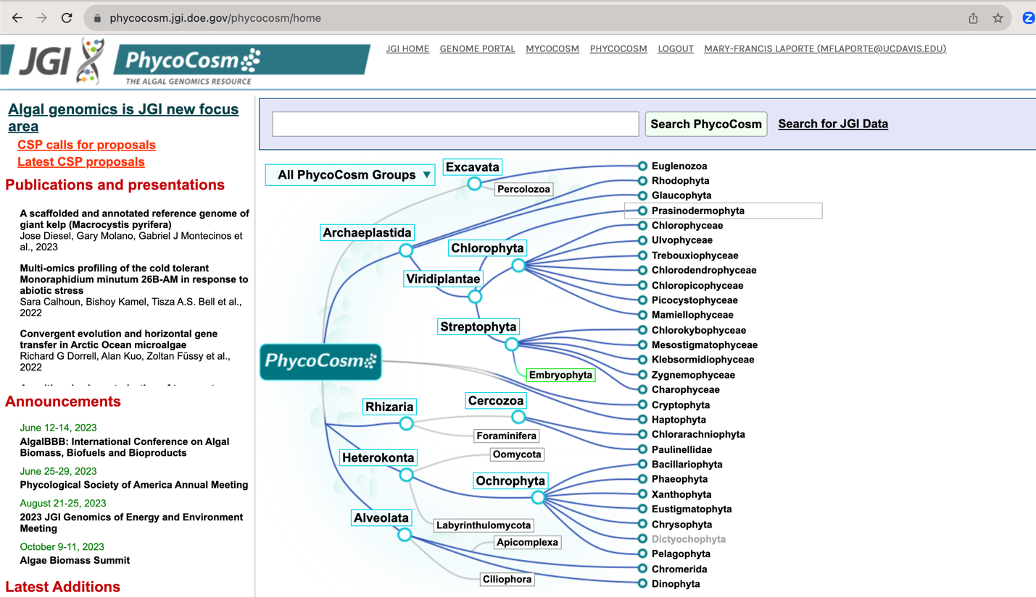

Supplementary Figure 2: The dropdown menu for Chlorophyta, from JGI’s PhycoCosm as of Dec 13 2023.

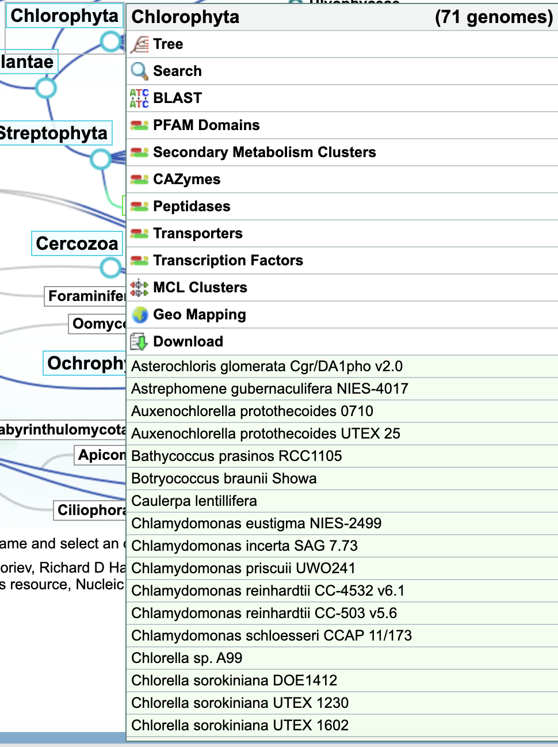

Supplementary Figure 3: A search query for bZIP in Chlorophyta, as well as the dark-gray dropdown menu to select and download protein sequences of interest as a protein FASTA file, from JGI’s PhycoCosm as of Dec 13 2023.

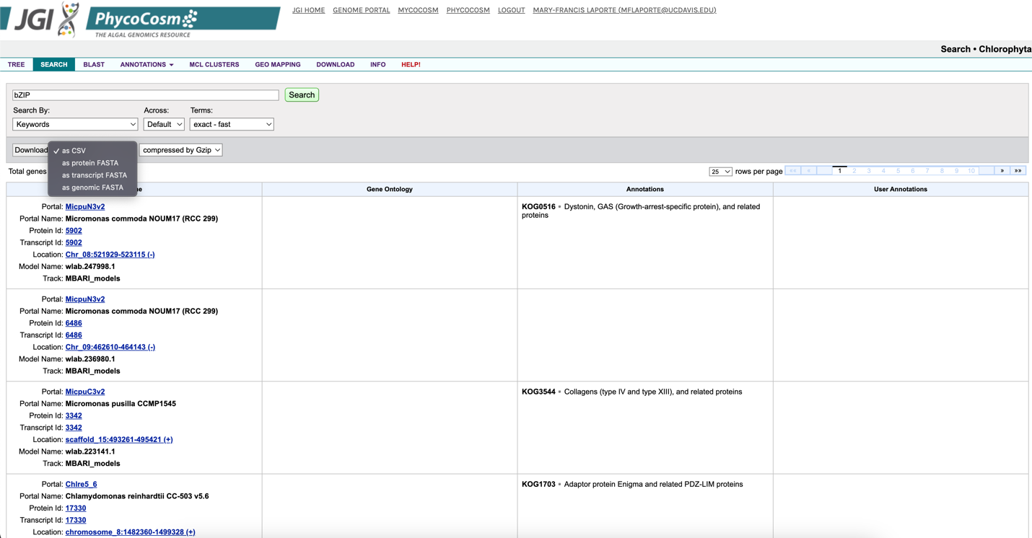

Section 2: How to generate ortholog groups using SonicParanoid?
The application works with the ortholog group we generated using the sequences in Supplementary Table 1 using SonicParanoid. If a different ortholog group is desired, the following are instructions to generate that file. Instructions for download and installation of Sonic Paranoid are found on the website: http://iwasakilab.k.u-tokyo.ac.jp/sonicparanoid/
The input file needed to run SonicParanoid is a folder that contains only the relevant aa.fasta protein sequences from JGI (Figure S3). The output generated from SonicParanoid constitutes a folder containing a series of files, including one called “ortholog_groups.csv” to be used with the AlgaeOrtho application if desired (Figure S4).

The following line of code should be run in the command line, and it identifies orthologous groups for all proteins included in the input folder using SonicParanoid for as many algal species as desired.
$ sonicparanoid -i InputDirectory -o OutputDirectoryName -p NAME --output-pairs
Note: this line of BASH code (to be run in the terminal) requires that SonicParanoid is already installed.
InputDirectory denotes the path to the folder that contains only the relevant aa.fasta protein sequences from JGI
OutputDirectoryName is the path to the output folder (this must be a path to a directory that already exists.
NAME is the name you'd like to give to this analysis for your internal records.
Supplementary Table 1:
List of the 92 Algae Protein Files used with SonicParanoid to be the basis of analysis for the query search. All files were accessed using JGI’s Phycocosm portal and are searchable using the name (the set of characters before the first underscore “_”).
Astpho2_GeneCatalog_proteins_20111209.aa.fasta
Auran1_GeneCatalog_proteins.FilteredModels3.fasta
Auxeprot1_GeneCatalog_proteins_20170909.aa.fasta
Batpra1_GeneCatalog_proteins_20180426.aa.fasta
Botrbrau1_GeneCatalog_proteins_20200805.aa.fasta
Caulen1_GeneCatalog_proteins_20200307.aa.fasta
Chabra1_GeneCatalog_proteins_20200807.aa.fasta
Chlat1_GeneCatalog_proteins_20200803.aa.fasta
Chleu1_GeneCatalog_proteins_20200804.aa.fasta
Chlin1_GeneCatalog_proteins_20200804.aa.fasta
ChlNC64A_1_GeneCatalog_Chlorella_NC64A.best_proteins.fasta
ChloA99_1_GeneCatalog_proteins_20200807.aa.fasta
ChloDOE1412_1_GeneCatalog_proteins_20200805.aa.fasta
Chloso1228_1_GeneCatalog_proteins_20200805.aa.fasta
Chloso1230_1_GeneCatalog_proteins_20200805.aa.fasta
Chloso1602_1_GeneCatalog_proteins_20200805.aa.fasta
Chlpri1_GeneCatalog_proteins_20200307.aa.fasta
Chlre5_6_GeneCatalog_proteins_20200117.aa.fasta
Chlsc1_GeneCatalog_proteins_20200804.aa.fasta
ChlUWO241_1_GeneCatalog_proteins_20220210.aa.fasta
Chrzof1_GeneCatalog_proteins_20190731.aa.fasta
Claok1_GeneCatalog_proteins_20200804.aa.fasta
Coc_C169_1_GeneCatalog_Coccomyxa_C169_v2_filtered_proteins.fasta
Cyapar1_GeneCatalog_proteins_20200807.aa.fasta
Cyccr1_GeneCatalog_proteins_20200805.aa.fasta
Ectsil1_GeneCatalog_proteins_20171109.aa.fasta
Edade1_GeneCatalog_proteins_20200805.aa.fasta
Fisso1_GeneCatalog_proteins_20200805.aa.fasta
Gonpec1_GeneCatalog_proteins_20180501.aa.fasta
Klenit1_GeneCatalog_proteins_20200807.aa.fasta
Mesen1_GeneCatalog_proteins_20200803.aa.fasta
Mesovir1_GeneCatalog_proteins_20200803.aa.fasta
Mesvir1_GeneCatalog_proteins_20200803.aa.fasta
Micco1_GeneCatalog_proteins_20200804.aa.fasta
MicpuC3v2_GeneCatalog_proteins_20160125.aa.fasta
MicpuN3v2_GeneCatalog_proteins_20160404.aa.fasta
MicrAD1_1_GeneCatalog_proteins_20220220.aa.fasta
MicrYARC1_GeneCatalog_proteins_20220803.aa.fasta
Monneg1_GeneCatalog_proteins_20170920.aa.fasta
Nangad1_GeneCatalog_proteins_20180307.aa.fasta
Nansal1776_1_GeneCatalog_proteins_20200807.aa.fasta
Nemde1_GeneCatalog_proteins_20200804.aa.fasta
Nithil2_GeneCatalog_proteins_20201125.aa.fasta
Ochro2298_1_GeneCatalog_proteins_20160817.aa.fasta
Ost9901_3_GeneCatalog_O.lucimarinus.FM.aa.fasta
Ostta1115_2_GeneCatalog_proteins_20170131.aa.fasta
Ostta4221_3_GeneCatalog_proteins_20161028.aa.fasta
Pelago2097_1_GeneCatalog_proteins_20160408.aa.fasta
Phypa1_1_GeneCatalog_proteins.1.FilteredModels.fasta
Pico_ML_1_GeneCatalog_proteins_20200807.aa.fasta
Picre1_GeneCatalog_proteins_20200805.aa.fasta
Picsp_1_GeneCatalog_proteins_20170909.aa.fasta
Rapsub1_GeneCatalog_proteins_20191119.aa.fasta
Sacja1_GeneCatalog_proteins_20210418.aa.fasta
Scesp_1_GeneCatalog_proteins_20191220.aa.fasta
Semro1_GeneCatalog_proteins_20200811.aa.fasta
Spimu1_GeneCatalog_proteins_20200803.aa.fasta
Tetso1_GeneCatalog_proteins_20200805.aa.fasta
Tetstr1_GeneCatalog_proteins_20200807.aa.fasta
Thaoce1_GeneCatalog_proteins_20171026.aa.fasta
TrebA12_1_GeneCatalog_proteins_20200804.aa.fasta
Trimin1_GeneCatalog_proteins_20201122.aa.fasta
Ulvmu1_GeneCatalog_proteins_20200803.aa.fasta
Undpi1_GeneCatalog_proteins_20200805.aa.fasta
Volca2_1_GeneCatalog_proteins_20200117.aa.fasta
Dunsal1_1_GeneCatalog_proteins_20200511.aa.fasta
Auxpr25_1_GeneCatalog_proteins_20200805.aa.fasta
Mintr2_GeneCatalog_proteins_20160618.aa.fasta
Ochro1393_1_4_GeneCatalog_proteins_20181204.aa.fasta
Parimp1_4_GeneCatalog_proteins_20180208.aa.fasta
Sceobl1_GeneCatalog_proteins_20200506.aa.fasta
Sceobl1450_1_GeneCatalog_proteins_20200927.aa.fasta
Sceobl2630_1_GeneCatalog_proteins_20200906.aa.fasta
SceoblDOE13_1_GeneCatalog_proteins_20200927.aa.fasta
SceoblEN4_1_GeneCatalog_proteins_20190921.aa.fasta
Sobl393_1_GeneCatalog_proteins_20200120.aa.fasta
Dicre1_GeneCatalog_proteins_20171101.aa.fasta
Nanoce1779_2_GeneCatalog_proteins_20180119.aa.fasta
OstRCC809_2_GeneCatalog_OstreococcusRCC809v2.FilteredModels3.proteins.fasta
Psemu1_GeneCatalog_proteins_20111011.aa.fasta
SymretAf1_GeneCatalog_proteins_20180322.aa.fasta
SymretSc1_GeneCatalog_proteins_20180314.aa.fasta
SymretSp1_GeneCatalog_proteins_20171013.aa.fasta
SymretSw1_GeneCatalog_proteins_20180321.aa.fasta
DesarB2533_2_GeneCatalog_proteins_20210517.aa.fasta
Enacos1_1_GeneCatalog_proteins_20210913.aa.fasta
Flerot1_1_GeneCatalog_proteins_20210723.aa.fasta
Meskra657_3_GeneCatalog_proteins_20220510.aa.fasta
Monmin1_GeneCatalog_proteins_20190530.aa.fasta
Sceobl393_2_GeneCatalog_proteins_20200804.aa.fasta
TetrdesSNI2_1_GeneCatalog_proteins_20210729.aa.fasta
Tetrobl72_1_GeneCatalog_proteins_20210717.aa.fasta

Supplementary Figure 4: Screenshot of the application: AlgaeOrtho allows for three different settings, the first two case studies, as well as the user’s own protein files of interest

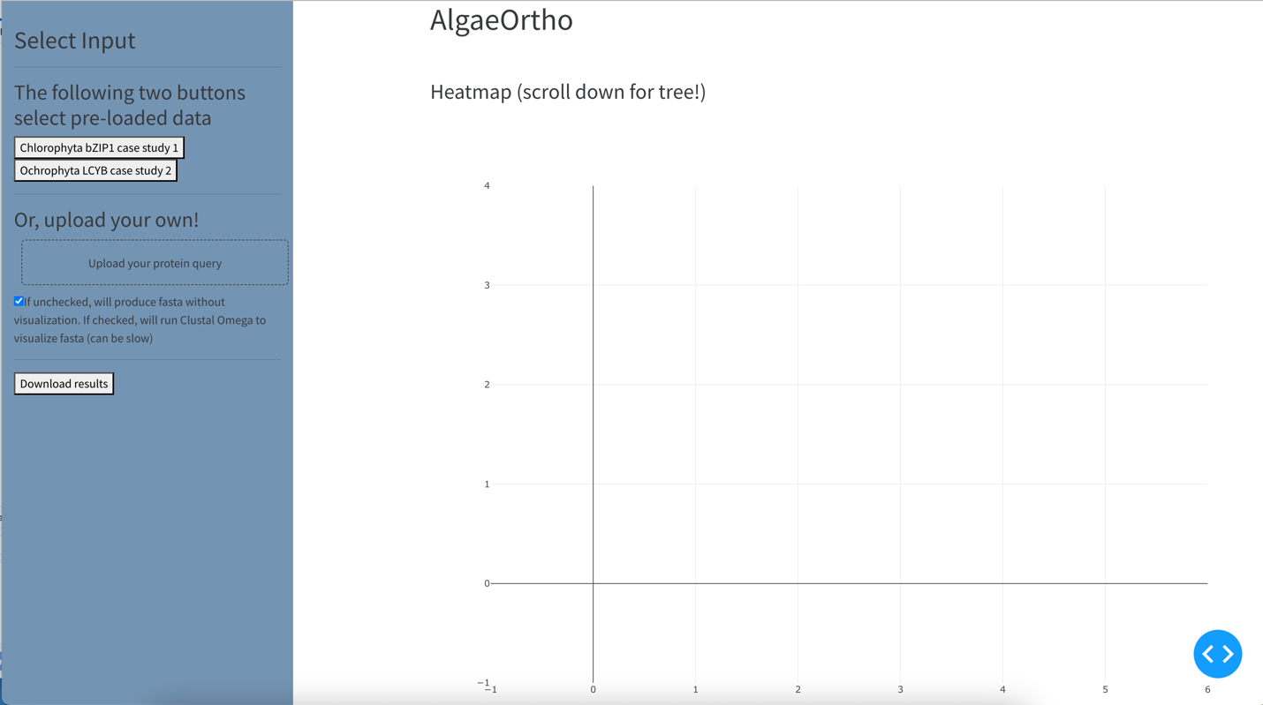

Section 3: How to install and use the AlgaeOrtho Application?
3.1: Helpful software and pre-requisites
- Docker: a tool to handle the software prerequisites for the AlgaeOrtho application: https://hub.docker.com/. Once Docker is installed, it will handle the Python software installation that our application uses to run. Although it will require the user to run a couple of lines of code in the terminal, this is easier than the user needing to handle software installation and versioning themselves.

- GitHub: a tool to share code and make it accessible over the internet. The user will want a GitHub account https://github.com/ to retrieve the code for this application: https://github.com/laporpe/AlgaeOrtho . This code can then be downloaded to the user’s device so they can run the code.

- One way to download the code for the application is through the GitHub Desktop application: https://desktop.github.com/ . The GitHub Desktop application can be connected with the users’ GitHub account, so that the user can run AlgaeOrtho code (or any other code accessed from GitHub) on their computer. Here are instructions on how to do that: https://docs.github.com/en/desktop/adding-and-cloning-repositories/cloning-a-repository-from-github-to-github-desktop

- Visual Studio Code (VS Code): a code editor that allows the user to open up the AlgaeOrtho files and run the application. VS Code is advantageous because it has a built-in terminal. Once the code has been obtained from Github, the user should open it in VS Code.

3.2: How to use Docker?

- Download Docker https://hub.docker.com/
- Pull the code for the application from Github https://github.com/laporpe/AlgaeOrtho.
  - One way to do this is through using the GitHub Desktop App: https://desktop.github.com/. See link in Part 3 above.

- Open the directory that contains the code for the application locally in VS Code. This can be done by pressing the “Open in Visual Studio Code” button in the GitHub Desktop application (center section, two boxes beneath the “No local changes” heading).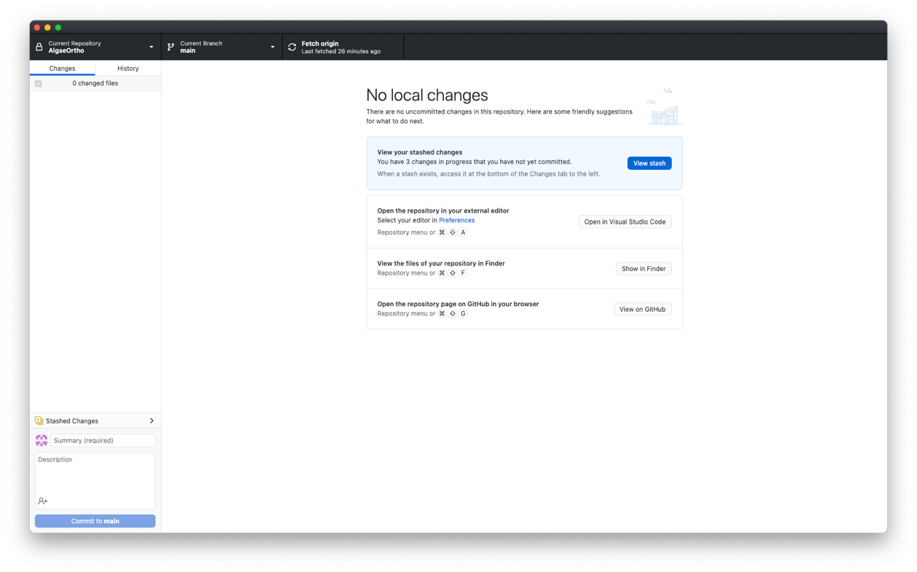
- Once the application files have been opened in VS Code, navigate to the Terminal in VS code (usually at the bottom of the screen), and run this:

docker compose build

  - This command builds the docker container so that all of the necessary prerequisites for this application are pre-installed.
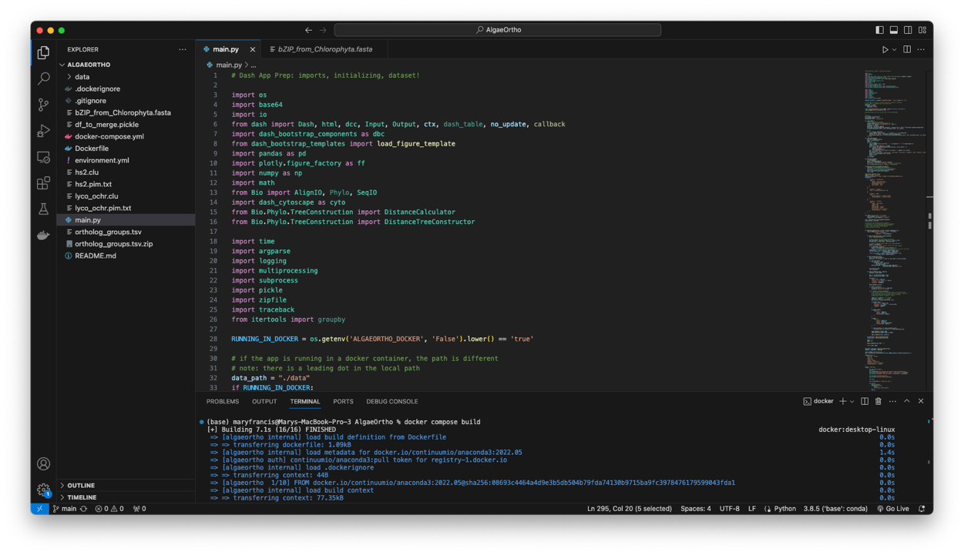
- Once that command has finished, In the Terminal in VS code (with the application directory open), run this command:
docker compose up

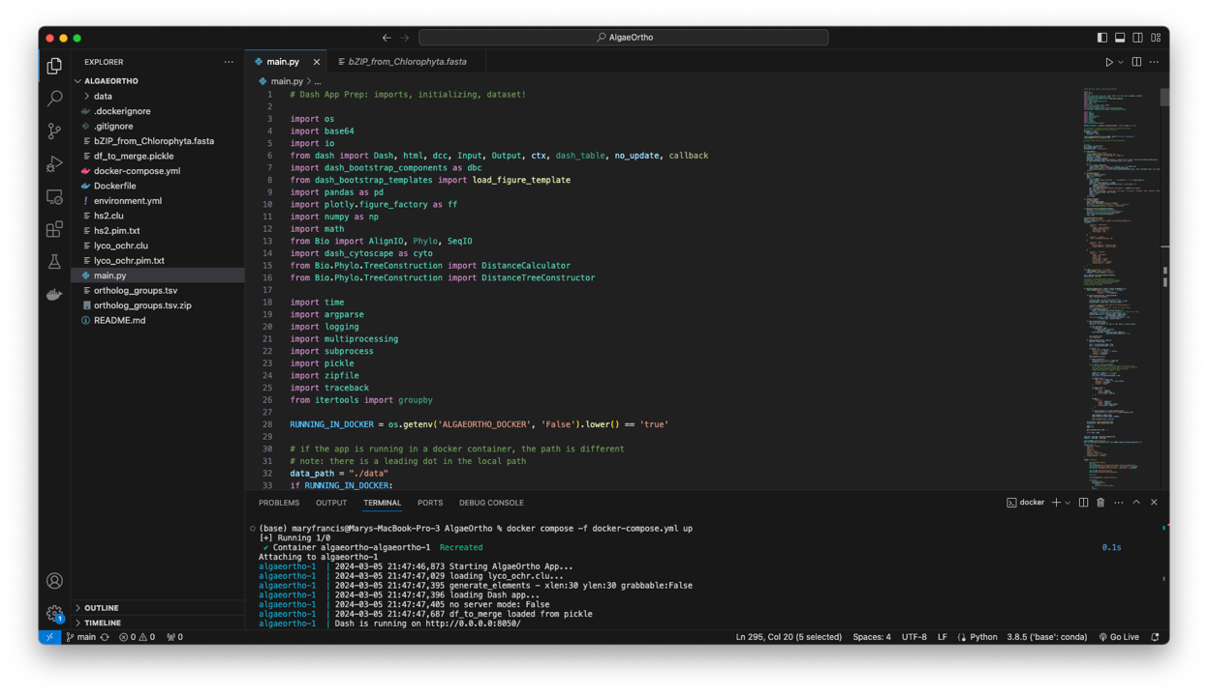
- This will make the application accessible locally at http://127.0.0.1:8050 (another equivalent option: localhost:8050)
  - In other words, type 127.0.0.1:8050 (or localhost:8050) into your browser (for example, Google Chrome) and the application will open. The application is running locally, and using the graphical tools from your browser to display the application. As the application is running locally, anything you upload only is being processed on your computer and is not being uploaded online.
- From here you should be able to use the example buttons as well as upload your own sequences!
3.3: How to use the Algae Ortho application?
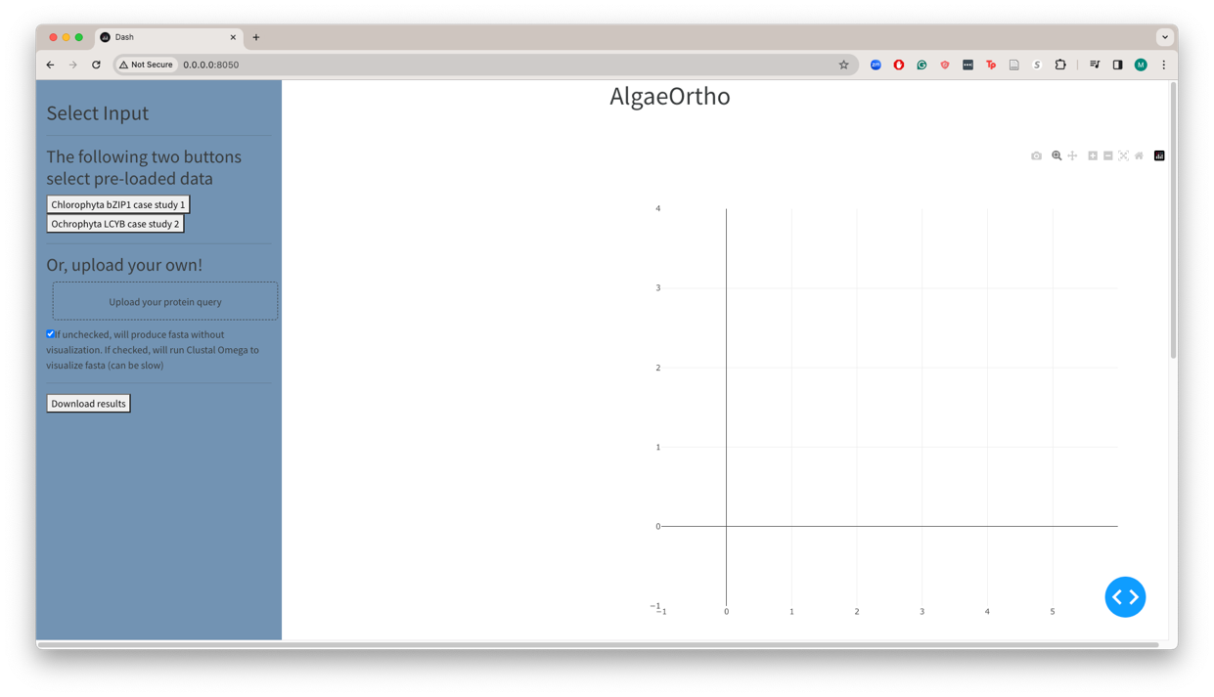
This is how the application will appear when it is first loaded. Select the buttons on the upper left to visualize pre-loaded data (described in the manuscript).

To upload your own data, use the “upload your protein query” button. Upload any protein .fasta file, that does not end each protein with asterisks (*). Try a short file with only a few proteins first, as these run quickly.
Leave the checkbox “unchecked” for the “quick” version of the application, which only finds the putative orthologs from the sonic paranoid results, but does not visualize them. This will allow you to download the resulting protein fasta file using the “download results” button. Leave the checkbox “checked” to visualize the results of the putative ortholog file in the application.
Download all results files by clicking the “download results” button. This will download a folder that needs to be unzipped, that will contain the.fasta file of all putative orthologs, as well as the generated Newick file to visualize a tree of those sequences in your tree visualizer of choice.
Remember to scroll down (on the white-background section of the application) to see the ortholog tree!
The figures can be zoomed in and out using the Dash app controls 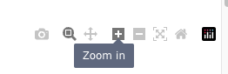

3.4: Troubleshooting:
If you are running this on an M1 Mac: the visualization aspect of the application uses a function that cannot work with an M1 Mac.

There is a separate container distributed for users on an M1 Mac, that has a “checkbox unchecked” version of the application. To access this container, follow the instructions above, but replace the docker commands with the following:

docker compose -f docker-compose-noclustalo.yml build
docker compose -f docker-compose-noclustalo.yml up

This specifies the “noclustalo” (non-visualized) version, which should work on all machines.

