Supplementary Information

Satellite Observations of Water Origins Reveal New Dimensions of Hydroclimate Vulnerability of Global Croplands

Yan Jiang^{1,2,*}, Jennifer A. Burney^{1,2,*}

¹School of Global Policy and Strategy, University of California San Diego, La Jolla, CA, USA 92093
²Scripps Institution of Oceanography, University of California San Diego, La Jolla, CA, USA 92093

Tables
Supplementary Table 1. Parameter estimates from the multiple linear regression for all crop grids.
Climate indices | NIR_{v}_max
Climate indices | all | f $≥$40% | f < 40%
Rainwater (vegetative)  Rainwater (reproductive)  RZSM (vegetative)  RZSM (reproductive) | 0.1 (± 0.01)**  0.02 (± 0.01)  0.05 (± 0.012)**  0.17 (± 0.013)** | 0.14 (± 0.014)**  0.02 (± 0.015)  0.05 (± 0.017)**  0.25 (± 0.02)** | 0.04 (± 0.014)**  0.01 (± 0.015)  0.03 (± 0.016)*  0.1 (± 0.017)**
R² | 0.07 | 0.15 | 0.02
Note: Values are estimated coefficients with standard errors in parentheses. “*” indicates that the coefficient is significant at 90% confidence level. “**” indicates that the coefficient is significant at 99% confidence level.

Supplementary Table 2. Parameter estimates from the multiple linear regression for maize.
Climate indices | NIR_{v}_max
Climate indices | all | f $≥$40%
Rainwater (vegetative)  Rainwater (reproductive)  RZSM (vegetative)  RZSM (reproductive) | 0.08 (± 0.012)**  0.01 (± 0.012)  0.02 (± 0.014)*  0.15 (± 0.015)** |  | 0.13 (± 0.018)**  -0.02 (± 0.019)  0.00 (± 0.022)  0.26 (± 0.024)**
R² | 0.04 |  | 0.11
Note: Values are estimated coefficients with standard errors in parentheses. “*” indicates that the coefficient is significant at 90% confidence level. “**” indicates that the coefficient is significant at 99% confidence level.
Supplementary Table 3. Parameter estimates from the multiple linear regression for rice.
Climate indices | NIR_{v}_max
Climate indices | all | f $≥$40%
Rainwater (vegetative)  Rainwater (reproductive)  RZSM (vegetative)  RZSM (reproductive) | 0.04 (± 0.021)*  0.03 (± 0.012)  0.01 (± 0.024)  0.09 (± 0.027)** |  | 0.20 (± 0.052)**  0.03 (± 0.055)  -0.03 (± 0.06)  0.24 (± 0.067)**
R² | 0.02 |  | 0.13
Note: Values are estimated coefficients with standard errors in parentheses. “*” indicates that the coefficient is significant at 90% confidence level. “**” indicates that the coefficient is significant at 99% confidence level.

Supplementary Table 4. Parameter estimates from the multiple linear regression for soybean.
Climate indices | NIR_{v}_max
Climate indices | all | f $≥$40%
Rainwater (vegetative)  Rainwater (reproductive)  RZSM (vegetative)  RZSM (reproductive) | 0.05 (± 0.016)**  0.02 (± 0.012)  0.05 (± 0.018)*  0.12 (± 0.020)** |  | 0.09 (± 0.025)**  -0.03 (± 0.025)  -0.00 (± 0.030)  0.25 (± 0.033)**
R² | 0.03 |  | 0.08
Note: Values are estimated coefficients with standard errors in parentheses. “*” indicates that the coefficient is significant at 90% confidence level. “**” indicates that the coefficient is significant at 99% confidence level.

Supplementary Table 5. Parameter estimates from the multiple linear regression for winter wheat.
Climate indices | NIR_{v}_max
Climate indices | all | f $≥$40%
Rainwater (vegetative)  Rainwater (reproductive)  RZSM (vegetative)  RZSM (reproductive) | 0.12 (± 0.013)**  0.03 (± 0.014)*  0.04 (± 0.016)*  0.23 (± 0.018)** |  | 0.16 (± 0.017)**  0.02 (± 0.018)  0.03 (± 0.022)  0.31 (± 0.025)**
R² | 0.12 |  | 0.19
Note: Values are estimated coefficients with standard errors in parentheses. “*” indicates that the coefficient is significant at 90% confidence level. “**” indicates that the coefficient is significant at 99% confidence level.

Figures
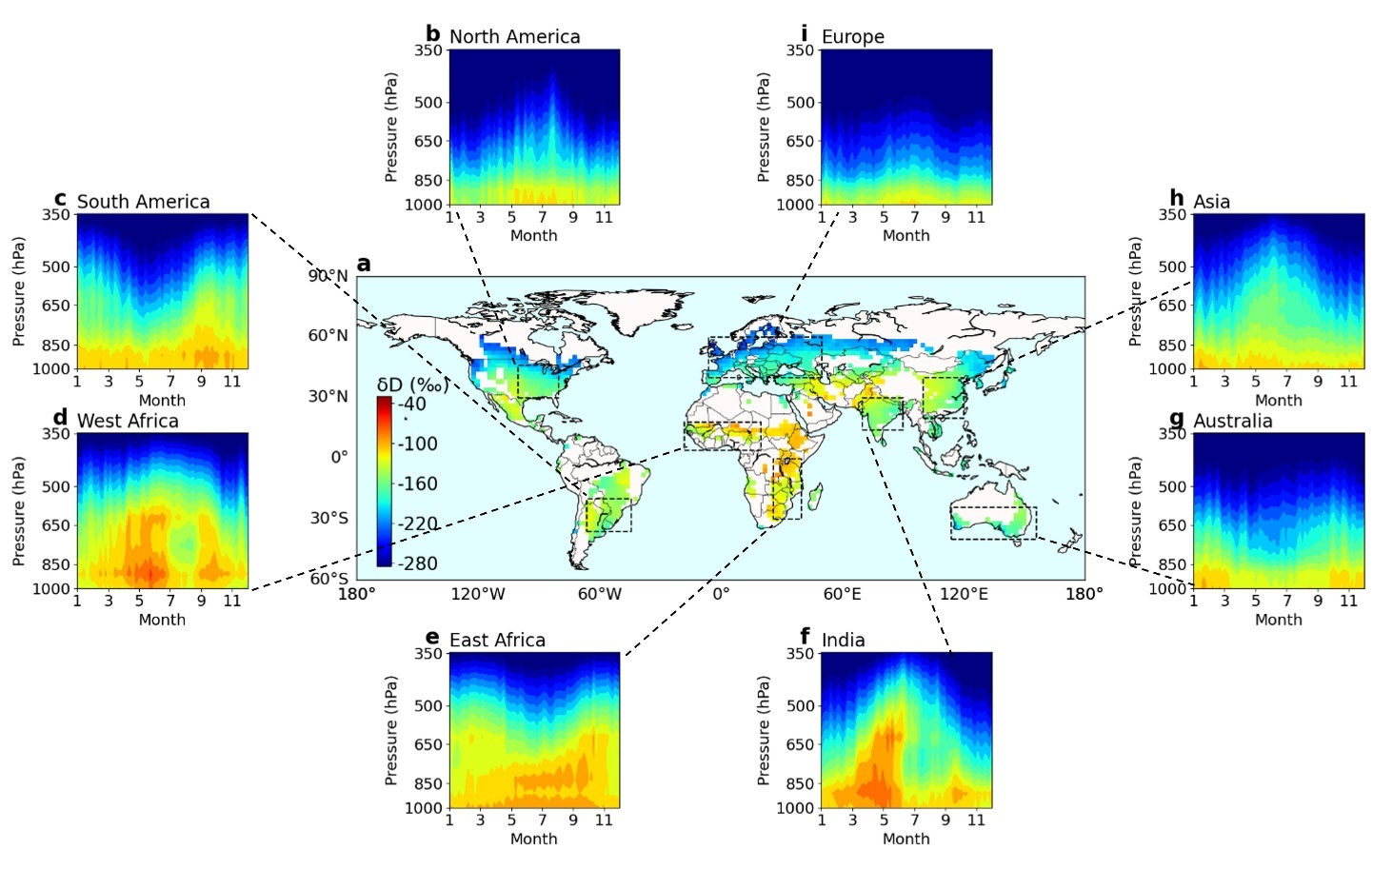
Supplementary Figure 1: Spatial and vertical patterns of $δD$ (unit: ‰) during 2005-2011 from AIRS observations. a, Global distribution of $δD$ averaged vertically between 900 and 600hPa during the growing season. b-i, Long-term mean annual vertical profiles of $δD$ over breadbaskets including North America, South America, West Africa, East Africa, India, Australia, Asia, and Europe.

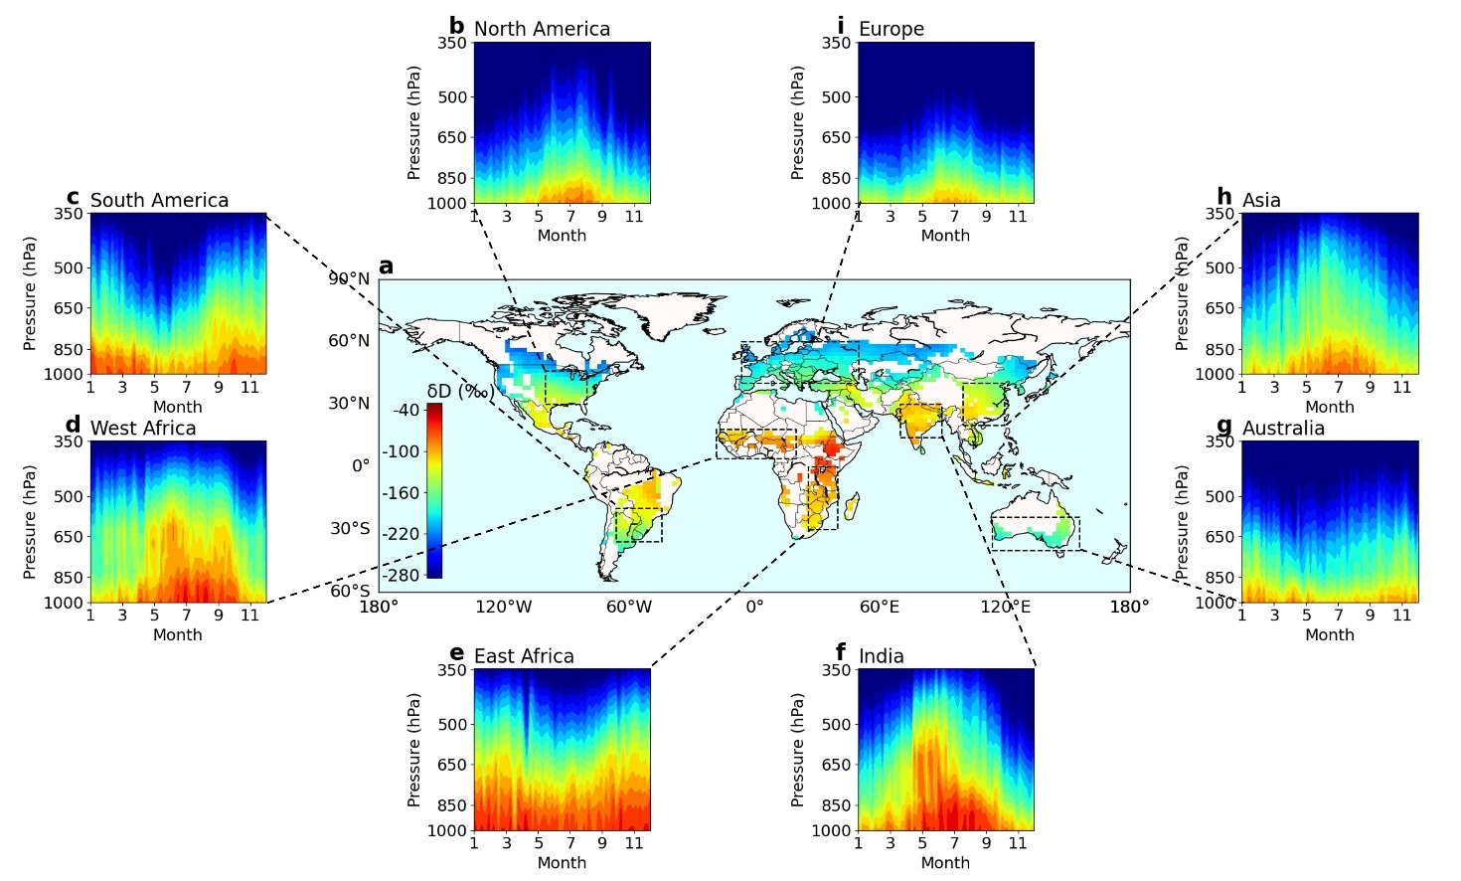
Supplementary Figure 2: The same as Supplementary Fig. 1, but estimated based on TES observations.

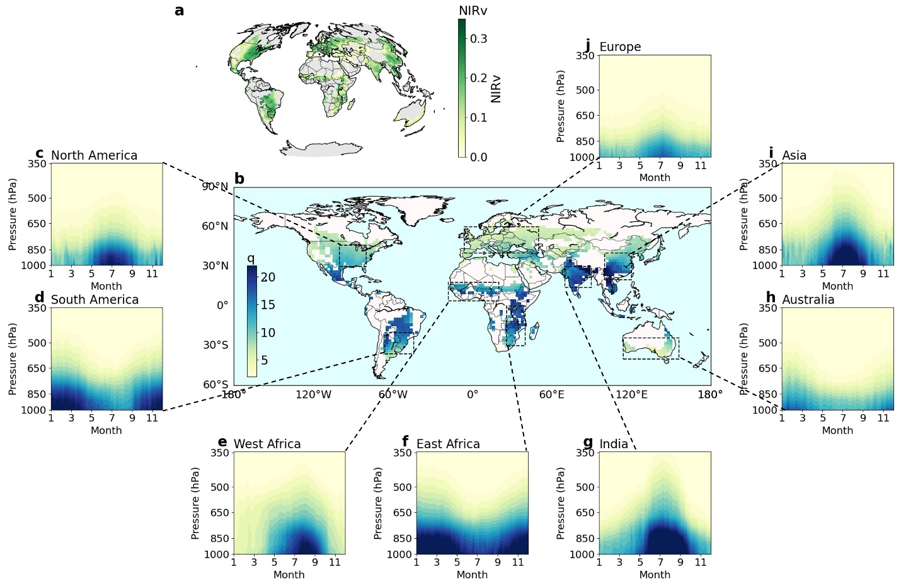
Supplementary Figure 3: Spatial and vertical patterns of $q$ (unit: g/kg) during 2003-2019 from AIRS observations. a, Studied croplands estimated by the cropland extent dataset and corresponding mean NIRv values (unitless) during the growing season. b, Global distribution of $δD$ averaged vertically between 900 and 600hPa during the growing season. c-j, Long-term mean annual vertical profiles of $δD$ over breadbaskets including North America, South America, West Africa, East Africa, India, Australia, Asia, and Europe.

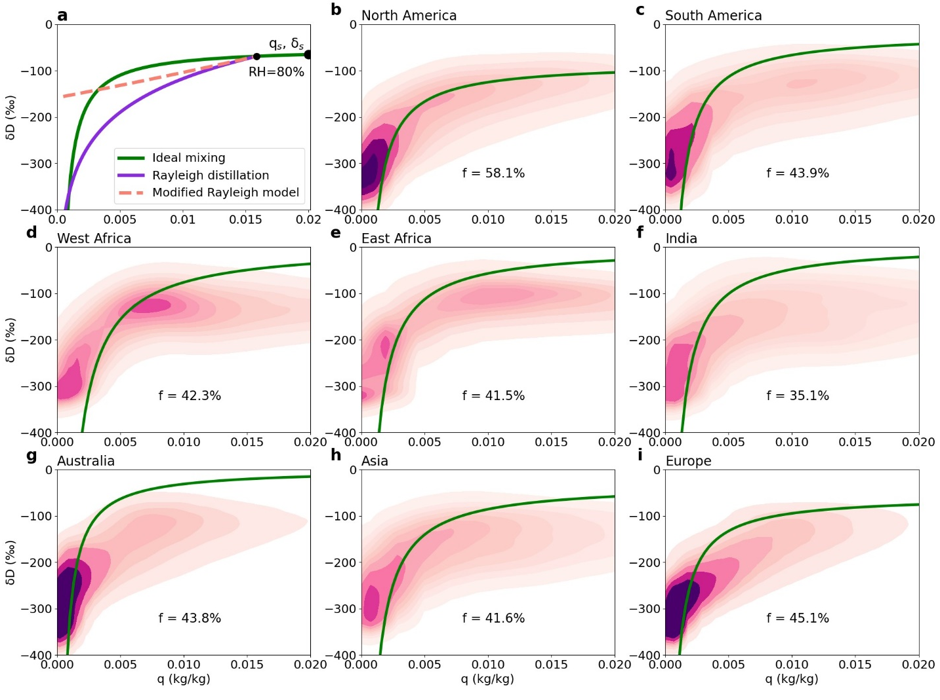
Supplementary Figure 4: Theoretical models of hydrologic processes and scatter plots of $δD$ versus q. a, Theoretical predictions of the evolution of $δD$ as a function of q. The joint dot of the three curves (q_{s}, $δ$_{s}) is set as the original air mass that has 80% relative humidity relative to equilibrium with an ocean source and an assumed temperature of 300 K following Noone¹. The green line represents evaporation as mixing with vapor in equilibrium with the source air mass (q_{s}, $δ$_{s}). When the air mass originates from terrestrial transpiration, it is more enriched and can represent an upper bound of all hydrologic processes. The purple curve represents the Rayleigh distillation as a pseudo adiabatic process, during which all moisture precipitates out of the air mass. The dashed pink line shows the case of a reversible moist adiabatic process, during which the condensation is to ice and irreversible. Joint distribution of $δD$ and q in the troposphere (908-348 hPa) based on AIRS observations during 2003-2019 over b, North America (30$°$N-46$°$N, 100$°$W-80$°$W), c, South America(36$°$S-18$°$S 66$°$W-44$°$W), d, West Africa (4$°$N-18$°$N, 18$°$W-0$°$), e, East Africa (28$°$S-0$°$, 26$°$E-40$°$E), f, India (14$°$N-30$°$N, 70$°$E-90$°$E), g, Australia (40$°$S-24$°$S, 114$°$W-156$°$W), h, Asia (20$°$N-40$°$N, 100$°$E-120$°$E), i, Europe (40$°$N-60$°$N, 6$°$W-50$°$E). The fraction of land-based moisture (f) and available samples (n) over each subregion are shown as well.

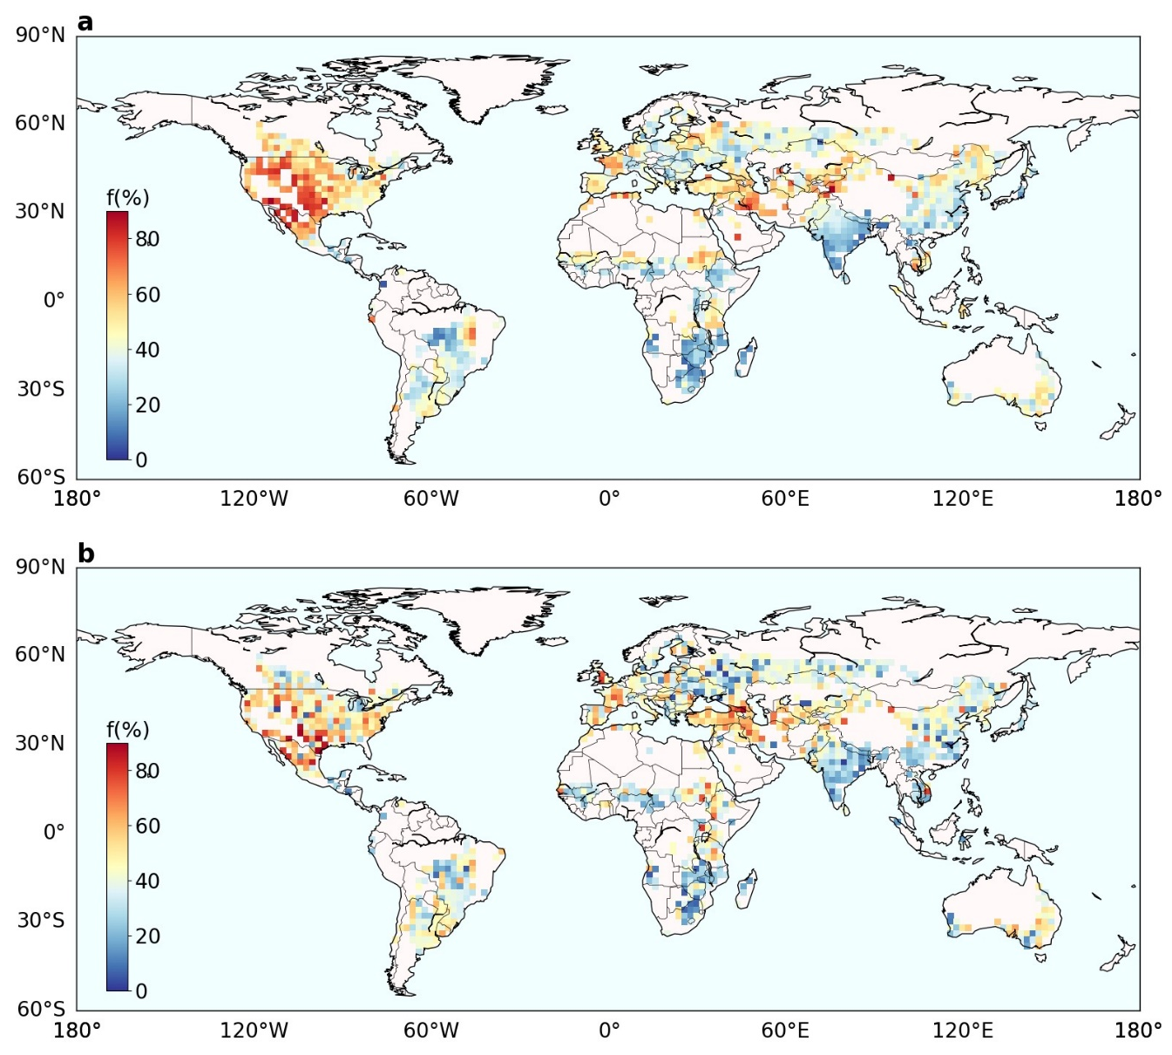
Supplementary Figure 5: Spatial patterns of the fraction of land-based moisture ($f$, unit: %) during 2005-2011 from a, AIRS and b, TES during the growing season.

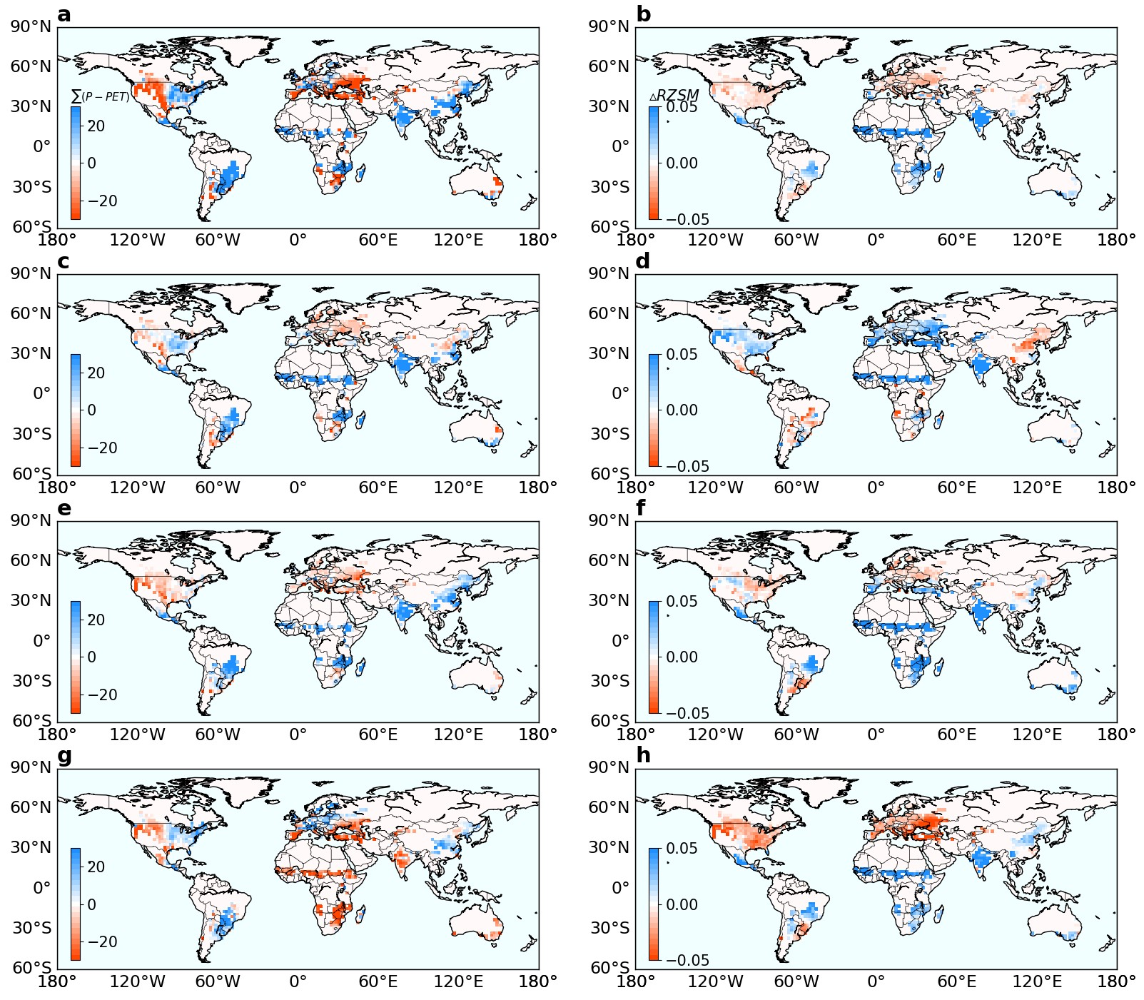
Supplementary Figure 6: Spatial patterns of long-term mean rainwater supply (mm; left column) and root-zone soil moisture (RZSM; m³/ m³; right column) during a-b, the whole growing season, c-d, the vegetative stage, e-f, the reproductive stage, and g-h, the harvest time during 2003-2019.

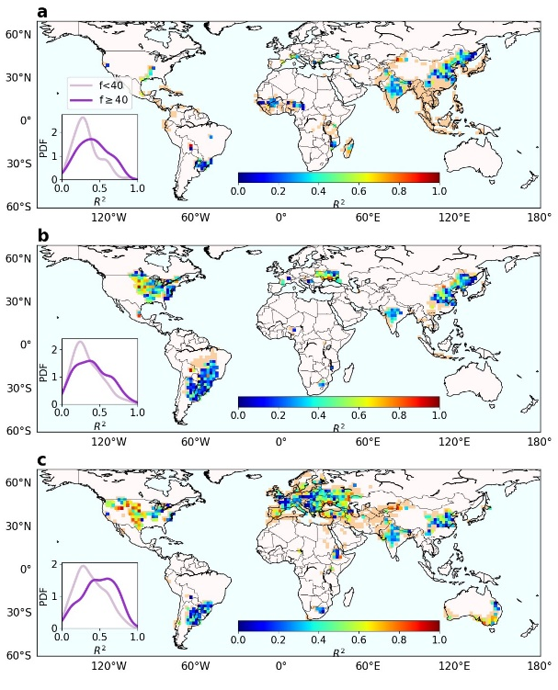
Supplementary Figure 7: Spatial patterns of R² of the multiple linear regression models of crop yield against rainwater supply and RZSM during the vegetative and reproductive stages for a, rice, b, soybean, and c, winter wheat. Grids marked with light orange are crop grids not included in the regression for each crop type. The histograms of R² for crop grids with f $≥$40% (dark purple) and f < 40% (light purple) are shown in the sub-panel for each crop type.

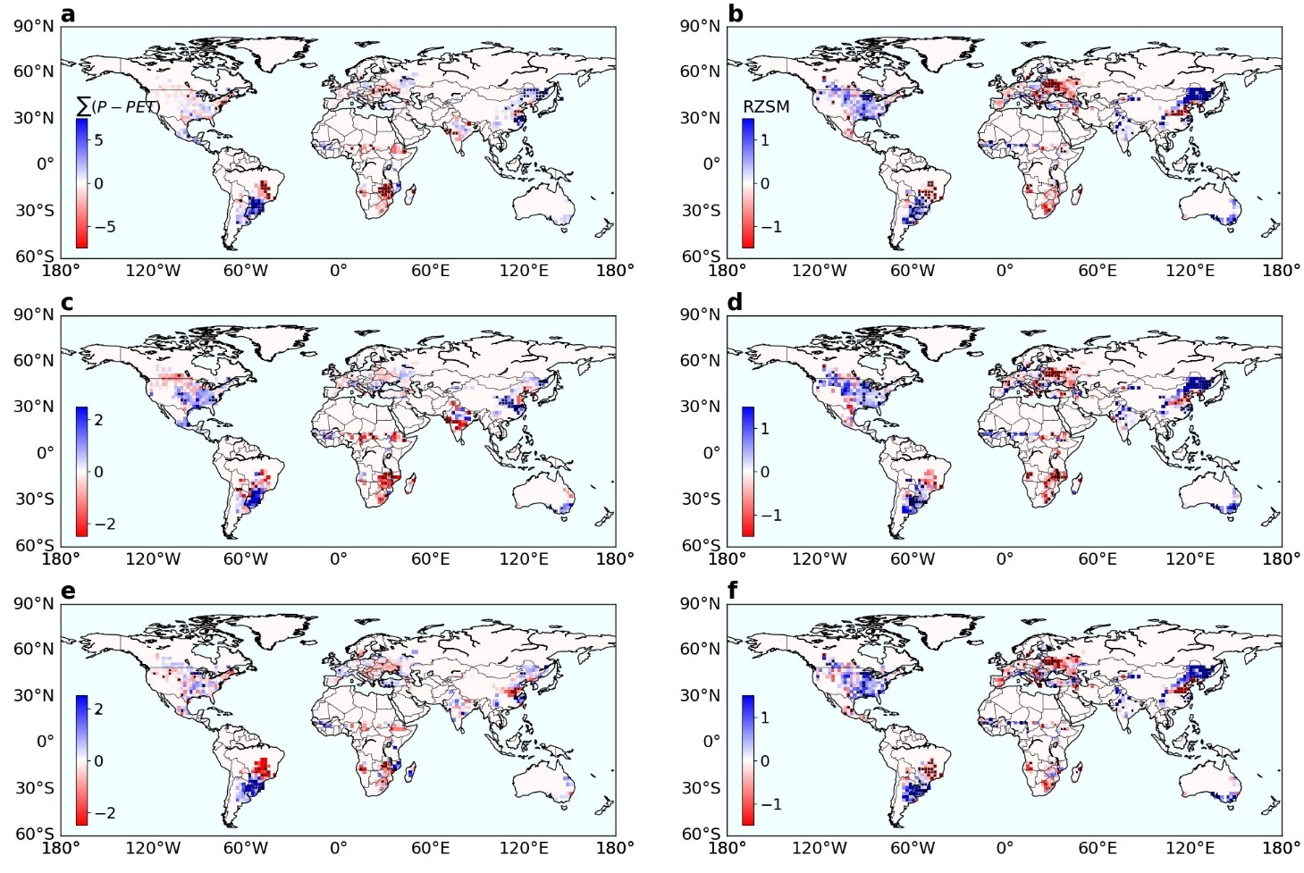
Supplementary Figure 8: Spatial patterns of linear trends of rainwater supply (mm/day/yr; left column) and RZSM (%/yr; right column) during a-b, the whole growing season, c-d, the vegetative stage, and e-f, the reproductive stage for the period 2003-2019. Grids marked with black dots have a significant linear trend at p < 0.1.

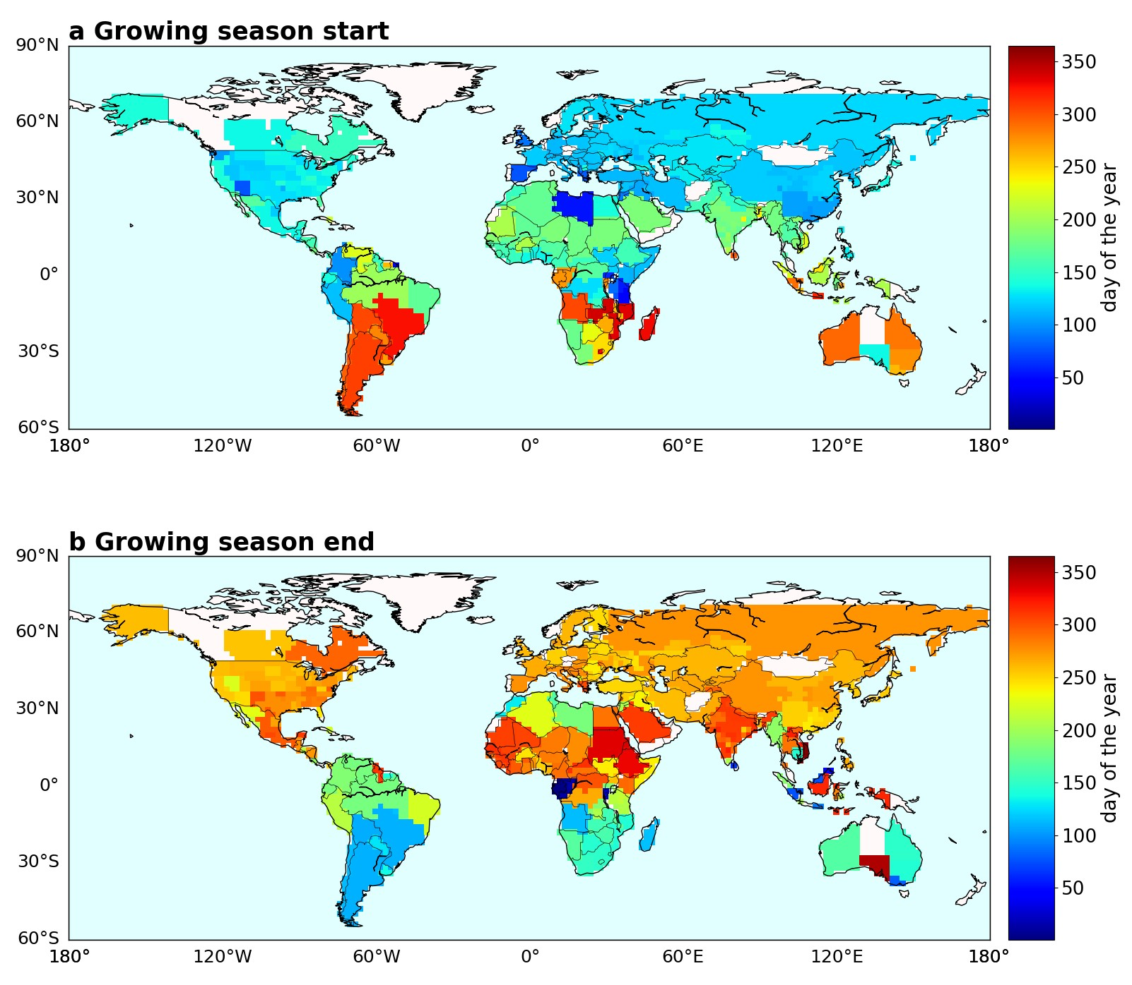
Supplementary Figure 9: Maps of conventional crop calendar (day of the year) merged from the 0.5$°$ resolution global gridded crop calendar dataset covering 11 crops². a, Planting dates. b, Harvesting dates.

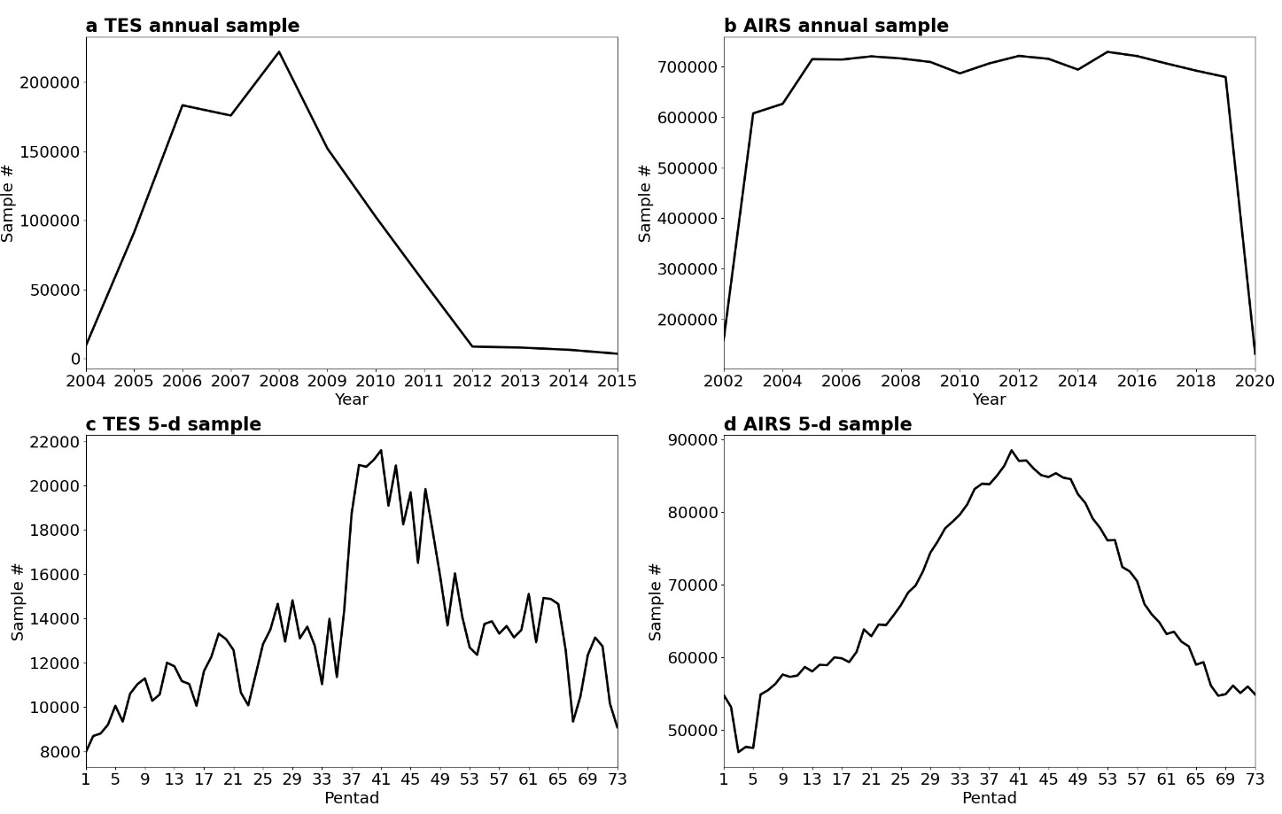
Supplementary Figure 10: Sample sizes of the TES and AIRS observations. Annual sample number of a, TES and b, AIRS over the full time period of each dataset. Total sample numbers of c, TES and d, AIRS at 5-d (pentad) time interval for the period 2005-2011.

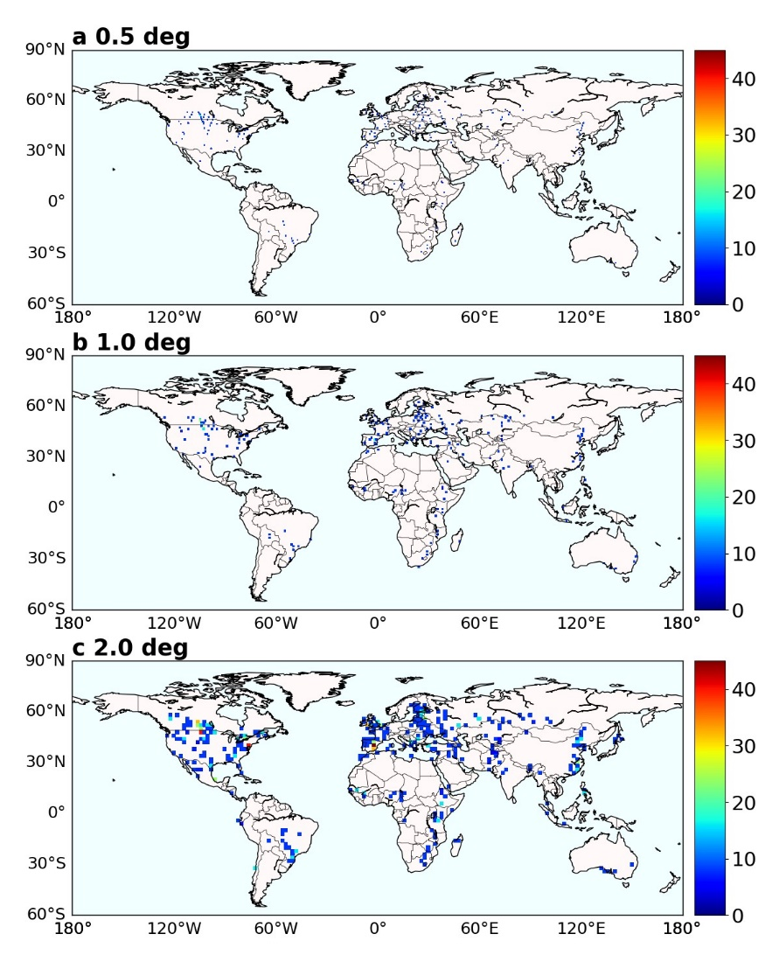
Supplementary Figure 11: Available observation between 908-348 hPa during the first pentad in July 2006 from TES observations at a, 0.5$°$, b, 1.0$°$, and c, 2.0$°$ that aligned with the cropland map.

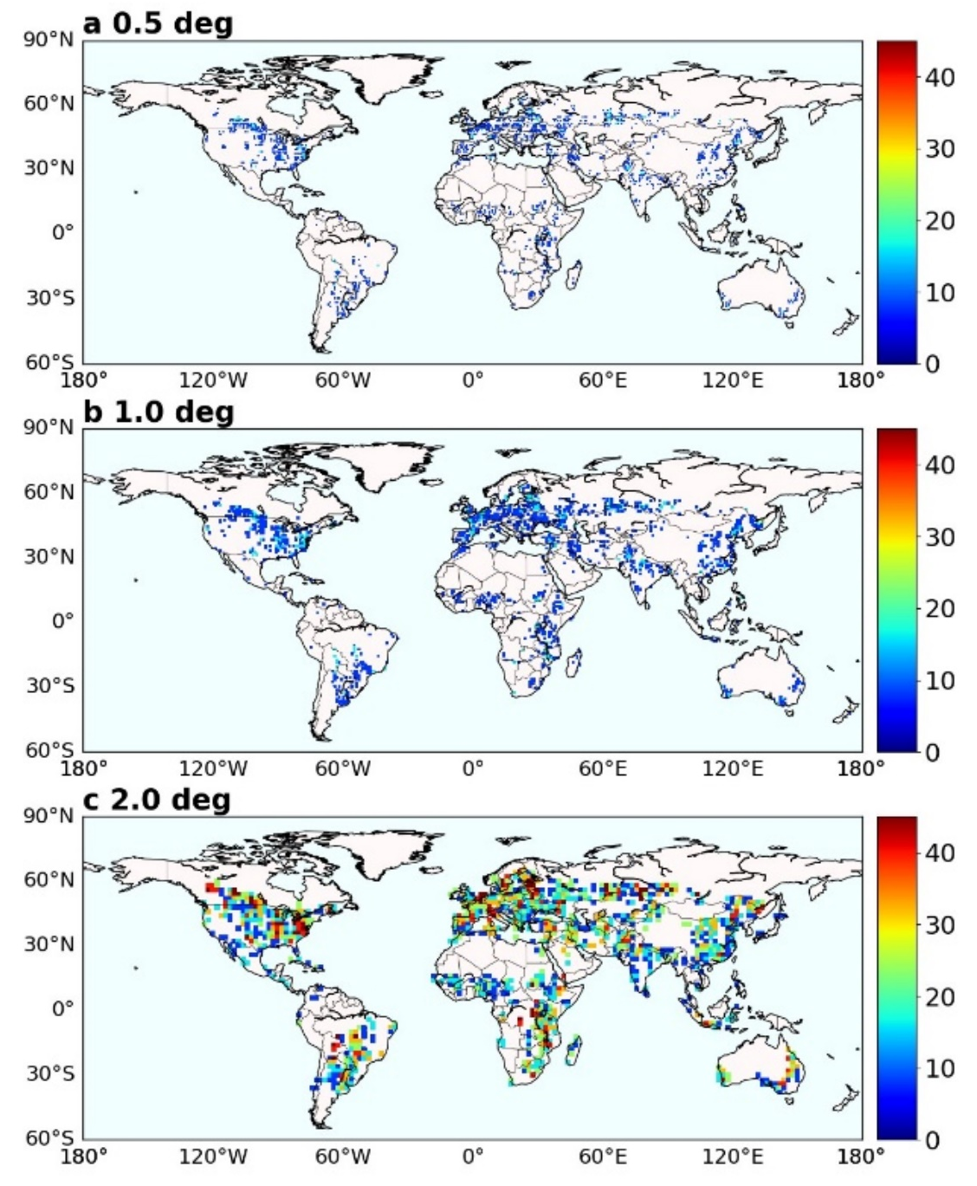
Supplementary Figure 12: The same as Supplementary Fig. 12 but from AIRS observations.

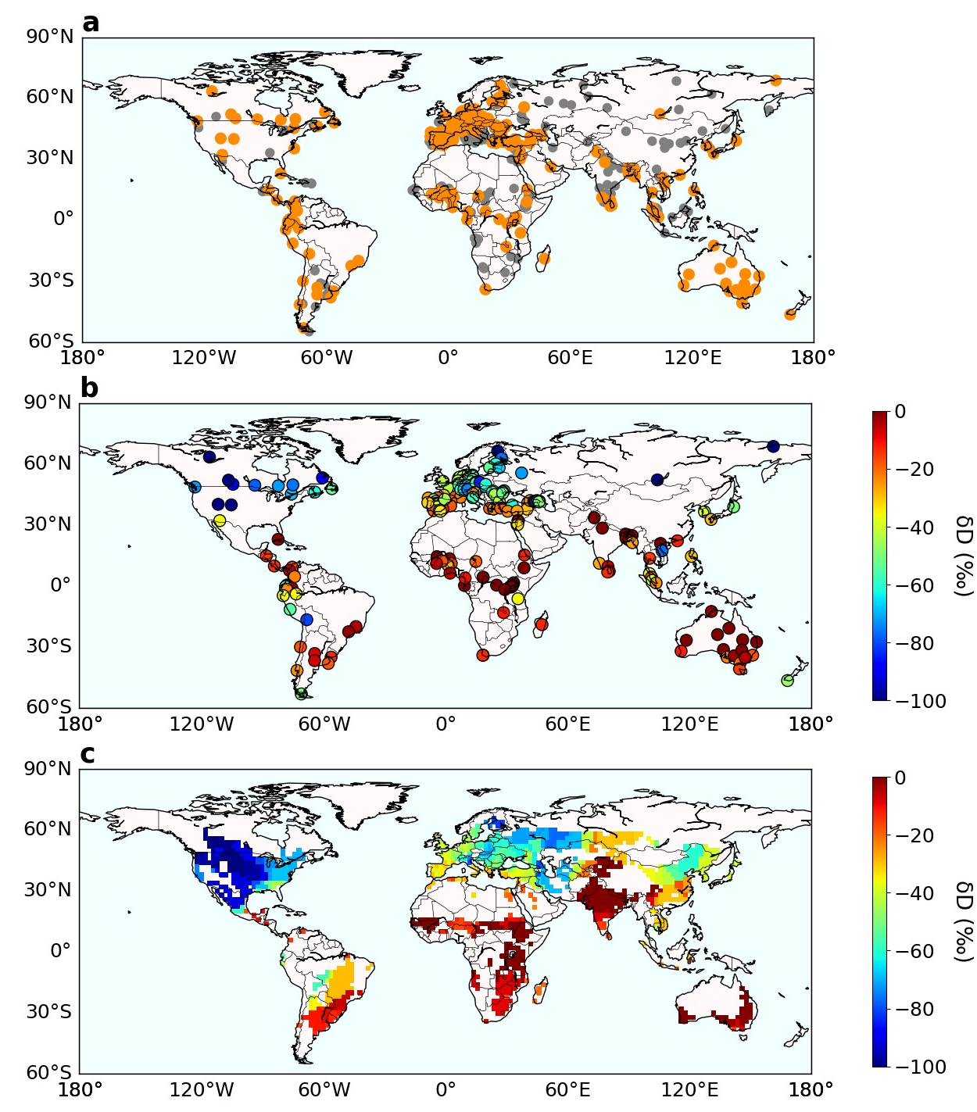
Supplementary Figure 13: Maps of gauge stations from the Global Network of Isotopes in precipitation (GNIP). a, All stations from GNIP since 1960. Orange dots mark stations satisfying all data criteria to be used in this study. Gray dots mark stations not included. b, Monthly mean $δD$ value during the transitional season constrained by intermediate precipitation and temperature levels. c, Interpolated transitional season mean $δD$ aligned with the cropland extent map with the 2º resolution.

References
1. Noone, D. Pairing measurements of the water vapor isotope ratio with humidity to deduce atmospheric moistening and dehydration in the tropical midtroposphere. J. Clim. 25, 4476–4494 (2012).
2. Sacks, W. J., Deryng, D., Foley, J. A. & Ramankutty, N. Crop planting dates: an analysis of global patterns. Glob. Ecol. Biogeogr. 19, 607–620 (2010).

