SUPPLEMENTAL MAERIAL

Create and maintain Protected Areas (PA)

Data and projections
In 2018, the Legal Amazon encompassed 131 Mha of Conservation Units (“Cadastro Nacional de Unidades de Conservação (CNUC),” 2021) , 143 Mha of Indigenous Lands (“Terras Indígenas,” 2020), and 72.6 Mha of Undesignated Public Lands, the latter subsequently divided into Undesignated Public Forests (49.8 Mha) and Other Undesignated Public Lands without forests (22.8 Mha) (Alencar et al., 2021).
For simplicity, we only considered demand for allocation of public lands to Indigenous territories with demarcation/legal recognition already in progress, which totaled 103,000 km² according to (“Terras Indígenas,” 2020). Since deforestation trends are similar in Conservation Units (CUs) and Indigenous Lands (ILs) (Kruid et al., 2021; Walker et al., 2020), the impact of this designation should not significantly affect future deforestation projections. It does, however, alter the economic outcomes attributed to the use of the Conservation Units.
Furthermore, we considered bill PL 2633/20, which stipulates that land parcels attributed to small-medium holders within Undesignated Public Lands without forests that were converted to other land uses before 2014, can be reallocated to private properties. Using PRODES Amazônia and Cerrado (2014-2019) (INPE, 2021; Parente et al., 2021) and the Rural Environmental Registry (SFB, 2020), we estimate the area that could be allocated (legally) to private properties to total 0,2 Mha.
All remaining Undesignated Public Lands (with or without forests) would be converted to CUs ranging from more permissive to more restrictive categories. A relatively permissive designation would provide basic infrastructure for conservation (CU Type I) in more remote areas while a more restrictive designation would consolidate CUs in areas at greater risk of deforestation (CU Type II) through additional research and socio-environmental monitoring (e.g., technical reports from Programa Áreas Protegidas da Amazônia-ARPA). Type II CUs are located up to 50km from roads (Geluda et al., 2012; Muanis et al., 2009). The allocation of new CUs followed the same proportion of CU categories (e.g., national park, extractive reserve, etc.) found in 2018. Some of the CU categories allow for sustainable use. In these cases we considered income from non-timber forest products (NTFP) and selective logging for 77,000 km² based on estimated demand (Serviço Florestal Brasileiro, 2019). Public use and its economic impacts, including tourism, were estimated only for new Type II areas since they are more easily accessible and would have the infrastructure to receive visitors.

Existing and new costs
Costs for establishing new CUs consist of one-time expenses for creation and consolidation, the latter depending on type I or II (Geluda et al., 2012). The one-time cost total for consolidated type I was around BRL 1.5 million per area and for type II BRL 3.5 million per area. This process can sometimes require extra costs for land tenure regularization, which we assumed to happen in 0.03% of the cases at a cost of BRL 567.65/ha (Araújo and Barreto, 2015). We assumed that existing CUs were already fully consolidated. Annual costs were estimated at BRL 38,000 (40,000)/area for maintenance (Ministério do Meio Ambiente, 2017) and BRL 90,000 (94,000)/area for surveillance (BNDES, 2019) for type I (type II). Indigenous Lands had a one-time cost of BRL 4.95 ha⁻¹ for creation and a yearly operational cost of BRL 4.30 ha⁻¹ (Weigand, 2013).

Revenues
To estimate the return on extractive activities from NTFPs (açaí, rubber, Brazil nuts) and forest management, we adopted the conservative scenario described in Young and Medeiros (2018), based on the Bolsa Verde Program and resulting in total annual revenue of BRL 6.09 ha⁻¹yr⁻¹. We calculated the economic impact of tourism based on Young and Medeiros (2018), as follows:
$$impact=visitants×{spending}_{visitor}×multiplier$$
We considered all visitors as tourists based on visitation data collected from (CNUC 2021). Average visitor spending and the multiplier depended on local prices. As recommended, we used municipal population estimated by IBGE to categorize the municipality and estimate the indicated parameters. The increase in visitation in CUs followed the geometric average of the 2014-2019 increase in the Legal Amazon. We assumed that only CUs classified as Consolidated type II (given easier road access and better infrastructure), yielding a conservative estimate of tourist potential.
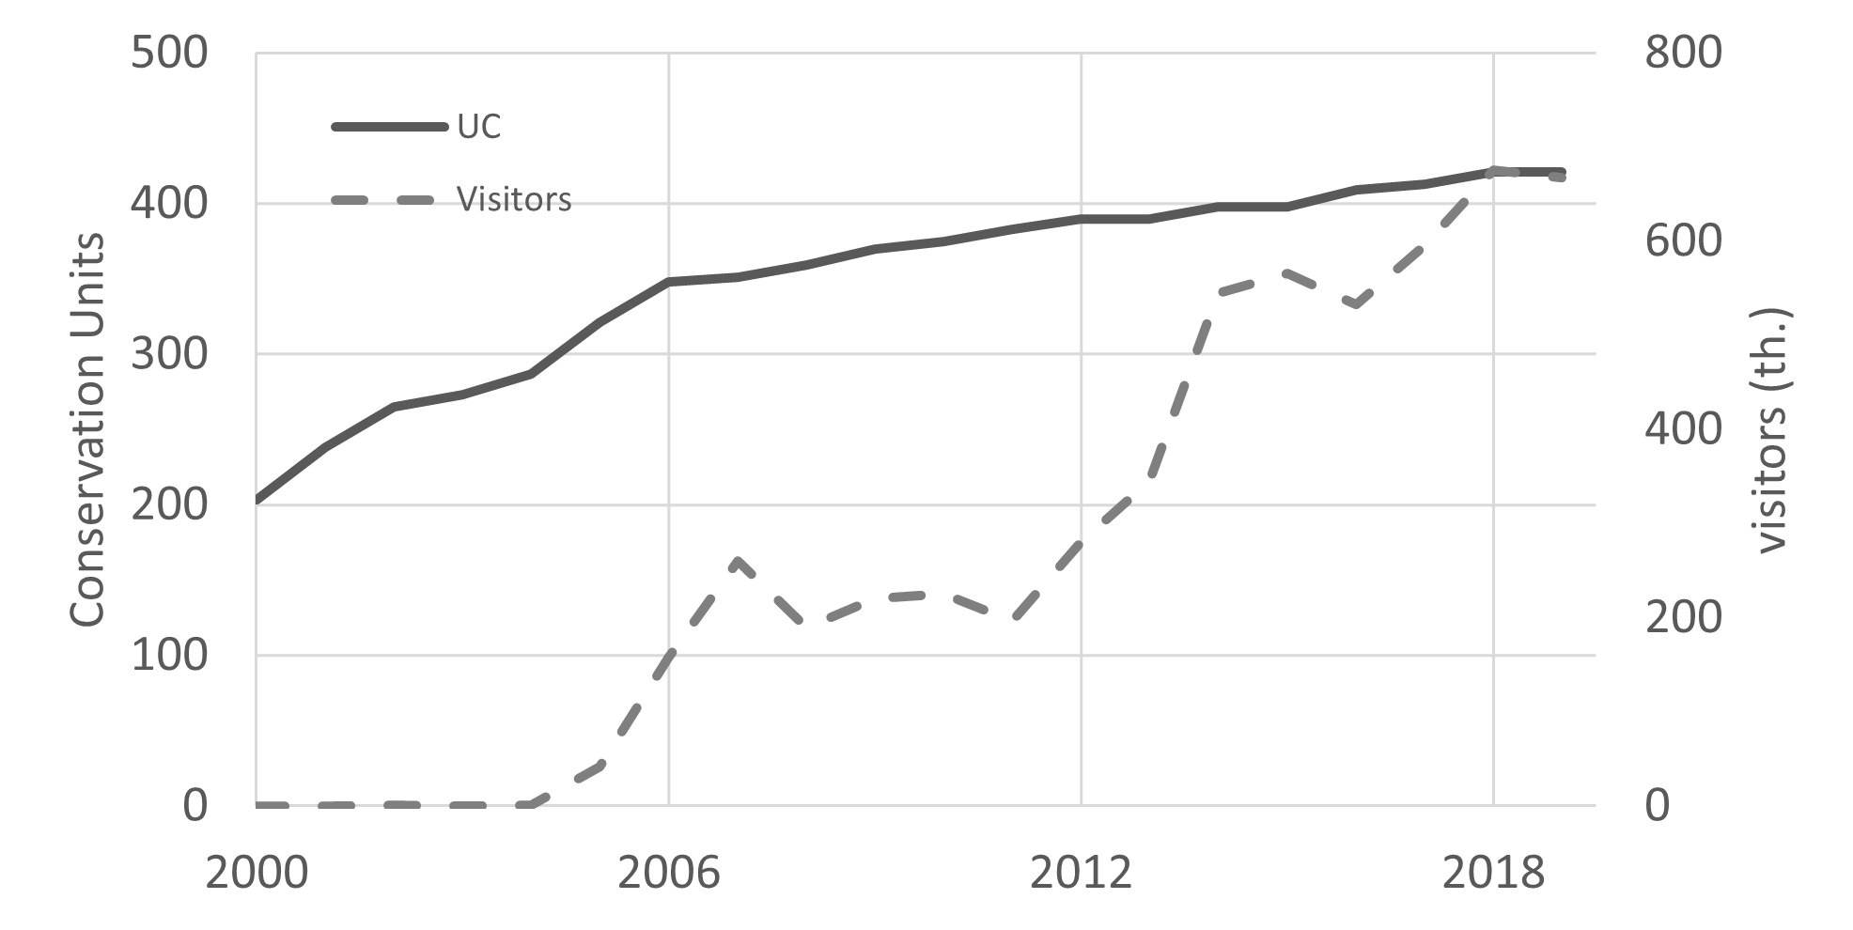
Figure S1: Evolution of conservation units (CUs) and visitors from the creation of the National System of Conservation Units (CNUC) in 2000 until 2019. (Data from: CNUC)

Environmental compliance and incentives to avoid deforestation

Data and projections
The Legal Amazon has 14.1 Mha that could be legally cleared. According to Art. 61 of Federal Law 12.651/2012, these rural properties must restore/offset their forest deficits in one of three ways: natural regeneration, compensation or offsets using ERQ, or forest restoration. A consortium of exotic and native woody species is allowed for restoration in up to 50% of the total area on small properties or family agriculture and on properties above four fiscal modules, Riparian areas along streams (APPs) can be included in the calculation of the LR. However, according to Decree n° 8.235/2014, which instituted the Environmental Regularization Program (PRA), rural properties that were deforested after 2008 lose the option of compensation. Given that, only 4.2 Mha of the forest deficit could use compensation as a mechanism to comply with Brazilian legislation.
We used data from Planaveg (Ministério do Meio Ambiente et al., 2017) to estimate the distribution of restoration strategies and Instituto Escolhas (2023), Bioflora (Personal Communication, 2018), FGVces (2018) and Benini e Adeodato (2017) to estimate the costs and revenues associated with each strategy. We then modeled subsequent restoration cycles which totaled seven, with a proportion of the total area implemented each year. This period coincides with the 7-year revenue cycle such that the last implementation year coincided with the first returns (revenue).
Even though the restoration costs are higher than the returns until 2030, the returns can continue for up to 30 years depending on the species. To evaluate the net return on investments in restoration, we used the Net Present Value (NPV), standard financial indicator used to evaluate the net return on capital investments during a specified period. It consists of the cash flow of activity, discounting a rate relative to the opportunity cost of capital, formally:
$$NPV=\sum_{0}^{t}{\frac{(B_{t}-C_{t})}{{(1+i)}^{t}}}$$
Where B represents the financial gains at year t, C the costs at year t, and i the discount rate. The discount rate was calculated by averaging data from PRONAF, PRONAMP, BNDES AGRO, resulting in an estimate of 6.7% yr⁻¹.
The Environmental Reserve Quota (ERQ) is a legal mechanism established by Brazil's Native Vegetation Protection Law that allows landowners to trade forest certificates, but still lacks regulation. ERQ will enable landowners with forest deficits (i.e. illegally deforested land) to buy certificates from landowners that have a forest surplus (Soares-Filho et al., 2016).
We assumed that areas tradable under the ERQ scheme proposed in Brazil's Native Vegetation Protection Law (Brasil, 2012) would opt to participate in such an instrument. The existing surplus of 23.2 Mh would be traded with an eligible area with “vegetation surplus” (i.e., cleared prior to 2008). The remaining areas of forest assets (14.1 Mha) that could be legally deforested and exceeded ERQ market demand were assumed to take advantage of nascent opportunities for Payments for Ecosystem Services (PES). Legislation on PES has recently passed in Brazil (Brasil, 2021). We consider the ERQ to be a zero-sum market in terms of cash flow. Farmers with assets would lease their assets to farmers with deficits and, while there would be cash transfers, the sum of these operations would be zero. However, given the area (4.2 Mha) and an estimated annual payment of BRL 240,00 ha⁻¹ based on the land value (Informa Economics FNP, 2018), this market would mobilize almost BRL 1 billion per year.

Existing and new costs
Expenses of this strategy included operational restoration costs, implementation of Brazil's Native Vegetation Protection Law, and levying infraction notices or fines for rural properties that are not regularized. Restoration costs were obtained by taking the proportion of restoration practices contained in PLANAVEG, and the average costs per hectare from three different sources. These values varied depending on the strategy and year after implementation. Commercialization costs were not considered. The full implementation of Brazil's Native Vegetation Protection Law is estimated to cost BRL 0.7 B (OCF, 2019). The individual infraction notices cost an estimated BRL 0.01 per year (Soares-Filho et al., 2016).

Revenue
The primary revenue came from restoration activities. Given the diversity of biomes occurring within the territory of the Legal Amazon, we took an average of the estimated returns from different sources based on Planaveg (Ministério do Meio Ambiente et al., 2017). In some cases, the returns from restoration may take longer than the investments themselves. This study focuses on outcomes out to 2030, but restoration returns could come 7, 14, or even 30 years later. Given this time lag, revenues beyond the study horizon were brought to 2030 value using the NPV method described above. For the PES initiative, we considered a yearly payment of BRL 192.72 ha⁻¹, obtained by dividing the total farmland lease value in the Amazon by the lease area (IBGE, 2017).

Production intensification to meet future demand.

Data and projections
This front comprises medium and large properties (over 4 MF in the rural environmental registry) located in the Legal Amazon. Meat production statistics for a 4 MF cut was not readily available, so we used the heads for slaughter from the Agricultural Census (IBGE, 2017). To translate from the Census grouping to MF units we assumed values were equally distributed inside each area group. The result was the number of heads for slaughter in properties over 4 MF by municipality, which then was filtered for the Legal Amazon. We then multiplied it, 5 million heads, by 276 Kg, the average weight of the carcasses in the Legal Amazon (IBGE, 2019), resulting in a total of 1.4 million tons of meat.
Beef production is estimated to increase 1.7% per year (Brasil and Secretaria de Política Agrícola, 2020). Pastureland in areas above 4 MF was estimated to occupy 34 Mha in 2018, using data from MapBiomas collection 5 and clipping for areas above 4 MF (MapBiomas, 2020). For soy, the production is estimated to increase by 2.9% yearly and the area by 2.3% (Brasil and Secretaria de Política Agrícola, 2020). In 2018, soy production was estimated at 39.5 million tons (IBGE, 2022b), occupying an area of 12 Mha (MapBiomas, 2020). We assumed soy properties smaller than 4 MF to be negligible in the Brazilian Amazon.

Existing and new costs
For the calculation of expenses, different levels of pasture productivity were considered. The increase in productivity was assumed to increase profitability, reducing relative costs. The baseline productivity increase was calculated based on the meat demand and the expected pastureland, the product of the linear trend from 2008 to 2018 (MapBiomas, 2020). The result is an increase from 41 Kg × ha⁻¹ in 2018 to 46 Kg × ha⁻¹ in 2030. The yearly expenses were assumed to vary accordingly to the productivity, and so at any point, the total cost was calculated using a linear trend based on the two levels described below:
Table 1: Productivity and associated costs (adapted from Rode et al., (2019))
 | Level 1 | Level 2
Productivity (Kg×ha⁻¹×year⁻¹) | 61.5 | 145.7
Total cost (Kg⁻¹, in 2019 prices)* | BRL 10.90 | BRL 9.50
Intensification cost (ha-1 in 2019 prices)* | - | BRL 627.00
- Prices deflated using IPCA

For land-use conversion costs and due to the Soy Moratorium, we assumed that pastureland expanded over forests costing BRL 1,614.00 ha⁻¹ (Benini, and Adeodato., 2017), and soy crops expanded exclusively over pastureland BRL 1,499.00 ha⁻¹ (Banco da Amazônia, 2011), both values deflated using IPCA.
For the soy, annual operational costs were assumed to be BRL 3,969.97 ha⁻¹ (IMEA, 2018), adding to the expansion land-use conversion cost. This expansion also means that the land demand for pasture must consider the expansion of soy.

Revenue
For revenues, CEPEA (2023) data was used for beef prices and IBGE (2022b) for soybean prices. Projections were made based on the historical data and deflated by the Extended National Consumer Price Index (IPCA). The trend was estimated to increase based on a linear trend for beef. For soy, the study used the average from 2014 to 2019 to be conservative since using the linear trend would result in an almost stable but negative trend. Incorporating more elaborate economic models and projections to estimate prices was out of the scope of the work.
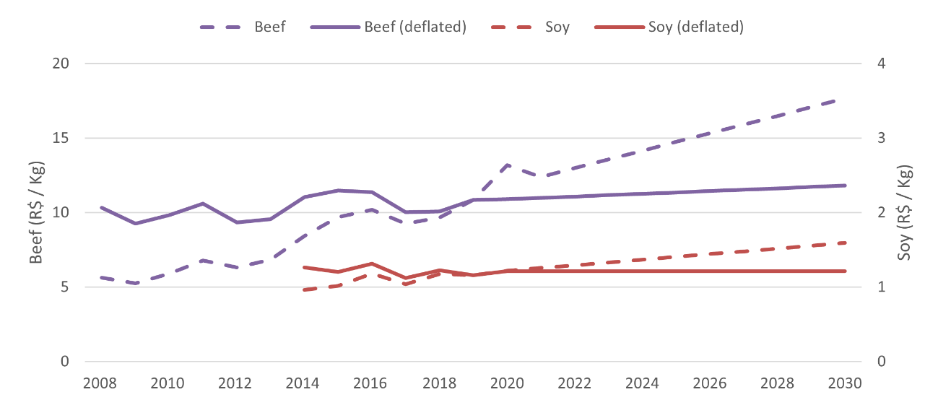
Figure S2: Beef and soy prices from 2008 to 2019 and projected until 2030. Values deflated using National Consumer Price Index (IPCA) and projected using linear trend. (Source for 2008-2019 data: CEPEA for beef, IBGE for soybean)

Business as Usual x Governance scenario
For the BAU scenario, the pasture extension in medium and large private land is estimated to have increased by 8%, from 34.4 Mha in 2018 to 37 Mha in 2030, requiring the clearing of new areas. Productivity was calculated by dividing annual production by grazing area, going from 41 Kg × ha⁻¹ to 46 Kg × ha⁻¹.
As for soy, it was considered a 2.9% increase in production to meet demand, going from 39.5 Mton in 2018 to 55.6 Mton in 2030. There was also a yearly area increase of 2.3%, from 11.6 Mha in 2018 (MapBiomas, 2020) to 15.2 Mha in 2030. This increase in 31% of land requires new areas to be converted.
In the governance scenario, some establishments invested in intensifying production, resulting in an increase in productivity going from 46 Kg × ha⁻¹ to 120 Kg × ha⁻¹ on average in these regions. This investment shows up as a transition cost, BRL 627.00 (jump from level I to level II, see table on the previous section).
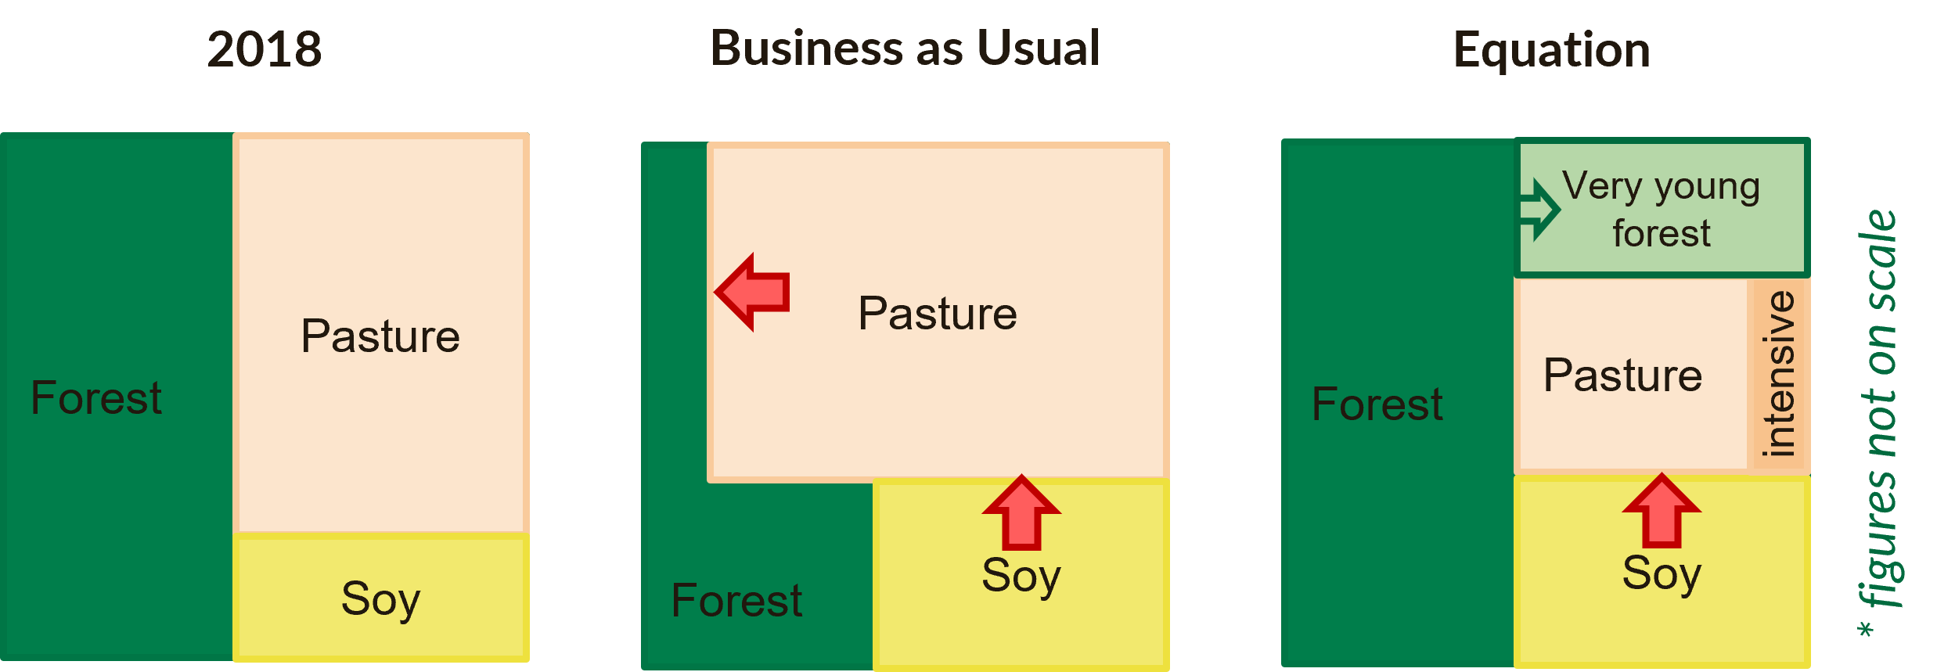
Figure S3: Typical land expansion scheme post Soy-moratorium. Red arrows indicate expansion direction. Pasture expands over forests and soy over pasture.

For this framework, the area to be intensified should respond to the growing land demand driven by meat and soy and the shortening of land available due to restoration. Formally:
$$A_{p}^{2018}=A_{ip}^{t}+A_{bp}^{t}+{∆A}_{restoration}^{2018-t}+{∆A}_{soy}^{2018-t}$$
Where, $A_{landuse}^{t}$ is the area a given year t for a pasture (p), intensive-only pasture (ip) extensive-only (BAU-like) pasture (bp), forest restoration since 2018, and soy expansion since 2018;
At any year, production is the same, and productivity is fixed. Thus, the adjustment is made on the area to be intensified.
$$Q_{p}^{t}=A_{bp}^{t}×γ_{bp}^{t}+A_{ip}^{t}×γ_{ip}^{t}$$
where $Q_{landuse}^{t}$ refers to the quantity produced and $γ_{landuse}^{t}$ refers to the productivity at any year. Rewriting this equation, we have:
$$A_{bp}^{t}=\frac{Q_{p}^{t}- A_{ip}^{t}×γ_{ip}^{t}}{γ_{bp}^{t}}$$
Substituting it in the first equation gives us:
$$A_{p}^{2018}=A_{ip}^{t}+\frac{Q_{p}^{t}- A_{ip}^{t}×γ_{ip}^{t}}{γ_{bp}^{t}}+{∆A}_{restoration}^{2018-t}+{∆A}_{soy}^{2018-t}$$
We can then rearrange it to isolate $A_{ip}^{t}$ :
$$\frac{ A_{ip}^{t}×γ_{ip}^{t}}{γ_{bp}^{t}}-A_{ip}^{t}=-A_{p}^{2018}+\frac{Q_{p}^{t}}{γ_{bp}^{t}}+{∆A}_{restoration}^{2018-t}+{∆A}_{soy}^{2018-t}$$
$$A_{ip}^{t}×(γ_{ip}^{t}-γ_{bp}^{t})=Q_{p}^{t}-(A_{p}^{2018}-{∆A}_{restoration}^{2018-t}-{∆A}_{soy}^{2018-t} )×γ_{bp}^{t}$$
$$A_{ip}^{t}=\frac{Q_{p}^{t}-(A_{p}^{2018}-{∆A}_{restoration}^{2018-t}-{∆A}_{soy}^{2018-t} )×γ_{bp}^{t}}{γ_{ip}^{t}-γ_{bp}^{t}}$$

This formula guarantees that at any given year, the demand for land for restoration, soy expansion, and meat production is met by intensifying new areas. The result is a decrease of 12 Mha, from 34.4 Mha (equal in the BAU scenario) in 2018 to 21.6 Mha in 2030 (against 37 Mha in the BAU scenario).
Both scenarios are the same in terms of food production and meeting the demand. In 2030 medium and large farms in Amazon are expected to be producing 1.7 Mton of beef, totaling BRL 20.1 B and 55.6 Mton of soybean, resulting in BRL 67.6 Bi. The difference in the scenarios is in the cost to achieve this yield. In the BAU, extensive cattle ranching and agriculture require additional costs related to the conversion of new areas, while in the governance scenario, additional costs serve as investments in intensification, increasing its overall profitability already in the short term.
Thus, for the BAU scenario, until 2030, the accumulated cost for soy and meat was BRL 933 B and an accumulated revenue of BRL 968 Bi, thus resulting in a net of BRL 35 Bi (Figure X). Land expansion can be expected to reinforce existing land conflicts and generate new ones. It can also be expected to lose public goods with land grabbing, and large-scale wildfires.
For the governance scenario, in accumulated values from 2018 to 2030, the cost was BRL 917 B, while the revenue was BRL 968 Bi, resulting in a net income of BRL 51 Bi. In addition to the increase in profit, there would be zero deforestation, and 7.6 Mha of beef cattle pastures would average 120 kg/ha productivity.

Fostering technical assistance to improve the livelihoods of smallholder farmers

Data and projections
Smallholders’ land was defined as properties of up to 4 fiscal modules. Georeferenced data (Rural Environmental Registry) and socio-economic data (IBGE, 2017) were collected. For the latter, data was only available in groups of areas which had TARE. We assumed values were equally distributed inside each group, allowing us to regroup using municipality MF size to filter data below 4 MF. In this way, we arrived in an area occupied by smallholders of 71 Mha belonging to 776 thousand agricultural establishments, of which only 9% receive technical guidance (IBGE, 2017).
Regarding technical guidance, two possible models were listed, the one carried out by INCRA, which encompasses virtually all current guidance, and the one carried out by the Amazon Sustainable Settlements Program (PAS) (Ane Alencar and Maria Lucimar de Souza, 2021; Erika de Paula Pedro Pinto, 2016).

Existing and new costs
The total annual expenses are estimated at BRL 15.9 thousand/establishment (IBGE, 2017). According to data from the last contract implemented by INCRA for TARE in Settlements in the Legal Amazon, in the period 2014-2017, the average monthly aid per family was BRL 177.75. For PAS, there is a first-year investment of BRL 5,100.00 per family and monthly support of BRL 570.40.

Revenues
Annual family revenue is estimated as BRL 31,500, BRL 21,600 from production, BRL 1,000 from other activities, and BRL 8,800 from other sources (IBGE, 2017). To estimate the return by financial aid, we calculated a “PAS Effect” based on the increase in gross income divided by the aid. The effect was estimated at 1.06%, meaning that for each BRL 1, the establishment increases its revenue by BRL 1.06. We can expect this effect to change based on the technical guidance associated.

$${effect}_{PAS}=\frac{{revenue}_{after}-{revenue}_{before}}{{aid}_{monthly}*12}$$

Business as Usual x Governance scenario
The BAU scenario assumed that the current technical guidance ratio (9%) and the current model (INCRA) would remain until 2030. For this reason, there would be no increase in income, thus remaining with the same revenue found in 2018.
The governance scenario assumed farmers would gradually receive more assistance and move gradually towards the PAS model during the first 5 years. By 2030, 100% of farmers would receive PAS-like technical guidance. As for revenue, we apply the “PAS effect” over the additional aid given. Formally, we have:
$${revenue}_{t}={revenue}_{2018}+({aid}_{t}-{aid}_{2018})*effect$$
Where t is a given year from 2018 to 2030, and the aid each year increases as new farmers receive guidance. The result is a shift from a BRL 1,803 monthly family income in 2018 to BRL 2,396 in 2030, following the gradual increase in the rate of establishments receiving guidance.
For the BAU scenario, until 2030, the accumulated cost was BRL 162 Bi and an accumulated revenue of BRL 218 Bi, thus resulting in a net of BRL 56 Bi (Figure X). In this scenario, we considered no expansion or reduction of the technical guidance, so there would be no increase in income.
In the governance scenario, 2018 to 2030 accumulated cost was BRL 200 Bi, while the accumulated revenue was BRL 319 Bi, resulting in a positive net return of BRL 119 Bi. In the governance scenario until 2030, 100% of agricultural establishments receive technical guidance (PAS Model), inducing a 33% increase in income.
Unlocking these benefits would require new investments on the order of $30 billion Brazilian Reais (BRL) until 2030. The return on that investment could be as high as BRL$100 billion in net revenue to the private sector, smallholders, and the government, while substantially reducing deforestation in the Brazilian Amazon, and its associated emissions. Adding restoration would require an additional BRL$77 billion, with a potential return of BRL$200 billion over the next 30 years.

