Supplementary Information:
Harnessing Medicinal Chemical Intuition from Collective Intelligence
Pierre Llompart^{1, 2, *}, Kwame Amaning¹, Marc Bianciotto¹, Bruno Filoche-Rommé¹, Yann Foricher¹, Pablo Mas^{1,3}, David Papin¹, Jean-Philippe Rameau¹, Laurent Schio¹, Gilles Marcou², Alexandre Varnek², Mehdi Moussaid^{4,5}, Claire Minoletti^{1, *}, Paraskevi Gkeka^{1, *}

¹Integrated Drug Discovery, Sanofi, Vitry-sur-Seine, France
²Laboratory of Chemoinformatics, UMR7140, University of Strasbourg, Strasbourg, France
³ Theoretical Chemistry Department, École Normale Supérieure, Paris, France
⁴Center for Adaptive Rationality, Max Planck Institute for Human Development, Berlin, Germany
⁵School of Collective Intelligence, Université Mohammed VI Polytechnique, Rabat, Morocco

*Corresponding authors: Paraskevi.Gkeka@sanofi.com, Pierre.Llompart@sanofi.com, Claire.Minoletti@sanofi.com
Keywords: medicinal chemistry intuition, collective intelligence, ADMET, drug design, GNN, lead optimization

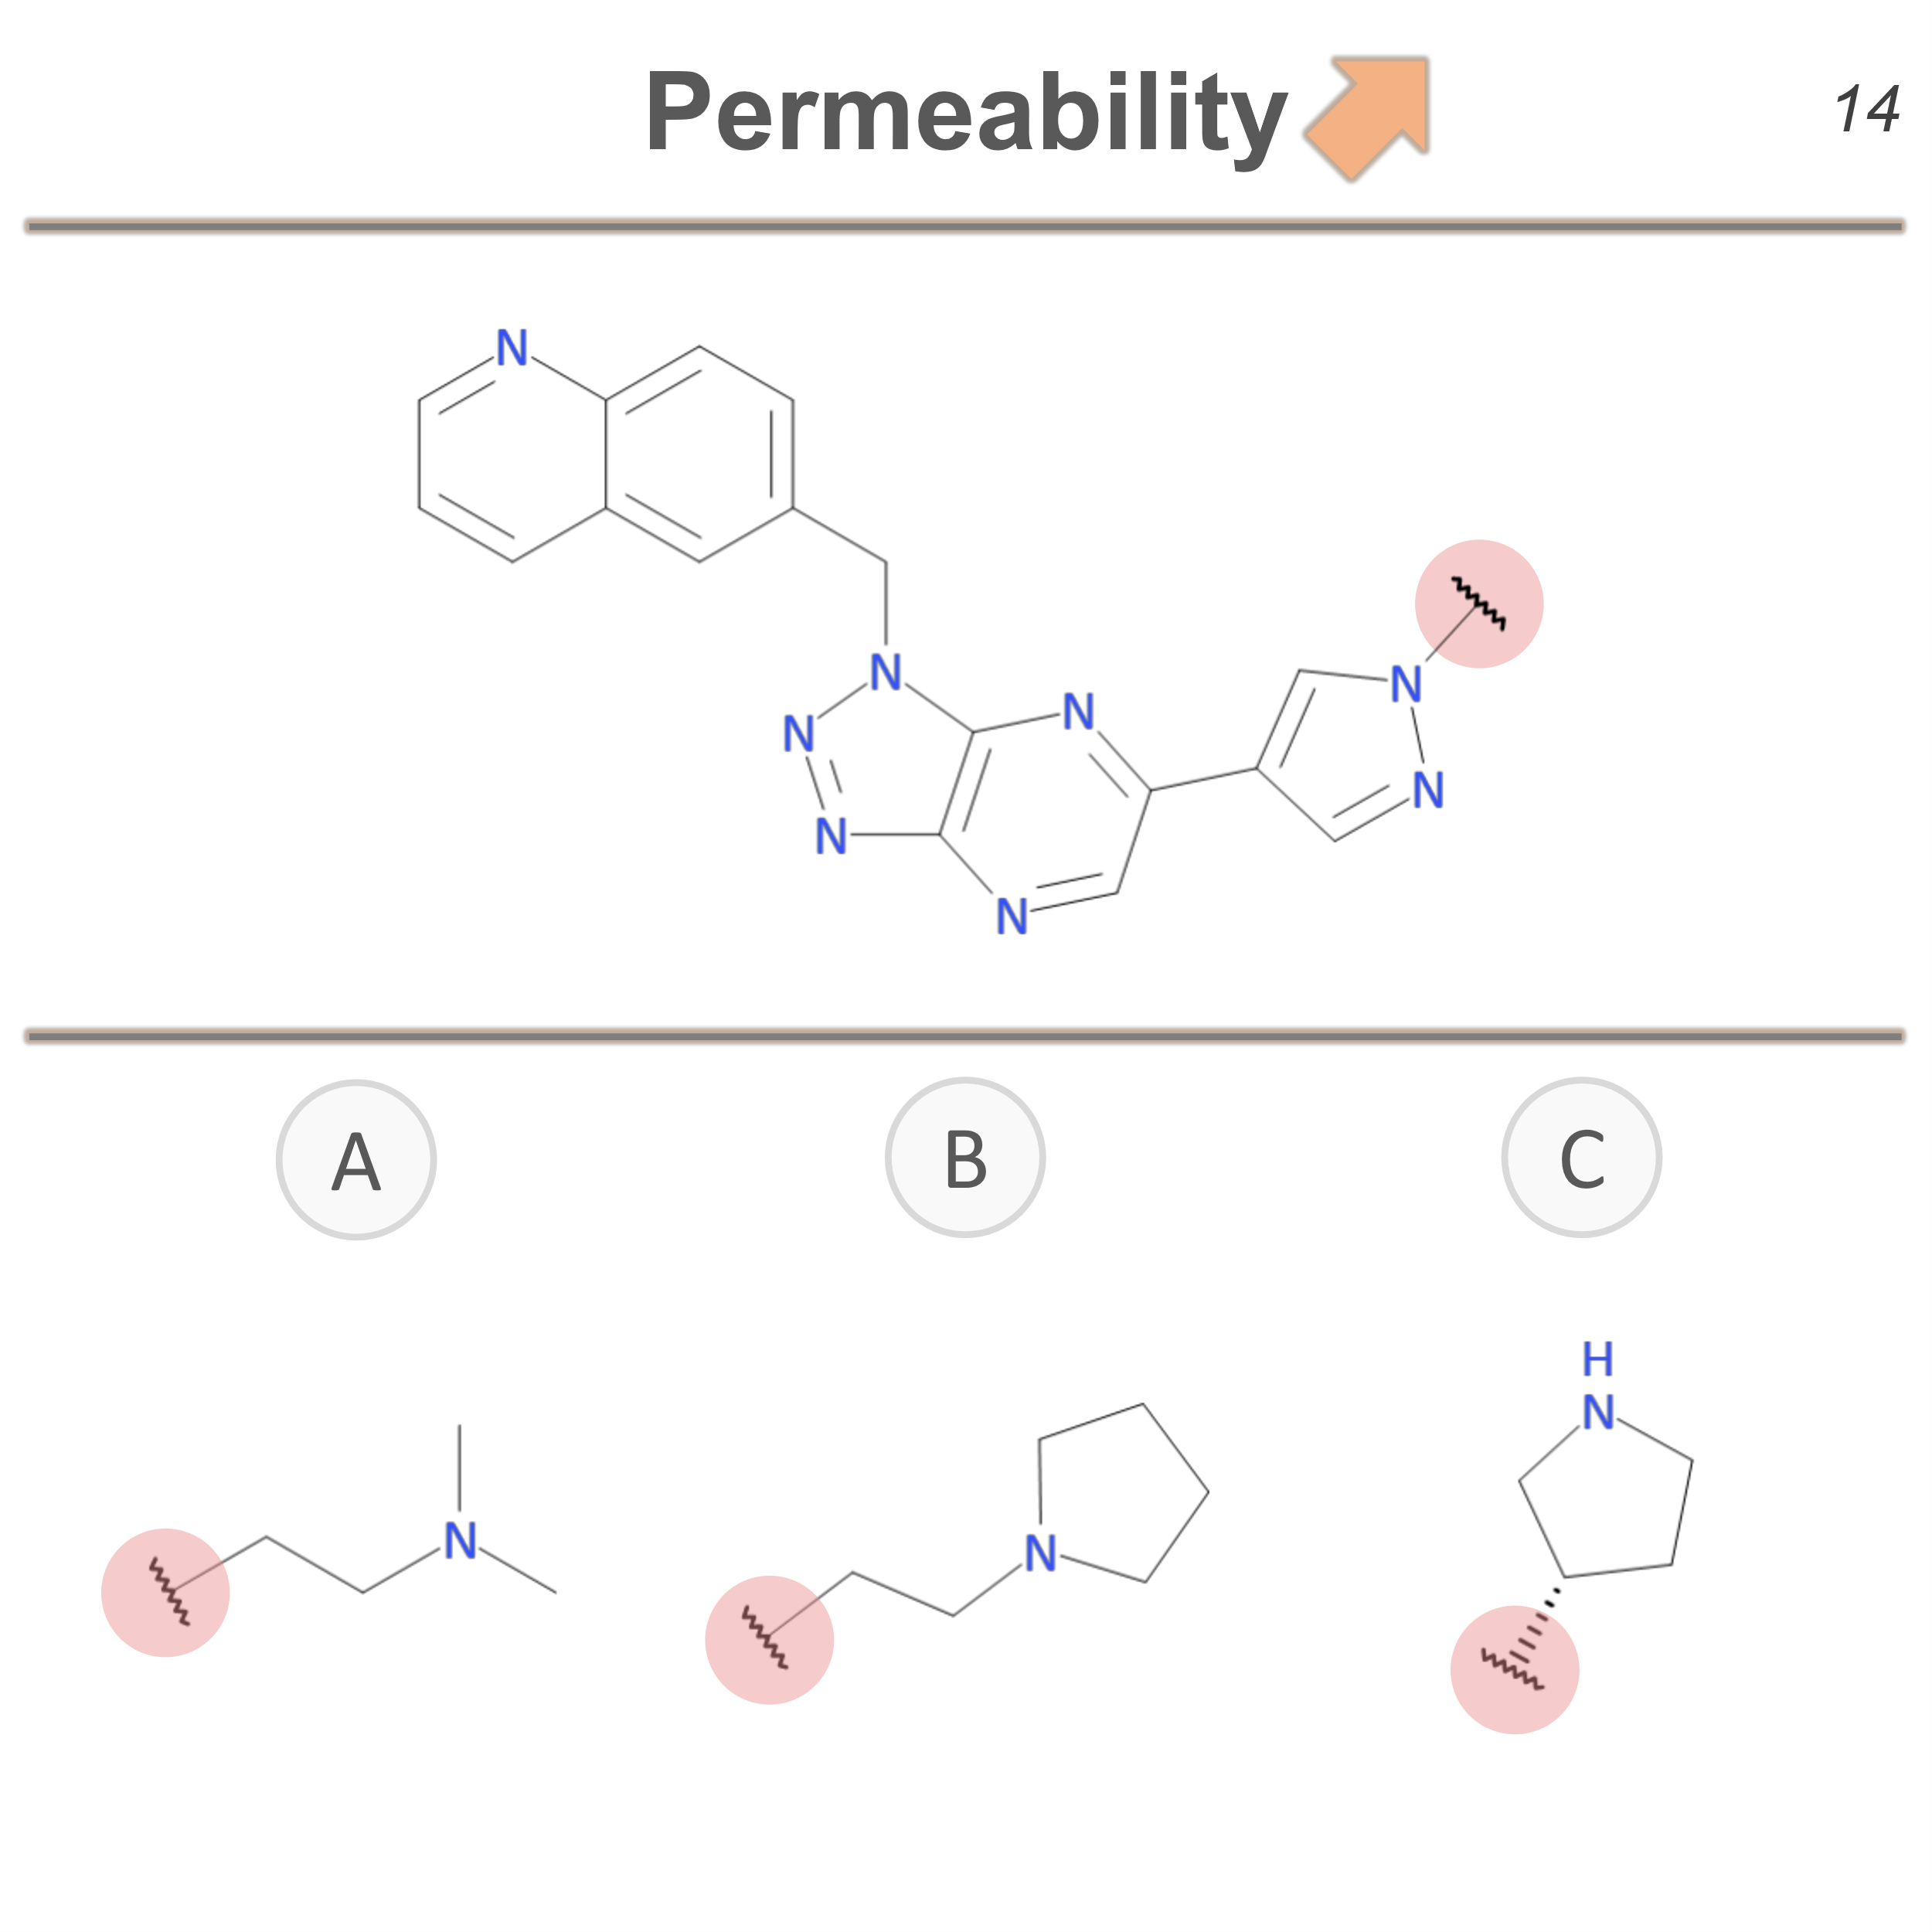
Figure S1: Example of the way the questions were presented to the participants. Each question had a title that corresponded to the endpoint of interest (top), one scaffold with an R-group substitution point to be replaced (middle) and three possible substituents (bottom).

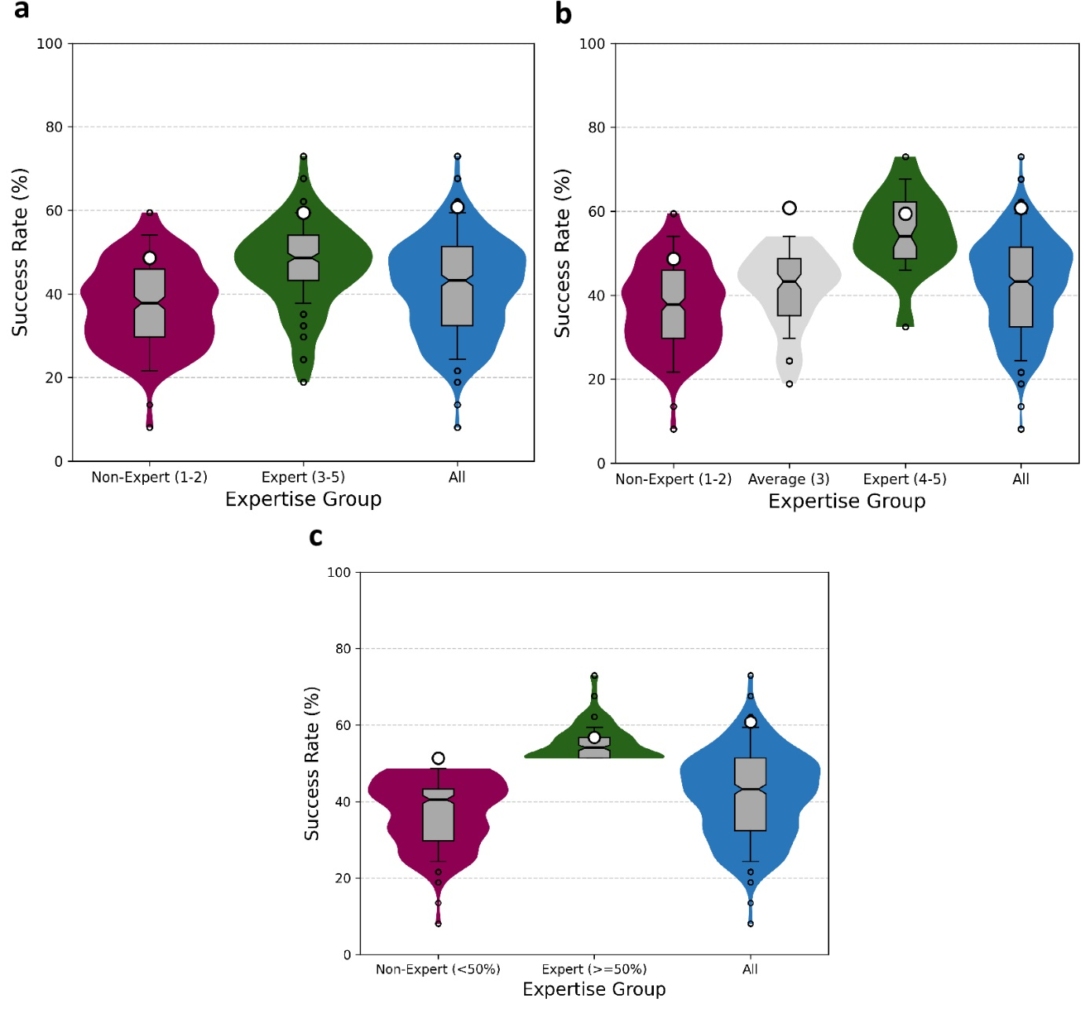
Figure S2: Violin plots representing the success rate by expertise level in medicinal chemistry. a) SR for groups 1-2 (low or no background), 3-5 (experts) and all the participants. The median is shown as a horizontal line across the thinnest part of the grey boxes. Alongside the boxes, error bars extend from the median line to cover the interquartile range. The collective or democratic SR are shown as white-filled circles. The outliers per group are depicted as small circles. b) SR for groups 1-2 (low or no background), 3 (averaged and mixed level), 4-5 (experts) and all the participants. c) SR by non-experts, i.e., participants with personal SR less than 50%, and experts, i.e., individuals with SR more than 50%. The violin plot of the SR of all participants is shown again here as a guide for the eye.

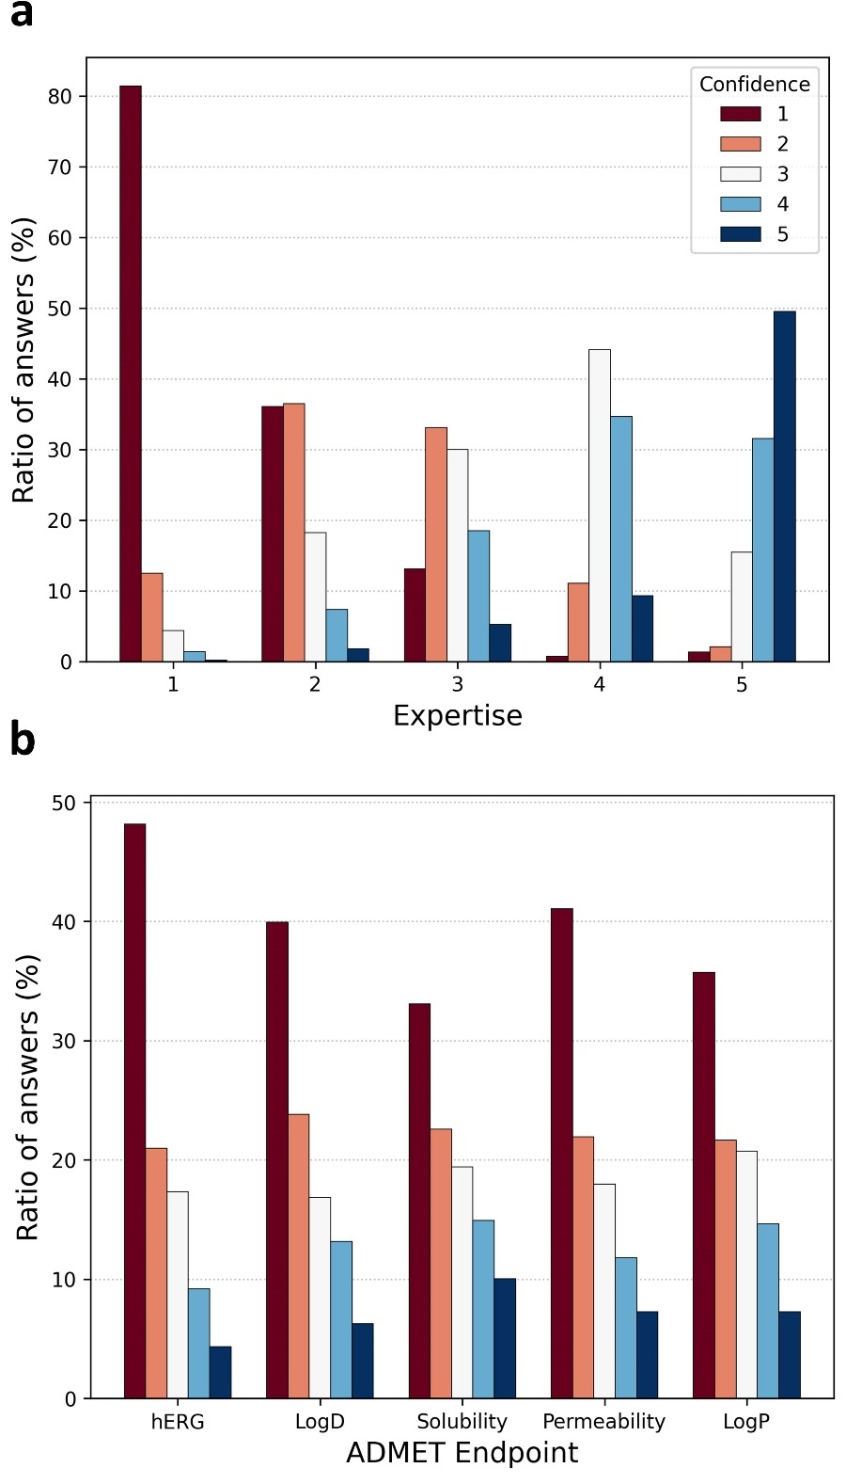
Figure S3: Distribution of the proportion of answer per confidence level in function of the ADMET endpoint and self-labeled expertise level. a) Bar plot of the ratio of answers per expertise level grouped by confidence from low (red) to high (blue). b) Bar plot of the ratio of answers per ADMET endpoint.

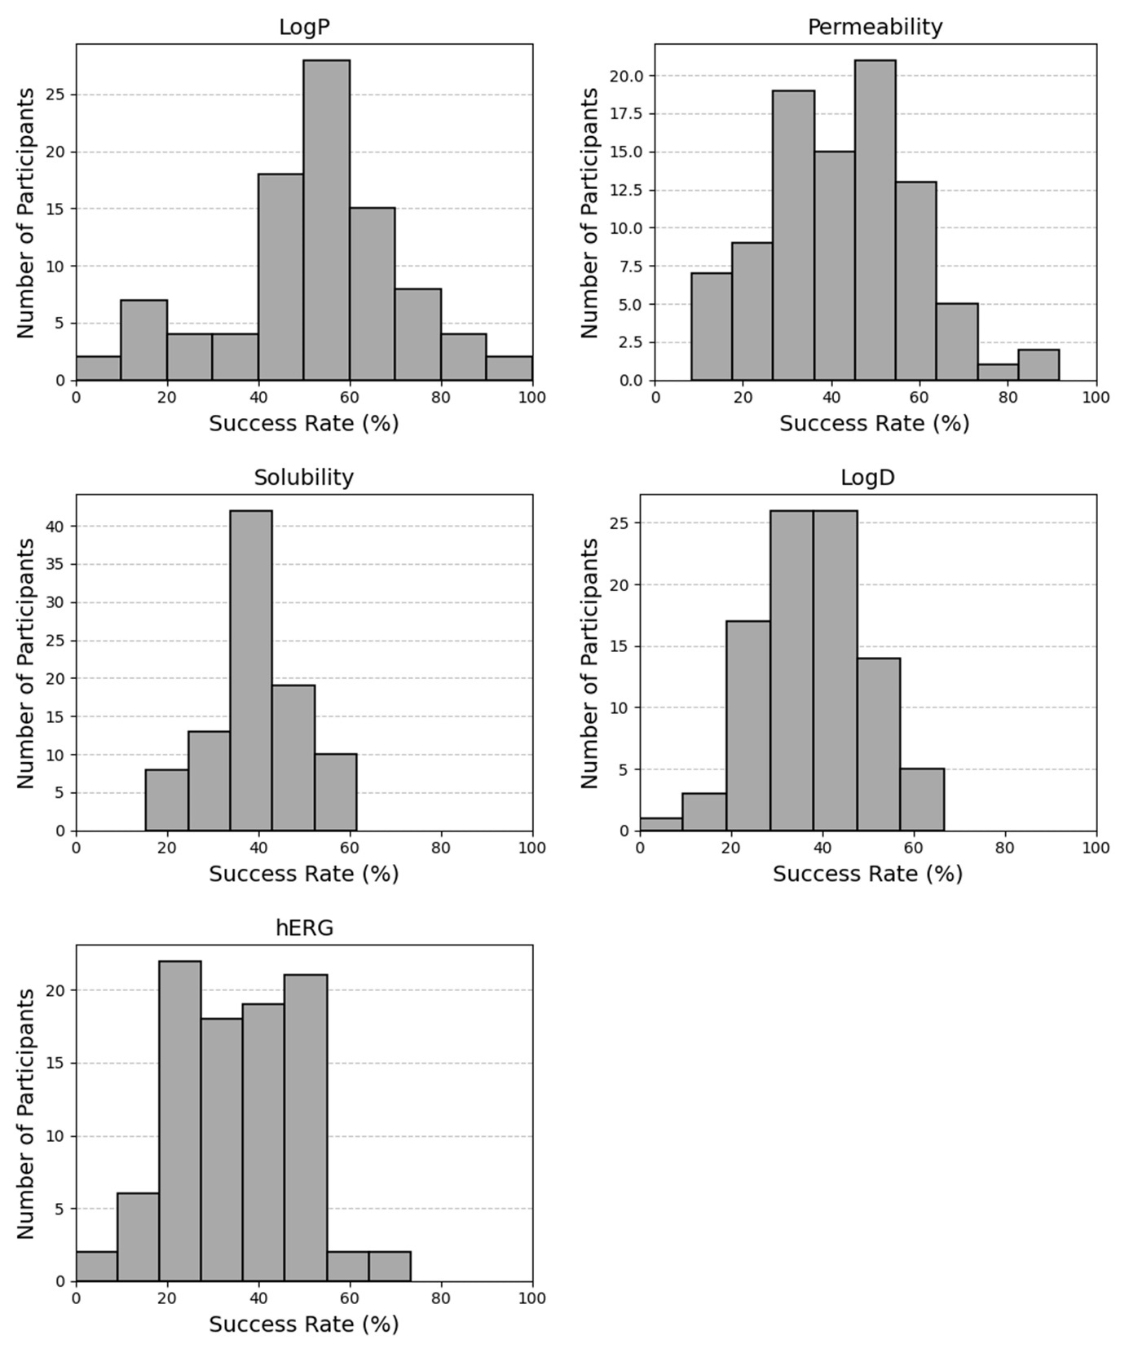
Figure S4: Success rate distribution for all participants per ADMET endpoint.

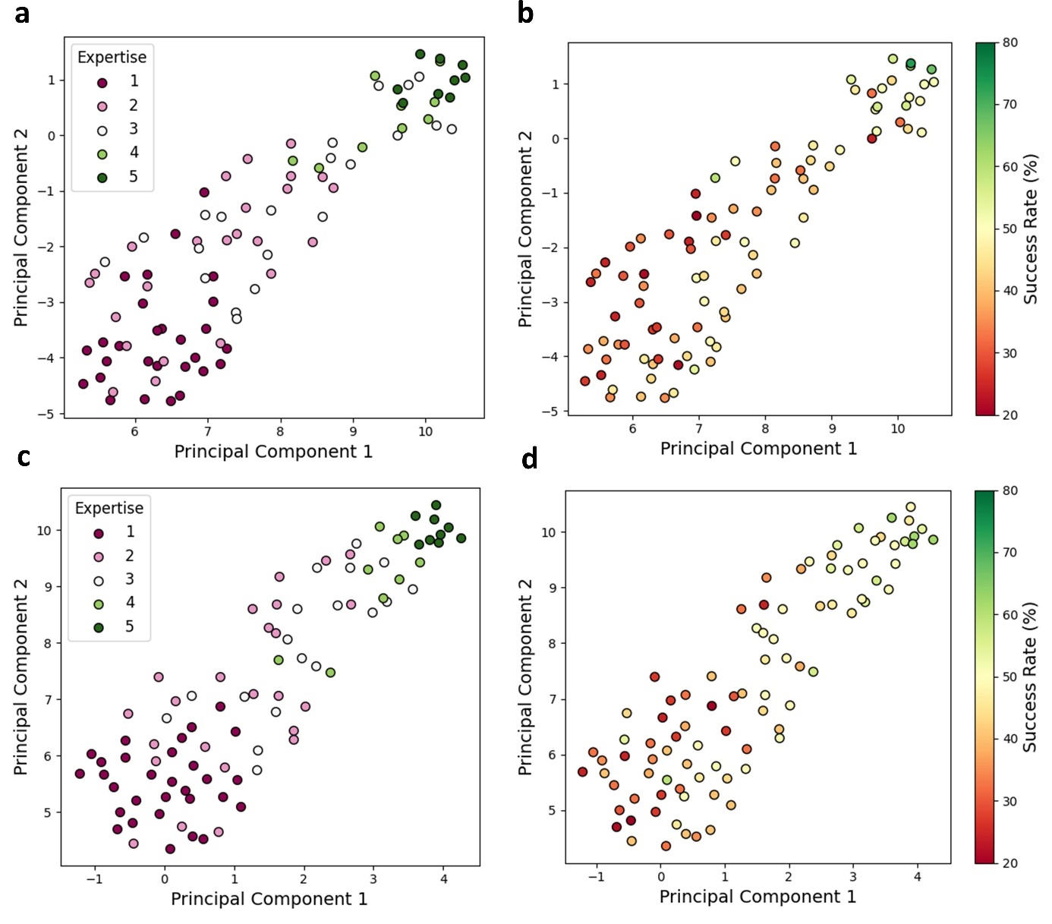
Figure S5: UMAP of the participant space per session explored using the expertise level and the success rate. Session one colored by a) expertise level and b) success rate. Session two colored by c) expertise level and d) success rate.

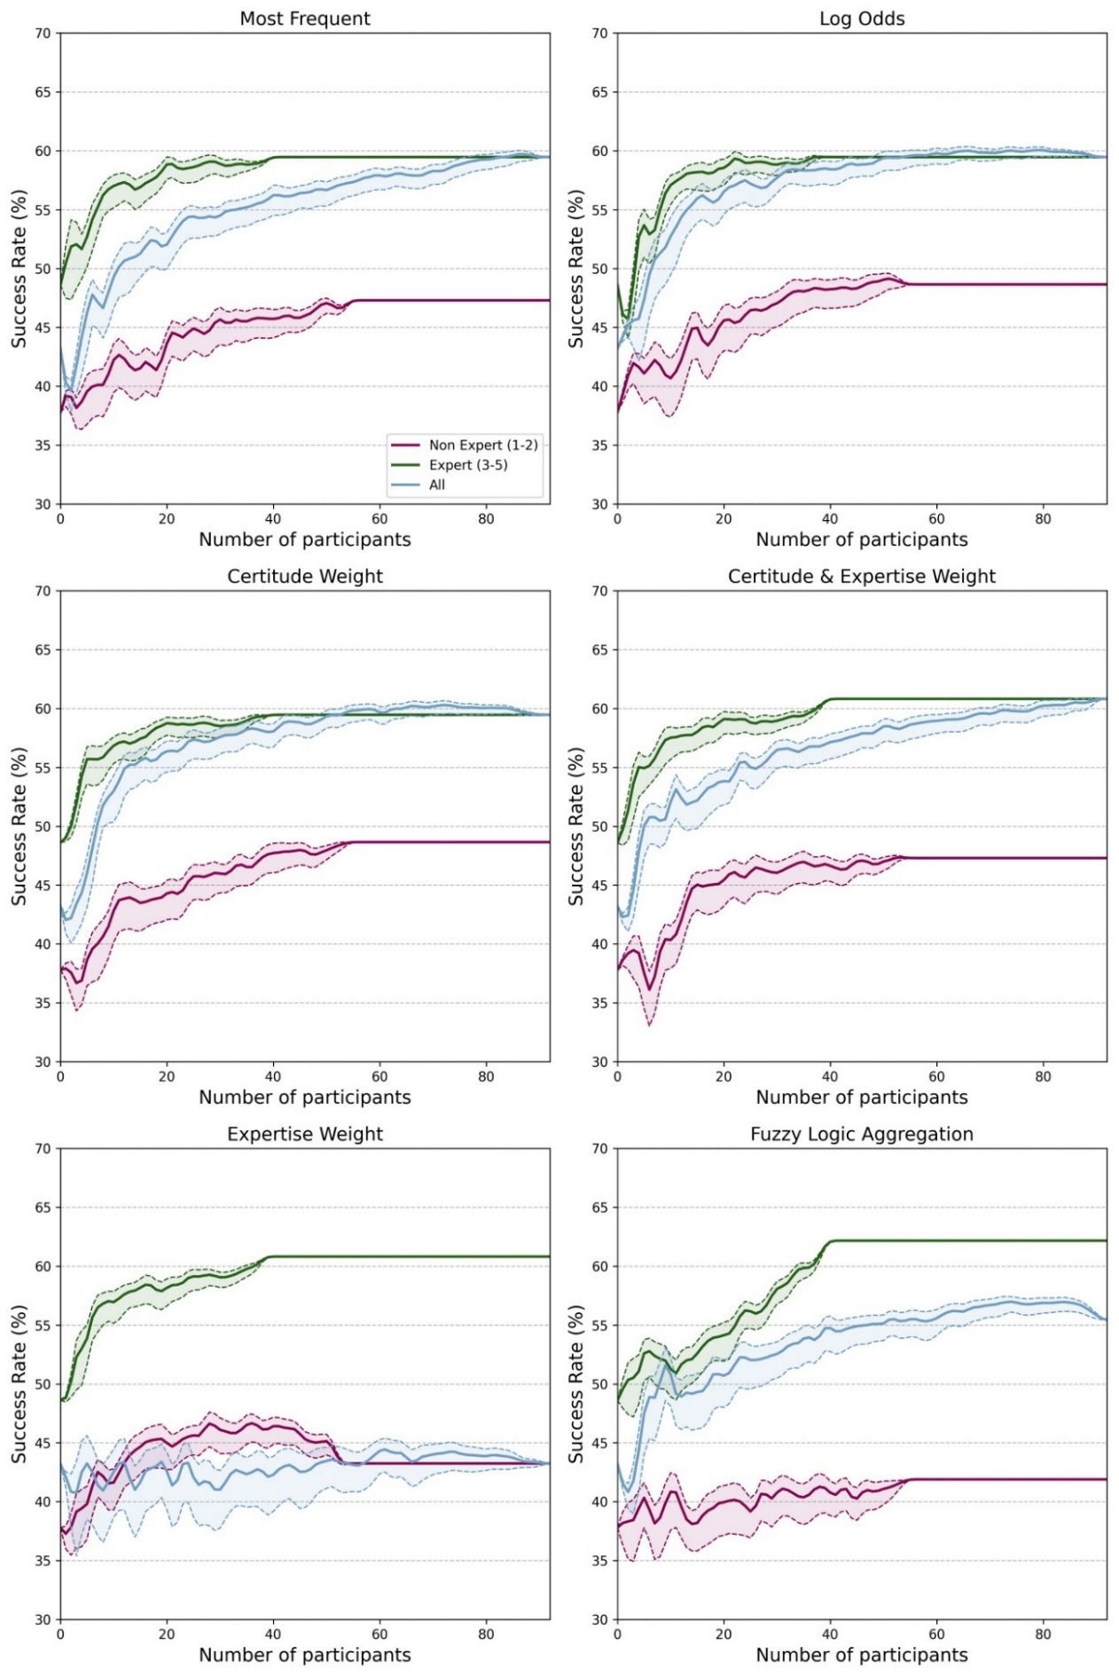
Figure S6: Evolution of the collective success rate as a function of the number of participants in the population per aggregation method. The collective SR is denoted per expertise group, from non-expert (1-2), expert (3-5), and all participants.
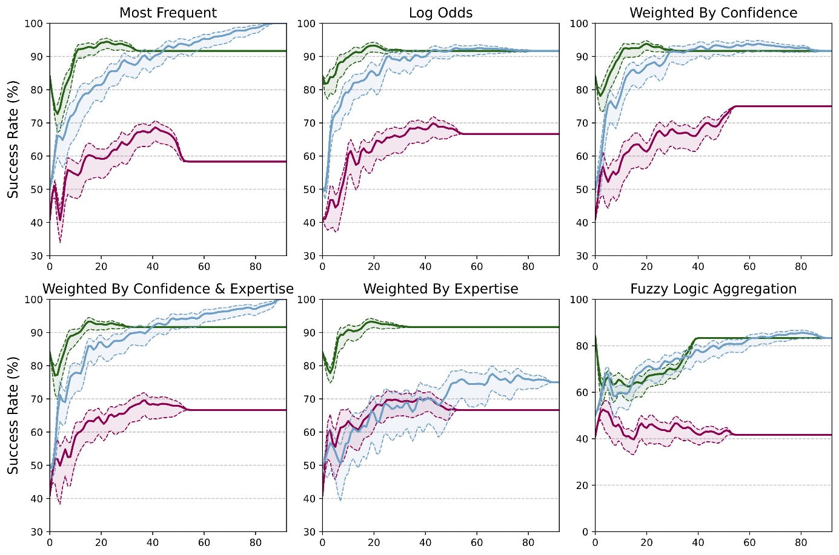
Figure S7: Evolution of the collective success rate as a function of the number of participants in the population per aggregation method for the LogP endpoint. The collective SR is denoted per expertise group, from non-expert (1-2), expert (3-5), and all participants. Groups are colored as in Figure S6.
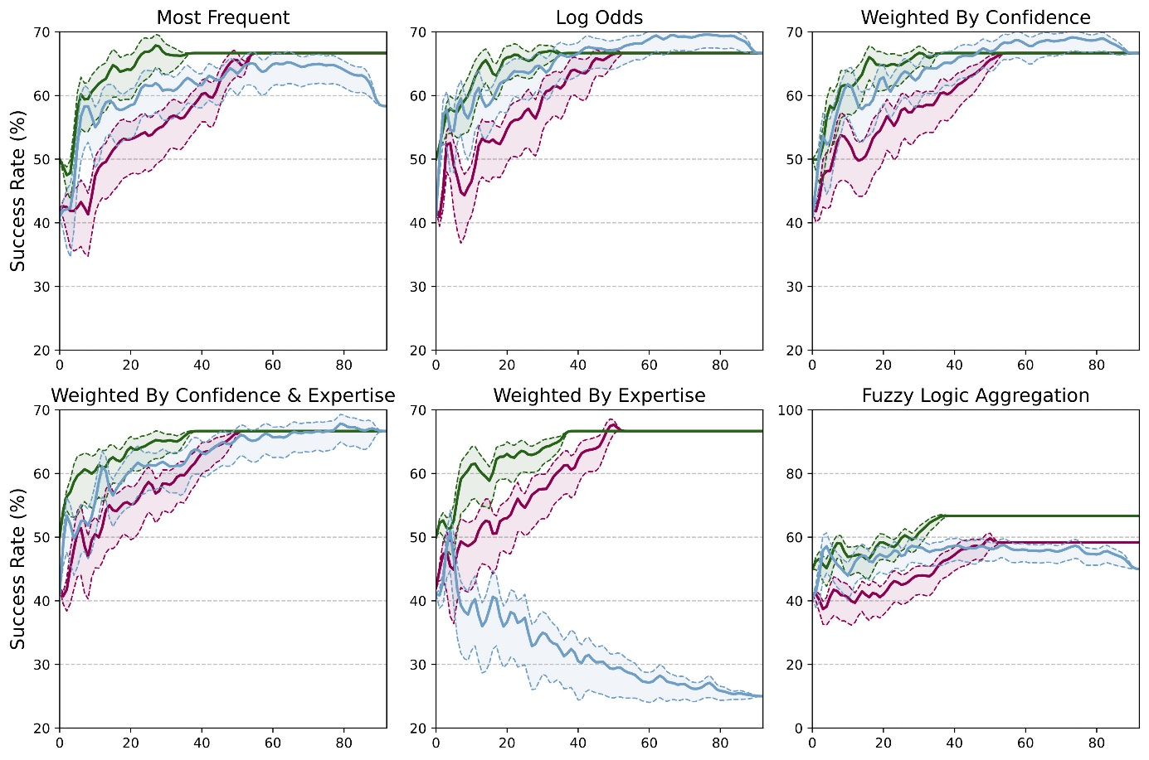
Figure S8: Evolution of the collective success rate as a function of the number of participants in the population per aggregation method for the permeability endpoint. The collective SR is denoted per expertise group, from non-expert (1-2), expert (3-5), and all participants. Groups are colored as in Figure S6.
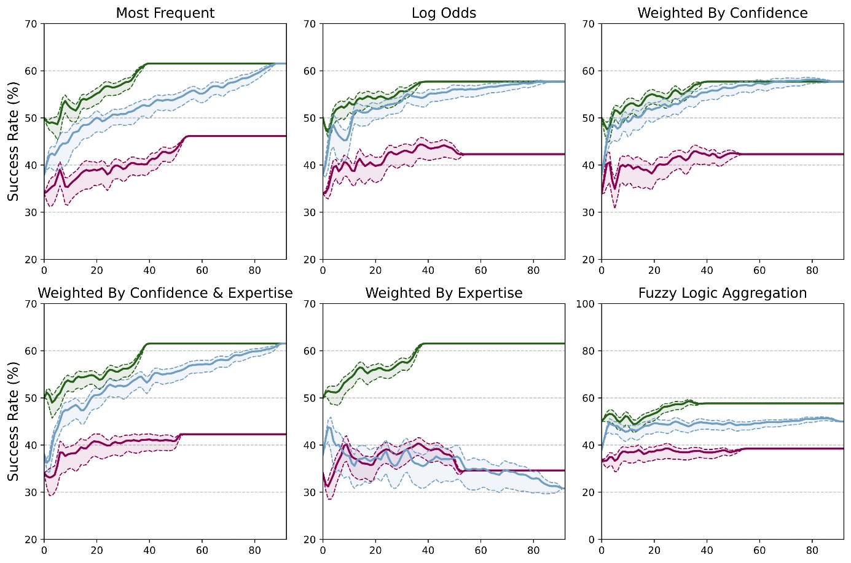
Figure S9: Evolution of the collective success rate against the number of participants in the population per aggregation method for the solubility endpoint. The collective SR is denoted per expertise group, from non-expert (1-2), expert (3-5), and all participants. Groups are colored as in Figure S6.
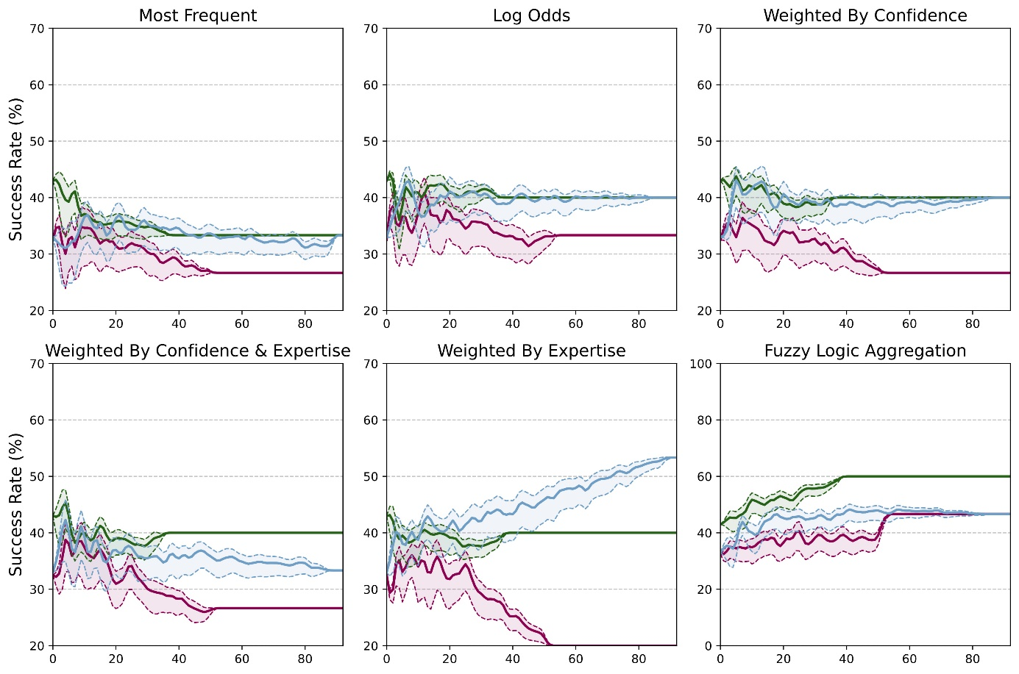
Figure S10: Evolution of the collective success rate against the number of participants in the population per aggregation method for the hERG endpoint. The collective answer is denoted per expertise group, from non-expert (1-2), expert (3-5), and all participants. Groups are colored as in Figure S6.
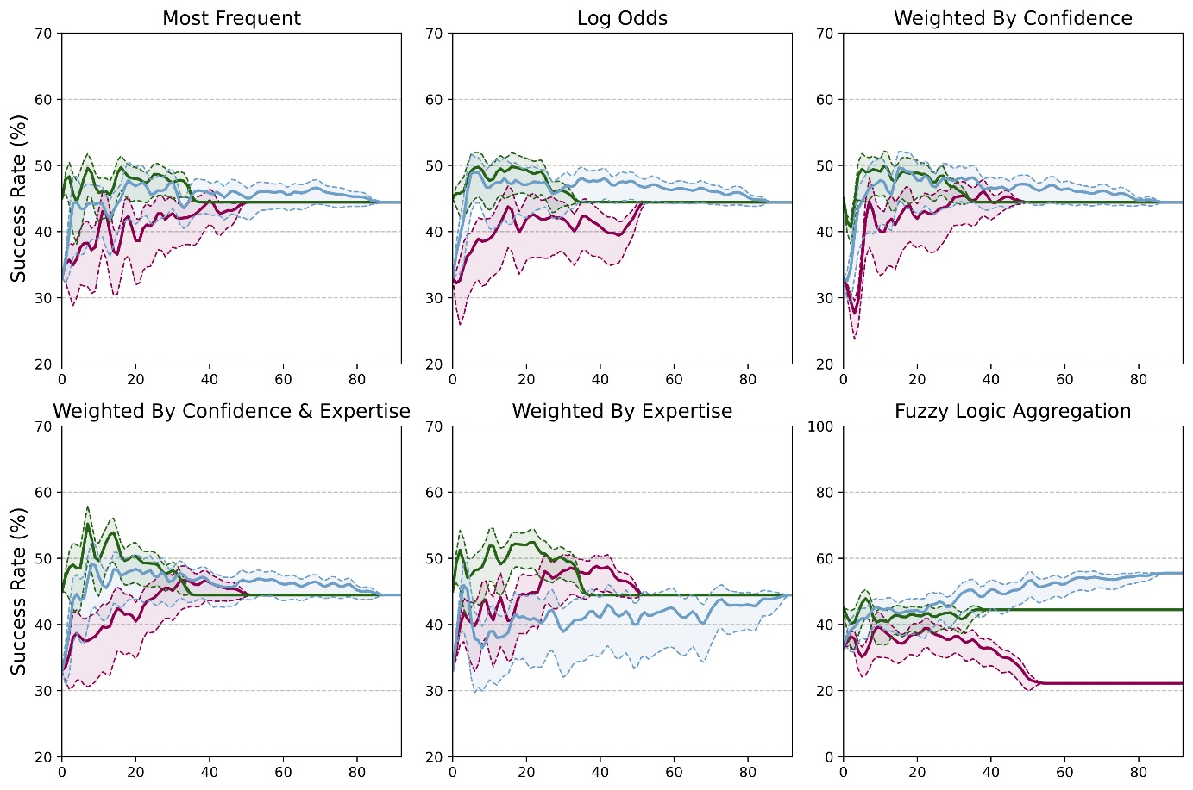
Figure S11: Evolution of the collective success rate against the number of participants in the population per aggregation method for the LogD endpoint. The collective answer is denoted per expertise group, from non-expert (1-2), expert (3-5), and all participants. Groups are colored as in Figure S6.

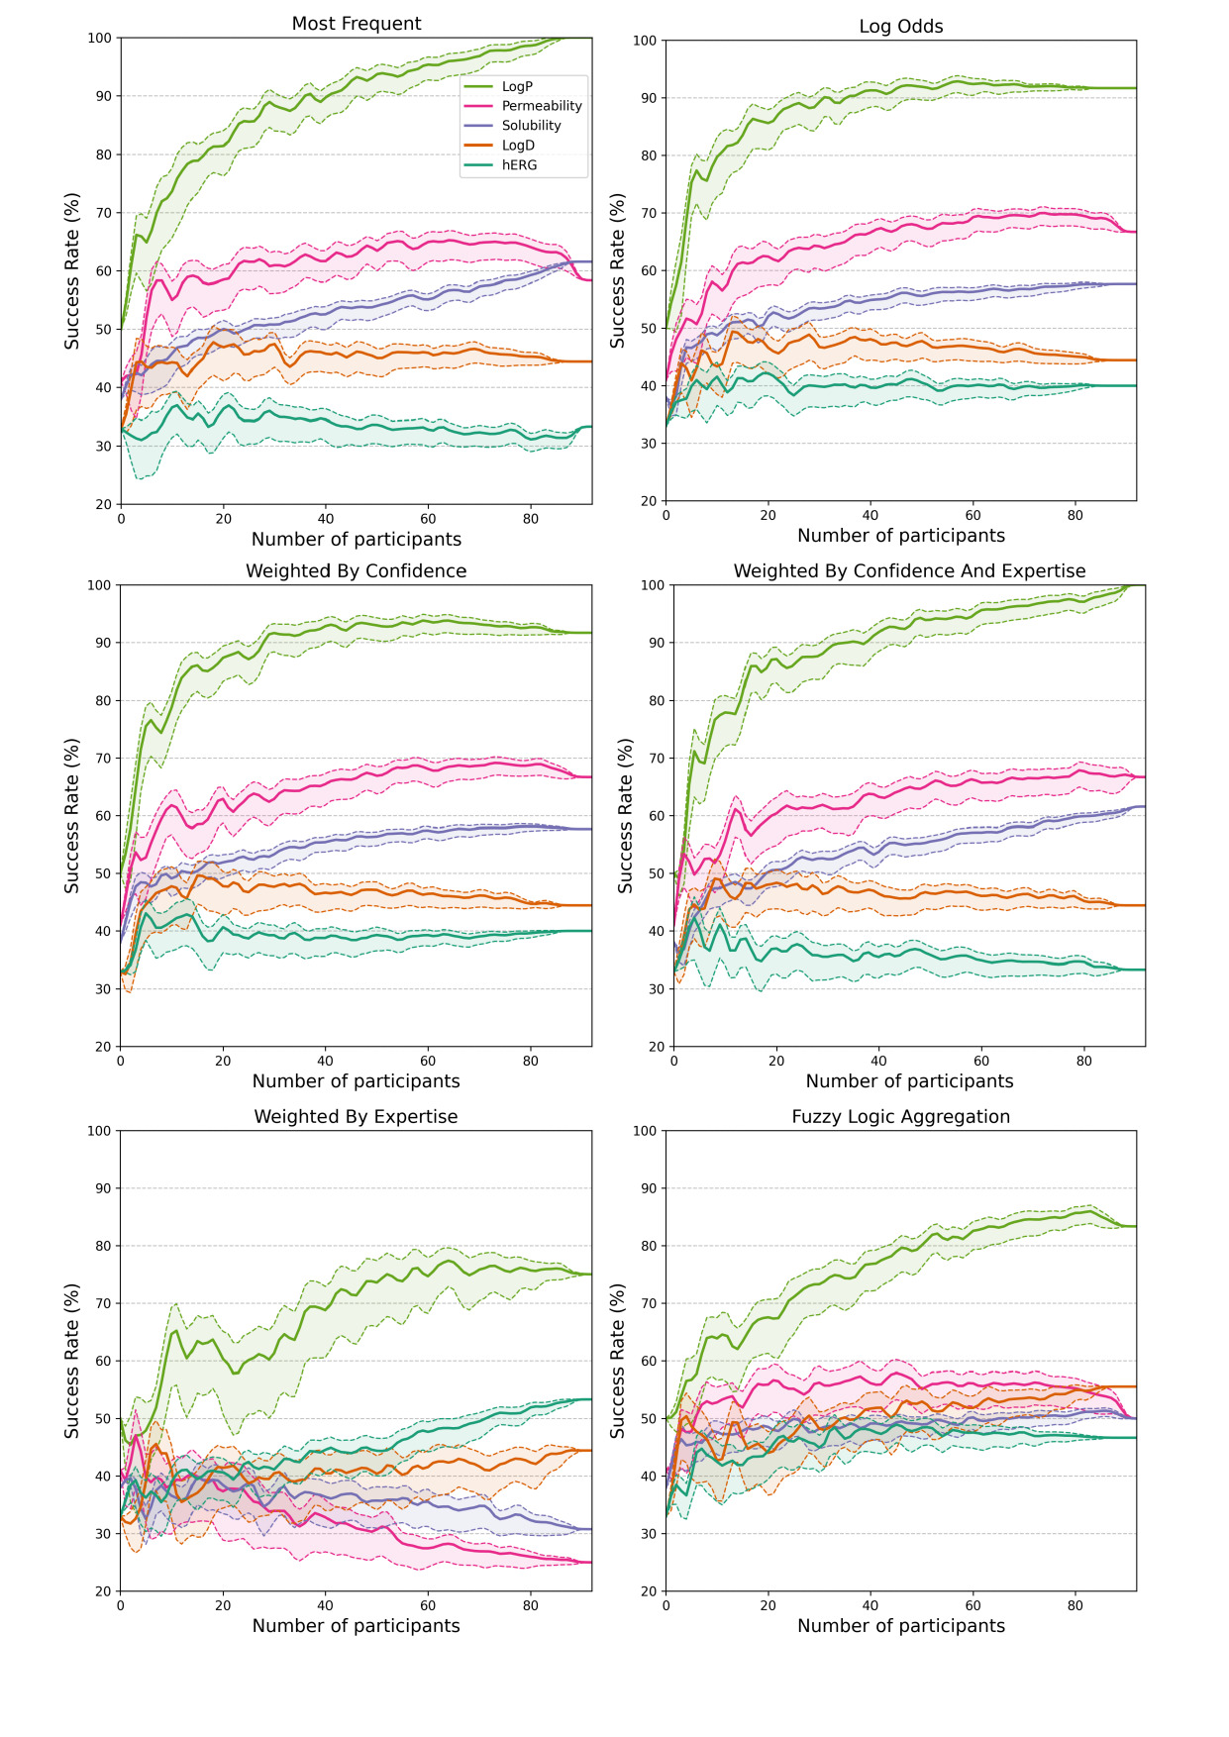
Figure S12: Evolution of the collective success rate as a function of the number of participants in the population per endpoint and per aggregation method.
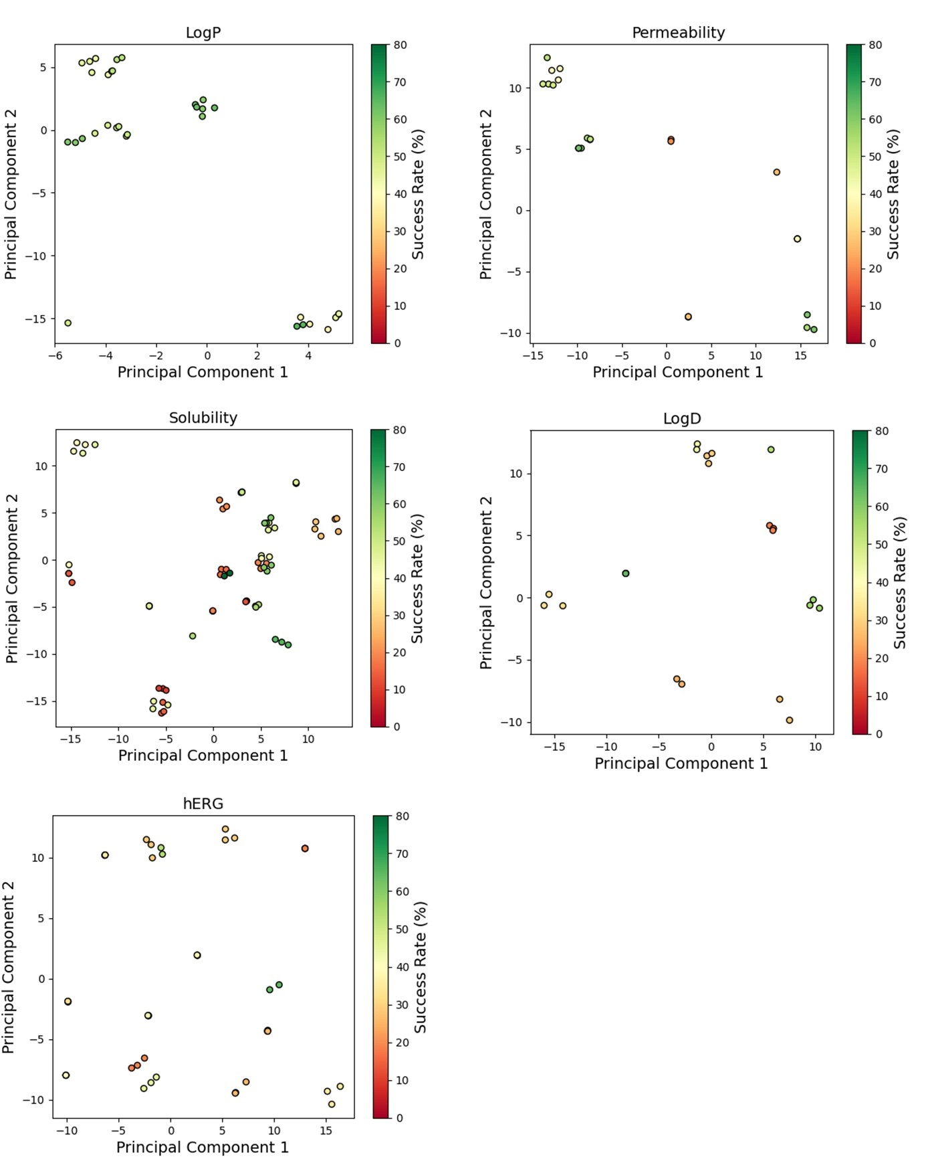
Figure S13: t-SNE map of the collective intelligence chemical space per endpoint. Each point represents a unique compound colored by the success rate of the related question.

Table S1: Performance of the Graph Neural Networks on the public internal test set on ADMET endpoints.
Endpoints | Number of unique compounds | R² | RMSE | MAE
LogP | 10,668 | 0.93 | 0.47 | 0.33
Permeability | 1,259 | 0.55 | 0.56 | 0.42
Solubility | 5,012 | 0.48 | 0.68 | 0.52
LogD | 5,347 | 0.84 | 0.60 | 0.44
hERG | 8,050 | 0.56 | 0.61 | 0.43

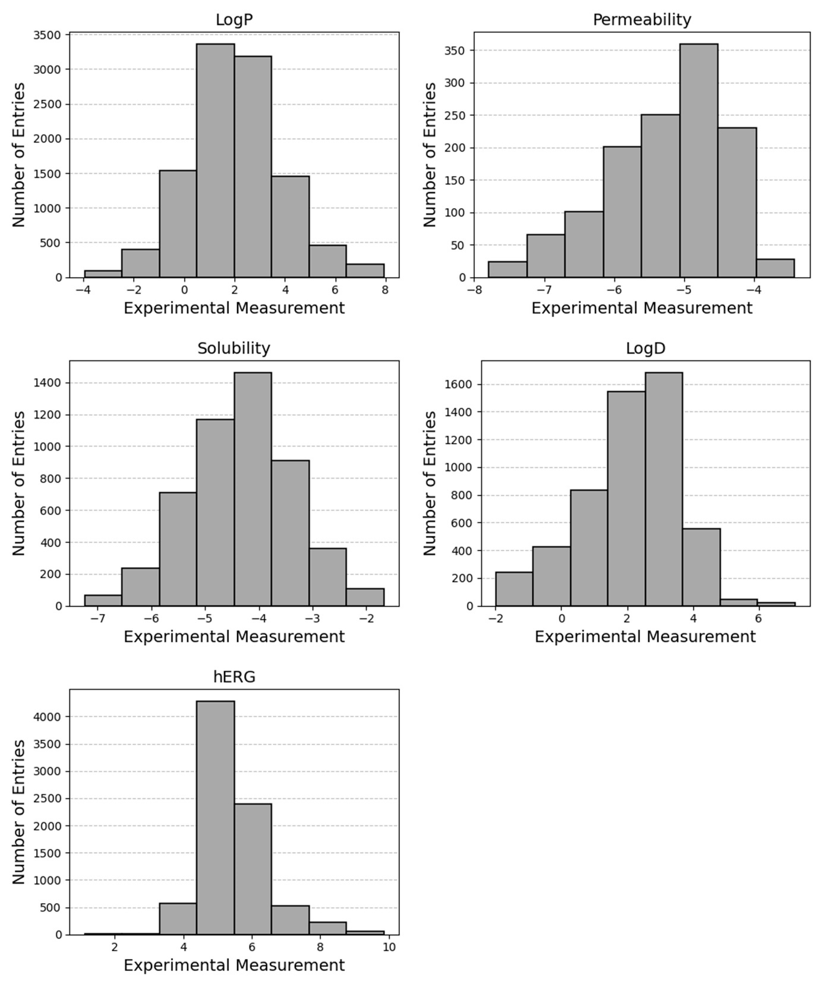
Figure S14: Distribution of experimental measurements from public data used for modelling purposes. The present endpoints are expressed in log₁₀(C_{octanol}/C_{water}) for LogP, log₁₀(cm/s) for permeability, log₁₀(C_{buffer}) for solubility, log₁₀(C_{octanol}/C_{buffer}) for LogD, and pIC50 for hERG inhibition.

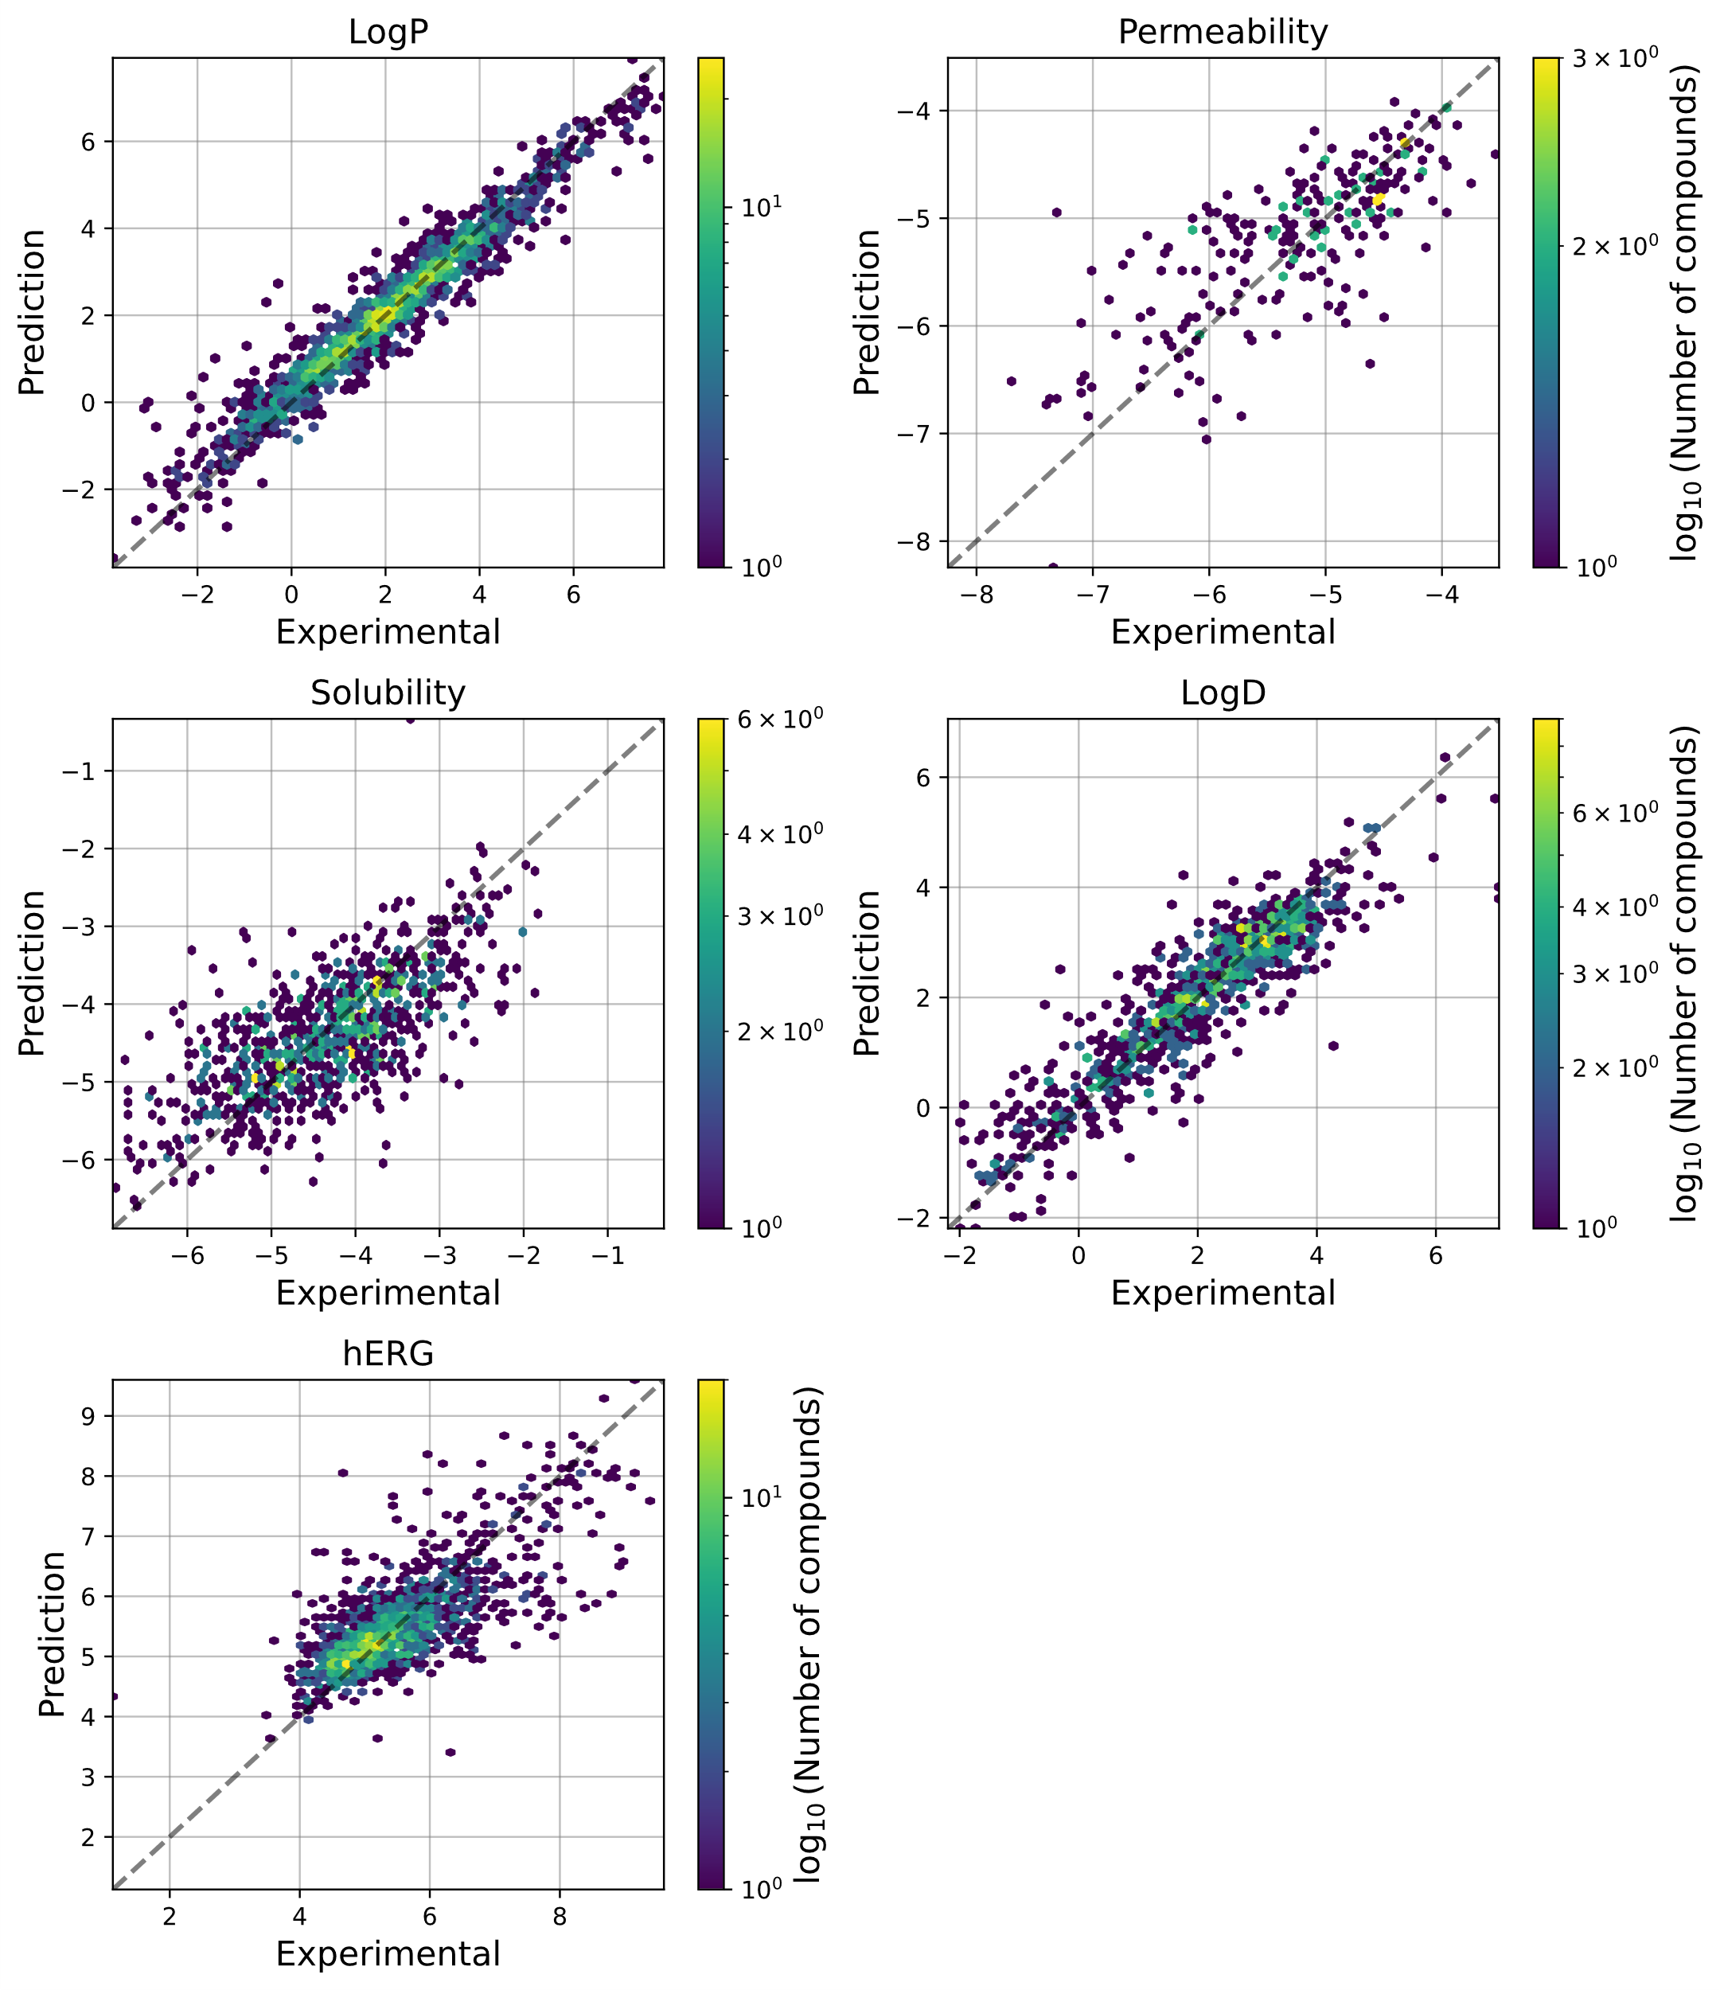
Figure S15: Correlation between experimental and predicted value per endpoint. The coloration depicts the density of compounds as the base-10 logarithm of the number of unique compounds. Answer success and failure count per ADMET endpoint. Answers are grouped per source such as human, GNN (predictive model), GNN & Human, and all.

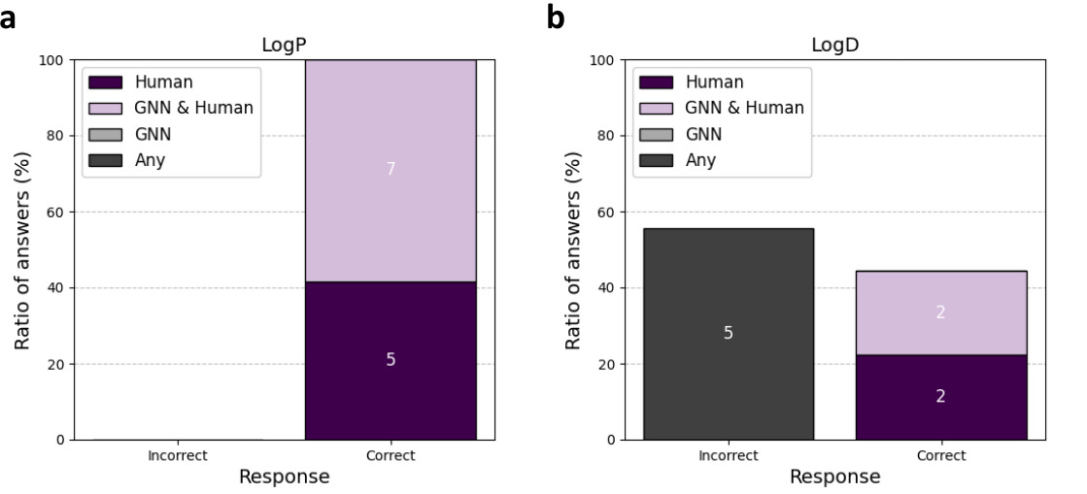Figure S16: Answer success and failure ratio (y-axis) and count (number in boxes) for a) logP and for b) logD. Answers are grouped per source, i.e., human, GNN (predictive model), GNN & Human, and all.

