ADDITIONAL FILES

Supplementary Figures
Figure S1. Volcano plots of differentially expressed genes (DEGs). Volcano plots of DEGs are presented for days 0, 14, 18 and 22 (A-D). Unigenes in blue are under-represented in stressed seedlings (FDR ⩽ 0.05 and a log2FC ⩽ -2), while transcripts in red are over-represented in stressed seedlings (FDR ⩽ 0.05 and a log2FC ⩾ 2). Unigenes in gray are not significantly different between the two groups.
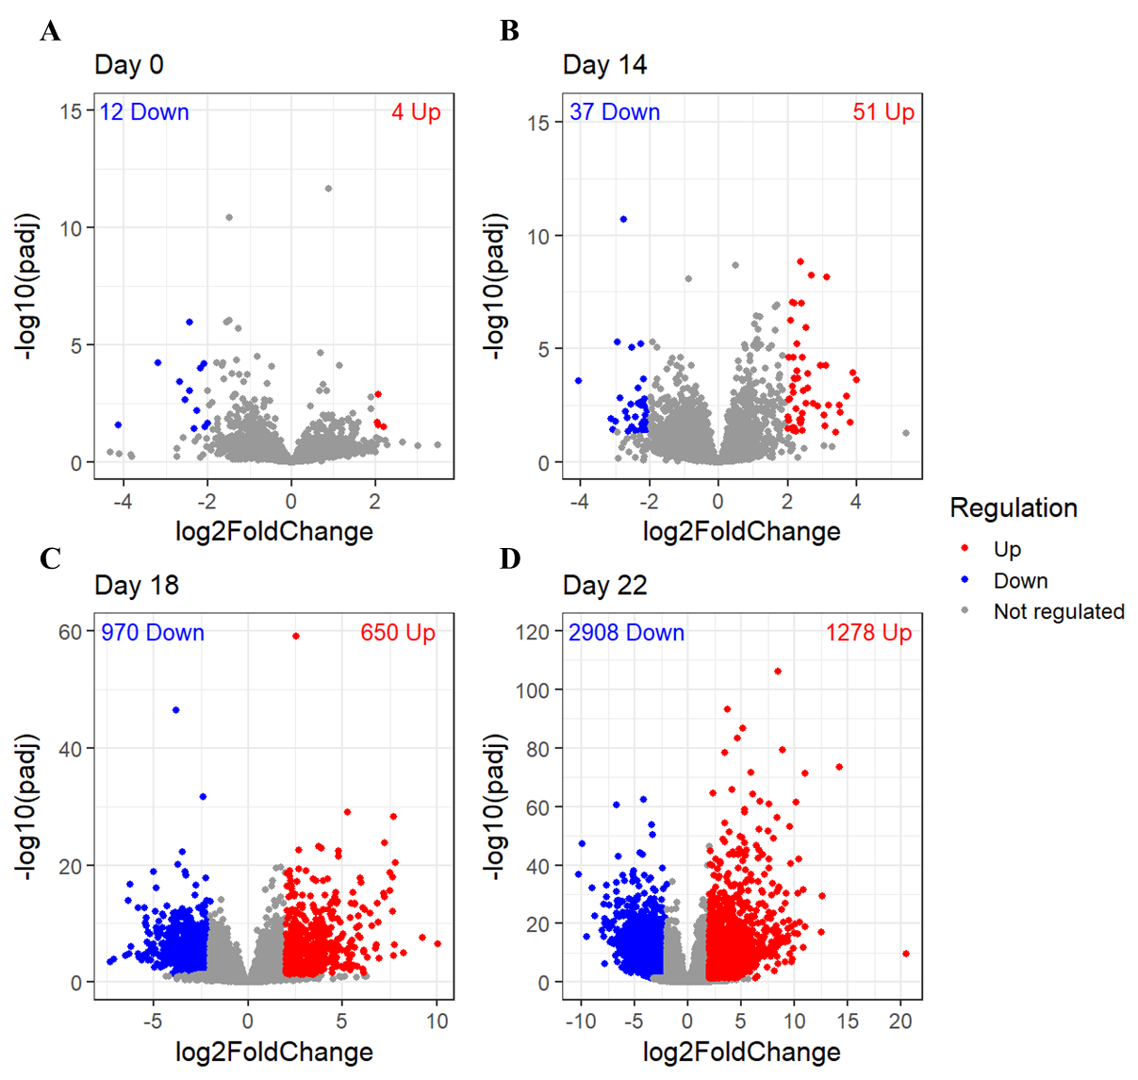

Figure S2. Major protein families involved in the drought response among the differentially expressed genes (DEGs) at day 22. The plot represents the number of up- and down-regulated DEGs at day 22 encoding selected protein families with known roles in plant drought response.
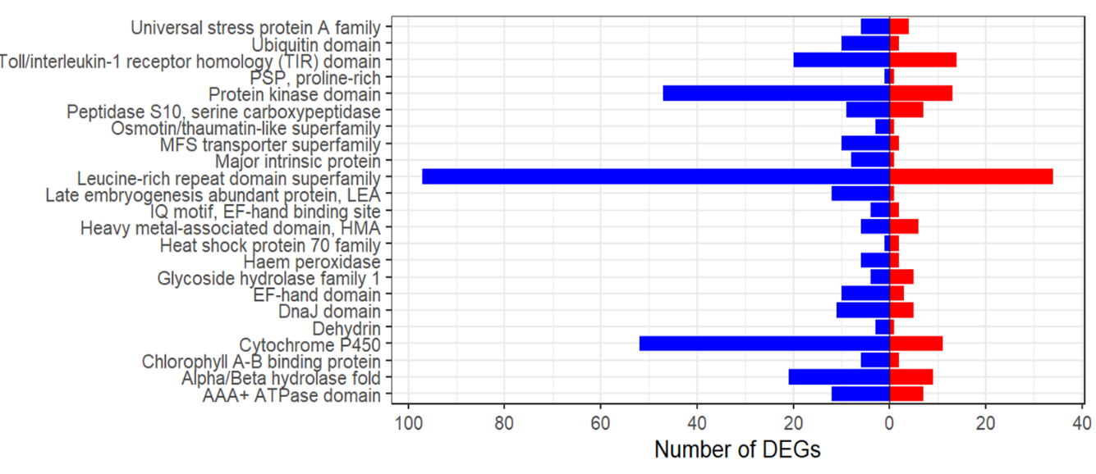

Figure S3. Unique and shared differentially expressed genes (DEGs) among clones. The Venn diagrams depict the overlaps of (A) up-regulated (red) and (B) down-regulated (blue) DEGs across the C8, C11, and C95 clones. The total number of DEGs are shown in bold brackets.
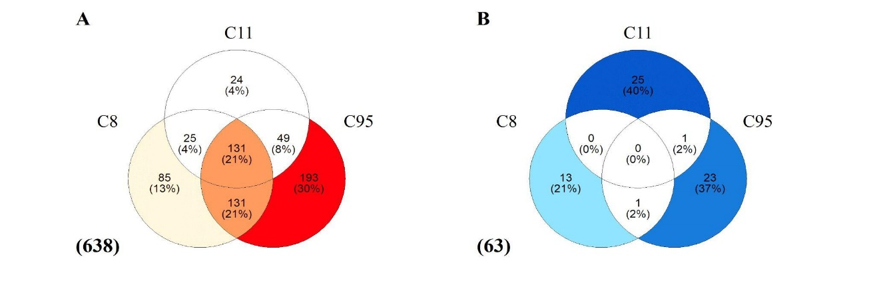

Figure S4. Gene Ontology (GO) annotation of unique and shared differentially expressed genes (DEGs) among clones. GO annotation of biological process (BP) of (A) up- and (B) down-regulated DEGs of clones and GO annotation of molecular functions (MF) of (C) up- and (D) down-regulated DEGs. Unique DEGs correspond to C8, C11 or C95 and the shared DEGs among clones correspond to C8-C11, C11-C95 and C8-C11-C95.
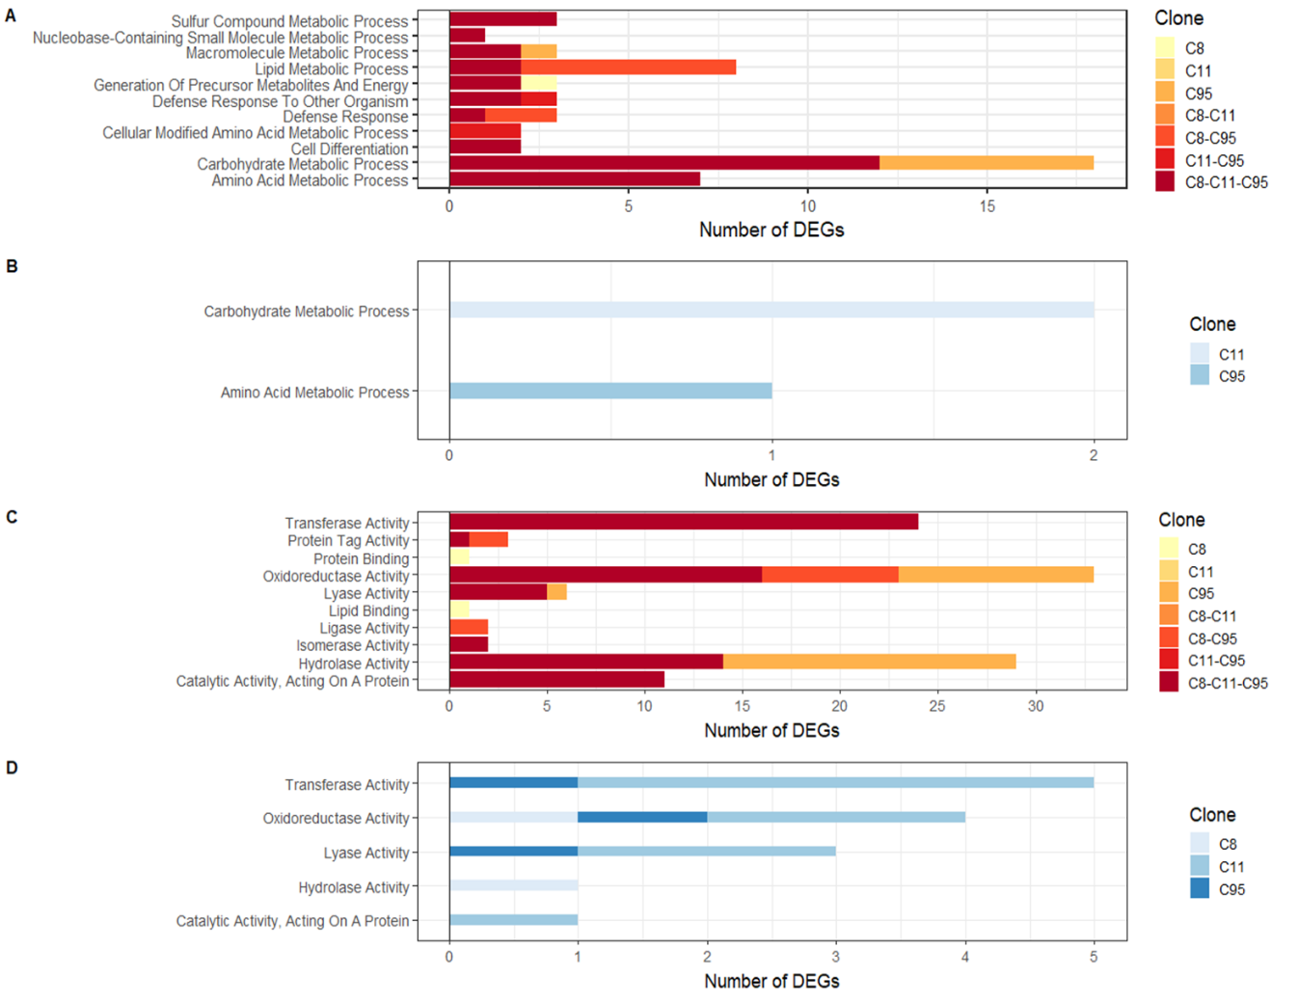

Supplementary Tables
Table S1. Summary of plant material used for de novo transcriptome assembly and transcriptomic analyses.

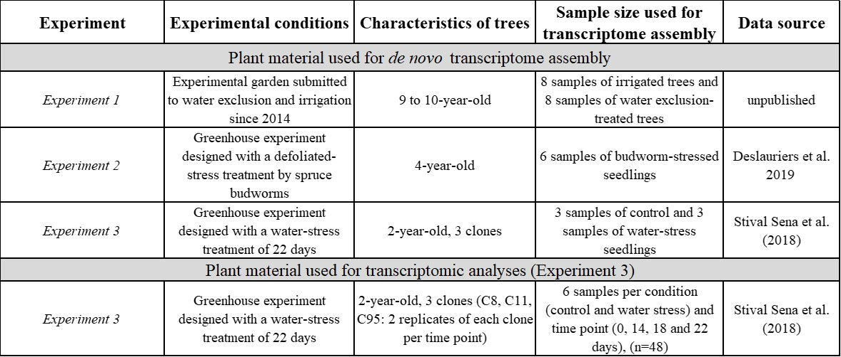

Table S2. Statistics summary of the de novo transcriptome assembly GCAT 4.0.
Statistic | Transcripts
Total Number | 33,287
Average length (bp) | 1,488.6
Median length (bp) | 1,173.0
N50 (bp) | 1,816
L50 | 8,661
N90 (bp) | 746
L90 | 25,238
Number of ORF | 33,283
Average ORF length | 852.2

Table S3. Complete functional annotation of the de novo transcriptome assembly GCAT 4.0 based on the OmicsBox analysis. See the separate Table_S3.xls. The Excel file contains four sheets; Caption, Table S3.1 (Blast2GO annotation and BLASTX), Table S3.2 (BLASTN WS77111v2), Table S3.3 (BLASTN GCAT3.3).

DB | DB sequences (%) | DB unique sequences (%) | Unigenes (%) | Unique unigenes (%)
UniProt (SwissProt) | 65,27 | 32,22 | 59,83 | 41,65
PlantTF | 43,50 | 11,46 | 40,50 | 29,04
Viridiplantae | 80,62 | 52,95 | 73,48 | 49,56
RefSeq | 79,41 | 55,35 | 89,80 | 56,87
Table S4. Summary of BLASTX results of the de novo transcriptome assembly GCAT 4.0. The table gathers the results of BLASTX expressed in percentage realized with different public databases. The refSeq_29sep22 database (NCBI) was used in Blast2GO pro suite for our analyses. The meaning of variables: DB: database; DB sequences (%): the percentage of matched sequence; DB unique sequences (%): the percentage of unique matched sequence; Unigenes (%): the percentage of matched unigene; Unique unigenes (%): the percentage of unique matched unigenes. The genome used is the reference genome of white spruce WS77111v2 (https://www.ncbi.nlm.nih.gov/datasets/genome/GCA_000966675.3).

Table S5. Transcription Factors (TFs) annotation of differentially expressed transcripts (DETs) and their corresponding genes (DEGs). See the separate Excel file. Table_S5.xls. The Excel file contains three sheets; Caption, Table S5.1 (TFs annotation among all transcripts), Table S5.2 (TFs annotation among DEGs).

Table S6. List of differentially expressed transcripts (DETs) as a function of time points and their corresponding genes (DEGs) under drought. See the separate Excel file. Table_S6.xls. The Excel file contains two sheets: Caption, Table S6 (results of DEG analysis and annotation according to time points).

Table S7. List of differentially expressed transcripts (DETs) and Gene Ontology (GO) enrichment as a function of clones and their corresponding genes (DEGs) under drought. See the separate Excel file. Table_S7.xls. The Excel file contains three sheets; Caption, Table S7.1 (results of DEG analysis and annotation according to clones), Table S7.2 (GO enrichment according to clones).

Table S8. Gene Ontology (GO) enrichment of differentially expressed transcripts (DETs) as a function of time points under drought. See the separate Excel file. Table_S8.xls. The Excel file contains three sheets; Caption, Table S8.1 (GO enrichment according to time points), Table S8.2 (selected GO enrichment according to time points).

Table S9. MapMan analyses performed on differentially expressed genes (DEGs) from all sampling days and on DEGs from day 22. See the separate Excel file. Table_S9.xls. The Excel file contains five sheets; Caption, Table S9.1 (export results of all sampling days), Table S9.2 (the main Bin categories of all sampling days), Table S9.3 (export results of day 22), Table S9.4 (the main Bin categories of day 22).

Table S10. Cross-checking information from previously published studies on differentially expressed transcripts (DETs) and their corresponding genes (DEGs). See the separate Excel file. Table_S10.xls. The Excel file contains two sheets; Caption, Table S10 (list of key drought-responsive genes previously observed in published studies).

Supplementary Methods S1

Methodological details of experiences used for de novo transcriptome assembly

1. Experiment 1
1.1. Study site, water treatment and plant material
Samples were obtained from an experimental garden established in 2013 at the Ontario Forest Research Institute Nursery and Arboretum in Sault Ste. Marie, Ont, Canada (46.546501°N, -84.45565°W, 220 m a.s.l.). Water treatment began in the spring of 2014 and consisted of rainfall exclusion and irrigation treatments. The rainfall exclusion system consisted of a network of gutters that removed ~25% of the surrounding canopy, and the irrigation treatment consisted of 25 mm of water per week using overhead sprinklers from June to August. Trees were arranged in a randomized complete block design. We sampled needles from 3 trees in 8 blocks to have 12 irrigated and 12 rainfall exclusion samples. Sampling was performed at 10 am in early September 2021. Foliage samples were frozen in liquid nitrogen immediately after removal from the trees and stored at -70 °C. Further details of the experimental garden can be found in the publication by Belluau et al. (2021).
1.2. RNA extraction, RNA-seq libraries synthesis and sequencing
RNA was extracted by grinding 15 to 20 mg of tissue to a fine powder in liquid nitrogen and using Promega's ReliaPrep™ RNA Tissue Miniprep System, which uses guanidine thiocyanate (GTC) and 1-thioglycerol. Total RNA concentration was determined using a Thermo Scientific™ NanoDrop™ OneC (http://www.nanodrop.com/support) and stored at -70°C. The 16 samples with the best nucleic acid ratio (260/280 and 260/230) were selected for sequencing, providing 8 control samples and 8 stressed samples with good representation of the block design sampling. Quality assessment, RNA-seq libraries and sequencing were performed by the Genome Quebec Innovation Center at McGill University (Montreal, Quebec, Canada). Sequencing was performed on an Illumina NovaSeq6000 S4 sequencing lane (Pair End, 2x100pb).

2.Experiment 2

2.1. Plant material
Four-year-old white spruce seedlings were placed in a greenhouse in Chicoutimi, Canada, in the spring of 2015 and exposed to control and defoliation treatments by spruce budworms (Choristoneura fumiferana). A total of 47 plants were used as either controls (n = 30) or defoliated treatments (n = 17). For the defoliation treatment, 60 second-stage larval spruce budworms (Choristoneura fumiferana) were placed on each sapling (see Deslauriers et al. 2019 for details). Foliage of the year was then sampled six and four times for control and defoliation treatment saplings, respectively, between days 154 and 258 of the year (no foliage of the year remained for the defoliation treatment in the last two samplings). Foliage samples were frozen in liquid nitrogen immediately after removal from the trees and stored at -80°C. Needles were ground to powder using a MixerMill 300 (Retsch. http://www.retsch.com/) and nitrogen-cooled steel grinding balls. Powdered foliage tissue was stored at -80°C until RNA extraction. Further details of the experiment can be found in the methods of (Stival Sena et al. (2018).
2.2. RNA extraction, cDNA preparation and sequencing
RNA extraction and cDNA preparation conditions were performed as described by Stival Sena et al. (2018). 500 ng of RNA per sample was used to synthesize mRNA libraries using the TruSeq® Stranded mRNA Kit (Illumina Canada Inc., Victoria, BC, Canada), following the manufacturer's protocol with a few modifications. First, custom adapters compatible with the Illumina technology were synthesized (IDT, Coralville, IA, USA) and their concentration was halved at 25 nM per reaction to avoid adapter dimer molecules, and Tris-NaCl (10 mM. 50 mM) was used at 25 nM to complete the volume. Second, strand synthesis, label clean-up and library amplification clean-up were performed using the Axygen® AxyPrep™ Mag PCR Clean-Up Kit (Axygen Biosciences, Union City, CA, USA), while post-ligation clean-up was performed using a 0.85 ratio of PEG/NaCl SPRI® solution on beads containing adapter-ligated DNA. Quantification of each library was determined using a Nanodrop ND-1000 (Thermo Scientific, Wilmington, DE, USA), and library fragment size distribution and absence of dimer molecules were verified using an Agilent Bioanalyzer 2100 with High Sensitivity DNA Chips (Agilent Technologies Inc., Santa Clara, CA, USA).
Six pools of 19 libraries at equimolar concentration (114 libraries in total) were prepared and purified according to the library amplification cleanup protocol described in the library preparation protocol. The libraries included in these pools were the 47 white spruce libraries for this publication, and 66 libraries for the rest of the experiment with black spruce or balsam fir (see Deslauriers et al. (2019) for a description of the full experiment). The concentration and fragment size distribution of the pools were evaluated using a Nanodrop ND1000 and an Agilent Bioanalyzer 2100, respectively. The six pools were sequenced at the Genome Quebec Innovation Centre at McGill University (Montreal, Quebec, Canada) on an Illumina HiSeq 2500 sequencing system (2 × 250 bp), one pool per run.
3. Experience 3
This experiment was carried out as described by Stival Sena et al. (2018). Samples from this experiment were used to perform transcriptome assembly (n=3 stressed and n=3 control) and for the transcriptomic analysis presented in this study (n=16).

3.1. Plant material
Young trees from three genetically unrelated Picea glauca clones (8, 11, and 95), propagated in vitro by somatic embryogenesis and grown in containers for 2 years, were used. Two replicates were grown under two conditions (well-watered control and drought without watering) and foliage was sampled at five time points (0, 7, 14, 18, and 22 days) from the start of the treatments. Five plants per clone (replicates) in both irrigation treatments were sampled at each sampling time point (150 plants in total). Foliage samples were frozen in liquid nitrogen immediately after removal from the trees and stored at -80°C. Needles were ground to powder using a MixerMill 300 (Retsch. http://www.retsch.com/) and nitrogen-cooled steel grinding balls. Powdered foliage tissue was stored at -80°C until RNA extraction. Further details of the experiment can be found in the methods of Stival Sena et al. (2018).

3.2. RNA extraction and cDNA preparation
RNA was extracted by grinding tissues in liquid nitrogen to a fine powder and by utilizing the cetyltrimethyl ammonium bromide (CTAB) extraction method as described by Chang et al. (1993), with modifications (Pavy et al., 2008). The total RNA concentration was determined using a NanoDrop 1000 (Thermo Scientific. http://www.thermoscientific.com/) and assessed for quality with an Agilent 2100 Bioanalyzer and Agilent RNA 6000 Nano Kit LabChips (Agilent Technologies Inc., http://www.agilent.com/) and stored at −80 °C. Complementary DNAs were prepared from 500 ng of total RNA using the Quantitect Reverse Transcription Kit (Qiagen, Germantown, MD, USA) and then diluted 1:4 in RNase-free water.

3.3. Libraries and sequencing
We used 500 ng of RNA per sample to synthesize mRNA libraries using the TruSeq® Stranded mRNA Kit (Illumina Canada Inc., Victoria, BC, Canada), following the manufacturer's protocol with a few modifications. First, custom adapters compatible with the Illumina technology were synthesized (IDT, Coralville, IA, USA) and their concentration was halved at 25 nM per reaction to avoid adapter dimer molecules, and Tris-NaCl (10 mM. 50 mM) was used at 25 nM to complete the volume. Second, strand synthesis, label clean-up and library amplification clean-up were performed using the Axygen® AxyPrep™ Mag PCR Clean-Up Kit (Axygen Biosciences, Union City, CA, USA), while post-ligation clean-up was performed using a 0.85 ratio of PEG/NaCl SPRI® solution on beads containing adapter-ligated DNA. Quantification of each library was determined using a Nanodrop ND-1000 (Thermo Scientific, Wilmington, DE, USA), and library fragment size distribution and absence of dimer molecules were verified using an Agilent Bioanalyzer 2100 with High Sensitivity DNA Chips (Agilent Technologies Inc., Santa Clara, CA, USA). An equimolar pool of 59 libraries was prepared and purified according to the library amplification cleanup protocol as described in the library construction protocol. The concentration and fragment size distribution of the pool were evaluated using a Nanodrop ND1000 and an Agilent Bioanalyzer 2100, respectively. The pool was sequenced using the rapid run method (2 × 250 bp) at the Genome Quebec Innovation Centre at McGill University (Montreal, Quebec, Canada) using an Illumina HiSeq 2500 sequencing system.

3.4. Data filtering
Raw sequencing produced a total of 120 FASTQ files representing 148 Gbases in 592 million 2x125 bp reads. Filtering retained 114.6 Gbases (74.7% bases) in 551.6 million HQ sequences (93.1% sequences), of which 495.6 million (89.9%) are Paired-End (both reads from paired sequencing yielded a HQ segment. Read counts were obtained for 37,491 genes and 36,701 of these genes had at least one read count. For more information, see the publication of Stival Sena et al. (2018).

References
Belluau, M., Vitali, V., Parker, W. C., Paquette, A., and Messier, C. (2021). Overyielding in young tree communities does not support the stress-gradient hypothesis and is favoured by functional diversity and higher water availability. J. Ecol. 109, 1790–1803. doi: 10.1111/1365-2745.13602
Chang, S., Puryear, J., and Cairney, J. (1993). A Simple and Efficient Method for Isolating RNA from Pine Trees. Plant Mol. Biol. Report. 11, 113–116. doi: 10.1007/BF02670468
Deslauriers, A., Fournier, M.-P., Cartenì, F., and Mackay, J. (2019). Phenological shifts in conifer species stressed by spruce budworm defoliation. Tree Physiol. 39, 590–605. doi: 10.1093/treephys/tpy135
Pavy, N., Pelgas, B., Beauseigle, S., Blais, S., Gagnon, F., Gosselin, I., et al. (2008). Enhancing genetic mapping of complex genomes through the design of highly-multiplexed SNP arrays: application to the large and unsequenced genomes of white spruce and black spruce. BMC Genomics 9, 21. doi: 10.1186/1471-2164-9-21
Stival Sena, J., Giguère, I., Rigault, P., Bousquet, J., and Mackay, J. (2018). Expansion of the dehydrin gene family in the Pinaceae is associated with considerable structural diversity and drought-responsive expression. Tree Physiol. 38, 442–456. doi: 10.1093/treephys/tpx125

