Supplementary Materials

Supplementary Table S1: The percentage of residues participated in the average structure formation of MTH1.
 | Coil | β-sheet | β-bridge | Bend | Turn | α-helix | π-helix | 3₁₀-helix
MTH1 | 32 | 67 | 2 | 13 | 14 | 23 | 0 | 3
MTH1-Resveratol | 31 | 63 | 3 | 15 | 15 | 21 | 3 | 3

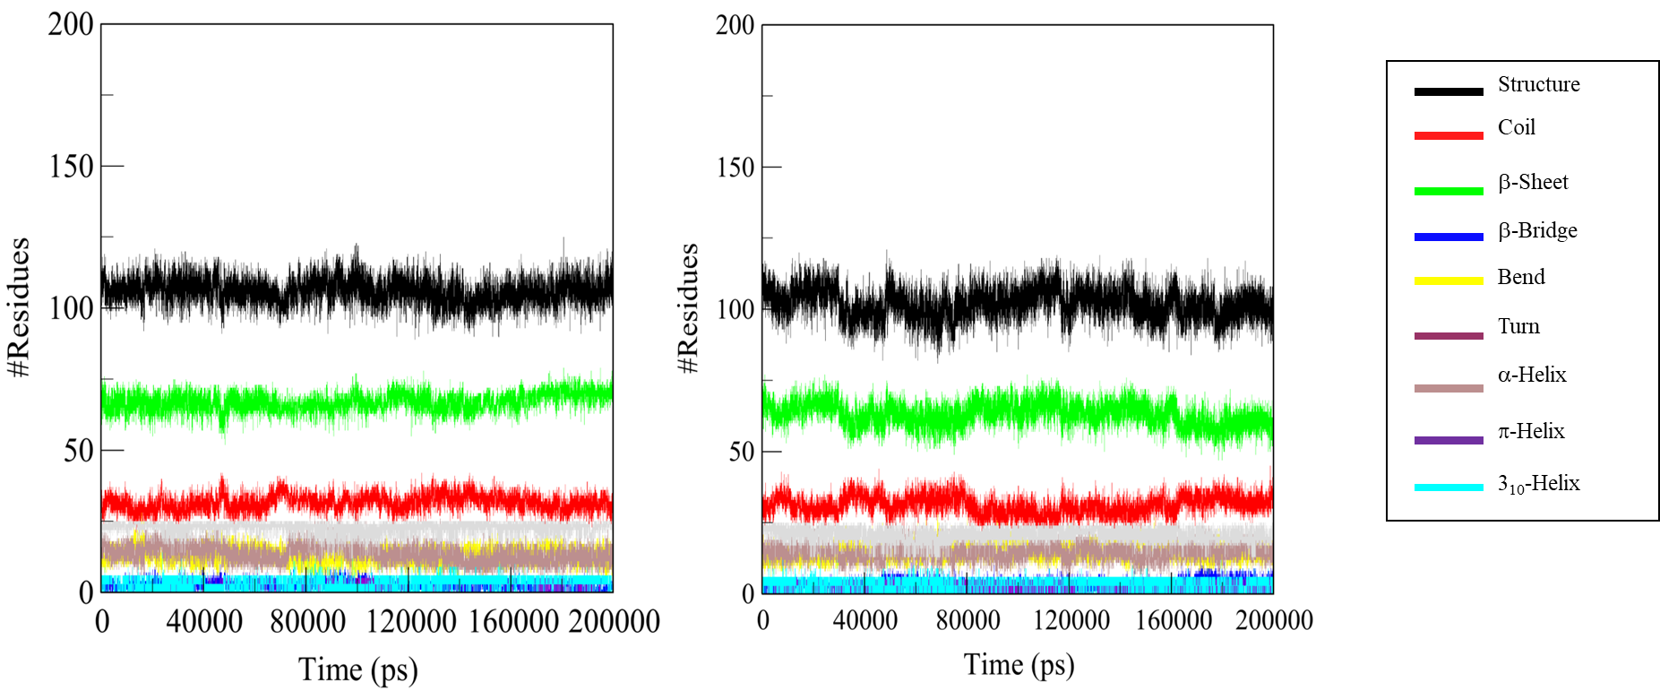
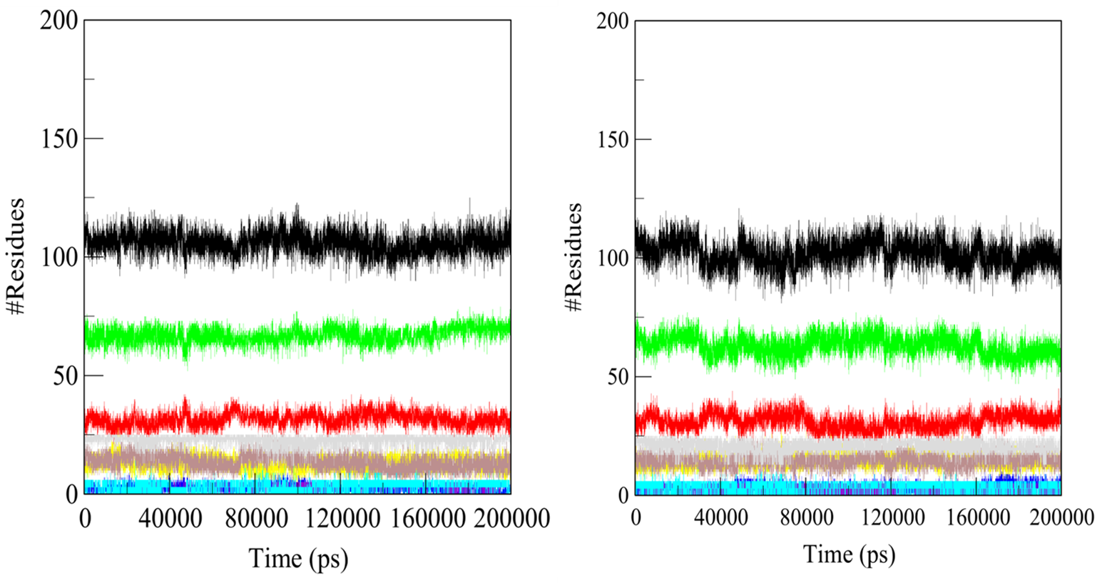
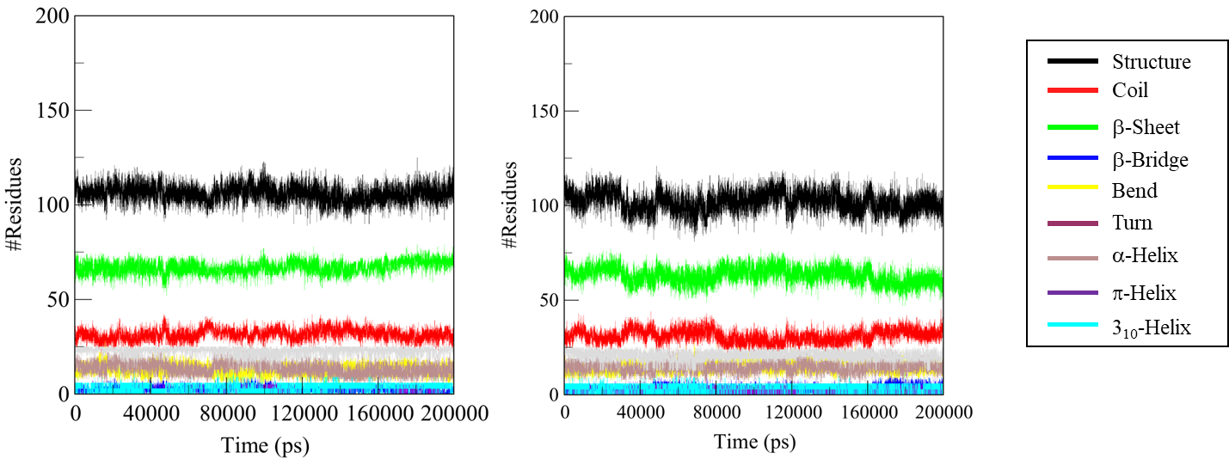

Supplementary Figure S1: Time evaluation of the secondary structure content. (A) Free MTH1, (B) MTH1 upon Resveratrol binding. *Structure=α-helix+β-sheet+β-bridge+Turn.

