Electronic Supplementary Information
Room Temperature Giant Magnetoelectric Coupling for Magnetic Energy Harvesting in Single Phase {Co^{III}₃Dy^{III}} Molecular Nanogenerator
Deepanshu Chauhan^{1‡}, Dalip Saini^{2‡}, Rajashi Haldar¹, Dipanti Borah¹, Dipankar Mandal²*, Gopalan Rajaraman¹*, Maheswaran Shanmugam¹*
¹Department of Chemistry, Indian Institute of Technology Bombay Powai, Mumbai 400076, Maharashtra (India) Email: rajaraman@chem.iitb.ac.in, eswar@chem.iitb.ac.in
²Quantum Materials and Devices Unit, Institute of Nano Science and Technology Knowledge City, Sector 81, Mohali 140306 (India) Email: dmandal@inst.ac.in
‡ These authors contributed equally to this work

Table of Contents
Materials and Methods……………………………………………………………………….5
Synthesis of Ligand…………………………………………………………………………...5
Synthesis Procedure of Metal Complex……………………………………………………..5
Single-Crystal X-ray and Powder Diffraction Studies……………………………………...5
TGA-DTA/ and DSC studies…………………………………………………………………5
Hirschfield Surface Analysis…………………………………………………………………5
Magnetic Measurements……………………………………………………………………..6
Ferroelectric and Dielectric Measurements………………………………………………...6
Piezoresponse Force Microscopy (PFM) ……………………………………………………6
Computational Details………………………………………………………………………..7
Device Fabrication……………………………………………………………………………7
Magnetic Coupling Description……………………………………………………………...8
Supplementary Text
Structural Descriptions………………………………………………………………...8
Magnetic Properties……………………………………………………………………9
Supplementary Figures (S1-S24)
Supplementary Fig. 1. Systematic reaction scheme used to isolate the complex Co3Dy……10
Supplementary Fig. 2. TGA-DTA analysis of complex Co3Dy…………………………….10
Supplementary Fig. 3. Variable temperature powder XRD analysis of complex Co3Dy in the temperature ranges of 298 K to 348 K………………………………………………………...11
Supplementary Fig. 4. Differential scanning calorimetry (DSC) curve of complex Co3Dy showing a thermal anomaly at ~350 K………………………………………………………..12
Supplementary Fig. 5. Temperature dependence dielectric analysis of complex Co3Dy. (a) real part of complex dielectric constant (ε_{r}) and (b) dielectric loss (tan δ) at various frequencies; (c) 1/ε` vs T curve at 0.1 MHz and its linear fit following Curie-Weiss law…………………..13
Supplementary Fig. 6. Temperature-dependent Direct Current (DC) magnetic susceptibility measurement of complex Co3Dy. (a) χ_{M}T versus T (represented black and red dots are experimental and computational respectively) (b) Magnetisation (M) vs. Magnetic Field (H) plot at 2, 4 and 6 K…………………………………………………………………………….14
Supplementary Fig. 7. Alternate current (ac) susceptibility measurement at applied zero DC field. (a) The in-phase (χ’) and (b) out-of-phase (χ’’) susceptibility in the temperature range of 2 - 6.2 K for complex Co3Dy. The solid lines are the best fit using the Debye model. The solid lines have been extended up to 10,000 Hz using the fitting parameters obtained from experimental AC data………………………………………………………………………...15
Supplementary Fig. 8. The Cole-Cole plot for complex Co3Dy…………………………….15
Supplementary Fig. 9. Arrhenius plot of complex Co3Dy………………………………….16
Supplementary Fig. 10. The orientation of the magnetic anisotropy axis (represented by the blue arrow) for the Dy^{III} ion within complex Co3Dy…………………………………………16
Supplementary Fig. 11. The observed LoProp charge on each atom from the CASSCF step of complex Co3Dy………………………………………………………………………………17
Supplementary Fig. 12. Dynamics of magnetization relaxation for Dy^{III} ion in complex Co3Dy………………………………………………………………………………………..18
Supplementary Fig. 13. The computed electron density of complex Co3Dy………………..18
Supplementary Fig. 14. Magnetic hysteresis at 2K for complex Co3Dy…………………….19
Supplementary Fig.15. Variation of dielectric constant and loss tangent with frequency for complex Co3Dy………………………………………………………………………………19
Supplementary Fig.16. (a) Schematic illustration of the fabrication process of Co3Dy-MENG, Cross-sectional (a) real optical photograph and (c) FeSEM image of Co3Dy-MENG, (d) Real image of flexible Co3Dy-MENG ………………………………………………………………………………20
Supplementary Fig. 17. PXRD pattern of the complex Co3Dy-MENG device and complex Co3Dy………………………………………………………………………………………..21
Supplementary Fig.18. (a) Schematic representation of the experimental setup for α measurement, (b) Relationship between obtained open circuit voltage and applied ac magnetic field………………………………………………………………………………………...…22
Supplementary Fig.19. Finite elemental analysis-based theoretical simulation (a) magnetic flux density around a current-carrying conducting cylindrical coil, (b) induced electrical polarization at complex Co3Dy surface………………………………………………………23
Supplementary Fig.20. Schematic representation of experimental setup for investigation of magnetic energy harvesting performance of Co3Dy-MENG …………………………………………24
Supplementary Fig.21. Experimental setup for capacitor charging performance of Co3Dy-MENG ……………………………………………………………………………………….25
Supplementary Fig. 22. Packing diagram of complex Co3Dy. Dark red line shows the shortest distance between two Dy centre. Colour Code: Dy: cyan; Co: pink; Nitrogen: blue; Oxygen: Red; Carbon: grey; and Hydrogen: black……………………………………………………..26
Supplementary Fig. 23. The Hirshfield surface analysis of complex Co3Dy. Generated d_{norm} (left) and the 2D fingerprint plot (right)………………………………………………………27
Supplementary Fig. 24 The experimental and simulated PXRD pattern of complex Co3Dy at temperatures 150 K and 300 K………………………………………………………………..28
Supplementary Tables (T1-T12)
Supplementary Table 1. Crystallographic parameters for complex Co3Dy………………..29
Supplementary Table 2. The observed best-fitting parameters for the Cole-Cole plot in complex Co3Dy………………………………………………………………………………30
Supplementary Table 3. Computed energies of the eight low-lying KDs of Dy^{III} ion along with the ground state g-tenors for complex Co3Dy………………………………………….31
Supplementary Table 4. Computed crystal field parameter of Dy^{III} ion in complex Co3Dy………………………………………………………………………………………..32
Supplementary Table 5. Magnetodielectric Effect Comparison of Complex Co3Dy with Other Organic-Inorganic Hybrid and Coordination Complexes……………………………..33
Supplementary Table 6. SHAPE analysis of the coordination polyhedra around the Dy^{III} ion in complex Co3Dy……………………………………………………………………………34
Supplementary Table 7. SHAPE analysis of the coordination polyhedra around the Co^{III} ion in complex Co3Dy……………………………………………………………………………35
Supplementary Table 8. Selected bond length at 150 K in complex Co3Dy………………36
Supplementary Table 9. Selected bond angle at 150 K in complex Co3Dy………………..37
Supplementary Table 10. Selected bond length at 300 K in complex Co3Dy……………..38
Supplementary Table 11. Selected bond angle at 300 K in complex Co3Dy………………..39
Supplementary Table 12. Summarizes hydrogen bonding in Complex Co3Dy, showcasing atom pairs, bond distances (Å), and angles (degrees)………………………………………....40
References…………………………………………………………………………………...41

Materials and Methods
All experiments were carried out under aerobic conditions. All the solvents in these experiments were used in analytical grade without further purification. The Dy(NO₃)₃.5H₂O and CoBr₂ salt were purchased from Sigma Aldrich.
Synthesis of Ligand H2L: The ligand was synthesized as per the earlier literature report. The ligand was formed in-situ. The general method followed is detailed below.
Synthesis procedure for complex Co3Dy: A mixture of 0.25 g (1 mmol) of R 2-phenylglycinol and 0.27 g (1.1 mmol) of 2-hydroxy-3-methyl benzaldehyde in 20 ml of methanol gives a yellow color solution. The yellow mixture was refluxed for 5 hours. Then this solution was cooled down to room temperature. Into this solution, Dy(NO₃)₃.5H₂O (0.22 g, 0.5 mmol) and Et₃N(0.55 ml, 4mmol) was added. The resultant mixture was stirred at room temperature for 2 hrs. After that, CoBr₂ (0.218 g, 1 mmol) was added into the above reaction mixture. Upon addition of cobalt ion the solution turn brown along with a brown color precipitate formation immediately. This resultant reaction mixture was continued to stir for another 3 hrs. After completion of the reaction, the reaction mixture was filtered and the filtrate was kept for crystallization at room temperature without any disturbance. Brown colour block shaped single crystals of Co3Dy grown from the filtrate within a day which is suitable for single crystal X-ray diffraction. The yield of Co3Dy: 0.40 g (60 %). Elemental composition of Co3Dy Calc. (%): C, 57.68; H, 5.08; N, 4.04. Found (%): C, 57.20; H, 5.23; N, 4.11.
Single Crystal and Powder X-ray Diffraction Studies
Single crystal X-ray diffraction measurements of complex Co3Dy were conducted using a Bruker machine equipped with a graphite diffractometer (Mo Kα, λ = 0.71073 Å). Selected single crystals were mounted on a fiber loop with mineral oil, and then placed in the cold flow created by an Oxford Cryo-cooling device. Complete hemispheres of data were collected using ω and φ scans (0.3°, 16 s per frame). Integrated intensities were obtained using Rigaku Crysalis Pro and APEX software. The compounds were solved through direct methods with SHELXS-97 and refined with SHELXL-97, followed by iterative cycles of ΔF syntheses and full-matrix least-squares refinement against F². The SQUEEZE capability from PLATON is used to handle this, resulting in smooth convergence of all the atoms throughout refining. The CCDC numbers are 2295667 for complex Co3Dy at 150 K and 2295665 at 300 K. These data can be obtained free of charge from the Cambridge Crystallographic Data Centre via www.ccdc.cam.ac.uk/data_request/cif. Elemental analysis (C, H, and N) was performed using a Thermo-Quest micro-analyzer spectrometer. Powder XRD measurements were performed using a Rigaku D/tex Ultra 250 instrument with a Cu K_{β} filter, and the scan speed was set at 5°/min at room temperature. Diffraction patterns were collected in the 2θ range of 5–50° with a step size of 0.01.
TGA/DTA and DSC Studies
Thermogravimetric analyses (TGA) were conducted using a Rigaku TG-DTA instrument, with crystalline samples heated at a rate of 10 K/min under a nitrogen atmosphere. Additionally, Differential Scanning Calorimetry was performed using a Rigaku Thermo Plus EVO2 DSC instrument, where crystalline samples were heated at a rate of 10 K/min in aluminium crucibles within a nitrogen atmosphere.
Hirschfield Surface Analysis
To generate the Hirschfeld surface (HS), we utilized the asymmetric unit of the complex. Using the CrystalExplorer program, we provided a crystallographic information file (CIF) as input to map the HS with d_{norm}. HS analysis offers a unique approach to map and quantify the various non-covalent interactions that stabilize the crystal lattice and packing of all the complexes. For better visualization, HSs mapped with d_{norm} of Co3Dy are plotted. The intermolecular contacts present in the crystals were mapped using normalized contact distance d_{norm}, which is defined in terms of d_{i} and d_{e} and van der Waals radii (r^{vdW}) of atoms by the following equation:
$$d_{norm}=\frac{d_{i}-{r_{i}}^{vdW}}{{r_{i}}^{vdW}}+\frac{d_{e}-{r_{e}}^{vdW}}{{r_{e}}^{vdW}}$$
Where, d_{i} and d_{e} represent the distance from the HS to the nearest nucleus inside and outside the surface, and ${r_{i}}^{vdW}$ and ${r_{e}}^{vdW}$are the van der Waals radii of the atoms.
The value of d_{norm} can be either negative or positive, depending on whether intermolecular contacts are shorter or longer than the van der Waals separations. This equation was visually represented using a red-white-blue color code. In this color scheme, red, white, and blue regions visible on the d_{norm} surfaces indicate contacts with distances shorter, longer, and equal to the van der Waals separations, respectively. Similarly, employing fingerprint plots, a set of points in 2D space illustrates the overall contribution of intermolecular interactions. For a given crystal structure and set of spherical atomic electron densities, the HS is unique, suggesting the potential for gaining additional insights into the intermolecular interactions of molecular crystals. HSs enable the visualization of these interactions and indicate their relative strength through different colors and color intensity. Two-dimensional (2D) fingerprint plots of HSs for complex Co3Dy indicate the % contributions of each interactions.
Magnetic Measurement
Magnetic susceptibility measurements were carried out on a Quantum Design SQUID magnetometer MPMS-XL 7, see below, which operated between 1.8 and 300 K for dc-applied fields that range from 0 – 7 T. The magnetometer was calibrated by use of a standard palladium pellet of accurately known susceptibility (Quantum Design) and checked by use of chemical calibrants such as CuSO4.5H2O or Hg[Co(NCS)4]. For anisotropic species microcrystalline samples were dispersed in Vaseline to avoid torqueing of the crystallites. The sample mulls were contained in a calibrated gelatine capsule held at the center of a drinking straw that was fixed at the end of the sample rod. The magnetic data were corrected for the sample holder and the diamagnetic contribution Alternating current (AC) susceptibilities were carried out under an oscillating AC field of 3.5 Oe with frequencies ranging from 0.1 to 1000 Hz in a zero DC field.
Ferroelectric and Dielectric measurements
The measurement of complex dielectric permittivity was conducted using the Keysight Impedance Analyzer E4990A system, employing a two-parallel plate capacitor geometry. For this setup, the silver conductive paste was applied to both sides of pressed pellets comprising the sample, serving as the top and bottom electrodes. Additionally, ferroelectric measurements were carried out on the pressed pellets, utilizing a Radiant Precision II ferroelectric loop tracer equipped with a high-voltage amplifier from Radiant Technologies USA.
Piezoresponse Force Microscopy (PFM) measurement
The investigation of local topography, piezoelectric properties, and ferroelectric switching involved the use of scanning probe microscopy (SPM), specifically employing piezo-response force microscopy (PFM) in DART (Dual AC Resonance Tracking) mode. This study was conducted using an MFP-3D BIO instrument from Asylum Research, utilizing an SCM-PIT-V2 probe. The amplitude and phase images were captured by applying a fixed AC voltage, while typical butterfly loops and phase loops were recorded by introducing various DC biases to the tip along with the AC voltage.
Computational Details
To understand the magnetic properties of complex Co3Dy we have performed high level Ab-initio CASSCF/RASSI-SO/SINGLE_ANISO calculations on the single crystal XRD structure without any geometry optimization using MOLCAS 8.2 program. We have used the Douglas-Kroll Hamiltonian (DKH) to consider the relativistic effect of the Ln^{III} ions. Here we have taken the basis set from the ANO-RCC library. Particularly we have used the [ANO-RCC...8s7p5d3f2g1h.] basis set for paramagnetic Dy^{III} ion, the [ANO-RCC... 5s4p2d.] basis set for diamagnetic Co^{III} ion, the [ANO-RCC...3s2p.] basis set for O atoms, the [ANO-RCC...3s2p.] basis set for N atom, the [ANO-RCC...3s2p.] basis set for the C atom, and the [H.ANO-RCC...2s.] basis set for H atoms to perform the Guessorb calculations and to find out the active space for the Complete active space self-consistent field (CASSCF) calculations. We have used CAS (9,7) for Dy^{III} ion. State-averaged CASSCF calculations were performed, including the sextet (21 roots), quartet (224 roots) and doublet (490 roots) of Dy^{III} ions. In RASSI-SO, roots were mixed through spin-orbit coupling for the Dy^{III} ion, 21 sextets, 128 quartets and 130 doublets included. Moreover, these computed spin-orbital (SO) states have been considered in the SINGLE_ANISO program to compute the g-tensor and Crystal-field (CF) parameters. The CF parameters were analyzed for deeper insight into the mechanism of magnetic relaxation. The corresponding crystal field Hamiltonian is given in the equation:
$${\hat{H}}_{CF}=\sum{\sum_{k= -q}^{q}{B_{k}^{q}{\tilde{O}}_{k}^{q}}}$$
Where $B_{k}^{q}$ is the crystal field parameter and ${\tilde{O}}_{k}^{q}$ is Steven`s operator.
Device Fabrication
Supplementary Fig. 16a illustrates the fabrication process of Co3Dy-MENG. Initially, Complex Co3Dy powder undergoes uniform dispersion in isopropanol through a 30-minute ultrasonication process. Subsequently, the resulting dark brownish Complex Co3Dy solution is drop-casted onto ITO-coated PET (bottom electrode, 2 × 4 cm²) using a dropper and is left to dry on a hot plate at 30 °C for 2 hours. Finally, a top electrode is applied by pasting conducting Al tape. The real optical photograph and FeSEM image in Supplementary Fig. 16b and 16c, respectively, provide a cross-sectional view of the prepared Co3Dy-MENG. The flexibility of the Co3Dy-MENG device is evident in the real photograph image shown in Supplementary Fig. 16d. Moreover, Supplementary Fig. 17 presents the PXRD pattern of the Co3Dy-MENG device for Complex Co3Dy, confirming its resemblance to the PXRD pattern obtained for Co3Dy. This assures that after drop-casting, Complex Co3Dy retains its natural crystal structure similar to the powdered form.

Magnetoelectric Coupling Device Setup
It involves a Helmholtz coil connected to an amplifier and a frequency generator to produce an alternating magnetic field (H_{AC}) at various frequencies. The Co3Dy -MENG is placed between these coils, and the resulting induced output voltage, generated as a function of H_{AC}, is recorded using an oscilloscope.
Supplementary Text
Structural Description
The molecular structure of Co3Dy consists of a central Dy(III) ion surrounded by three Co(III) ions, which are occupied at the corners of a triangle in a "propeller"-like conformation (Fig. 1a). The arrangement of three Co(III) ions is close to a regular triangle. The Dy(III) ion is located at the center of the triangle. Three Co(III) ions and one Dy(III) ion are nearly on the same plane. All the metal ions are almost arranged in a co-planar fashion, and the six coordination sites of the central Dy(III) ion are completed by the alkoxy arm of the chiral L1 and exhibit distorted trigonal prism geometry. The average Dy1-O bond length was observed to be 2.3626 (3) Å. The link between the central Dy(III) and the peripheral Co(III) ion is provided by two µ-alkaoxo of L1 ligand with an average Dy-O-Co bond angle of 101.8(2)°. Besides, a pair of imino nitrogen and the phenoxy atom derived from two L1 completes the remaining coordination sites of the Co(III) ion, thus exhibiting a distorted octahedral geometry. The average Co-N, Co-O (alkoxy), and Co-O (phenoxy) bond distances are observed to be 1.9388(4) Å, 1.8983(5) Å, and 1.8798(3) Å, respectively. Overall, in Co3Dy, six dianionic L1 charges neutralize the twelve cationic charges, confirming that both cobalt and dysprosium are in their +3 oxidation state. Further, the observed bond distance of both the metal ions is consistent with the literature reports, which further affirms the trivalent oxidation state of the metal ions.^{ref} The central Dy(III) atom is coordinated with six oxygen (O) atoms and surrounded by three Co(III) sites coordinated with four O and two nitrogen N atoms. The geometry of Dy(III) and Co(III) centers is thoroughly examined using SHAPE 2.1 software, which confirms a distorted trigonal prism of the Dy(III) ion (with a deviation value of 2.405) (Supplementary Table 6) and distorted octahedral geometries for Co(III) ions (with a deviation of 0.338) (Supplementary Table 7). The asymmetric unit includes three Co(III) ions, one Dy(III) ion, six deprotonated ligands, and four methanol molecules. The central Dy(III) ions coordinate through six O donor atoms through the average bond length of Dy-O = 2.265 Å formed trigonal prismatic geometry. All Co(III) ions have octahedral geometry with four O and two N donor atoms with the average bond length Co-O = 1.908 Å and Co-N = 1.898 Å. The average intermetallic Co-Dy and Co-Co separation in the tetranuclear core are 3.270 and 5.661 Å, respectively. The selected bond length and angle at 150 and 300 K are shown in Supplementary Tables 8-9 and 10-11, respectively. The four non-coordinated MeOH molecules are involved in the H-bonding with the complex and the other MeOH molecules (Supplementary Table 12). The packing diagram of Co3Dy reveals the inter/intramolecular C-H pi and O-H interactions (Supplementary Fig. 22). To quantify the all supramolecular interactions, present within the crystal lattice of 1, we have done the Hershfield analysis. The obtained Fingerprint plots suggested that the C-H and O-H interactions contribute almost 16 % (11.0 % C-H interaction and 5.0 % O-H interactions) of the overall supramolecular interaction that exists in the crystal lattice of complex Co3Dy (Supplementary Fig. 23). The high purity of Co3Dy was confirmed by powder X-ray diffraction (PXRD) analysis. The PXRD data also suggest that the complex shows the polar point group at RT (Supplementary Fig. 24). Hence, the T_{c} of Co3Dy is expected to be above RT.
Magnetic Properties
The magnetic properties of Co3Dy were investigated by using a Superconducting Quantum Interference Device (SQUID). The variable temperature Direct Current (DC) magnetic susceptibility of a polycrystalline sample was measured of complex Co3Dy in the 2 to 300 K temperature range under a DC Field 1 kOe (Figure). The room temperature, the χ_{M}T value of 14.01 cm³K mol⁻¹ is in good agreement with the theoretical values of 14.17 cm³Kmol⁻¹ for a free Dy^{III} (S = 5/2, L = 5, J = 15/2, g = 4/3, ⁶H_{15/2}) indicating the high purity of 1. As the temperature χ_{M}T gradually starts decreasing reaches a minimum of 10.43 cm³Kmol⁻¹ at 2 K due to the thermal depopulation of the stark sublevels and/ or intermolecular antiferromagnetic exchange interactions.
The field dependence of the magnetization was studied in the range of 0-7 T at 2, 4, and 6K of Co3Dy. At low temperatures, an initial rapid increase for fields up to 2 T, reaching 4.89 μ_{B} for Co3Dy was observed. This was followed by a slower quasi-linear increase up to 7 T, reaching 5.55 μ_{B,} close to the value observed for free Dy⁺³ ions in a comparable crystal field (see Figure XX). The non-superposed reduced magnetization curves at different temperatures indicate the presence of magnetic anisotropy and/or the population of low-lying excited states.
To explore the magnetization dynamics of Co3Dy, Alternate Current (AC) susceptibility measurements were performed, and both in-phase (χ′) and out-of-phase (χ″) signals are shown in the 2-6.2 K temperature range under zero field, which indicate the presence of SMM behaviour. The relaxation time (τ) was investigated from the Cole-Cole fitting plots using a generalized Debye model (see Equation 1) with α values ranging from 0.02 to 0.45, suggesting a single-step relaxation process of magnetization.
$χ_{ac}(ω)= χ_{S }+ \frac{χ_{T }- χ_{S }}{1+{(iωτ)}^{1-α}}$…………………..Equation 1
Where, $χ_{S, }$ $χ_{T, }$ $ω$, and $τ$ represents adiabatic susceptibility, isothermal susceptibility, angular frequency, and relaxation time.
Here we used the fitted Cole-Cole plot to extract the effective energy barrier (U_{eff}) and relaxation time($τ)$. The relaxation of magnetization data was modelled by using various relaxation processes, with the following general equation employed:
$$\frac{1}{τ} = \frac{1}{τ_{QTM}} + CT^{n} + \frac{1}{τ_{0}}exp\left(- \frac{U_{eff}}{k_{B}T}\right)$$
Here, the first term corresponds to the magnetization relaxation via QTM, the second term corresponds to the Raman process, and the third term is the Orbach relaxation pathways. The linear fit (represented via a red line) is corresponding to the Orbach process (Figure Sx). The satisfactory match for the Arrhenius plot can be received by way of considering the QTM, Orbach and Raman process, with the value of the Raman exponent n being 3.2. The values obtained from the best fit are n = 3.24, QTM = 0.065 s, C = 1.7 × 10⁻³ s⁻¹ K^{-3.24}, U_{eff} = 21.3 K, and τ₀ = 2.8 × 10⁻⁷ s.

Supplementary Figures (S1-S24)
Supplementary Fig. 1. The general synthetic method was followed to isolate Co3Dy complex.

Supplementary Fig. 2. TGA-DTA analysis of complex Co3Dy.

Supplementary Fig. 3. Variable temperature powder XRD analysis of Co3Dy performed at the indicated temperature ranges.

Supplementary Fig. 4. Differential scanning calorimetry (DSC) curve of Co3Dy showing a thermal anomaly at ~350 K
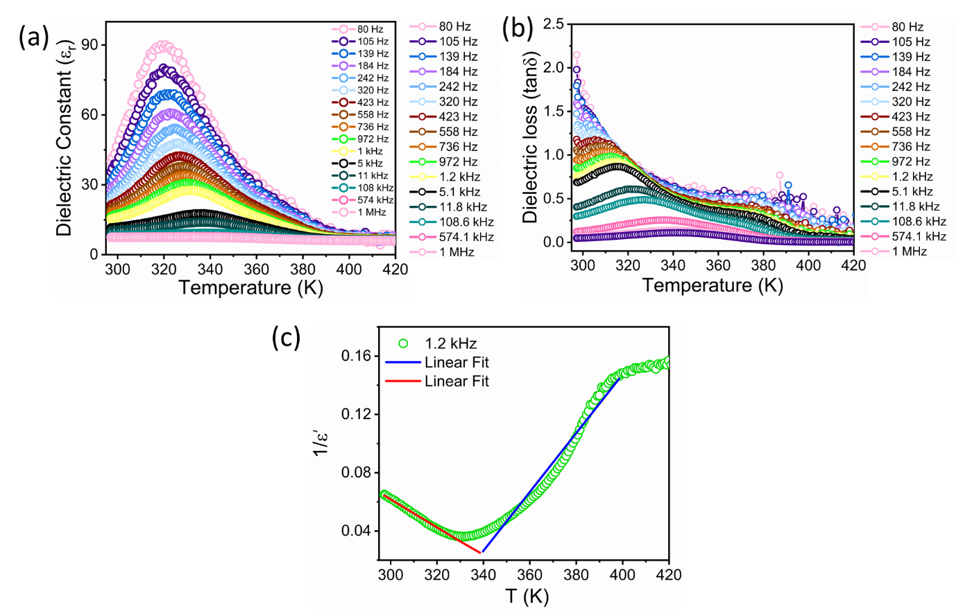
Supplementary Fig. 5. Temperature dependence dielectric analysis of complex Co3Dy. (a) real part of complex dielectric constant (ε_{r}) and (b) dielectric loss (tan δ) at various frequencies; (c) 1/ε` vs T curve at 0.1 MHz and its linear fit following Curie-Weiss law.
Supplementary Fig. 6. Temperature-dependent Direct Current (DC) magnetic susceptibility measurement of complex Co3Dy. (a) χ_{M}T versus T (represented black and red dots are experimental and computational respectively) (b) Magnetisation (M) vs. Magnetic Field (H) plot at 2, 4 and 6 K.

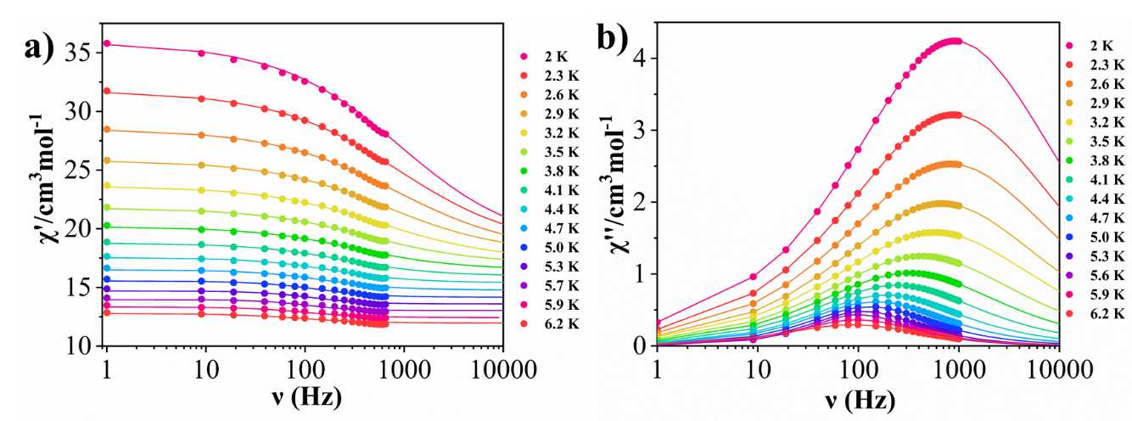
Supplementary Fig. 7. Alternate current (ac) susceptibility measurement at applied zero DC field. (a) The in-phase (χ’) and (b) out-of-phase (χ’’) susceptibility in the temperature range of 2 - 6.2 K for complex Co3Dy. The solid lines are the best fit using the Debye model. The solid lines have been extended up to 10,000 Hz using the fitting parameters obtained from experimental AC data.

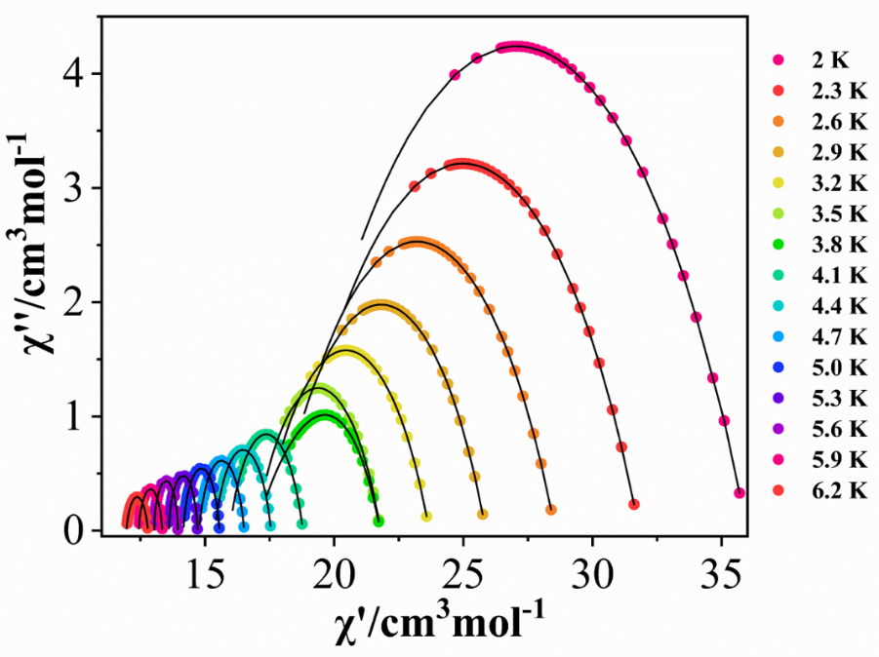
Supplementary Fig. 8. The Cole-Cole plot for complex Co3Dy.
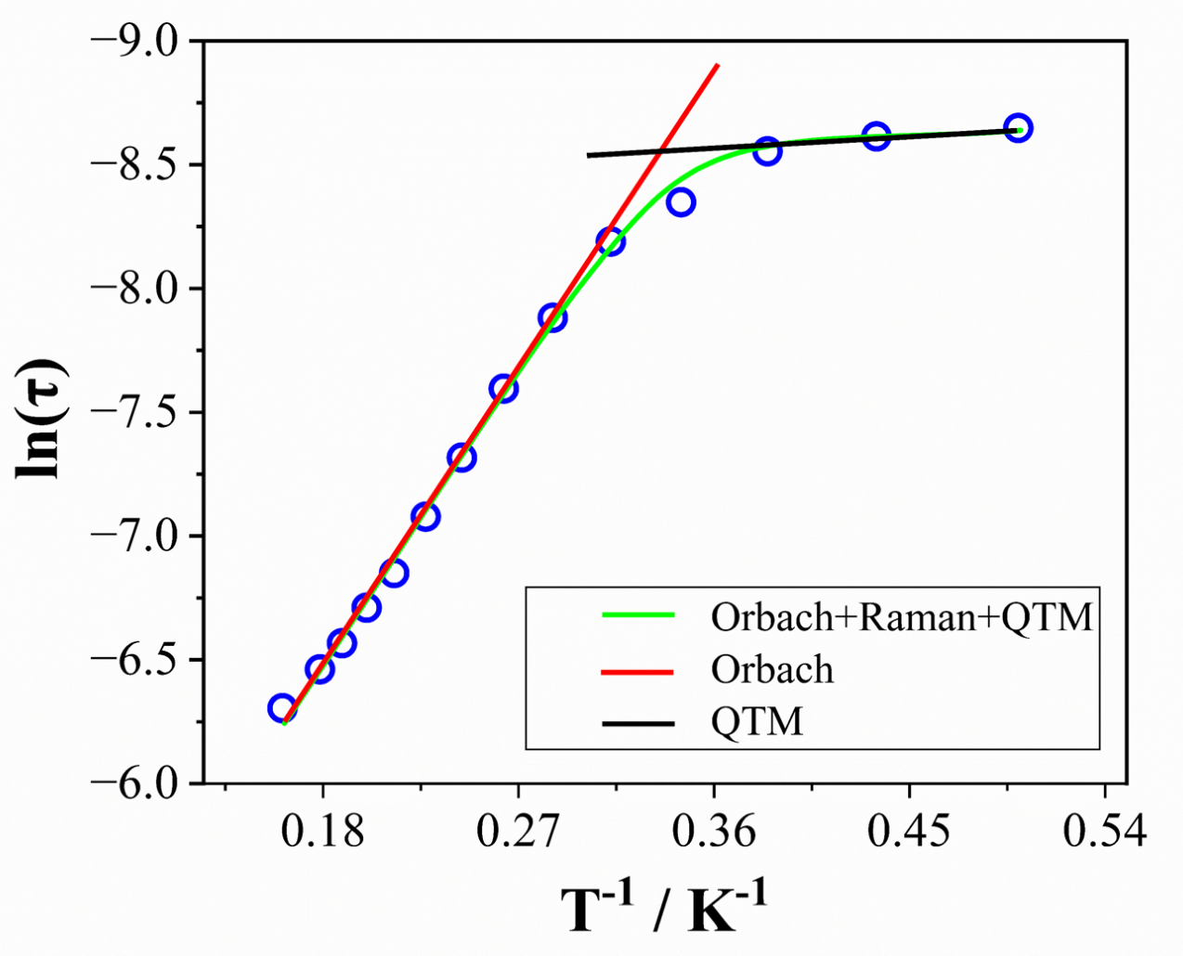
Supplementary Fig. 9. Arrhenius plot of complex Co3Dy.
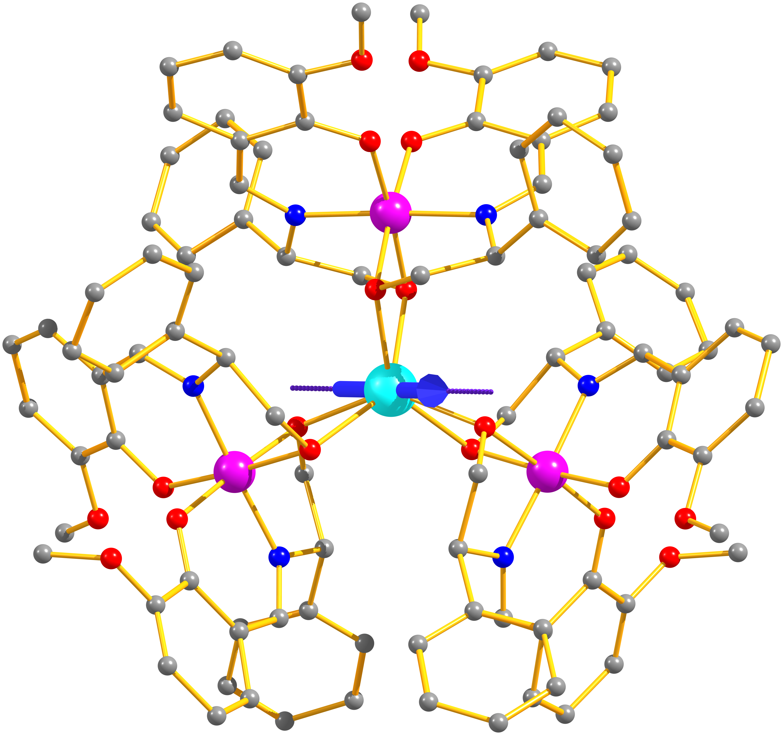
Supplementary Fig. 10. The orientation of the magnetic anisotropy axis (represented by the blue arrow) for the Dy^{III} ion within complex Co3Dy.

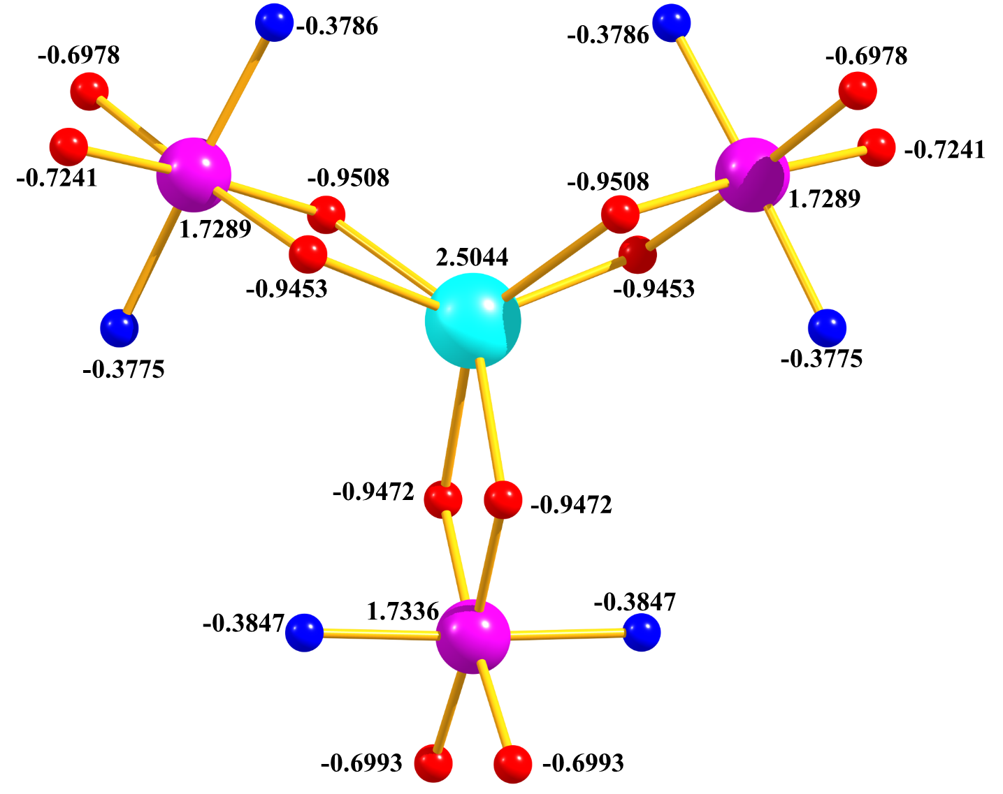
Supplementary Fig. 11. The observed LoProp charge on each atom from the CASSCF step of complex Co3Dy.
Supplementary Fig. 12. Dynamics of magnetization relaxation for Dy^{III} ion in complex Co3Dy.
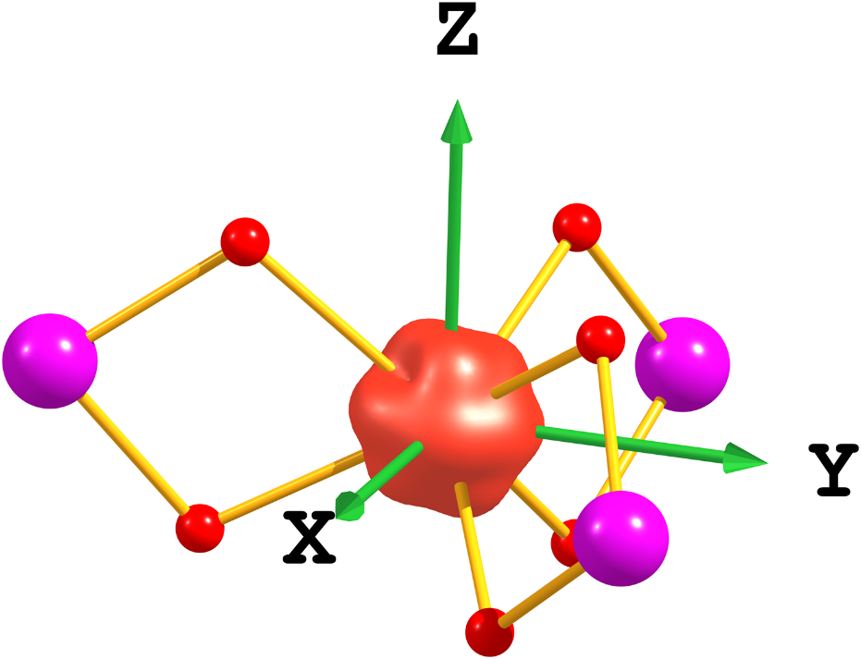
Supplementary Fig. 13. The computed beta-electron density of complex Co3Dy.
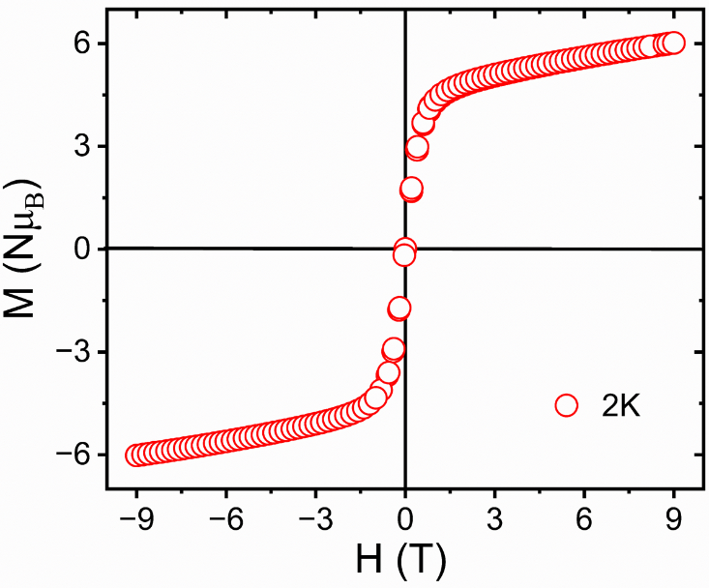
Supplementary Fig. 14. Magnetic hysteresis loop measurement performed on polycrystalline sample of Co3Dy at 2 K.
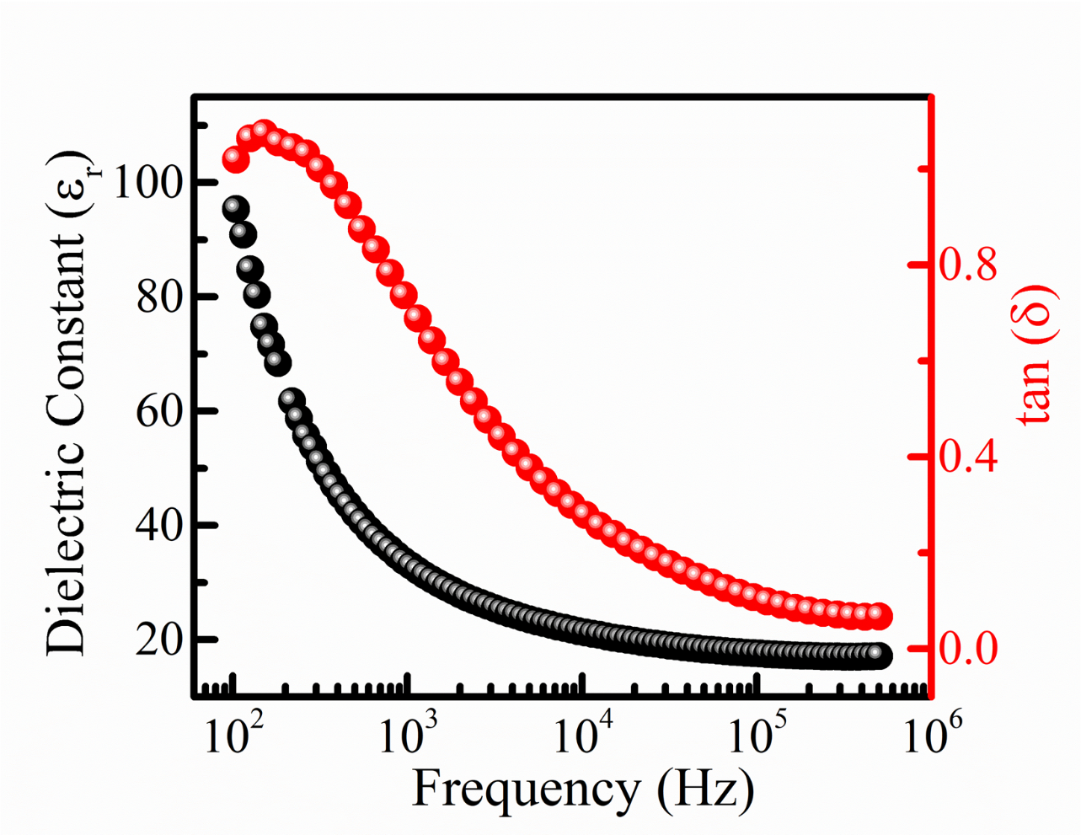
Supplementary Fig.15. Variation of dielectric constant and loss tangent with frequency for complex Co3Dy.
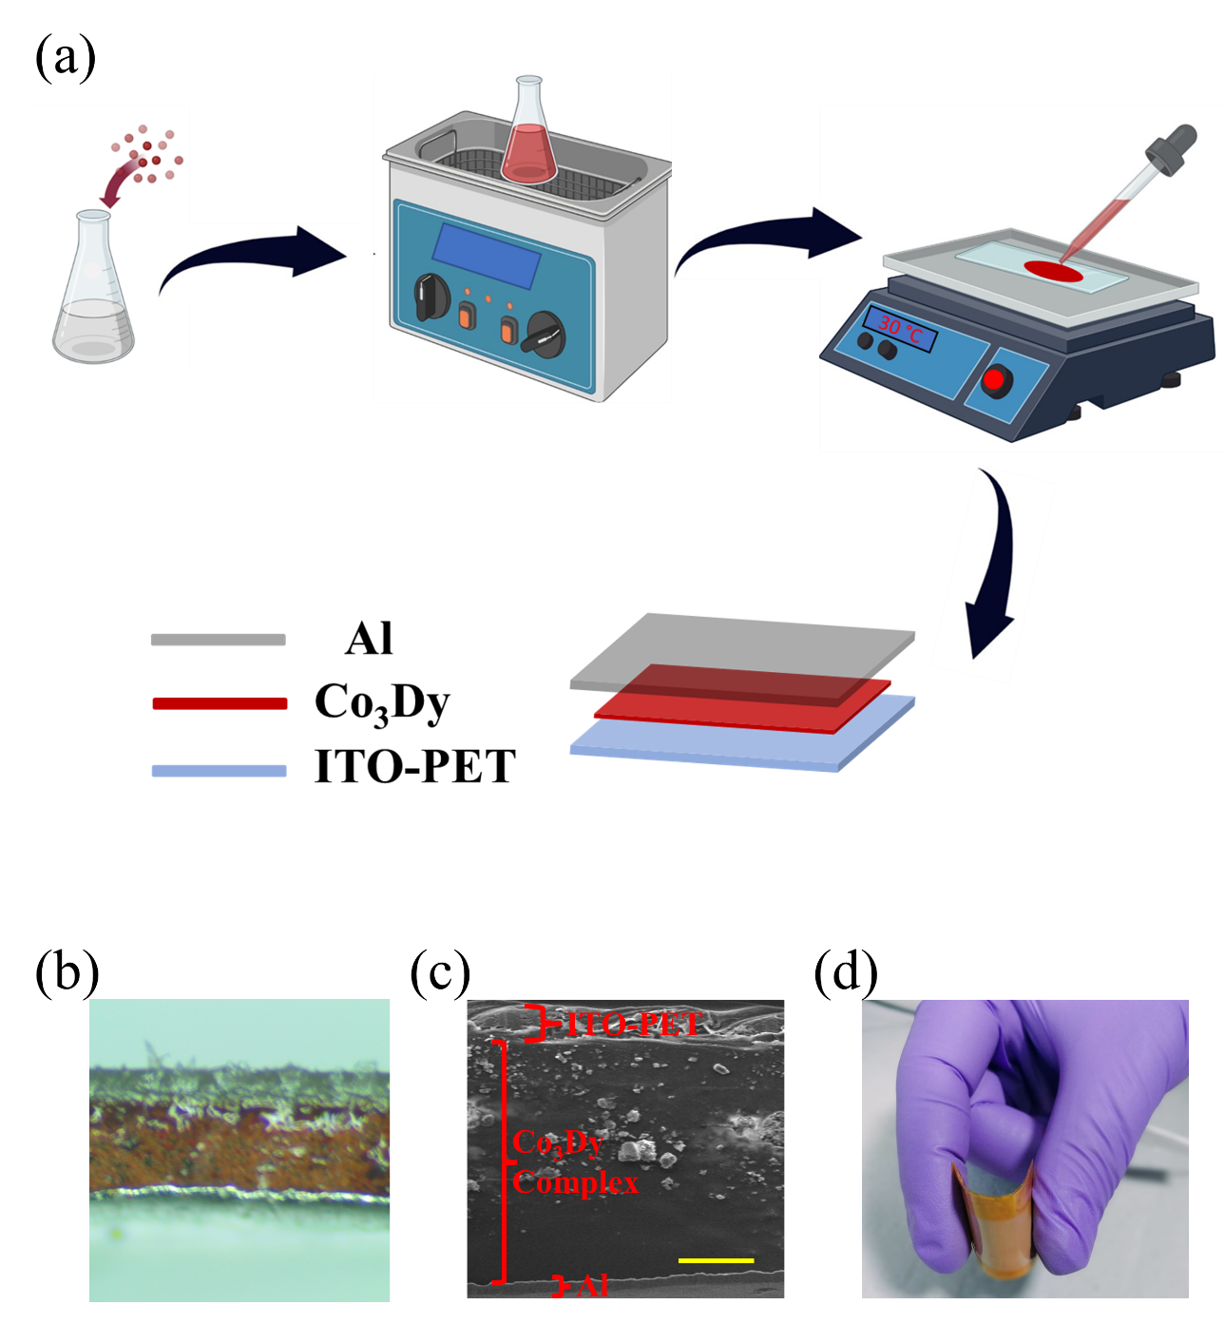
Supplementary Fig.16. (a) Schematic illustration of the fabrication process of Co3Dy-MENG, Cross-sectional (a) real optical photograph and (c) FeSEM image of Co3Dy-MENG, (d) Real image of flexible Co3Dy-MENG.

Supplementary Fig. 17. PXRD pattern of the complex Co3Dy-MENG device and the 100 % sample of Co3Dy.
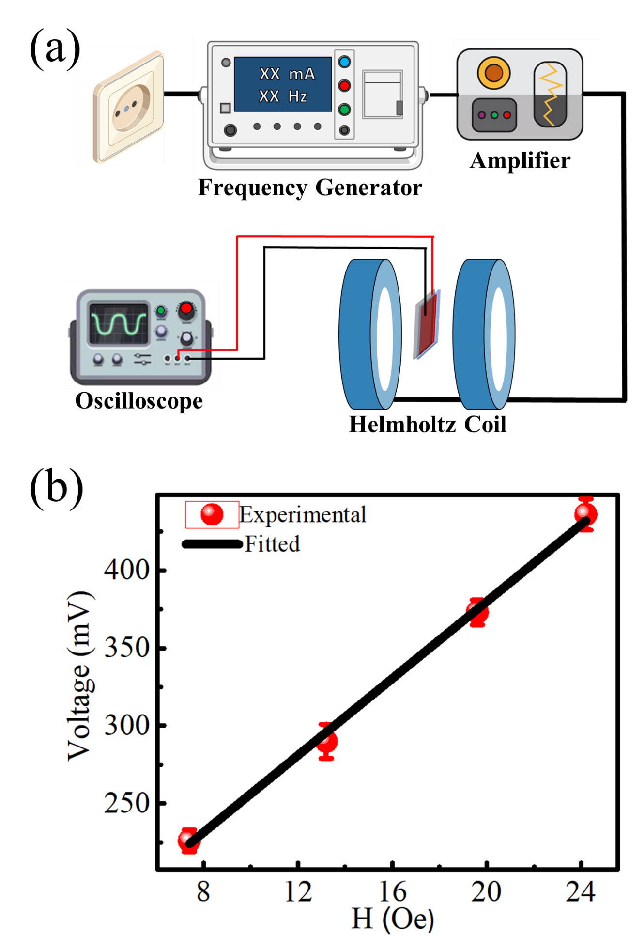
Supplementary Fig.18. (a) Schematic representation of the experimental setup for α measurement, (b) Relationship between obtained open circuit voltage and applied ac magnetic field.
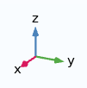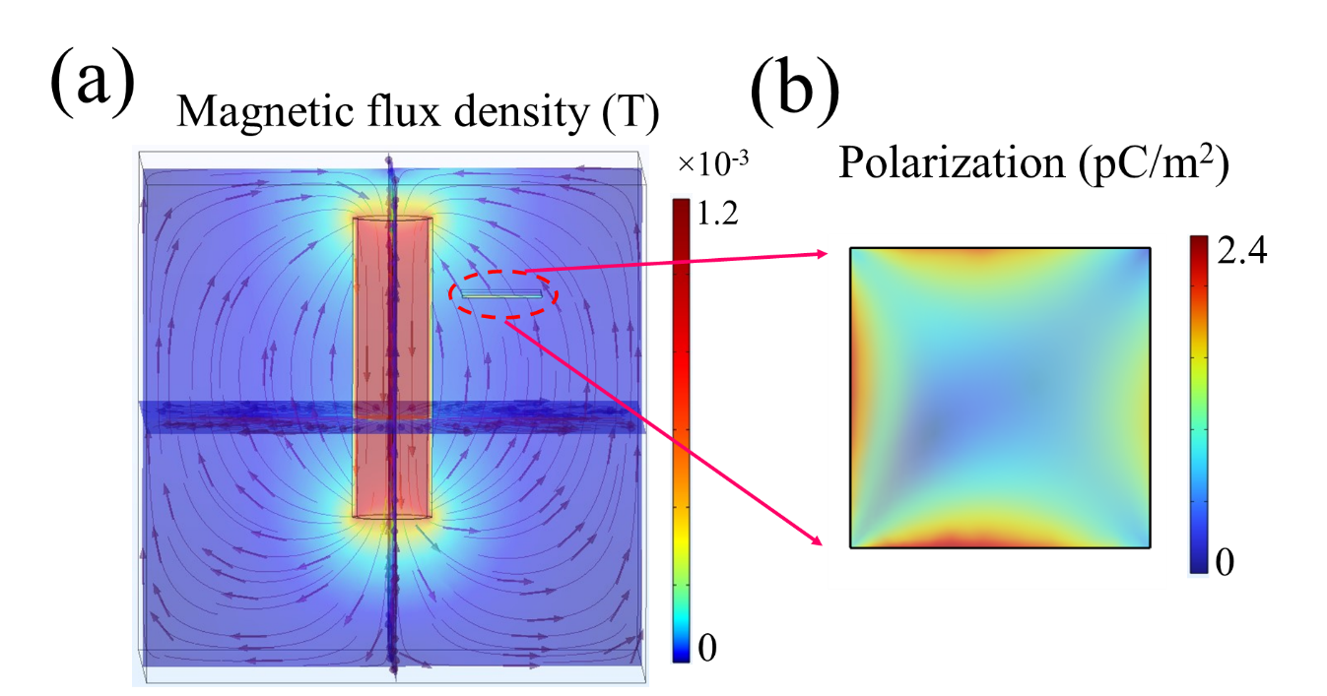
Supplementary Fig.19. Finite elemental analysis-based theoretical simulation (a) magnetic flux density around a current-carrying conducting cylindrical coil, (b) induced electrical polarization at complex Co3Dy surface.
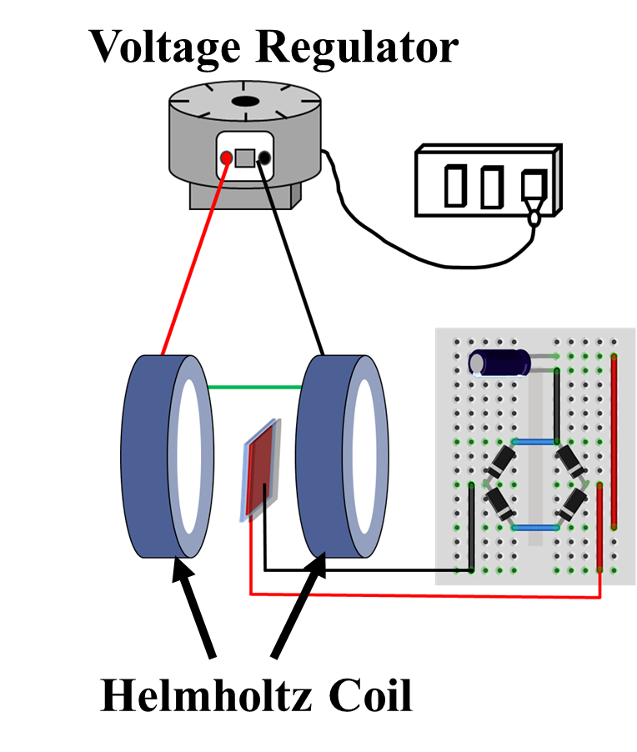
Supplementary Fig.20. Schematic representation of experimental setup for investigation of magnetic energy harvesting performance of Co3Dy-MENG.
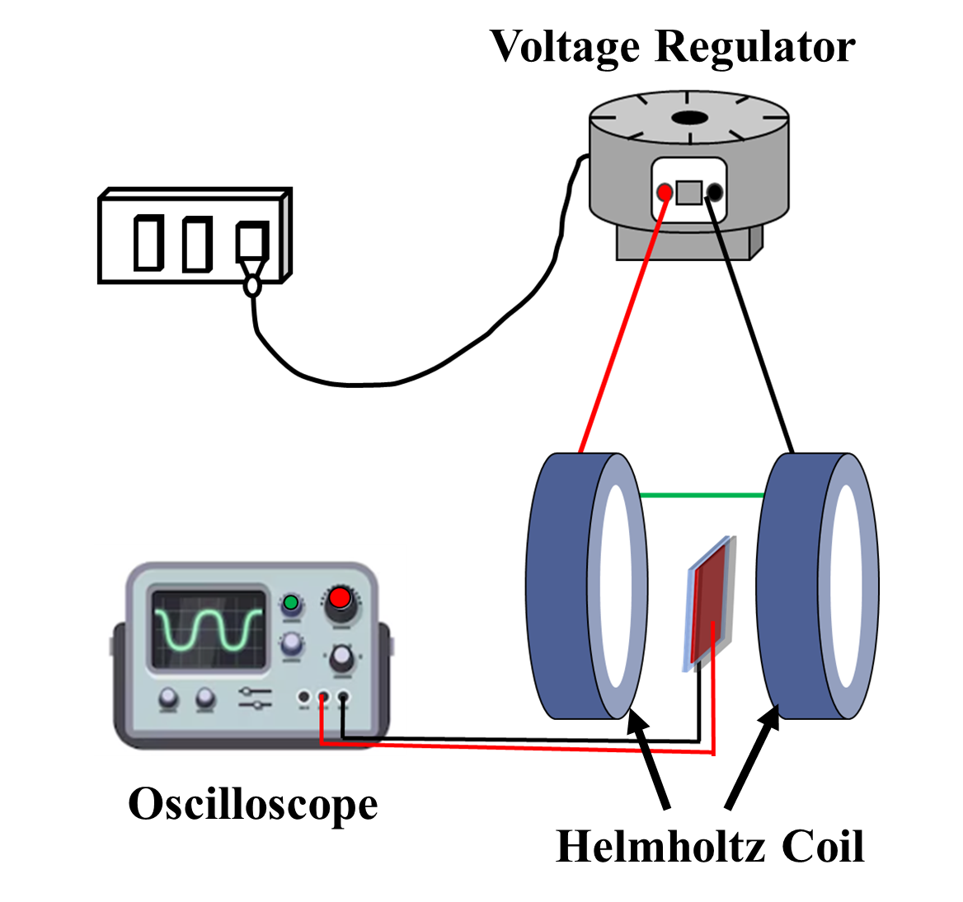
Supplementary Fig.21. Experimental setup for capacitor charging performance of Co3Dy-MENG.

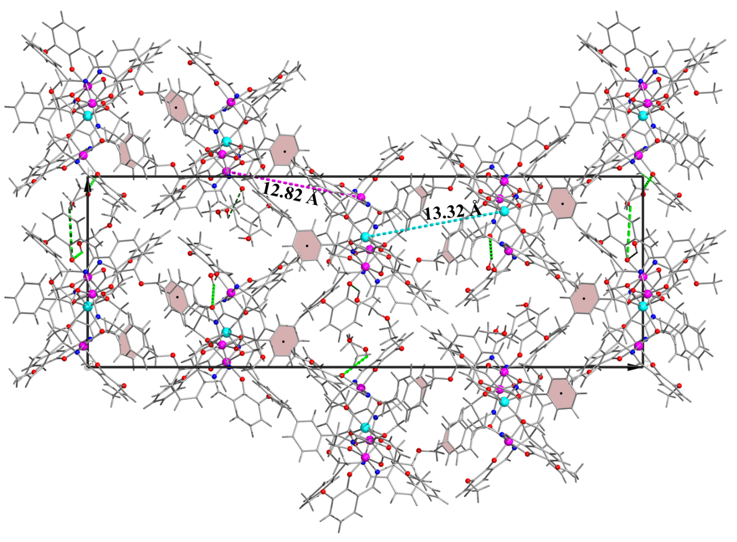
Supplementary Fig. 22. Packing diagram of complex Co3Dy. Dark red line shows the shortest distance between two Dy centre. Colour Code: Dy: cyan; Co: pink; Nitrogen: blue; Oxygen: Red; Carbon: grey; and Hydrogen: black.
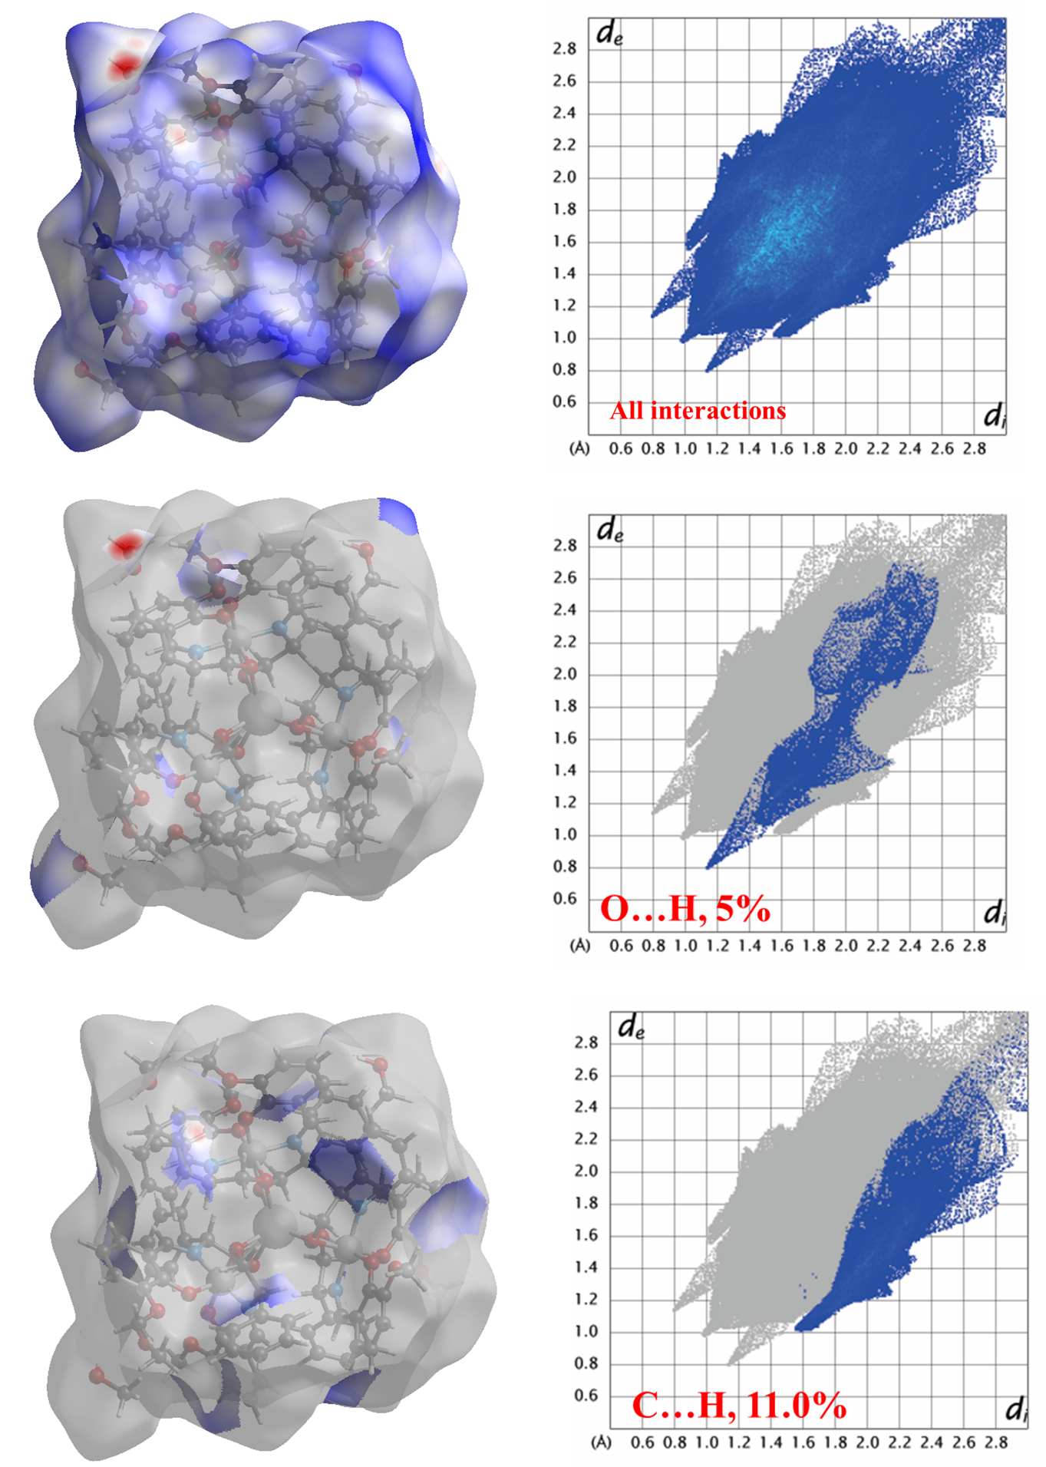
Supplementary Fig. 23. The Hirshfield surface analysis of complex Co3Dy. Generated d_{norm} (left) and the 2D fingerprint plot (right).

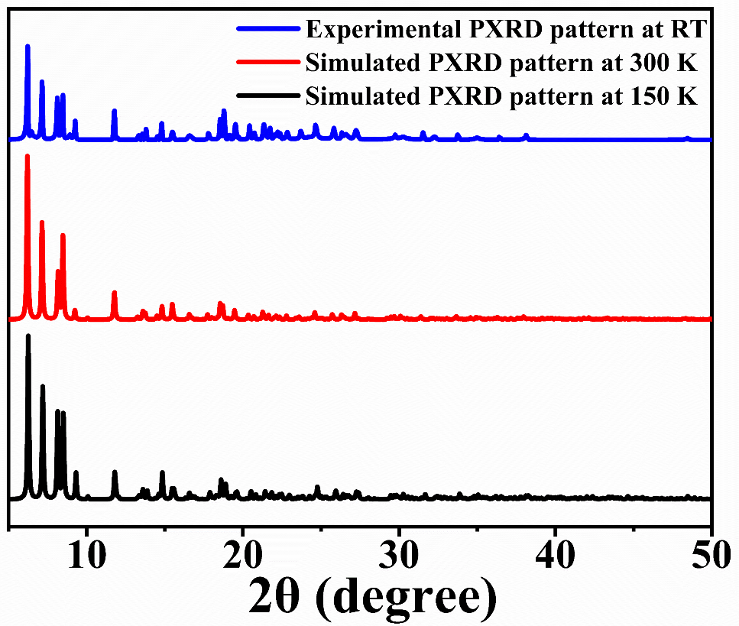
Supplementary Fig. 24 The experimental and simulated PXRD pattern of complex Co3Dy at temperatures 150 K and 300 K.

Supplementary Tables (T1-T12)
Supplementary Table 1. Crystallographic parameters for complex Co3Dy.
 | 150 K | 300 K
Empirical formula | C₁₀₀H₉₀Co₃DyN₆O₂₂ | C₁₀₀H₉₀Co₃DyN₆O₂₂
Formula weight (g/mol) | 2067.06 | 2067.06
Temperature/K | 150.00(10) | 300.00(10)
Crystal system | tetragonal | tetragonal
Space group | P4₃ | P4₃
a/Å | 14.9198(2) | 15.0715(3)
b/Å | 14.9198(2) | 15.0715(3)
c/Å | 43.3931(9) | 43.2852(14)
α/° | 90 | 90
β/° | 90 | 90
γ/° | 90 | 90
Volume/Å³ | 9659.3(3) | 9832.2(5)
Z | 4 | 4
ρ_{calc}g/cm³ | 1.421 | 1.321
μ/mm⁻¹ | 1.345 | 1.314
F(000) | 4220.0 | 3996.0
Crystal size/mm³ | 0.17 × 0.14 × 0.12 | 0.17 × 0.14 × 0.12
Radiation | Mo Kα (λ = 0.71073) | Mo Kα (λ = 0.71073)
2Θ range for data collection/° | 3.922 to 50 | 3.764 to 49.992
Index ranges | -17 ≤ h ≤ 17, -17 ≤ k ≤ 16, -51 ≤ l ≤ 51 | -17 ≤ h ≤ 17, -17 ≤ k ≤ 16, -51 ≤ l ≤ 51
Reflections collected | 91533 | 114219
Independent reflections | 16960 [R_{int} = 0.0969, R_{sigma} = 0.0751] | 17332 [R_{int} = 0.1493, R_{sigma} = 0.1080]
Data/restraints/parameters | 16960/75/1153 | 17332/13/1123
Goodness-of-fit on F² | 1.031 | 0.959
Final R indexes [I>=2σ (I)] | R₁ = 0.0496, wR₂ = 0.1175 | R₁ = 0.0518, wR₂ = 0.0836
Final R indexes [all data] | R₁ = 0.0641, wR₂ = 0.1263 | R₁ = 0.0885, wR₂ = 0.0970
Largest diff. peak/hole / e Å⁻³ | 1.18/-0.70 | 0.57/-0.56
Flack parameter | -0.012(6) | -0.029(8)

Supplementary Table 2. The observed best-fitting parameters for the Cole-Cole plot in complex Co3Dy.
S. No. | Temperature  (K) | χ_{S} | χ_{T} | τ | α | residual
1 | 2 | 18.1711 | 35.9272 | 0.175362E-03 | 0.450267 | 0.595365
2 | 2.3 | 18.1547 | 31.8020 | 0.181464E-03 | 0.439602 | 0.510206
3 | 2.6 | 17.8526 | 28.5490 | 0.192673E-03 | 0.437401 | 0.456678
4 | 2.9 | 17.7730 | 25.8596 | 0.236796E-03 | 0.420407 | 0.410512
5 | 3.2 | 17.2397 | 23.6755 | 0.277500E-03 | 0.419232 | 0.300157
6 | 3.5 | 16.9639 | 21.7898 | 0.377467E-03 | 0.391861 | 0.290121
7 | 3.8 | 16.4752 | 20.1947 | 0.502484E-03 | 0.364254 | 0.258827
8 | 4.1 | 15.9519 | 18.7909 | 0.664189E-03 | 0.316742 | 0.195373
9 | 4.4 | 15.3882 | 17.5529 | 0.842985E-03 | 0.262309 | 0.238650
10 | 4.7 | 14.7727 | 16.5124 | 0.105830E-02 | 0.216584 | 0.266861
11 | 5.0 | 14.1587 | 15.5557 | 0.121734E-02 | 0.154618 | 0.275793
12 | 5.3 | 13.5962 | 14.7047 | 0.140616E-02 | 0.087635 | 0.385595
13 | 5.6 | 13.0322 | 13.9506 | 0.156158E-02 | 0.030968 | 0.477394
14 | 5.9 | 12.4317 | 13.3428 | 0.162909E-02 | 0.021413 | 0.183250
15 | 6.2 | 11.9526 | 12.7888 | 0.182705E-02 | 0.217434 | 0.065079

Supplementary Table 3. Computed energies of the eight low-lying KDs of Dy^{III} ion along with the ground state g-tenors for complex Co3Dy.
Energy (cm-1) | g_{x} | g_{y} | g_{z} | The angle of g_{zz} between ground and higher excited KD’s (°)
0.0 | 0.236 | 0.250 | 18.025
9.3 | 0.181 | 0.205 | 16.332 | 51.34
103.3 | 0.270 | 0.355 | 11.470 | 31.69
219.1 | 1.41 | 1.934 | 8.437 | 25.45
265.6 | 0.021 | 0.034 | 19.796 | 27.13
328.1 | 0.620 | 2.382 | 5.702 | 31.56
408.6 | 5.575 | 5.389 | 2.385 | 15.11
459.8 | 0.857 | 5.202 | 15.113 | 89.31

Supplementary Table 4. Computed crystal field parameter of Dy^{III} ion in complex Co3Dy.
k | q | B(k,q)
2 | -2 | 1.41E+00
 | -1 | -5.32E-01
 | 0 | -3.73E+00
 | 1 | 2.45E-01
 | 2 | 7.83E+00
4 | -4 | 9.13E-03
 | -3 | 1.90E-02
 | -2 | 3.07E-02
 | -1 | 4.08E-02
 | 0 | 6.95E-02
 | 1 | -2.20E-02
 | 2 | 1.76E-02
 | 3 | 6.78E-01
 | 4 | -5.46E-03
6 | -6 | -9.17E-05
 | -5 | -3.43E-03
 | -4 | -3.96E-04
 | -3 | -3.65E-04
 | -2 | -6.41E-04
 | -1 | 1.09E-03
 | 0 | 7.41E-04
 | 1 | -6.27E-04
 | 2 | -2.03E-04
 | 3 | -9.42E-03
 | 4 | 2.08E-04
 | 5 | -1.69E-03
 | 6 | -2.56E-03

Supplementary Table 5. Magnetodielectric effect comparison of complex Co3Dy with other Organic-Inorganic hybrid and coordination complexes.
Compound | MD in % | MD temperature zone in K | Reference
[(CH₃)₂NH₂]Cu(HCOO)₃ | -0.06 at 7 T | ˂ 55 | ¹
[(CH₃)₂NH₂]Fe(HCOO)₃ | -0.06 at 5 T | ˂ 40 | ²
[Co(C₁₆H₁₅N₅O₂)] | 0.038 at 5 T | ˂ 40 | ³
[C₆H₅CH₂CH₂NH₃]₂[MnCl₄] | 0.34 at 0.1 T | ˂ 50 | ⁴
[C₆H₅CH₂CH₂NH₃]₂[CuCl₄] | 0.21 at 0.1 T | ˂ 11 | ⁴
MnO₃PC₆H₄-m-Br⋅H₂O | 0.04 at 9 T | ˂ 40 | ⁵
[{Mn^{III}(CH₂(CN)₂)₂(H₂O)₂}  {Chloranil^{•−}}]·(H₂O)_{x} | -1.9 at 2 T | 300 | ⁶
[Dy(L)₂(C₂H₅OH)Cl₃]·C₂H₅OH  (L=tricyclohexylphosphine oxide) | 0.75 at 9 T  (Hǁb axis) | ˂ 40 | ⁷
Cr[(H₃N-(CH₂)₂-PO₃)(Cl)H₂O | 0.0275 at 5 T | ˂ 10 | ⁸
Co₂(OH)_{3.8}(C₂₉H₄₂O₆P₂)_{0.10}·2.9H₂O | 0.16 at 7 T | ˂ 110 | ⁹
[N(CH₃)(CH₂CH₃)₃][FeBr₄] | 18 at 9 T | 330-380 | ¹⁰
[NH₂(CH₃)₂]_{n}[Fe^{III}Fe^{II}_{(1−x)}  Ni^{II}_{x}(HCOO)₆]_{n} (x≈ 0.63–0.69) | -20 to -24 at 0.1 T | 300-410 | ¹¹
[NH₂(CH₃)₂]_{n}[Fe_{III}Fe_{II}(HCOO)₆]_{n} | 7.5 at 9 T | < 25 | ¹²
Iron-tetracyanoquinodimethane (FeTCNQ) | 0.3 at 2 T | 160 | ¹³
[Co3Dy(L)6].4MeOH  (L = (R, E)-2-(((2-hydroxy-1-phenylethyl)  imino)methyl)-6-methoxyphenol | -2 at 0.5 T  and  -3 at 0.8 T | 300 | This work

Supplementary Table 6. SHAPE analysis of the coordination polyhedra around the Dy^{III} ion in complex Co3Dy.
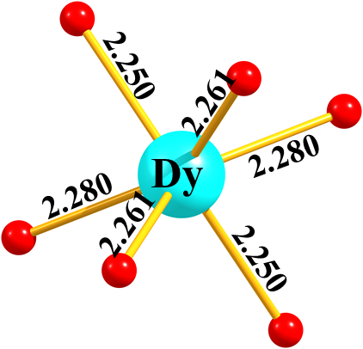

S. No. | Geometry | CShM value
1. | Johnson pentagonal pyramid J2 (C5v) | 21.273
2. | Trigonal prism (D3h) | 2.405
3. | Octahedron (Oh) | 9.693
4. | Pentagonal pyramid (C5v) | 17.182
5. | Hexagon (D6h) | 37.663

Supplementary Table 7. SHAPE analysis of the coordination polyhedra around the Co^{III} ion in complex Co3Dy.
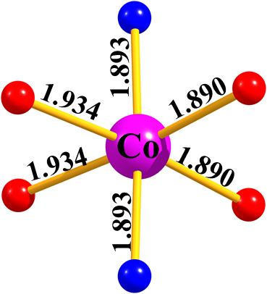

S. No. | Geometry | CShM value
1. | Johnson pentagonal pyramid J2 (C5v) | 30.428
2. | Trigonal prism (D3h) | 14.768
3. | Octahedron (Oh) | 0.338
4. | Pentagonal pyramid (C5v) | 26.951
5. | Hexagon (D6h) | 28.877

Supplementary Table 8. Selected bond length at 150 K in complex Co3Dy.
Atom | Atom | Length/Å
Dy(1) | Co(1) | 3.2666(13)
Dy(1) | Co(2) | 3.2666(13)
Dy(1) | Co(3) | 3.2772(12)
Dy(1) | O(2) | 2.249(7)
Dy(1) | O(3) | 2.246(7)
Dy(1) | O(6) | 2.259(7)
Dy(1) | O(4) | 2.289(7)
Dy(1) | O(5) | 2.259(7)
Dy(1) | O(1) | 2.280(7)
Co(1) | O(2) | 1.932(7)
Co(1) | O(1) | 1.947(7)
Co(1) | O(7) | 1.876(7)
Co(1) | O(8) | 1.869(7)
Co(1) | N(2) | 1.910(9)
Co(1) | N(1) | 1.899(8)
Co(2) | O(3) | 1.951(7)
Co(2) | O(4) | 1.937(7)
Co(2) | O(11) | 1.879(7)
Co(2) | O(12) | 1.869(7)
Co(2) | N(3) | 1.894(9)
Co(2) | N(4) | 1.890(8)
Co(3) | O(6) | 1.937(7)
Co(3) | O(5) | 1.929(7)
Co(3) | O(16) | 1.900(7)
Co(3) | O(15) | 1.889(7)
Co(3) | N(5) | 1.897(8)
Co(3) | N(6) | 1.900(8)

Supplementary Table 9. Selected bond angle at 150 K in complex Co3Dy.
Atom | Atom | Atom | Angle (˚)
Co(1) | Dy(1) | Co(2) | 125.19(3)
Co(1) | Dy(1) | Co(3) | 117.38(3)
Co(2) | Dy(1) | Co(3) | 117.44(3)
O(2) | Dy(1) | Co(1) | 35.26(17)
O(2) | Dy(1) | Co(2) | 122.34(17)
O(2) | Dy(1) | Co(3) | 107.79(17)
O(2) | Dy(1) | O(6) | 92.1(2)
O(2) | Dy(1) | O(4) | 92.1(2)
O(2) | Dy(1) | O(5) | 117.8(2)
O(2) | Dy(1) | O(1) | 71.1(2)
O(3) | Dy(1) | Co(1) | 122.39(17)
O(3) | Dy(1) | Co(2) | 35.74(17)
O(3) | Dy(1) | Co(3) | 107.47(17)
O(3) | Dy(1) | O(2) | 144.7(2)
O(3) | Dy(1) | O(6) | 117.5(2)
O(3) | Dy(1) | O(4) | 71.3(2)
O(3) | Dy(1) | O(5) | 91.5(2)
O(3) | Dy(1) | O(1) | 92.0(3)
O(6) | Dy(1) | Co(1) | 120.02(16)
O(6) | Dy(1) | Co(2) | 104.57(16)
O(6) | Dy(1) | Co(3) | 35.25(17)
O(6) | Dy(1) | O(4) | 88.7(2)
O(6) | Dy(1) | O(5) | 70.3(2)
O(6) | Dy(1) | O(1) | 143.2(2)
O(4) | Dy(1) | Co(1) | 111.96(17)
O(4) | Dy(1) | Co(2) | 35.61(17)
O(4) | Dy(1) | Co(3) | 118.51(17)
O(5) | Dy(1) | Co(1) | 104.83(16)
O(5) | Dy(1) | Co(2) | 119.84(17)
O(5) | Dy(1) | Co(3) | 35.06(17)
O(5) | Dy(1) | O(4) | 143.1(2)
O(5) | Dy(1) | O(1) | 88.5(2)
O(1) | Dy(1) | Co(1) | 35.82(17)
O(1) | Dy(1) | Co(2) | 112.15(17)
O(1) | Dy(1) | Co(3) | 118.09(17)
O(1) | Dy(1) | O(4) | 123.4(2)
O(2) | Co(1) | Dy(1) | 42.2(2)
O(2) | Co(1) | O(1) | 85.5(3)
O(1) | Co(1) | Dy(1) | 43.3(2)
O(7) | Co(1) | Dy(1) | 136.9(2)
O(7) | Co(1) | O(2) | 177.8(3)
O(7) | Co(1) | O(1) | 93.6(3)
O(7) | Co(1) | N(2) | 95.1(4)
O(7) | Co(1) | N(1) | 84.9(3)
O(8) | Co(1) | Dy(1) | 132.6(2)
O(8) | Co(1) | O(2) | 90.5(3)
O(8) | Co(1) | O(1) | 175.5(3)
O(8) | Co(1) | O(7) | 90.5(3)
O(8) | Co(1) | N(2) | 87.5(4)
O(8) | Co(1) | N(1) | 95.8(3)
N(2) | Co(1) | Dy(1) | 89.3(3)
N(2) | Co(1) | O(2) | 83.0(3)
N(2) | Co(1) | O(1) | 94.0(3)
N(1) | Co(1) | Dy(1) | 88.5(2)
N(1) | Co(1) | O(2) | 96.9(3)
N(1) | Co(1) | O(1) | 82.8(3)
N(1) | Co(1) | N(2) | 176.7(4)
O(3) | Co(2) | Dy(1) | 42.3(2)
O(4) | Co(2) | Dy(1) | 43.5(2)
O(4) | Co(2) | O(3) | 85.7(3)
O(11) | Co(2) | Dy(1) | 136.8(2)
O(11) | Co(2) | O(3) | 178.0(3)
O(11) | Co(2) | O(4) | 93.3(3)
O(11) | Co(2) | N(3) | 94.6(4)
O(11) | Co(2) | N(4) | 85.3(3)
O(12) | Co(2) | Dy(1) | 132.9(2)
O(12) | Co(2) | O(3) | 90.8(3)
O(12) | Co(2) | O(4) | 175.9(3)
O(12) | Co(2) | O(11) | 90.2(3)
O(12) | Co(2) | N(3) | 87.9(4)
O(12) | Co(2) | N(4) | 94.8(4)
N(3) | Co(2) | Dy(1) | 89.7(2)
N(3) | Co(2) | O(3) | 83.7(3)
N(3) | Co(2) | O(4) | 93.8(3)
N(4) | Co(2) | Dy(1) | 88.5(2)
N(4) | Co(2) | O(3) | 96.3(3)
N(4) | Co(2) | O(4) | 83.6(3)
N(4) | Co(2) | N(3) | 177.3(4)
O(6) | Co(3) | Dy(1) | 42.3(2)
O(5) | Co(3) | Dy(1) | 42.3(2)
O(5) | Co(3) | O(6) | 84.6(3)
O(16) | Co(3) | Dy(1) | 134.7(2)
O(16) | Co(3) | O(6) | 175.9(3)
O(16) | Co(3) | O(5) | 92.5(3)
O(15) | Co(3) | Dy(1) | 134.3(2)
O(15) | Co(3) | O(6) | 92.0(3)
O(15) | Co(3) | O(5) | 175.5(3)
O(15) | Co(3) | O(16) | 91.0(3)
O(15) | Co(3) | N(5) | 94.3(3)
O(15) | Co(3) | N(6) | 87.0(3)
N(5) | Co(3) | Dy(1) | 88.8(2)
N(5) | Co(3) | O(6) | 94.9(3)
N(5) | Co(3) | O(5) | 83.1(3)
N(5) | Co(3) | O(16) | 87.6(3)
N(5) | Co(3) | N(6) | 177.5(3)
N(6) | Co(3) | Dy(1) | 88.8(2)
N(6) | Co(3) | O(6) | 82.9(3)
N(6) | Co(3) | O(5) | 95.6(3)
N(6) | Co(3) | O(16) | 94.6(3)
Co(1) | O(2) | Dy(1) | 102.5(3)

Supplementary Table 10. Selected bond length at 300 K in complex Co3Dy.
Atom | Atom | Length (Å)
Dy(1) | Co(1) | 3.2847(14)
Dy(1) | Co(2) | 3.2820(14)
Dy(1) | Co(3) | 3.2877(13)
Dy(1) | O(2) | 2.251(7)
Dy(1) | O(5) | 2.251(7)
Dy(1) | O(3) | 2.242(7)
Dy(1) | O(4) | 2.280(6)
Dy(1) | O(1) | 2.277(7)
Dy(1) | O(6) | 2.249(7)
Co(1) | O(2) | 1.929(7)
Co(1) | O(1) | 1.944(7)
Co(1) | O(7) | 1.881(7)
Co(1) | O(8) | 1.893(7)
Co(1) | N(2) | 1.893(9)
Co(1) | N(1) | 1.894(8)
Co(2) | O(3) | 1.932(7)
Co(2) | O(4) | 1.935(6)
Co(2) | O(12) | 1.884(7)
Co(2) | O(11) | 1.878(7)
Co(2) | N(3) | 1.887(9)
Co(2) | N(4) | 1.908(8)
Co(3) | O(5) | 1.940(7)
Co(3) | O(6) | 1.942(7)
Co(3) | O(15) | 1.886(7)
Co(3) | O(17) | 1.881(8)
Co(3) | N(6) | 1.923(9)
Co(3) | N(5) | 1.903(9)

Supplementary Table 11. Selected bond angle at 300 K in complex Co3Dy.
Atom | Atom | Atom | Angle (˚)
Co(1) | Dy(1) | Co(3) | 117.40(4)
Co(2) | Dy(1) | Co(1) | 125.19(4)
Co(2) | Dy(1) | Co(3) | 117.41(4)
O(2) | Dy(1) | Co(1) | 34.85(17)
O(2) | Dy(1) | Co(2) | 122.67(18)
O(2) | Dy(1) | Co(3) | 107.77(17)
O(2) | Dy(1) | O(5) | 117.7(3)
O(2) | Dy(1) | O(4) | 93.0(3)
O(2) | Dy(1) | O(1) | 70.2(2)
O(5) | Dy(1) | Co(1) | 105.06(17)
O(5) | Dy(1) | Co(2) | 119.57(17)
O(5) | Dy(1) | Co(3) | 35.08(17)
O(5) | Dy(1) | O(4) | 142.4(2)
O(5) | Dy(1) | O(1) | 88.7(2)
O(3) | Dy(1) | Co(1) | 122.33(18)
O(3) | Dy(1) | Co(2) | 34.92(17)
O(3) | Dy(1) | Co(3) | 108.04(17)
O(3) | Dy(1) | O(2) | 144.2(2)
O(3) | Dy(1) | O(5) | 92.1(2)
O(3) | Dy(1) | O(4) | 70.1(2)
O(3) | Dy(1) | O(1) | 92.7(3)
O(3) | Dy(1) | O(6) | 117.9(3)
O(4) | Dy(1) | Co(1) | 112.46(17)
O(4) | Dy(1) | Co(2) | 35.22(16)
O(4) | Dy(1) | Co(3) | 118.20(17)
O(1) | Dy(1) | Co(1) | 35.38(16)
O(1) | Dy(1) | Co(2) | 112.50(17)
O(1) | Dy(1) | Co(3) | 118.02(18)
O(1) | Dy(1) | O(4) | 123.8(2)
O(6) | Dy(1) | Co(1) | 119.77(18)
O(6) | Dy(1) | Co(2) | 104.86(18)
O(6) | Dy(1) | Co(3) | 35.14(17)
O(6) | Dy(1) | O(2) | 92.1(2)
O(6) | Dy(1) | O(5) | 70.2(2)
O(6) | Dy(1) | O(4) | 88.8(2)
O(6) | Dy(1) | O(1) | 142.6(2)
O(2) | Co(1) | Dy(1) | 41.8(2)
O(2) | Co(1) | O(1) | 84.5(3)
O(1) | Co(1) | Dy(1) | 42.7(2)
O(7) | Co(1) | Dy(1) | 137.0(2)
O(7) | Co(1) | O(2) | 178.0(3)
O(7) | Co(1) | O(1) | 94.2(3)
O(7) | Co(1) | O(8) | 90.6(3)
O(7) | Co(1) | N(2) | 95.2(4)
O(7) | Co(1) | N(1) | 84.5(4)
O(8) | Co(1) | Dy(1) | 132.5(2)
O(8) | Co(1) | O(2) | 90.7(3)
O(8) | Co(1) | O(1) | 175.0(3)
O(8) | Co(1) | N(2) | 87.0(4)
O(8) | Co(1) | N(1) | 95.8(4)
N(2) | Co(1) | Dy(1) | 89.0(3)
N(2) | Co(1) | O(2) | 83.3(4)
N(2) | Co(1) | O(1) | 93.8(4)
N(2) | Co(1) | N(1) | 177.2(4)
N(1) | Co(1) | Dy(1) | 89.2(2)
N(1) | Co(1) | O(2) | 96.9(3)
N(1) | Co(1) | O(1) | 83.4(3)
O(3) | Co(2) | Dy(1) | 41.6(2)
O(3) | Co(2) | O(4) | 84.4(3)
O(4) | Co(2) | Dy(1) | 42.82(19)
O(12) | Co(2) | Dy(1) | 136.5(2)
O(12) | Co(2) | O(3) | 177.5(3)
O(12) | Co(2) | O(4) | 93.7(3)
O(12) | Co(2) | N(3) | 95.0(4)
O(12) | Co(2) | N(4) | 84.6(4)
O(11) | Co(2) | Dy(1) | 132.5(2)
O(11) | Co(2) | O(3) | 91.0(3)
O(11) | Co(2) | O(4) | 175.1(3)
O(11) | Co(2) | O(12) | 90.9(3)
O(11) | Co(2) | N(3) | 87.4(4)
O(11) | Co(2) | N(4) | 95.1(4)
N(3) | Co(2) | Dy(1) | 89.4(3)
N(3) | Co(2) | O(3) | 83.4(4)
N(3) | Co(2) | O(4) | 93.7(3)
N(3) | Co(2) | N(4) | 177.5(4)
N(4) | Co(2) | Dy(1) | 89.2(2)
N(4) | Co(2) | O(3) | 96.9(3)
N(4) | Co(2) | O(4) | 83.8(3)
O(5) | Co(3) | Dy(1) | 41.8(2)
O(5) | Co(3) | O(6) | 83.6(2)
O(6) | Co(3) | Dy(1) | 41.8(2)
O(15) | Co(3) | Dy(1) | 134.8(2)
O(15) | Co(3) | O(5) | 175.8(3)
O(15) | Co(3) | O(6) | 93.1(3)
O(15) | Co(3) | N(6) | 86.5(3)
O(15) | Co(3) | N(5) | 94.8(4)
O(17) | Co(3) | Dy(1) | 134.3(3)
O(17) | Co(3) | O(5) | 92.5(3)
O(17) | Co(3) | O(6) | 175.6(3)
O(17) | Co(3) | O(15) | 90.9(3)
O(17) | Co(3) | N(6) | 95.1(4)

Supplementary Table 12. Summarizes hydrogen bonding in Complex Co3Dy, showcasing atom pairs, bond distances (Å), and angles (degrees).
H-Bond Donor(D)- Acceptor(A) | D….A (Å) | ∠DHA (°)
C33-H33B...O1 | 3.296(12) | 106.2
C33-H33A...O12 | 2.839(12) | 106.2
C1-H1A...O7 | 2.861(12) | 106.7
C50-H50...O6 | 3.093(11) | 138.9
C82-H82...O2 | 3.201(12) | 136.6
C49-H49A...O11 | 2.858(13) | 106.7
C34-H34...O1 | 3.385(12) | 132.7
C17-H17B...O4 | 3.337(12) | 104.6
C17-H17A...O8 | 2.809(12) | 107.1
C66-H66...O3 | 3.209(12) | 136.7
C81-H81B...O2 | 3.268(13) | 100.7
C81-H81A...O15 | 2.868(13) | 107
C18-H18...O4 | 3.376(12) | 133.3
C65-H65B...O3 | 3.247(12) | 101.9
C65-H65A...O16 | 2.897(13) | 106.1
C40-H40...O13 | 3.329(16) | 145.1
C2-H2...O5 | 3.111(12) | 137.6
C24-H24...O9 | 3.342(16) | 143.5
C72-H72...O17 | 3.347(16) | 147.4
C84-H84...O18 | 3.387(17) | 145
C56-H56...O14 | 3.428(18) | 125.5
C8-H8...O10 | 3.397(17) | 126.5
C16-H16A...O10_$1 | 3.40(2) | 112.1
C64-H64B...O14_$2 | 3.38(2) | 110.4
C93-H93...O13_$3 | 3.320(15) | 131.4
C77-H77...O9_$4 | 3.320(14) | 130.4
C92-H92...O13_$3 | 3.454(17) | 118.4
C76-H76...O9_$4 | 3.431(17) | 119
C48-H48B...O11 | 3.08(2) | 114.6
C32-H32A...O7 | 3.13(2) | 111.8
C32-H32A...O21 | 3.34(4) | 128.3
$1 = 1-y,1+x,-0.25+z, $2 = +y,1-x,0.25+z, $3 = -1+x,+y,+z, $4 = +x,-1+y,+z, $5 = +x,1+y,+z

References
1 Wang, Z. et al. Dimethylammonium copper formate [(CH 3) 2 NH 2] Cu (HCOO) 3: A metal-organic framework with quasi-one-dimensional antiferromagnetism and magnetostriction. Physical Review B 87, 224406 (2013).
2 Tian, Y. et al. Cross coupling between electric and magnetic orders in a multiferroic metal-organic framework. Sci. Rep. 4, 6062 (2014).
3 Basu, T. et al. Magnetodielectric coupling in a non-perovskite metal–organic framework. Materials Horizons 4, 1178-1184 (2017).
4 Huang, B. et al. Spin-reorientation-induced magnetodielectric coupling effects in two layered perovskite magnets. Chem. Sci. 9, 7413-7418 (2018).
5 Basu, T. et al. Designing of a Magnetodielectric System in Hybrid Organic–Inorganic Framework, a Perovskite Layered Phosphonate MnO3PC6H4‐m‐Br⋅ H2O. Advanced Functional Materials 29, 1901878 (2019).
6 Shaw, B. K. & Saha, S. K. Giant magnetoresistance and magneto-dielectric effects in a charge transfer metal complex for multiferroic applications. The Journal of Physical Chemistry C 116, 20700-20707 (2012).
7 Wang, Y.-X. et al. Observation of magnetodielectric effect in a dysprosium-based single-molecule magnet. J. Am. Chem. Soc. 140, 7795-7798 (2018).
8 Nénert, G. et al. Magnetodielectric coupling of a polar organic-inorganic hybrid Cr (II) phosphonate. Physical Review B 78, 054443 (2008).
9 Evrard, Q. et al. Layered Simple Hydroxides Functionalized by Fluorene‐Phosphonic Acids: Synthesis, Interface Theoretical Insights, and Magnetoelectric Effect. Advanced Functional Materials 27, 1703576 (2017).
10 Cai, H.-L. et al. Above-room-temperature magnetodielectric coupling in a possible molecule-based multiferroic: triethylmethylammonium tetrabromoferrate (III). J. Am. Chem. Soc. 134, 18487-18490 (2012).
11 Chen, L. H. et al. Giant Room‐Temperature Magnetodielectric Response in a MOF at 0.1 Tesla. Advanced Materials 29, 1702512 (2017).
12 Guo, J. et al. An insight into the magnetoelectric coupling effect in the MOF of [NH2 (CH3) 2] n [FeIIIFeII (HCOO) 6] n. Applied Physics Letters 110 (2017).
13 Huang, Y. et al. Strongly correlated molecular magnet with curie temperature above 60 K. Matter 2, 1639-1650 (2020).

