Appendix
Appendix Figure S1. Age-standardized suicide-rates (ASSR) globally (all age groups), 2019.
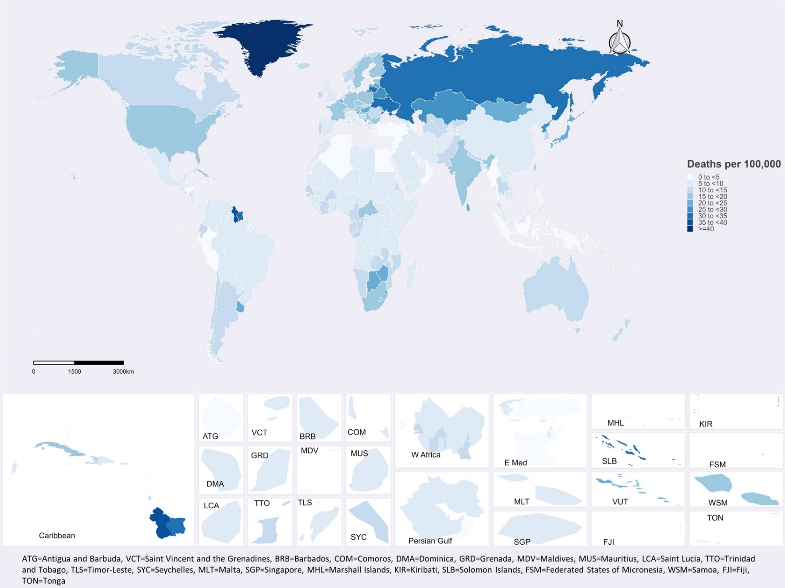
Appendix Figure S2. Percentage change in age-standardized suicide-rates (ASSR) globally (all age groups) between 1990 and 2019.
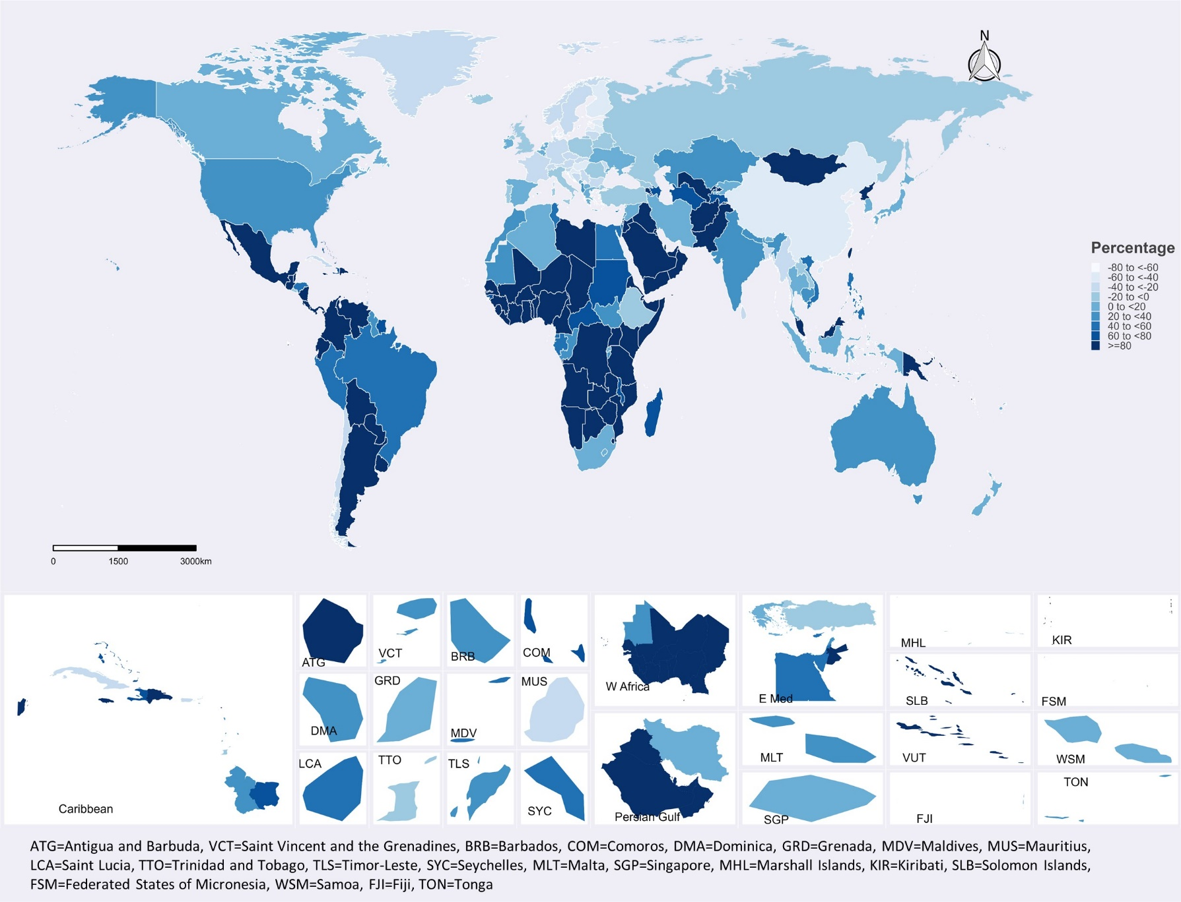
Appendix Figure S3. Global OA-NOA suicide-rates ratio in 2019.
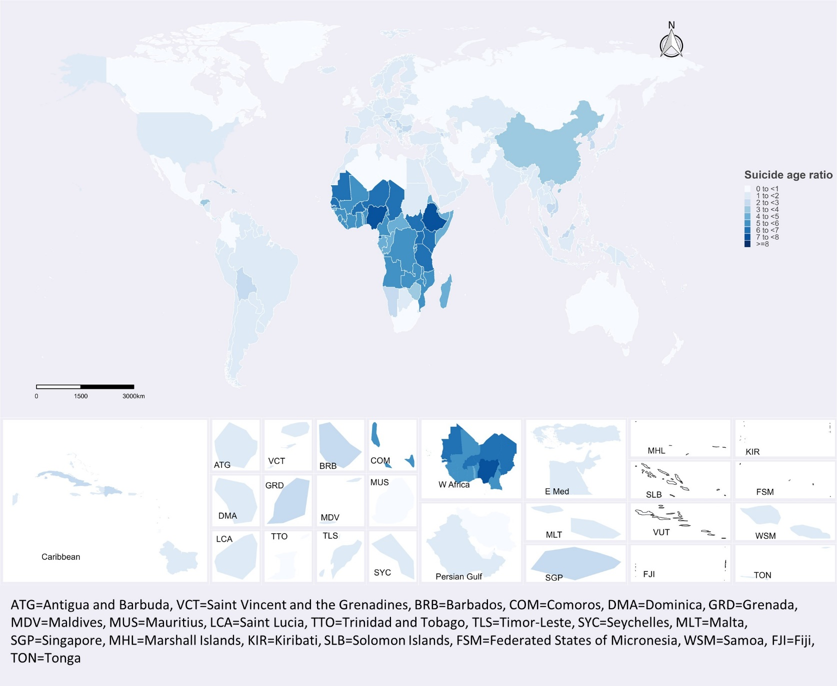
Appendix Table S1. Total number of older adult (OA) suicides, OA age-standardized suicide-rates (ASSR) per 100,000 in 1990 and 2019, total percent change in OA ASSR from 1990 to 2019, with uncertainty intervals (UI), and older-adult to non-older-adult (OA-NOA) suicide-rates ratios, in 2019, for all countries.
Location | Number of OA suicides (95% UI) |  | ASSR (95% UI) |  | Percent change (95% UI) | OA to NOA ASSR ratio
Location | 1990 | 2019 | 1990 | 2019 | Percent change (95% UI) | 1990 | 2019
Afghanistan | 696 (595, 797) | 1613 (1314, 1913) | 8.9 (7.62, 10.19) | 6.23 (5.07, 7.38) | -30.08 (-30.62, -29.54) | 1.31 | 1.61
Albania | 125 (114, 135) | 152 (133, 172) | 4.91 (4.5, 5.33) | 6.33 (5.52, 7.14) | 28.81 (28.19, 29.43) | 1.31 | 1.08
Algeria | 1405 (1161, 1649) | 1515 (1247, 1784) | 7.89 (6.52, 9.25) | 4.51 (3.71, 5.31) | -42.8 (-43.25, -42.36) | 0.74 | 0.96
American Samoa | 3 (3, 3) | 4 (3, 5) | 8.75 (7.52, 9.97) | 8.8 (7.41, 10.19) | 0.62 (-0.08, 1.31) | 1.24 | 1.16
Andorra | 6 (5, 7) | 8 (7, 9) | 12.36 (10.72, 13.99) | 10.62 (9.34, 11.89) | -14.07 (-14.58, -13.57) | 1.81 | 1.73
Angola | 973 (829, 1116) | 1928 (1665, 2190) | 14.23 (12.12, 16.33) | 9.57 (8.26, 10.87) | -32.77 (-33.21, -32.33) | 4.85 | 5.37
Antigua and Barbuda | 1 (1, 1) | 3 (2, 3) | 2.81 (2.55, 3.08) | 3.52 (3.11, 3.93) | 25.17 (24.55, 25.79) | 2.19 | 1.32
Argentina | 2758 (2670, 2846) | 5029 (4759, 5299) | 10.49 (10.16, 10.83) | 13.23 (12.52, 13.94) | 26.09 (25.84, 26.35) | 2.61 | 1.28
Armenia | 105 (99, 111) | 287 (266, 309) | 3.93 (3.71, 4.15) | 11.04 (10.21, 11.87) | 181.09 (180.25, 181.92) | 2.11 | 2.67
Australia | 2342 (2281, 2403) | 2898 (2771, 3025) | 16.35 (15.92, 16.77) | 13.48 (12.89, 14.07) | -17.55 (-17.68, -17.42) | 1.04 | 0.91
Austria | 1858 (1813, 1904) | 1418 (1354, 1481) | 27.1 (26.44, 27.76) | 17.6 (16.82, 18.39) | -35.04 (-35.14, -34.93) | 1.87 | 2.1
Azerbaijan | 224 (200, 248) | 379 (326, 433) | 3.99 (3.57, 4.41) | 4.36 (3.74, 4.98) | 9.38 (8.76, 10) | 1.59 | 1.64
Bahamas | 7 (6, 7) | 12 (10, 13) | 3.34 (3.05, 3.62) | 3.56 (3.18, 3.95) | 6.85 (6.38, 7.33) | 1.89 | 1.39
Bahrain | 28 (23, 32) | 77 (67, 88) | 7.08 (5.94, 8.22) | 5.99 (5.16, 6.82) | -15.42 (-15.98, -14.86) | 1.32 | 0.9
Bangladesh | 10883 (9555, 12212) | 7365 (6401, 8329) | 14.68 (12.89, 16.48) | 5.64 (4.9, 6.38) | -61.59 (-61.81, -61.37) | 1.03 | 1.48
Barbados | 12 (12, 13) | 15 (14, 16) | 5.8 (5.42, 6.18) | 5.59 (5.1, 6.09) | -3.65 (-4, -3.31) | 2.19 | 2.23
Belarus | 2341 (2270, 2412) | 2272 (2011, 2533) | 26.53 (25.73, 27.34) | 27.18 (24.06, 30.3) | 2.44 (2.07, 2.81) | 1.09 | 1.26
Belgium | 2187 (2134, 2240) | 2212 (2114, 2310) | 24.9 (24.3, 25.51) | 21.82 (20.85, 22.78) | -12.4 (-12.54, -12.25) | 1.71 | 1.34
Belize | 7 (7, 8) | 28 (25, 30) | 5.74 (5.3, 6.19) | 8.35 (7.57, 9.12) | 45.32 (44.76, 45.87) | 2.78 | 1.87
Benin | 282 (250, 314) | 742 (638, 847) | 9.29 (8.24, 10.33) | 8.72 (7.49, 9.95) | -6.1 (-6.64, -5.55) | 5.89 | 5.57
Bermuda | 4 (4, 4) | 3 (3, 3) | 7.45 (6.96, 7.94) | 4.92 (4.47, 5.36) | -34.05 (-34.29, -33.81) | 2.71 | 2.26
Bhutan | 37 (29, 44) | 41 (33, 49) | 8.47 (6.73, 10.21) | 6.54 (5.33, 7.75) | -22.81 (-23.53, -22.1) | 2.28 | 2.89
Bolivia (Plurinational State of) | 390 (337, 443) | 743 (638, 848) | 8.7 (7.52, 9.88) | 8.08 (6.93, 9.22) | -7.12 (-7.72, -6.53) | 1.72 | 2.03
Bosnia and Herzegovina | 471 (433, 509) | 366 (326, 405) | 12.37 (11.38, 13.37) | 12.23 (10.9, 13.55) | -1.18 (-1.59, -0.76) | 1.38 | 1.75
Botswana | 162 (134, 189) | 403 (319, 487) | 17.78 (14.76, 20.8) | 21.64 (17.14, 26.15) | 21.73 (20.64, 22.82) | 2.31 | 1.69
Brazil | 9249 (9056, 9441) | 13503 (13101, 13906) | 8.12 (7.95, 8.29) | 7.29 (7.07, 7.51) | -10.25 (-10.35, -10.15) | 1.69 | 1.25
Brunei Darussalam | 12 (10, 14) | 25 (22, 27) | 6.31 (5.23, 7.4) | 6.57 (5.95, 7.19) | 4.06 (3.37, 4.75) | 2.11 | 2.24
Bulgaria | 1788 (1731, 1845) | 1087 (991, 1183) | 23.58 (22.83, 24.34) | 17.29 (15.76, 18.81) | -26.71 (-26.92, -26.49) | 2.9 | 2.07
Burkina Faso | 700 (618, 782) | 1545 (1354, 1736) | 11.45 (10.11, 12.79) | 10.16 (8.91, 11.42) | -11.25 (-11.73, -10.77) | 7.08 | 6.27
Burundi | 615 (535, 695) | 800 (687, 912) | 17.04 (14.82, 19.27) | 9.91 (8.52, 11.31) | -41.83 (-42.17, -41.49) | 5.22 | 5.31
Cabo Verde | 32 (28, 35) | 82 (72, 92) | 13.14 (11.61, 14.67) | 17.89 (15.66, 20.13) | 36.18 (35.45, 36.91) | 2.45 | 3.05
Cambodia | 584 (506, 662) | 785 (687, 884) | 8.49 (7.36, 9.62) | 5.97 (5.22, 6.72) | -29.66 (-30.07, -29.25) | 1.86 | 2.22
Cameroon | 675 (602, 748) | 2260 (1929, 2591) | 9.87 (8.81, 10.94) | 10.85 (9.27, 12.44) | 9.94 (9.29, 10.59) | 5.32 | 5.13
Canada | 4086 (3986, 4187) | 4699 (4474, 4923) | 17.47 (17.03, 17.9) | 14.45 (13.76, 15.14) | -17.26 (-17.4, -17.12) | 0.9 | 0.86
Central African Republic | 380 (326, 434) | 620 (515, 724) | 20.6 (17.67, 23.53) | 16.62 (13.81, 19.44) | -19.3 (-19.86, -18.73) | 4.37 | 4.01
Chad | 356 (311, 400) | 996 (863, 1129) | 9.25 (8.1, 10.4) | 9.66 (8.37, 10.94) | 4.36 (3.75, 4.97) | 6.28 | 6.8
Chile | 2554 (2450, 2658) | 2006 (1907, 2105) | 24.31 (23.32, 25.3) | 12.71 (12.08, 13.33) | -47.72 (-47.83, -47.61) | 1.42 | 1.13
China | 214743 (203550, 225936) | 121217 (114001, 128432) | 22.29 (21.13, 23.45) | 9.56 (8.99, 10.13) | -57.11 (-57.22, -57.01) | 2.79 | 3.7
Colombia | 1416 (1345, 1487) | 2731 (2427, 3034) | 5.79 (5.5, 6.08) | 6.75 (6, 7.5) | 16.5 (16.06, 16.94) | 1.15 | 0.99
Comoros | 25 (20, 29) | 41 (34, 48) | 7.82 (6.3, 9.35) | 7.32 (6.01, 8.63) | -6.43 (-7.24, -5.61) | 6.05 | 5.02
Congo | 302 (259, 345) | 423 (359, 487) | 18.19 (15.59, 20.79) | 10.87 (9.22, 12.51) | -40.25 (-40.66, -39.85) | 4.22 | 4.9
Cook Islands | 3 (3, 4) | 2 (2, 3) | 21.61 (18.6, 24.61) | 15.26 (13.27, 17.25) | -29.39 (-29.8, -28.97) | 1.41 | 1.37
Costa Rica | 165 (156, 174) | 389 (349, 428) | 7.32 (6.94, 7.7) | 9.66 (8.68, 10.65) | 32.03 (31.55, 32.52) | 1.17 | 0.91
Côte d'Ivoire | 907 (794, 1021) | 1960 (1675, 2245) | 11.36 (9.94, 12.79) | 10.55 (9.02, 12.08) | -7.16 (-7.74, -6.58) | 5.97 | 5.65
Croatia | 1233 (1192, 1273) | 694 (630, 758) | 28.92 (27.96, 29.88) | 18.01 (16.35, 19.67) | -37.72 (-37.91, -37.54) | 2.45 | 2.26
Cuba | 2265 (2207, 2322) | 1736 (1593, 1879) | 24.8 (24.17, 25.42) | 17.09 (15.69, 18.5) | -31.07 (-31.26, -30.88) | 2.37 | 2.82
Cyprus | 42 (37, 47) | 67 (61, 73) | 6.5 (5.76, 7.25) | 5.71 (5.19, 6.23) | -12.23 (-12.64, -11.82) | 1.48 | 1.11
Czechia | 2323 (2260, 2386) | 1479 (1363, 1596) | 25.93 (25.23, 26.63) | 15.55 (14.33, 16.78) | -40.02 (-40.17, -39.87) | 2.04 | 1.42
Democratic People's Republic of Korea | 2882 (2485, 3278) | 2954 (2510, 3399) | 17.66 (15.23, 20.09) | 12.85 (10.92, 14.78) | -27.24 (-27.7, -26.77) | 1.94 | 2.17
Democratic Republic of the Congo | 2899 (2559, 3238) | 5980 (5153, 6806) | 11.52 (10.17, 12.87) | 9.76 (8.41, 11.11) | -15.3 (-15.79, -14.8) | 5.53 | 5.21
Denmark | 1533 (1493, 1573) | 668 (629, 706) | 33.44 (32.56, 34.32) | 12.88 (12.14, 13.63) | -61.47 (-61.54, -61.39) | 1.67 | 1.8
Djibouti | 22 (18, 25) | 75 (60, 90) | 6.62 (5.49, 7.75) | 8.26 (6.62, 9.9) | 24.76 (23.67, 25.84) | 5.75 | 4.94
Dominica | 3 (3, 3) | 4 (3, 4) | 5.45 (4.92, 5.97) | 6.37 (5.6, 7.13) | 16.89 (16.33, 17.45) | 2.25 | 1.8
Dominican Republic | 276 (237, 315) | 671 (566, 776) | 5.22 (4.49, 5.95) | 7.64 (6.45, 8.84) | 46.39 (45.41, 47.37) | 2.11 | 2.06
Ecuador | 486 (432, 541) | 1678 (1487, 1869) | 6.62 (5.88, 7.37) | 11.81 (10.46, 13.16) | 78.3 (77.33, 79.27) | 0.99 | 1
Egypt | 1949 (1620, 2279) | 3105 (2443, 3767) | 4.88 (4.06, 5.71) | 4.04 (3.18, 4.91) | -17.2 (-17.93, -16.48) | 1.38 | 1.8
El Salvador | 574 (526, 623) | 531 (458, 605) | 14.99 (13.73, 16.26) | 10.41 (8.97, 11.85) | -30.56 (-30.91, -30.21) | 0.76 | 1.05
Equatorial Guinea | 50 (42, 57) | 77 (61, 94) | 17.96 (15.34, 20.58) | 7.38 (5.79, 8.97) | -58.92 (-59.26, -58.57) | 4.25 | 6.11
Eritrea | 230 (194, 266) | 580 (483, 676) | 11.58 (9.76, 13.4) | 11.83 (9.86, 13.81) | 2.19 (1.46, 2.92) | 4.67 | 4.38
Estonia | 473 (457, 490) | 208 (188, 228) | 35.58 (34.36, 36.8) | 17.8 (16.11, 19.48) | -49.98 (-50.14, -49.82) | 1.28 | 1.44
Eswatini | 87 (74, 99) | 226 (182, 270) | 16.27 (13.92, 18.62) | 26.18 (21.07, 31.3) | 60.93 (59.67, 62.19) | 2.86 | 1.58
Ethiopia | 5877 (5385, 6369) | 5655 (5139, 6171) | 17.58 (16.11, 19.06) | 7.48 (6.79, 8.16) | -57.49 (-57.65, -57.32) | 5.34 | 7.44
Fiji | 78 (68, 89) | 84 (74, 95) | 13.79 (11.96, 15.63) | 11.53 (10.07, 12.98) | -16.45 (-16.95, -15.95) | 1.23 | 1.23
Finland | 1631 (1591, 1671) | 873 (831, 915) | 37.32 (36.4, 38.24) | 17.58 (16.74, 18.42) | -52.91 (-52.99, -52.82) | 0.82 | 1.05
France | 15103 (14731, 15474) | 11014 (10472, 11555) | 30.27 (29.52, 31.01) | 18.82 (17.89, 19.74) | -37.83 (-37.94, -37.72) | 2.14 | 1.68
Gabon | 122 (106, 138) | 172 (144, 201) | 17.71 (15.36, 20.05) | 12.71 (10.62, 14.81) | -28.2 (-28.69, -27.71) | 4.44 | 4.78
Gambia | 43 (36, 50) | 129 (108, 149) | 6.62 (5.52, 7.73) | 7.99 (6.72, 9.27) | 20.69 (19.81, 21.57) | 6.12 | 6.28
Georgia | 314 (296, 331) | 313 (285, 342) | 6.84 (6.46, 7.22) | 9.92 (9.01, 10.82) | 44.89 (44.41, 45.38) | 2.02 | 1.67
Germany | 14918 (14556, 15281) | 11664 (11126, 12201) | 20.97 (20.46, 21.48) | 15.12 (14.42, 15.82) | -27.89 (-28, -27.77) | 1.9 | 1.85
Ghana | 772 (678, 867) | 2065 (1786, 2345) | 7.63 (6.7, 8.57) | 8.68 (7.51, 9.86) | 13.74 (13.1, 14.37) | 5.26 | 5.06
Global | 739087 (721967, 756208) | 759028 (737148, 780909) | 17.88 (17.47, 18.3) | 11.82 (11.48, 12.16) | -33.89 (-33.97, -33.81) | 1.93 | 1.87
Greece | 439 (423, 455) | 500 (470, 529) | 4.8 (4.63, 4.98) | 5.31 (5, 5.63) | 10.6 (10.36, 10.84) | 2.08 | 1.49
Greenland | 52 (46, 58) | 34 (30, 38) | 115.08 (101.99, 128.16) | 70.05 (62.33, 77.76) | -39.13 (-39.43, -38.83) | 0.81 | 0.96
Grenada | 5 (4, 5) | 5 (5, 6) | 7.27 (6.71, 7.83) | 5.83 (5.34, 6.32) | -19.86 (-20.17, -19.55) | 2.44 | 2.36
Guam | 22 (20, 24) | 32 (29, 35) | 20.19 (18.31, 22.07) | 22.84 (20.81, 24.88) | 13.15 (12.69, 13.61) | 1.33 | 0.87
Guatemala | 447 (414, 481) | 953 (847, 1059) | 8.38 (7.76, 9) | 6.89 (6.12, 7.66) | -17.81 (-18.16, -17.47) | 1.47 | 0.98
Guinea | 353 (308, 398) | 805 (694, 916) | 8.69 (7.58, 9.8) | 9.4 (8.1, 10.7) | 8.14 (7.5, 8.78) | 5.08 | 5.51
Guinea-Bissau | 92 (78, 105) | 163 (141, 186) | 13.84 (11.86, 15.83) | 12.15 (10.46, 13.84) | -12.21 (-12.77, -11.64) | 4.66 | 4.6
Guyana | 193 (178, 207) | 250 (222, 279) | 33.38 (30.88, 35.87) | 39.68 (35.13, 44.23) | 18.88 (18.37, 19.39) | 1.98 | 1.3
Haiti | 612 (533, 692) | 1017 (861, 1173) | 13.82 (12.02, 15.62) | 10.75 (9.1, 12.39) | -22.23 (-22.72, -21.74) | 1.76 | 1.86
Honduras | 168 (141, 194) | 241 (185, 296) | 5.33 (4.49, 6.18) | 3.17 (2.44, 3.9) | -40.55 (-41.1, -40.01) | 1.53 | 3.67
Hungary | 4240 (4134, 4346) | 1902 (1756, 2048) | 46.5 (45.34, 47.66) | 21.66 (20, 23.33) | -53.41 (-53.53, -53.3) | 1.9 | 1.84
Iceland | 39 (37, 41) | 37 (35, 39) | 18.35 (17.49, 19.22) | 12.37 (11.66, 13.09) | -32.59 (-32.76, -32.43) | 1.99 | 1.9
India | 154133 (146292, 161975) | 195336 (183617, 207055) | 24.8 (23.54, 26.06) | 17.01 (15.99, 18.04) | -31.4 (-31.57, -31.23) | 0.94 | 1.1
Indonesia | 6520 (6036, 7004) | 7658 (6976, 8339) | 4.67 (4.33, 5.02) | 3.52 (3.2, 3.83) | -24.76 (-25.02, -24.5) | 1.37 | 1.7
Iran (Islamic Republic of) | 3640 (3381, 3899) | 4172 (3872, 4472) | 9.06 (8.41, 9.7) | 5.94 (5.51, 6.37) | -34.44 (-34.66, -34.23) | 0.85 | 0.91
Iraq | 766 (618, 914) | 2075 (1723, 2427) | 6.5 (5.25, 7.76) | 6.33 (5.25, 7.4) | -2.68 (-3.5, -1.87) | 1.06 | 1.49
Ireland | 370 (357, 384) | 435 (408, 463) | 12.46 (12.02, 12.9) | 10.28 (9.64, 10.92) | -17.48 (-17.66, -17.29) | 1.02 | 0.79
Israel | 373 (360, 387) | 545 (516, 574) | 9.5 (9.16, 9.85) | 7.27 (6.89, 7.66) | -23.48 (-23.64, -23.32) | 2.35 | 1.76
Italy | 5166 (5107, 5225) | 4315 (4221, 4410) | 10.11 (9.99, 10.22) | 7.81 (7.64, 7.98) | -22.7 (-22.76, -22.64) | 2.43 | 1.62
Jamaica | 34 (32, 36) | 89 (80, 99) | 1.89 (1.75, 2.02) | 3.68 (3.29, 4.08) | 95.32 (94.54, 96.09) | 1.95 | 1.52
Japan | 24234 (24058, 24409) | 24773 (24381, 25166) | 21.72 (21.57, 21.88) | 21.04 (20.71, 21.38) | -3.13 (-3.18, -3.07) | 2.25 | 1.28
Jordan | 123 (108, 139) | 260 (230, 291) | 4.73 (4.15, 5.32) | 2.84 (2.5, 3.17) | -40.11 (-40.44, -39.77) | 2.06 | 1.74
Kazakhstan | 3378 (3273, 3482) | 4275 (3952, 4598) | 26.39 (25.58, 27.21) | 28.92 (26.73, 31.1) | 9.56 (9.28, 9.85) | 1.4 | 1.13
Kenya | 1141 (1017, 1264) | 3155 (2852, 3458) | 7.52 (6.71, 8.34) | 8.44 (7.63, 9.25) | 12.16 (11.64, 12.67) | 8.77 | 6.5
Kiribati | 24 (20, 27) | 30 (26, 34) | 44.72 (38.75, 50.69) | 33.6 (28.79, 38.41) | -24.87 (-25.34, -24.39) | 0.7 | 0.69
Kuwait | 42 (39, 46) | 135 (120, 150) | 3.11 (2.84, 3.38) | 3.52 (3.13, 3.91) | 13.31 (12.82, 13.81) | 1.42 | 1.46
Kyrgyzstan | 599 (575, 622) | 600 (556, 644) | 18.26 (17.54, 18.97) | 11.89 (11.02, 12.77) | -34.86 (-35.04, -34.68) | 1.46 | 1.16
Lao People's Democratic Republic | 450 (382, 518) | 430 (365, 495) | 15.79 (13.4, 18.18) | 7.65 (6.49, 8.8) | -51.57 (-51.9, -51.23) | 1.07 | 1.33
Latvia | 812 (786, 839) | 392 (357, 426) | 35.9 (34.74, 37.07) | 22.88 (20.84, 24.92) | -36.27 (-36.46, -36.08) | 1.36 | 1.22
Lebanon | 129 (105, 152) | 176 (141, 212) | 5.4 (4.41, 6.38) | 4.2 (3.36, 5.04) | -22.22 (-22.92, -21.52) | 1.07 | 1.12
Lesotho | 290 (236, 344) | 736 (588, 885) | 22.56 (18.39, 26.73) | 44.49 (35.53, 53.45) | 97.17 (95.48, 98.86) | 3.34 | 2.05
Liberia | 124 (105, 143) | 259 (218, 299) | 9.41 (7.99, 10.84) | 7.33 (6.18, 8.48) | -22.13 (-22.67, -21.58) | 5.3 | 5.21
Libya | 166 (138, 195) | 347 (289, 404) | 5.69 (4.71, 6.66) | 5.95 (4.97, 6.94) | 4.67 (3.89, 5.45) | 1.01 | 0.97
Lithuania | 1159 (1122, 1195) | 857 (788, 927) | 37.28 (36.11, 38.45) | 34.16 (31.39, 36.94) | -8.36 (-8.6, -8.12) | 1.12 | 1.12
Luxembourg | 76 (72, 80) | 69 (65, 74) | 22.61 (21.55, 23.67) | 12.52 (11.69, 13.35) | -44.61 (-44.76, -44.47) | 1.58 | 1.9
Madagascar | 925 (819, 1031) | 1522 (1321, 1722) | 11.61 (10.28, 12.94) | 7.97 (6.92, 9.02) | -31.33 (-31.7, -30.95) | 4.17 | 4.96
Malawi | 718 (637, 798) | 1209 (1054, 1363) | 11.36 (10.09, 12.64) | 9.17 (8, 10.35) | -19.28 (-19.72, -18.84) | 5.54 | 5.77
Malaysia | 988 (874, 1102) | 1803 (1546, 2060) | 7.56 (6.68, 8.43) | 6.89 (5.91, 7.87) | -8.82 (-9.34, -8.3) | 3.06 | 2.61
Maldives | 13 (11, 14) | 20 (17, 23) | 8.71 (7.45, 9.96) | 4.78 (4.06, 5.49) | -45.15 (-45.51, -44.79) | 1.99 | 1.76
Mali | 477 (403, 551) | 947 (783, 1111) | 8.52 (7.2, 9.83) | 6.55 (5.41, 7.68) | -23.13 (-23.7, -22.57) | 4.44 | 5.47
Malta | 20 (19, 21) | 24 (22, 26) | 6.36 (6, 6.72) | 6.08 (5.67, 6.49) | -4.38 (-4.66, -4.1) | 2.45 | 1.59
Marshall Islands | 9 (8, 11) | 12 (10, 14) | 30.76 (26.18, 35.35) | 26.68 (22.72, 30.65) | -13.26 (-13.83, -12.68) | 1.09 | 0.9
Mauritania | 118 (101, 135) | 155 (126, 184) | 8.57 (7.35, 9.79) | 5.29 (4.31, 6.28) | -38.24 (-38.71, -37.76) | 5.34 | 6.68
Mauritius | 142 (135, 150) | 113 (103, 124) | 16.05 (15.24, 16.86) | 9.9 (8.98, 10.81) | -38.34 (-38.54, -38.13) | 0.75 | 0.62
Mexico | 2702 (2660, 2744) | 7805 (7385, 8225) | 4.31 (4.24, 4.37) | 7.53 (7.12, 7.94) | 74.84 (74.54, 75.14) | 1.44 | 0.91
Micronesia (Federated States of) | 24 (20, 27) | 23 (19, 27) | 32.84 (27.91, 37.77) | 28.31 (23.62, 33.01) | -13.78 (-14.39, -13.17) | 0.92 | 0.89
Monaco | 5 (4, 5) | 5 (5, 6) | 17.5 (15.6, 19.4) | 15.89 (14.25, 17.53) | -9.21 (-9.65, -8.78) | 1.56 | 1.64
Mongolia | 317 (274, 360) | 592 (502, 681) | 20.83 (18.02, 23.63) | 22.4 (18.99, 25.8) | 7.52 (6.84, 8.21) | 0.72 | 0.51
Montenegro | 103 (94, 111) | 117 (104, 129) | 19.78 (18.22, 21.35) | 21.22 (18.96, 23.48) | 7.26 (6.82, 7.7) | 1.76 | 2.39
Morocco | 1865 (1550, 2180) | 2566 (2049, 3083) | 10.08 (8.38, 11.78) | 8.63 (6.89, 10.37) | -14.35 (-15.11, -13.6) | 1.18 | 1.51
Mozambique | 900 (797, 1002) | 2440 (2108, 2772) | 10.3 (9.13, 11.48) | 12.38 (10.7, 14.07) | 20.22 (19.51, 20.92) | 5.86 | 5.48
Myanmar | 2704 (2243, 3166) | 1956 (1693, 2220) | 8.98 (7.45, 10.51) | 4.38 (3.79, 4.97) | -51.25 (-51.58, -50.92) | 1.2 | 1.28
Namibia | 136 (117, 155) | 261 (210, 312) | 13.7 (11.77, 15.63) | 14.31 (11.51, 17.12) | 4.48 (3.67, 5.29) | 2.97 | 2.26
Nauru | 2 (2, 3) | 2 (2, 3) | 31.3 (25.61, 36.98) | 27.63 (22.8, 32.46) | -11.71 (-12.44, -10.99) | 1 | 0.89
Nepal | 2685 (2329, 3041) | 3528 (3068, 3988) | 20.03 (17.38, 22.69) | 14.46 (12.57, 16.35) | -27.81 (-28.25, -27.38) | 1.05 | 1.46
Netherlands | 1883 (1835, 1931) | 2017 (1923, 2112) | 14.37 (14, 14.74) | 13.12 (12.51, 13.74) | -8.7 (-8.85, -8.55) | 1.51 | 1.28
New Zealand | 474 (459, 488) | 512 (492, 533) | 16.43 (15.92, 16.95) | 13.12 (12.59, 13.65) | -20.17 (-20.29, -20.04) | 0.89 | 0.76
Nicaragua | 194 (178, 210) | 355 (310, 400) | 7.47 (6.85, 8.09) | 6.86 (5.99, 7.74) | -8.09 (-8.55, -7.63) | 1.45 | 1.6
Niger | 371 (316, 426) | 972 (814, 1129) | 7.44 (6.34, 8.53) | 6.71 (5.62, 7.8) | -9.71 (-10.31, -9.1) | 5.49 | 6.22
Nigeria | 4330 (3725, 4935) | 7970 (6808, 9131) | 7.03 (6.04, 8.01) | 5.31 (4.54, 6.09) | -24.37 (-24.86, -23.88) | 5.94 | 7.07
Niue | 0 (0, 0) | 0 (0, 0) | 20.02 (16.75, 23.29) | 14.56 (12.05, 17.07) | -27.3 (-27.84, -26.75) | 1.3 | 1.39
North Macedonia | 192 (177, 207) | 211 (189, 234) | 11.6 (10.69, 12.5) | 10.98 (9.81, 12.15) | -5.32 (-5.72, -4.91) | 2.57 | 2.49
Northern Mariana Islands | 8 (6, 9) | 8 (7, 9) | 20.84 (17.31, 24.37) | 20.76 (18.18, 23.33) | -0.39 (-1.06, 0.28) | 1.11 | 1.26
Norway | 734 (725, 744) | 562 (547, 576) | 19.78 (19.52, 20.04) | 11.87 (11.56, 12.18) | -40 (-40.06, -39.94) | 1 | 1.06
Oman | 65 (53, 77) | 118 (87, 148) | 4.86 (3.96, 5.75) | 3.07 (2.27, 3.86) | -36.87 (-37.52, -36.22) | 1.56 | 1.68
Pakistan | 7232 (5804, 8660) | 17688 (13934, 21443) | 9.47 (7.6, 11.34) | 10.76 (8.47, 13.04) | 13.55 (12.47, 14.63) | 1.1 | 0.81
Palau | 2 (2, 3) | 3 (2, 3) | 19.28 (16.1, 22.46) | 16.18 (13.94, 18.42) | -16.06 (-16.64, -15.49) | 1.08 | 0.95
Palestine | 58 (48, 68) | 124 (109, 139) | 4.35 (3.58, 5.12) | 3.37 (2.96, 3.78) | -22.55 (-23.1, -22) | 1.46 | 1.47
Panama | 106 (98, 114) | 199 (177, 222) | 5.84 (5.41, 6.27) | 5.89 (5.22, 6.56) | 0.85 (0.4, 1.29) | 1.36 | 1.22
Papua New Guinea | 125 (90, 160) | 289 (212, 367) | 4.31 (3.1, 5.51) | 4.01 (2.93, 5.08) | -6.99 (-8.22, -5.76) | 1.95 | 1.98
Paraguay | 116 (105, 127) | 427 (373, 482) | 4.06 (3.67, 4.46) | 7.6 (6.62, 8.57) | 86.95 (85.99, 87.92) | 1.34 | 1.13
Peru | 664 (588, 741) | 1016 (878, 1154) | 4.17 (3.69, 4.65) | 3.65 (3.16, 4.15) | -12.33 (-12.83, -11.84) | 1.39 | 1.29
Philippines | 3125 (2888, 3362) | 4569 (4187, 4950) | 6.86 (6.34, 7.38) | 5.21 (4.77, 5.64) | -24.1 (-24.36, -23.84) | 0.97 | 1.13
Poland | 6942 (6858, 7026) | 6578 (6107, 7049) | 21.78 (21.52, 22.05) | 19.06 (17.69, 20.42) | -12.51 (-12.71, -12.31) | 1 | 1.01
Portugal | 1659 (1601, 1716) | 1357 (1282, 1433) | 18.72 (18.06, 19.37) | 13.88 (13.1, 14.65) | -25.86 (-26.01, -25.71) | 2.34 | 2.59
Puerto Rico | 367 (352, 382) | 249 (224, 274) | 12.38 (11.88, 12.88) | 7.76 (6.98, 8.53) | -37.34 (-37.55, -37.13) | 1.73 | 1.27
Qatar | 25 (20, 30) | 131 (105, 158) | 6.98 (5.61, 8.36) | 5.11 (4.08, 6.14) | -26.87 (-27.54, -26.21) | 1.36 | 0.92
Republic of Korea | 5032 (3453, 6610) | 14575 (13647, 15504) | 13.6 (9.33, 17.87) | 29.83 (27.93, 31.73) | 119.33 (116.87, 121.8) | 1.82 | 2.33
Republic of Moldova | 776 (749, 803) | 549 (507, 591) | 21.56 (20.8, 22.31) | 16.57 (15.3, 17.83) | -23.15 (-23.35, -22.95) | 1.28 | 1.14
Romania | 2405 (2332, 2478) | 2182 (2005, 2359) | 12.1 (11.73, 12.46) | 12.6 (11.58, 13.63) | 4.18 (3.89, 4.47) | 1.49 | 1.32
Russian Federation | 46396 (45482, 47310) | 39040 (36271, 41809) | 36.43 (35.71, 37.15) | 30.49 (28.33, 32.65) | -16.31 (-16.51, -16.11) | 1.24 | 0.96
Rwanda | 731 (648, 814) | 759 (654, 864) | 15.56 (13.79, 17.34) | 8.06 (6.95, 9.18) | -48.2 (-48.5, -47.89) | 4.85 | 5.12
Saint Kitts and Nevis | 2 (2, 2) | 2 (2, 3) | 6.54 (6.09, 6.99) | 4.3 (3.68, 4.92) | -34.28 (-34.62, -33.95) | 2.43 | 2.57
Saint Lucia | 9 (8, 9) | 13 (12, 15) | 8.39 (7.79, 8.99) | 8.71 (7.92, 9.49) | 3.77 (3.4, 4.15) | 2.53 | 1.88
Saint Vincent and the Grenadines | 6 (6, 7) | 8 (8, 9) | 7.33 (6.72, 7.94) | 8.46 (7.73, 9.2) | 15.5 (15.05, 15.94) | 2.31 | 1.9
Samoa | 23 (20, 27) | 25 (21, 30) | 19.49 (16.21, 22.78) | 15.5 (12.86, 18.13) | -20.5 (-21.13, -19.86) | 1.31 | 1.23
San Marino | 3 (3, 3) | 4 (4, 5) | 14.69 (13.2, 16.19) | 14.32 (12.08, 16.55) | -2.57 (-3.18, -1.97) | 2.29 | 2.32
Sao Tome and Principe | 2 (1, 2) | 4 (3, 5) | 2.13 (1.81, 2.45) | 2.64 (2.19, 3.09) | 24.02 (23.13, 24.91) | 2.78 | 2.43
Saudi Arabia | 411 (334, 489) | 1791 (1457, 2125) | 3.65 (2.96, 4.34) | 5.76 (4.69, 6.84) | 57.93 (56.57, 59.3) | 1.36 | 1.06
Senegal | 548 (488, 608) | 1126 (981, 1271) | 11.05 (9.84, 12.27) | 10.3 (8.97, 11.62) | -6.84 (-7.34, -6.34) | 6.65 | 6.46
Serbia | 2193 (2036, 2350) | 1535 (1386, 1684) | 27.28 (25.32, 29.24) | 19.69 (17.78, 21.61) | -27.81 (-28.09, -27.54) | 2.12 | 2.6
Seychelles | 6 (5, 7) | 9 (8, 10) | 10.52 (9.38, 11.66) | 10.08 (8.9, 11.25) | -4.21 (-4.71, -3.7) | 1.67 | 1.38
Sierra Leone | 202 (173, 232) | 491 (420, 562) | 8.19 (7.01, 9.38) | 8.26 (7.07, 9.45) | 0.81 (0.16, 1.46) | 5.81 | 5.27
Singapore | 455 (440, 471) | 464 (442, 485) | 17.35 (16.77, 17.93) | 9.08 (8.66, 9.51) | -47.65 (-47.74, -47.55) | 2.7 | 2.45
Slovakia | 953 (884, 1021) | 695 (617, 773) | 21.5 (19.95, 23.05) | 14.28 (12.68, 15.89) | -33.57 (-33.84, -33.29) | 1.27 | 1.34
Slovenia | 650 (591, 709) | 410 (366, 454) | 38.04 (34.59, 41.48) | 22 (19.62, 24.38) | -42.16 (-42.42, -41.9) | 1.66 | 1.96
Solomon Islands | 71 (56, 85) | 144 (116, 171) | 30.83 (24.6, 37.05) | 30.31 (24.55, 36.08) | -1.67 (-2.54, -0.79) | 0.93 | 0.77
Somalia | 513 (422, 605) | 1325 (1073, 1576) | 10.9 (8.96, 12.84) | 9.81 (7.94, 11.67) | -10.01 (-10.79, -9.24) | 5.1 | 4.83
South Africa | 6732 (6145, 7320) | 7864 (7003, 8725) | 24.19 (22.08, 26.3) | 17.33 (15.43, 19.23) | -28.36 (-28.68, -28.04) | 0.77 | 0.98
South Sudan | 315 (268, 362) | 419 (349, 489) | 7.85 (6.68, 9.02) | 6.52 (5.43, 7.61) | -16.95 (-17.57, -16.33) | 7.3 | 6.87
Spain | 3538 (3436, 3640) | 3759 (3576, 3942) | 10.36 (10.06, 10.66) | 9.02 (8.58, 9.46) | -12.96 (-13.11, -12.8) | 2.51 | 1.74
Sri Lanka | 6791 (6336, 7246) | 4425 (3917, 4933) | 50.38 (47.01, 53.76) | 23.82 (21.09, 26.55) | -52.72 (-52.93, -52.52) | 1.66 | 1.71
Sudan | 1256 (1038, 1474) | 2029 (1609, 2450) | 9.22 (7.62, 10.82) | 6.76 (5.36, 8.16) | -26.69 (-27.35, -26.03) | 0.9 | 1.05
Suriname | 86 (79, 93) | 145 (131, 159) | 28.94 (26.69, 31.2) | 30.23 (27.37, 33.08) | 4.44 (4.03, 4.85) | 1.79 | 1.53
Sweden | 1893 (1851, 1935) | 1369 (1320, 1418) | 25.11 (24.55, 25.67) | 15.18 (14.64, 15.72) | -39.55 (-39.63, -39.47) | 1.28 | 1.38
Switzerland | 1824 (1777, 1871) | 1171 (1115, 1228) | 29.97 (29.19, 30.75) | 14.85 (14.13, 15.56) | -50.47 (-50.56, -50.38) | 1.6 | 1.92
Syrian Arab Republic | 292 (250, 333) | 320 (275, 365) | 3.4 (2.92, 3.89) | 2.64 (2.27, 3.01) | -22.53 (-23.03, -22.02) | 1.3 | 1.55
Taiwan (Province of China) | 1906 (1847, 1966) | 4299 (3897, 4701) | 11.28 (10.93, 11.63) | 19.9 (18.04, 21.76) | 76.39 (75.85, 76.92) | 3.5 | 1.82
Tajikistan | 264 (246, 283) | 464 (408, 520) | 7.17 (6.67, 7.68) | 6.45 (5.67, 7.24) | -10.05 (-10.47, -9.62) | 1.31 | 1.35
Thailand | 7044 (6233, 7856) | 7107 (6214, 8000) | 15.35 (13.58, 17.11) | 11.21 (9.8, 12.62) | -26.95 (-27.35, -26.54) | 1.23 | 1.04
Timor-Leste | 52 (42, 62) | 63 (52, 74) | 9.75 (7.87, 11.63) | 6.32 (5.24, 7.4) | -35.16 (-35.72, -34.6) | 1.31 | 1.91
Togo | 200 (176, 223) | 591 (513, 669) | 8.44 (7.43, 9.44) | 10.31 (8.94, 11.67) | 22.17 (21.47, 22.87) | 5.57 | 4.59
Tokelau | 0 (0, 0) | 0 (0, 0) | 16.93 (14.15, 19.71) | 12.26 (10.21, 14.3) | -27.58 (-28.15, -27.02) | 1.4 | 1.35
Tonga | 4 (3, 4) | 5 (4, 6) | 5.52 (4.86, 6.19) | 6.16 (5.2, 7.12) | 11.5 (10.78, 12.22) | 1.81 | 1.61
Trinidad and Tobago | 167 (159, 175) | 155 (136, 173) | 18.02 (17.16, 18.87) | 12.78 (11.22, 14.33) | -29.08 (-29.36, -28.8) | 0.93 | 0.88
Tunisia | 276 (233, 319) | 410 (342, 479) | 4.44 (3.75, 5.13) | 4.19 (3.49, 4.89) | -5.59 (-6.28, -4.89) | 1.34 | 1.34
Turkey | 3054 (2663, 3446) | 2585 (2277, 2894) | 6.76 (5.89, 7.63) | 3.62 (3.19, 4.06) | -46.37 (-46.67, -46.07) | 1.34 | 1.27
Turkmenistan | 268 (255, 280) | 440 (393, 488) | 10.19 (9.7, 10.67) | 10.98 (9.79, 12.17) | 7.75 (7.36, 8.14) | 1.1 | 0.79
Tuvalu | 2 (2, 2) | 2 (2, 2) | 26.48 (22.53, 30.42) | 19.72 (16.59, 22.85) | -25.52 (-26.05, -24.99) | 1.14 | 1.04
Uganda | 935 (809, 1061) | 2167 (1872, 2461) | 8.43 (7.29, 9.57) | 7.82 (6.75, 8.88) | -7.28 (-7.86, -6.71) | 8.11 | 6.79
Ukraine | 11821 (11473, 12169) | 13690 (12599, 14781) | 26.24 (25.46, 27.01) | 34.69 (31.92, 37.45) | 32.22 (31.86, 32.57) | 1.39 | 0.85
United Arab Emirates | 114 (94, 133) | 664 (510, 818) | 7.97 (6.61, 9.33) | 7.84 (6.03, 9.66) | -1.58 (-2.46, -0.69) | 1.34 | 0.93
United Kingdom | 6236 (6188, 6285) | 5618 (5528, 5708) | 12.47 (12.38, 12.57) | 9.47 (9.32, 9.62) | -24.11 (-24.15, -24.07) | 1.03 | 0.82
United Republic of Tanzania | 1772 (1579, 1966) | 3231 (2837, 3625) | 10.33 (9.2, 11.46) | 8.23 (7.22, 9.23) | -20.38 (-20.8, -19.97) | 5.97 | 6.23
United States of America | 33964 (33712, 34216) | 45349 (44751, 45947) | 15.76 (15.65, 15.88) | 15.68 (15.47, 15.89) | -0.52 (-0.57, -0.48) | 1.33 | 1.18
United States Virgin Islands | 7 (7, 8) | 9 (8, 10) | 8.77 (7.73, 9.81) | 9.67 (8.45, 10.9) | 10.29 (9.66, 10.91) | 1.97 | 2.21
Uruguay | 361 (347, 375) | 666 (633, 698) | 13.9 (13.36, 14.44) | 22.41 (21.32, 23.5) | 61.21 (60.89, 61.54) | 2.16 | 1.68
Uzbekistan | 1434 (1382, 1487) | 3793 (3476, 4109) | 9.72 (9.36, 10.07) | 14.31 (13.11, 15.5) | 47.25 (46.83, 47.66) | 1.17 | 0.77
Vanuatu | 24 (19, 28) | 51 (42, 60) | 22.83 (18.64, 27.03) | 23.43 (19.44, 27.41) | 2.6 (1.76, 3.44) | 1.14 | 0.97
Venezuela (Bolivarian Republic of) | 1054 (1007, 1102) | 2310 (2041, 2579) | 7.56 (7.22, 7.91) | 9.86 (8.71, 11) | 30.33 (29.8, 30.86) | 1.8 | 1.24
Viet Nam | 5507 (4763, 6252) | 8114 (7050, 9178) | 11.07 (9.57, 12.57) | 9.88 (8.58, 11.18) | -10.74 (-11.27, -10.22) | 2.83 | 2.5
Yemen | 596 (465, 728) | 1560 (1265, 1856) | 7.04 (5.49, 8.59) | 6.89 (5.59, 8.2) | -2.13 (-3.09, -1.17) | 1.21 | 1.14
Zambia | 584 (518, 649) | 1398 (1214, 1582) | 11.1 (9.87, 12.34) | 10.89 (9.46, 12.33) | -1.88 (-2.42, -1.34) | 5.95 | 5.08
Zimbabwe | 1024 (880, 1167) | 2403 (2042, 2764) | 14.71 (12.66, 16.77) | 22.06 (18.75, 25.38) | 49.97 (48.99, 50.95) | 4.36 | 3.07

