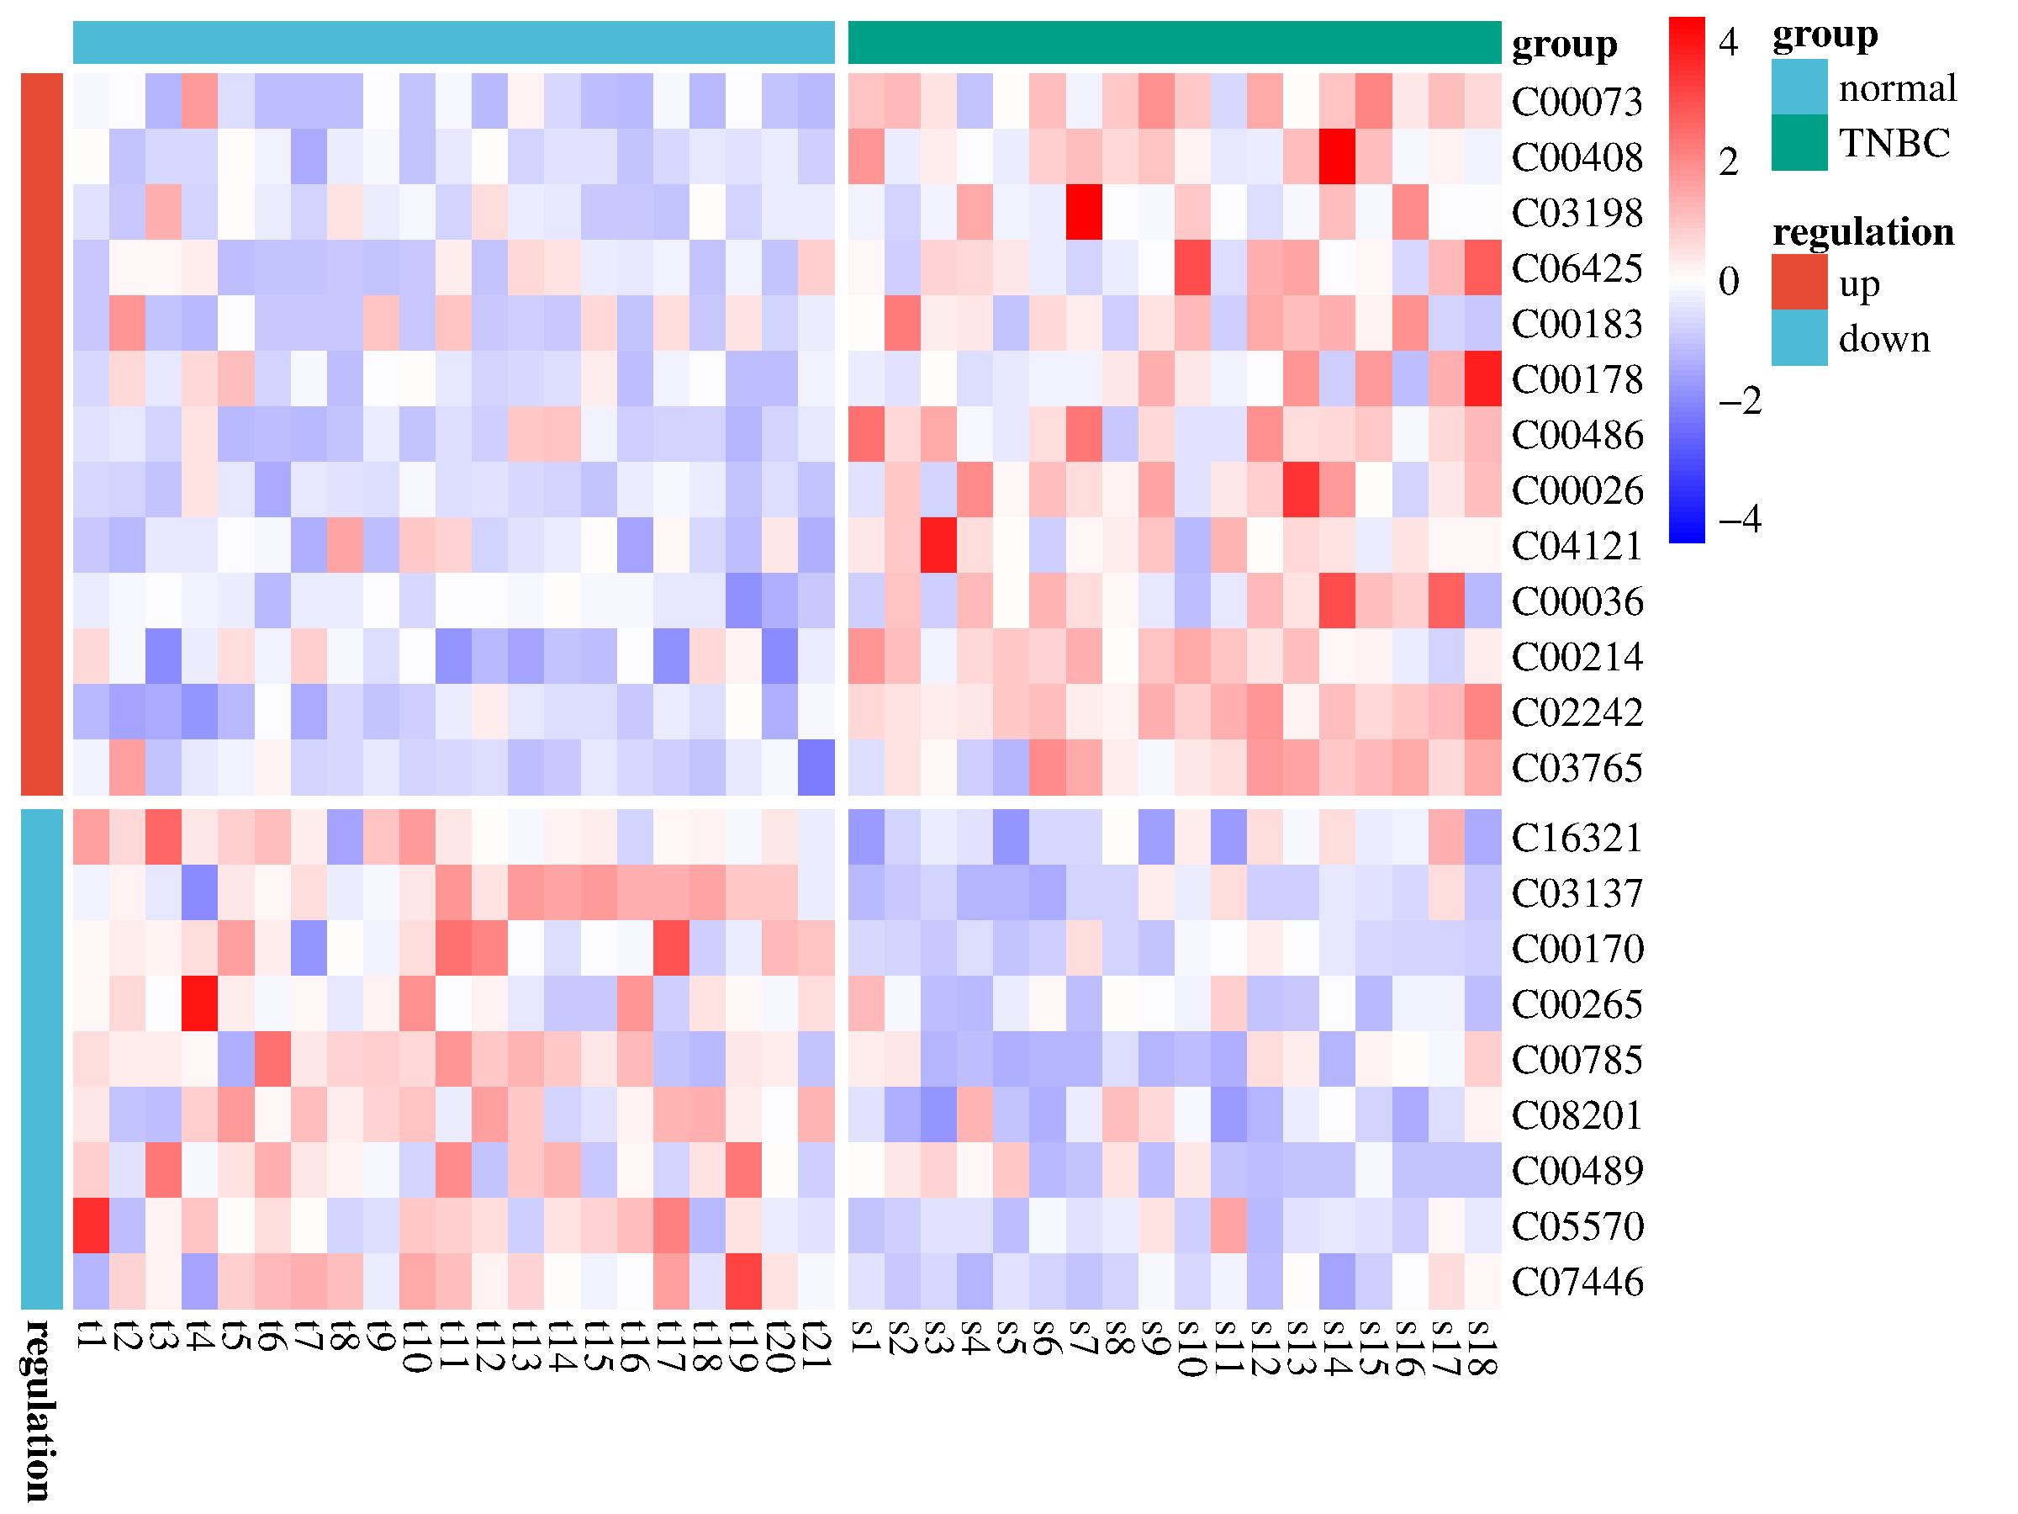
Supplementary Figure 1 The heat map for the peak areas of 22 DMs between TNBC and HC.
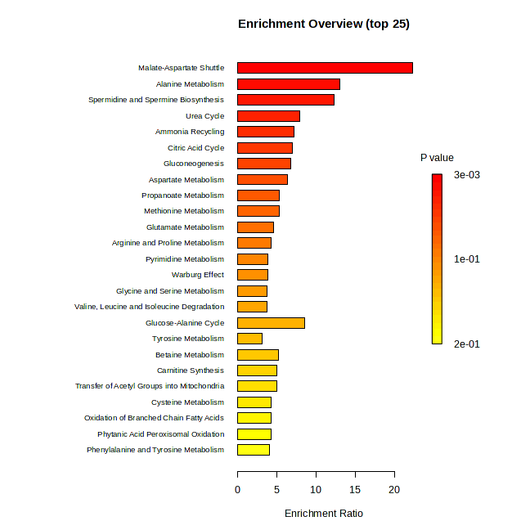
Supplementary Figure 2 Metabolite set enrichment analysis (MSEA) of 22 DMs from TNBC patients and HC subjects.

