Supplementary Information
Knowledge-driven design of fluorinated ether electrolytes via a multi-model approach
Rasha Atwi¹, Daniel A. Gribble², Dan Thien Nguyen^{3,4}, Minyung Song^{3,4}, Agrim Babbar⁵, Vijayakumar Murugesan^{3,4}, Vilas G. Pol², Nav Nidhi Rajput¹*
¹Department of Materials Science and Chemical Engineering, Stony Brook University,
Stony Brook, New York 11794, United States
²Davidson School of Chemical Engineering, Purdue University, West Lafayette, Indiana 47907, United States
³Pacific Northwest National Laboratory, Richland, Washington 99352, United States
⁴Joint Center for Energy Storage Research, Argonne National Laboratory, Lemont, IL, 60439, United States.
⁵Department of Chemical Engineering, Birla Institute of Technology and Science Pilani,
Hyderabad Campus, Shameerpet, Hyderabad, Telangana 500078, India

Corresponding Author
*navnidhi.rajput@stonybrook.edu

Tables
Supplementary Table S1. Fluorinated ether solvents reported in the lithium-sulfur literature. 4
Supplementary Table S2. Calculated estimates (this work) and experimental values of boiling point of common electrolyte solvents. 6
Supplementary Table S3. Definition of the derived descriptors of the fluorinated solvents used in the XGBoost model to identify features of high impact on redox potentials and binding affinities. The code used for descriptor calculation is provided in the GitHub repository associated with this work. 8
Supplementary Table S4. Fluorinated ether solvents screened based on their boiling point, flash point, solubility of salt, electrochemical window, and binding affinity to salt and polysulfide. 11

Figures
Supplementary Fig. 1 Distribution of the structural similarity score between 14 fluorinated ether solvents reported in the lithium-sulfur battery literature and all other solvents in the dataset of this work. 5
Supplementary Fig. 2 Distribution of the computed properties of the fluorinated solvents in the dataset of this work. 7
Supplementary Fig. 3 SHAP analysis showing the top 10 most essential features ranked by their overall impact for (a) electron affinity of FLS and (b) binding energy of fluorinated solvents with LiTFSI. 9
Supplementary Fig. 4 Representation of the HOMO and LUMO of BTFE and TFEP solvents determined at the B3LYP/6-31+G* level of theory. 9
Supplementary Fig. 5 Sample fluorinated solvent molecules with a 50% fluorination degree yet different ionization potentials and binding affinities towards the electrolyte components. PubChem CIDs of the compounds are shown on the top. 10
Supplementary Fig. 6 SHAP analysis showing the top 10 most essential features for the ionization potential of fluorinated solvents, ranked by their overall impact, using a model with custom calculated FLS features combined with (a) RDKit and (b) Mordred descriptors. 10
Supplementary Fig. 7 Radial distribution function between the terminal sulfur atoms of PS species in electrolytes composed of 1M LiTFSI and 0.3 M LiNO₃ in DOL/Solvent (1/1; v/v) with 0.25 M of (a) Li₂S₂, (b) Li₂S₄, and (c) Li₂S₈. 12
Supplementary Fig. 8 Radial distribution function between the terminal sulfur atoms of PS species and the ether oxygen of the solvent in electrolytes composed of 1M LiTFSI and 0.3 M LiNO₃ in DOL/Solvent (1/1; v/v) with 0.25 M of (a) Li₂S₂, (b) Li₂S₄, and (c) Li₂S₈. 13
Supplementary Fig. 9 Radial distribution function between Li⁺ and the ether oxygen of the solvent in electrolytes composed of 1M LiTFSI and 0.3 M LiNO₃ in DOL/Solvent (1/1; v/v) with 0.25 M of (a) Li₂S₂, (b) Li₂S₄, and (c) Li₂S₈. 13
Supplementary Fig. 10 Radial distribution function between Li⁺ and O (TFSI⁻) in electrolytes composed of 1M LiTFSI and 0.3 M LiNO₃ in DOL/Solvent (1/1; v/v) with 0.25 M of (a) Li₂S₂, (b) Li₂S₄, and (c) Li₂S₈. 13
Supplementary Fig. 11 Radial distribution function between Li⁺ and O (DOL) in electrolytes composed of 1M LiTFSI and 0.3 M LiNO₃ in DOL/Solvent (1/1; v/v) with 0.25 M of (a) Li₂S₂, (b) Li₂S₄, and (c) Li₂S₈. 14
Supplementary Fig. 12 MD snapshots showing the clustering of Li₂S₂ in electrolytes composed of 1M LiTFSI, 0.3 M LiNO₃, and 0.25 M Li₂S₂ in DOL/Solvent (1/1; v/v). Li⁺ is depicted in purple in space-filling format, $S22-$ in yellow in space-filling format, and the rest of the electrolyte components in line format. 14
Supplementary Fig. 13 MD snapshots showing the clustering of Li₂S₄ in electrolytes composed of 1M LiTFSI, 0.3 M LiNO₃, and 0.25 M Li₂S₄ in DOL/Solvent (1/1; v/v). Li⁺ is depicted in purple in space-filling format, $S42-$ in yellow in space-filling format, and the rest of the electrolyte components in line format. 15
Supplementary Fig. 14 MD snapshots showing the clustering of Li₂S₈ in electrolytes composed of 1M LiTFSI, 0.3 M LiNO₃, and 0.25 M Li₂S₈ in DOL/Solvent (1/1; v/v). Li⁺ is depicted in purple in space-filling format, $S82-$ in yellow in space-filling format, and the rest of the electrolyte components in line format. 15
Supplementary Fig. 15 Distribution of diffusion coefficients of the co-solvent and Li⁺ in systems containing 1 M LiTFSI, 0.3 M LiNO₃, 0.25 M Li₂S_{x} (x = 2 in (a), 4 in (b), and 8 in (c)) in DOL/co-solvent (1/1: v/v; cosolvent: DME, TTE, and each of the FLS presented in Table S4. 16
Supplementary Fig. 16 Comparison of experimental and computed properties of electrolytes composed of 1 M LiTFSI, 0.3 M LiNO₃ in DOL/DME/FLS0 and 1 M LiTFSI, 0.1 M LiNO₃ in DOL/DME/FLS18 as a function of temperature. Properties include (a) Viscosity, (b) density, and (c) ionic conductivity, with experimental values shown in white circles and computed values shown in solid colored circles. 17
Supplementary Fig. 17 Voltages of the first plateau for solid S conversion to LiPSs (corresponding to capacity of 15mAh/g) and the second plateau for the LiPSs conversion to Li₂S (corresponding to capacity of 900 mAh/g). 17

Supplementary Table S1. Fluorinated ether solvents reported in the lithium-sulfur literature.
Solvent | PubChem CID | Molecular Weight (g/mol) | Fluorination Degree (%) | Structure
BTFE¹ | 9528 | 182.06 | 60.0 | 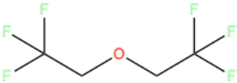
DFEP² | 54272766 | 124.13 | 16.67 | 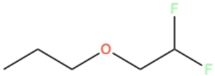
ETE^{1, 3} | 120272 | 146.08 | 40.0 | 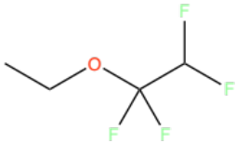
ETTFP² | 12824701 | 160.11 | 33.33 | 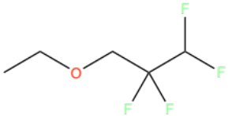
FDE⁴ | 15155940 | 276.12 | 50.0 | 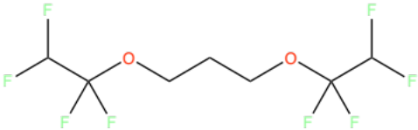
FEP² | 54215081 | 106.14 | 8.33 | 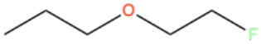
OTE¹ | 2782579 | 332.09 | 75.0 | 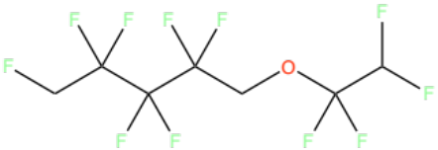
PTTFEP² | 2776016 | 250.06 | 75.0 | 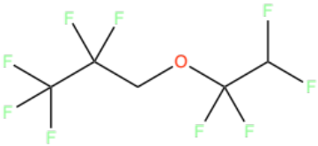
TFEE⁵ | 15155939 | 262.1 | 57.14 | 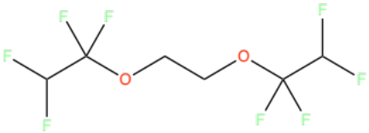
TFEP² | 14024097 | 142.12 | 25.0 | 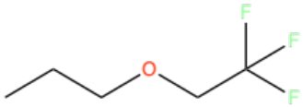
TFTFE⁶ | 164596 | 200.05 | 70.0 | 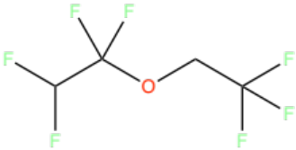
TTE¹ | 2776662 | 232.07 | 66.67 | 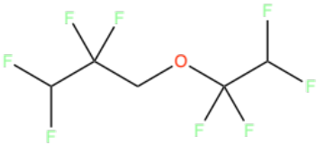
TTFEP⁷ | 22005454 | 160.11 | 33.33 | 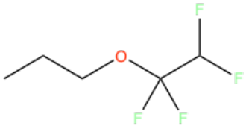
FDMB⁸ | 58361980 | 190.14 | 28.57 | 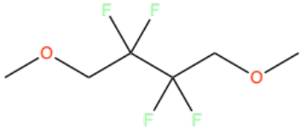

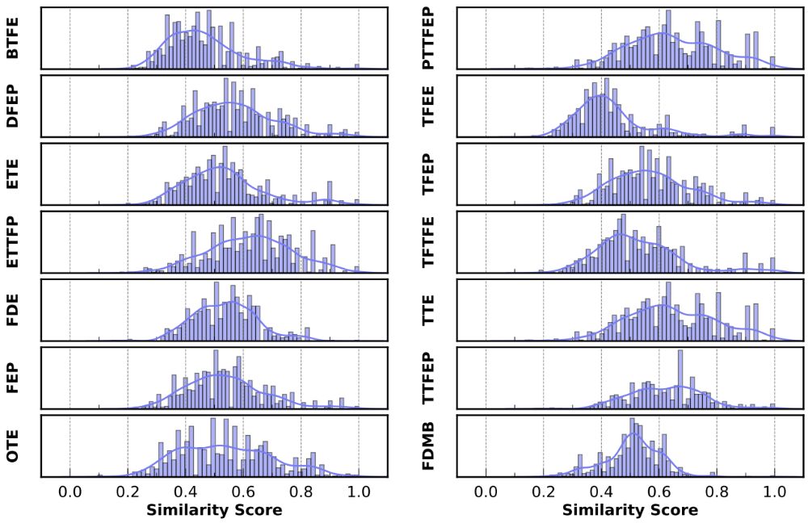
Supplementary Fig. 1 Distribution of the structural similarity score between 14 fluorinated ether solvents reported in the lithium-sulfur battery literature and all other solvents in the dataset of this work.

Supplementary Table S2. Calculated estimates (this work) and experimental values of boiling point of common electrolyte solvents.
PubChem CID | COSMO-RS BP (℃) | Experimental BP (℃)
8071 | 88.178 | 85⁹
18335957 | 58.8 | 72
21616969 | 45.4 | 66
2776662 | 68.48 | 93.2¹
2782579 | 111.94 | 133^{1, 9}
120272 | 34.14 | 57.5¹
54272766 | 73.335 | 84.5 – 86.0²
14024097 | 57.008 | 70.5 – 71.5²
22005454 | 62.754 | 74²
12824701 | 68.864 | 84 - 88²
2776016 | 51.97 | 68²
MAD | 16.04
R | 0.93

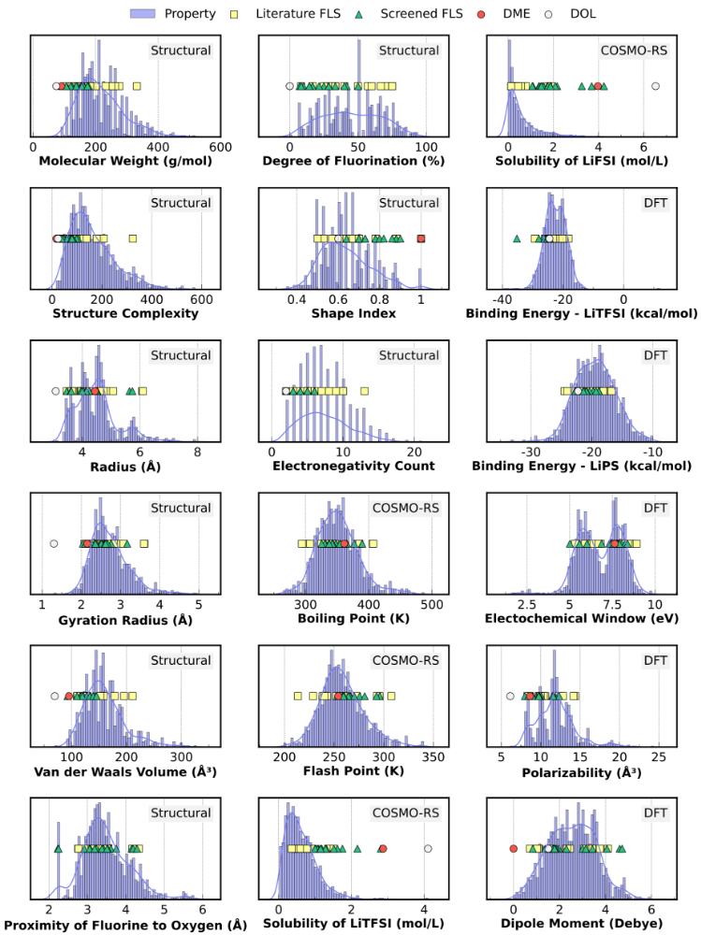
Supplementary Fig. 2 Distribution of the computed properties of the fluorinated solvents in the dataset of this work.
Supplementary Table S3. Definition of the derived descriptors of the fluorinated solvents used in the XGBoost model to identify features of high impact on redox potentials and binding affinities. The code used for descriptor calculation is provided in the GitHub repository associated with this work.
Property | Category | Definition
Radius (Å) | Structural | Radius of a compound¹⁰
Complexity | Topological | Estimate of how complicated the compound is based on the size, rings, symmetry, branching, bonds, and number of heteroatoms¹¹
Molecular weight (g/mol) | Physical | Sum of atomic weights of atoms making up a compound
van der Waals volume (Å³) | Steric | Space occupied by a compound and not penetrable by other compounds¹²
Shape index | Topological | Estimate of how spherical or linear a molecule is
Steric effect | Steric | Topological steric effect index of the ether oxygen computed from the covalent radii and topological distances¹³
Proximity of fluorine to oxygen (Å) | Structural | Shortest distance between a fluorine atom and an ether oxygen in a compound
Fluorination degree (%) | Chemical | Degree of fluorination of a compound
Electron count | Chemical | Number of electronegative atoms in a compound
B1, B5 (Å) | Steric | Verloop’s Sterimol parameter¹⁴ calculated for a lithium-solvent complex: a main axis (L) is first defined along the direction of the coordinated lithium cation and ether oxygen atom of the solvent; B1 and B5 then represent the minimum and maximum widths of the complex along the direction perpendicular to this main axis L, respectively
Dipole moment (Debye) | Electronic (DFT computed) | Measure of the overall polarity of a compound
Polarizability (Å³) | Electronic (DFT computed) | Measure of the ability of a compound to form instantaneous dipoles in response to an external electric field
Minimum partial charge | Electronic (DFT computed) | Minimum value of the electrostatic partial charges on a compound
Maximum partial charge | Electronic (DFT computed) | Maximum value of the electrostatic partial charges on a compound
Minimum absolute partial charge | Electronic (DFT computed) | Minimum value of the absolute electrostatic partial charges on a compound
Maximum absolute partial charge | Electronic (DFT computed) | Maximum value of the absolute electrostatic partial charges on a compound


Supplementary Fig. 3 SHAP analysis showing the top 10 most essential features ranked by their overall impact for (a) electron affinity of FLS and (b) binding energy of fluorinated solvents with LiTFSI.

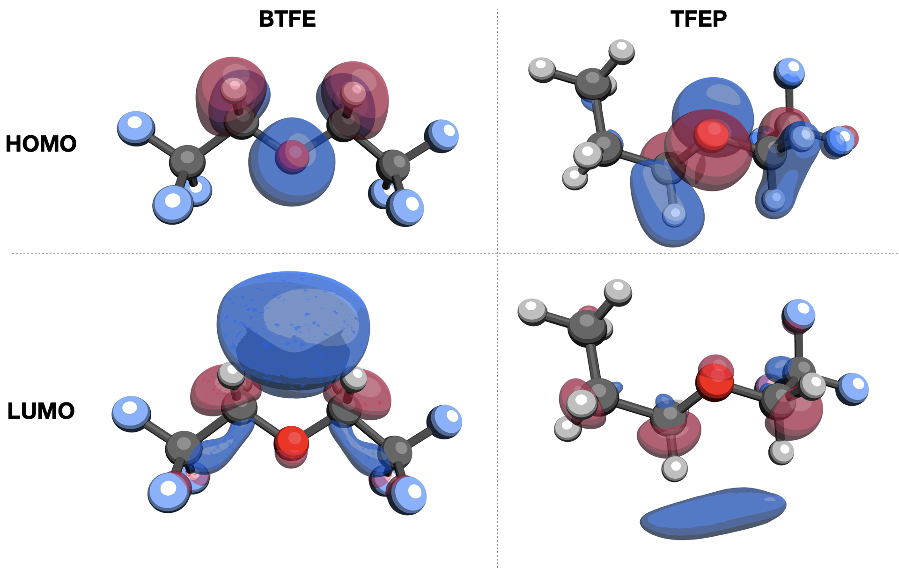
Supplementary Fig. 4 Representation of the HOMO and LUMO of BTFE and TFEP solvents determined at the B3LYP/6-31+G* level of theory.
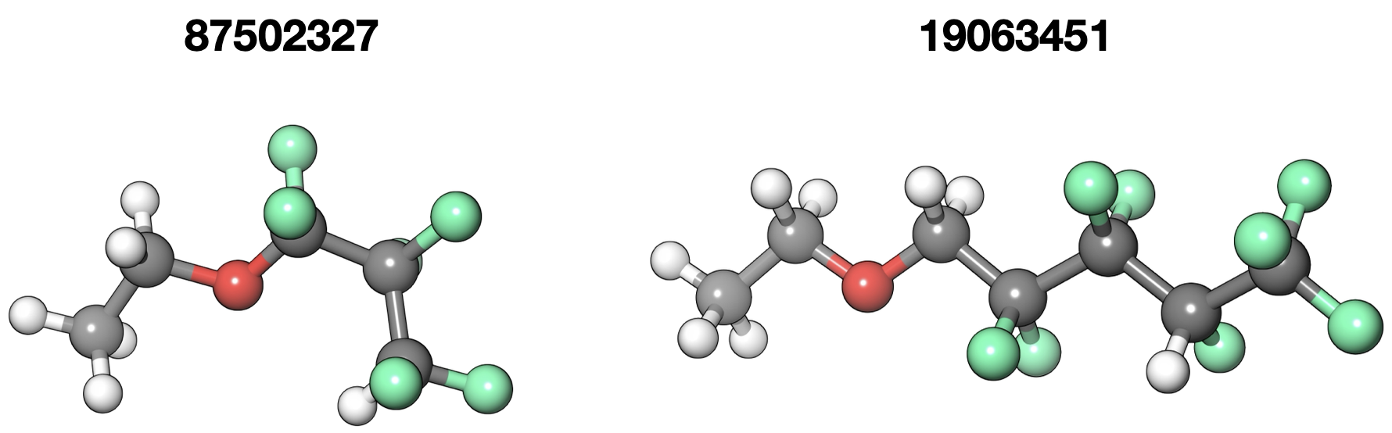
Supplementary Fig. 5 Sample fluorinated solvent molecules with a 50% fluorination degree yet different ionization potentials and binding affinities towards the electrolyte components. PubChem CIDs of the compounds are shown on the top.


Supplementary Fig. 6 SHAP analysis showing the top 10 most essential features for the ionization potential of fluorinated solvents, ranked by their overall impact, using a model with custom calculated FLS features combined with (a) RDKit and (b) Mordred descriptors.

Supplementary Table S4. Fluorinated ether solvents screened based on their boiling point, flash point, solubility of salt, electrochemical window, and binding affinity to salt and polysulfide.
Solvent | PubChem CID | Molecular Weight (g/mol) | Fluorination Degree (%) | Structure
FLS0 | 92551 | 200.05 | 70.0 | 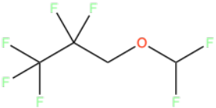
FLS1 | 91607507 | 160.11 | 33.33 | 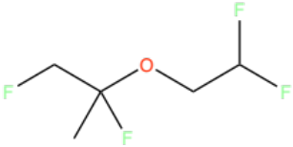
FLS2 | 89393880 | 154.15 | 14.29 | 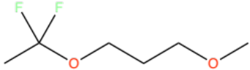
FLS3 | 139775149 | 164.07 | 50.0 | 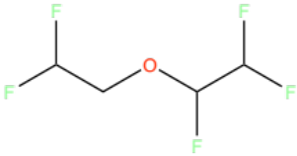
FLS4 | 54465191 | 124.13 | 16.67 | 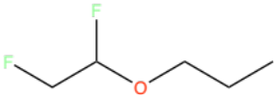
FLS5 | 88850722 | 178.1 | 41.67 | 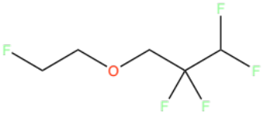
FLS6 | 21083128 | 138.16 | 14.29 | 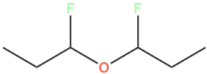
FLS7 | 21024143 | 162.08 | 40.0 | 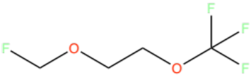
FLS8 | 140985949 | 174.14 | 28.57 | 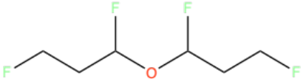
FLS9 | 150733090 | 174.14 | 28.57 | 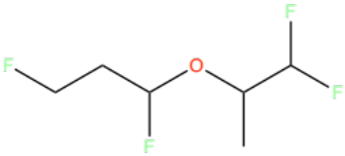
FLS10 | 54128414 | 106.14 | 8.33 | 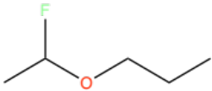
FLS11 | 54212056 | 156.15 | 21.43 | 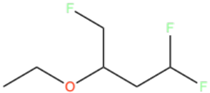
FLS12 | 54489129 | 124.13 | 16.67 | 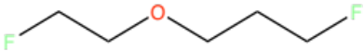
FLS13 | 57271144 | 174.14 | 28.57 | 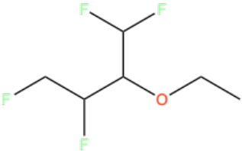
FLS14 | 132186867 | 154.15 | 14.29 | 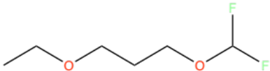
FLS15 | 59650563 | 142.12 | 25.0 | 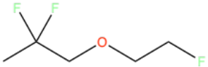
FLS16 | 53916352 | 120.17 | 7.14 | 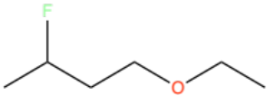
FLS17 | 54183389 | 106.14 | 8.33 | 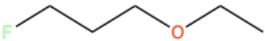
FLS18 | 18335957 | 92.11 | 10.0 | 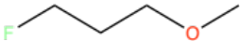

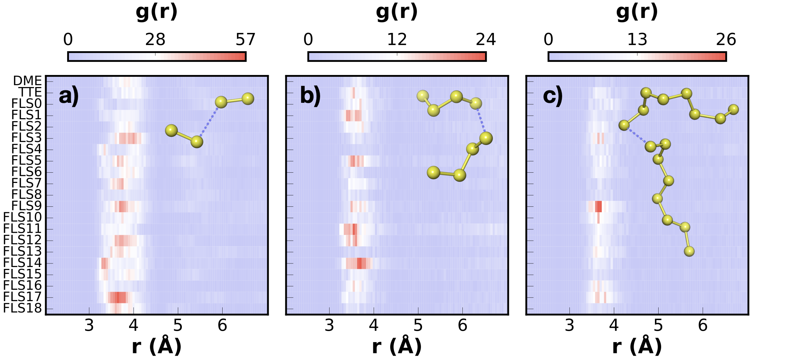
Supplementary Fig. 7 Radial distribution function between the terminal sulfur atoms of PS species in electrolytes composed of 1M LiTFSI and 0.3 M LiNO₃ in DOL/Solvent (1/1; v/v) with 0.25 M of (a) Li₂S₂, (b) Li₂S₄, and (c) Li₂S₈.
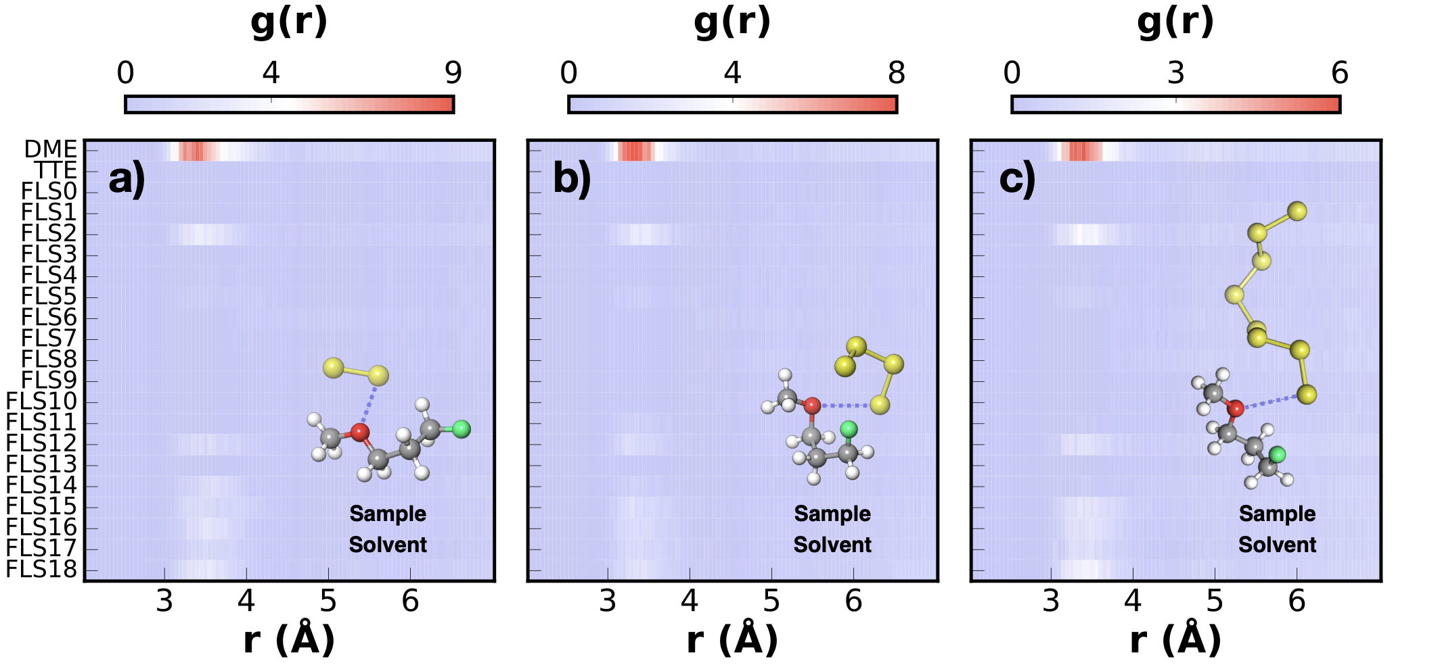
Supplementary Fig. 8 Radial distribution function between the terminal sulfur atoms of PS species and the ether oxygen of the solvent in electrolytes composed of 1M LiTFSI and 0.3 M LiNO₃ in DOL/Solvent (1/1; v/v) with 0.25 M of (a) Li₂S₂, (b) Li₂S₄, and (c) Li₂S₈.

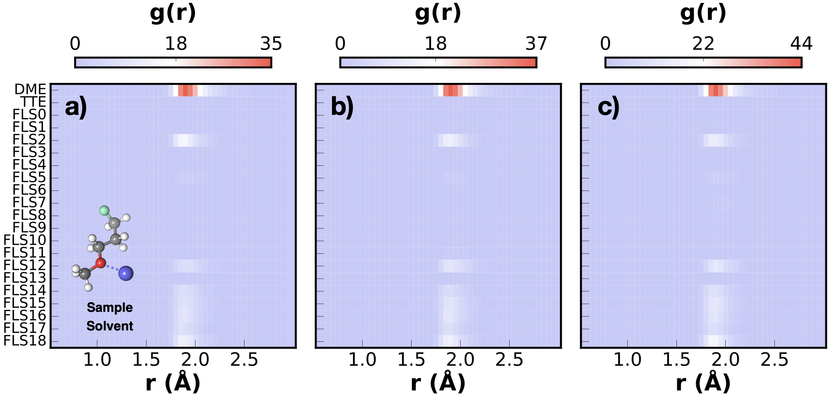
Supplementary Fig. 9 Radial distribution function between Li⁺ and the ether oxygen of the solvent in electrolytes composed of 1M LiTFSI and 0.3 M LiNO₃ in DOL/Solvent (1/1; v/v) with 0.25 M of (a) Li₂S₂, (b) Li₂S₄, and (c) Li₂S₈.

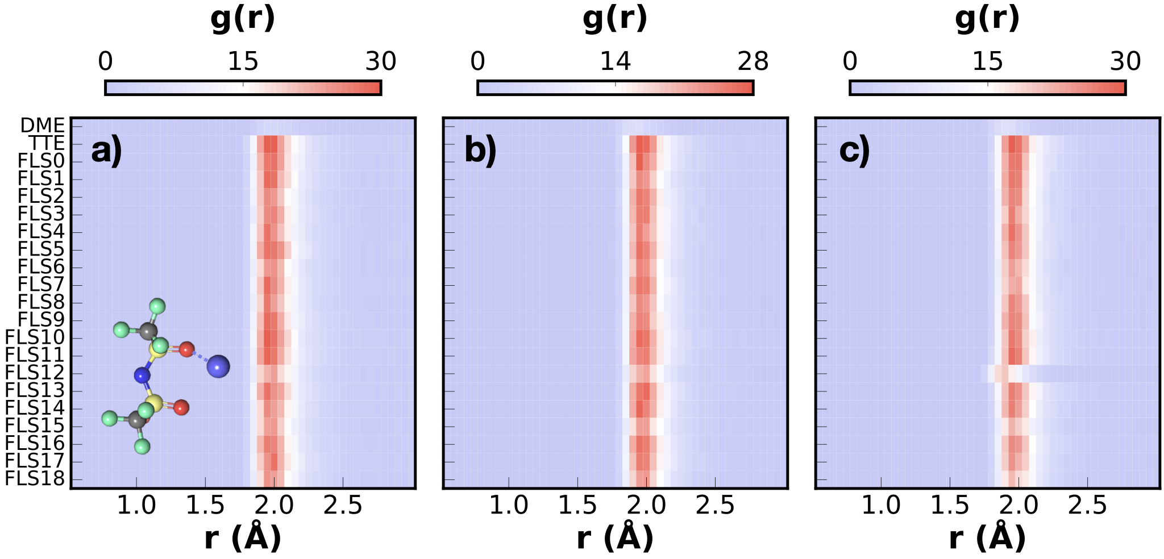
Supplementary Fig. 10 Radial distribution function between Li⁺ and O (TFSI⁻) in electrolytes composed of 1M LiTFSI and 0.3 M LiNO₃ in DOL/Solvent (1/1; v/v) with 0.25 M of (a) Li₂S₂, (b) Li₂S₄, and (c) Li₂S₈.
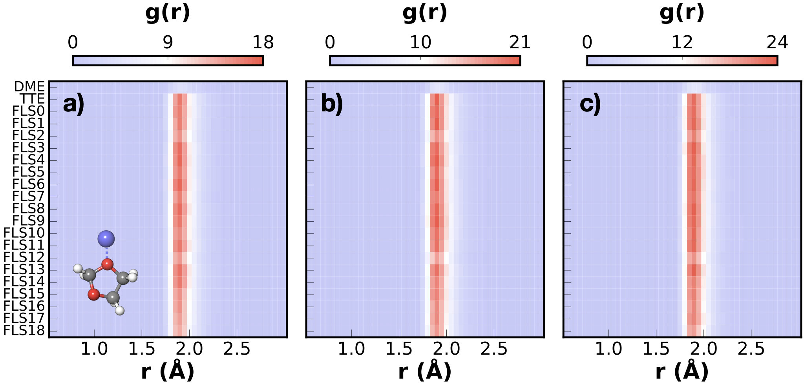
Supplementary Fig. 11 Radial distribution function between Li⁺ and O (DOL) in electrolytes composed of 1M LiTFSI and 0.3 M LiNO₃ in DOL/Solvent (1/1; v/v) with 0.25 M of (a) Li₂S₂, (b) Li₂S₄, and (c) Li₂S₈.

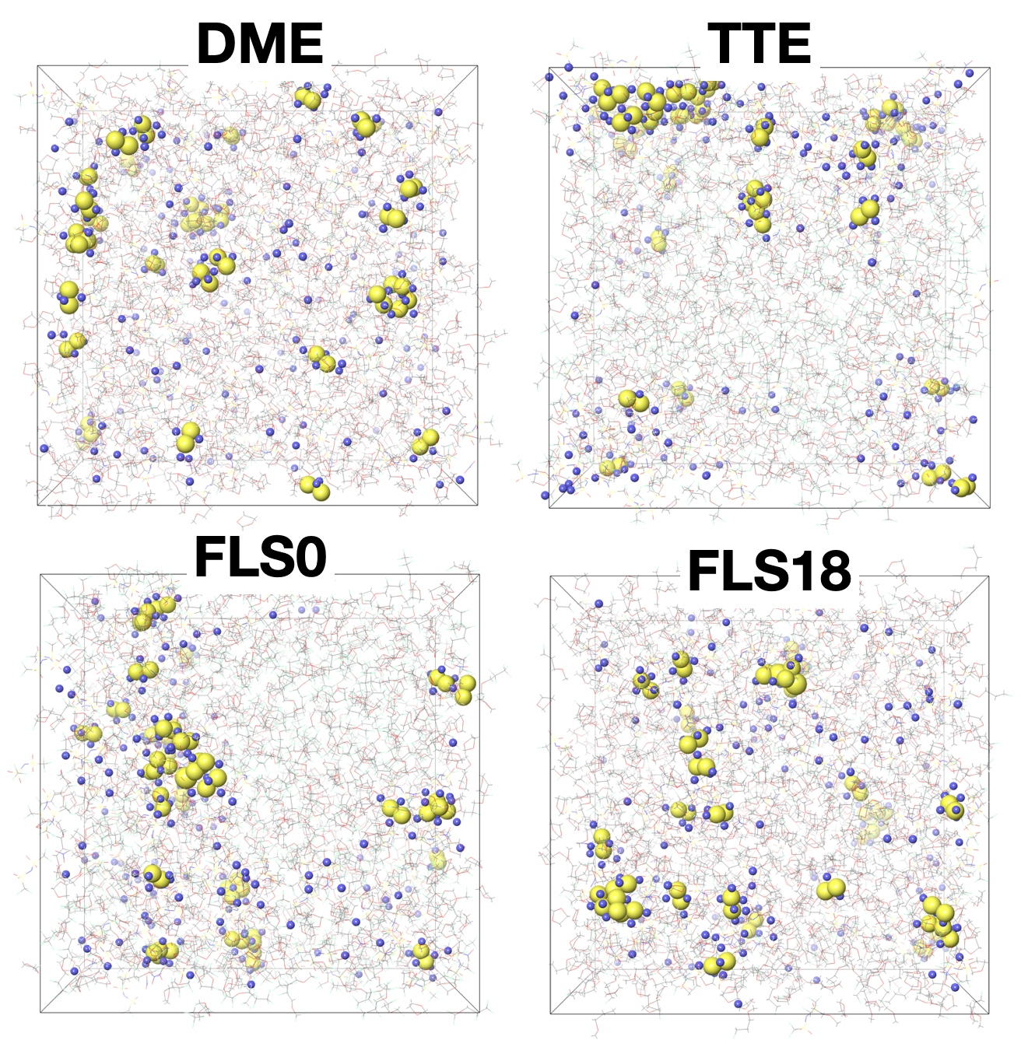
Supplementary Fig. 12 MD snapshots showing the clustering of Li₂S₂ in electrolytes composed of 1M LiTFSI, 0.3 M LiNO₃, and 0.25 M Li₂S₂ in DOL/Solvent (1/1; v/v). Li⁺ is depicted in purple in space-filling format, $S_{2}^{2-}$ in yellow in space-filling format, and the rest of the electrolyte components in line format.
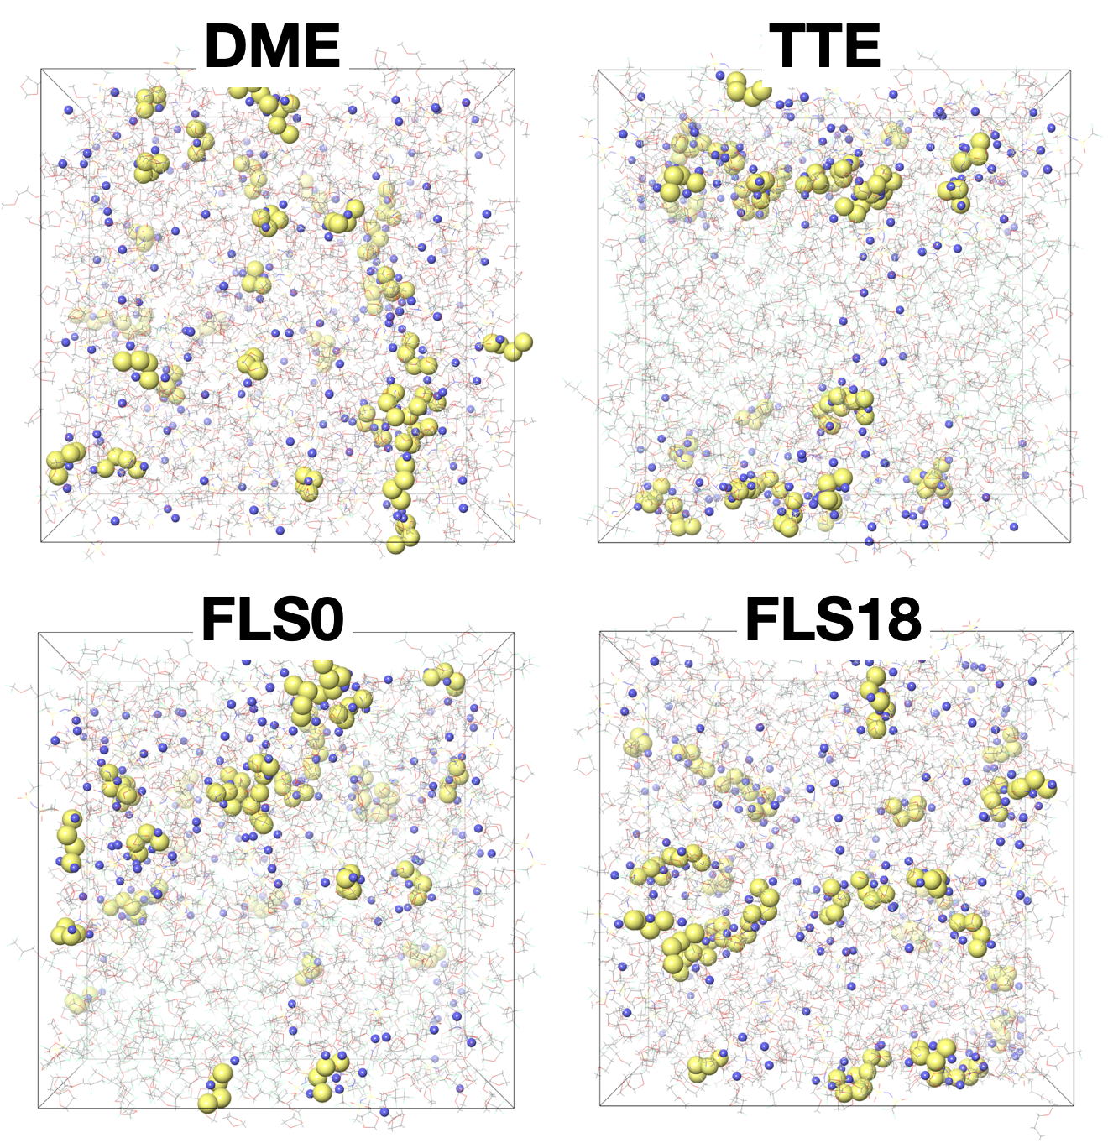
Supplementary Fig. 13 MD snapshots showing the clustering of Li₂S₄ in electrolytes composed of 1M LiTFSI, 0.3 M LiNO₃, and 0.25 M Li₂S₄ in DOL/Solvent (1/1; v/v). Li⁺ is depicted in purple in space-filling format, $S_{4}^{2-}$ in yellow in space-filling format, and the rest of the electrolyte components in line format.

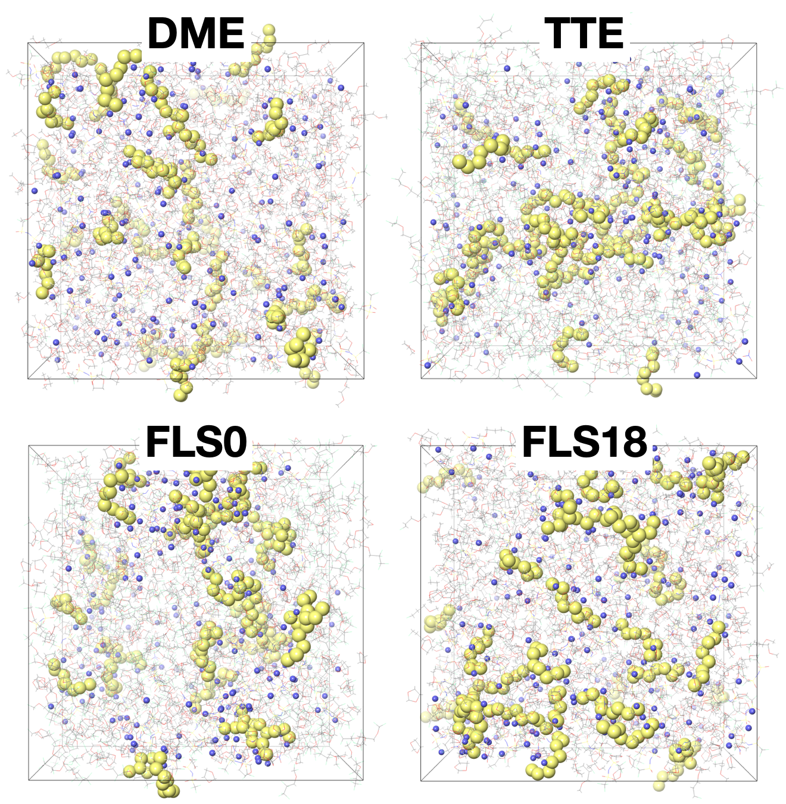
Supplementary Fig. 14 MD snapshots showing the clustering of Li₂S₈ in electrolytes composed of 1M LiTFSI, 0.3 M LiNO₃, and 0.25 M Li₂S₈ in DOL/Solvent (1/1; v/v). Li⁺ is depicted in purple in space-filling format, $S_{8}^{2-}$ in yellow in space-filling format, and the rest of the electrolyte components in line format.

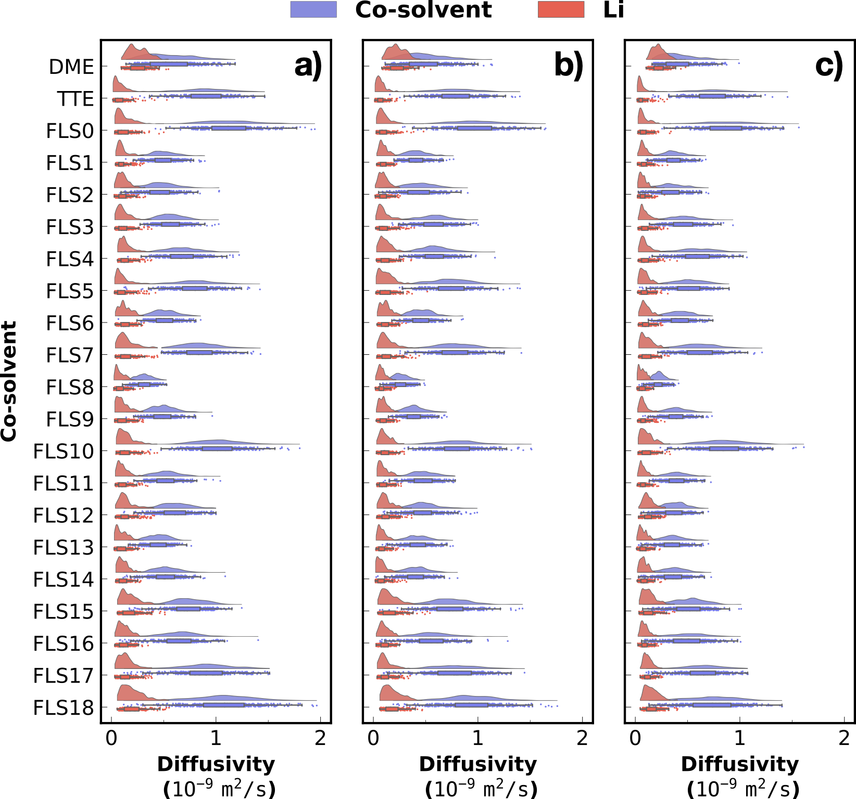
Supplementary Fig. 15 Distribution of diffusion coefficients of the co-solvent and Li⁺ in systems containing 1 M LiTFSI, 0.3 M LiNO₃, 0.25 M Li₂S_{x} (x = 2 in (a), 4 in (b), and 8 in (c)) in DOL/co-solvent (1/1: v/v; cosolvent: DME, TTE, and each of the FLS presented in Table S4.

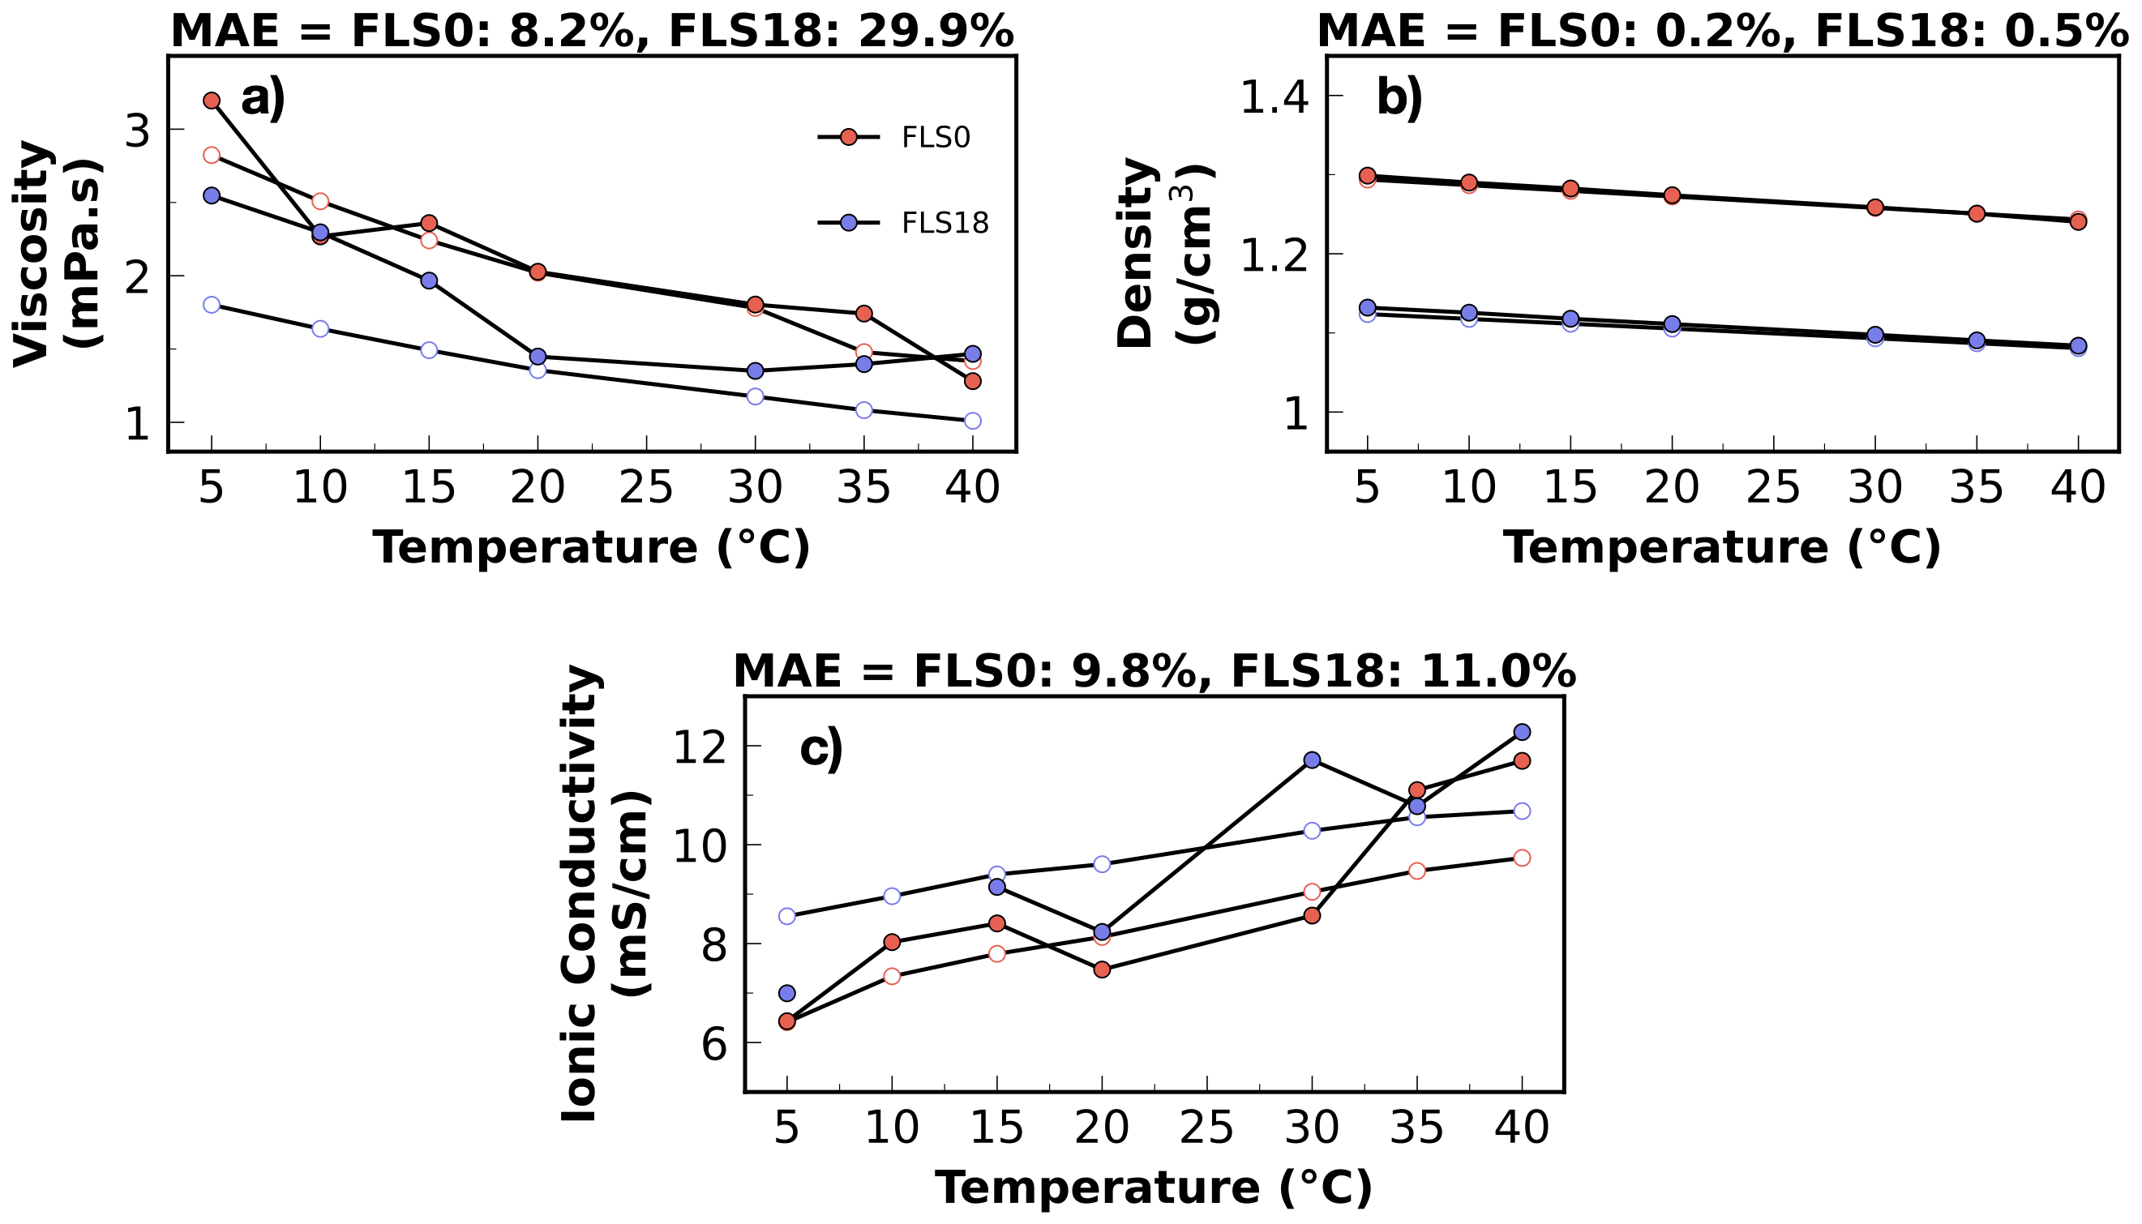
Supplementary Fig. 16 Comparison of experimental and computed properties of electrolytes composed of 1 M LiTFSI, 0.3 M LiNO₃ in DOL/DME/FLS0 and 1 M LiTFSI, 0.1 M LiNO₃ in DOL/DME/FLS18 as a function of temperature. Properties include (a) Viscosity, (b) density, and (c) ionic conductivity, with experimental values shown in white circles and computed values shown in solid colored circles.

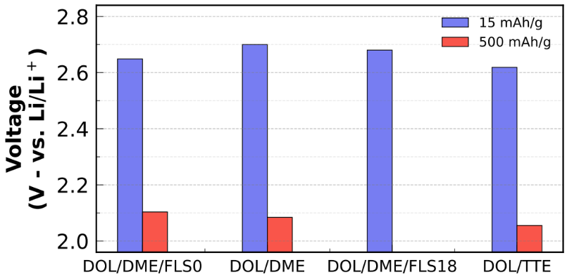
Supplementary Fig. 17 Voltages of the first plateau for solid S conversion to LiPSs (corresponding to capacity of 15mAh/g) and the second plateau for the LiPSs conversion to Li₂S (corresponding to capacity of 900 mAh/g).

