Supporting Information

Interplay Between Strain and Charge in Cu(In,Ga)Se₂ Flexible Photovoltaics

Ha Kyung Park^{1§}, Kanghoon Yim^{2§}, Jiyoon Lee¹, Yunae Cho³, Inyoung Jeong³, Donghyeop Shin³, Jihye Gwak³, Aron Walsh^{1,4}, Kihwan Kim^{3*}, and William Jo^{1*}

¹Department of Physics, Ewha Womans University, Seoul 03760, Republic of Korea
²Computational Science and Engineering Laboratory, Korea Institute of Energy Research, Daejeon 34129, Republic of Korea
³Photovoltaics Research Department, Korea Institute of Energy Research, Daejeon 34129, Republic of Korea
⁴Department of Materials, Imperial College London, London SW7 2AZ, UK

§ These authors contributed equally to this work.
*Corresponding authors: kimkh@kier.re.kr, wmjo@ewha.ac.kr

Keywords: Flexible Cu(In,Ga)Se₂ solar cells, polyimide, alkali incorporation, stress-induced property, defect formation energy, surface current
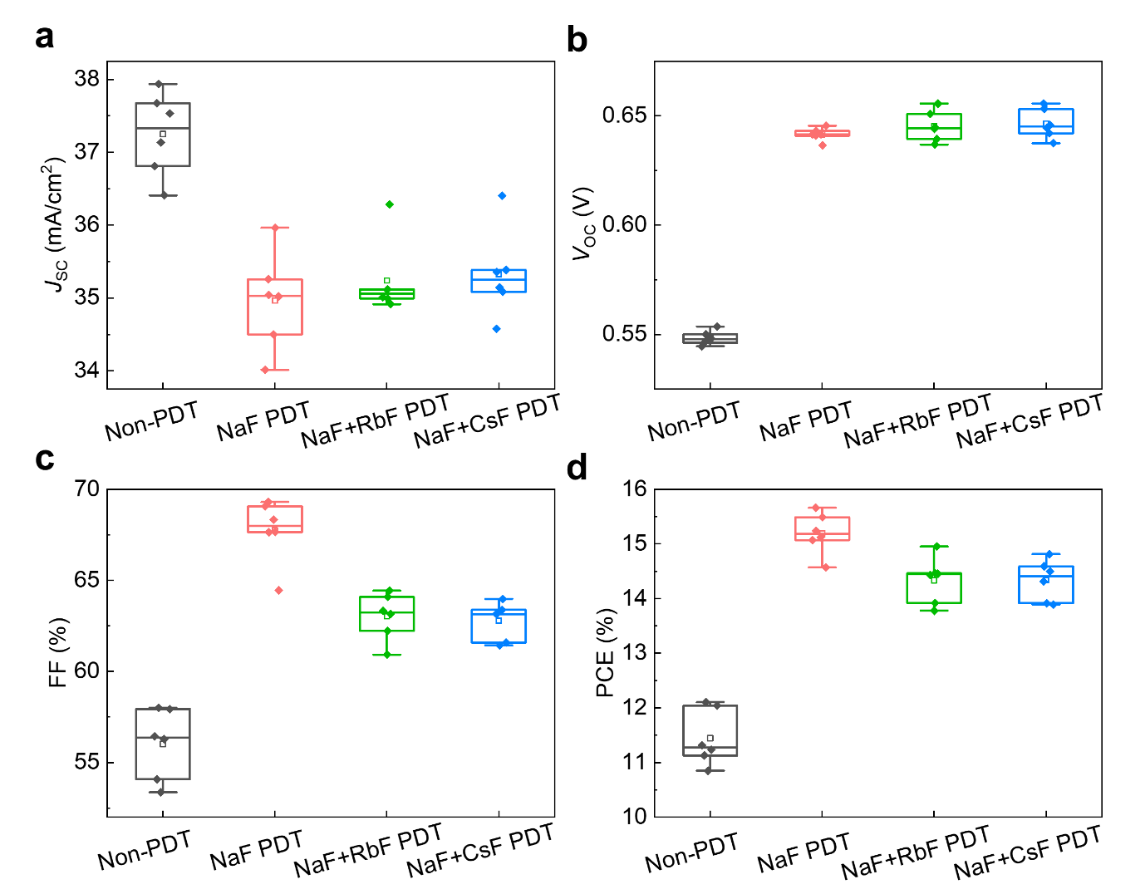
Figure S1. Box plot of the performance of the CIGS solar cell devices with various alkali treatments. (a) Short-circuit current density (J_{SC}), (b) open-circuit voltage (V_{OC}), (c) fill factor (FF), and (d) power conversion efficiency (PCE). The best performances of each sample are presented in Table 1 in the main manuscript. Devices with additional alkali treatment showed enhanced PCE. NaF+RbF PDT and NaF+CsF PDT samples showed lower FF than the NaF PDT CIGS probably due to the formation of Alk–In–Se compounds.

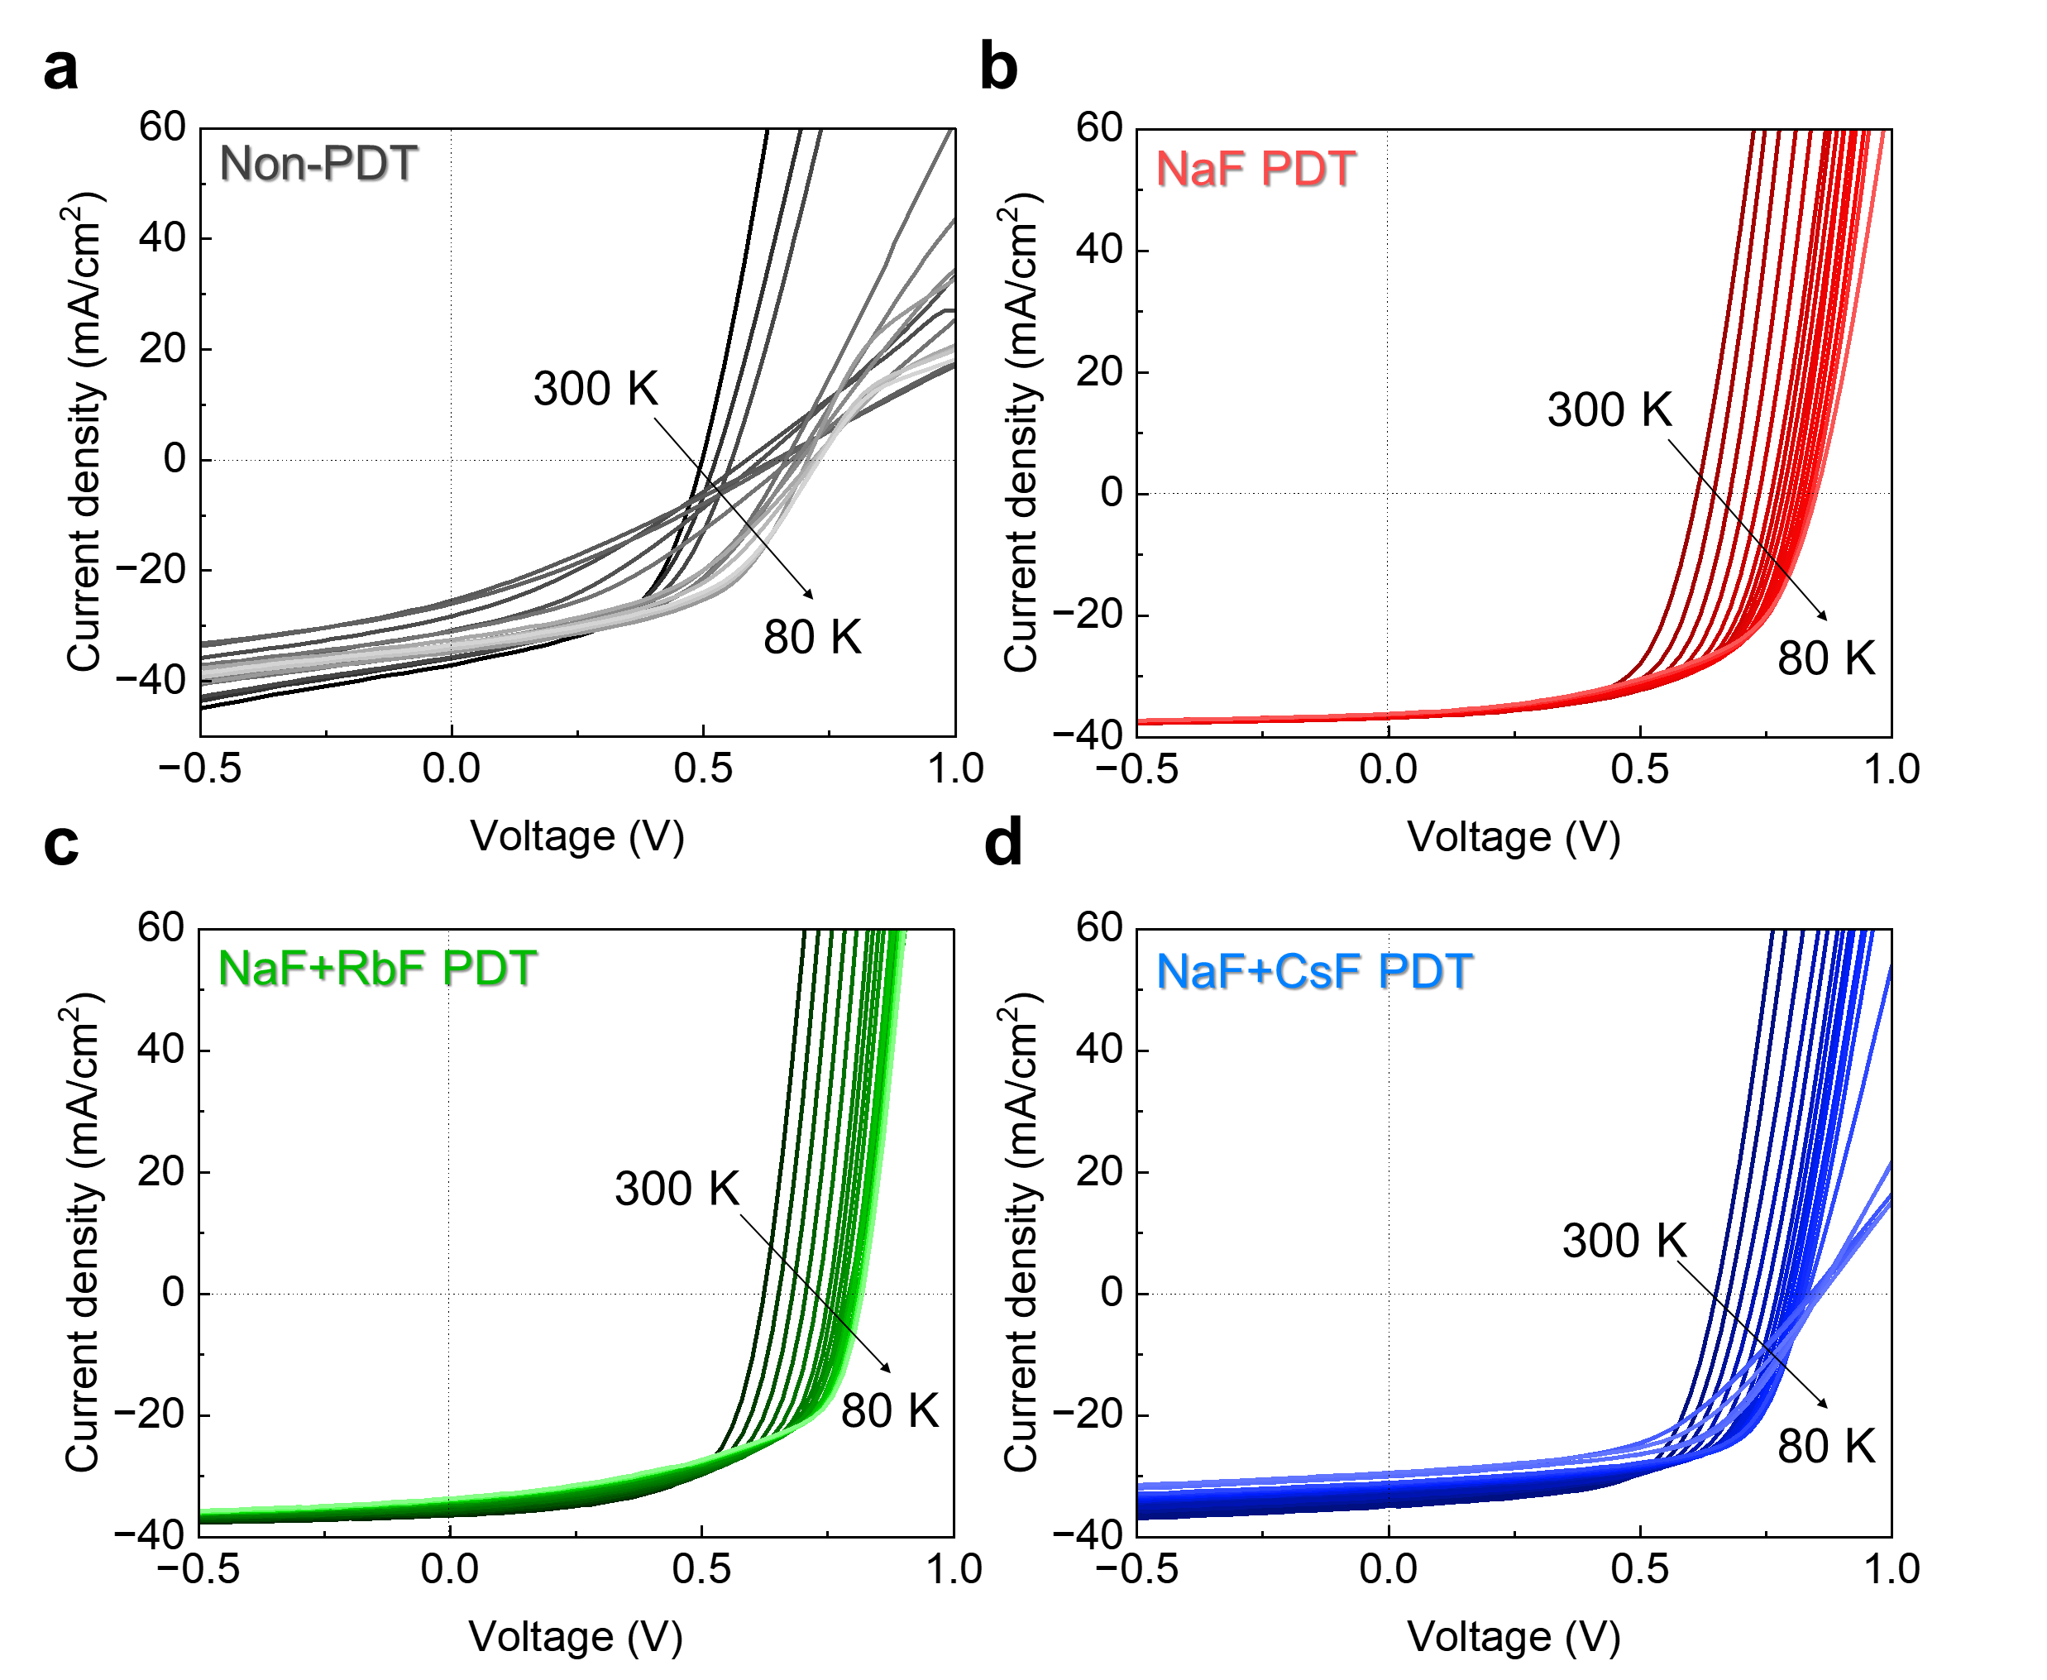
Figure S2. Temperature-dependent current density-voltage (J-V) curves of the CIGS solar cell devices. J-V curves were obtained from 300 K to 80 K.

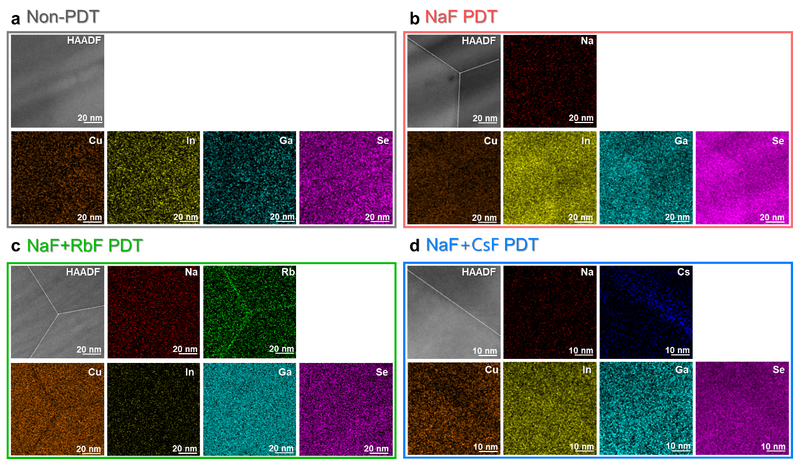
Figure S3. STEM-EDS images of constituent elements in the CIGS with and without alkali treatment. The grain boundaries showed Cu-depleted and slightly Se-poor composition. The amount of Na was too low to be detected because of its relatively small mass.

Efdefect=Etotdefect-Etotperfect+ Niμi+qεF+εVBM+Ecorr

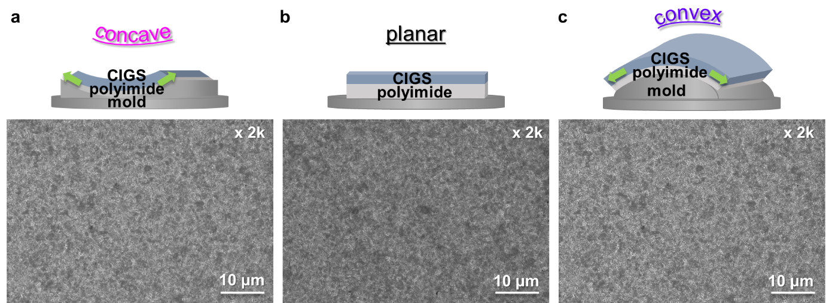
Figure S4. Scanning electron microscopy (SEM) images of the NaF PDT CIGS samples under (a) concave, (b) planar, and (c) convex bending states. No severe cracks or gaps were observed under the mechanical bending states with bending radius of 20.47 mm (i.e. curvature angle of 20°). SEM images were obtained at the Western Seoul Center KBSI by using HITACHI SU8220.

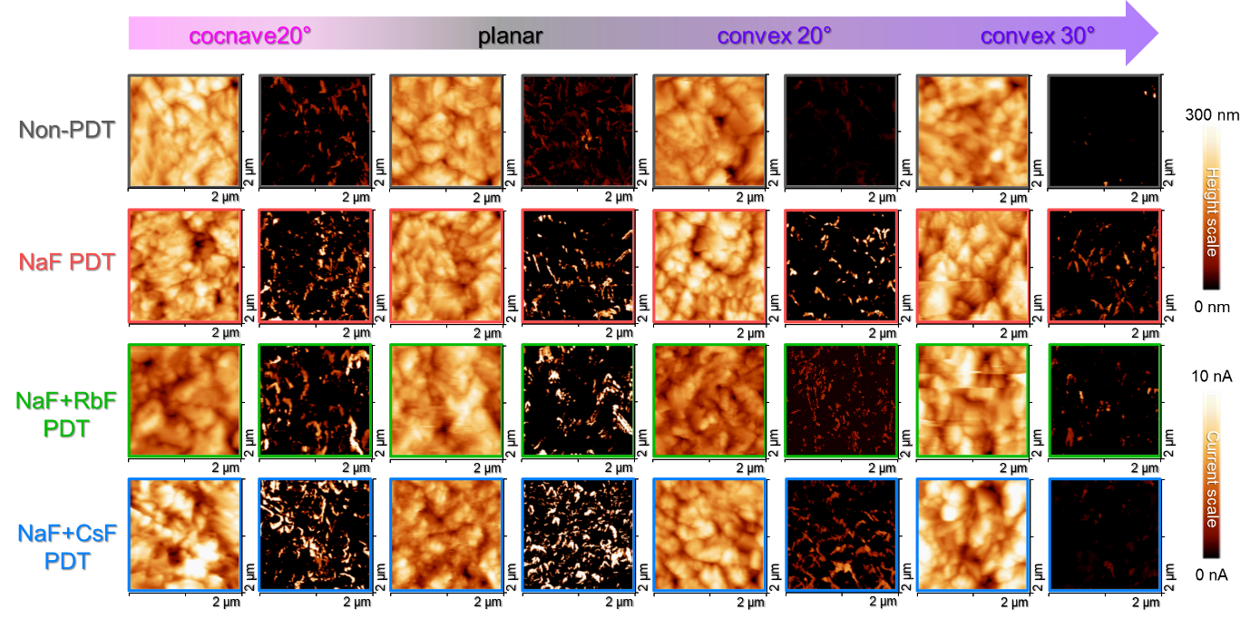
Figure S5. 2-dimensional topography and surface current map of the CIGS with NaF+RbF and NaF+CsF PDT. The surface current under concave bending decreased compared to those of the planar and convex bending states. Nevertheless, the degradation of its surface current values was lower than that under convex bending. Obtaining topography and surface current maps under concave bending with a bending radius of 14 mm (corresponding to a curvature angle of 30°) proved challenging due to technical issues, specifically the movement of the cantilever was hindered by the curved surface.

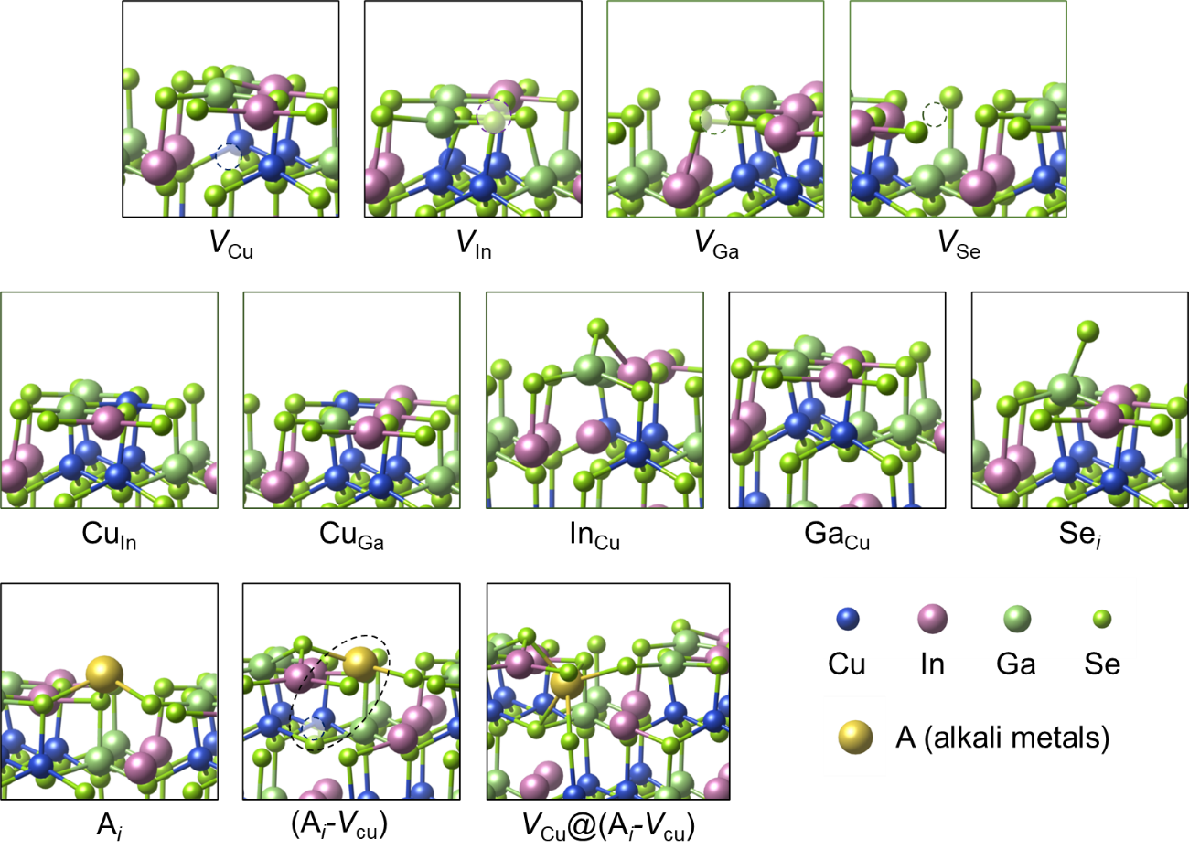
Figure S6. The atomic structures of calculated defects at the CIGS (1 1 2) surface obtained from structural optimization via DFT.

Table S1. The calculated formation energies (eV) at (E_{F} = valence band maximum) for defects shown in Figure S8.
 | V_{Cu}^{1–} | V_{In}^{1–} | V_{Ga}^{1–} | V_{Se}¹⁺ | Cu_{In}^{1–} | Cu_{Ga}^{1–} | In_{Cu}²⁺ | Ga_{Cu}²⁺ | Se_{i}^{1–}
convex  (–1%) | 0.360 | 0.736 | - | 0.946 | 0.617 | 0.929 | 0.735 | 0.327 | 1.110
planar | 0.297 | 0.694 | 0.787 | 1.082 | 0.755 | 0.880 | 0.972 | 0.464 | 1.248
concave  (+1%) | 0.194 | 0.622 | - | 1.257 | 0.605 | 0.801 | 0.540 | 0.643 | -
 | Na_{i}¹⁺ | Rb_{i}¹⁺ | Cs_{i}¹⁺ | Na_{i}-V_{Cu} | Rb_{i}-V_{Cu} | Cs_{i}-V_{Cu} | V_{Cu}^{1–}@  Na_{i}-V_{Cu} | V_{Cu}^{1–}@  Rb_{i}-V_{Cu} | V_{Cu}^{1–}@  Cs_{i}-V_{Cu}
convex  (–1%) | 0.346 | 0.167 | -0.005 | 0.326 | 0.315 | 0.207 | 0.183 | 0.370 | 0.428
planar | 0.384 | 0.215 | 0.048 | 0.309 | 0.307 | 0.201 | 0.129 | 0.305 | 0.362
concave  (+1%) | 0.439 | 0.283 | 0.119 | 0.272 | 0.281 | 0.179 | 0.039 | 0.205 | 0.260

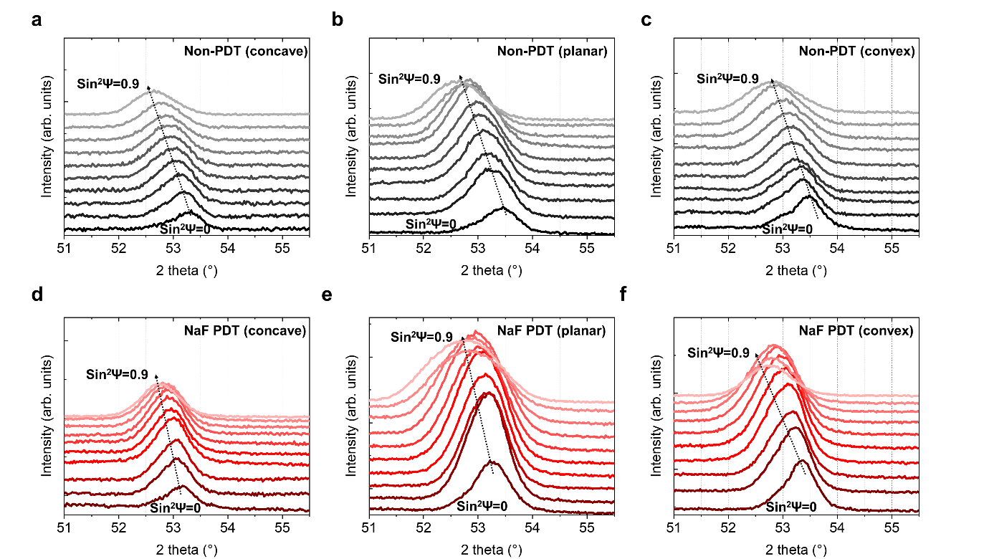
Figure S7. Angle-tilted XRD pattern. The XRD peak of (3 1 2) orientation shifted as the tilting angles increased, indicating that intrinsic tensile strain was applied on the CIGS thin film: (a–c) Non-PDT and (d–f) NaF PDT. Under planar and mechanical bending states, the samples experienced intrinsic tensile strain, indicating that additional mechanical stress could not invert the strain applied to the entire film.
Table S2. Calculations of d-spacing modifications under artificial biaxial strain conditions. The direction in the c axis was parallel to the (1 1 2) orientation plane where the d-spacing increased and decreased under convex and concave bending states, respectively.
Forced strain (x-y) | Strain in c  (1 1 2) facet | d-spacing (Å)  (3 1 2)
–2% (convex) | +1.42% | 1.75285
0% (unstrained) | - | 1.74313
+2% (concave) | –1.25% | 1.73453

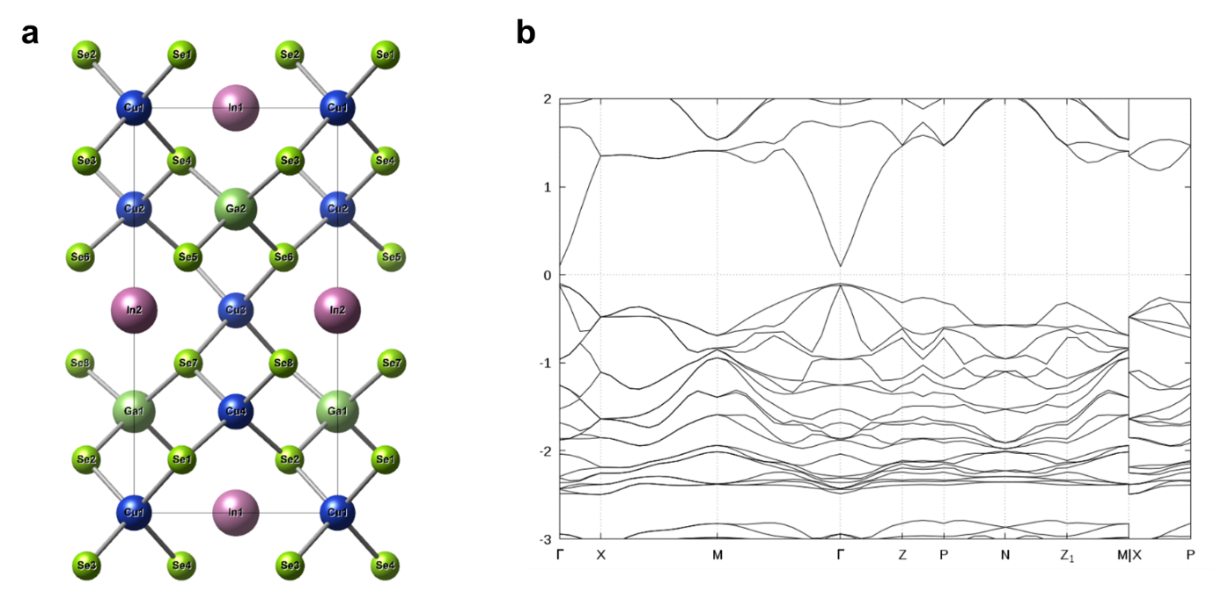
Figure S8. (a) The unit-cell used to represent CuIn_{0.5}Ga_{0.5}Se₂. (b) The calculated electronic band structure of CuIn_{0.5}Ga_{0.5}Se₂.

