Supplementary Figures and Tables
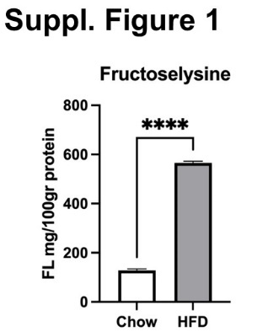
Supplementary figure 1: Concentrations of protein-bound fructoselysine measured in standard chow diet and high-fat diet. Concentrations in diet shown as ratios of mg protein-bound fructoselysine per 100gr of dietary proteins. Data are shown as mean values ± SEM (N=3/group), *** P < 0.001.
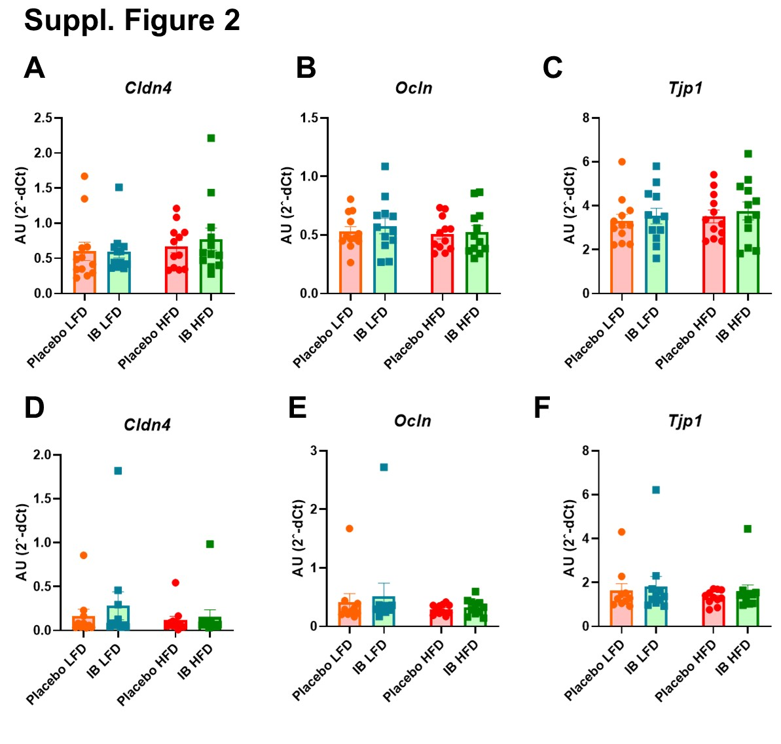
Supplementary figure 2: (A-F) Expression levels of genes encoding critical molecules for intestinal barrier function in (A-C) the small intestine and (D-F) the colon. All data are shown as mean values ± SEM (N=12/group). *P < 0.05, ** P < 0.01, *** P < 0.001.
Supplementary table 1: Fructoselysine pathway genes found in genomes of four Intestinimonas strains. +: presence; -: absence
Pathway genes | AF 211 | GL3 | IY4 | AS_BT
Fructoselysine kinase | + | + | + | +
Glucosamine--fructose-6-phosphate aminotransferase | + | + | + | +
Lysine 2,3-aminomutase | + | + | + | +
L-beta-lysine 5,6-aminomutase alpha subunit | + | + | + | +
3,5-diaminohexanoate dehydrogenase | + | + | + | +
3-keto-5-aminohexanoate cleavage enzyme | + | + | + | +
3-aminobutyryl-CoA ammonia-lyase | + | + | + | +
Butyryl-CoA dehydrogenase | + | + | + | +
Electron transfer flavoprotein, alpha subunit | + | + | + | +
Electron transfer flavoprotein, beta subunit | + | + | + | +
Butyrate-acetoacetate CoA-transferase subunit A | + | + | + | +
Butyrate-acetoacetate CoA-transferase subunit B | + | + | + | +
Acetyl-CoA:acetoacetyl-CoA transferase, alpha subunit | + | + | + | +
3-ketoacyl-CoA thiolase | + | + | + | +
Phosphate acetyltransferase | + | + | + | +
Acetate kinase | + | + | + | +
D-lactate dehydrogenase | + | + | + | -
Pyruvate:ferredoxin oxidoreductase, beta subunit | + | + | + | -
Pyruvate:ferredoxin oxidoreductase, alpha subunit | + | + | + | -
Pyruvate:ferredoxin oxidoreductase, delta subunit | + | + | + | -
Pyruvate:ferredoxin oxidoreductase, gamma subunit | + | + | + | -
Cobalt-precorrin-6y C5-methyltransferase | + | + | + | -
3-ketoacyl-CoA thiolase | + | + | + | +
3-hydroxybutyryl-CoA dehydrogenase | + | + | + | +
3-hydroxybutyryl-CoA dehydratase | + | + | + | +
4-hydroxybutyrate coenzyme A transferase | + | + | + | +
Supplementary table 2: Genes involved in pseudovitaminB12 synthesis in 4 Intestinimonas strains. +: presence; -: absence
Pathway genes | AF211 | AB_ST | IY4 | GL3
Nicotinate-nucleotide--dimethylbenzimidazole phosphoribosyltransferase | + | + | + | +
Adenosylcobinamide-phosphate guanylyltransferase | + | + | + | +
Cobalamin synthase | + | + | + | +
Cobalamin biosynthesis protein CbiG | + | - | + | +
Cobyric acid synthase | + | - | + | +
Cobyrinic acid A,C-diamide synthase | + | - | + | +
Adenosylcobinamide-phosphate synthase | + | - | + | +
Cobalamin biosynthesis protein CbiG | + | - | + | +
Cobalt-precorrin-8x methylmutase | + | - | + | +
Cobalt-precorrin-6 synthase, anaerobic | + | - | + | +
Cobalt-precorrin-6y C5-methyltransferase | + | - | + | +
Cobalt-precorrin-6y C5-methyltransferase | + | - | + | +
Cobalt-precorrin-4 C11-methyltransferase | + | - | + | +
Cobalamin biosynthesis protein CbiG | + | - | + | +
Cobalt-precorrin-3b C17-methyltransferase | + | - | + | +
Cobalt-precorrin-6x reductase | + | - | - | +
Sirohydrochlorin cobaltochelatase CbiK | + | - | + | +
Cobalt-precorrin-2 C20-methyltransferase | + | - | + | +
Porphobilinogen deaminase | + | - | + | +
Siroheme synthase / Precorrin-2 oxidase | + | + | + | +
Uroporphyrinogen-III methyltransferase | + | + | + | +

Supplementary table 3: Antibiotic resistance profiles of 4 Intestinimonas strains. Minimal inhibitory concentrations are indicated (µg/ml).
Antibiotics | AF211 | IY4 | GL3 | AS-BT
Vancomycin | 0.75 | 0.5 | 1 | 0.38
Sulfamethoxazole | >32 | >32 | >32 | >32
Tetracycline | 16 | 6 | 16 | 2
Ciprofloxacin | >32 | >32 | >32 | >32
Erythromycin | >256 | 2 | >256 | 0.064
Oxacillin | 1.5 | 1.5 | 1.5-2 | 16
Tobramycine | 6 | 16 | 8 | 4
Cefotaxime | 0.094 | 0.125 | 0.125 | 12
Chloramphenicol | 0.19 | 0.38 | 0.5 | 0.19

Supplementary table 4: Numbers of resistance genes detected in the genomes of four Intestinimonas strains (AF211, AS-BT, IY4 and GL3)
Roles | Groups | Intestinimonas strains
Roles | Groups | AF211 | AS-BT | IY4 |  | GL3
Heavy metals | Arsenic resistance | 4 | 1 |  | 3 | 3
Heavy metals | Zinc resistance | 7 | 2 |  | 5 | 6
Heavy metals | Cadmium resistance | 1 | 1 |  | 1 | 1
Heavy metals | Cobalt-zinc-cadmium resistance | 9 | 5 |  | 7 | 8
Heavy metals | Copper homeostasis | 4 | 3 |  | 4 | 4
 | Beta-lactamase | 6 | 4 |  | 5 | 4
 | Resistance to Vancomycin (VanA, S, R and W) | 5 | 4 |  | 5 | 5
Antibiotics | Resistance to fluoroquinolones | 4 | 4 |  | 4 | 4
 | Tetracycline resistance related protein, translation elongation factor G | 5 | 3 |  | 4 | 5
 | Tetracycline resistance protein tetW | 1 | 1 |  | 1 | 0
Multidrug resistance efflux pumps | Acriflavin resistance protein | 1 | 1 |  | 1 | 1
Multidrug resistance efflux pumps | Macrolide export ATP-binding/permease MacB | 2 | 3 |  | 1 | 2
Multidrug resistance efflux pumps | Multi antimicrobial extrusion protein (Na+/drug antiporter) MATE family of MDR efflux pumps | 17 | 11 |  | 25 | 27

Supplementary table 5: Elemental composition and retention time of the analytes quantified through the three procedures described in material and methods section, HILIC-MS/MS for lysine and fructoselysine, reversed phase (RP) LC-MS/MS upon derivatization for SCFA in plasma, LC-MS/MS for SCFA in fecal supernatants (PGC); in bold internal standard used for quantification and recovery of the derivatization procedure. Error (Δ ppm) was calculated as the ratio between the difference of the theoretical mass minus the experimental mass and the theoretical mass, multiplied per one million. In the case of reversed phase (RP), each compound is intended as hydrazone derivative and reported in italic. For porous graphite column (PGC), target analytes were detected and quantified in their native form without any derivatization.
Compound Name | Elemental Composition | LC | RT | m/z theoretical | m/z experimental | Δ ppm
acetic acid | C8H9N3O3 | RP | 9.10 | 194.0571 | 194.0572 | 0.5
propionic acid | C9H11N3O3 | RP | 11.10 | 208.0728 | 208.0724 | -1.9
butyric acid | C10H13N3O3 | RP | 12.80 | 222.0884 | 222.0881 | -1.4
¹³C₂-acetic acid | ¹³C2C6H9N3O3 | RP | 9.10 | 196.0638 | 196.0639 | 0.5
¹³C₃-propionic acid | ¹³C3C6H11N3O3 | RP | 11.10 | 211.0828 | 211.0827 | -0.5
¹³C₄-butyric acid | ¹³C4C6H11N3O3 | RP | 12.80 | 226.1018 | 226.1014 | -1.8
acetic acid | C2H4O2 | PGC | 1.20 | 61.0284 | 61.0284 | 0.0
propionic acid | C3H6O2 | PGC | 1.60 | 75.0441 | 75.0440 | -1.3
butyric acid | C4H8O2 | PGC | 3.00 | 89.0957 | 89.0957 | 0.0
¹³C₂-acetic acid | ¹³C2H4O2 | PGC | 1.20 | 63.0351 | 63.0352 | 1.6
¹³C₃-propionic acid | ¹³C3H6O2 | PGC | 1.60 | 78.0541 | 78.0542 | 1.3
¹³C₄-butyric acid | ¹³C4H8O2 | PGC | 3.10 | 93.0731 | 93.0730 | -1.1
FL | C12H24N2O7 | HILIC | 4.56 | 309.1656 | 309.1656 | 0.0
lysine | C6H14N2O2 | HILIC | 4.15 | 147.1128 | 147.1129 | 0.7

Supplementary table 6: primer sequences for assessing the expression of transcripts by qPCR in murine tissues
Gene | Forward Primer sequence | Reverse Primer sequence
Hprt | TGACACTGGTAAAACAATGCAA | GTCCTTTTCACCAGCAAGCT
Ppargc1a4 | TCACACCAAACCCACAGAAA | CTGGAAGATATGGCACAT
Ppara | CTGAFACCCTCGGGGAAC | AAACGTCAGTTCACAGGGAAG
Cpt1a | AGAGGGGAGGACAGAGACTG | TCTGCTCTGCCGTTGTTGTG
Ucp1 | TCAGGATTGGCCTCTACGAC | CCTTCACGACCTCTGTAGGC
Cidea | TGACATTCATGGGATTGCAGAC | CATGGTTTGAAACTCGAAAAGGG
Prdm16 | CCACCAGCGAGGACTTCAC | GGAGGACTCTCGTAGCTCGAA
Dio2 | AATTATGCCTCGGAGAAGACCG | GGCAGTTGCCTAGTGAAAGGT
Tbx1 | GTCAAGGCTCCGGTGAAGAAG | GCTGATTGAACTCGTCCCACA
Irs2 | ACAACCTATCGTGGCACCTC | CCATGAGACTTAGCCGCTTC
Cldn4 | CGCTACTCTTGCCATTACG | ACTCAGCACACCATGACTTG
Ocln | ATGTCCGGCCGATGCTCTC | TTTGGCTGCTCTTGGGTCTGTAT
Tjp1 | TTTTTGACAGGGGGAGTGG | TGCTGCAGAGGTCAAAGTTCAAG

