Supplementary Materials
Table S1: Processing workflow for PGS MC3D data.
- P-UP generation
- Full source deghosting
- 3D surface related multiple elimination (SRME)
- Convolutional 3D SRME
- Wave equation 3D SRME
- 2D surface related multiple elimination (SRME)
- High resolution radon demultiple
- HyperTomo velocity model building
- Kirchhoff prestack time migration (PSTM)
- Kirchhoff prestack depth migration (PSDM)
- Anisotropic Kirchhoff prestack time migration (PSTM)
- Poststack time migration
- Post-migration image optimization

Figure S1: Depth maps showing the surface crater morphology at the KPg1, KPg2 and KPg3 horizons. The KPg1 horizon is interpreted as the crater geometry below an in-situ breccia/suevite unit, KPg2 as the crater floor immediately after the crater modification stage, and KPg3 as crater floor after resurge deposition. All three surfaces show a pronounced central uplift, a stepped terrace zone above the rim syncline/annular moat and a well-developed crater rim. The crater depth is greater for KPg1 (~230 m) than for KPg2 (~130 m) or KPg3 (~70 m). Contour interval is 10 m. The inner rim is interpreted at the area of greatest elevation for all three reflections, providing an accurate measure of crater diameter (average 9.2 km) and area (67 km²).
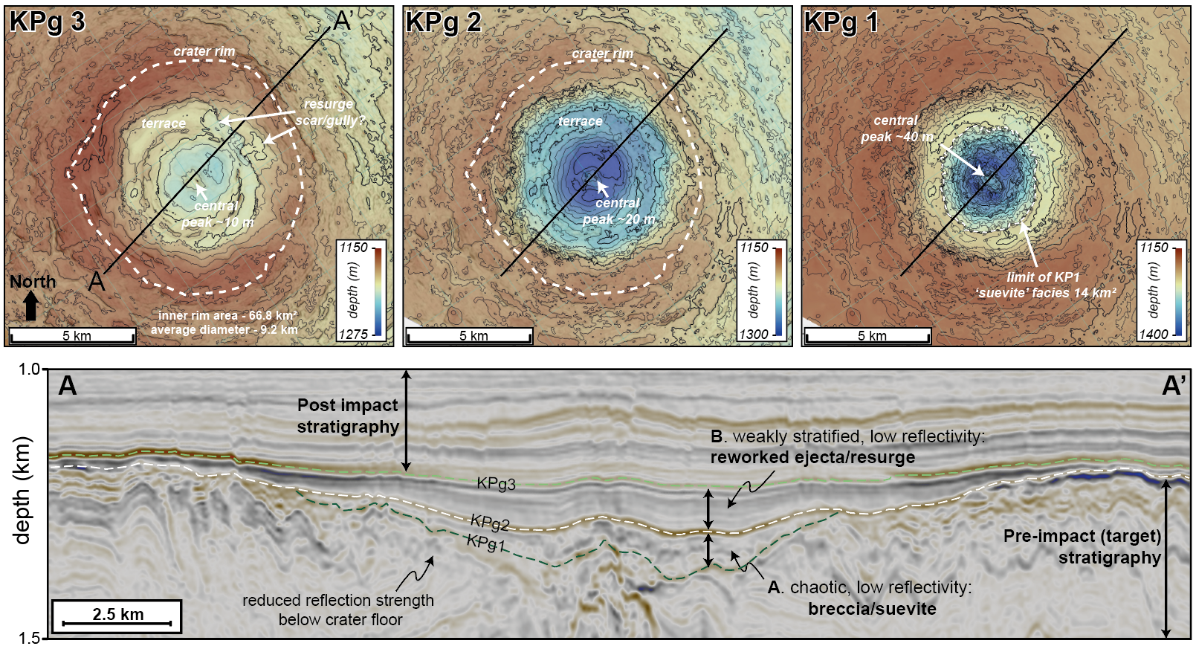

Movie S1: Three-dimensional architecture of Nadir Crater shown by sequentially removing seismic horizons. Video annotated using Clipchamp video editor.

