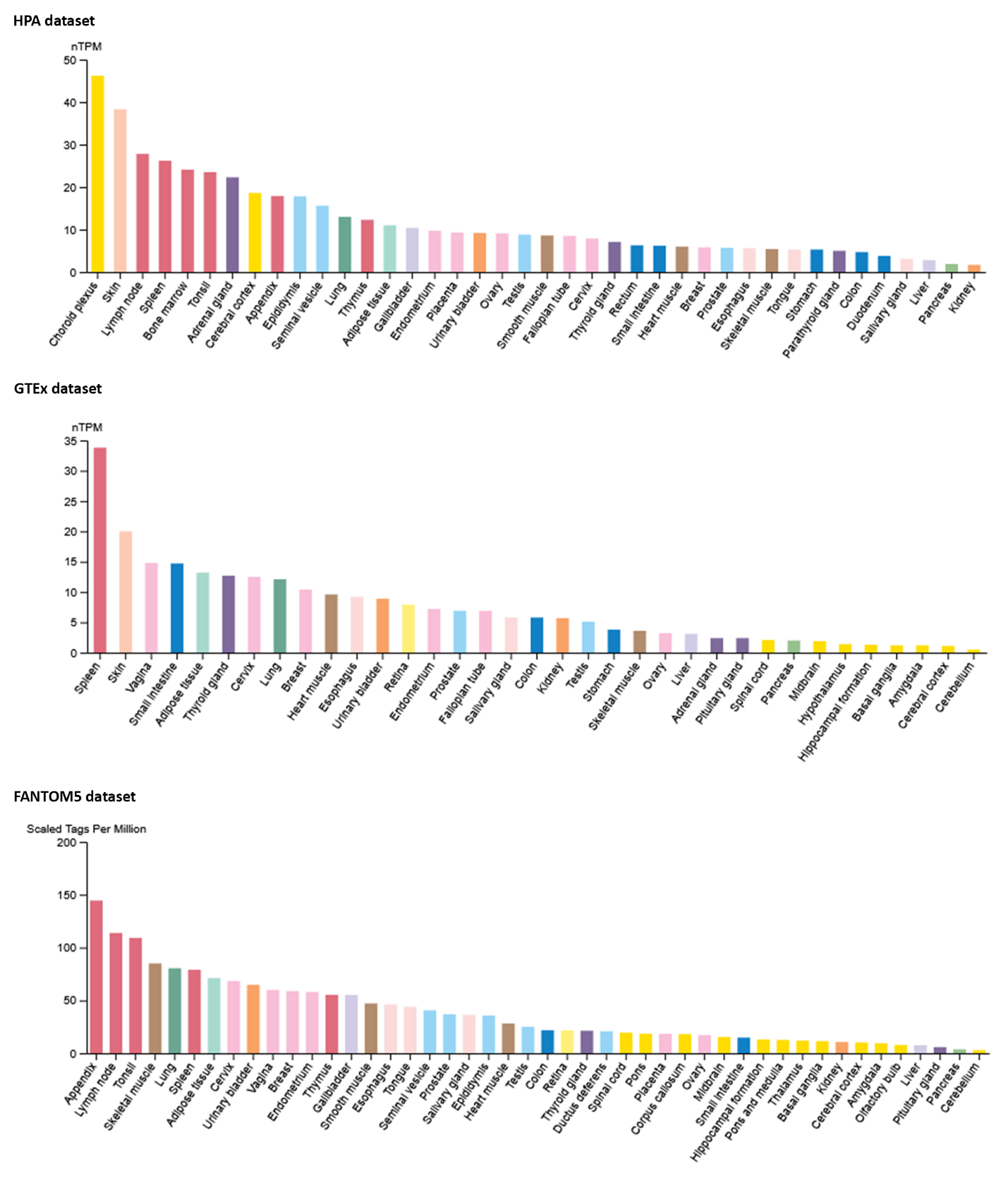
Supplementary Figure 1. NLRP1 expression pattern in various normal tissues based on HPA, GTEx, and FANTOM5 datasets.

