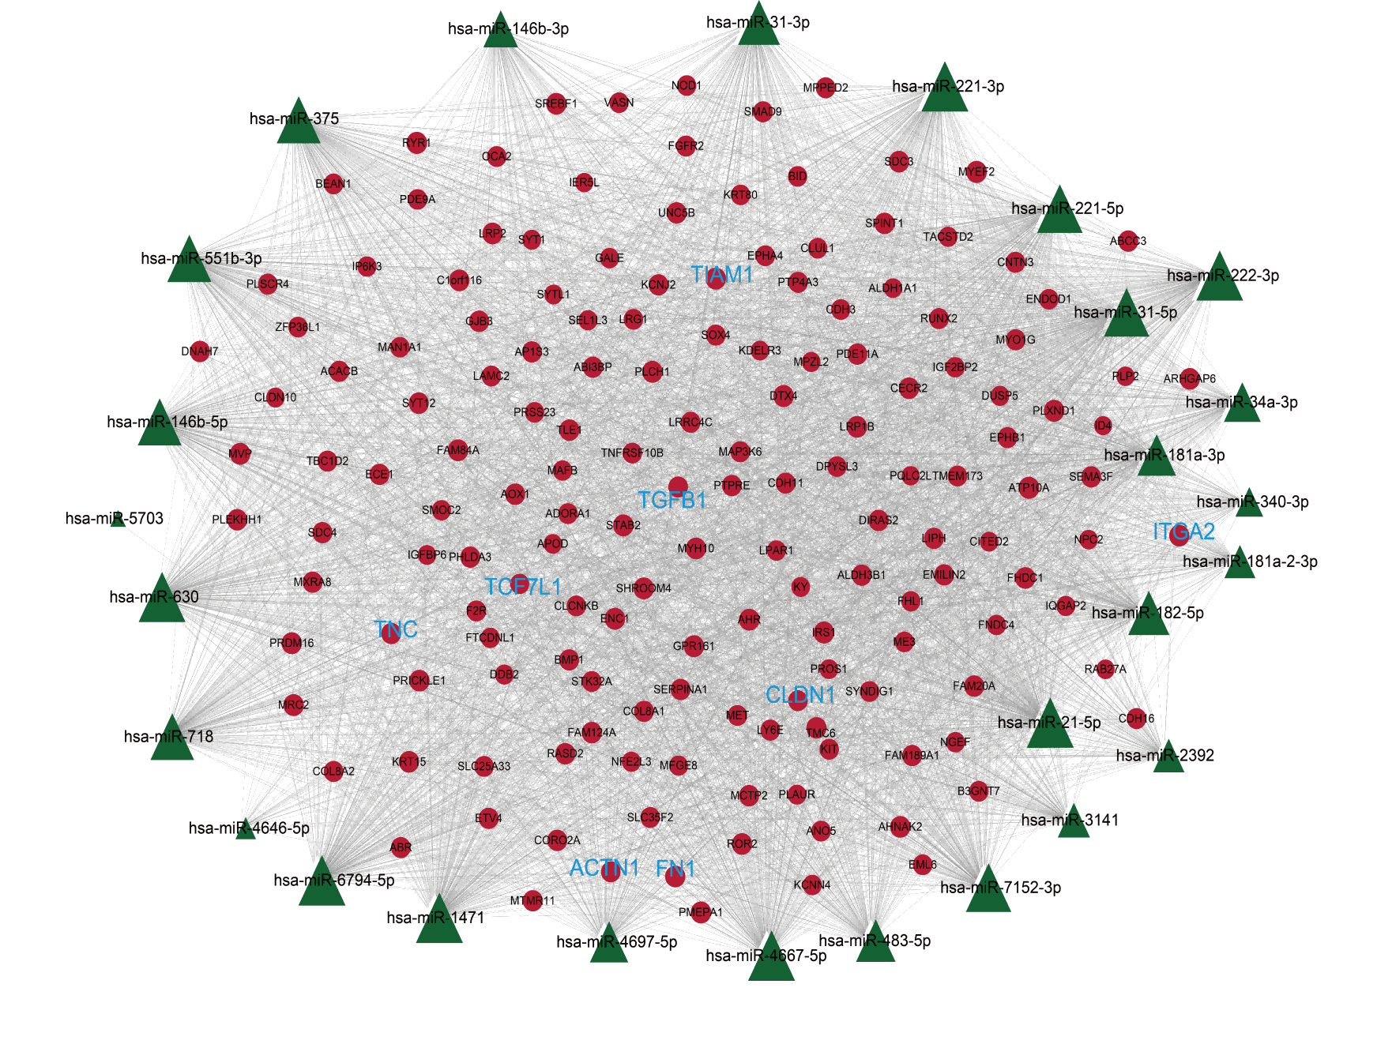
Fig. S1

Fig. S1 Top 20% miRNA-mRNA network from the mRNA-miRNA-mRNA network visualized by Cytoscape, circles represent mRNA, rectangle stands for miRNA.

