Supplementary
Restriction Enzyme-Free Method for Generating PCR Product Sticky Ends in Recombinant Vector Construction for Cloning

Figure. 1S: Scheme of pJEBB-eGFP-miR-21

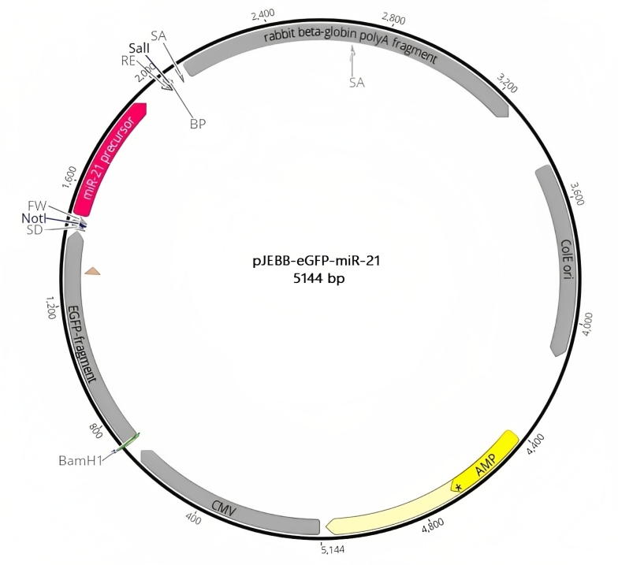
Figure. 1S

