Mapping Mitochondrial Channel Toxicity: A Case Study for Predicting Mito-Target Interactions for the Per- and Poly-Fluoroalkyl Compounds on the Zebrafish Voltage-Dependent Anion Channel 2
Michael González-Durruthy ^{a,b}, Amit Kumar Halder ^{a,c}, Ana Silveira Moura ª, Maria Natália Dias Soeiro Cordeiro ^{a,*}
ªLAQV-REQUIMTE/Faculty of Sciences, University of Porto, 4169-007 Porto, Portugal.
^{b}NanoSafety Group, INL-International Iberian Nanotechnology Laboratory, Braga, 4715-330, Portugal.
^{c}Dr B C Roy College of Pharmacy and AHS, Bidhan Nagar, Durgapur, West Bengal 713206, India.

* To whom correspondence should be addressed:
Maria Natália Dias Soeiro Cordeiro, Email: ncordeiro@fc.up.pt, Fax: +351220402659.

Associated content:
Figure S1. Representation of the 3D-superimposed docking complexes in the same biophysical environment placed close to the voltage-sensing N-terminal α-helix segment of zfVDAC2. A) best-ranked zfVDAC-PFAS#25 docking complex, and B) worst-ranked zfVDAC-PFAS#29 docking complex.
Figure S2. A) Scatter plot of predicted vs. observed docking scores obtained from the 2D-QSAR model, B) Williams plot for the 2D-QSAR model. C) Scatter plot of observed vs. predicted affinity scores obtained from the 3D-QSAR model.
Table S2. Variation inflation factors (VIF) for the descriptors of the 2D-QSAR model.

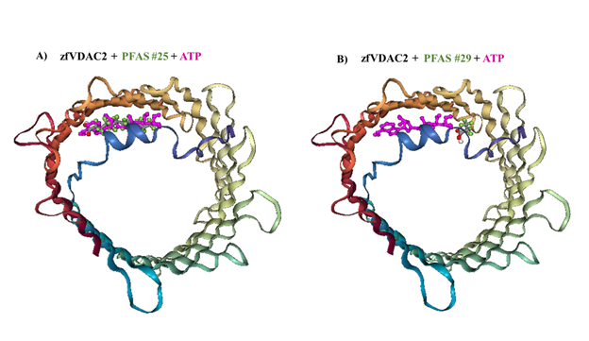
Figure S1. Representation of the 3D-superimposed docking complexes in the same biophysical environment placed close to the voltage-sensing N-terminal α-helix segment of zfVDAC2. A) best-ranked zfVDAC-PFAS#25 docking complex, and B) worst-ranked zfVDAC-PFAS#29 docking complex.

Figure S2. A) Scatter plot of predicted vs. observed docking scores obtained from the 2D-QSAR model, B) Williams plot for the 2D-QSAR model. C) Scatter plot of observed vs. predicted affinity scores obtained from the 3D-QSAR model.

Table S2. Variation inflation factors (VIF) for the descriptors of the 2D-QSAR model.
Descriptors | VIF
S-110 | 2.910
CATS2D_03_AA | 1.748
CATS2D_07_AL | 1.201
B02[O-O] | 1.248
B05[N-S] | 2.332
B08[C-O] | 2.206
B10[C-C] | 1.814
F06[S-F] | 1.823
F09[O-F] | 2.219
PDI | 3.198

