Supplementary Information

Intraband Transitions at a CsPbBr₃/GaAs Heterointerface in a Two-Step Photon Upconversion Solar Cell

Hambalee Mahamu*, Shigeo Asahi, and Takashi Kita.

Department of Electrical and Electronic Engineering, Graduate School of Engineering, Kobe University, 1-1 Rokkodai, Nada, Kobe 657-8501, Japan

*Hambalee Mahamu: 203t268t@cloud.kobe-u.ac.jp

S1. X-ray Diffractograms
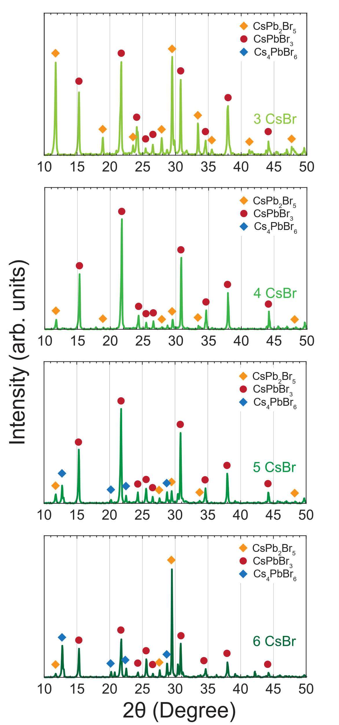
Fig. S1 X-ray diffractograms of CsPbBr₃ films prepared on glass substrates using 3, 4, 5 and 6 CsBr deposition cycles. The diffraction intensity is shown on a linear scale. The orange and blue squares indicate the undesired derivative phases $\text{CsP}{\text{b}}_{\text{2}}\text{B}{\text{r}}_{\text{5}}$ and $\text{C}{\text{s}}_{\text{4}}\text{PbB}{\text{r}}_{\text{6}}$, respectively. The dark red points indicate the diffraction intensity of the CsPbBr₃ perovskite phase.

The measurement of the X-ray diffractograms was performed using a Rigaku Ultima IV automated multipurpose X-ray diffractometer. The X-ray photons with a wavelength of 1.541 Å (Cu K-α) were generated using an accelerating voltage of 40 kV. In the film prepared using three CsBr deposition cycles, the CsPb₂Br₅ phase (indicated by the orange squares) is dominant. The diffraction peaks corresponding to CsPbBr₃ (indicated by dark red points) first increase with the number of deposition cycles. However, when more than four deposition cycles are used, the Cs₄PbBr₆ phase appears (indicated by the blue squares). Therefore, four deposition cycles are considered to be the optimum condition in our case.

S2. Photoluminescence Spectrum
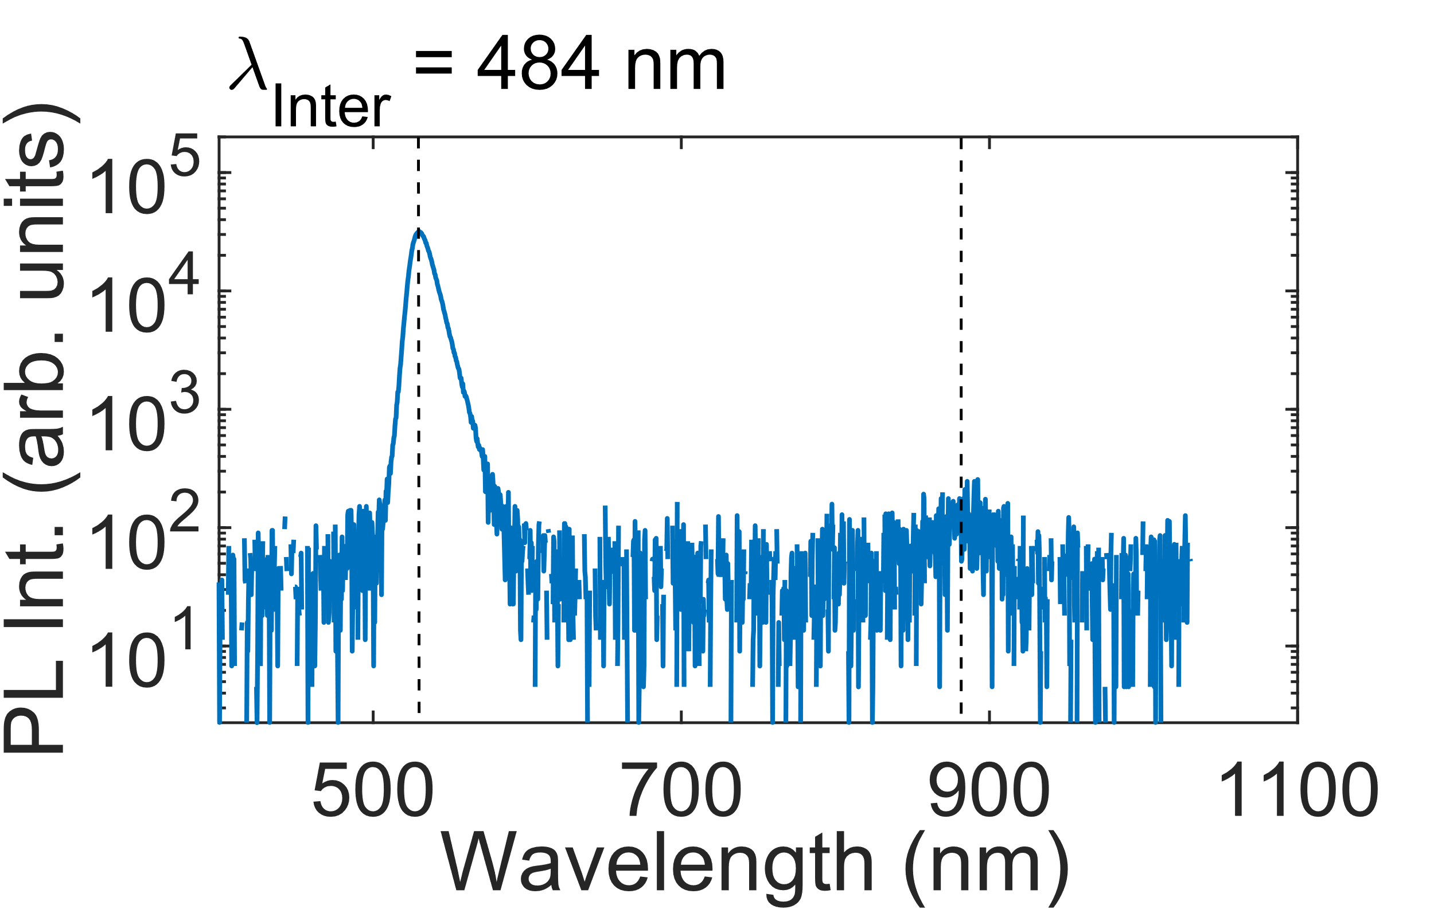
Fig. S2 PL spectrum of CsPbBr₃ on GaAs.
The room-temperature photoluminescence spectrum of CsPbBr₃ on GaAs was measured by employing a continuous-wave solid-state laser operating at 484 nm. The excitation power was 39.5 mW. The 484-nm photons are mainly absorbed in the CsPbBr₃ layer, but a small fraction also reaches the GaAs layer. Thus, the emission peak at about 535 nm, which corresponds to CsPbBr₃, exhibits a much higher intensity than the emission peak of GaAs at about 870 nm. The spectrum was measured using an OceanOptics USB2000 spectrometer with a Sony ILX511B linear silicon CCD array (Ocean Insight).
S3. Scanning Electron Microscopy Image

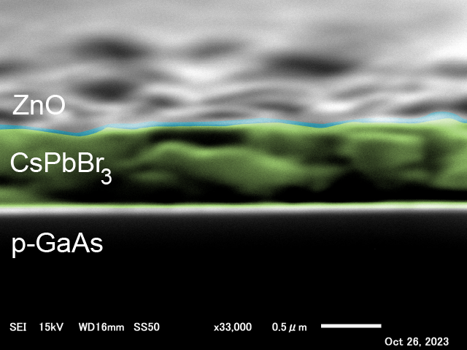
Fig. S3 Cross-sectional scanning electron microscopy (SEM) image of the $\text{CsPbB}{\text{r}}_{\text{3}}$/GaAs-heterointerface.

For the characterization of the layer thicknesses, a ZnO/CsPbBr₃/p-GaAs sample was installed in a scanning electron microscope (JSM-IT200 InTouchScopeTM). Figure S3 shows a SEM image at a magnification of 33,000× for an accelerating voltage of 15 kV. The scale bar indicates that the thicknesses of ZnO and CsPbBr₃ are approximately 130 nm and 800 nm, respectively. These two values were used to estimate the total amount of 500-nm photons absorbed in each layer.

S4. Total Amount of 500-nm Photons Absorbed in Each Layer
In Section 3.2 in the main text, we considered the fraction of 500-nm light absorbed in each semiconductor in our TPU-SC. In order to estimate the total amount of absorbed light in each layer, we employed the Beer–Lambert law,
T = exp(–αx),
where T is the transmittance, α is the absorption coefficient of the considered semiconductor, and x is the thickness of the layer. To simplify the calculation, we neglected the influences of reflection and scattering. The SEM image in Fig. S3 provided the thicknesses of the ZnO and CsPbBr₃ layers (approximately 130 nm and 800 nm, respectively). Regarding the absorption coefficients, we used the values reported in the literature^{1–3}. The result indicated in Fig. S4 reveals that 17% of the incident 500-nm photons are absorbed in ZnO and 82% are absorbed in CsPbBr₃. The remaining 1% reaches GaAs. Therefore, the absorption of 500-nm photons in GaAs is negligible. Since more than 80% of the 500-nm photons are absorbed in CsPbBr₃, the photon absorption by CsPbBr₃ results in a significant reduction of the electron accumulation at HI-I as the energy of the photons for interband excitation increases.
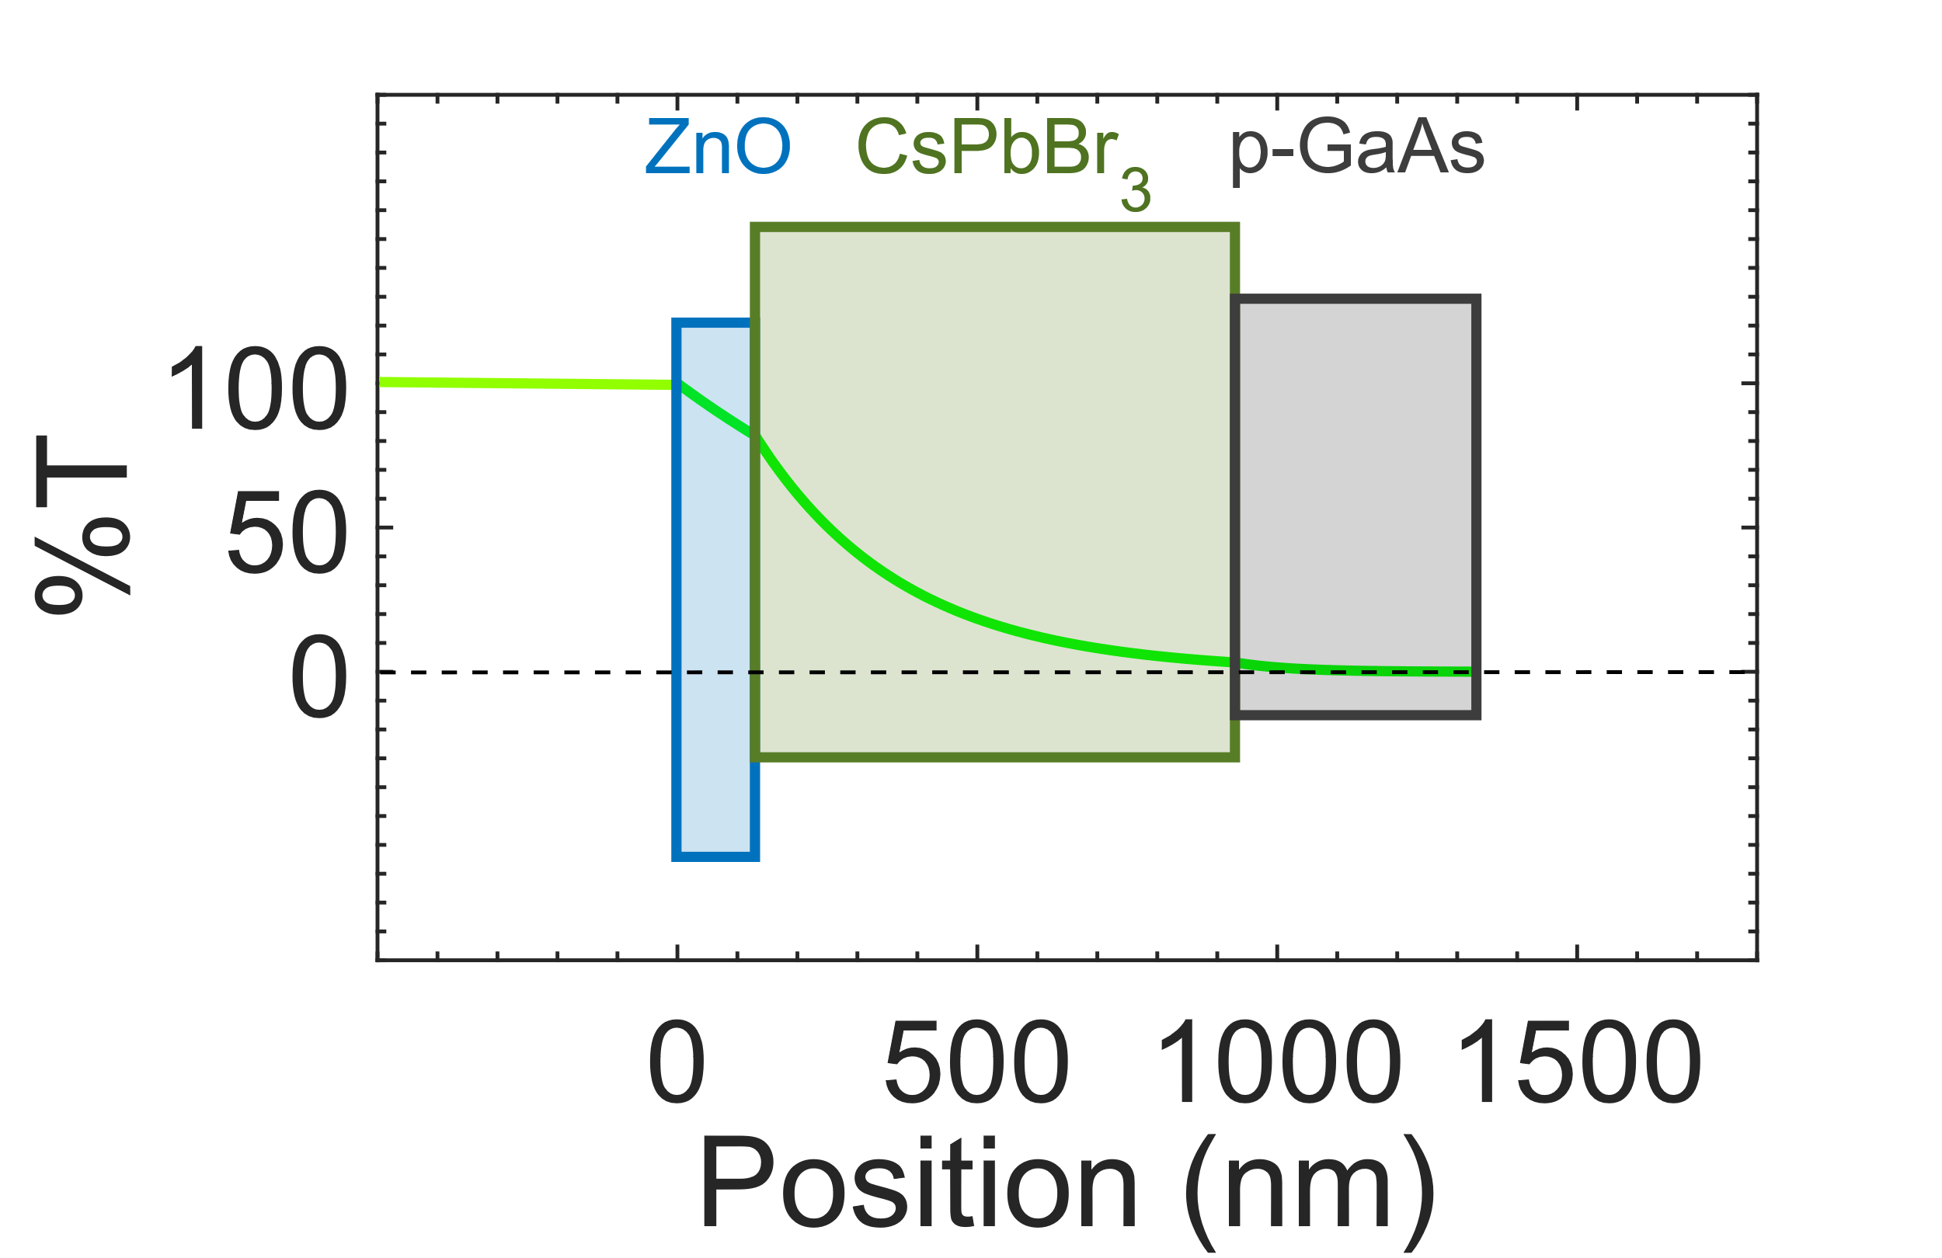
Fig. S4 Transmission of 500-nm photons as a function of the position in the $\text{CsPbB}{\text{r}}_{\text{3}}$/GaAs-based two-step photon upconversion solar cell.

_________________________________________
References
1. Aspnes, D. E., Kelso, S. M., Logan, R. A. & Bhat, R. Optical properties of Al_{x}Ga_{1-x}As. J. Appl. Phys. 60, 754–767 (1986).
2. Aguilar, O., de Castro, S., Godoy, M. P. F. & Rebello Sousa Dias, M. Optoelectronic characterization of Zn_{1-x}Cd_{x}O thin films as an alternative to photonic crystals in organic solar cells. Opt. Mater. Express 9, 3638 (2019).
3. Ermolaev, G. et al. Giant and Tunable Excitonic Optical Anisotropy in Single-Crystal Halide Perovskites. Nano Lett. 23, 2570–2577 (2023).

