Characterization of Tobacco Stalk Ash
Ananya Buragohain †,⸙, Victoria Vartic♦,⸙, Rebecca Lalmuanpuii†,‡, Khawlhring Lalrammawia†, Kahramon Mamatkuhlov♦, Grigory Arzymanyan♦,*, Nikita Yushin♦, Pavel Nekhoroshkov♦, Inga Zinicovscaia♦, Rajendra Bose Muthukumaran†,*

Fig. S1(a) Fig. S1(b)
Fig. S1(c) Fig. S1(d)
Fig. S1(e)
Fig. S1: XPS features of various elements present in tobacco stalk ash: (a) Si 2p; (b) S 2p; (c) P 2p; (d) Mg 1s; (e) Cl 2p

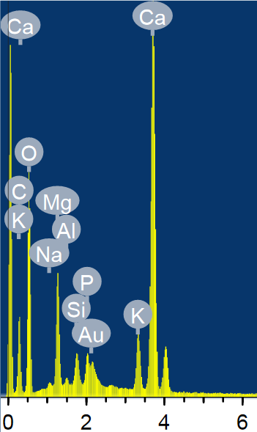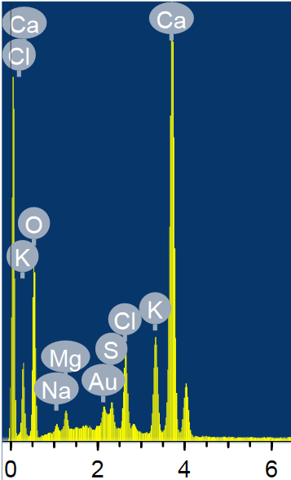
Fig. S2(a) Fig. S2(b)

Fig. S2: EDS analysis of tobacco stalk ash

Table S2(a): Mineral components of tobacco stalk ash.
Element | Weight% | Atomic %
Carbon(C) | 16.44 | 25.31
Oxygen(O) | 50.36 | 58.18
Sodium(Na) | 0.34 | 0.28
Magnesium(Mg) | 4.67 | 3.55
Aluminum(Al) | 0.28 | 0.19
Silicon(Si) | 1.04 | 0.68
Phosphorous(P) | 1.22 | 0.73
Potassium(K) | 2.60 | 1.23
Calcium(Ca) | 20.94 | 9.66

Table S2(b): Mineral components of tobacco stalk ash.
Element | Weight% | Atomic %
Oxygen(O) | 55.59 | 75.93
Sodium(Na) | 0.69 | 0.66
Magnesium(Mg) | 1.05 | 0.95
Sulfur(S) | 1.26 | 0. 86
Chlorine(Cl) | 4.08 | 2.51
Potassium(K) | 5.54 | 3.10
Calcium(Ca) | 28.71 | 15.65

