Supplementary data

Figures

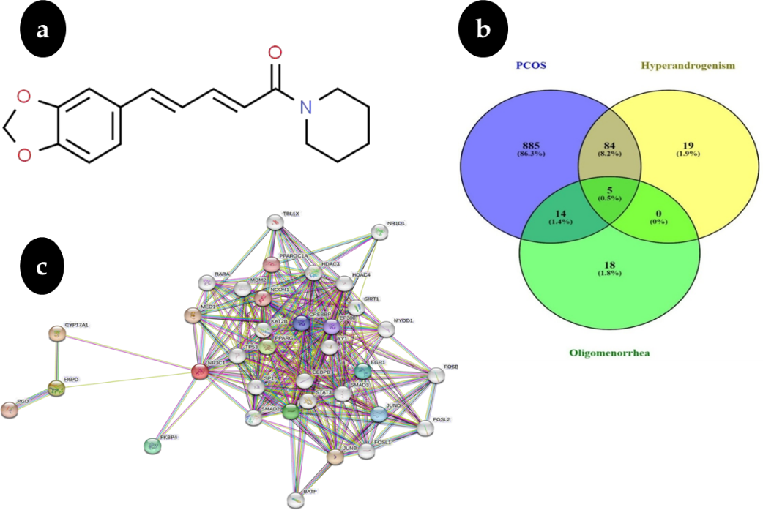

Figure. S1: (a)PiperineChemical Structure(b) Targets in Poly Cystic Ovary Common Protein Syndrome(c) Protein-Protein (PPI) interaction network of common targets in PCOS

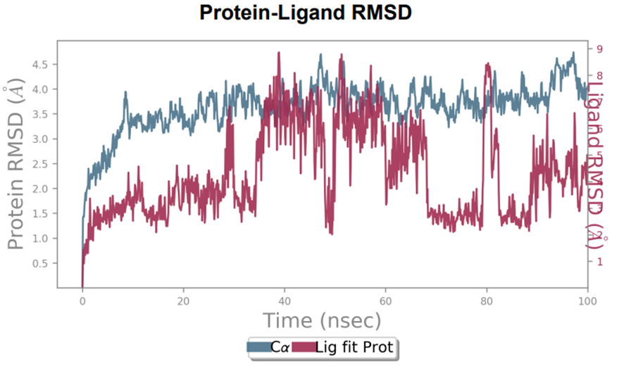

Figure. S2:The stability of the receptor-ligand complex is assessed by employing the root mean square deviation (RMSD) value.

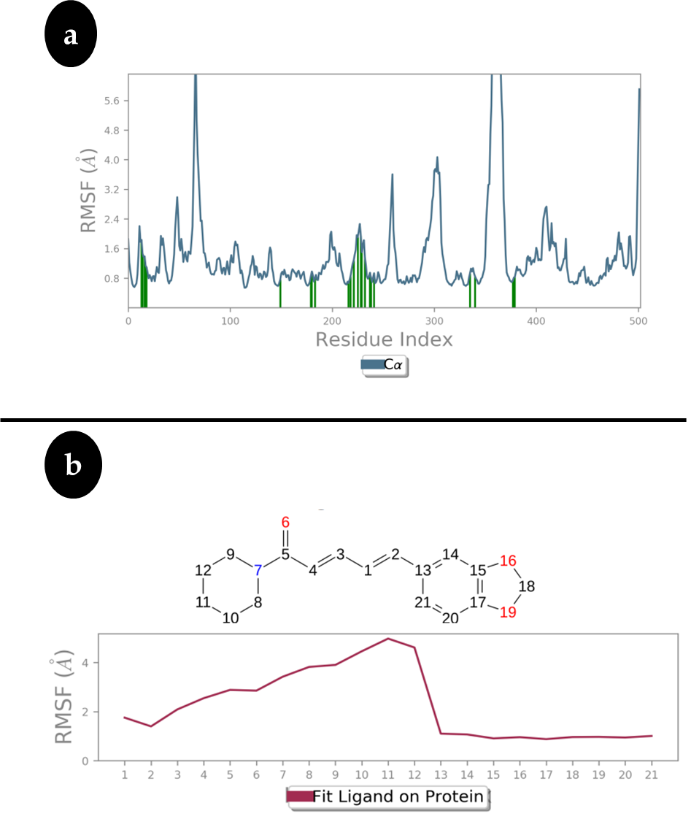
Figure. S3: (a)For ligand (Piperine), the average RMSF values of Hexose-6-phosphate dehydrogenase amino acid residues have been calculated using Desmond software(b)Fluctuation of the Ligand Root Means Square (L-RMSF)

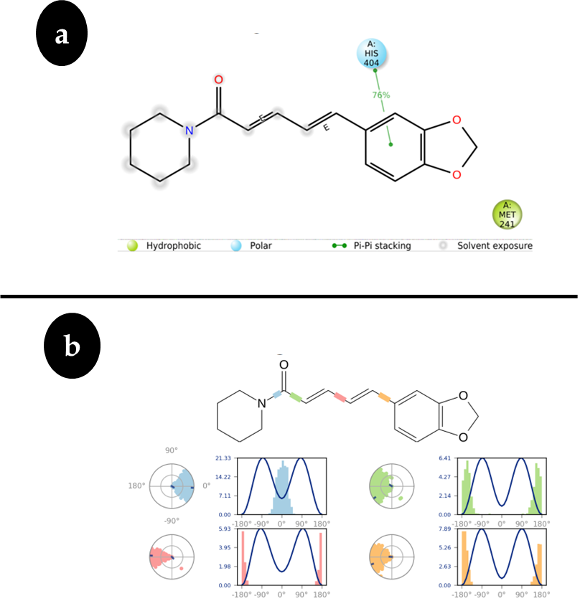

Figure. S4: (a)A thorough representation of the molecular reactions taking place inside the protein-ligand complex would be provided by a diagram showing the precise connections between the protein and ligand atoms.(b) The conformational development of potentially rotatable bonds is depicted by a ligand (Piperine) torsion map through the simulation study (100 ns).

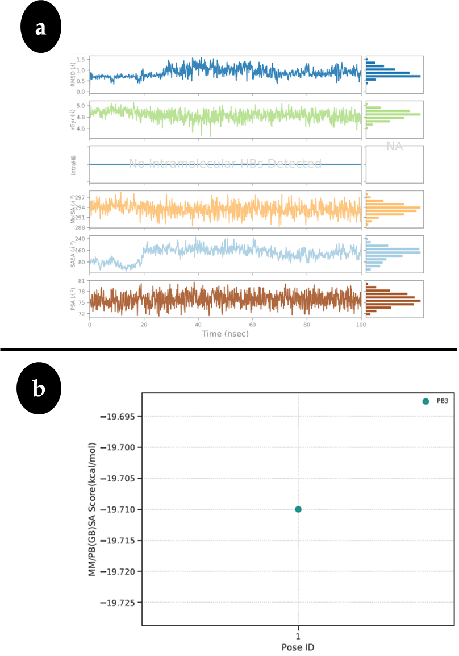
Figure. S5: (a)According to the RMSD ligand plot, the piperine has an RMSD value of 1.0. Å.(b) MM/PBSA calculation Plot of Hexose-6-phosphate dehydrogenase/Piperine docked complex.

Tables
Table. S1:ADMETCharacteristicsofPiperine
Name | ExpectedValue
Absorptions
Water' dissolution | -3.464mol/L
Caco2permeation | 1.596Pappin10-6cm/s
Gastro intestinalassimilation(human) | 94.444%Absorbed
EpidermisPermeation | -3.131Kp
Glycoprotein Psubstance | Yes
Glycoprotein PIinhibitory agent | Yes
Glycoprotein PII inhibitory agent | No
Distributions
Volume of distribution | 0.158L/kg
Portion of loosely bound (human) | 0.134Fu
Blood-brain barrier (BBB) accessibility | -0.102BB
Central nervous system (CNS) permeability | -1.879PS
Metabolisms
CYP2D6substance | No
CYP3A4substance | Yes
CYP1A2inhibitory agent | No
CYP2C19inhibitory agent | Yes
Excretions
Total Clearance | 0.232ml/min/kg
kidneyOCT2substance | Yes
Toxicity
Max.permitteddosages (human) | -0.38mg/kg/day
hERGIinhibitory agent | No
hERGII inhibitory agent | No
Acute oralToxic effect rat(LD50) | 2.811 mol/kg
Chronic oral Toxic effect(LOAEL) | 1.51mg/kg_bw/day
T.Pyriformistoxic effect | 1.879μg/L
Minnowtoxic effect | 1.732 Mm

Table. S2:List ofpathwaysofcommonproteintargets
Sr.No | Name | P-Value | AdjustedP-Value
1 | Prolactinsignalingpathway | 0.0001199 | 0.006716
2 | Pentosephosphate pathway | 0.007478 | 0.05026
3 | Osteoclastdifferentiation | 0.0003951 | 0.01097
4 | Thyroidcancer | 0.009217 | 0.05026
5 | Non-alcoholicfattyliverdisease | 0.0005877 | 0.01097
6 | Ovariansteroidogenesis | 0.01269 | 0.05026
7 | Lipidandatherosclerosis | 0.001126 | 0.01576
8 | Steroid hormone biosynthesis | 0.01516 | 0.05026
9 | Cortisol synthesis and secretion | 0.01615 | 0.05026
10 | Amphetamine addiction | 0.01713 | 0.05026
11 | PPAR signaling pathway | 0.01837 | 0.05026
12 | Pertussis | 0.01886 | 0.05026
13 | Leishmaniasis | 0.01910 | 0.05026
14 | Signaling pathway of B cell receptor | 0.02009 | 0.05026
15 | Colorectal cancer | 0.02132 | 0.05026
16 | The PD-1 checkpoint mechanism and PD-L1 expression in cancer | 0.02205 | 0.05026
17 | Differentiation of Th1 and Th2 cell | 0.02279 | 0.05026
18 | Rheumatoid arthritis | 0.02304 | 0.05026
19 | IL-17 signaling pathway | 0.02328 | 0.05026
20 | Circadian entrainment | 0.02402 | 0.05026
21 | Choline metabolism in cancer | 0.02426 | 0.05026
22 | Longevity regulating pathway | 0.02524 | 0.05026
23 | Signaling pathway of T cell receptor | 0.02573 | 0.05026
24 | Synthesis secretion and action Parathyroid hormone | 0.02622 | 0.05026
25 | Th17 cell differentiation | 0.02647 | 0.05026
26 | signaling pathway of TNF | 0.02769 | 0.05026
27 | Cholinergic synapse | 0.02794 | 0.05026
28 | Synthesis secretion and action Growth hormone | 0.02940 | 0.05026

Supplementary Figures Legends

Figure. S1: (a)PiperineChemical Structure(b) Targets in Poly Cystic Ovary Common Protein Syndrome(c) Protein-Protein (PPI) interaction network of common targets in PCOS

Figure. S2:The stability of the receptor-ligand complex is assessed by employing the root mean square deviation (RMSD) value.

Figure. S3: (a)For ligand (Piperine), the average RMSF values of Hexose-6-phosphate dehydrogenase amino acid residues have been calculated using Desmond software(b)Fluctuation of the Ligand Root Means Square (L-RMSF)

Figure. S4: (a)A thorough representation of the molecular reactions taking place inside the protein-ligand complex would be provided by a diagram showing the precise connections between the protein and ligand atoms.(b) The conformational development of potentially rotatable bonds is depicted by a ligand (Piperine) torsion map through the simulation study (100 ns).

Figure. S5: (a)According to the RMSD ligand plot, the piperine has an RMSD value of 1.0. Å.(b) MM/PBSA calculation Plot of Hexose-6-phosphate dehydrogenase/Piperine docked complex.

