Supplementary Material

Inferring Enterovirus D68 Transmission Dynamics from the Genomic Data of Two 2022 North American outbreaks
Martin Grunnill^{1,2}, Alireza Eshaghi¹, Lambodhar Damodaran³, Sandeep Nagra¹, Ali Gharouni¹, Thomas Braukmann^{1,4}, Shawn Clark¹, Adriana Peci¹, Sandra Isabel¹, Philip Banh¹, Louis du Plessis^{5,6}, Carmen Lia Murall⁷, Caroline Colijn⁸, Samira Mubareka^{4,9}, Maan Hasso¹, Justin Bahl¹⁰, Heba H. Mostafa¹¹, Jonathan B. Gubbay^{1,12}, Samir N. Patel^{1,4}, Jianhong Wu², and Venkata R. Duvvuri^{1,2,4,†, *}
¹ Public Health Ontario, Toronto, Ontario, Canada
² Laboratory for Industrial and Applied Mathematics, Department of Mathematics and Statistics, York University, Toronto, Ontario, Canada
³ Department of Pathobiology, School of Veterinary Medicine, University of Pennsylvania, Philadelphia, Pennsylvania, USA
⁴ Department of Laboratory Medicine and Pathobiology, Temerty Faculty of Medicine, University of Toronto, Toronto, Ontario, Canada
⁵ Department of Biosystems Science and Engineering, ETH Zurich, Basel, Switzerland
⁶ Swiss Institute of Bioinformatics, Lausanne, Switzerland
⁷ National Microbiology Laboratory, Public Health Agency of Canada, Montreal, Canada
⁸ Department of Mathematics, Simon Fraser University, Burnaby, BC V5A 1S6, Canada.
⁹ Sunnybrook Research Institute, Toronto, Ontario, Canada
¹⁰ Center for the Ecology of Infectious Disease, Department of Infectious Diseases, Institute of Bioinformatics, University of Georgia, Athens, Georgia, USA
¹¹ Johns Hopkins School of Medicine, Department of Pathology, Division of Medical Microbiology, United States
¹² Department of Pathology and Laboratory Medicine, Faculty of Medicine, University of British Columbia, Vancouver, British Columbia, Canada

1. Methods

Table S1: Primers used to sequence whole EV-D68 genome.
PCR | primer | sequence (5'-3') | Position in genome* | Amplicon size (bp)
1 | EV_D68-F1_For | TTAAAACAGCCTTGGGGTTG | 1- 20 | 2764
1 | EV_D68-F1_Rev | ACAGTTGTGAGTATAGTGATCTCAGC | 2739- 2764 | 2764
2 | EV_D68-F2_For | ATAATACCTTGGATTAGTGGATCCCA | 2145-2170 | 2736
2 | EV_D68-F2_Rev | CACAGATCAATGGGCAGCATCT | 4860- 4881 | 2736
3 | EV_D68-F3_For | AAAGTACGCACCACTTTACGCA | 4283- 4304 | 3045
3 | EV_D68-F3_Rev | CCAAGTGGCCAAAATTTACC | 7309- 7328 | 3045
*Relative position to Enterovirus D68 (EV-D68) isolate NY328 (GenBank: KP745766.1)

Table S2: Common Parameter Priors used in Birth-Death Skyline Serial Models
Parameter description | Distribution | Distribution Value 1 | Distribution Value 2
Optimised lognormal relaxed clock rates. | Lognormal (mean in real space) | Mean = 1.0 | S.D. = 0.2
Optimised lognormal relaxed clock standard deviation. | Gamma | shape = 5 | scale = 0.05
Optimised lognormal relaxed clock mean. | Lognormal (mean in real space) | Mean = 0.003 | S.D. = 1
Prior on gamma shape | Lognormal | Mean = 1.0 | S.D. = 1.25
HKY transition-transversion | Lognormal | Mean = 1.0 | S.D. = 1.25
Origin | Uniform | 0.0 | 20.0
Reproduction number (R_{e}) | Lognormal | Mean = 0 | S.D. = 1.0
Sampling proportion | Beta | α = 1 | β = 9999

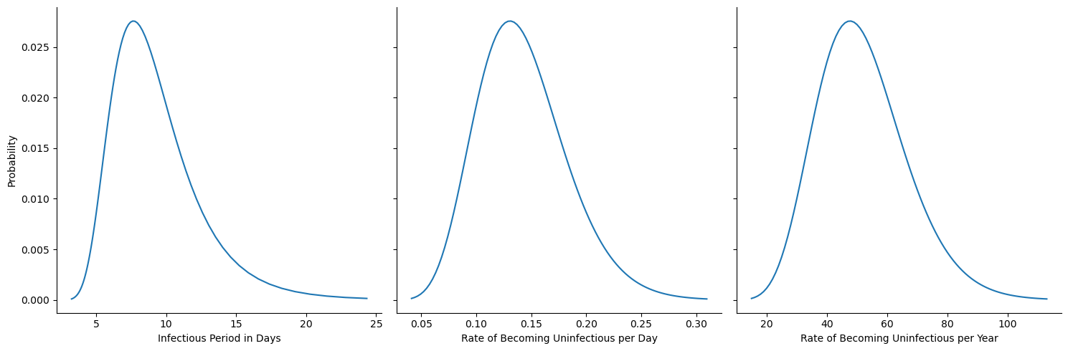

Figure S1: Prior used for Infection period (δ⁻¹) or Rate of Becoming Uninfectious (δ). The mean infection period (δ-1= 7 days) was inverted to become the rate of becoming uninfectious (δ, also called recovery rate) and converted to years (i.e. δ =1/7 days = 52 year⁻¹). To produce gamma distributed prior ⁴³ for δ, we used formulas $shape=\frac{{mean}^{2}}{variance}=12.018$ and $scale=\frac{variance}{mean}=4.3269$ with a standard deviation of 15 year⁻¹.

2. Results

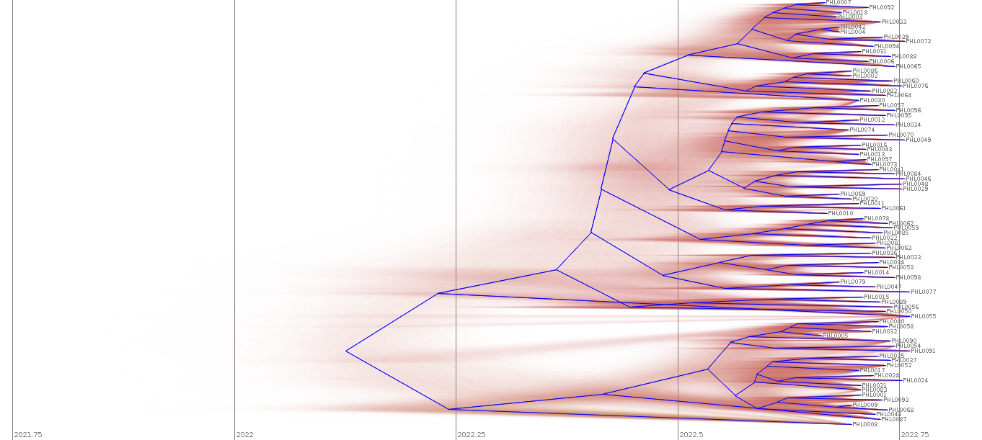
Figure S2: Summery tree plot of combined files from 3 runs of best performing BDSS model fitted to ON-2022 dataset. Plot produced using Densitree (Bouckaert 2010). Summery root canal tree is in blue.

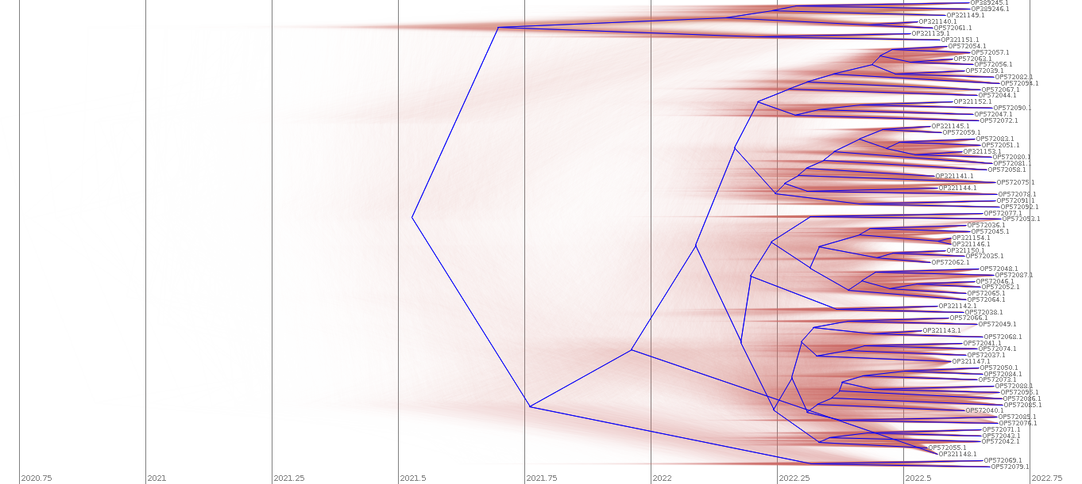
Figure S3: Summery tree plot of combined files from 3 runs of best performing BDSS model fitted to MD-2022 dataset. Plot produced using Densitree (Bouckaert 2010). Summery root canal tree is in blue.

Reference
Bouckaert, Remco R. 2010. “DensiTree: Making Sense of Sets of Phylogenetic Trees.” Bioinformatics 26 (10): 1372–73. https://doi.org/10.1093/bioinformatics/btq110.

