Supplementary Data
TMEM100 acts as a TAK1 receptor that prevents pathological cardiac hypertrophy progression

Bin-Bin Zhang^{1*}, Yi-Lin Zhao^{2*}, Yan-Yu Lu¹, Ji-Hong Shen³, Hui-Yong Li¹, Han-Xue Zhang⁴, Xiao-Yue Yu¹, Wen-Cai Zhang¹, Gang Li¹, Zhan-Ying Han^{1#}, Sen Guo^{1#} and Xu-Tao Zhang ^{1,5#}

¹Department of Cardiology, The First Affiliated Hospital of Zhengzhou University, No.1 Jianshe East Road, Zhengzhou, China
²Department of Cardiology, The Third Affiliated Hospital of Xinxiang Medical University, Xinxiang, China
³Department of Electrocardiogram, The Second Affiliated Hospital of Zhengzhou University, Zhengzhou, China
⁴Institute of Chronic Non-communicable Diseases, Henan Provincial Center for Disease Control and Prevention, Zhengzhou, China
⁵Department of Cardiology, Renmin Hospital of Wuhan University, Wuhan, China

*These authors contributed equally to this work

#Corresponding authors: Xu-Tao Zhang, Tel: 86-0371-67967622; Fax: 86-0371-67967626; E-mail: zbbgzr@126.com; Sen Guo, Tel: 86-0371-67967622; Fax: 86-0371-67967626; E-mail: fccguos@edu.zzu.com. Zhan-Ying Han, Tel: 86-0371-67967622; Fax: 86-0371-67967626; E-mail: hzy91@163.com.
Keywords: TMEM100, TAK1, cardiac hypertrophy, cardiomyocytes hypertrophy, protein-protein interaction
Financial support: This work was supported by The National Natural Science Foundation of China (Grant No.81770047)
Conflict of interest: None.

Supplementary tables
Supplementary table1
 | Gene | Primer sequence (5’-3’)
 | AdTMEM100 | F | GGCTAGCGATATCGGATCCGCCACCATGACTGAAGAACCCACAAAAGAGAAC
 | AdTMEM100 | R | CGTCCTTGTAATCACTAGTAGCAAACAAACTTCTCTGATTTACCACC
 | AdshTMEM100 | F | CCGGGGTTCCGTCATCTCCATCTTACTCGAGTAAGATGGAGATGACGGAACCTTTTTG
 | AdshTMEM100 | R | AATTCAAAAAGGTTCCGTCATCTCCATCTTACTCGAGTAAGATGGAGATGACGGAACC
 | AAV9-TMEM100 | F | CACGCTTAACTAGCTAGCATGACCGAAGAATCCACAAAAGAGAACC
 | AAV9-TMEM100 | R | ATCCTTGTAATCACGCGTAGCAAACAAGCACCTCTGATTTACC
 | TMEM100 | F | TCGGGTTTAAACGGATCCATGACTGAAGAGCCCATCAAGG
 | TMEM100 | R | GGGCCCTCTAGACTCGAGTCAAGCAAACAAGCTTCTCTGATTTGCC
ASK1 |  | F | TCGGGTTTAAACGGATCCATGTCTACAGCCTCTGCCGC
 |  | R | GGGCCCTCTAGACTCGAGTCATGAAGTGCCTTGTCGTTTCTGC
TPL2 |  | F | TCGGGTTTAAACGGATCCATGGAGTACATGAGCACTGGAAGTG
 |  | R | GGGCCCTCTAGACTCGAGTCAGCCATATTCAAGCGTTGGTGG
TAK1 |  | F | TCGGGTTTAAACGGATCCATGTCTACAGCCTCTGCCGC
 |  | R | GGGCCCTCTAGACTCGAGTCATGAAGTGCCTTGTCGTTTCTGC
 | TMEM100-KO-1 | F | GAGATAATAGACCCATGGGAATTGAAGCTGTA
 | TMEM100-KO-1 | R | ATGGGAATTGAAGCTGTAAGGAGAGCTCGGTACCCCCTGTAG
 | TMEM100-KO-2 | F | AAAGTGAGACAAAGGAGCAAGAAAGCCAAG
 | TMEM100-KO-2 | R | GCTCCTTTGTCTCACTTTTAATAGACCCATGGGAATTGAAGCTGTAAG
 | TMEM100-DKO | F | AAAGTGAGACAAAGGAGCAAGAAAGCCAAG
 | TMEM100-DKO | R | GCTCCTTTGTCTCACTTTTAATAGACCCATGGGAATTGAAGCTGTAAG
 | TAK1-S1 | F | TCGGGTTTAAACGGATCCATGTCTACAGCCTCTGCCGC
 | TAK1-S1 | R | GGGCCCTCTAGACTCGAGTCAATCTGAATACTGACAAGGATACTGTAATGGC
 | TAK1-S2 | F | TCGGGTTTAAACGGATCCATGGAAGGACAGAGCAACTCTGCC
 | TAK1-S2 | R | GGGCCCTCTAGACTCGAGTCATAGTTGGTGATCCAGTGTAAGATAAGCCATTG
 | TAK1-S3 | F | TCGGGTTTAAACGGATCCATGCAGCCTCTAGCACCGTGC
 | TAK1-S3 | R | GGGCCCTCTAGACTCGAGTCATGAAGTGCCTTGTCGTTTCTGC

Supplementary table2
Gene name | Forward primer (mouse) | Reverse primer (mouse)
TMEM100 | GAAAAACCCCAAGAGGGAAG | ATGGAACCATGGGAATTGAA
Anp | TCGGAGCCTACGAAGATCCA | TTCGGTACCGGAAGCTGTTG
Bnp | GAAGGACCAAGGCCTCACAA | TTCAGTGCGTTACAGCCCAA
Myh7 | CAACCTGTCCAAGTTCCGCA | TACTCCTCATTCAGGCCCTTG
Myh6 | TCTGCCTACCTTATGGGGCT | CGTACACTGACTTGGCCAGT
Collagen Iα1 | TGCTAACGTGGTTCGTGACCGT | ACATCTTGAGGTCGCGGCATGT
Collagen IIIα1 | ACGTAAGCACTGGTGGACAG | CCGGCTGGAAAGAAGTCTGA
Collagen Ⅷα1 | GCAACCAGGAGCAAAAGGTG | ATGCATACCTGGAGGACCCT
Ctgf | TGACCCCTGCGACCCACA | TACACCGACCCACCGAAGACACAG
Gapdh | ACTCCACTCACGGCAAATTC | TCTCCATGGTGGTGAAGACA
Gene name | Forward primer (rat) | Reverse primer (rat)
TMEM100 | GTCTTCATCACCGGGATCGT | TGTTCCTTTGTCTCACCTTCCA
Anp | AAAGCAAACTGAGGGCTCTGCTCG | TTCGGTACCGGAAGCTGTTGCA
Bnp | TGCCCCAGATGATTCTGCTC | TGTAGGGCCTTGGTCCTTTG
Myh7 | AGTTCGGGCGAGTCAAAGATG | CAGGTTGTCTTGTTCCGCCT
Gapdh | CAGTGCCAGCCTCGTCTCAT | AGGGGCATCCACAGTCTTC

Supplementary table 3
Anbibody | Manufacturer | Catalogue number | Source of species | Dilution
TMEM100 | ImmunoWay | YN3571 | rabbit | 1:1000
ANP | Proteintech | 27426-1-AP | rabbit | 1:1000
MYH7 | Proteintech | 22280-1-AP | rabbit | 1:1000
p-ERK | CST | 4370 | rabbit | 1:1000
ERK | CST | 4695 | rabbit | 1:1000
P-JNK | CST | 4668 | rabbit | 1:1000
JNK | CST | 9252 | rabbit | 1:1000
p-p38 | CST | 4511 | rabbit | 1:1000
p38 | CST | 9212 | rabbit | 1:1000
p-ASK1 | CST | 3764 | rabbit | 1:1000
ASK1 | Abclonal | A6274 | rabbit | 1:1000
p-TAK1 | CST | 4508S | rabbit | 1:1000
TAK1 | CST | 5206 | rabbit | 1:1000
p-IKKβ | CST | 2694 | rabbit | 1:1000
IKKβ | Abclonal | A0714 | rabbit | 1:1000
IKBα | CST | 4814 | rabbit | 1:1000
p-p65 | CST | 3033 | rabbit | 1:1000
p65 | CST | 8242 | rabbit | 1:1000
Flag | MBL | M185-3LL | mouse | 1:1000
HA | MBL | M180-3 | mouse | 1:1000
GAPDH | CST | 2118 | rabbit | 1:5000

Supplementary figure 1
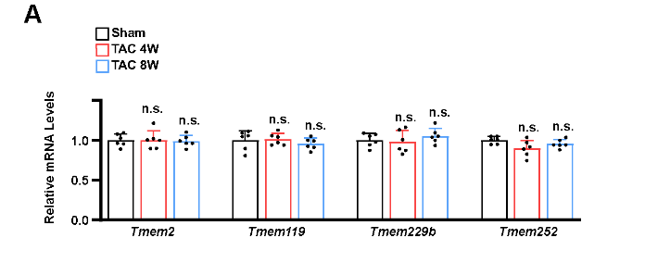
Supplementary figure 1. TMEM family members expression was not changed in cardiac hypertrophy. (A) Expression of TMEM2, TMEM119, TMEM229b and TMEM252 was not changed in pathological hypertrophy.
Supplementary figure 2
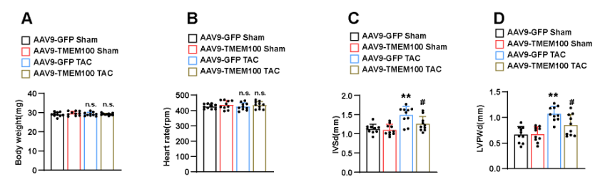
Supplementary figure 2. TMEM100 expression improved the cardiac structure and function in cardiac hypertrophy. (A) The body weight in each group (n=10). (B-D) The heart rate, interventricular septal thickness at diastole (IVSD) and LV posterior wall (LVPW) in each group (n=10). **p < 0.01 vs. AAV9-GFP sham, #p < 0.05 vs. AAV9-GFP TAC. n.s. indicates no significance.
Supplementary figure 3
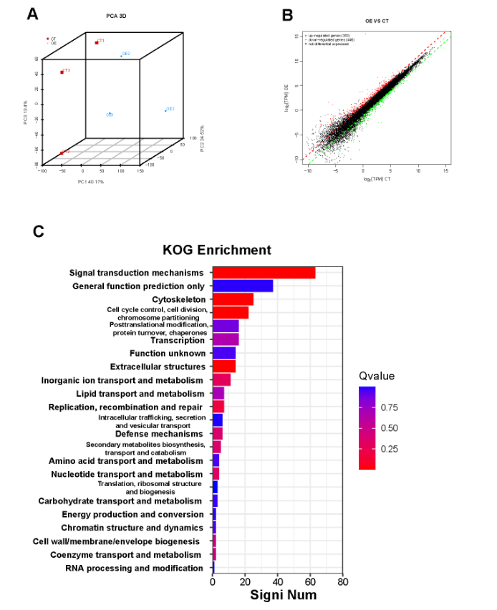
Supplementary figure 3. RNA-sequence analysis of AdTMEM100 and its control group. (A) PCA showing the AdTMEM100 and AdVector sample distribution. (B) The scatter map revealed the differential genes in AdTMEM100 and AdVector group after PE stimulation. (C) KOG analysis displaying the major events in NRCMs after PE stimulation.

