Supplementary Data

Convergent Synthesis, Kinetics and Computational Comprehensions of Indole-(Phenyl)triazole Bi-heterocycles Amalgamated with Propanamides as Elastase Inhibitors
Shakila¹. Muhammad A. Abbasi^{1*}. Aziz-ur-Rehman¹. Sabahat Z. Siddiqui¹. Majid Nazir¹. Shabbir Muhammad². Hussain Raza³. Syed A. Ali Shah^{4,5}. Muhammad Shahid⁶. Aijaz Rasool Chaudhry⁷. Song Ja Kim³
- Department of Chemistry, Government College University, Lahore-54000, Pakistan.
- Department of Chemistry, College of Science, King Khalid University, Abha, 61413, P.O. Box 9004, Abha 61413, Saudi Arabia.
- Department of Biological Sciences, College of Natural Sciences, Kongju National University, Gongju-32588, South Korea.
- Faculty of Pharmacy Universiti Teknologi MARA, Cawangan Selangor Kampus, Puncak Alam, 42300, Selangor, Malaysia.
- Atta-ur-Rahman Institute for Natural Products Discovery (AuRIns), Universiti Teknologi MARA, Cawangan Selangor Kampus, Puncak Alam, 42300, Selangor, Malaysia.
- Department of Biochemistry, University of Agriculture, Faisalabad, Pakistan
- Department of Physics, College of Science, University of Bisha, Bisha 61922, P.O. Box 551, Saudi Arabia.
*Corresponding Author: Prof. Dr. Muhammad Athar Abbasi, E-mail: atrabbasi@yahoo.com; abbasi@gcu.edu.pk

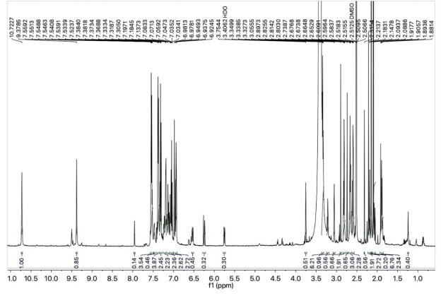
Fig. S1. ¹H-NMR spectrum of 9a molecule.

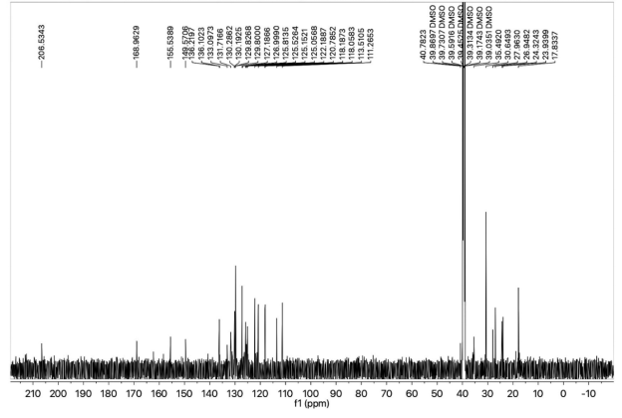

Fig. S2. ¹³C-NMR spectrum of 9a molecule.
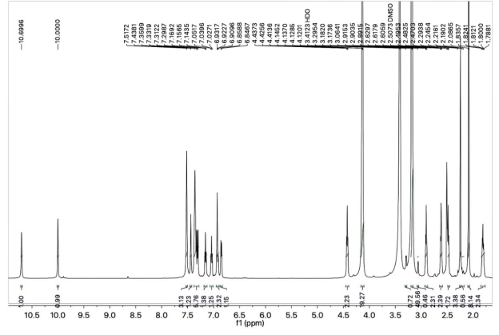

Fig. S3. ¹H-NMR spectrum of 9b molecule.
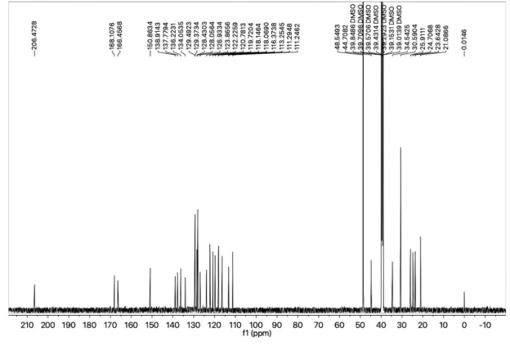

Fig. S4. ¹³C-NMR spectrum of 9b molecule.
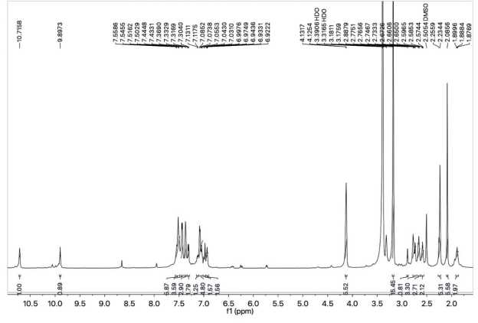

Fig. S5. ¹H-NMR spectrum of 9c molecule.

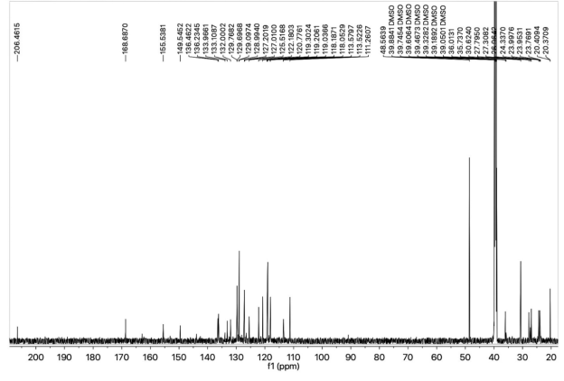

Fig. S6. ¹³C-NMR spectrum of 9c molecule.

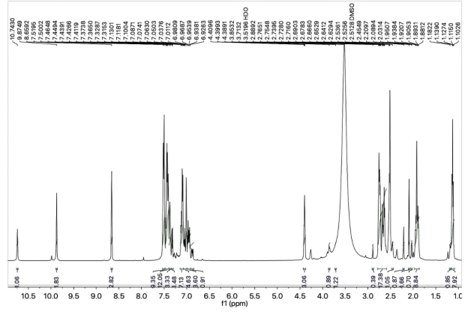

Fig. S7. ¹H-NMR spectrum of 9d molecule.
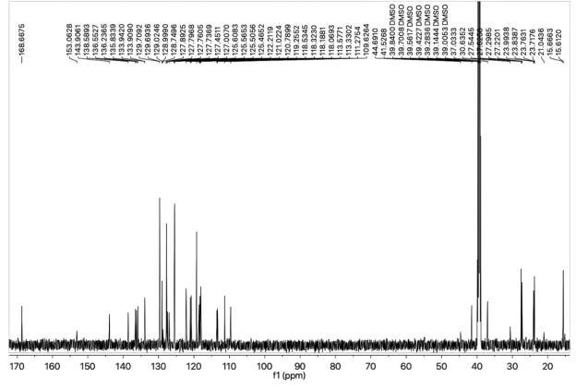

Fig. S8. ¹³C-NMR spectrum of 9d molecule.

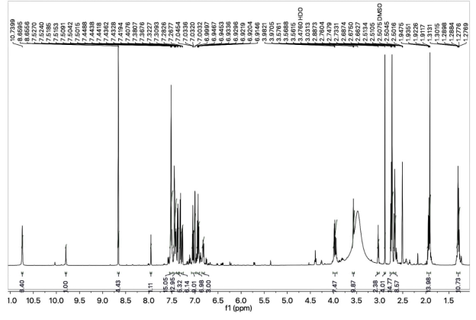

Fig. S9. ¹H-NMR spectrum of 9e molecule.

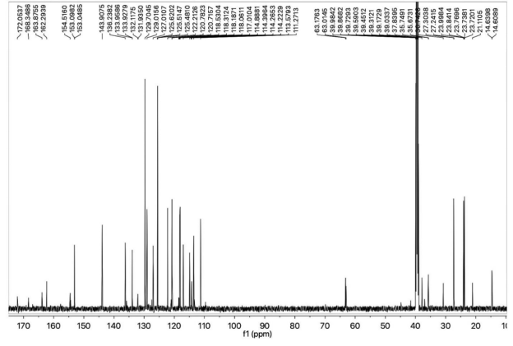

Fig. S10. ¹³C-NMR spectrum of 9e molecule.
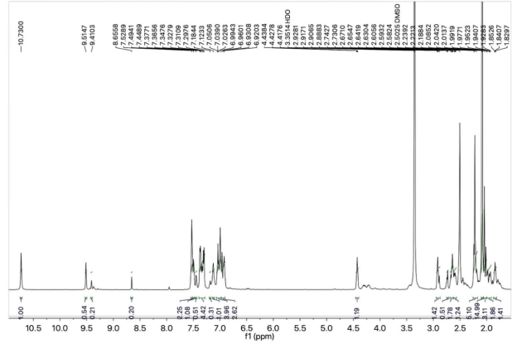

Fig. S11. ¹H-NMR spectrum of 9f molecule.
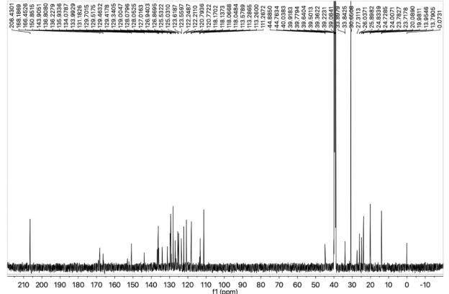

Fig. S12. ¹³C-NMR spectrum of 9f molecule.

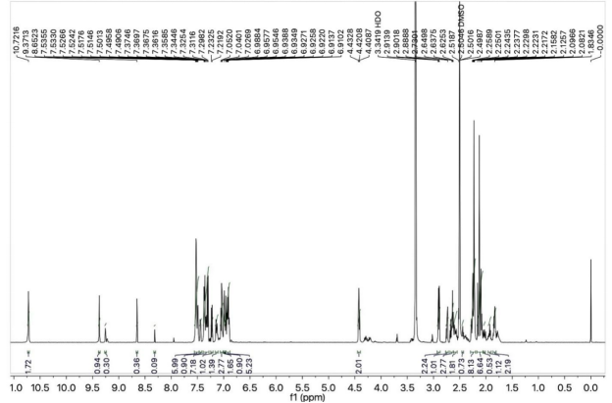

Fig. S13. ¹H-NMR spectrum of 9g molecule.

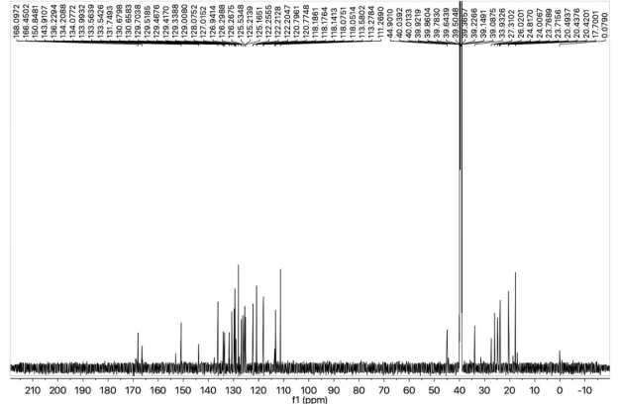

Fig. S14. ¹³C-NMR spectrum of 9g molecule.

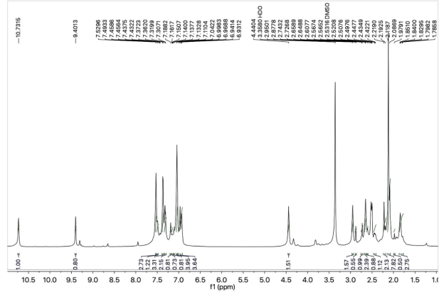

Fig. S15. ¹H-NMR spectrum of 9i molecule.

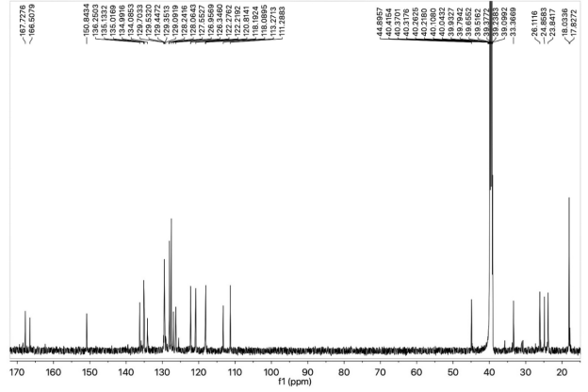

Fig. S16. ¹C-NMR spectrum of 9i molecule.

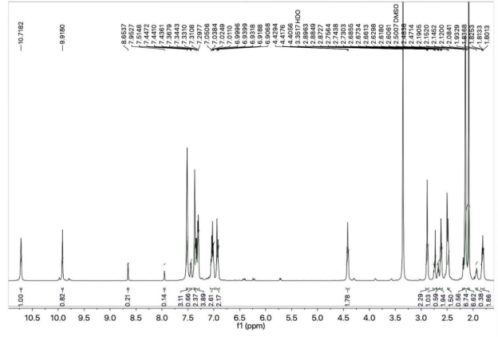

Fig. S17. ¹H-NMR spectrum of 9j molecule.

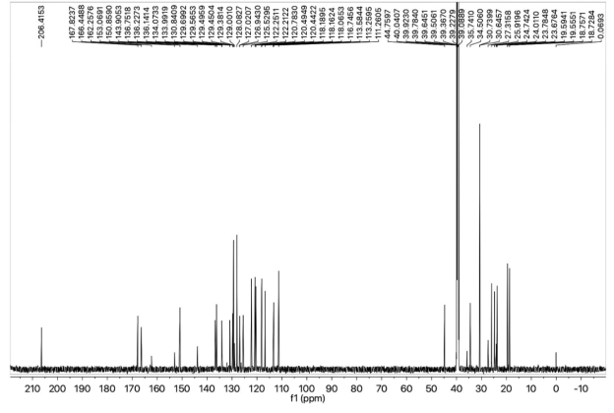

Fig. S18. ¹³C-NMR spectrum of 9j molecule.

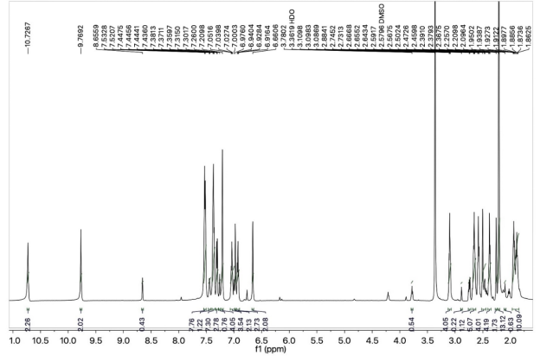

Fig. S19. ¹H-NMR spectrum of 9k molecule.

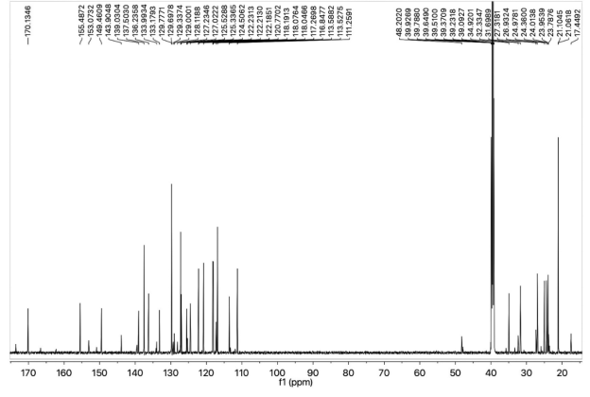

Fig. S20. ¹³C-NMR spectrum of 9k molecule.

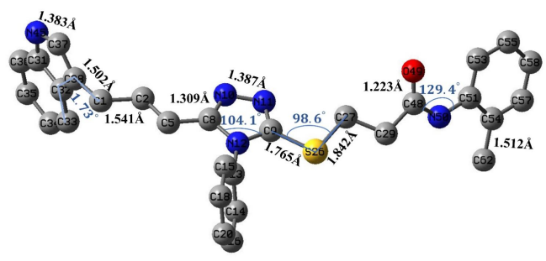

Fig. S21 Optimized molecular geometry analysis of compound 9a including bond lengths, bond angles and dihedral angles at B3LYP/6-31G* level of theory.

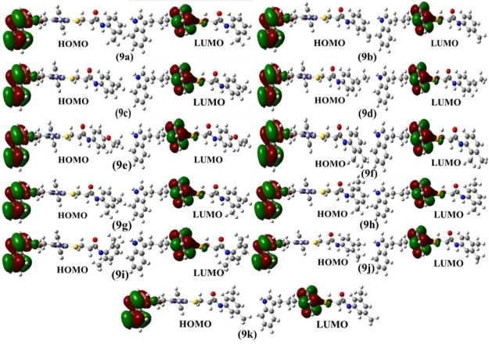Fig. S22. The 3-D representation of highest occupied molecular orbital (HOMO) and the lowest unoccupied molecular orbital (LUMO) for all the compounds.
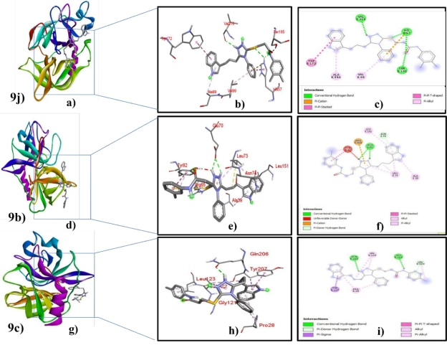

Fig. S23 2D (right) and 3D (Left) visualization of interactions of ligand 9j(a, b and c), 9b(d, e and f) and 9c ( g, h and i) with active site of elastase protein.
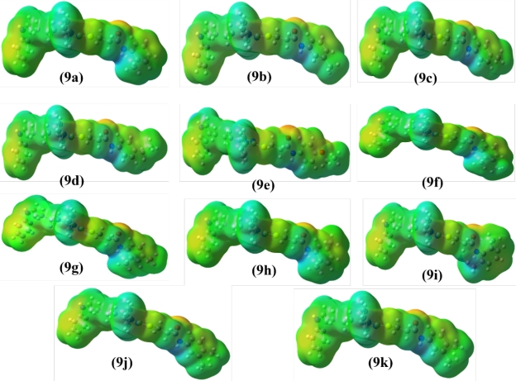
Fig. S24. Molecular electrostatic potentials (MEPs) of compounds 9a-9k where an iso-value of ± 0.002 a. u. is used.
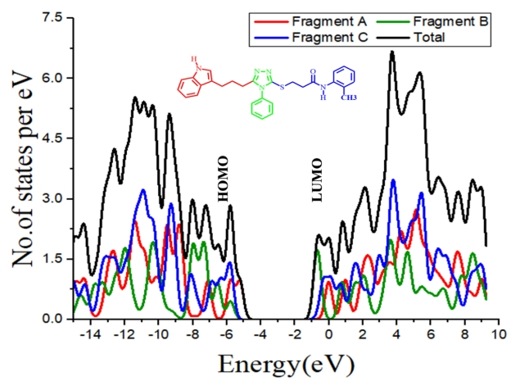
Fig. S25. The density of states (DOS) for compound 9a calculated at B3LYP/6-31G* level of theory.

