Supplementary Figure 1. Methylation arrays yielded high quality samples with few low-quality probes (A) Mean detection P values shown across all samples. (B) Quality control plot shown for all samples. (C) Comparison of Beta Values to M values for all samples, coloured by cell line. (D) Comparison of raw beta values to SWAN normalised beta values for all samples, coloured by concentration of azacytidine.
Supplementary Figure 2. Hierarchical clustering of differentially methylated probes for 4 cell lines (Mel270, OMM2.5, MP41, and MP46, labeled on graph) compared to 80 primary UM cases from the TCGA database using SWAN normalized Beta Values, with dark red indicating a locus is fully hypermethylated and dark blue indicating a locus is fully hypomethylated.

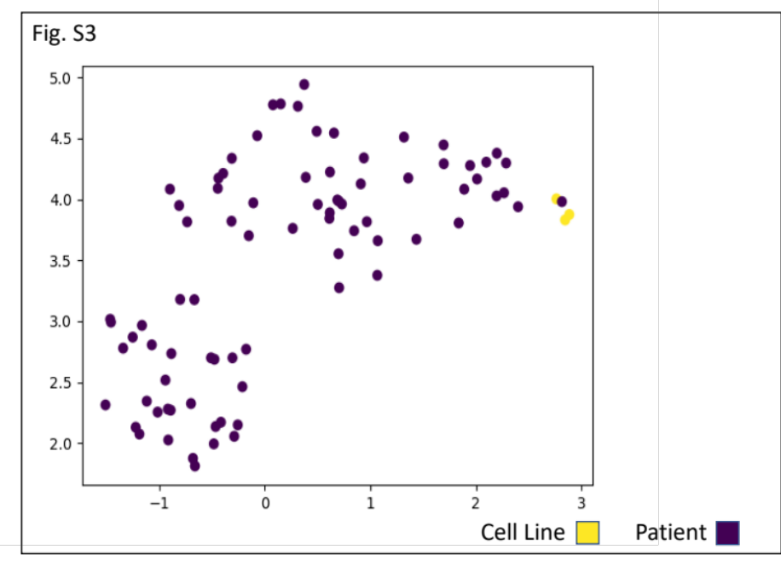
Supplementary Figure 3. Uniform Manifold Approximation and Projection (UMAP) along the YZ axis, showing the differences in this dimension between genomic DNA from the 4 cell lines (MP41, MP46, Mel270, and OMM2.5) for 80 UM patients from the TCGA database

Supplementary Figure 4. Significantly differentially methylated regions across the genome based on dose for all samples, with sample type and cell line as covariates with venn diagrams for the genomic locations found to be significantly differentially methylated for (A) the Mel270 and OMM2.5 cell lines and (B) The MP41 and MP46 cell lines, and (C) All cell lines using a lower cutoff value.
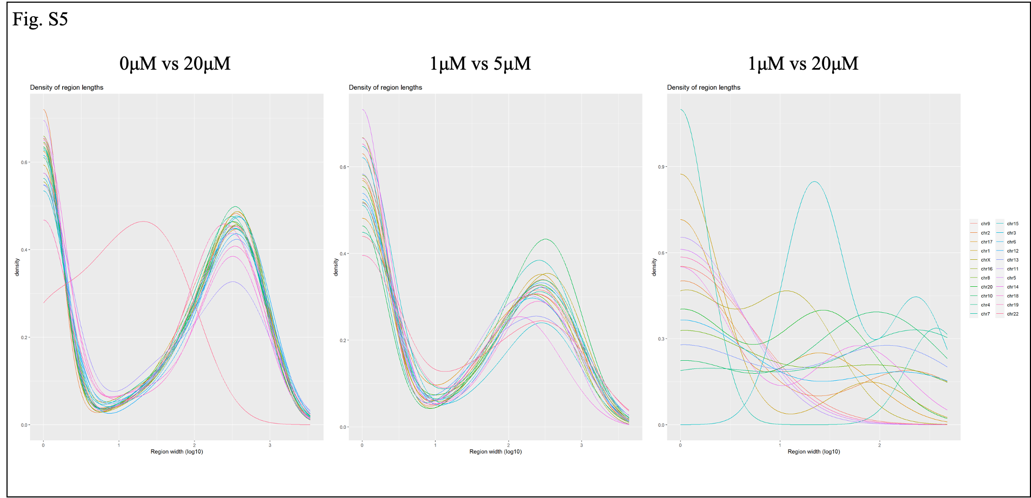
Supplementary Figure 5. Density plot of region widths for differentially methylated regions in analysis of DMRs for different treatment comparisons.
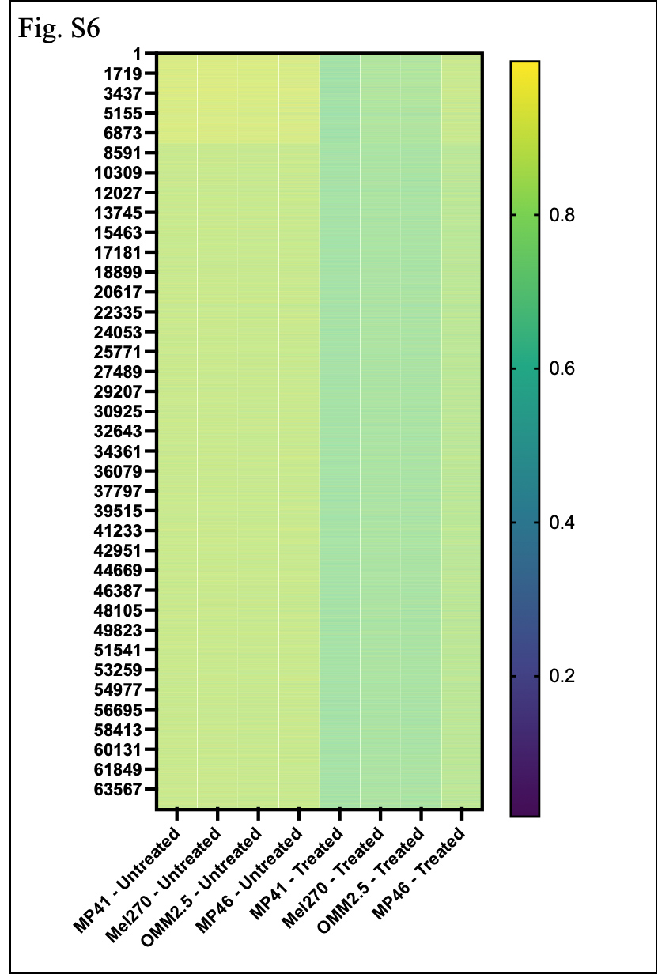

Supplementary Figure 6. Beta values for significantly differentially methylated probes across cell lines (ChAMP analysis) in untreated samples vs. samples treated with 20μM azacytidine.

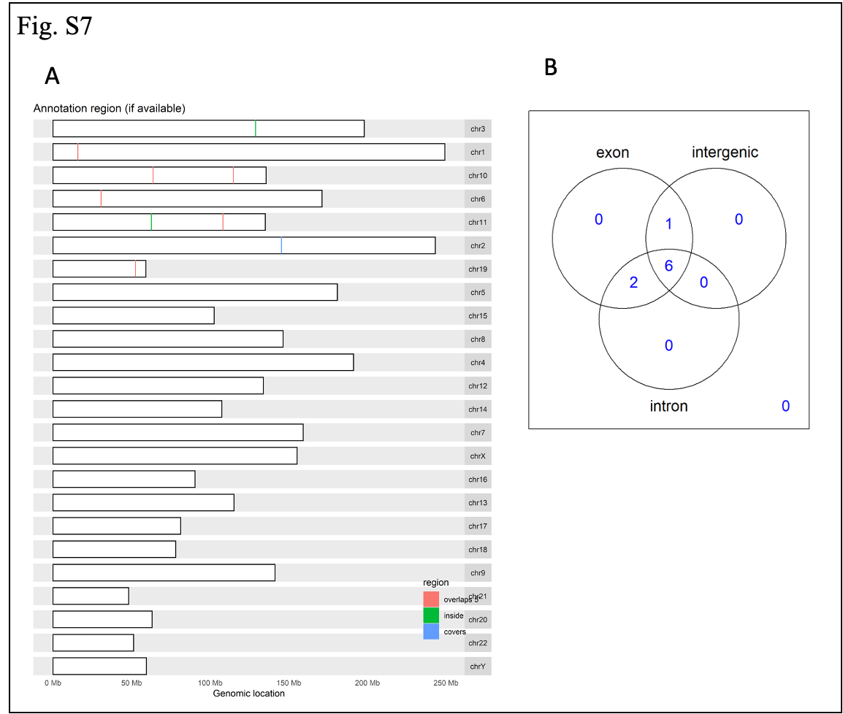
Supplementary Figure 7. Significantly differentially methylated regions across the genome based on dose for all samples, with sample type and cell line as covariates with venn diagrams for the genomic locations found to be significantly differentially methylated between cell-free and genomic DNA based on A) chromosomal location and B) type of genomic region.

