Supplementary Table 1
Image assessment criteria
 | Geometric distortion | Susceptibility artifacts | Overall image quality | Lesion conspicuity (contrast between lesion and surrounding background) | Diagnostic confidence for acute infarction
1 | Severe distortion | Severe artifacts | Poor, insufficient for diagnosis | Unable to evaluate | Vague (10–39%)
2 | Moderate distortion | Major artifacts | Fair, adequate for diagnosis | Acceptable for visualization | Likely (40–69%)
3 | Mild distortion | Only minor artifacts | Good for diagnosis | Obvious visibility | High (70–89%)
4 | No distortion | No artifacts | Excellent for diagnosis | Excellent for visualization | Definite (90–100%)
Supplementary Figure 1
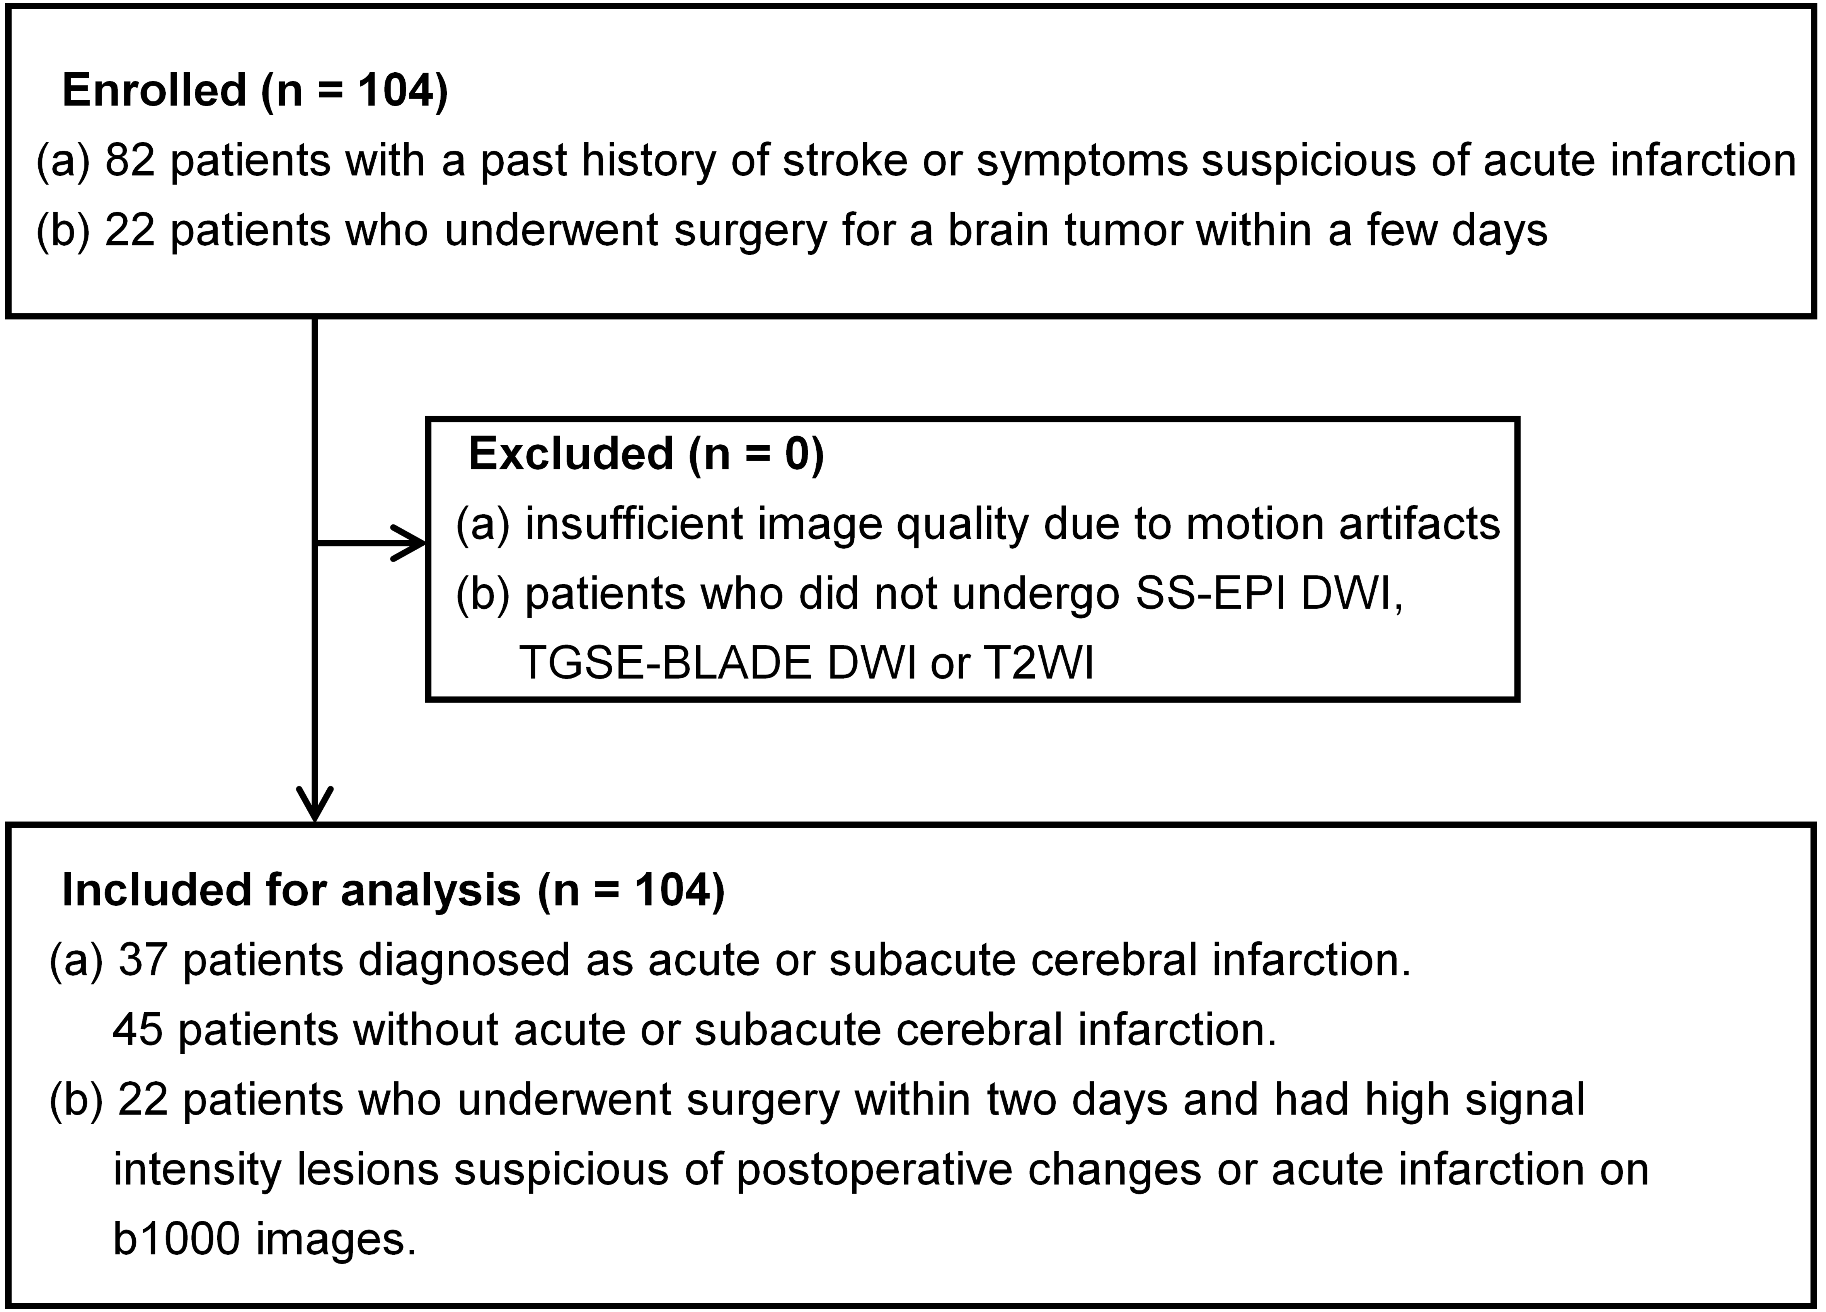

Flowchart of study enrollment.
Supplementary Figure 2

(a) Scatter plots of ADC values in lesions show a linear correlation between SS-EPI DWI and TGSE-BLADE DWI. The correlation was very strong (r=0.80). (b) Bland–Altman analysis performed between the ADC values of SS-EPI DWI and TGSE-BLADE DWI showed that most data were distributed between ±1.96 SD.

