SUPPLEMENTARY DATA

Supplementary Table 1: Regions analyzed in the targeted NGS Panel
Gene | Transcript | Regions of interest
AKT1 | NM_001014431.1 | exon 3 (c.47-139 to c.104) (p.16 to p.35)
ALK | NM_004304.4 | exon 22 (c.3451-44 to c.3515+122) (p.1151 to p.1172), exon 23 (c.3516-88 to c.3645+9) (p.1172 to p.1215), exon 24 (c.3646-35 to c.3743+95) (p.1216 to p.1248), exon 25 (c.3763 to c.3836+158) (p.1255 to p.1279)
BRAF | NM_004333.4 | exon 11 (c.1315-24 to c.1432+79) (p.439 to p.478), exon 12 (c.1433-75 to c.1517+4) (p.478 to p.506), exon 15 (c.1742-43 to c.1860+54) (p.581 to p.620)
CDKN2A | NM_001195132.1 | exon 2 (c.151-10 to c.374) (p.51 to p.125), exon 3 (c.*151-40 to c.*307) (p.168 to p.168)
CTNNB1 | NM_001904.3 | exon 3 (c.55 to c.241+33) (p.19 to p.81)
EGFR | NM_005228.3 | exon 2 (c.95 to c.240+74) (p.32 to p.80), exon 7 (c.749 to c.889+88) (p.250 to p.297), exon 9 (c.1007-39 to c.1134-48) (p.336 to p.378), exon 18 (c.2091 to c.2184+124) (p.697 to p.728), exon 19 (c.2185-4 to c.2283+125) (p.729 to p.761), exon 20 (c.2284-115 to c.2399) (p.762 to p.800), exon 21 (c.2470-63 to c.2625+12) (p.824 to p.875)
ERBB2 | NM_004448.3 | exon 8 (c.902-15 to c.1021+77) (p.301 to p.341), exon 17 (c.1947-90 to c.2040) (p.649 to p.680), exon 19 (c.2209-19 to c.2307+94) (p.737 to p.769), exon 20 (c.2308-108 to c.2417) (p.770 to p.806), exon 21 (c.2494-11 to c.2649+1) (p.832 to p.883)
ERBB4 | NM_005235.2 | exon 10 (c.1125-144 to c.1198+8) (p.375 to p.400), exon 12 (c.1307 to c.1489+45) (p.436 to p.497)
FGFR1 | NM_023110.2 | exon 4 (c.359-120 to c.448+17) (p.120 to p.150), exon 12 (c.1553-47 to c.1663+58) (p.518 to p.555), exon 14 (c.1855-76 to c.1977+28) (p.619 to p.659)
FGFR2 | NM_000141.4 | exon 7 (c.749-147 to c.824) (p.250 to p.275), exon 12 (c.1562-56 to c.1672+57) (p.521 to p.558), exon 14 (c.1884 to c.1986+64) (p.628 to p.662)
FGFR3 | NM_000142.4 | exon 7 (c.740-11 to c.831) (p.247 to p.277), exon 10 (c.1079 to c.1272+15) (p.360 to p.422), exon 14 (c.1898 to c.2010) (p.633 to p.670)
GNA11 | NM_002067.4 | exon 4 (c.494 to c.593) (p.165 to p.198), exon 5 (c.606-62 to c.735+47) (p.202 to p.245)
GNAQ | NM_002072.4 | exon 4 (c.477-60 to c.605+32) (p.159 to p.202), exon 5 (c.606-90 to c.735) (p.202 to p.245)
H3F3A | NM_002107.4 | exon 2 (c.-23-51 to c.128+19) (p.1 to p.43)
HIST1H3B | NM_003537.3 | exon 1 (c.4 to c.233) (p.2 to p.78)
HRAS | NM_001130442.2 | exon 2 (c.-53-71 to c.105) (p.1 to p.35), exon 3 (c.120 to c.277) (p.40 to p.93)
IDH1 | NM_005896.3 | exon 4 (c.209 to c.414+12) (p.70 to p.138)
IDH2 | NM_002168.3 | exon 5 (c.391 to c.535) (p.131 to p.179)
KIT | NM_000222.2 | exon 9 (c.1347-3 to c.1540+28) (p.449 to p.514), exon 11 (c.1647+26 to c.1774+28) (p.550 to p.592), exon 12 (c.1873 to c.1990+18) (p.625 to p.664), exon 17 (c.2362-5 to c.2484+90) (p.788 to p.828)
KRAS | NM_033360.3 | exon 2 (c.-11-76 to c.111+25) (p.1 to p.37), exon 3 (c.112-120 to c.199) (p.38 to p.67), exon 4 (c.291-122 to c.376) (p.97 to p.126), exon 4 (c.420 to c.450+179) (p.140 to p.150)
MAP2K1 | NM_002755.3 | exon 2 (c.81-67 to c.243) (p.27 to p.81), exon 3 (c.292-23 to c.438+56) (p.98 to p.146), exon 6 (c.569-62 to c.693+29) (p.190 to p.231)
MET | NM_001127500.2 | exon 14 (c.2942-96 to c.2989) (p.981 to p.997), exon 14 (c.3026 to c.3082+117) (p.1009 to p.1028), exon 16 (c.3314-20 to c.3394+17) (p.1105 to p.1132), exon 17 (c.3395-18 to c.3576+22) (p.1132 to p.1192), exon 18 (c.3577-19 to c.3686+80) (p.1193 to p.1229), exon 19 (c.3687-10 to c.3852+9) (p.1229 to p.1284)
MYC | NM_002467.4 | exon 2 (c.140 to c.368) (p.47 to p.123), exon 2 (c.423 to c.569) (p.141 to p.190), exon 3 (c.818 to c.1043) (p.273 to p.348)
NRAS | NM_002524.4 | exon 2 (c.6 to c.111+118) (p.2 to p.37), exon 3 (c.159 to c.290+87) (p.53 to p.97), exon 4 (c.291-31 to c.374) (p.97 to p.125), exon 4 (c.412 to c.450+44) (p.138 to p.150)
PDGFRA | NM_006206.4 | exon 12 (c.1653+72 to c.1738) (p.552 to p.580), exon 14 (c.1892-9 to c.2002+102) (p.631 to p.668), exon 18 (c.2440-33 to c.2562+69) (p.814 to p.854)
PIK3CA | NM_006218.3 | exon 2 (c.230 to c.341) (p.77 to p.114), exon 5 (c.910 to c.1059+71) (p.304 to p.353), exon 6 (c.1077 to c.1145+135) (p.359 to p.382), exon 8 (c.1252-41 to c.1371) (p.418 to p.457), exon 10 (c.1582 to c.1664+128) (p.528 to p.555), exon 21 (c.2961 to c.3181) (p.987 to p.1061)
POLD1 | NM_001256849.1 | exon 6 (c.595 to c.746) (p.299 to p.249), exon 7 (c.893 to c.970+78) (p.298 to p.324), exon 15 (c.1776-92 to c.1892+1) (p.592 to p.681), exon 16 (c.1892+99 to c.1898) (p.631 to p.633), exon 17 (c.2007-59 to c.2091) (p.669 to p.697), exon 24 (c.2953+6 to c.3067+34) (p.985 to p.1023)
POLE | NM_006231.3 | exon 9 (c.802-10 to c.909+104) (p.268 to p.303), exon 10 (c.910-74 to c.1020+44) (p.304 to p.340), exon 11 (c.1021-63 to c.1106+73) (p.341 to p.369), exon 12 (c.1107-53 to c.1226+46) (p.369 to p.409), exon 13 (c.1227-96 to c.1359+3) (p.409 to p.453), exon 14 (c.1360-53 to c.1473+51) (p.454 to p.491), exon 21 (c.2320-24 to c.2468+54) (p.774 to p.823), exon 25 (c.2468+116 to c.2468+328) (p.823 to p.823)
PTEN | NM_000314.6 | exon 1 (c.-66 to c.79+79) (p.1 to p.27), exon 2 (c.80-18 to c.164+93) (p.27 to p.55), exon 3 (c.165-25 to c.209+136) (p.55 to p.70), exon 4 (c.210-75 to c.253+75) (p.70 to p.85), exon 5 (c.258 to c.473) (p.86 to p.158), exon 6 (c.493-72 to c.634+11) (p.165 to p.212), exon 7 (c.635-43 to c.798) (p.212 to p.266), exon 8 (c.824 to c.1019) (p.275 to p.340), exon 9 (c.1027-16 to c.*7) (p.343 to p.404)
PTPN11 | NM_002834.3 | exon 3 (c.138-6 to c.332+11) (p.46 to p.111)
RAC1 | NM_018890.3 | exon 2 (c.36-20 to c.107+67) (p.12 to p.36)
RET | NM_020975.4 | exon 10 (c.1760-57 to c.1879+50) (p.587 to p.627), exon 11 (c.1880-66 to c.2015) (p.627 to p.672), exon 16 (c.2739 to c.2801+165) (p.913 to p.934)
TERT | NM_198253.2 | promoter (c.-181 to c.-42)
TP53 | NM_000546.5 | exon 5 (c.376-41 to c.547) (p.126 to p.183), exon 6 (c.560-7 to c.672+91) (p.187 to p.224), exon 7 (c.673-6 to c.782+102) (p.225 to p.261), exon 8 (c.783-25 to c.920-27) (p.261 to p.307)

Supplementary Table 2: Molecular profile of patients with available raw methylation data
Patient’s number. | Paper | ATRX status | TP53 status | PPM1D status | PDGFRA status | ACVR1 status | Calibrated Score for Methylation class DMG, K27 | MGMT  promoter  methylation | CNV
1  (VAF of H3K27M = 60%) | [1]-Supp | Protein loss  Mutated  NM_000489.6: c.3146del p.(Ile1049Lysfs*69)  VAF=39% | Wildtype | Mutated  NM_003620.4: c.1388del p.(Gly463Valfs*2)  VAF=34% | Mutated  NM_006206.6: c.2146A>G p.(Ser716Gly ) VAF = 26 % | Wildtype | 0.57 | Unmethylated | Tetraploid status  Gain of 1q, 7 and 12 chromosomes.  Loss of 14q and 19q  chromosomes  (partially).  LOH on chromosomes 14q and 19q (partially)  and on chromosome 17q with a neutral copy number variation  (4 copies).
2  (VAF of H3K27M = 25%) | [1]-Supp | Protein loss | Mutated  NM_000546.5  c.524G>A p.Arg175His  VAF = 49% | No data | Amplified | No data | 0.68 | Unmethylated | Loss of 4, 5q, 8q, 9q, 14, 21q  Gain of 9q, 10p12p, 17p, 20q  Gain of MYC
9 | [2]-Supp | No data | No data | No data | No data | No data | 0.03 | Unmethylated | Gain of 9 and X chromosomes.  Loss of 10 chromosome.
16 | [3]-Supp | No data | No data | No data | No data | No data | 0.99 | Unmethylated | Loss of 15.  Gain of 17q.  Gain of CDK4 and MDM2 (chromosome12).  Loss of MGMT (chromosome 10).
VAF: Variant allele frequency

Supplementary Table 3: Characteristics of diffuse non-midline gliomas with H3K27M mutation from the previous publications and herein reported patient (Full references see Supp References).
Patient’s number | Reference | Age (Years) | Sex | Tumor location | Histological grade | ATRX | TP53 | Receptor Tyrosine kinase / PI3K signaling alterations | Methylation Subgroup (dkfz) – (Score) | Follow-up (Months) | Outcome
1 | [1]– Supp | 27 | M | Temporo-polar region | 3 | Protein loss  ATRX mutated  (I1049fs) | Wildtype | PDGFRA mutated: (S716G) | Diffuse midline glioma  H3K27M –mutant  No Match  0.57 | 18 | Died
2 | [1]- Supp | 30 | M | Temporal lobe | 3 | Protein loss | Mutated  (R175H) | PDGFRA / KIT  amplification  KRAS mutated (Q61R) | Diffuse midline glioma  H3K27M –mutant  No Match  0.68 | 3 | Died
3 | [4]-Supp | 11 | M | Temporal lobe | 4 | No data | Wildtype | No data | No data | 5 | Died
4 | [5]Supp | 8 | M | Temporo-  parietal lobe | High | No data | Mutated | PDGFRA  mutated | No data | No data | No data
5 | [2]Supp | 27 | M | Frontal lobe | 4 | ATRX mutated  (V278fs) | Mutated  (I163fs-) | PDGFRA  Mutated  (C235Y)  PDGFRA  amplification | No data | 15 | Died
6 | [2]Supp | 25 | M | Temporal lobe | 4 | ATRX mutated  (K356fs) | Mutated  (G245S) | PDGFRA mutated  (D576G)  PTEN  Mutated  (M270fs-) | No data | 0.1 | Died
7 | [2, 4, 6] Supp | 5 | M | Temporo-  parietal lobe | 4 | Wildtype | Mutated  (R213*) | PDGFRA  Mutated  (K385M) | GBM-K27  No match  0.48 | 6 | Died
8 | [2, 4]Supp | 19 | M | Temporal lobe | 4 | No data | Mutated | No mutations in EGFR, FGFR1 PDGFRA, BRAF, ACVR1 and PIK3CA | GBM-K27  No match  0.29 | 8 | Died
9 | [2]Supp | 19,1 | M | Cerebrum | 3 | No data | No data | No mutations in EGFR, FGFR1 PDGFRA, BRAF, ACVR1 and PIK3CA | GBM-K27  0.03 | 2,9 | Died
10 | [2]Supp | 17,0 | F | Cerebrum | 3 | ATRX mutated  (D964fs) | Mutated  (R273C) | FGFR1 mutated  (N455K) | No data | 8,0 | Died
11 | [2]Supp | 6,3 | No data | Cerebrum | 4 | No data | No data | PDGFRA  amplification | No data | 4,8 | Died
12 | [2]Supp | 17,8 | No data | Cerebrum | 4 | Wildtype | Mutated  (R273H) | PDGFRA  amplification | No data | 9,6 | Died
13 | [2]Supp | 10,7 | No data | Cerebrum | 4 | No data | No data | No mutations in EGFR, FGFR1 PDGFRA, BRAF, ACVR1 and PIK3CA | No data | 4,8 | Died
14 | [2]Supp | 13,2 | No data | Cerebrum | 3 | No data | No data | No mutations in EGFR, FGFR1 PDGFRA, BRAF, ACVR1 and PIK3CA | No data | 4,8 | Alive
15 | [7]Supp | 20 | F | Insular  cortex | 2 | Protein retained  ATRX mutated  Q2194del | Wildtype | EPB41L2-BRAF fusion | No data | No data | No data
16 | [3]Supp | 54 | F | Parietal and occipital lobe | 4 | No data | No data | No data | Diffuse midline glioma  H3K27M –mutant  0.99 | No data | No data
17 | [3]Supp | 25 | F | Frontal lobe | 4 | No data | No data | No data | Diffuse midline glioma  H3K27M -mutant  0.966 | No data | No data
18 | [8]Supp | 44 | M | Temporal  lobe | 3 | Protein retained | Mutated | No data | No data | 32,8 | Alive
19 | [8]Supp | 44 | M | Frontal  lobe | 3 | Protein retained | Mutated | No data | No data | 6,6 | Alive
20 | [9]Supp | 41 | M | Fronto-  parietal  lobe | 4 | Protein loss | 5-10% | No data | No data | 42 | Alive
21 | [10]Supp | 19 | M | Temporal lobe | 3 | Protein loss  ATRX non  mutated | Mutated  (R273H) | PIK3CA mutated  (E545K) | Diffuse midline glioma, H3K27M  -mutant  0.99 | 11 | Died
22 | [11]Supp | 16 | F | Temporal lobe | 4 | Protein loss | Mutated  (P278T) | loss of PTEN | No data | 13 | Died
23 | [12]Supp | ≥ 20 years | No data | Temporal lobe | No data | No data | No data | No data | No data | No data | No data
24 | [12] Supp | ≥ 20 years | No data | Occipital lobe | No data | No data | No data | No data | No data | No data | No data
25-28 | [13]Supp | ≤ 20 years | No data | Cerebral hemisphere | No data | No data | No data | No data | No data | No data | No data
29 | [14]Supp | 28 | M | Frontal lobe | No data | No data | No data | No data | No data | No data | No data
30 | [14]Supp | 33 | F | Parietal lobe | No data | No data | No data | No data | No data | No data | No data
31 | [14]Supp | 38 | F | Temporal lobe | No data | ATRX mutated | No data | PIK3CA mutated | No data | No data | No data
32 | [14]Supp | 37 | F | Frontal lobe | No data | No data | No data | No data | No data | No data | No data
33 | [14]Supp | 14 | F | Frontal lobe | No data | ATRX mutated | TP53 mutated | No data | No data | No data | No data
34 | [15]Supp | 34 | F | Temporal lobe | High | Wildtype | Wildtype | No mutations in EGFR, FGFR1 PDGFRA, BRAF, ACVR1 and PIK3CA | Diffuse midline glioma, H3K27M  -mutant  No match | 84 | Died
35 | [15]Supp | 25 | M | Parietal lobe | High | Protein loss  ATRX  mutated  (D1940Vfs*14) | TP53 mutated  (E271V) | No mutations in EGFR, FGFR1 PDGFRA, BRAF, ACVR1 and PIK3CA | Diffuse midline glioma, H3K27M  -mutant  0.99 | 14 | Alive
36 | [16]Supp | 8 | M | Cerebrum | 4 | No data | No data | No data | No data | No data | No data
37 | [16]Supp | 4 | M | Frontal lobe | 4 | No data | No data | No data | No data | No data | No data
38 | [16]Supp | 10 | F | Occipital lobe | 4 | No data | No data | No data | No data | No data | No data
39 | [16]Supp | 9 | M | Cerebrum | 4 | No data | No data | No data | No data | No data | No data

Supplementary Table 4: Frequency of co-occurrence of PDGFRA mutations and histones mutations in gliomas, adapted from Mackay A et al, Cancer Cell. 2017 [2]Supp and Williams EA et al, Acta Neuropathol. 2023, [17]Supp
Group | Source | PDGFRA mutated | PDGFRA amplified
DMG K27M | [4-Supp] | 6% (n=11/172) | 10% (n=16/163)
DMG K27M | [17-Supp] | 5% (n=14/304) | 14% (n=41/304)
Histone Wild-type pHGG/DMG | [4-Supp] | 5% (n=6/129) | 8% (n=10/125)
Histone Wild-type pHGG/DMG | [17-Supp] | N/A | N/A
Histone G34 mutated pHGG | [4-Supp] | 35% (n=7/20) | 15% (n=3/20)
Histone G34 mutated pHGG | [17-Supp] | 9% (n=8/86) | 12% (n=10/86)
DNMG K27M | (our series) | 28% (n=5/18) | 27% (n=4/15)

Group Legend:
- DMG K27M: Diffuse midline glioma (DMG) with a K27M mutation in histones (H3-3A, H3C14 or H3C2)
- Histone Wild-type pHGG/DMG: pediatric diffuse high-grade gliomas (pHGG)/DMG without any mutations (K27M or G34) in histones
- Histone G34 mutated pHGG: pediatric diffuse high-grade gliomas (pHGG) with a G34R or G34V mutation in histones
- DNMG K27M: herein reported series

Supplementary Table 5: Description of the methylation classes present in Figure 2
Methylation class abbreviation | Methylation class short Description
ANA_PA | anaplastic pilocytic astrocytoma
CHGL | chordoid glioma of the third ventricle
CONTR_CEBM | control tissue, cerebellar hemisphere
CONTR_HEMI | control tissue, hemispheric cortex
CONTR_HYPTHAL | control tissue, hypothalamus
CONTR_INFLAM | control tissue, inflammatory tumor microenvironment
CONTR_PONS | control tissue, pons
DLGNT | diffuse leptomeningeal glioneuronal tumor
DMG_K27 | diffuse midline glioma H3 K27M mutant
GBM_G34 | glioblastoma, IDH wildtype, H3.3 G34 mutant
GBM_MES | glioblastoma, IDH wildtype, subclass mesenchymal
GBM_MID | glioblastoma, IDH wildtype, subclass midline
GBM_MYCN | glioblastoma, IDH wildtype, subclass MYCN
GBM_RTK_I | glioblastoma, IDH wildtype, subclass RTK I
GBM_RTK_II | glioblastoma, IDH wildtype, subclass RTK II
GBM_RTK_III | glioblastoma, IDH wildtype, subclass RTK III
HGNET_MN1 | CNS high grade neuroepithelial tumor with MN1 alteration
IHG | infantile hemispheric glioma
LGG_DIG/DIA | low grade glioma, desmoplastic infantile astrocytoma / ganglioglioma
LGG_DNT | low grade glioma, dysembryoplastic neuroepithelial tumor
LGG_GG | low grade glioma, ganglioglioma
LGG_MYB | low grade glioma, MYB/MYBL1
LGG_PA_MID | low grade glioma, subclass midline pilocytic astrocytoma
LGG_PA_PF | low grade glioma, subclass posterior fossa pilocytic astrocytoma
LGG_RGNT | low grade glioma, rosette forming glioneuronal tumor
LGG_SEGA | low grade glioma, subependymal giant cell astrocytoma
PXA | (anaplastic) pleomorphic xanthoastrocytoma
SUBEPN_SPINE | subependymoma, spinal
GBM_LOW | Glioblastoma, IDHWT NOS, low tumor cell content

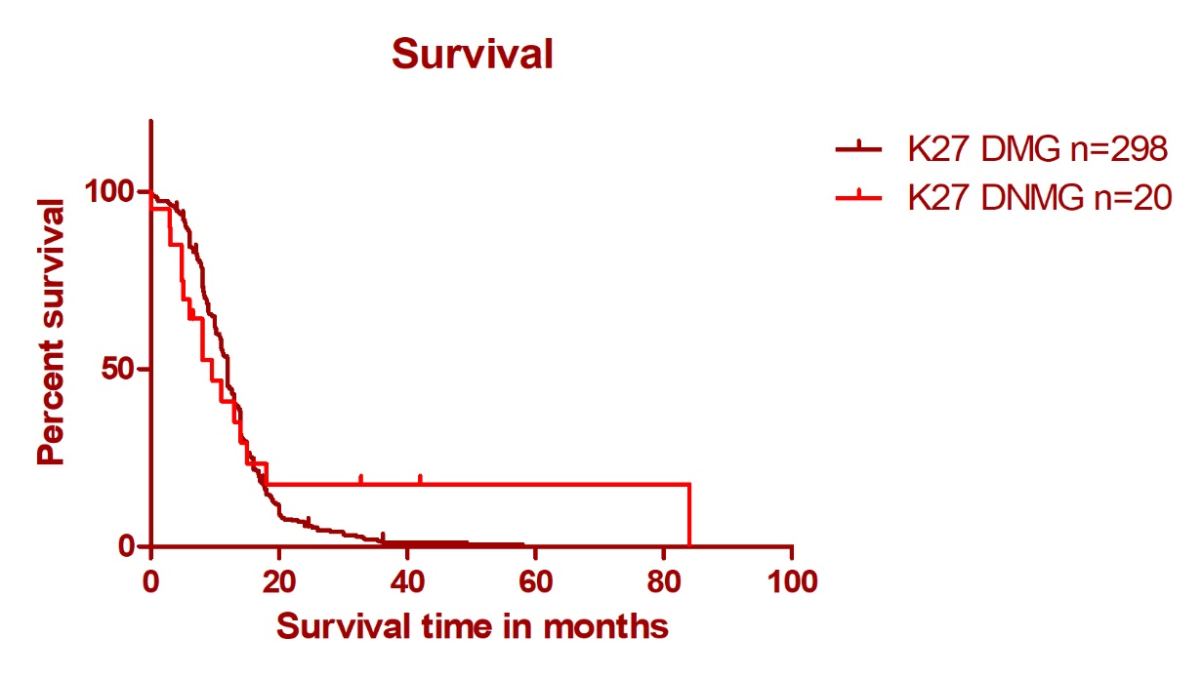

Supplementary Figure 1: Survival curves for patients presenting a diffuse non-midline glioma K27M altered (K27 DNMG, ie: our series) and for patients presenting a diffuse midline glioma K27M altered (K27 DMG) adapted from Mackay A et al, Cancer Cell. 2017 [2]Supp
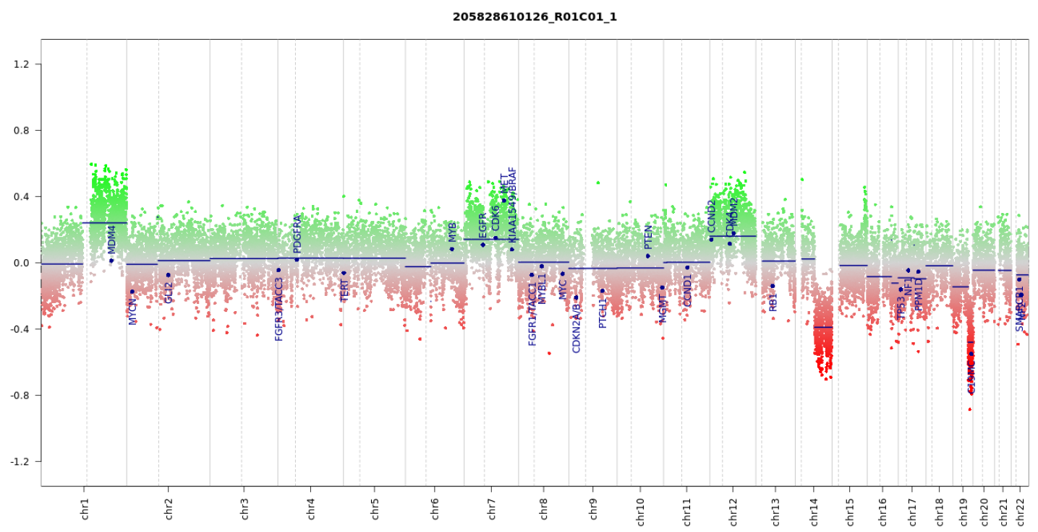
Supplementary Figure 2A: Copy number variation profile of P1
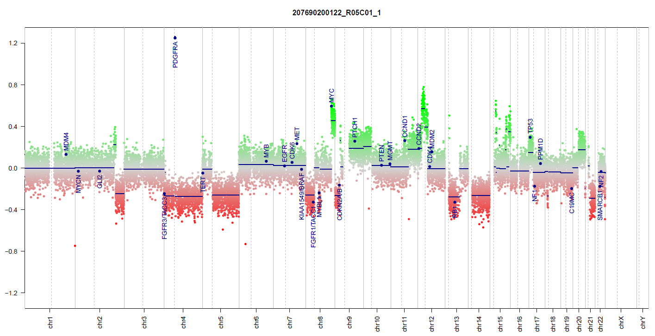
Supplementary Figure 2B: Copy number variation profile of P2
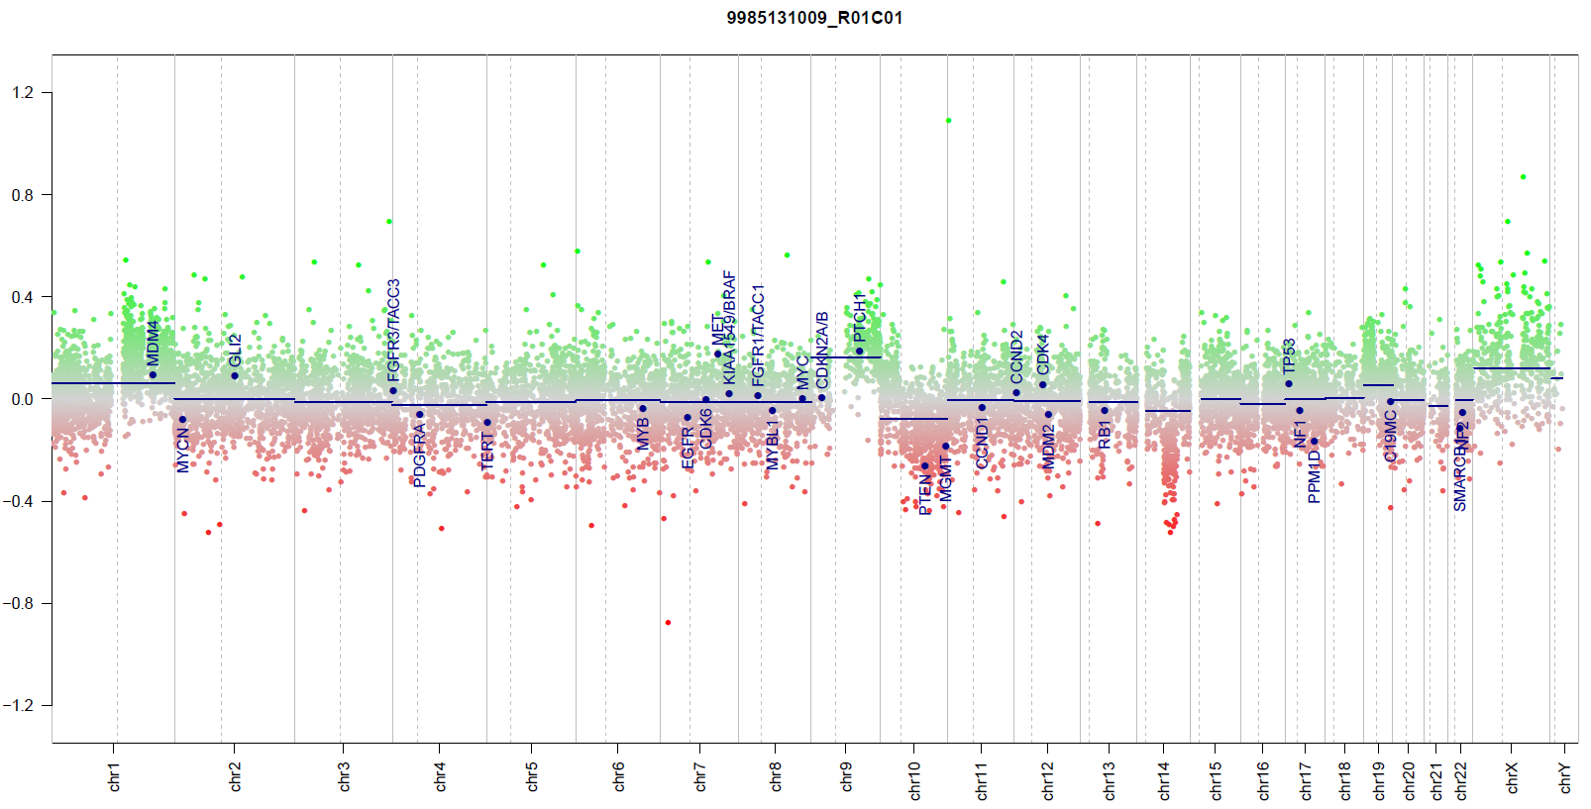
Supplementary Figure 2C: Copy number variation profile of P9
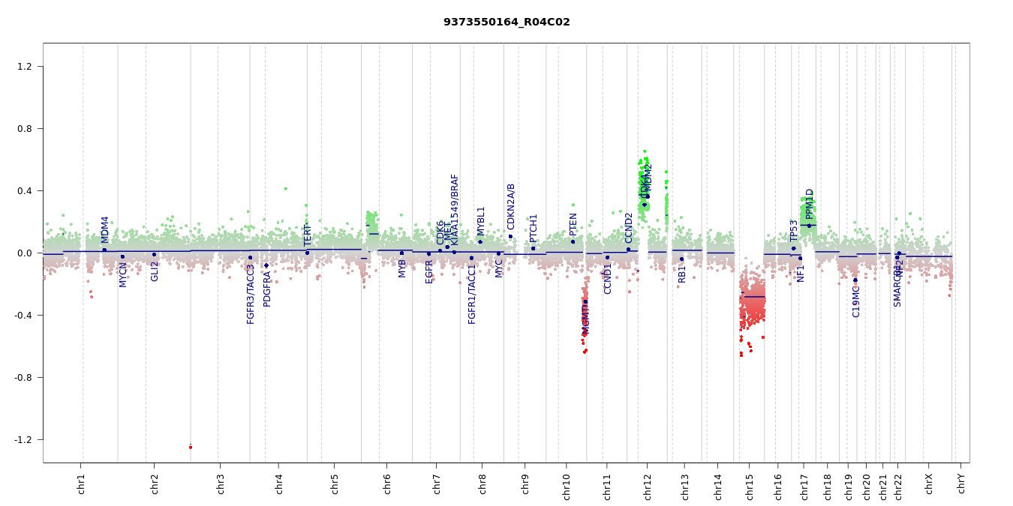
Supplementary Figure 2D: Copy number variation profile of P16

Supplementary Figure 2: Copy number variation profiles of P1, P2, P9 and P16

SUPPLEMENTARY REFERENCES
1. Reported patients
2. Mackay A, Burford A, Carvalho D, et al (2017) Integrated Molecular Meta-Analysis of 1,000 Pediatric High-Grade and Diffuse Intrinsic Pontine Glioma. Cancer Cell 32:520–537.e5. https://doi.org/10.1016/j.ccell.2017.08.017
3. Capper D, Jones DTW, Sill M, et al (2018) DNA methylation-based classification of central nervous system tumours. Nature 555:469–474. https://doi.org/10.1038/nature26000
4. Sturm D, Witt H, Hovestadt V, et al (2012) Hotspot Mutations in H3F3A and IDH1 Define Distinct Epigenetic and Biological Subgroups of Glioblastoma. Cancer Cell 22:425–437. https://doi.org/10.1016/j.ccr.2012.08.024
5. Fontebasso AM, Papillon-Cavanagh S, Schwartzentruber J, et al (2014) Recurrent somatic mutations in ACVR1 in pediatric midline high-grade astrocytoma. Nat Genet 46:462–466. https://doi.org/10.1038/ng.2950
6. Schwartzentruber J, Korshunov A, Liu X-Y, et al (2012) Driver mutations in histone H3.3 and chromatin remodelling genes in paediatric glioblastoma. Nature 482:226–231. https://doi.org/10.1038/nature10833
7. López G, Oberheim Bush NA, Berger MS, et al (2017) Diffuse non-midline glioma with H3F3A K27M mutation: a prognostic and treatment dilemma. Acta Neuropathol Commun 5:. https://doi.org/10.1186/s40478-017-0440-x
8. Wang L, Li Z, Zhang M, et al (2018) H3 K27M–mutant diffuse midline gliomas in different anatomical locations. Hum Pathol 78:89–96. https://doi.org/10.1016/j.humpath.2018.04.015
9. Chia N, Wong A, Teo K, et al (2021) H3K27M-mutant, hemispheric diffuse glioma in an adult patient with prolonged survival. Neuro-Oncol Adv 3:. https://doi.org/10.1093/noajnl/vdab135
10. Valério E, Alves de Castro JV, Carraro DM, et al (2022) Beyond Midline: Diffuse Hemispheric Glioma, H3 K27M-Mutant with Aggressive Behavior. J Neuropathol Exp Neurol nlac016. https://doi.org/10.1093/jnen/nlac016
11. Onishi S, Ohba S, Kuraoka K, et al (2022) Molecular and clinical characterization of H3 K27M-mutant “non-midline” glioblastoma: A case report and literature review. Neurocir Engl Ed 33:356–360. https://doi.org/10.1016/j.neucie.2021.06.008
12. Qiu T, Chanchotisatien A, Qin Z, et al (2020) Imaging characteristics of adult H3 K27M-mutant gliomas. J Neurosurg 133:1662–1670. https://doi.org/10.3171/2019.9.JNS191920
13. Huang T, Garcia R, Qi J, et al (2019) Correction: Detection of histone H3 K27M mutation and post-translational modifications in pediatric diffuse midline glioma via tissue immunohistochemistry informs diagnosis and clinical outcomes. Oncotarget 10:2788. https://doi.org/10.18632/oncotarget.26881
14. Odia Y, Hall MD, Cloughesy TF, et al (2024) Selective DRD2 Antagonist and ClpP Agonist ONC201 in a Recurrent Non-midline H3 K27M-mutant Glioma Cohort. Neuro-Oncol. https://doi.org/10.1093/neuonc/noae021
15. Donev K, Sundararajan V, Johnson D, et al (2024) Diffuse hemispheric glioma with H3 p.K28M (K27M) mutation: Unusual non-midline presentation of diffuse midline glioma, H3 K27M-altered? J Neuropathol Exp Neurol. https://doi.org/10.1093/jnen/nlae018
16. Venneti S, Santi M, Felicella MM, et al (2014) A sensitive and specific histopathologic prognostic marker for H3F3A K27M mutant pediatric glioblastomas. Acta Neuropathol (Berl) 128:743–753. https://doi.org/10.1007/s00401-014-1338-3
17. Williams EA, Brastianos PK, Wakimoto H, et al (2023) A comprehensive genomic study of 390 H3F3A-mutant pediatric and adult diffuse high-grade gliomas, CNS WHO grade 4. Acta Neuropathol (Berl) 146:515–525. https://doi.org/10.1007/s00401-023-02609-6

