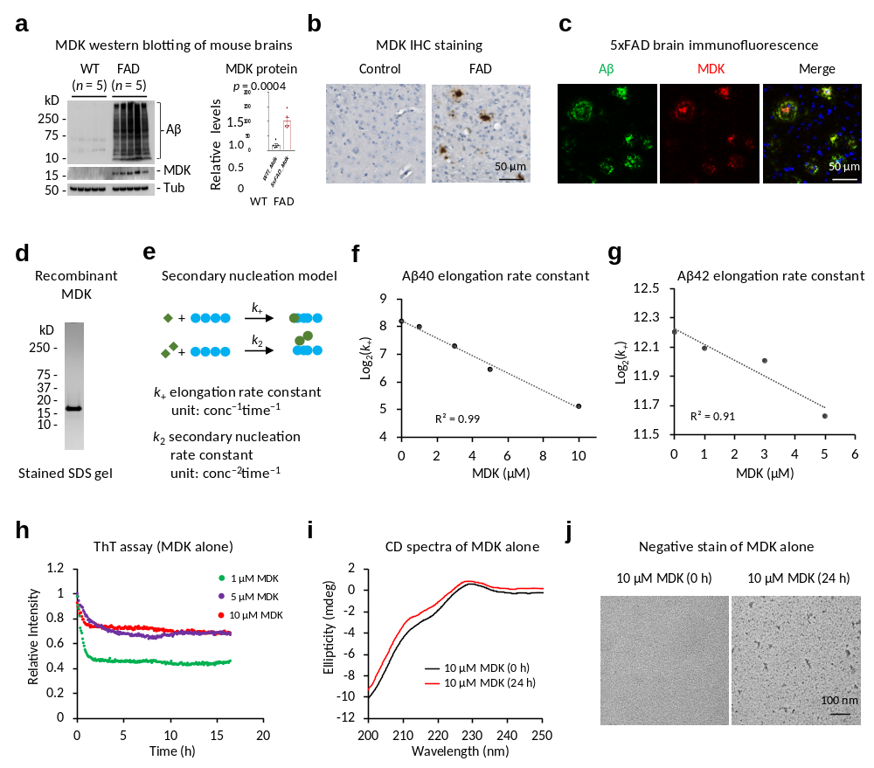

Extended Data Fig. 1. MDK is an Aβ-correlated protein in FAD mice, and it cannot independently form fibrils. a, MDK level is increased in FAD mice, compared to WT (12-month-old, WT n = 5, FAD n = 5). Statistical significance is analyzed by two-tailed Student's t-test. Data are shown as mean ± standard error of the mean (SEM). b, IHC staining of MDK in WT and FAD brain tissues, with the scale bar shown. c, Co-immunofluorescence staining of Aβ and MDK in FAD, with the scale bar shown. d, Highly purified recombinant protein of MDK on a silver-stained SDS gel, with the molecular weight markers shown. e, Diagram of the secondary nucleation model showing Aβ assembly. The rate constants (k₊ and k₂) are defined with units, reflecting their dependency on protein concentration and time. f-g, Analysis of Aβ40 and Aβ42 elongation constants (k₊) by fitting the ThT data. h, The ThT assay of MDK alone (n = 3 replicates, averaged data shown). i, CD spectroscopy of the MDK samples. j, Negative stain EM of the MDK samples, with the scale bar shown.

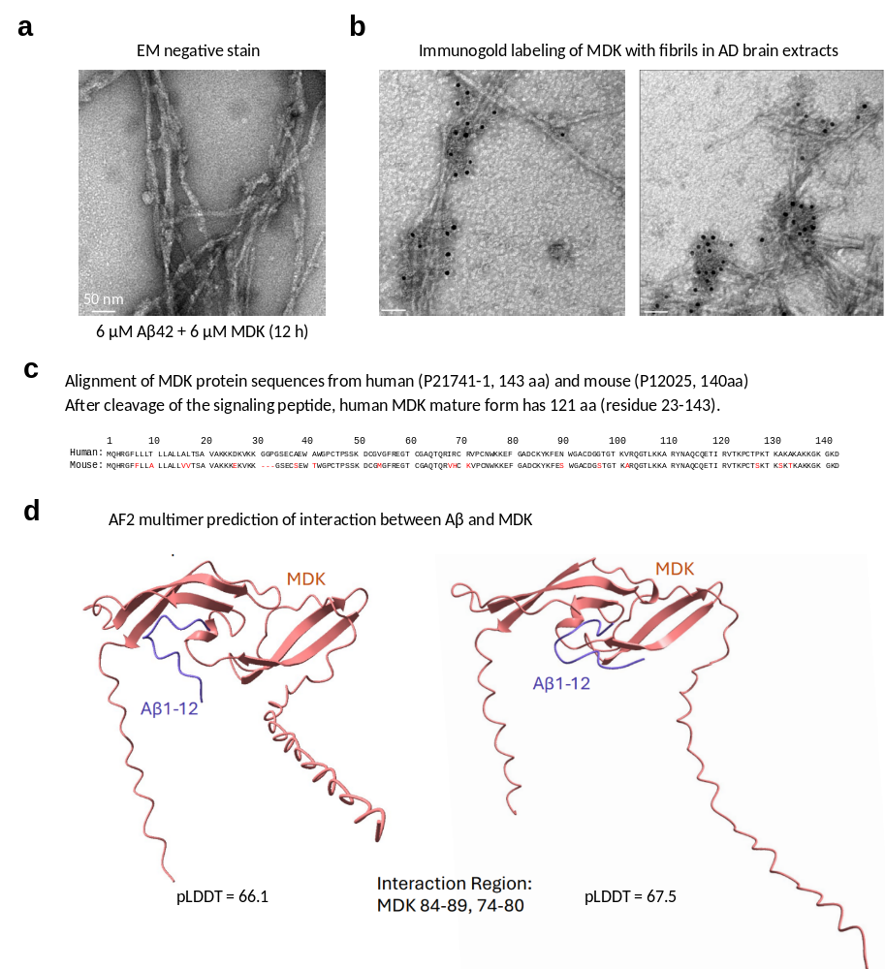

Extended Data Fig. 2. EM images and structural prediction of Aβ-MDK interaction. a, Negative stain EM of the fibril form of Aβ42 (6 µM) with MDK (6 µM). Scale bar: 50 nm. b, Immunogold labeling of MDK in human brain fibrils. Enriched Aβ filaments from human AD brain lysates were analyzed with anti-MDK goat antibodies. Scale bar: 50 nm. c, The alignment of human and mouse MDK protein sequences. MDK is a secreted protein containing a signal peptide for secretion (aa 1–20) and the main protein chain (aa 21–143). d, AlphaFold2-multimer predicted structures of the Aβ-MDK potential interacting interfaces. The confidence of the predicted 3D structures is evaluated by the predicted Local Distance Difference Test (pLDDT).

Extended Data Fig. 3. Proteomic Analysis of Mdk KO and FAD mice. a, Boxplot of the whole proteome data to demonstrate equal loading across samples, with different colors assigned to each genotype. b, PCA of the whole proteome data using DEPs, showing the separation of different genotypes. c, Representative volcano plot to show the DEPs between FAD/KO and FAD mice. The P values were generated by the LIMMA analysis. d, Selected DEPs in four WPCs. Each protein is represented by a colored box after log2 conversion followed by Z score analysis. e, Boxplot of the aggregated proteome data. f, PCA of the aggregated proteome data from the FAD and FAD/KO mice using DEPs. g, Volcano plot to compare the aggregated proteome of FAD and FAD/KO mice, with the P values derived from the LIMMA analysis.

