SUPPLEMENTARY MATERIALS
Supplementary Table 1: Mean Difference and Confidence Intervals for Significant Differences by Site and Gender
SITE: UCSD-WUSTL
 | P | Mean Difference (CI) | 95% CI (Low) | 95% CI (high)
Maximal Cardiovascular Fitness (METS) | <.001 | -1.0 | -1.4 | -0.7
DMN Connectivity | <.001 | 0.052 | 0.04 | 0.064
ECN Connectivity | <.001 | 0.034 | 0.029 | 0.04
DAN Connectivity | <.001 | 0.033 | 0.028 | 0.039
SAL Connectivity | <.001 | 0.088 | 0.07 | 0.107
MOT Connectivity | <.001 | 0.091 | 0.071 | 0.112
VIS Connectivity | <.001 | 0.061 | 0.049 | 0.073
BSDMN Connectivity | <.001 | 0.039 | 0.031 | 0.047
BSDAN Connectivity | <.001 | 0.028 | 0.016 | 0.04
Sex: Female-Male
Age (yrs) | 0.005 | -1.6 | -2.7 | -0.5
Maximal Cardiovascular Fitness (METS) | <.001 | -1.4 | -1.8 | -0.9
Body Fat (%) | <.001 | 9.4 | 7.9 | 10.9
Lean Tissue (g) | <.001 | -15307.6 | -16643.2 | -13972
Visceral Adipose Tissue (g) | <.001 | -1063 | -1240.4 | -885.6
Total Movement (VM CPM) | 0.026 | 135.5 | 16.6 | 254.5
DMN Connectivity | 0.019 | 0.019 | 0.003 | 0.034
Yrs=Years; METS= Metabolic Equivilant of Task; VM= Vector Magnitude; CPM= Counts per minute; g=grams; min= minutes; DMN = Default Mode Network; ECN = Executive Control Network; DAN = Dorsal Attentional Network; SAL = Salience Network; MOT = Motor Control Network; VIS = Visual Network; BS = Ben Sietzman defined network.

Supplementary Figure 1
Seitzman and Voss Coordinates and ROI’s
Default Mode Network
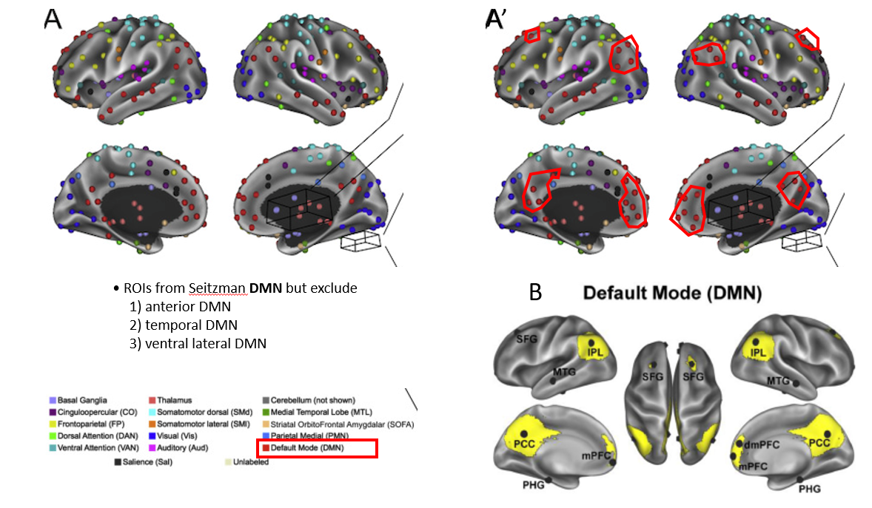A=Seitzman coordinates and associated ROI designations
B=Visual representation of Voss ROI designations
A’=Overlay of Voss visual representations on Seitzman coordinates/designations

Supplementary Figure 2
Seitzman and Voss Coordinates and ROI’s
Executive Control Network

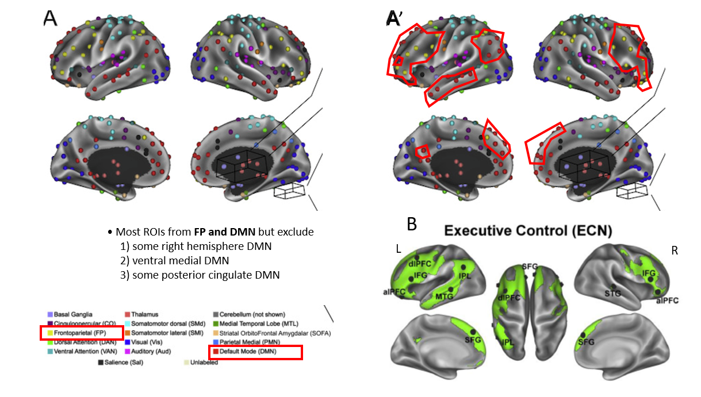A=Seitzman coordinates and associated ROI designations
B=Visual representation of Voss ROI designations
A’=Overlay of Voss visual representations on Seitzman coordinates/designations

Supplementary Figure 3
Seitzman and Voss Coordinates and ROI’s
Dorsal Attentional Network

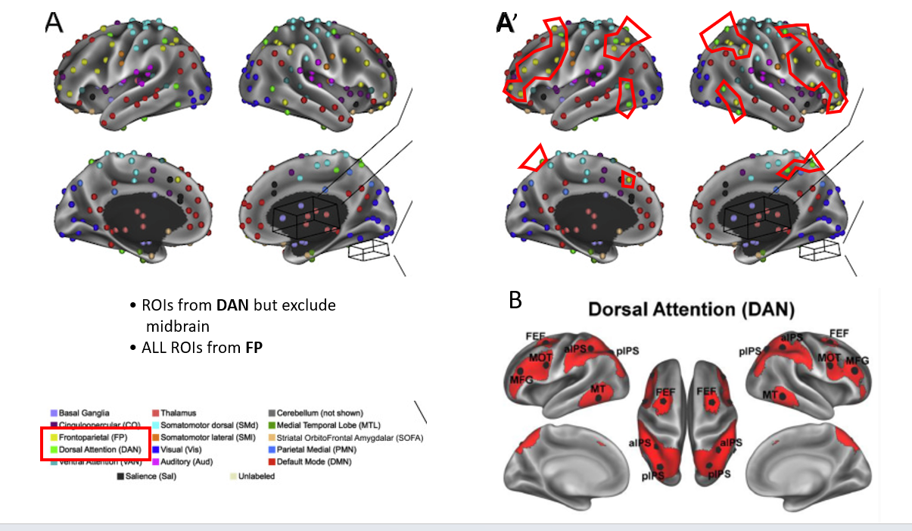
A=Seitzman coordinates and associated ROI designations
B=Visual representation of Voss ROI designations
A’=Overlay of Voss visual representations on Seitzman coordinates/designations

Supplementary Figure 4
Seitzman and Voss Coordinates and ROI’s
Salience Network

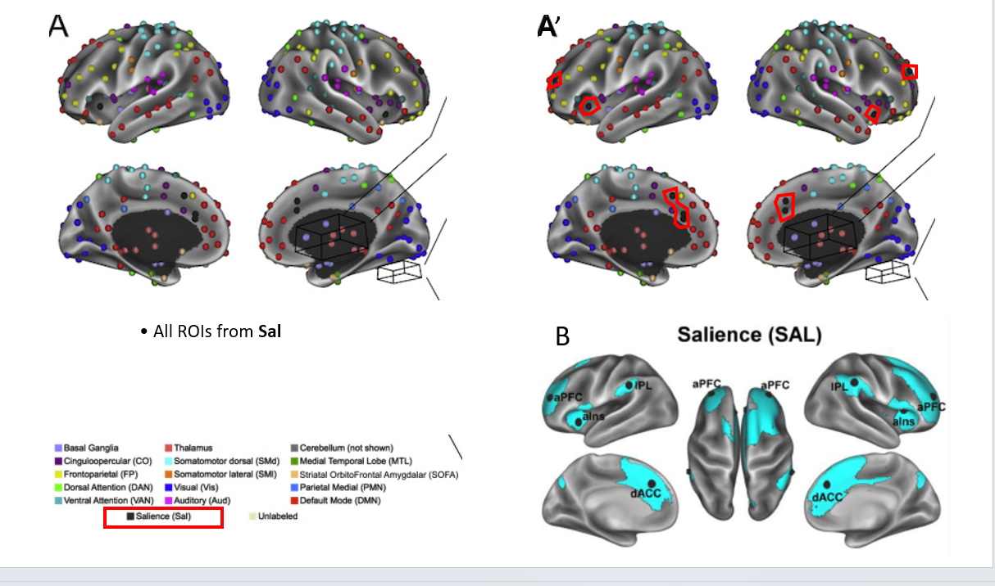

A=Seitzman coordinates and associated ROI designations
B=Visual representation of Voss ROI designations
A’=Overlay of Voss visual representations on Seitzman coordinates/designations

Supplementary Figure 5
Seitzman and Voss Coordinates and ROI’s
Sensory Networks
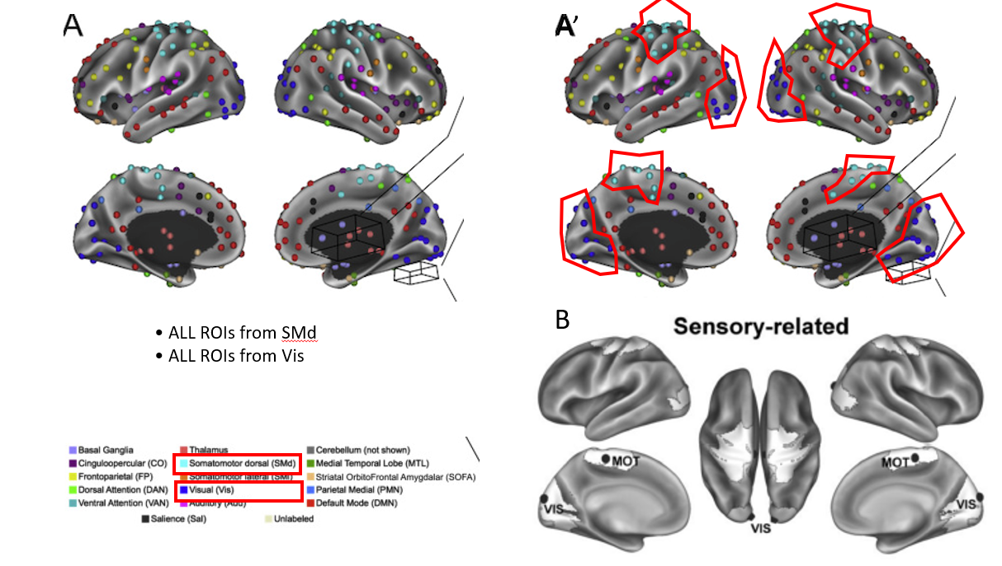

A=Seitzman coordinates and associated ROI designations
B=Visual representation of Voss ROI designations
A’=Overlay of Voss visual representations on Seitzman coordinates/designations

