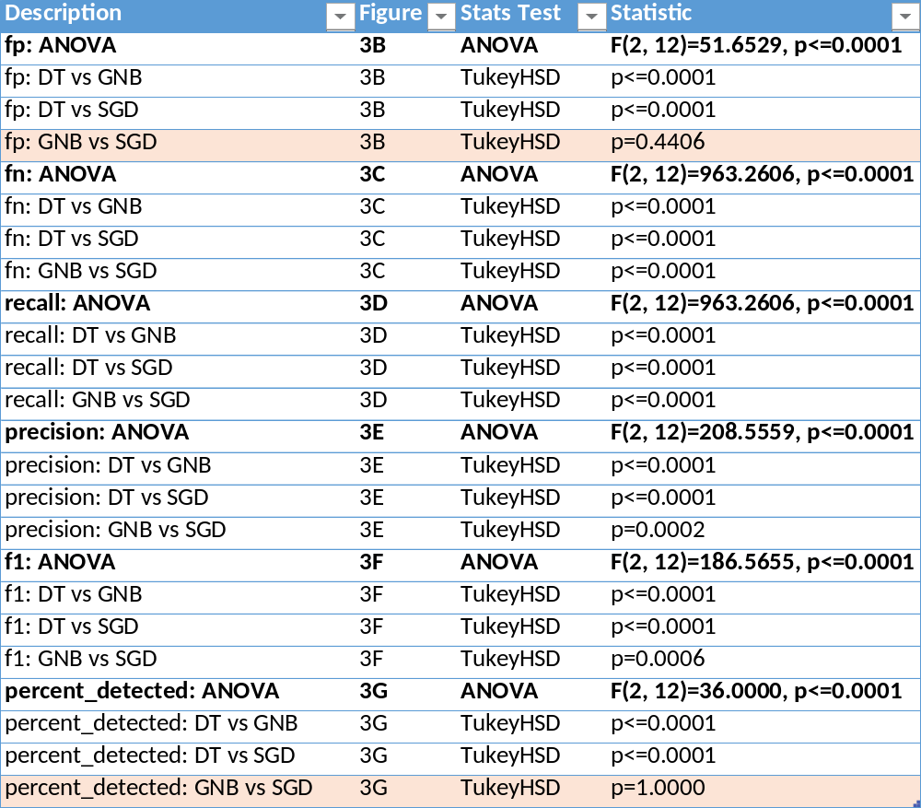
Supplementary Table 1: Statistical comparison of 3 models across metrics. Non-significant p-values (p > 0.05) are highlighted in orange.

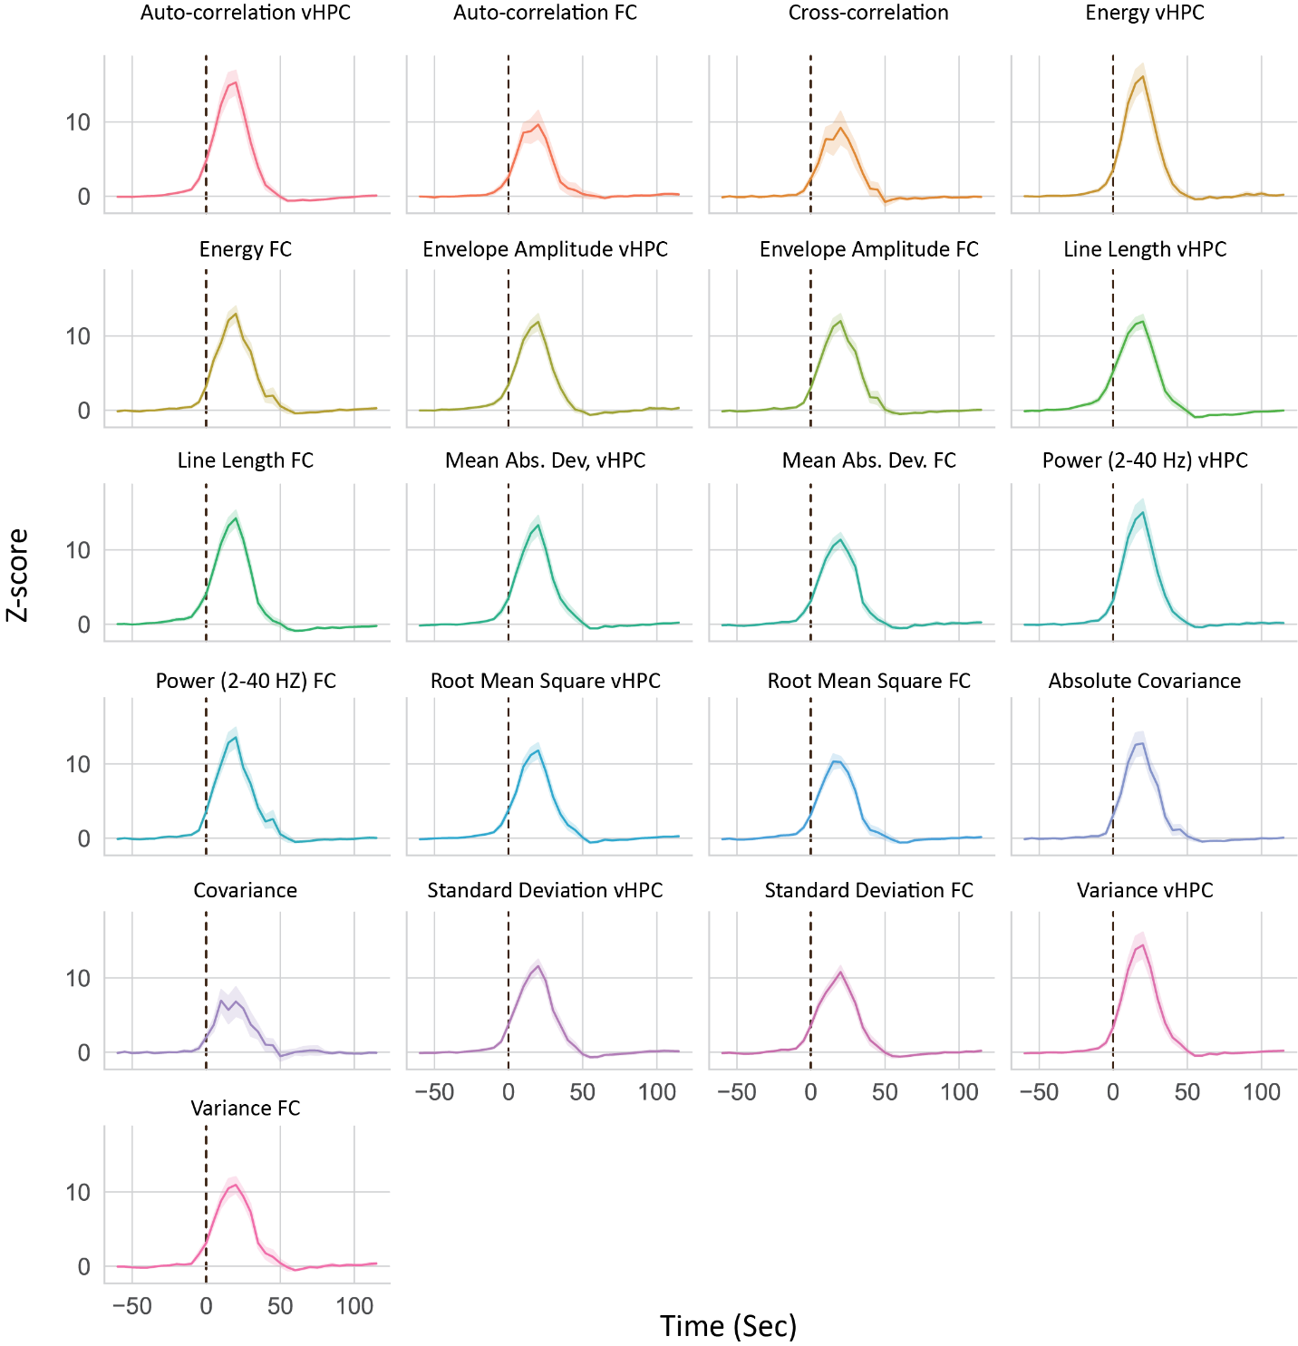
Supplementary Figure 1. Feature values change seizure onset. Graphs show how normalized feature values increase during time-locked seizure onset across all seizures in the training dataset. Seizure onset is marked by black dotted line.
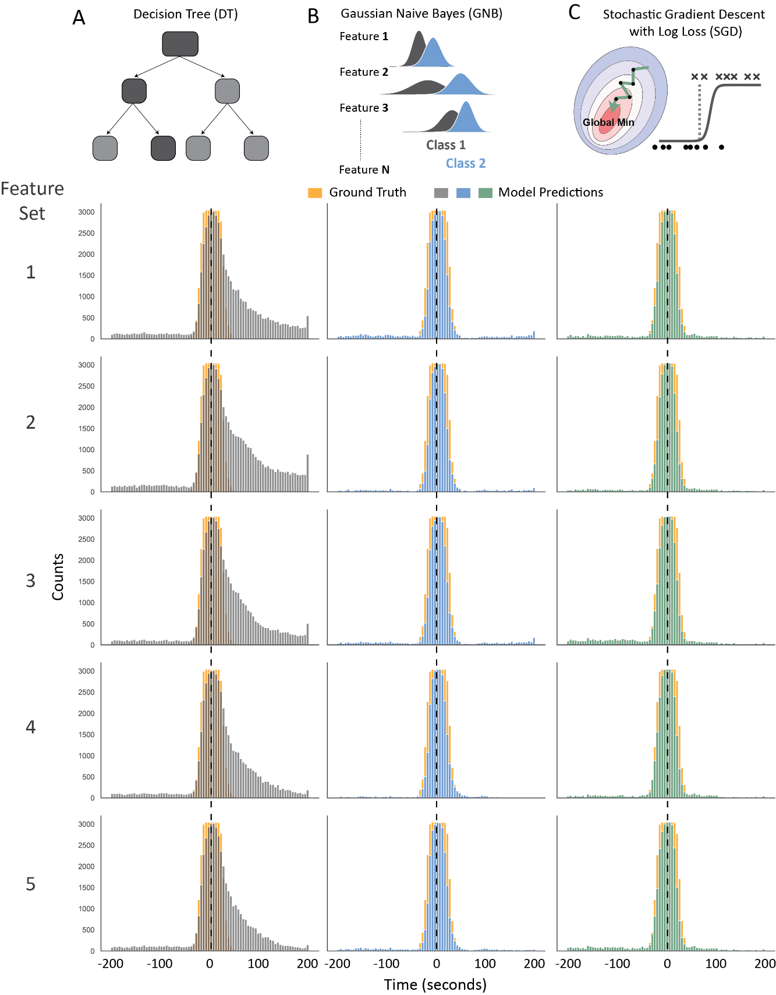
Supplementary Figure 2: Seizure prediction across time vs ground truth data. (A-C) Number of ground truth vs predicted seizure across features-sets. A) DT, B) GNB, C) SGD. Dotted line represents the seizure center.

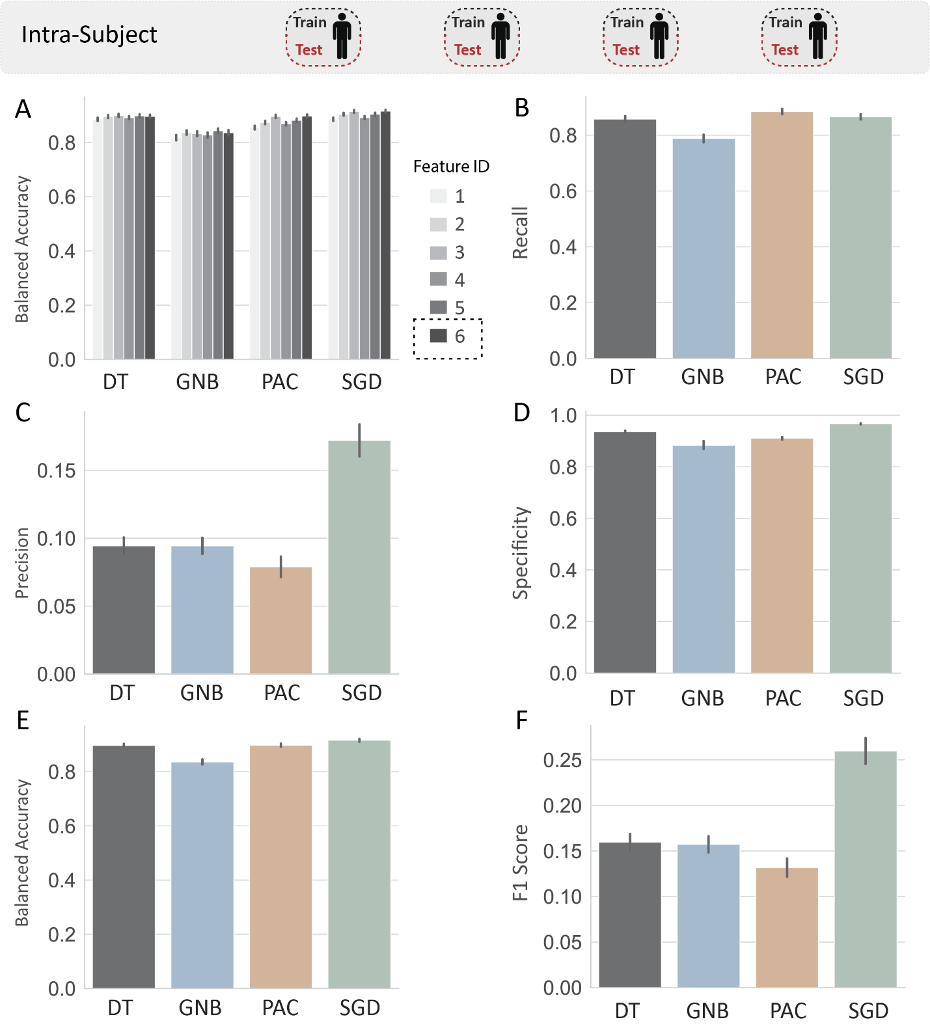
Supplementary Figure 3: Model metrics for intra-subject classification. A) Balanced accuracy across all feature IDs and models. (B-F) Model metrics for feature ID 6: B) Recall, C) Precision, D) Specificity, E) Balanced accuracy, F) F1 Score.

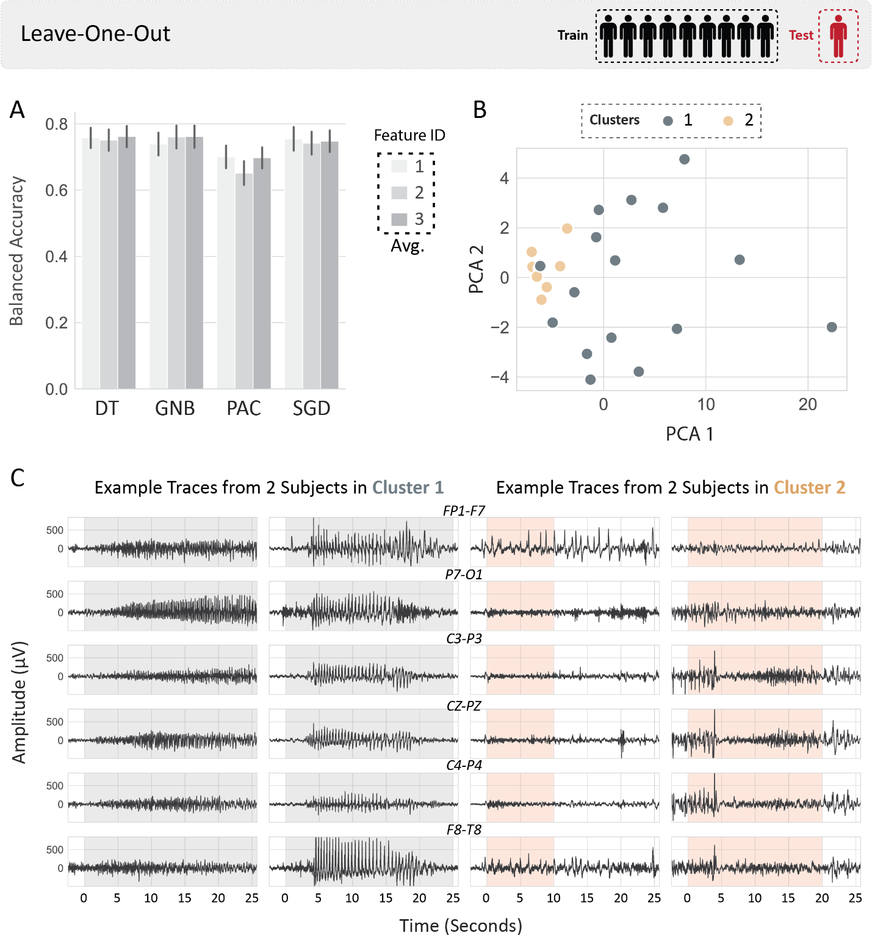
Supplementary Figure 4: Leave-one-out classification. A) Balanced accuracy across all feature IDs and models. B) Scatterplot of first two PCA components resulting from the max value of seizure features taken across subjects (1/3 of seizures taken for each subject); Colors indicate clusters of classification score from Figure 7F. The first two components captured 78% variance of the original features. C) Example EEG from subjects in clusters 1 and 2; traces in one column belong to the same subject; rows = channels. Highlighted regions indicate seizure periods (rounded to the nearest 5 second epoch).
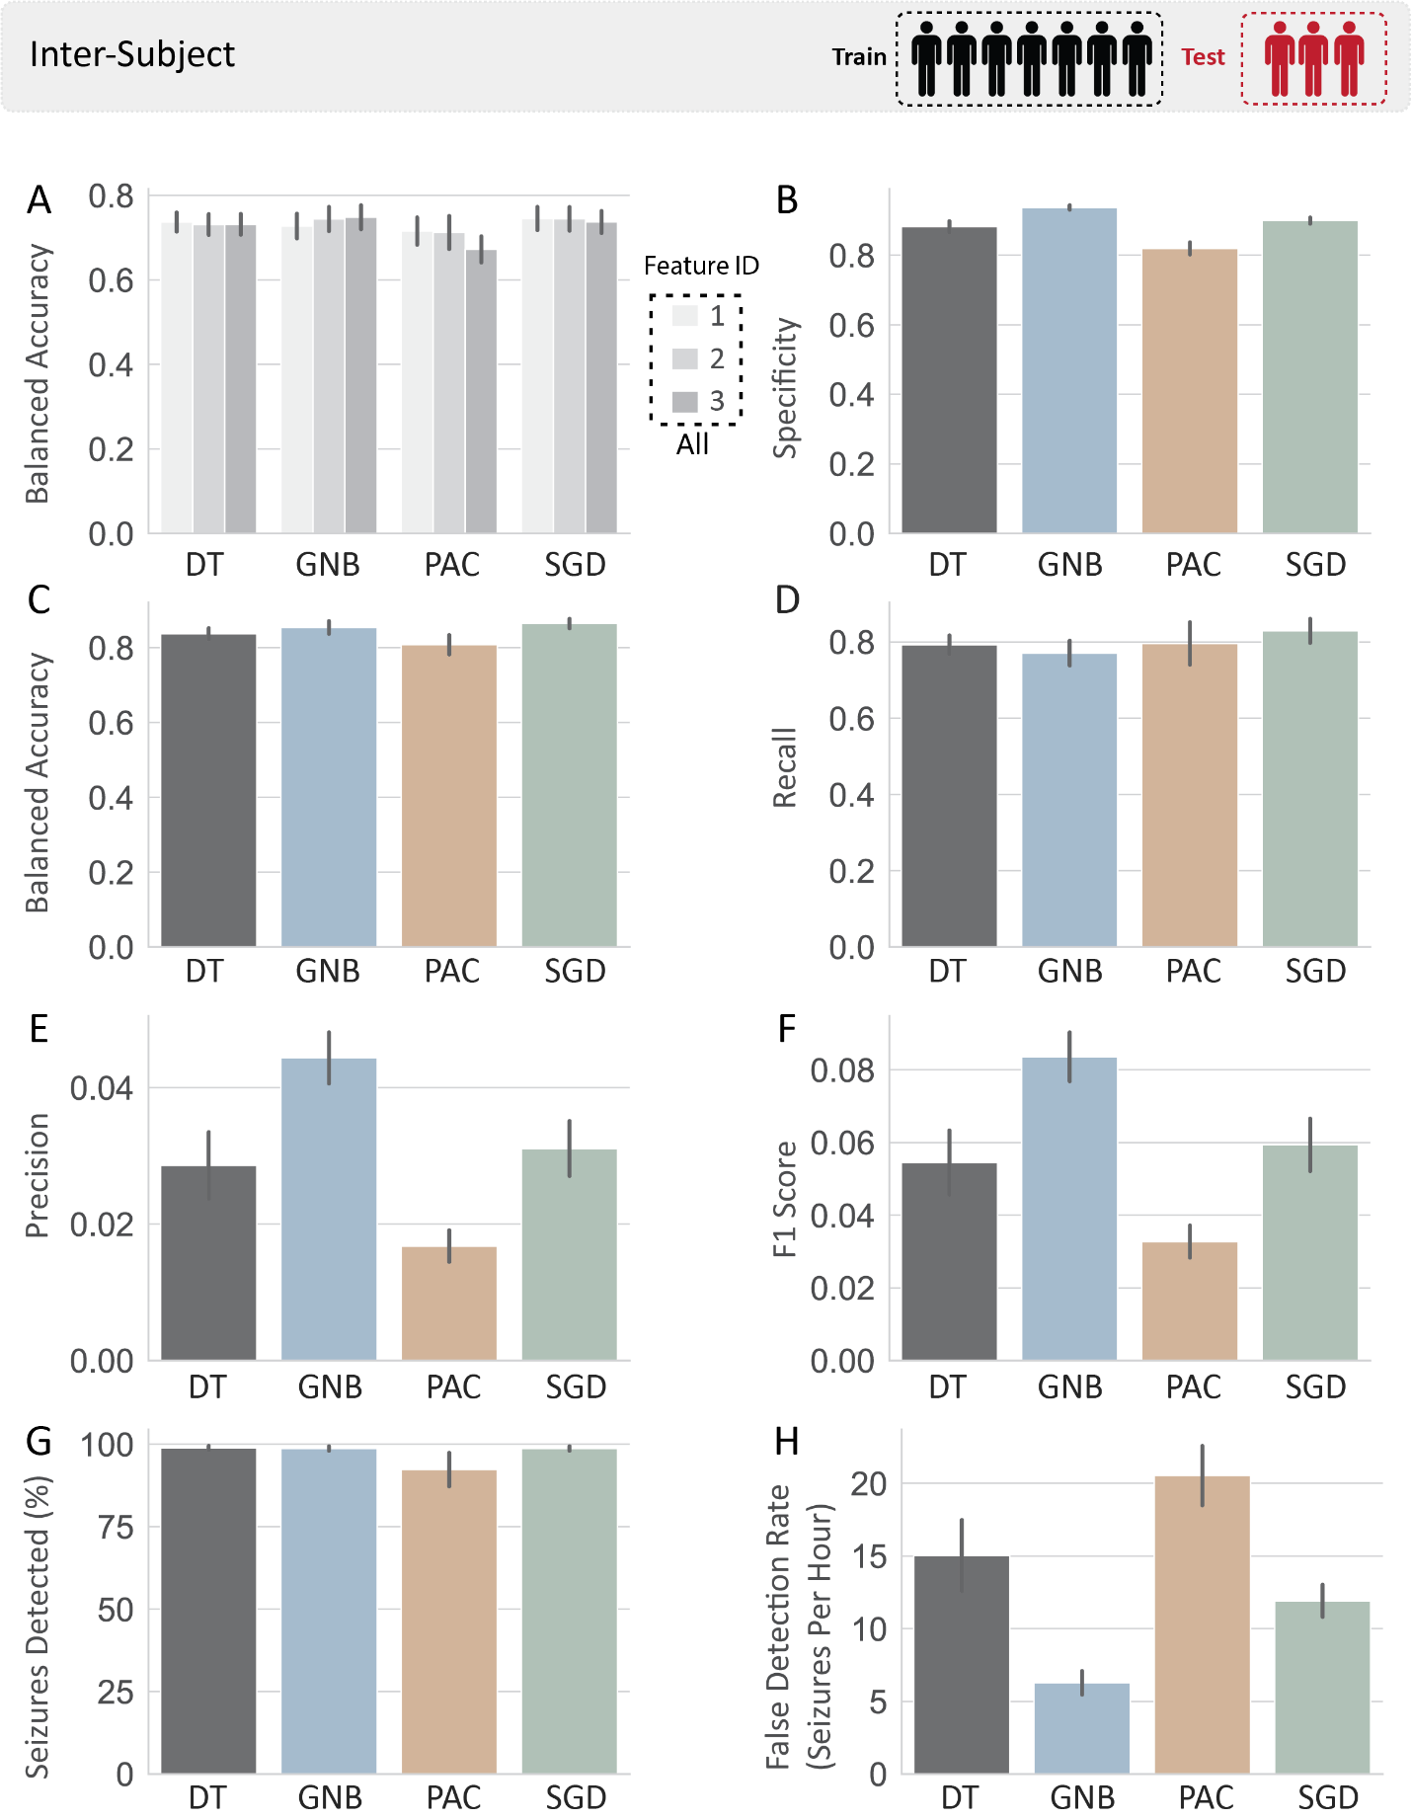
Supplementary Figure 5: Model metrics for inter-subject classification. A) Balanced accuracy across all feature IDs and models. (B-H) Model metrics from all feature IDs: B) Specificity, C) Balanced accuracy, D) Recall, E) Precision, F) F1 Score, G) Percent seizures detected, H) False detection rate.
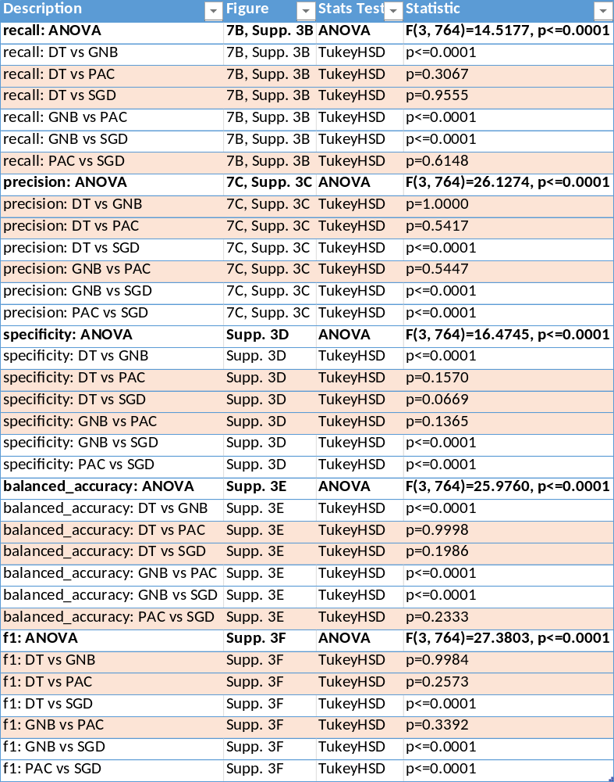
Supplementary Table 2: Statistical comparison of 4 models across metrics for intra-subject classification. Non-significant p-values (p > 0.05) are highlighted in orange.

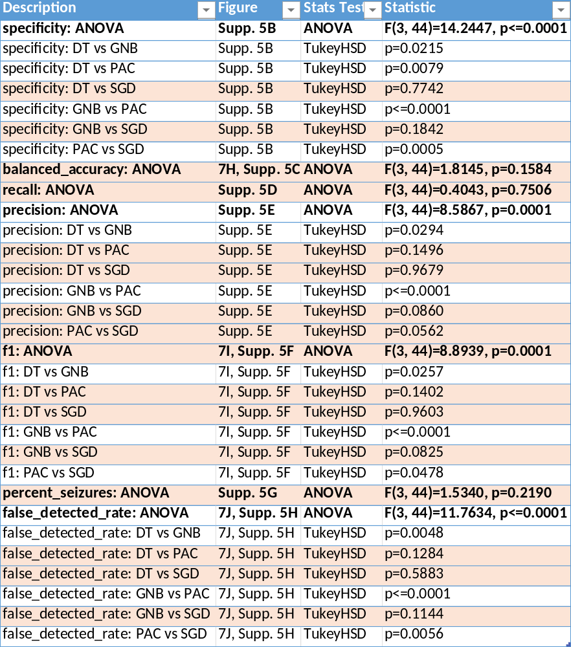
Supplementary Table 3: Statistical comparison of 4 models across metrics for inter-subject classification. Non-significant p-values (p > 0.05) are highlighted in orange.

