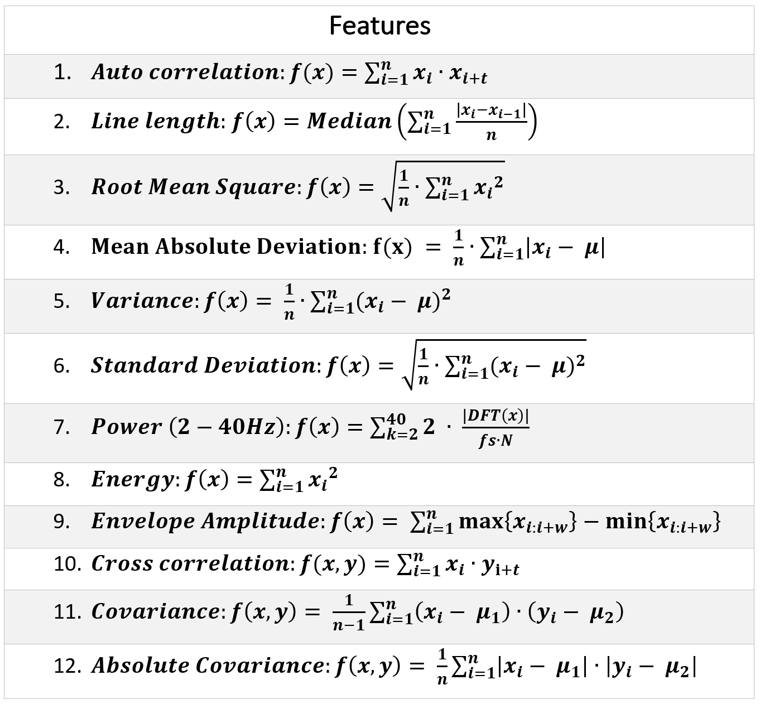
Table 1. Features. Where n is the length of the signal (n=500 samples, 5 seconds), i is the index, DFT is the Discrete Fourier Transform (from SciPy’s fft), fs is the sampling rate (fs=100 Hz), μ is the mean, t is the time lag (t=0), and w is the window (w=30 samples, 0.3 seconds).

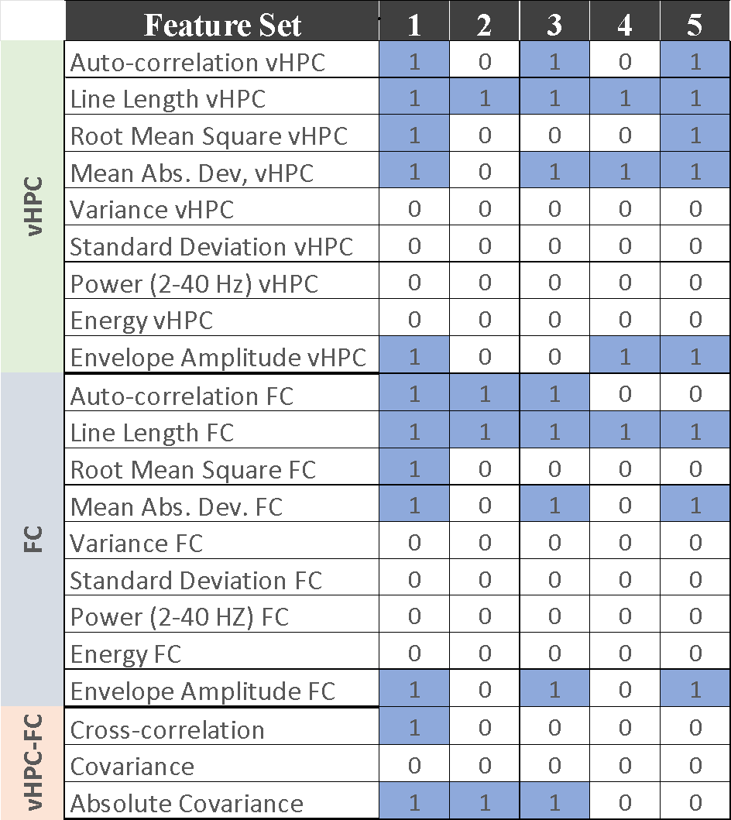
Table 2: Feature selection. Columns represent feature-sets. Cells that contain 1 in a blue background indicate that the feature was selected. Columns 1-5) Highly correlated features were removed. Columns 2-3) Best four and eight ranked features selected by ANOVA. Columns 4-5) four and eight ranked features selected by mutual information.

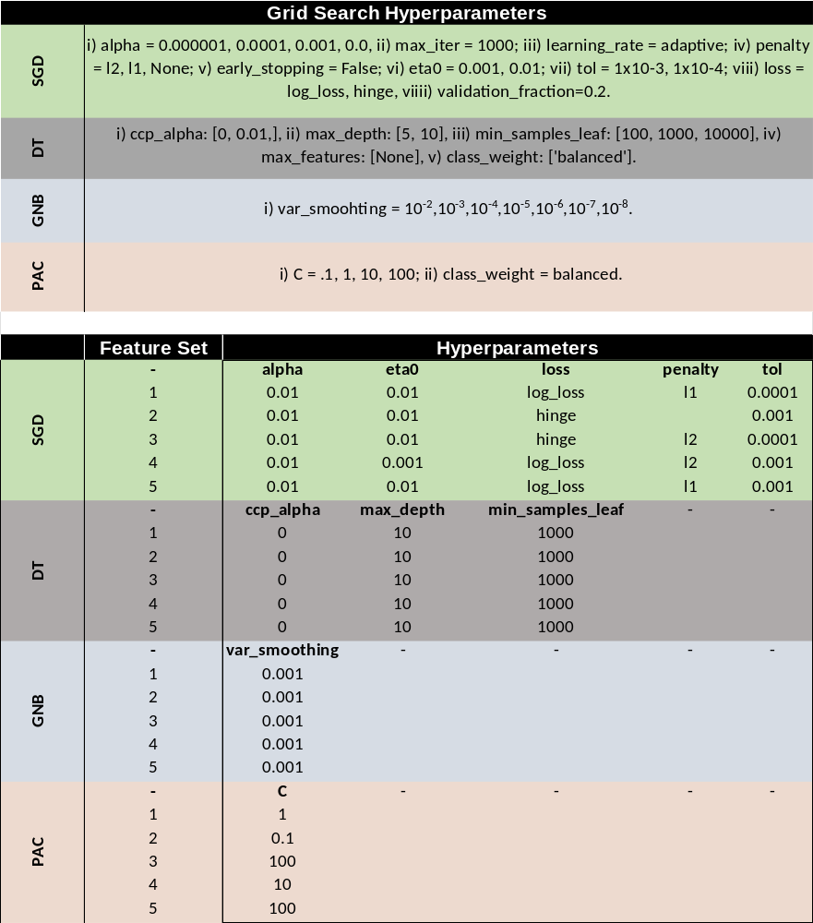
Table 3: Hyperparameter optimization. Top) Hyperparameter space used to perform grid search. Bottom) Hyperparameters that resulted in best balanced accuracy scores were selected for each model and feature-set. Note that only hyperparameters with more than one value from the top are displayed on the bottom table.

