Supplementary Material

(-)-Epicatechin metabolites as a GPER ligands: a theoretical perspective.
Rodolfo Daniel Ávila-Avilés^{1,2}, Erick Bahena-Culhuac^{1,2}, and J. Manuel Hernández-Hernández *¹
¹ Laboratory of Epigenetics of Skeletal Muscle Regeneration, Department of Genetics and Molecular Biology, Centre for Research and Advanced Studies of IPN (CINVESTAV), Mexico City, Mexico.
² Transdisciplinary Research for Drug Discovery, Sociedad Mexicana de Epigenética y Medicina Regenerativa A. C. (SMEYMER); Mexico City, Mexico.
*Corresponding author: jose.hernandezh@cinvestav.mx

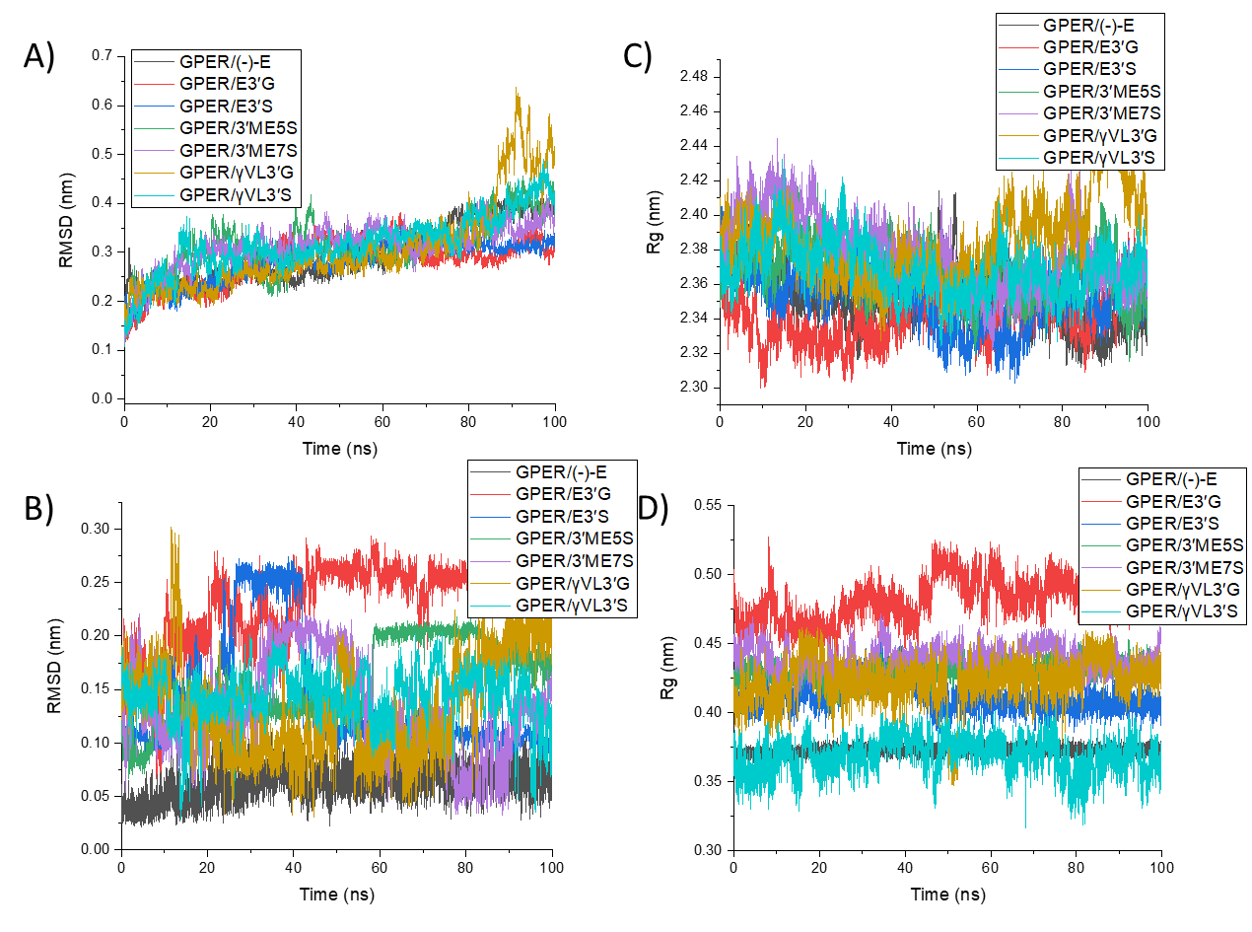
Figure S1. RMSD of GPER protein A), (-)-Epicatechin, and metabolites B): E3′G, E3′S, 3′ME5S, 3′ME7S, γVL3′G, and γVL3′S; and RG of GPER protein C), (-)-Epicatechin, and metabolites D): E3′G, E3′S, 3′ME5S, 3′ME7S, γVL3′G, and γVL3′S.
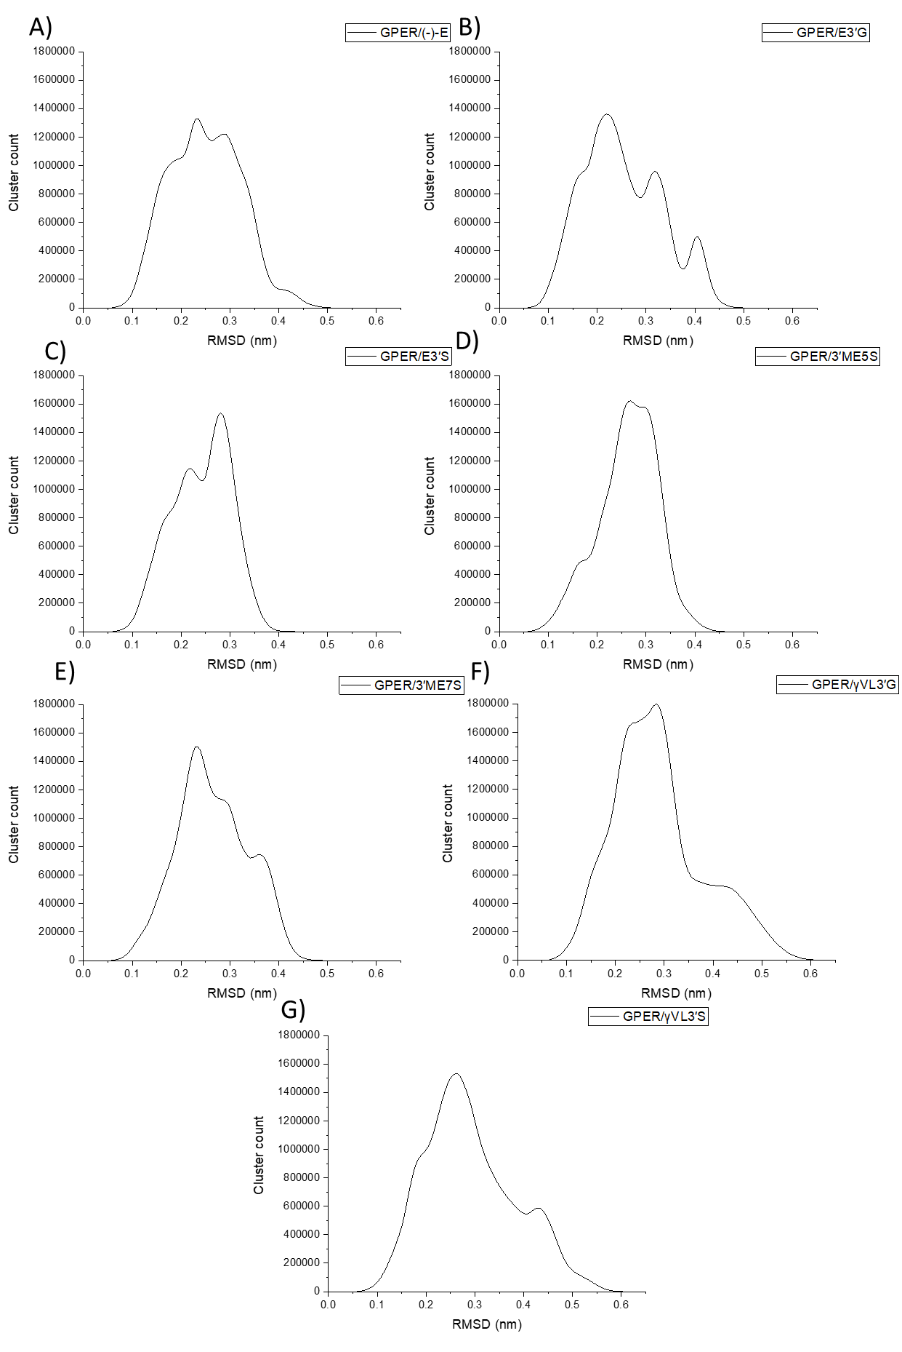
Figure S2. Cluster analysis distribution of GPER protein in complex with (-)-Epicatechin, and metabolites: E3′G, E3′S, 3′ME5S, 3′ME7S, γVL3′G, and γVL3′S
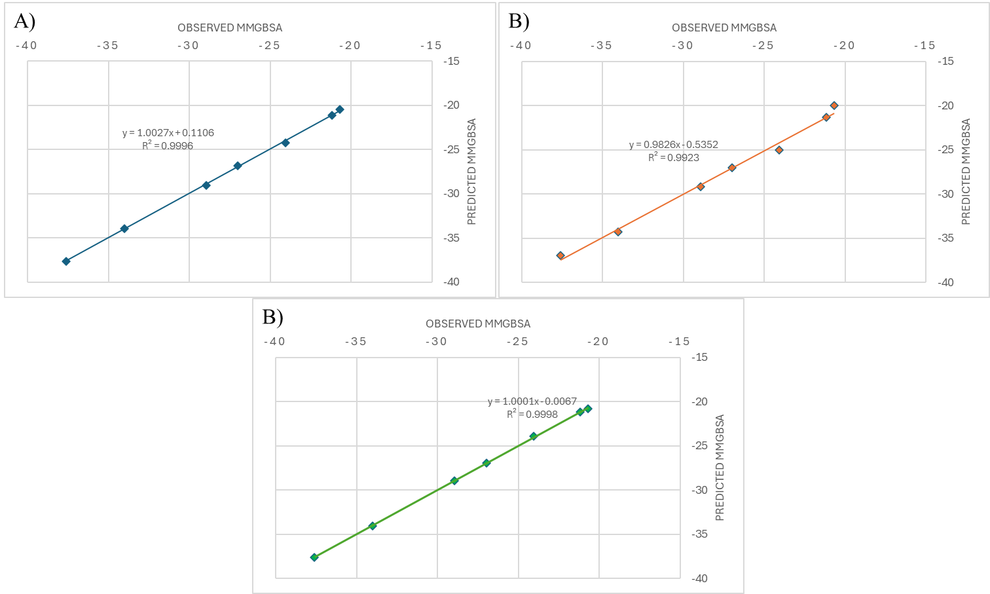
Figure S3. Graph of correlation between observed vs predicted MMGBSA based on the best model of A) Mordred, B) PaDEL 3D, and C) PaDEL 2D descriptors.

