Supplementary Material

Authors: Akira Shinohara, Yuki Takumoto, Junko Tauchi, Kohki Morishita, Toshikatsu Kawasaki, Manabu Akazawa
Title: Cost-effectiveness of systematic chemotherapy for metastatic pancreatic cancer: a retrospective study using Japanese clinical data

Table S1: Reference disutility values by type and severity of side effects.
Table S2: Comparison of real-world and clinical trial data on side effects.
Table S3: Efficacy parameters derived from individual patient data.
Table S4: Impact of QOL values and transition probability on ICER in the GnP arm.
Figure S1: Health care cost by category in the GnP arm.
Figure S2: Health care cost by category in the mFFX arm.
Figure S3: Tornado diagram illustrating one-way sensitivity analysis for the mFFX and GnP arms.
Figure S4: Kaplan–Meier curve depicting efficacy curve per health status.

Table S1: Reference disutility values by type and severity of side effects.
SE | SE Grade | Disutility | Reference
Febrile neutropenia | 3/4 | 0.311 | Quality of life surveys of  the general population  [16]
Neutropenia | 1/2 | 0 | Quality of life surveys of  the general population  [16]
Neutropenia | 3/4 | 0.093 | Quality of life surveys of  the general population  [16]
Diarrhea | 1/2 | 0.134 | Quality of life surveys of  the general population  [16]
Diarrhea | 3/4 | 0.328 | Quality of life surveys of  the general population  [16]
Nausea and vomiting | 1/2 | 0.212 | Quality of life surveys of  the general population  [16]
Nausea and vomiting | 3/4 | 0.392 | Quality of life surveys of  the general population  [16]
Peripheral neuropathy | 1/2 | 0.093 | Quality of life surveys of  the general population  [16]
Peripheral neuropathy | 3/4 | 0.264 | Quality of life surveys of  the general population  [16]
Fatigue | 1/2 | 0.193 | Quality of life surveys  of the healthcare provider
Fatigue | 3/4 | 0.386 | Quality of life surveys  of the healthcare provider
Hair loss | 1/2 | 0.099 | Quality of life surveys  of the healthcare provider
Taste disorder | 1/2 | 0.037 | Quality of life surveys  of the healthcare provider
SE, Side effects.

Table S2: Comparison of real-world and clinical trial data on side effects
SE | Grade | Real-world data (Analysis population) |  |  |  | Clinical trial
SE | Grade |  |  |  |  | (Only Japanese, ≥5%, Grade3/4)
SE | Grade | Percentage of SE morbidity day (%) |  | Percentage of patients with SE (%) |  | Percentage of patients with SE (%)
SE | Grade | mFFX | GnP | mFFX | GnP | mFFX ^{[2]} | GnP ^{[3]}
Febrile neutropenia | 3/4 | 2.7 | 1.3 | 5.6 | 2.1 | 8.7 | 5.9
Neutropenia | 1/2 | 0 | 0.7 | 0 | 0 | - | -
Neutropenia | 3/4 | 5.4 | 3.2 | 33.3 | 27.1 | 47.8 | 70.6
Diarrhea | 1/2 | 10.8 | 10.6 | 50 | 19.8 | - | -
Diarrhea | 3/4 | 0.2 | 0 | 5.6 | 0 | 10.1 | 5.9
Nausea  and vomiting | 1/2 | 29.3 | 15 | 77.8 | 43.8 | - | -
Nausea  and vomiting | 3/4 | 0 | 1.6 | 0 | 1 | 8.7^{*1} | -
Peripheral neuropathy | 1/2 | 8.5 | 9.2 | 44.5 | 54.2 | - | -
Peripheral neuropathy | 3/4 | 1.4 | 0.3 | 11.1 | 1 | 5.8 | 11.8
Fatigue | 1/2 | 15.9 | 14.4 | 66.7 | 33.3 | - | -
Fatigue | 3/4 | 3.2 | 5.4 | 5.6 | 2.1 | 12.2^{*2} | 17.0^{*2}
Hair loss | 1/2 | 9 | 13 | 11.1 | 42.7 | - | -
Taste disorder | 1/2 | 4.6 | 12.6 | 27.8 | 25 | - | -
*1 Nausea only.
*2 Frequency of occurrence in the total population including Japanese.
mFFX, modified FOLFIRINOX; GnP, Gemcitabine plus nab-paclitaxel; SE, side effects.

Table S3: Efficacy parameters derived from individual patient data.
State | mFFX |  | GnP
State | Mean | SD | Mean | SD
1stPFS (year) | 0.672 | 0.684 | 0.631 | 0.591
1stPD (year) | 0.045 | 0.053 | 0.080 | 0.110
2nd PFS (year) | 0.162 | 0.147 | 0.226 | 0.239
2ndPD (year) | 0.177 | 0.161 | 0.130 | 0.138
OS (year) | 1.046 | 0.841 | 0.967 | 0.713
mFFX, modified FOLFIRINOX; GnP, Gemcitabine plus nab-paclitaxel; PFS, progression-free survival; PD, progressive disease; OS, overall survival.
Table S4: Impact of QOL scores and transition probability on ICER in the GnP arm.
Change percentage | ICER of GnP for mFFX: Change in QOL score of 1stPFS in the GnP arm | ICER of GnP for mFFX: Change in the probability of 1stPFS in the GnP arm
-10% | Dominant | ^{*1}
-5% | Dominant | Dominant
-3% | Dominant | Dominant
-1% | 1,413,781 | Dominant
Base case | 835,824 | 835,824
1% | 593,287 | 245,661
3% | 375,414 | 123,270
5% | 274,580 | 91,948
10% | 16,428 | 65,036
*1 Total cost and total QALYs for mFFX were higher than that for GnP.
mFFX, modified FOLFIRINOX; GnP, Gemcitabine plus nab-paclitaxel.

Figure S1: Health care cost by category in the GnP arm.

Figure S2: Health care cost by category in the mFFX arm.

mFFX, modified FOLFIRINOX; GnP, Gemcitabine plus nab-paclitaxel; 1stSD, 1st line stable disease.

Figure S3: Tornado diagram illustrating one-way sensitivity analysis for the mFFX and GnP arms.
mFFX, modified FOLFIRINOX; GnP, Gemcitabine plus nab-paclitaxel; 1stSD, 1st line stable disease.

Figure S4: Kaplan–Meier curve depicting efficacy per health status.
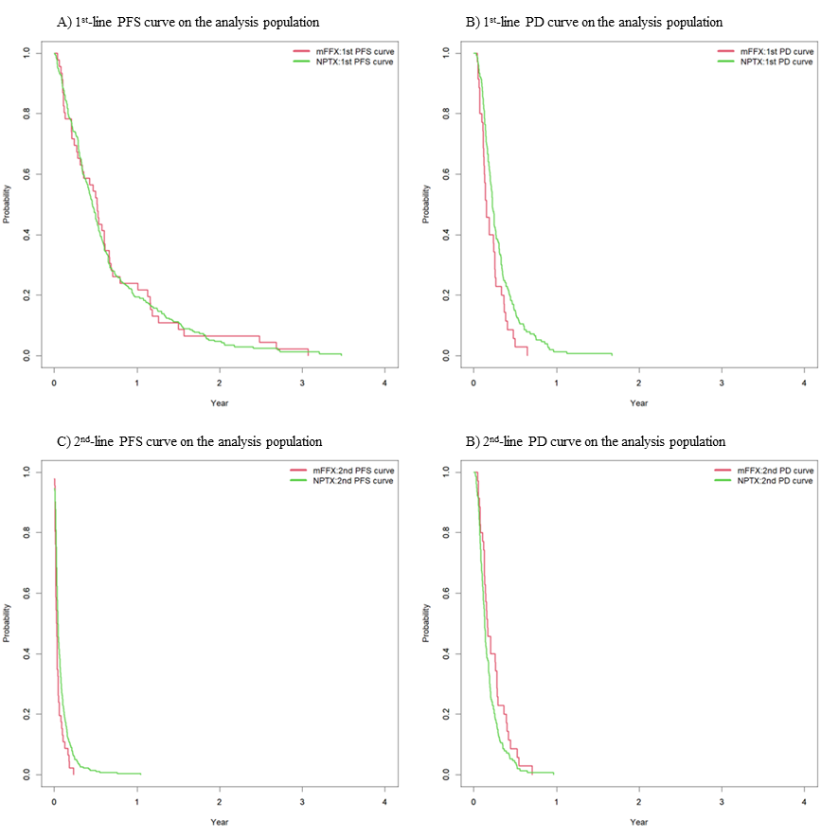
mFFX, modified FOLFIRINOX; GnP, Gemcitabine plus nab-paclitaxel; PFS, progression-free survival; PD, progressive disease.

