Supplementary Information for
“Discovery of universal phonon thermal Hall effect in crystals”

Xiaobo Jin^{1*}, Xu Zhang^{1*✉}, Wenbo Wan¹, Hanru Wang¹, Yihan Jiao¹ and Shiyan Li^{1,2,3✉}

¹State Key Laboratory of Surface Physics, Department of Physics, Fudan University, Shanghai 200433, China
²Shanghai Research Center for Quantum Sciences, Shanghai 201315, China
³Collaborative Innovation Center of Advanced Microstructures, Nanjing 210093, China

Corresponding author. Email: shiyan_li@fudan.edu.cn (S.Y.L.); xuzhang_fd@fudan.edu.cn (X.Z.)

Supplementary Note 1: Thermal Hall measurements on glass and Cu₃TeO₆
To validate the thermal Hall results from our experiment setup, we first carried out measurements on an amorphous non-magnetic sample—a piece of glass, in which there is negligible thermal Hall signal¹. A standard microscope slide was cut and polished to the similar dimensions as other samples. Figure S1a shows the thermal conductivity of the glass sample. Indeed, the thermal Hall signal in glass is negligible, as shown in Fig. S1b, which is consistent with previous report¹. This excludes an artificial finite κ_{xy} from our experiment setup.
For comparison, we measured the antiferromagnetic insulator Cu₃TeO₆, in which large κ_{xy} has been reported². As expected, we observed a large thermal Hall signal in Cu₃TeO₆ with a thermal Hall angle of 0.25% at 9 T (Fig. S1b), which is comparable with that in SiO₂. Further, we did detailed measurements on the Cu₃TeO₆ sample. In Fig. S1c, κ_{xx}(T) shows a phonon peak at around 20 K and a kink at T_{N}, suggesting the high quality of our sample. In a field of 12 T, large κ_{xy}(T) is observed, following the trend of κ_{xx}(T). All these behaviors are consistent with previous report, depicted as blue circles². Note that the relatively smaller value of κ_{xy} in our sample is due to the smaller κ_{xx} and magnetic field. The reproducibility of these data validates our experiment setup.

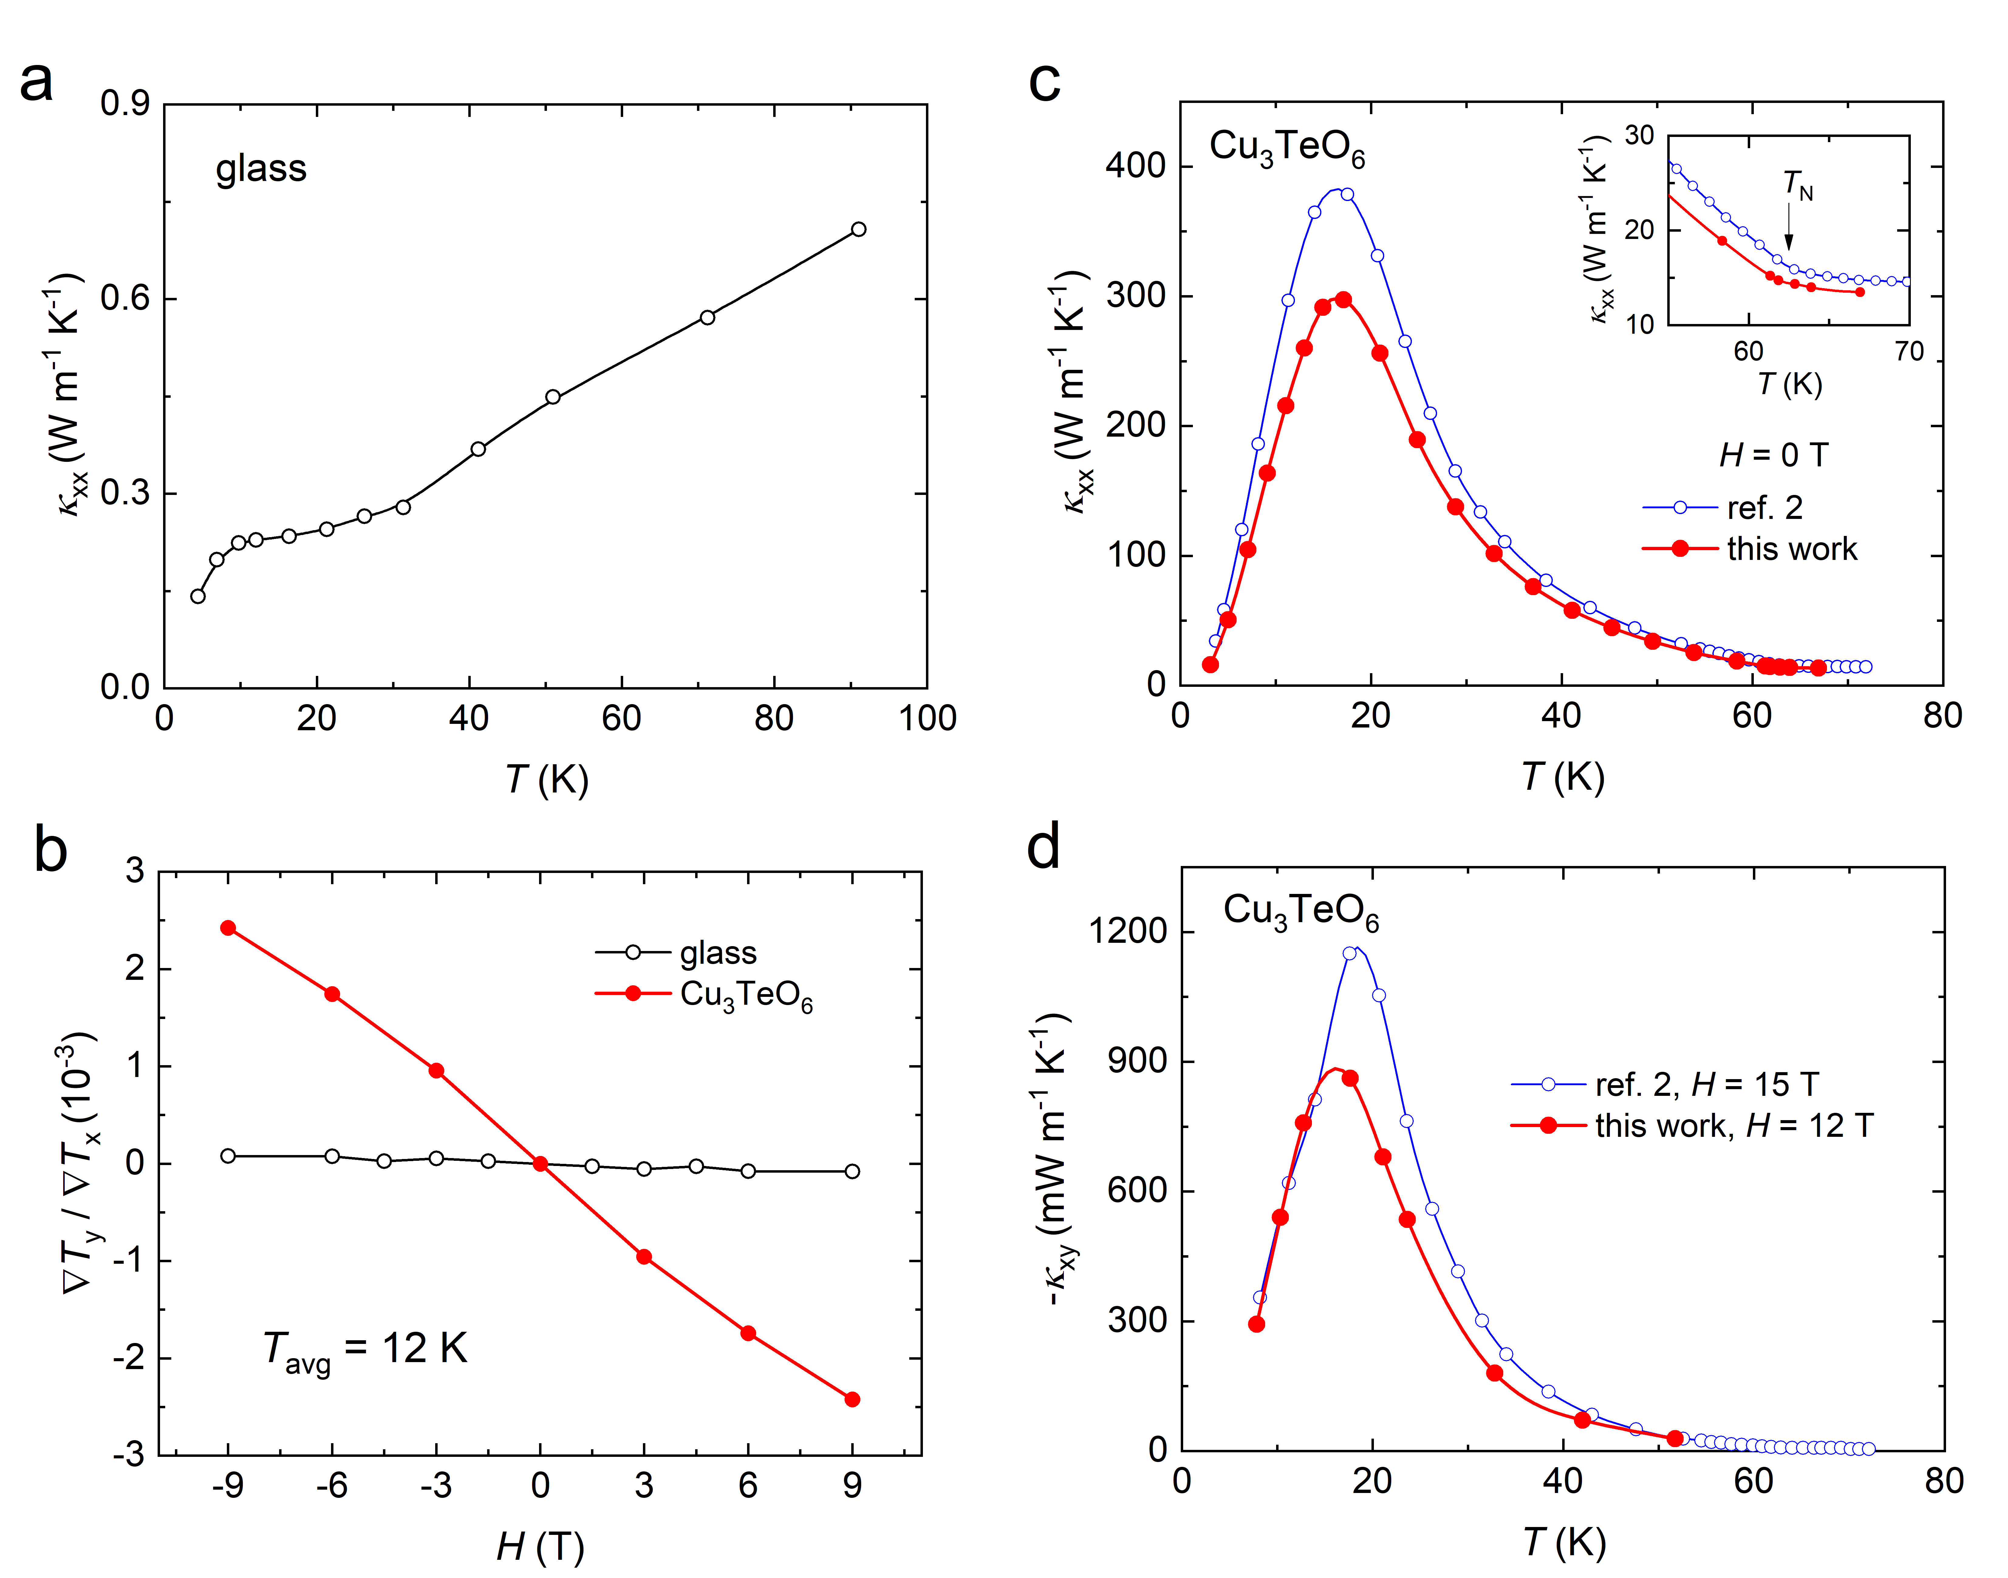
Figure S1 | The thermal Hall signals in glass and Cu₃TeO₆. a, κ_{xx} of glass as a function of temperature in zero field. b, The thermal Hall angles of glass and Cu₃TeO₆ as a function of magnetic field. The average temperature T_{avg} = (T₁ + T₂)/2 was hold at 12 K for both samples. c, κ_{xx} of Cu₃TeO₆ as a function of temperature in zero field. The inset gives the zoom-in κ_{xx}(T) around T_{N}. d, κ_{xy} of Cu₃TeO₆ measured at H = 12 T as a function of temperature. For comparison, the data from ref. 2 were also plotted in c and d as blue empty circles.

Supplementary Note 2: Thermal Hall measurements on VI₃ and CrI₃
If κ_{xy}(T) always follows κ_{xx}(T) in our samples, we still worry about whether it is an artificial result. Therefore, we chose to measure ferromagnetic insulators VI₃ and CrI₃, since the κ_{xy}(T) of VI₃ has special temperature dependence and different sign from that of CrI₃ (refs. 3 and 4). Figure S2a and b show κ_{xx}(T) and κ_{xy}(T) of VI_{3,} respectively. κ_{xx}(T) manifests a kink at T_{c} = 50 K. A large positive κ_{xy}, as reported in ref. 3, arises around T_{c}, then shows a broad peak at low temperature. For CrI₃, as shown in Fig. S2c and d, it has a negative κ_{xy} and it peaks at the same temperature as κ_{xx}(T). Compared with the data extracted from refs. 3 and 4, all the features we observed in VI₃ and CrI₃ are consistent with previous reports^{3,4}, thus further validate the reliability of our thermal Hall measurements.
Starting from a universal phonon THE in crystals, the conclusion of this work, one can see that the magnetic environment below T_{c} = 61 K in CrI₃ only slightly affects the phonon κ_{xy}(T). However, for VI₃, the distinct shape and positive sign of κ_{xy}(T) suggest that the magnetic environment below T_{c} = 50 K has huge effect on the phonon THE. We discuss it in the main text together with other ferromagnetic insulators.

Figure S2 | The thermal Hall effect in VI₃ and CrI₃. a, κ_{xx} of VI₃ as a function of temperature in zero field. b, κ_{xy} of VI₃ measured at H = 0.5 T in the spin polarized state, plotted as κ_{xy} vs T. For comparison, the data from ref. 3 were also plotted in a and b as empty circles. c, κ_{xx} of CrI₃ as a function of temperature in zero field. d, κ_{xy} of CrI₃ measured at H = 1 T in the spin polarized state, plotted as κ_{xy} vs T. For comparison, the data from ref. 4 were also plotted in c and d as blue empty circles.

Supplementary Note 3: Crystal structure of SiO₂
SiO₂ (quartz) has a chiral crystal structure, in which SiO₄ tetrahedra form a chiral helix along [001]. The resulting chiral space group is either P3₂21 (left quartz) or P3₁21 (right quartz). Figure S3 gives the crystal structure of right quartz.

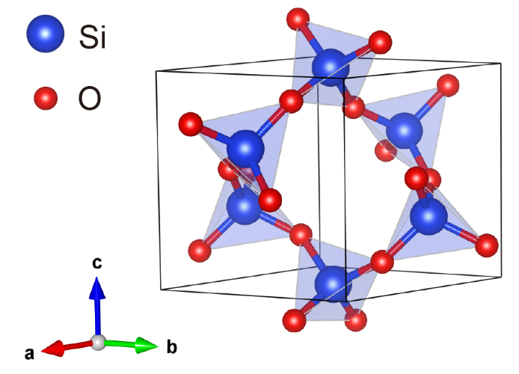
Figure S3 | Crystal structure of SiO₂.

Supplementary Note 4: Check the effect of copper block heat sink
In our thermal transport experiments, a copper block is used as the heat sink. In ref. 5, the authors observed a non-zero Hall signal in non-magnetic Y₂Ti₂O₇ (the data was extracted and plotted in Fig. S4a) and attributed this signal to temperature gradients on the heat sink (brass block). Although it is unlikely to generate a finite transverse temperature gradient that could affect the sample due to the large size of the copper block, we conducted comparative experiment to check it. The measurement on SiO₂ sample was conducted again with a different configuration. The measurement in the main text involved the direct adhesion of the sample to the copper block (Fig. 1a), while the comparative experiment took another configuration where the sample was connected to the copper block via silver wire (Configuration B in Fig. S4b). The results of both measurements are consistent (Fig. S4c and d), confirming that using copper block as the heat sink does not result in any detectable contamination on thermal Hall data. Based on our finding, the non-zero thermal Hall signal observed in ref. 5 should arise from Y₂Ti₂O₇ itself, in which the thermal Hall angle is approximately 0.25 × 10⁻³ at 15 K and 9 T, on the same order of magnitude as that of SrTiO₃. In ref. 5, the thermal Hall angle of magnetic Tb₂Ti₂O₇ is approximately 8 × 10⁻³ at 15 K and 9 T, which is comparable to the value of 5.5 × 10⁻³ for Si at 30 K and 9 T. The finite thermal Hall signal of non-magnetic Y₂Ti₂O₇ observed in ref. 5 further confirms the universal phonon THE in crystals discovered in our current work.

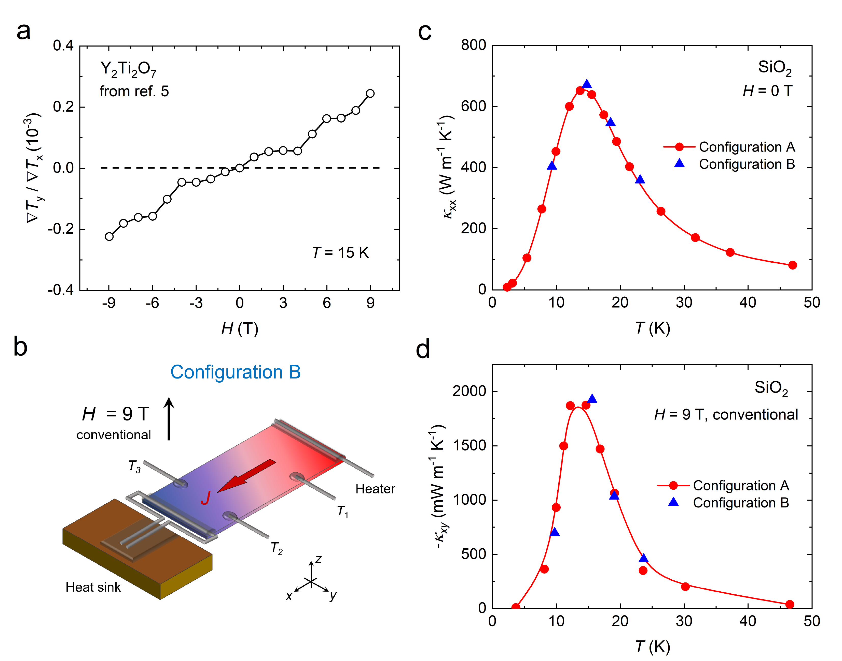
Figure S4 | Check the effect of copper block heat sink. a, The thermal Hall angle of Y₂Ti₂O₇ as a function of magnetic field. The data are from ref. 5. b, A measurement configuration in which the sample is connected to the copper block via silver wire. This is named Configuration B to distinguish it from the configuration in main text (Configuration A). c, d, Comparison of two thermal transport measurements with Configuration A and B on the same SiO₂ sample. The results of both measurements are consistent, confirming that using copper block as the heat sink does not result in any detectable contamination on thermal Hall data.
Supplementary Note 5: Thermal Hall measurements on KTaO₃
Previous work suggests that KTaO₃ (KTO) has a tiny κ_{xy} (ref. 6), which is at odds with the universal phonon THE observed in this study. Therefore, we also conducted thermal Hall measurements on KTO single crystal. As shown in Fig. S5a, the temperature dependence of κ_{xx} for our sample is consistent with that reported in ref. 7, and slightly different from that in ref. 6 at low temperature. Clearly, a finite κ_{xy} is observed, with the peak value about one-third of STO (Fig. S5). This finding further confirms the existence of universal phonon THE in crystals. The difference between our data and the previous work on KTO needs further study.

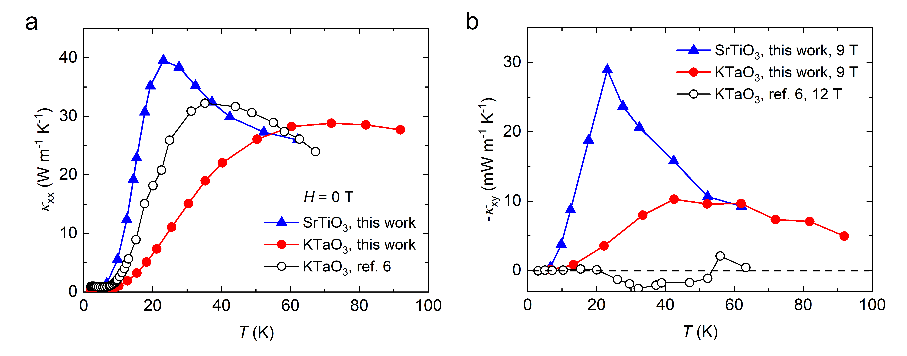
Figure S5 | The thermal Hall effect in KTaO₃ and SrTiO₃. a, κ_{xx} of KTaO₃ and SrTiO₃ measured in this work as a function of temperature in zero field. b, κ_{xy} of KTaO₃ and SrTiO₃ measured at H = 9 T as a function of temperature. The κ_{xx} and κ_{xy} of KTaO₃ from ref. 6 are also plotted for comparison.

Supplementary Note 6: κ_{yy} of SiO₂ single crystals
The thermal Hall conductivity is defined as κ_{xy} = κ_{yy}(ΔT_{y}/ΔT_{x})(L/w), where κ_{yy} is the longitudinal thermal conductivity along the y axis. For crystals with high symmetry (SrTiO₃, KTaO₃, MgO, MgAl₂O₄, Si and Ge), x is along the [100] axis, and [100], [010] and [001] directions are equivalent. Therefore, we take κ_{yy} = κ_{xx} when calculating κ_{xy}. For the samples of SiO₂, x is along the [001] axis and y is along the [110] axis. Due to the chiral crystal structure, κ_{yy} and κ_{xx} in SiO₂ should be unequal. We cut and polished another SiO₂ sample with the longest edges along [110] axis (y) to the same dimensions as the sample in main text. κ_{yy} was measured in this sample with J || [110]. As shown in Fig. S6, κ_{yy} exhibits a slightly larger value than κ_{xx.}

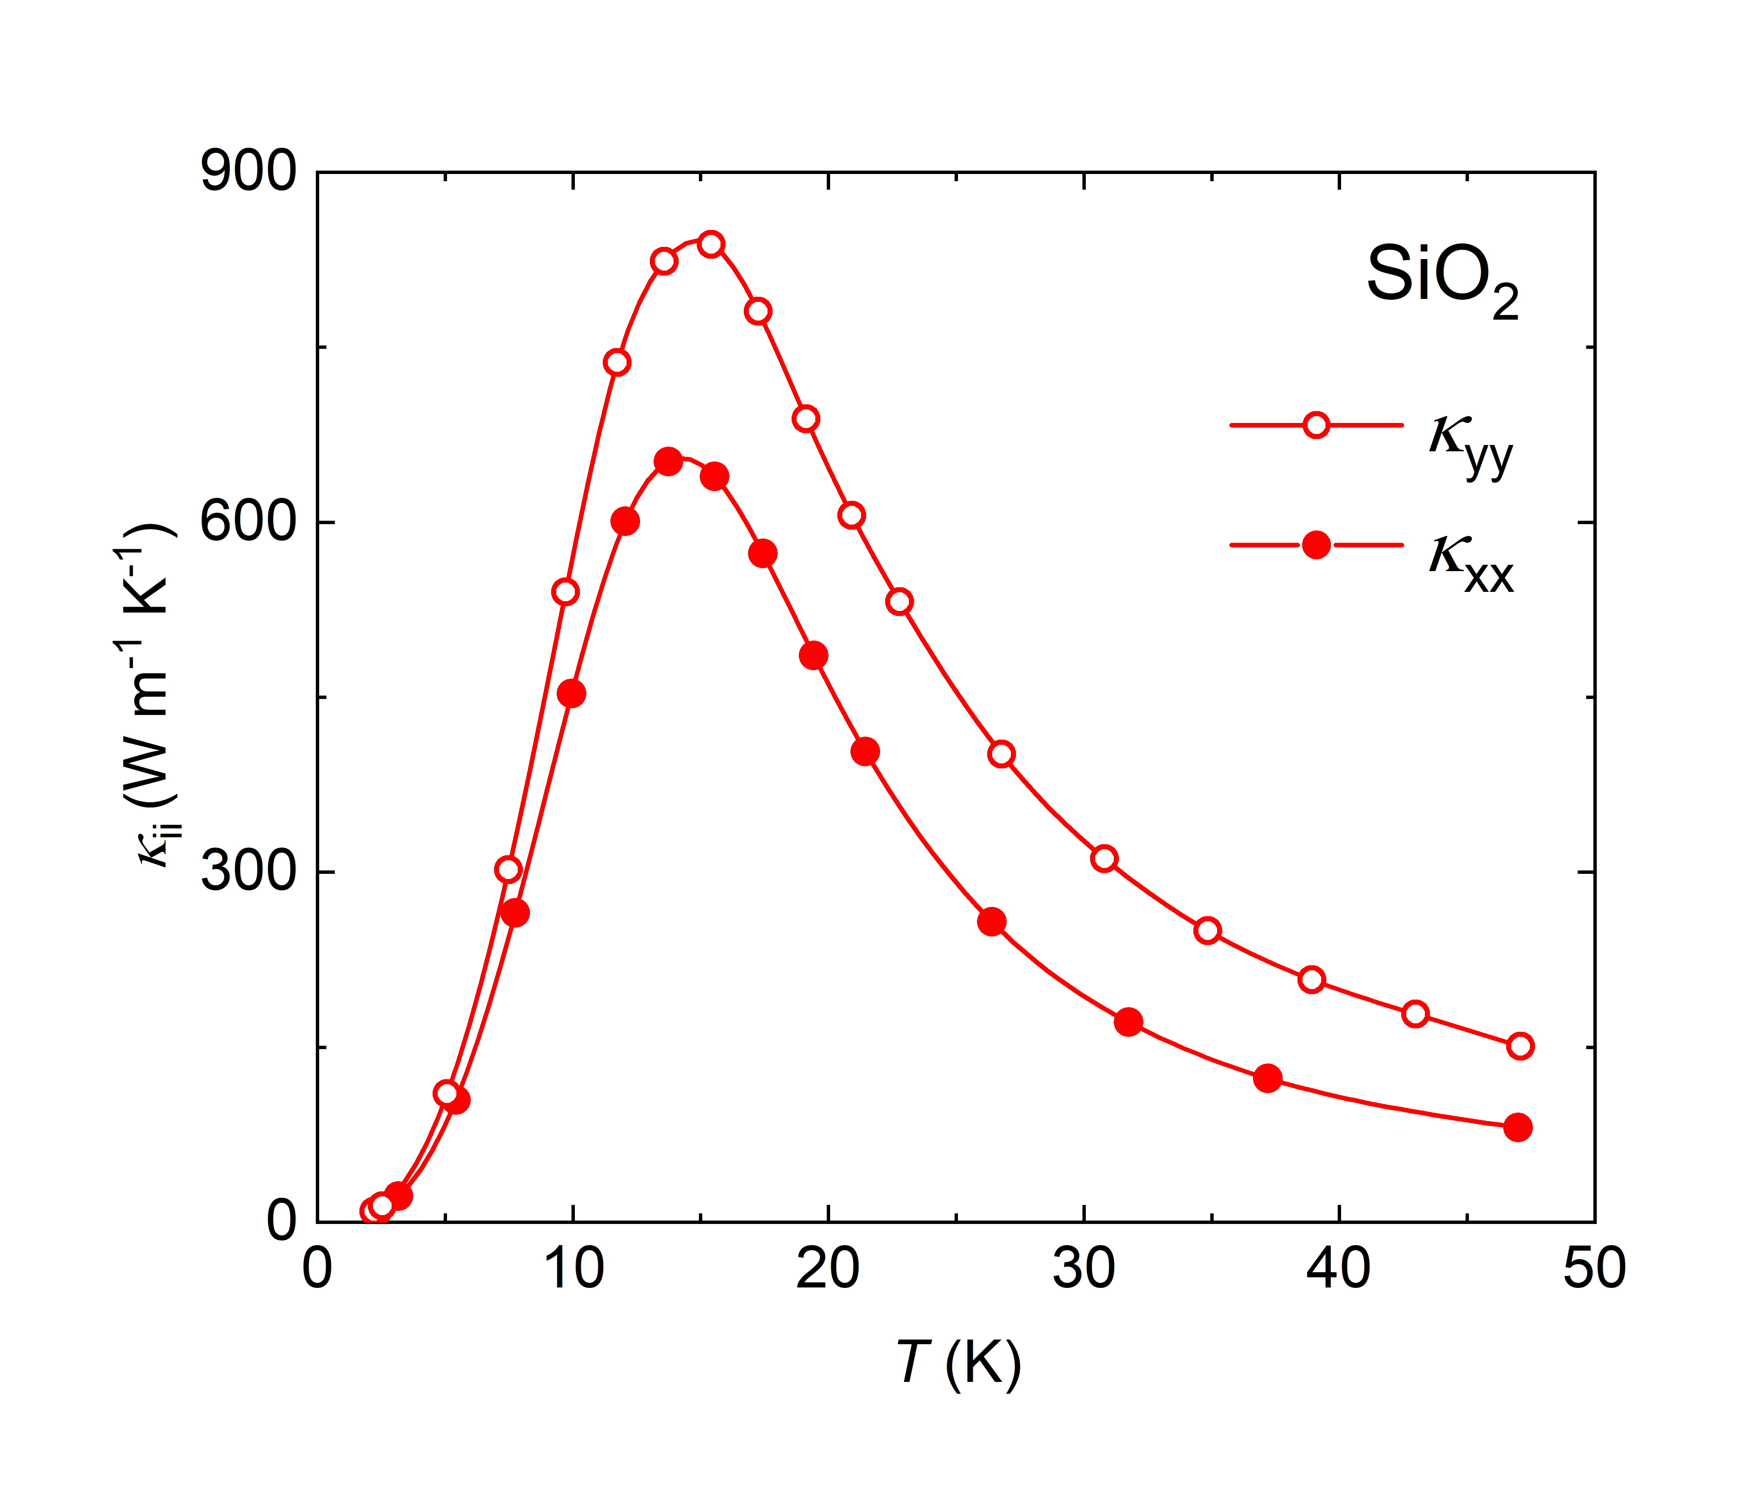
Figure S6 | κ_{xx} and κ_{yy} of SiO₂ single crystals.

Supplementary Note 7: Scaling law in MgAl₂O₄ and black phosphorous
In Fig. S7, we plot the conventional κ_{xy} (κ_{xz} and κ_{zx}) as a function of κ_{xx} for MgAl₂O₄ and black phosphorous (BP). The data of BP were extracted from ref. 8. The thermal transport data of MgAl₂O₄ and BP also obey the scaling law |κ_{xy}| ~ κ_{xx}², as the other non-magnetic insulators and semiconductors studied in this work.

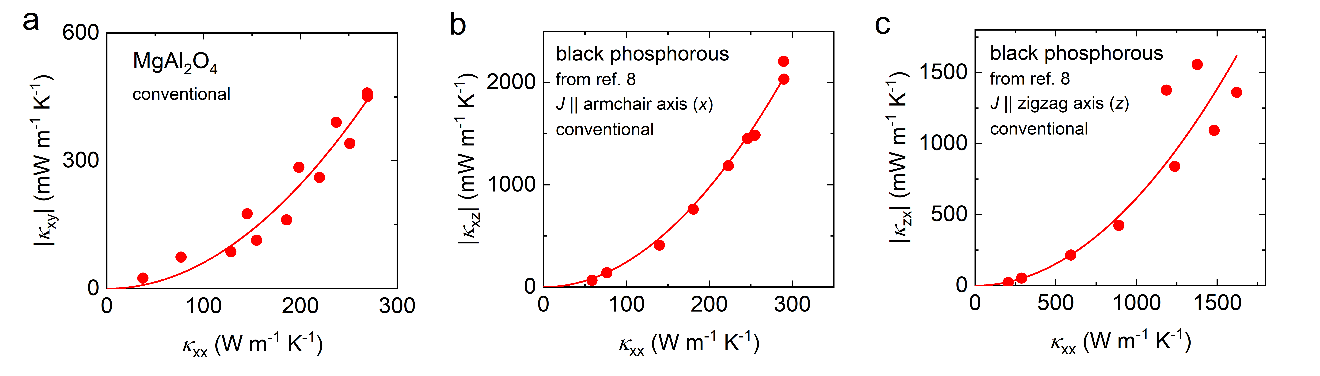
Figure S7 | |κ_{xy}| vs κ_{xx} for MgAl₂O₄ and black phosphorous.
Supplementary Note 8: Scaling law between planar κ_{xy} and κ_{xx} in SiO₂
In Fig. S8, we plot the conventional κ_{xy} and two planar κ_{xy} as a function of κ_{xx} for SiO₂ sample. One can clearly see that the planar κ_{xy} also obeys the scaling law |κ_{xy}| ~ κ_{xx}², as the conventional κ_{xy} does.

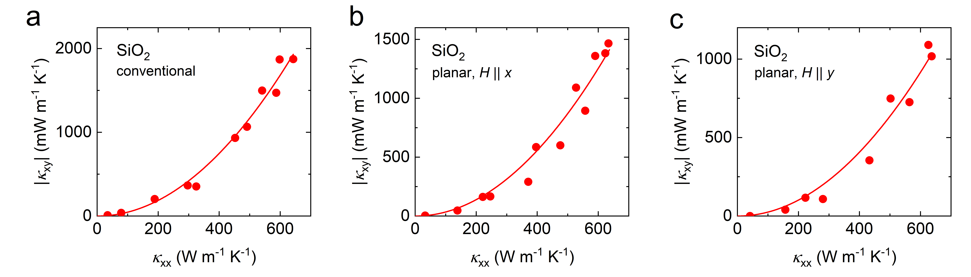
Figure S8 | |κ_{xy}| vs κ_{xx} in different configurations for SiO₂.

Supplementary Note 9: Absence of scaling law between κ_{xy} and κ_{xx} in magnetic materials
In Fig. S9, we plot |κ_{xy}| vs. κ_{xx} for various magnetic insulators in which THE has been observed⁹⁻¹². Unlike most non-magnetic insulators and semiconductors measured in this work, these materials manifest a deviation from the scaling law |κ_{xy}| ~ κ_{xx}², indicating the effect of magnetic environment on the phonon THE.

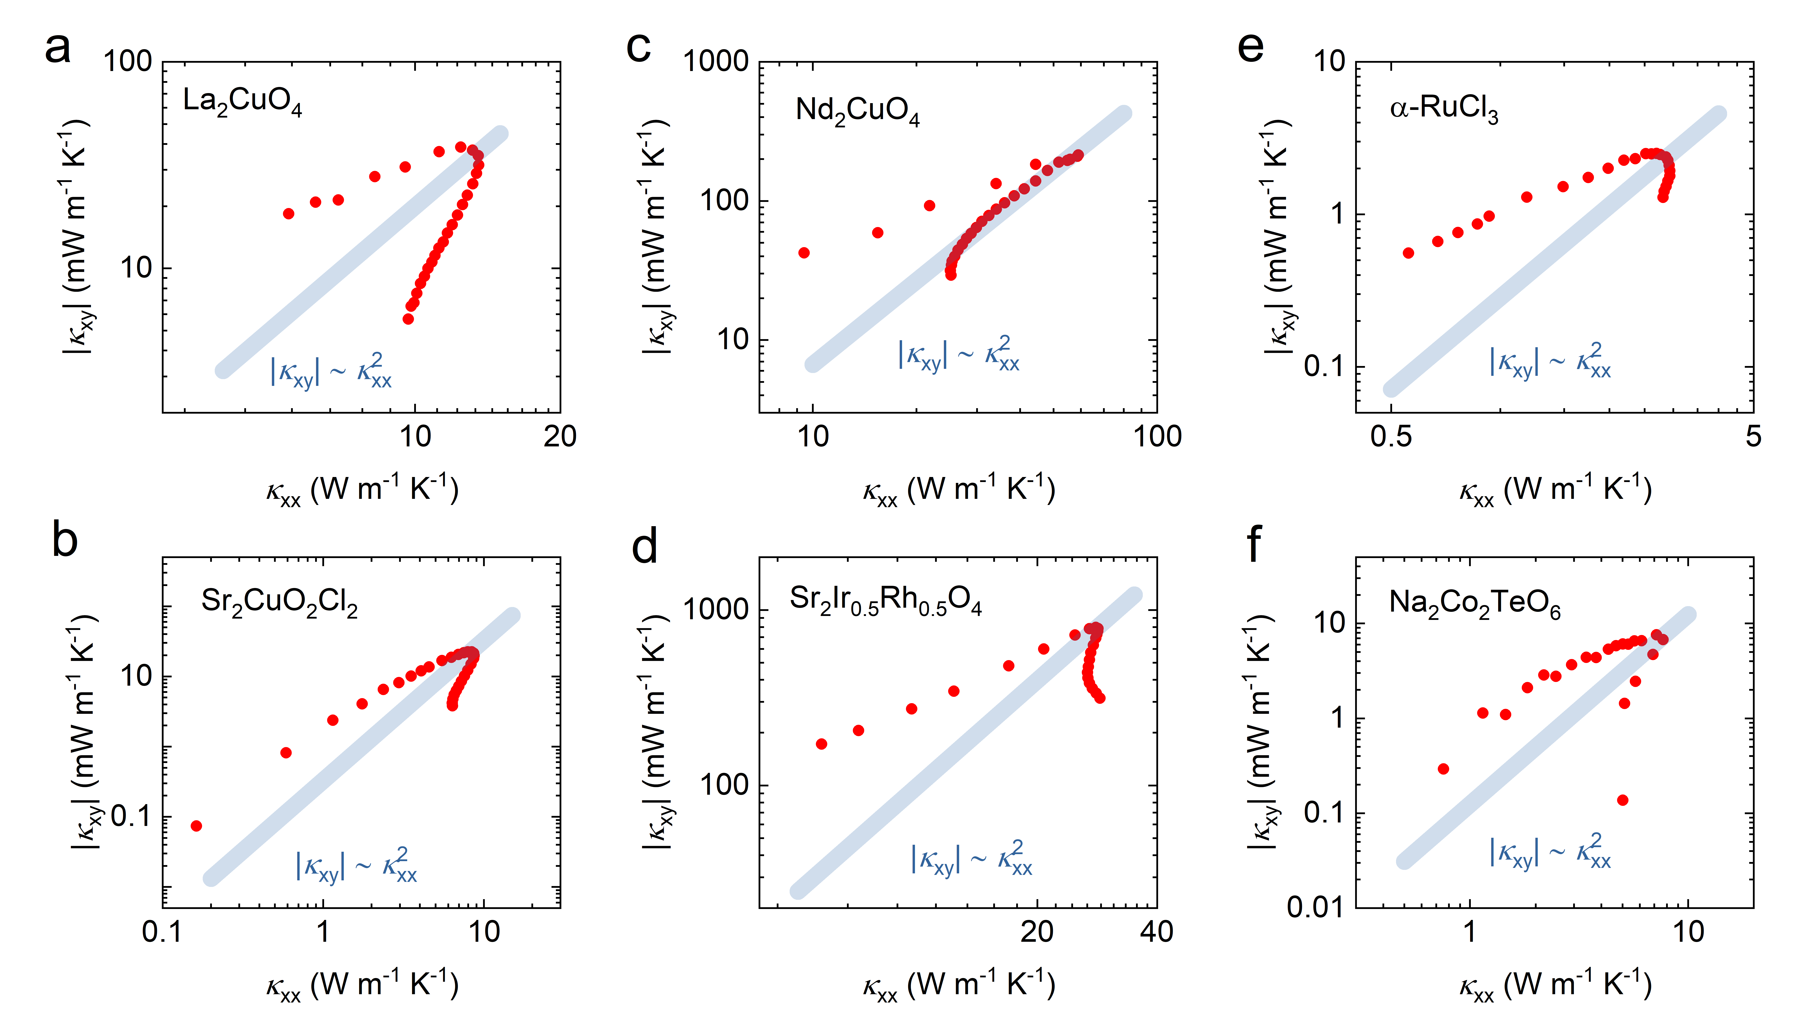
Figure S9 | |κ_{xy}| vs κ_{xx} for various magnetic insulators. |κ_{xy}| plotted as a function of κ_{xx} for La₂CuO₄ (ref. 9), Sr₂CuO₂Cl₂ (ref. 9), Nd₂CuO₄ (ref. 9), Sr₂Ir_{0.5}Rh_{0.5}O₄ (ref. 10), α-RuCl₃ (ref. 11) and Na₂Co₂TeO₆ (ref. 12). The blue lines represent the scaling relation of |κ_{xy}| ~ κ_{xx}².

Supplementary references

- Kim, H.-L. et al. Modular thermal Hall effect measurement setup for fast-turnaround screening of materials over wide temperature range using capacitive thermometry. Rev. Sci. Instrum. 90, 103904 (2019).
- Chen, L., Boulanger, M.-E., Wang, Z.-C., Tafti, F. & Taillefer, L. Large phonon thermal Hall conductivity in the antiferromagnetic insulator Cu₃TeO₆. Proc. Natl. Acad. Sci. U.S.A. 119, e2208016119 (2022).
- Zhang, H. et al. Anomalous thermal Hall effect in an insulating van der Waals magnet. Phys. Rev. Lett. 127, 247202 (2021).
- Xu, C. et al. Thermal Hall effect in the van der Waals ferromagnet CrI₃. Phys. Rev. B 109, 094415 (2024).
- Hirschberger, M., et al. Large thermal Hall conductivity of neutral spin excitations in a frustrated quantum magnet. Science 348, 106-109 (2015)
- Li, X., Fauqué, B., Zhu, Z. & Behnia, K. Phonon thermal Hall effect in strontium titanate. Phys. Rev. Lett. 124, 105901 (2020).
- Tachibana, M., Kolodiazhnyi, T., Takayama-Muromachi, E. Thermal conductivity of perovskite ferroelectrics. Appl. Phys. Lett. 93, 092902 (2008).
- Li, X. et al. The phonon thermal Hall angle in black phosphorus. Nat. Commun. 14, 1027 (2023).
- Boulanger, M.-E. et al. Thermal Hall conductivity in the cuprate Mott insulators Nd₂CuO₄ and Sr₂CuO₂Cl₂. Nat. Commun. 11, 5325 (2020).
- Ataei, A. et al. Phonon chirality from impurity scattering in the antiferromagnetic phase of Sr₂IrO₄. Nat. Phys. (2024).
- Lefrançois, É. et al. Evidence of a phonon Hall effect in the Kitaev spin liquid candidate α-RuCl₃. Phys. Rev. X 12, 021025 (2022).
- Yang, H. et al. Significant thermal Hall effect in the 3d cobalt Kitaev system Na₂Co₂TeO₆. Phys. Rev. B 106, L081116 (2022).

