Supplementary Information

Potential Threats of Nanoplastic Accumulation in Human Induced Pluripotent Stem Cells
Hyejoong Jeong^{1,}‡, Wijin Kim^{2,}‡, Daheui Choi¹, Jiwoong Heo¹, Uiyoung Han¹, Se Yong Jung³, Hee Ho Park⁴, Sung-Tae Hong⁵, Ju Hyun Park^{2,}*, and Jinkee Hong^{1,}*
¹Department of Chemical and Biomolecular Engineering, Yonsei University, Seoul 03722, Republic of Korea
²Department of Biomedical Science, Kangwon National University, Chuncheon, Gangwon-do, 24341, Republic of Korea.
³Department of Pediatrics, Yonsei University College of Medicine, Seoul 03722, Republic of Korea
⁴Department of Biotechnology and Bioengineering, Kangwon National University, Chuncheon, Gangwon-do 24341, Republic of Korea
⁵Department of Tropical Medicine and Parasitology, Seoul National University College of Medicine, Seoul 03080, Republic of Korea
KEYWORDS Microplastic; Nanoplastic; Long-term toxicity; Bioaccumulation; Induced Pluripotent Stem Cell
List of Supporting Information
Figure S1. Morphology and size analysis of PS NPs
Table S1. Characterization of PS NPs
Figure S2. Alkaline phosphates (AP) staining of hiPSC colonies after exposure to PS NPs.
Figure S3. hiPSC colony size analysis after exposure of PS NPs
Figure S4. Correlation between viable cell reduction rate and different dose measurements
Figure S5. Morphology and size analysis of PE MPs and MSN
Table S2. Characterization of PE MPs and MSN
Figure S6. Ultrastructure of hiPSCs: non-treated, exposed to PE MPs and MSN
Figure S7. Confocal images after exposure of PS NPs: bright field and merged images
Figure S8. Confocal microscopy Z-stack images of the hiPSC colony exposed to PS 100
Figure S9. Confocal microscopy Z-stack images of the hiPSC colony exposed to PS 500
Figure S10. Confocal microscopy Z-stack images of the hiPSC colony exposed to PS 1000
Figure S11. Live fluorescence microscope images of hiPSC colonies

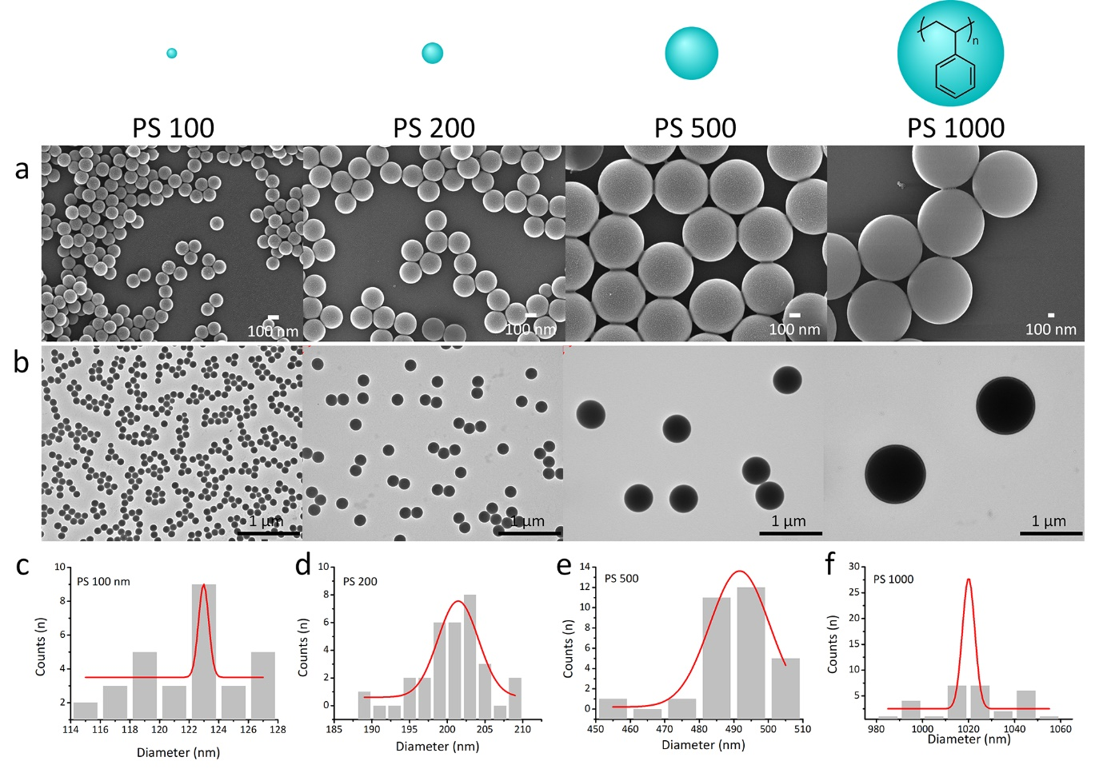
Fig. S1.
Characterization of PS NPs of various sizes (100, 200, 500, 1000 nm). Simple chemical structure of PS and relative size of PS NPs are shown in the figure at the top. Morphology observation of PS NPs using (a) SEM and (b) TEM. Size distribution of PS NPs corresponding to the SEM images; (c) 100 nm, (d) 200 nm, (e) 500 nm, and (f) 1000 nm. PS NPs, polystyrene nanoplastics; SEM, scanning electron microscopy; TEM, transmission electron microscopy.

Table S1. Characterization of PS NPs.
Type | Diameter (nm)ª | Polydispersity (%) | Zeta potential (mV) | D_{H} (nm)^{b}
PS 100 | 123.0 ± 0.4 | 0.3 | -50.9 ± 3.4 | 129.4 ± 2.9
PS 200 | 201.4 ± 2.7 | 1.3 | -26.7 ±1.5 | 223.8 ± 2.7
PS 500 | 491.7 ± 8.7 | 1.8 | -25.7 ± 0.9 | 509.2 ±12.1
PS 1000 | 1020.0 ± 2.7 | 0.3 | -17.2 ± 1.9 | - ± 208.0
- Diameters of PS NPs in dry state obtained from SEM images
- Hydrodynamic diameters obtained by dynamic light scattering (DLS) analysis

Characterization of NPs
Polystyrene (PS) and polyethylene (PE) were selected as nanoplastics (NPs) considering their representativeness according to density and all three particles are referred to as “NPs” for convenience. PS is one of the NPs found in marine pollutants¹. The density of PS is 1.05 g/mL, similar to the density of sea water (1.0236 g/mL, 25 °C, salinity 35 g/kg, 1 atm)². Therefore, PS is likely to be exposed to humans through water intake owing to limitations in water purification. Therefore, intensive studies on the cytotoxicity of various sized PS (100, 200, 500, and 1000 nm) have been performed. PE was selected as it has a low density of 0.95–0.96 g/mL and is one of the most widely used plastics for food wrapping. Mesoporous silica nanoparticles (MSN) with a high density of 2.2 g/mL (50% porosity)³ was selected as comparison, and it is a contaminant leaking from paints, electronic devices, and catalysis processes.
The different sized PS NPs were characterized in Fig S1. Both scanning electron microscopy (SEM) and transmission electron microscopy (TEM) images exhibited completely spherical shape of PS NPs (Fig S1a and S1b, respectively). Narrow size distributions of PS NPs were obtained from SEM images (Fig S1c-f). Homogeneous population of PS NPs was determined as low polydispersity (<5%) in Table S1.^{4, 5} Surface charge of PS NPs was quantified by ξ-potential while dispersed in distilled water. ξ-potential defines particle stability; $\left|30\right|$ mV is an accepted value and optimally above $\left|60\right|$ mV, particles are less likely to be flocculation by electrostatic repulsion between the particles.⁶ The surface charge increased as the particle size decreases, which means that the dispersion stability increases in inverse proportion to the size. Since dynamic light scattering method detects electrical double layer, hydrodynamic diameter (D_{H}) is slightly larger than the diameter at dry state.

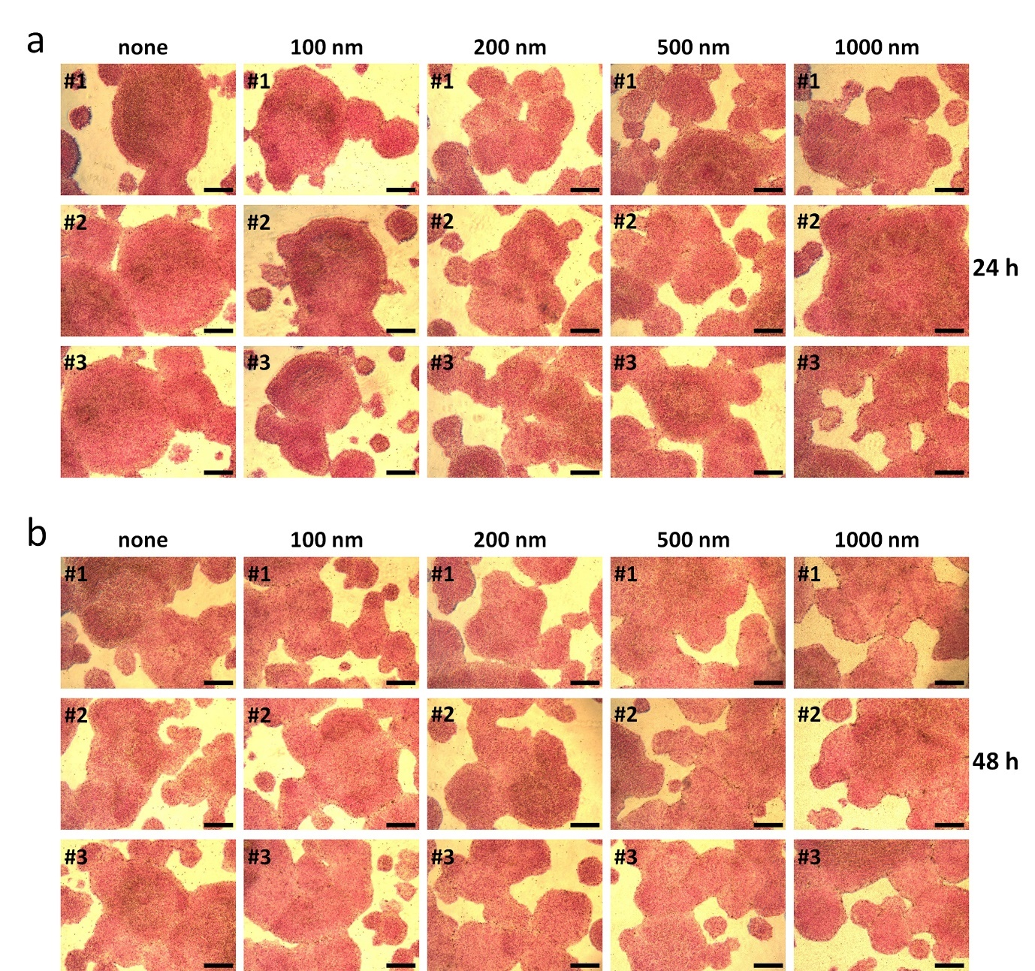
Fig. S2
Alkaline phosphates (AP) staining of hiPSC colonies after exposure to PS NPs. To assess the effect of PS NPs on the expression of marker for undifferentiated state, hiPSCs were analyzed by AP staining after PS NPs of different sizes for (a) 24 h and (b) 48 h, respectively. Three representative images of AP-stained hiPSC colonies per each experimental group are exhibited. Scale bars represent 400 μm.

Fig. S3.
hiPSC colony size analysis after exposure of different sized PS NPs. hiPSC colonies cultured in the feeder-free following 24 and 48 h exposure to 100 μg/mL of different size of PS NPs (100, 200, 500, 1000 nm, the units are omitted). Relative colony area after exposure of PS NPs: (a) 24 h, (b) 48 h (n=2~3). Optical images indicated colonies in black for analysis of area. PS NPs were treated for: (c) 24 h, (d) 48 h. The scale bar is 200 μm. hiPSC, human induced pluripotent stem cell; PS NPs, polystyrene nanoplastics.

Fig. S4.
Correlation between viable cell reduction rate and different dose measurements: (a) surface area per incubation volume, (b) number of NPs per incubation volume. Viable cell reduction rate was recalculated from Figure 1C.

Fig. S5.
Morphology and size analysis of PE MPs (1~10 μm) and MSN (1 μm). Simple figures with chemical structure of PE MPs and MSN are shown at the top. Particle morphologies were analyzed by SEM; (a) PE MPs and (b) MSN. Size distribution of the particles corresponding to the above SEM images are shown; (c) PE MPs and (d) MSN. PE MPs, polyethylene microplastics; MSN, mesoporous silica microparticles; SEM, scanning electron microscopy.

Table S2. Characterization of PE MPs and MSN.
Type | Diameter (μm)ª | Polydispersity (%) | Zeta potential (mV)
PE MPs 1-10 | 3.3 ± 2.5 | 75.5 | -
MSN 1000 | 1.1± 0.03 | 2.8 | -37.2 ± 0.5
- Diameters of particles in dry state obtained from SEM images

In addition, PE MPs and MSN are characterized in Fig S5. PE MPs exhibited complete sphere shapes with smooth surface similar to PS NPs. And heterogeneous population of PE MPs displayed large size distribution from 1 to 10 μm as shown in Fig S5a. Among them, the size of 1 μm accounts for predominant population in size distribution (Fig S5c). MSN exhibited homogenous distribution with averaged 1.1 μm of diameter and porous surface structure was observed in the magnified image (Fig S5b and S5d). The high surface area is a feature of the mesostructured MSN differentiated from PS NPs and PE MPs. In Table S2, monodispersed MSN was determined by 2.8% polydispersity. Negatively charged MSN was dispersed stably in water with -37 mV of ξ-potential. In the case of PE MPs, surface charge was not obtained due to hydrophobic characteristic.

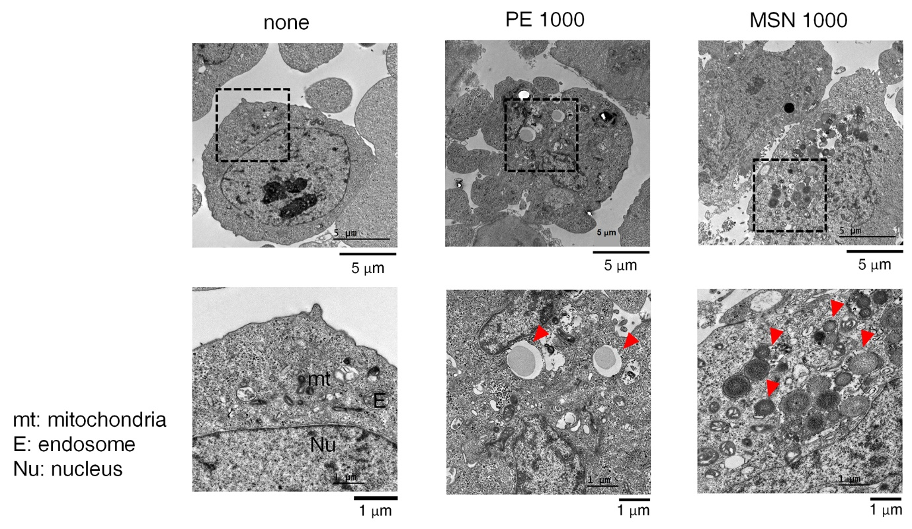
Fig. S6.
Ultrastructure of hiPSCs were observed by TEM; non-treated and after exposure to 100 μg/mL of 1000 nm of PE MPs and MSN (PE 1000 and MSN 1000) for 48 h. TEM analysis of non-treated hiPSCs allows identification of cellular organelles (none). The specific part of the TEM image (dotted square) is enlarged and shown below. The red arrows indicate the cluster of NPs. hiPSC, human induced pluripotent stem cell; TEM, transmission electron microscopy; PE MPs, polyethylene microplastics; MSN, mesoporous silica nanoparticles; NPs, nanoplastics.

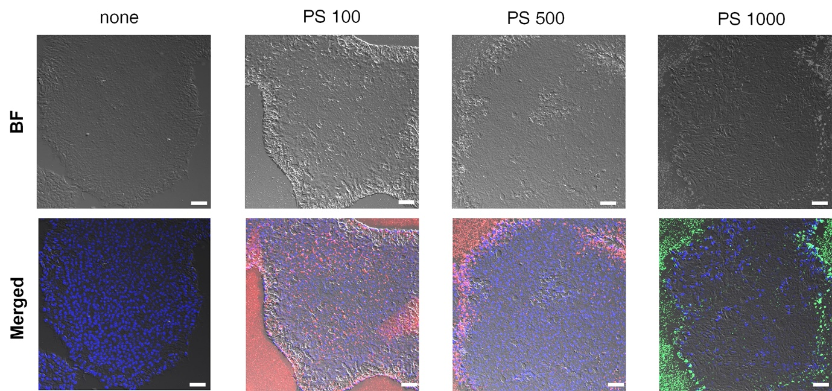
Fig. S7.
hiPSC colonies were exposed to 100 μg/mL of PS NPs (100 nm, 500 nm, 1000 nm) for 24 h and observed by confocal microscopy at the fixed state. BF is bright field image. PS 100 and 500 exhibited red fluorescence and PS 1000 showed green fluorescence. Nuclei were stained with DAPI (blue). Scale bar length is 75 μm. hiPSC, human induced pluripotent stem cell; PS NPs, polystyrene nanoplastics; PS 100, 100 nm of PS NPs; PS 1000, 1000 nm of PS NPs.

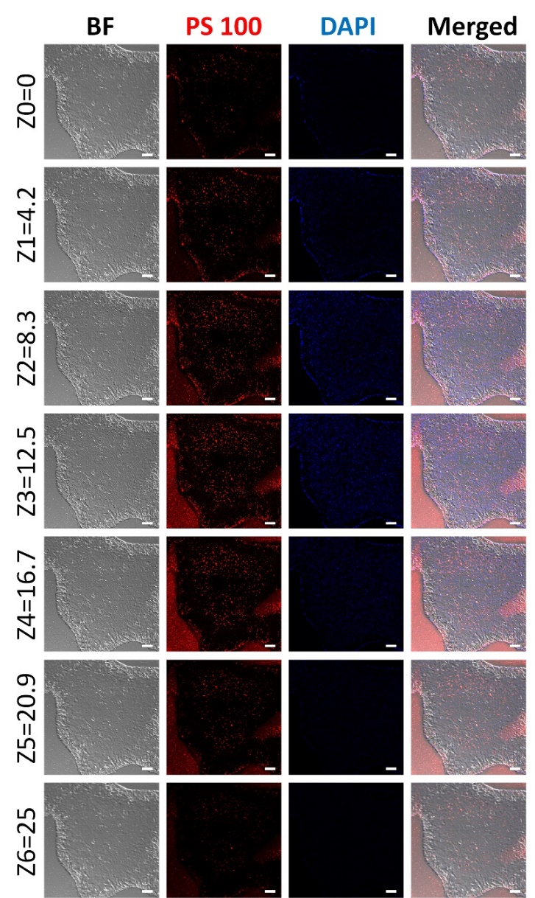
Fig. S8.
Confocal microscopy Z-stack imaging to corroborate PS 100 internalization within a hiPSC colony (exposed to 100 μg/mL of fluorescent PS 100 for 24 h). BF is bright field image. Red fluorescence indicates PS 100 localized within the cytoplasm. DAPI was used to stain nuclei (blue fluorescence). Z-stack images collected at 4.2 μm sections were presented from the top panel of the figure. The cell sections were identified by the section depth on the left in each image (the unit is μm.) Scale bar length is 75 μm. hiPSC, human induced pluripotent stem cell; PS 100; 100 nm of PS NPs.
Fig. S9.
Confocal microscopy Z-stack imaging to corroborate PS 500 internalization within a hiPSC colony (exposed to 100 μg/mL of fluorescent PS 500 for 24 h). BF is bright field image. Red fluorescence indicates PS 500 localized within the cytoplasm. DAPI was used to stain nuclei (blue fluorescence). Z-stack images collected at 4.2 μm sections were presented from the top panel of the figure. The cell sections were identified by the section depth on the left in each image (the unit is μm.) Scale bar length is 75 μm. hiPSC, human induced pluripotent stem cell; PS 500; 500 nm of PS NPs.
Fig. S10.
Confocal microscopy Z-stack imaging to corroborate PS 1000 internalization within a hiPSC colony (exposed to 100 μg/mL of fluorescent PS 1000 for 24 h). BF is bright field image. Green fluorescence indicates PS 1000 localized within the cytoplasm. DAPI was used to stain nuclei (blue fluorescence). Z-stack images collected at 4.2 μm sections were presented from the top panel of the figure. The cell sections were identified by the section depth on the left in each image (the unit is μm.) Scale bar length is 75 μm. hiPSC, human induced pluripotent stem cell; PS 1000; 1000 nm of PS NPs.
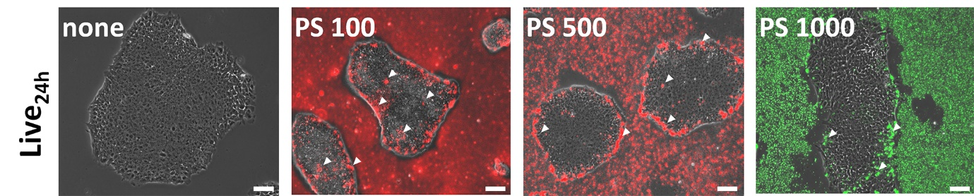
Fig. S11.
Live images of hiPSC colonies non-treated control and PS 100, PS 500, and PS 1000-treated groups (100 μg/mL, 24 h). White arrows indicate PS NPs located in the intracellular region. PS 100 and 500 exhibited red fluorescence and PS 1000 PS showed green fluorescence. All conditions are identical to the fixed confocal process, ruling out only the cell fixation process. Scale bar length is 100 μm. hiPSC, human induced pluripotent stem cell; PS 100, 100 nm of PS NPs; PS 500, 500 nm of PS NPs; PS 1000, 1000 nm of PS NPs; PS NPs, polystyrene nanoplastics.

References
1. Xu, S.; Ma, J.; Ji, R.; Pan, K.; Miao, A.-J., Microplastics in aquatic environments: Occurrence, accumulation, and biological effects. Sci. Total Environ. 2020, 703, 134699.
2. Nayar, K. G.; Sharqawy, M. H.; Banchik, L. D.; Lienhard V, J. H., Thermophysical properties of seawater: A review and new correlations that include pressure dependence. Desalination 2016, 390, 1.
3. Kempen, P. J.; Greasley, S.; Parker, K. A.; Campbell, J. L.; Chang, H.-Y.; Jones, J. R.; Sinclair, R.; Gambhir, S. S.; Jokerst, J. V., Theranostic mesoporous silica nanoparticles biodegrade after pro-survival drug delivery and ultrasound/magnetic resonance imaging of stem cells. Theranostics 2015, 5, 631.
4. Baalousha, M.; Lead, J. R., Nanoparticle dispersity in toxicology. Nat. Nanotechnol. 2013, 8, 308.
5. Park, J.-H.; Jeong, H.; Hong, J.; Chang, M.; Kim, M.; Chuck, R. S.; Lee, J. K.; Park, C.-Y., The effect of silica nanoparticles on human corneal epithelial cells. Sci. Rep. 2016, 6, 37762.
6. Heurtault, B.; Saulnier, P.; Pech, B.; Proust, J.-E.; Benoit, J.-P., Physico-chemical stability of colloidal lipid particles. Biomaterials 2003, 24, 4283.

