Supplementary Information

A Self-Powered, Soft, and Multifunctional Triboelectric-Electrohydrodynamic Pump
Fangming Li¹, Shuowen Sun¹, Xingfu Wan¹, Minzheng Sun¹, Steven L Zhang^{2, 3}*, Minyi Xu^{1, 4}*

¹ State Key Laboratory of Maritime Technology and Safety, Marine Engineering College, Dalian Maritime University, Dalian, 116026, China
² School of Materials Science and Engineering, Georgia Institute of Technology, Atlanta, Georgia, 30332-0245, United States
³ Robotic Materials Department, Max Planck Institute for Intelligent Systems, Stuttgart, 70569, Germany
⁴ Guangzhou Institute of Blue Energy, Knowledge City, Huangpu District, Guangzhou 510555, China

*Address correspondence to szhang@is.mpg.de, xuminyi@dlmu.edu.cn

Supplementary Note 1：Numerical simulation of the TEHD pump.
The working fluid in the TEHD pump is driven by an electric force which is powered by the TENG as the high voltage power source. The TENG converts mechanical energy into high voltage electric energy, with or without PMC enhancement; the high voltage, in turn, applies an electric field on the tip of the emitter electrode, thus charges are injected into the fluid. The charges in the fluid are subject to Coulomb forces under the electric field, and would induce fluid motion due to the draft of charges. Based on the above mechanism, a multiphysics coupled model is constructed. Simulations are conducted using COMSOL, coupling three physics: laminar flow, electric current, and charge transport. Dibutyl sebacate is employed as the working fluid, and a voltage, which is obtained from experimental results in Fig. 3f and Supplementary Fig. 7, as 11 kV without PMC, 16 kV with PMC, and ground is applied onto the electrode. Building upon the foundation of previous research^{1, 2}, a two-dimensional axisymmetric rotational approach is utilized to construct a three-dimensional simulation model for the TEHD pump. The equations that describe the model are given below.
According to electrohydrodynamics theory³, the emulsion satisfies the Navier-Stokes equations:
$ρ\frac{∂u}{∂t}+ρ\left(u⋅∇u\right)=∇⋅\left[-pI+η\left(∇u+{\left(∇u\right)}^{T}\right)\right]+ρg+F$ (1)
$∇⋅u=0$ (2)
where $ρ$ is the fluid density, $p$ is the pressure,$η$ is the fluid viscosity, and $u$ is the fluid velocity. Based on the previous data², $ρ$ and $η$ of the working medium, dibutyl sebacate, are 938 kg/m³ and 0.0075 Pa·s, respectively. The additional term $F$ is the Coulomb force, as described in the manuscript, the equation of the Coulomb force is:
$F=qE$ (3)
where $q$ is the charge density, and $E$ is the electric-field distribution.
From Gauss’ law:
$∇^{2}ϕ=-\frac{q}{ε_{0}ε_{r}}$ (4)
where $ϕ$ is the electric potential, $ε_{0}$ is the permittivity of free space, and $ε_{r}$ is the relative permittivity of the liquid. Based on the previous data¹，$ε_{r}$ here is 4.7.
The electric-field distribution can be calculated as:
$E=-∇ϕ$ (5)
The current density:
$j=qμ_{i}E+qu-D_{i}∇q+σE$ (6)
where $j$ is the current density, $μ_{i}$ is the ion mobility, $D_{i}$ is the charge diffusion coefficient, and $σ$ is the conductivity of the liquid. According to previous research², $μ_{i}$ is 6.93×10⁻⁸ m²/V·s, and $σ$ is 3.4×10⁻¹⁰ S/m.
The charge conservation law:
$∇⋅j=0$ (7)
Charge density injected from the emitter electrode obeys the following function:
$q_{e}=k(E_{static}-E_{thres})$ (8)
where $k$ is the proportional constant for injected charge density, $E_{static}$ is the electric field on the emission electrode surface, and $E_{thres}$ is the threshold value to generate flow motion. Based on the previous data¹, $k$ is 7.1×10⁻⁹ C/V·m², and $E_{thres}$ is 0.24×10⁶ V/m.
The geometric model and boundary conditions for the TEHD pump are given to the surfaces shown in Supplementary Fig.1 as follows:
- $u=U_{in}, v=0, q=0, \frac{∂ϕ}{∂x}=0$ (9)
- $\frac{∂u}{∂x}=0, \frac{∂v}{∂x}=0, \frac{∂q}{∂x}=0, \frac{∂ϕ}{∂x}=0$ (10)
- $u=0, v=0, \frac{∂ϕ}{∂y}=0$ (11)
- $\frac{∂u}{∂y}=0, v=0, \frac{∂q}{∂y}=0, \frac{∂ϕ}{∂y}=0$ (12)
- $u=0, v=0, q=0, ϕ=V$ (13)
- $u=0, v=q_{e}, ϕ=V$ (14)
- $u=0, v=0, ϕ=0$ (15)
where $V$ represents the voltage applied to the emission electrode by the TENG or PMC.
As the working fluid is dibutyl sebacate, in the experiment, the pressure ($P$) of the TEHD pump obtained in the experiment is 1.73 kPa. In the simulation, $P$ can be calculated from the outlet flow velocity of the pump using the following equation:
$P=\frac{1}{2}ρu^{2}$ (16)
The maximum outlet velocity in the simulation is approximately 1.93 m/s. Substituting this value into Eq. (16), the calculated pressure is approximately 1.75 kPa. The simulation accuracy is 99.86%.

Supplementary Note 2：Analysis of the performance of different PMCs
Previously, without a PMC, an alternating voltage (AV) is observed (Fig. 2d); in contrast, with the PMC, a direct voltage is observed (Fig. 3f), which would lead to a higher performance of the pump, as with AV, there would be regions where the voltage applied onto the pump would be too low, as it would not produce enough electric field that is greater than threshold electric field to generate ions. Supplementary Fig. 9 shows a comparison of the stabilized voltage of PMCs and the open circuit voltage of the TENG. The Villard circuit outputs pulsating direct voltage, both peak voltage and average voltage are not the highest. The output voltage of a half-wave voltage tripler is lower than that of a half-wave voltage doubler. This is because the output voltage is determined by the following formula⁴:
$$\begin{aligned}V_{out}=2nV_{OC}-\frac{V_{out}}{fCR}(\frac{2n^{3}}{3}+\frac{n^{2}}{2}-\frac{n}{6})\#\text{(17)}\end{aligned}$$where $V_{out}$ is the stabilized average output voltage of the circuit, $n$ represents the theoretical voltage multiplication factor of the circuit, $f$ is output frequency of the FR-TENG, $C$is the capacitance of the capacitor in the circuit, and $R$ is the equivalent resistance of the load. The 2nd term in the Eq. (17) is much higher for the half-wave voltage tripler compared to the half-wave voltage doubler, resulting in more losses. The full-wave voltage doubler achieves the highest $V_{out}$, but have more fluctuations than the half-wave voltage doubler. This occurs due to two series connected capacitors in the full-wave voltage doubler, which would cause the net capacitance to be lower; thus, filtering frequency of the circuit is higher. To test the effect, we changed the rotational speed, as shown in Supplementary Fig. 10. The full-wave voltage doubler performs better at lower speeds compared to the half-wave voltage doubler, making it a more suitable choice.

Supplementary Note 3：Calculation method and process of equivalent circuits for the TEHD pump.
Here, we assume the output waveform of the TENG is a sinusoidal wave, and considering the effects caused by air breakdown between the TENG electrodes (Supplementary Fig. S4).
- Calculation of the internal equivalent capacitance for the FR-TENG
The equivalent circuit of the FR-TENG consists of an ideal voltage source in series with an internal capacitor of TENG. The voltage of the ideal voltage source is equal to the open-circuit voltage ($V_{OC}$). Therefore:
$I_{SC}=\frac{U}{X_{C}}=\frac{V_{OC}}{X_{C}}$ (18)
where $I_{SC}$ is the short-circuit current from the FR-TENG, $U$ is the voltage of the ideal voltage source, and $X_{C}$ is the capacitive impedance of the internal capacitor of the TENG in the equivalent circuit. The formula for capacitive impedance is given by:
$X_{C}=\frac{1}{2πfC}$ (19)
where, $C$ is the capacitance of the FR-TENG, $f$ is the frequency of the ideal voltage source. As shown in Fig. 2d, no air breakdown occurs between the two electrodes of the FR-TENG at 100 rpm. At this point, $I_{SC}≈50 μA$, $V_{OC}≈8 kV$, and $f=10 Hz$. Substituting these values into equation (18), we get:
$X_{C}=\frac{V_{OC}}{I_{SC}}=60 MΩ$ (20)
Combining equations (19) and (20), we obtain:
$\frac{1}{2πfC}=60 MΩ$ (21)
By calculating equation (21), we get $C≈100 pF$.
When the rotation speed is 200 rpm, the two electrodes of the FR-TENG do not experience air breakdown. At this point, $I_{SC}≈100 μA$, $V_{OC}≈12 kV$, and $f=20 Hz$. Substituting these values into equation (18), we get:
$X_{C}=\frac{V_{OC}}{I_{SC}}=120 MΩ$ (22)
Combining equations (19) and (22), we obtain:
$\frac{1}{2πfC}=120 MΩ$ (23)
By calculating equation (23), we get $C≈66 pF$。
When the rotation speed reaches 300 rpm and 400 rpm, air breakdown occurs, making it impractical for $U$ to be equivalent to $V_{OC}$. However, as indicated by the power curve in Fig. 2e, the external load reaches its maximum power point at 60 MΩ. The external impedance should be equal to the internal impedance at this point. Therefore, it can be inferred that $X_{C}=60 MΩ$. Combining with Equation (19), we have:
$\frac{1}{2πfC}=60 MΩ$ (24)
At this point, with a rotation speed of 400 rpm, $f=40 Hz$. By calculating Equation (24), we obtain $C≈66 pF$.
Since the equivalent capacitance is the same at 200 rpm and 400 rpm, we can infer that the triboelectric effect saturates. It can be deduced that at 300 rpm, $C≈66 pF$. When the rotation speed is 100 rpm, the triboelectric effect has not yet reached saturation, thus $C$ is larger.
- Calculation of the equivalent circuit for the TEHD pump
According to the physical characteristics of the EHD pump and the results in the manuscript, the equivalent circuit appears to be a parallel combination of a capacitor and a resistor. Therefore, the voltage across the capacitor and resistor in the equivalent circuit is assumed to be $u\left(t\right)$. Let the total current in the circuit be $i(t)$, the current through the resistor be $i_{1}(t)$, and the current through the capacitor be $i_{2}(t)$, we have:
$i\left(t\right)=i_{1}\left(t\right)+i_{2}(t)$ (25)
Assume the equivalent resistance of the EHD pump is $R$ and the capacitive impedance is $X_{C, EHD}$. When the FR-TENG is directly connected to the EHD pump, both the voltage and current signals are AC. In this case, we have:
$i_{1}\left(t\right)=\frac{u\left(t\right)}{R}$ (26)
$i_{2}\left(t\right)=\frac{u\left(t\right)}{X_{C, EHD}}$ (27)
When the EHD pump is powered by PMC, the voltage and current signals are pulsating DC. In this case, $i_{1}\left(t\right)$ remains consistent with Formula (26). Since the current through the capacitor due to AC is given by:
$i=\frac{dq}{dt}=C\frac{du}{dt}$ (28)
Let $u_{average}$ be the average value of $u\left(t\right)$. Combining formulas (27) and (28), we can obtain:
$i_{2}\left(t\right)=\frac{u\left(t\right)-u_{average}}{X_{C, EHD}}$ (29)
From Fig. 3f-g and Supplementary Fig. 7, we can obtain $u\left(t\right)$ and $i\left(t\right)$. For simplicity, when directly connected, we can use $u_{peak, direct}$ to replace $u\left(t\right)$ and use $i_{peak}$ to replace $i\left(t\right)$. When connected to PMC, $u_{average}$ and $i_{average}$ are used to replace $u\left(t\right)$ and $i\left(t\right)$. Combining formulas (25), (26), (27), and (29), we get
$i_{peak}=u_{peak, direct}(\frac{1}{R}+\frac{1}{X_{C, EHD}}$) (30)
$i_{average}=\frac{u_{average}}{R}+\frac{(u_{peak,PMC}-u_{average})}{X_{C, EHD}}$ (31)
where $u_{peak,PMC}$ represents the peak voltage when the EHD pump is connected to the PMC.
When the rotation speed is 400 rpm, in the direct connection case, $i_{peak}=90 μA$, $u_{peak, direct}=11 kV$. When connected to the PMC, $i_{average}=21 μA$, $u_{peak,PMC}=18 kV$, $u_{average}=16 kV$. Substituting these values into equations (30) and (31), we have the following equations:
$90×{10}^{-6}=11000×(\frac{1}{R}+\frac{1}{X_{C, EHD}})$ (32)
$21×{10}^{-6}=\frac{16000}{R}+\frac{(18000-16000)}{X_{C, EHD}}$ (33)
Solving equations (32) and (33) gives：
$R=\frac{154}{51}×{10}^{9} Ω≈3 GΩ$ (34)
$X_{C, EHD}=\frac{154}{1209}×{10}^{9} Ω≈0.127 GΩ$ (35)
Please note that for the EHD pump, there is a higher real value of impedance compared to imaginary term, making the pump a more capacitive based device. Let the equivalent capacitance of the EHD pump is $C_{EHD}$, substituting $X_{C, EHD}$ into equation (19), we have:
$C_{EHD}=\frac{1209}{12320π}{×10}^{-9} F≈31 pF$ (36)
In summary, in the equivalent circuit of the EHD pump, the resistance is approximately 3 GΩ, and the capacitance is approximately 31 pF.

Supplementary References
1. Yanada, H., Yamada, T., Asai, Y. et al. Measurement and Numerical Simulation of Ion Drag Pump Characteristics. Journal of Fluid Science and Technology 5, 617-631 (2010).
2. Tang, W., Zhang, C., Zhong, Y. et al. Customizing a self-healing soft pump for robot. Nature Communications 12, 2247 (2021).
3. Lastow, O. & Balachandran, W. Numerical simulation of electrohydrodynamic (EHD) atomization. Journal of Electrostatics 64, 850-859 (2006).
4. Park, S.H., Katzir, L. & Shmilovitz, D. in 2015 17th European Conference on Power Electronics and Applications (EPE'15 ECCE-Europe) 1-7 (2015).

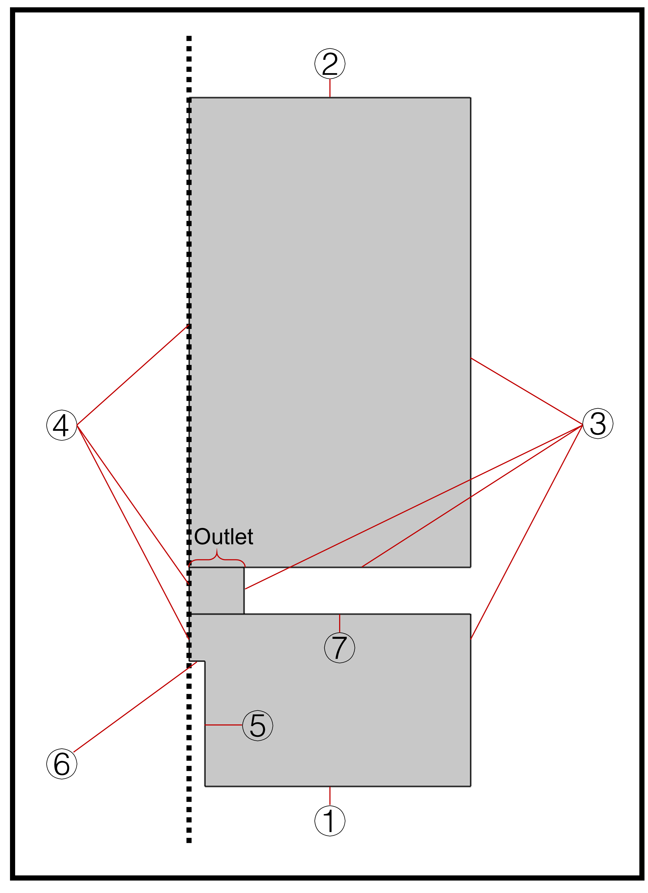
Supplementary Fig. 1 Boundary conditions for numerical simulation.

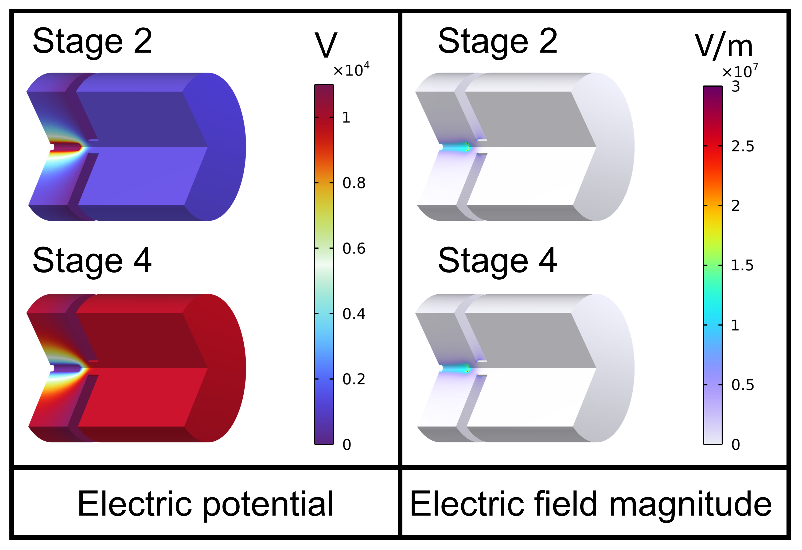
Supplementary Fig. 2 The electric potential and electric field distribution in the second and fourth stages.
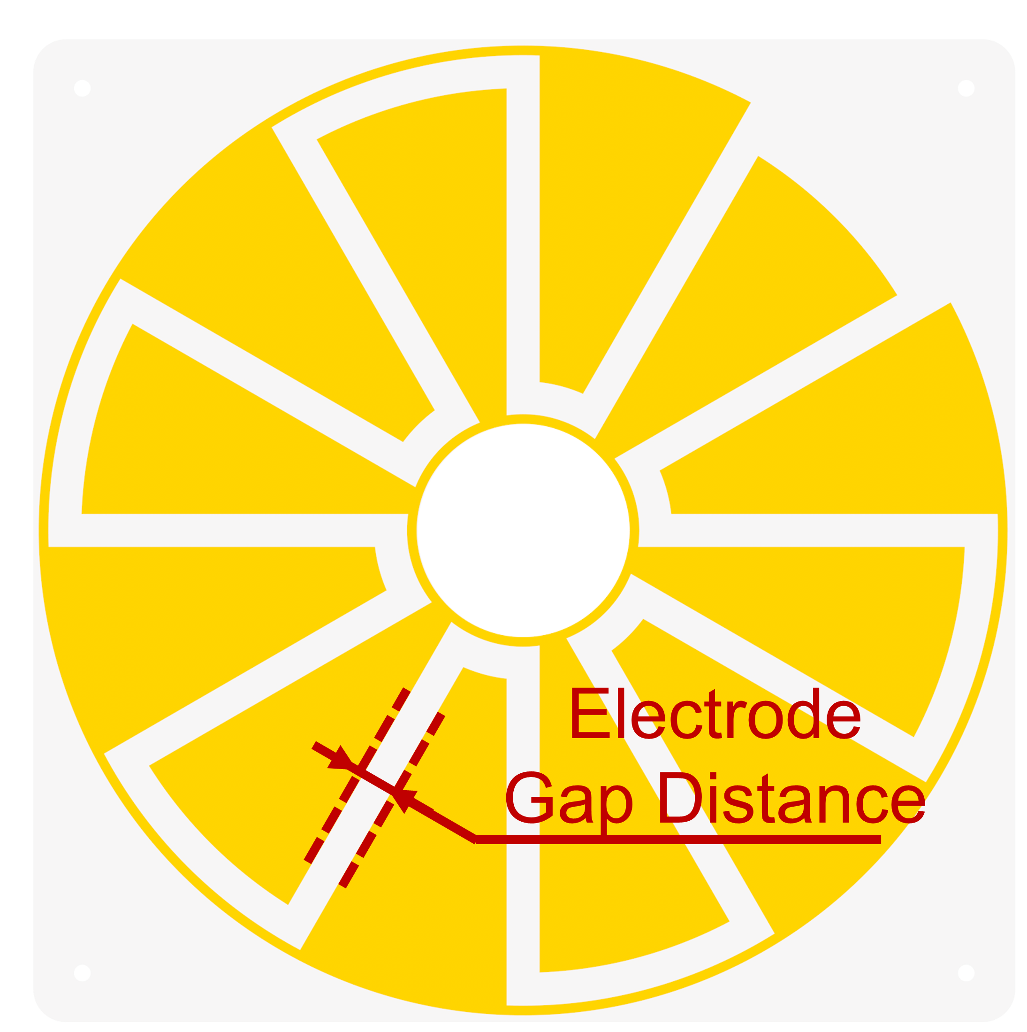
Supplementary Fig. 3 Schematic diagram of the FR-TENG electrode gap distance.

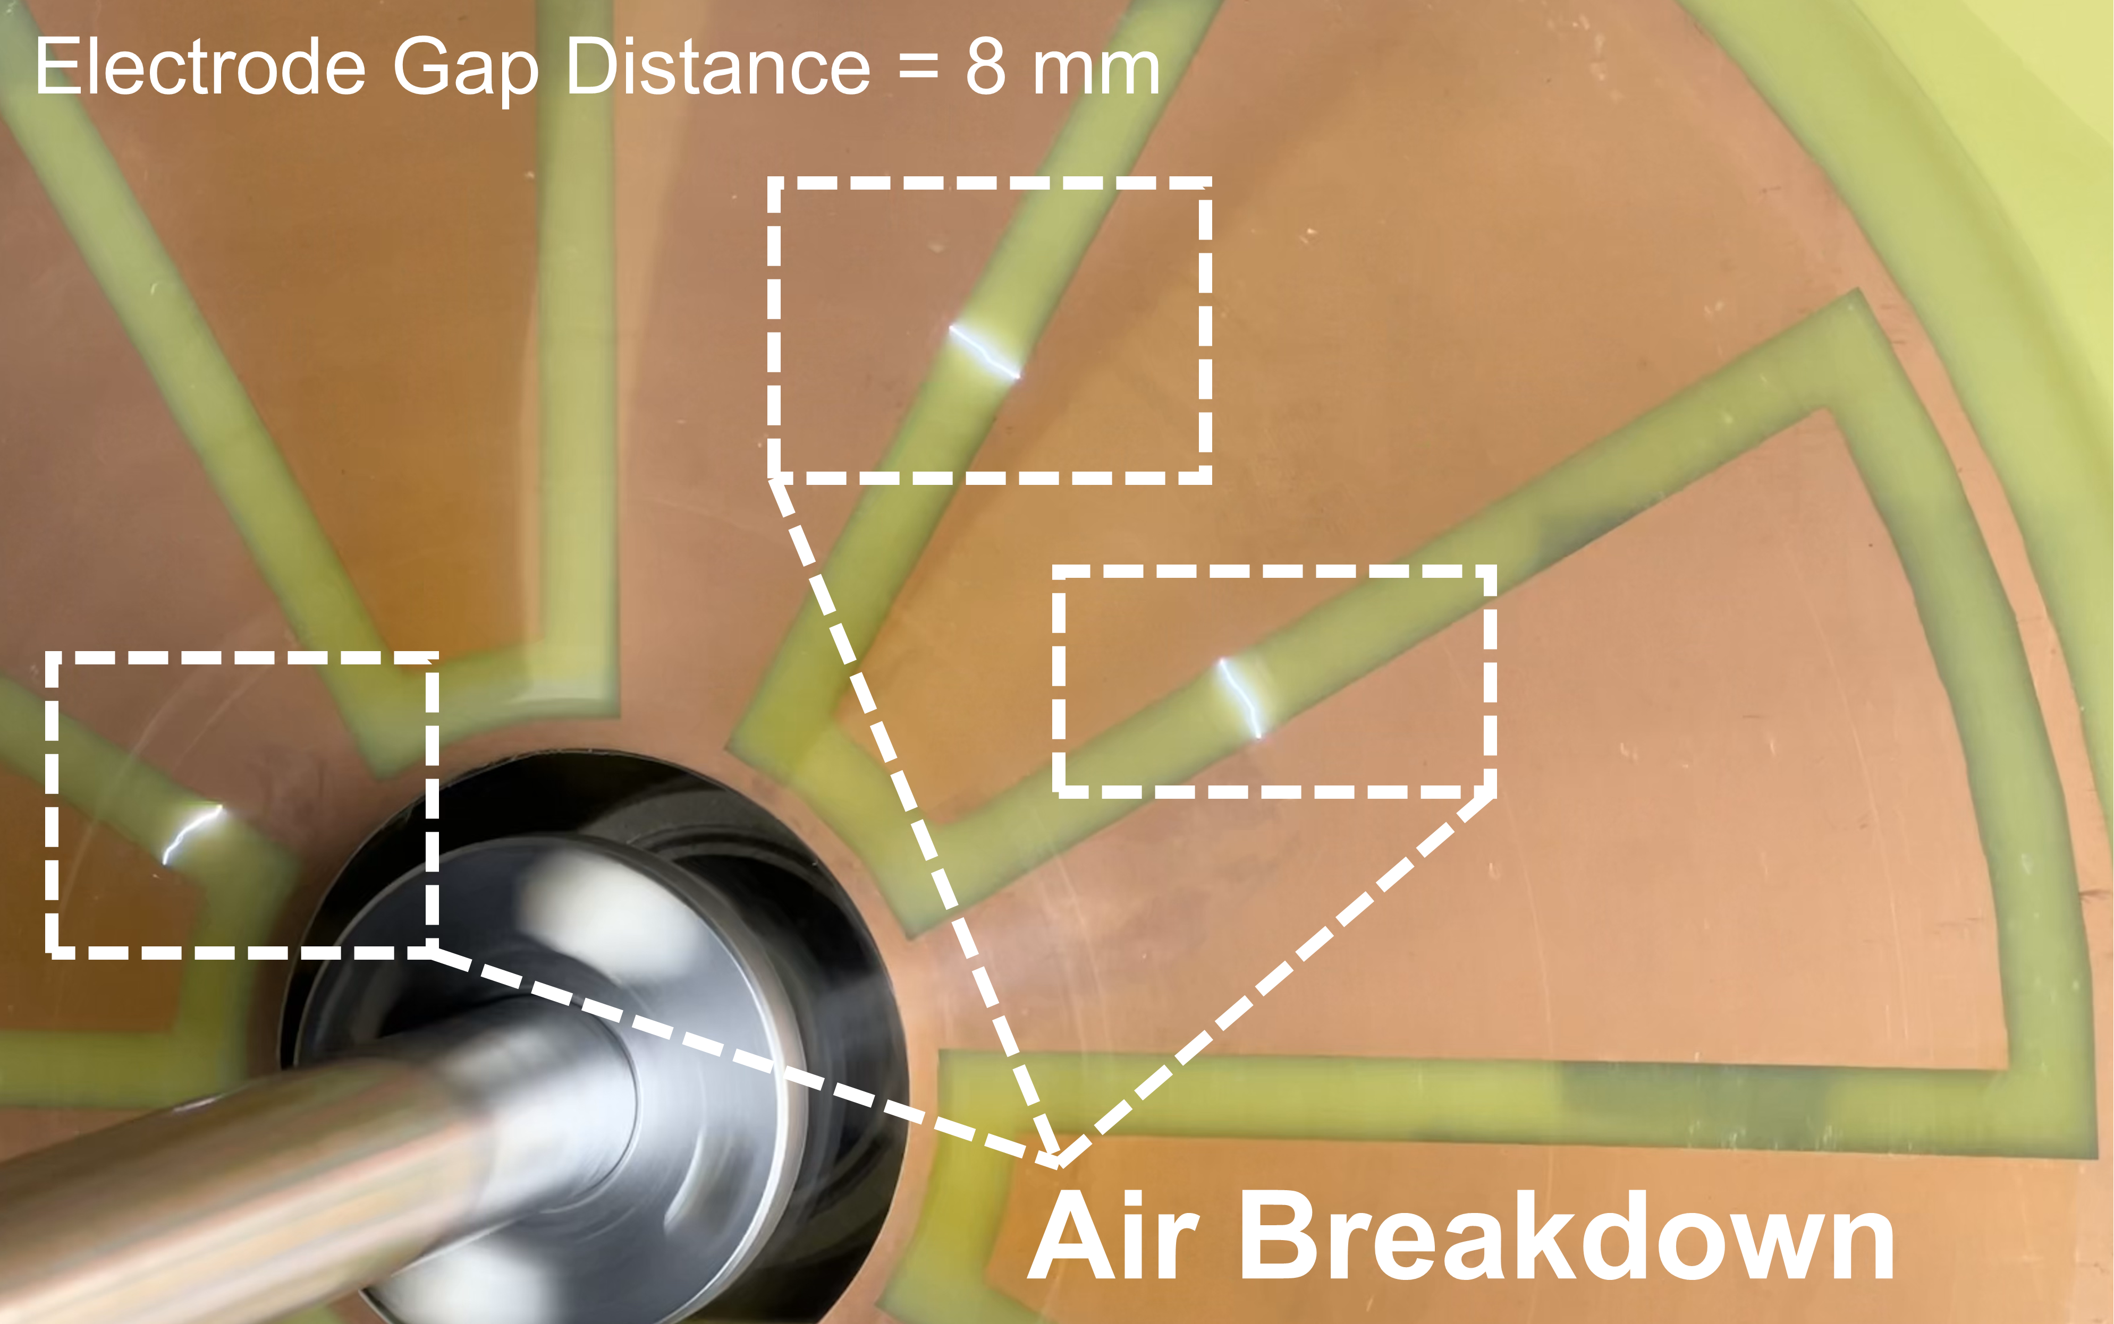
Supplementary Fig. 4 Air breakdown between electrode gaps of the FR-TENG.

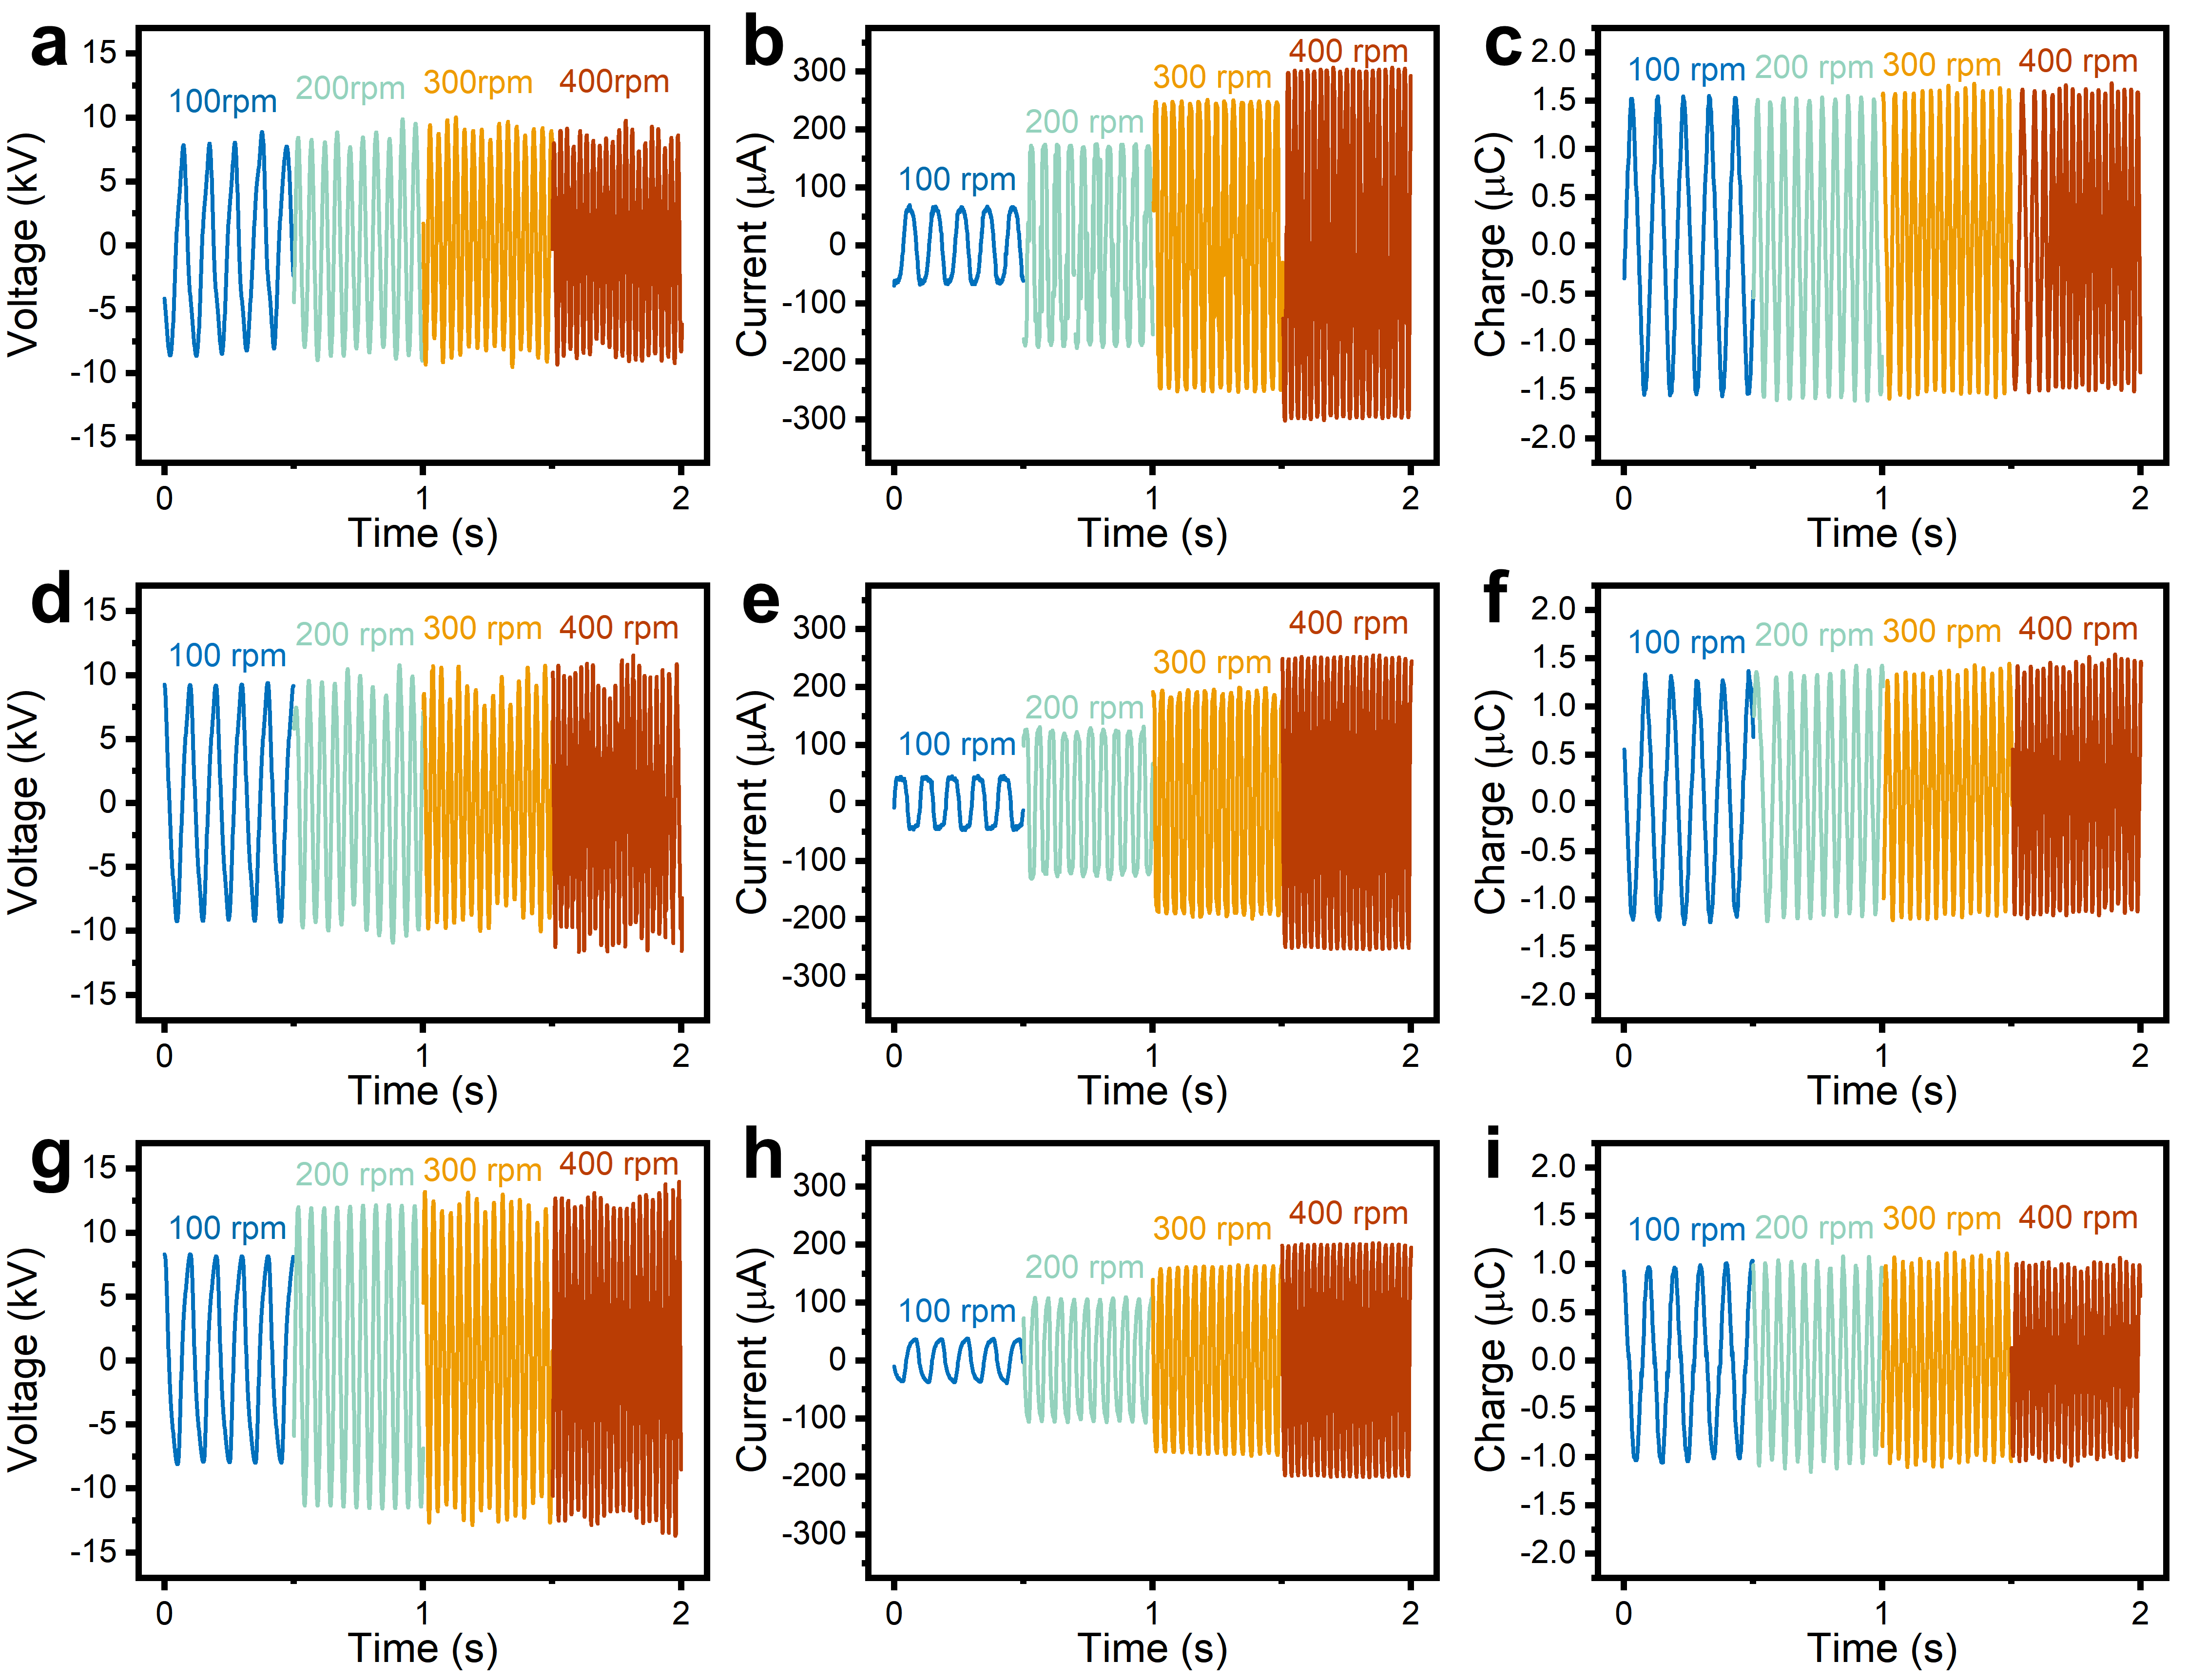
Supplementary Fig. 5 Output performance of FR-TENGs with different electrode gap distances.
a The open-circuit voltage, b short-circuit current and c transferred charge of the FR-TENG with 8 mm electrode gap distance. d The open-circuit voltage, e short-circuit current and f transferred charge of the FR-TENG with 10 mm electrode gap distance. g The open-circuit voltage, h short-circuit current and i transferred charge of the FR-TENG with 12 mm electrode gap distance.

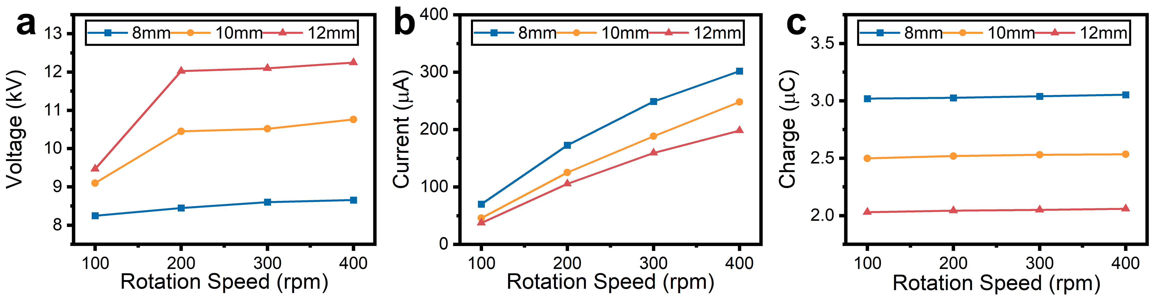
Supplementary Fig. 6 Comparison of FR-TENGs with different electrode gap distances.
a The open-circuit voltage, b short-circuit current and c transferred charge.

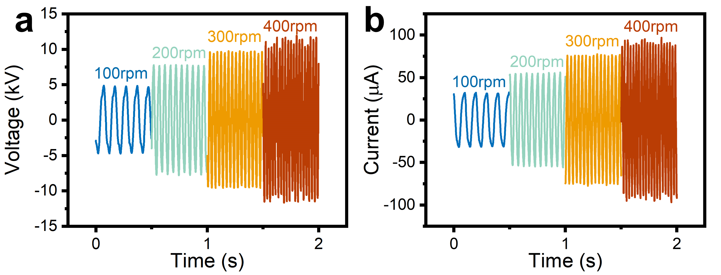
Supplementary Fig. 7 Electrical properties of the TEHD pump at different speeds.
a Voltage and b current on the TEHD pump.

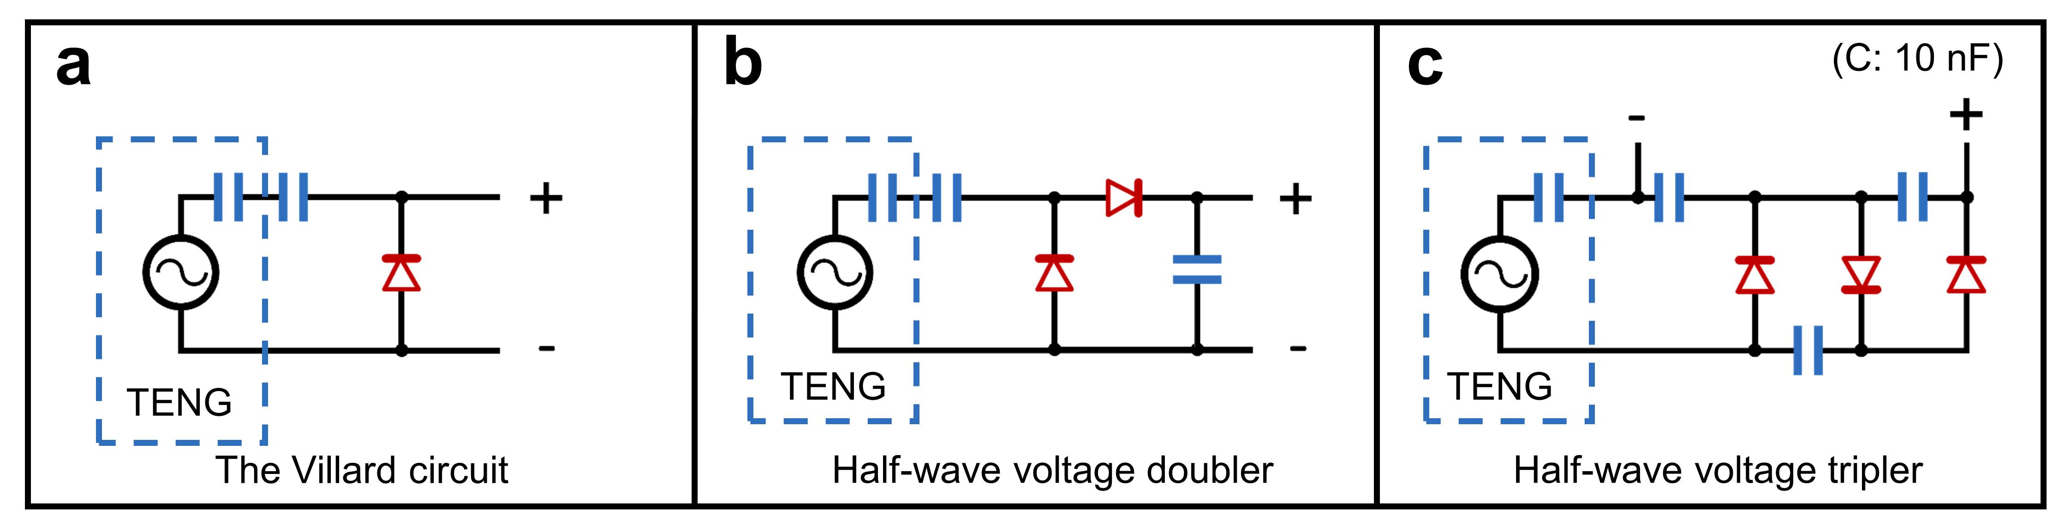
Supplementary Fig. 8 Equivalent circuit diagram of three PMCs.
a The Villard circuit. b Half-wave voltage doubler. c Half-wave voltage tripler.

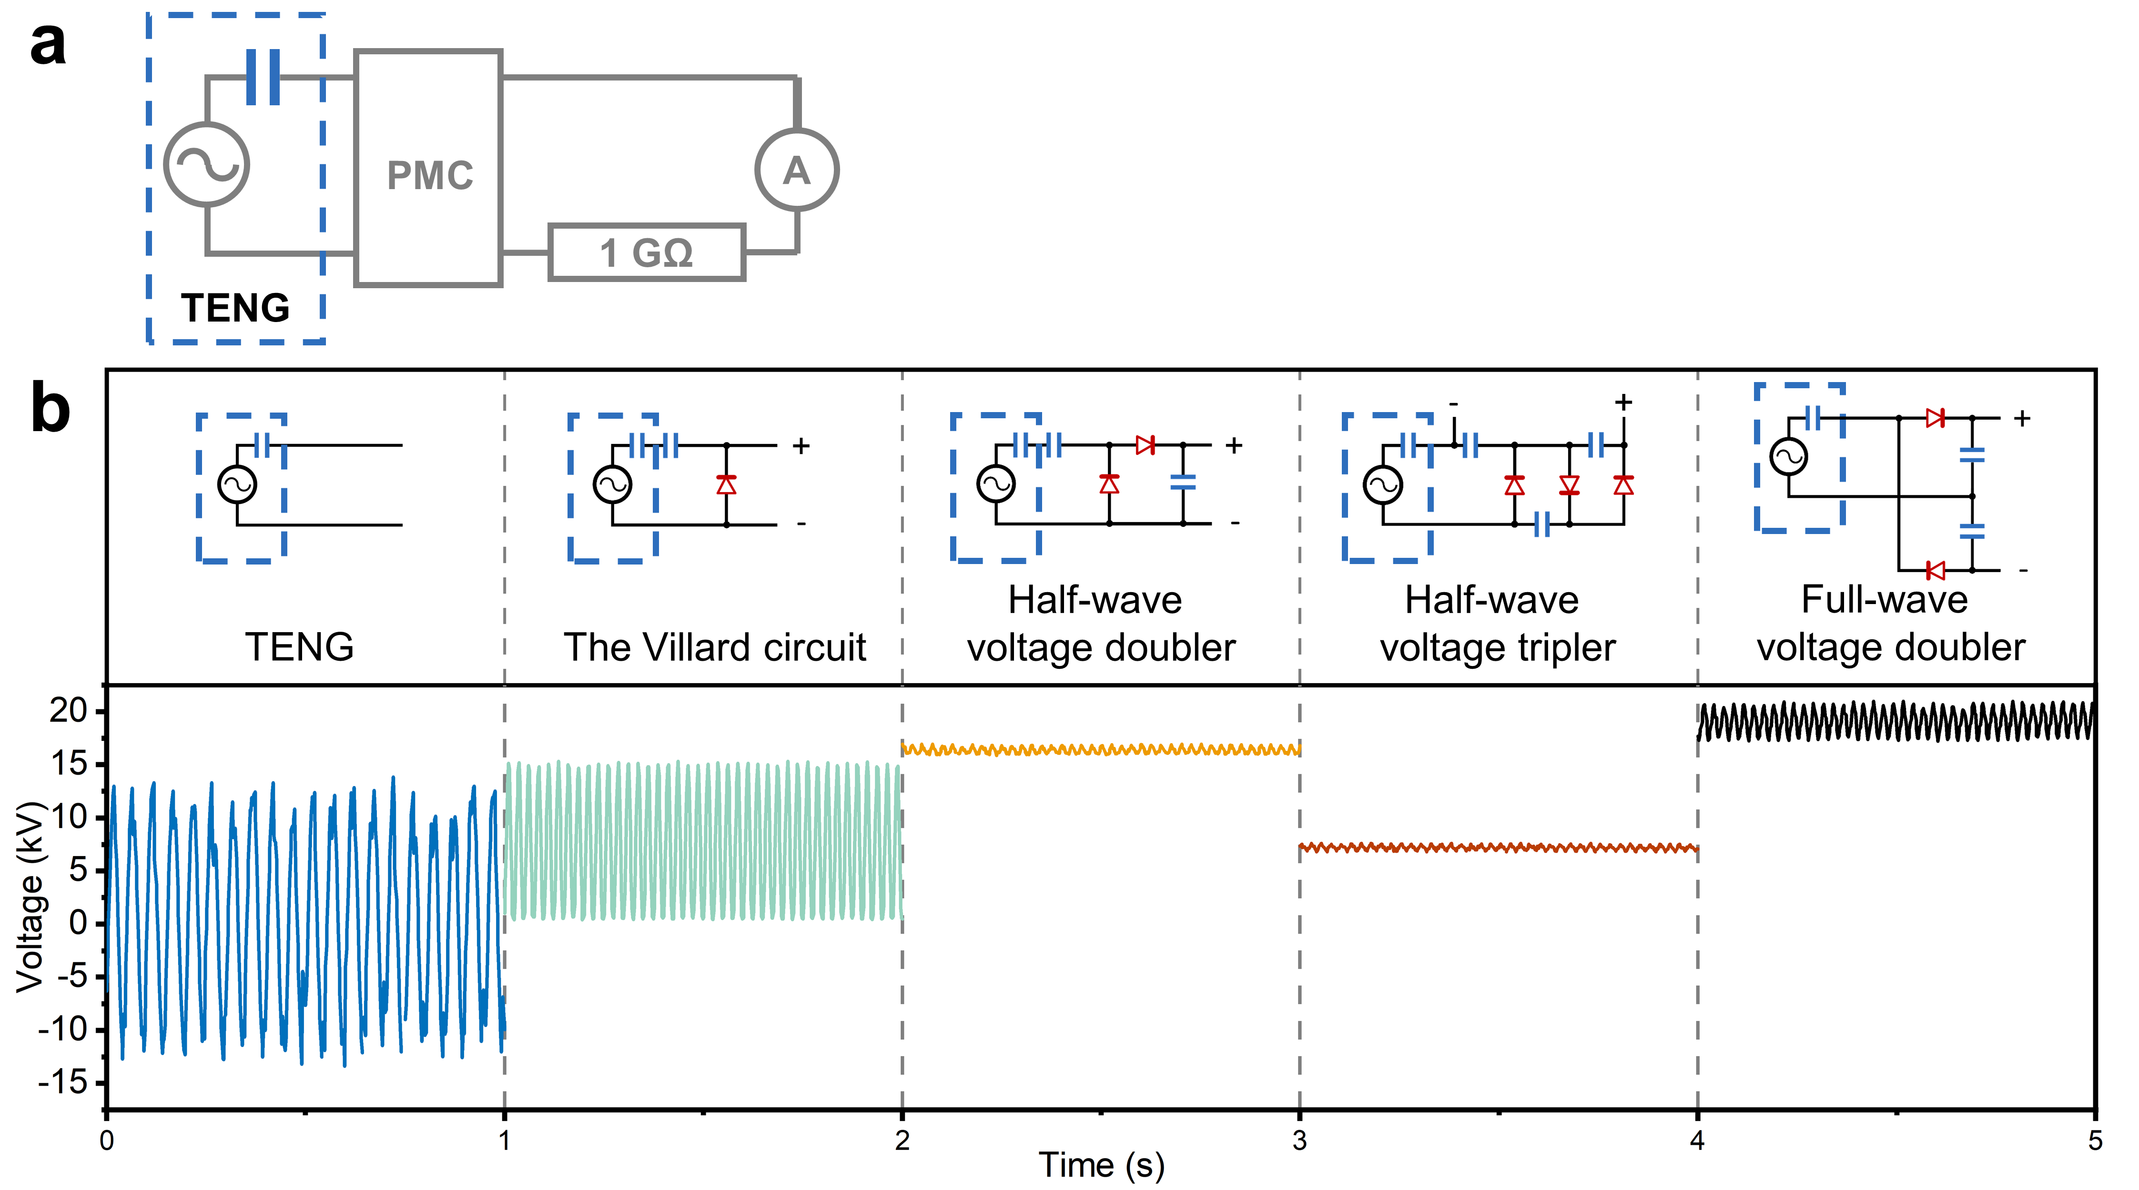
Supplementary Fig. 9 Measurement circuit and the stabilized output voltages for PMCs.
a the measurement circuit for PMCs. b The output voltages of various PMCs after stabilization compared with the open-circuit voltage of the FR-TENG.

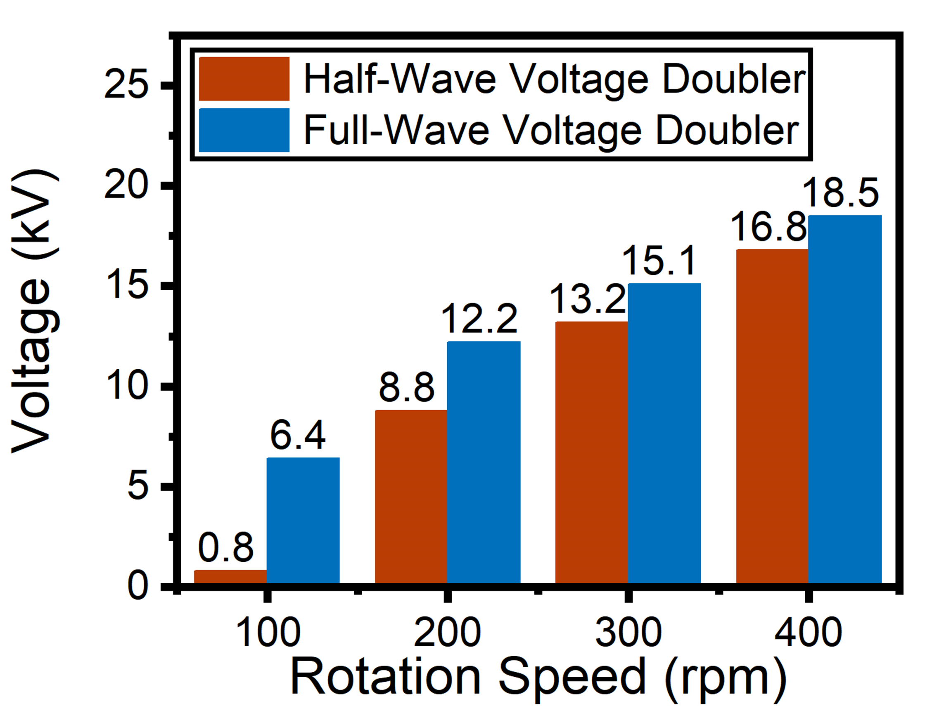
Supplementary Fig. 10 Stable output voltage (Average voltage) of the half-wave voltage doubler and the full-wave voltage doubler at different speeds.

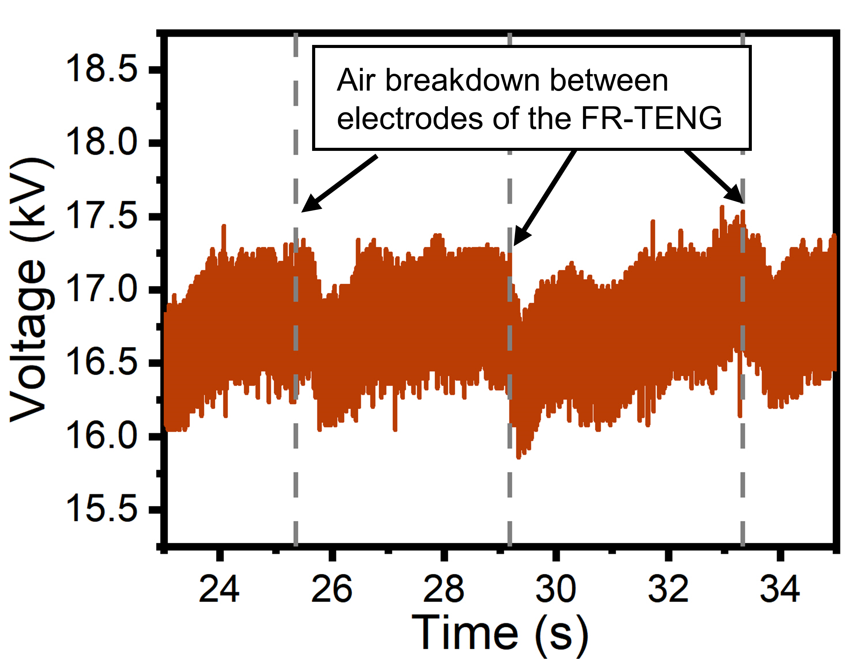
Supplementary Fig. 11 The impact of air breakdown between FR-TENG electrodes on the output voltage of the PMC.

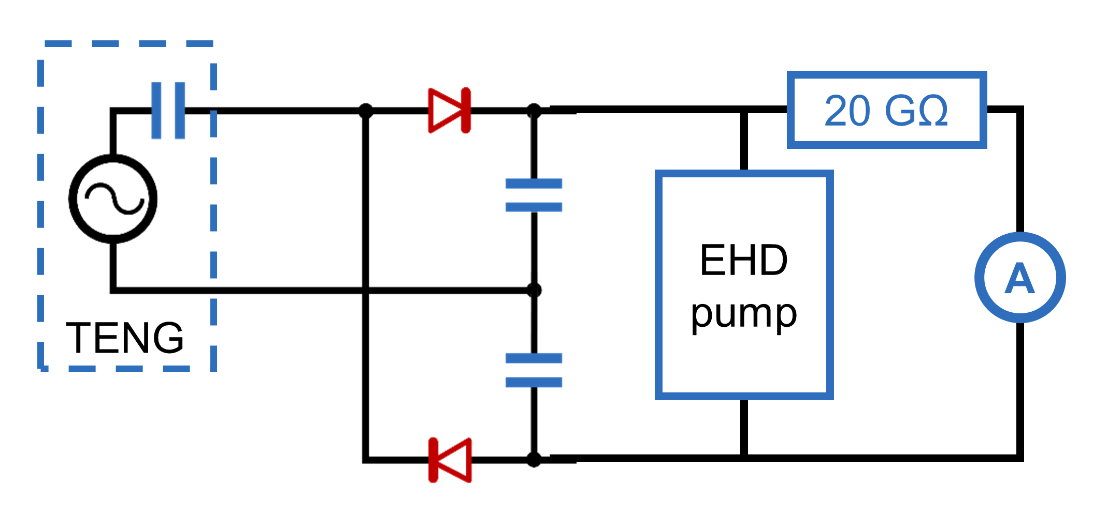
Supplementary Fig. 12 Measurement circuit for the current and voltage on the TEHD pump after PMC enhancement.

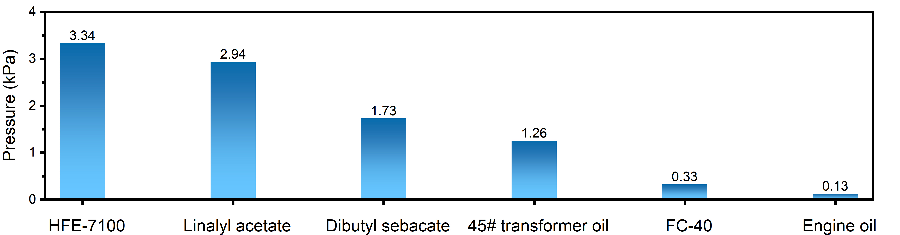
Supplementary Fig. 13 The pressure of the TEHD pump after PMC enhancement for pumping different fluids. (@400 rpm)

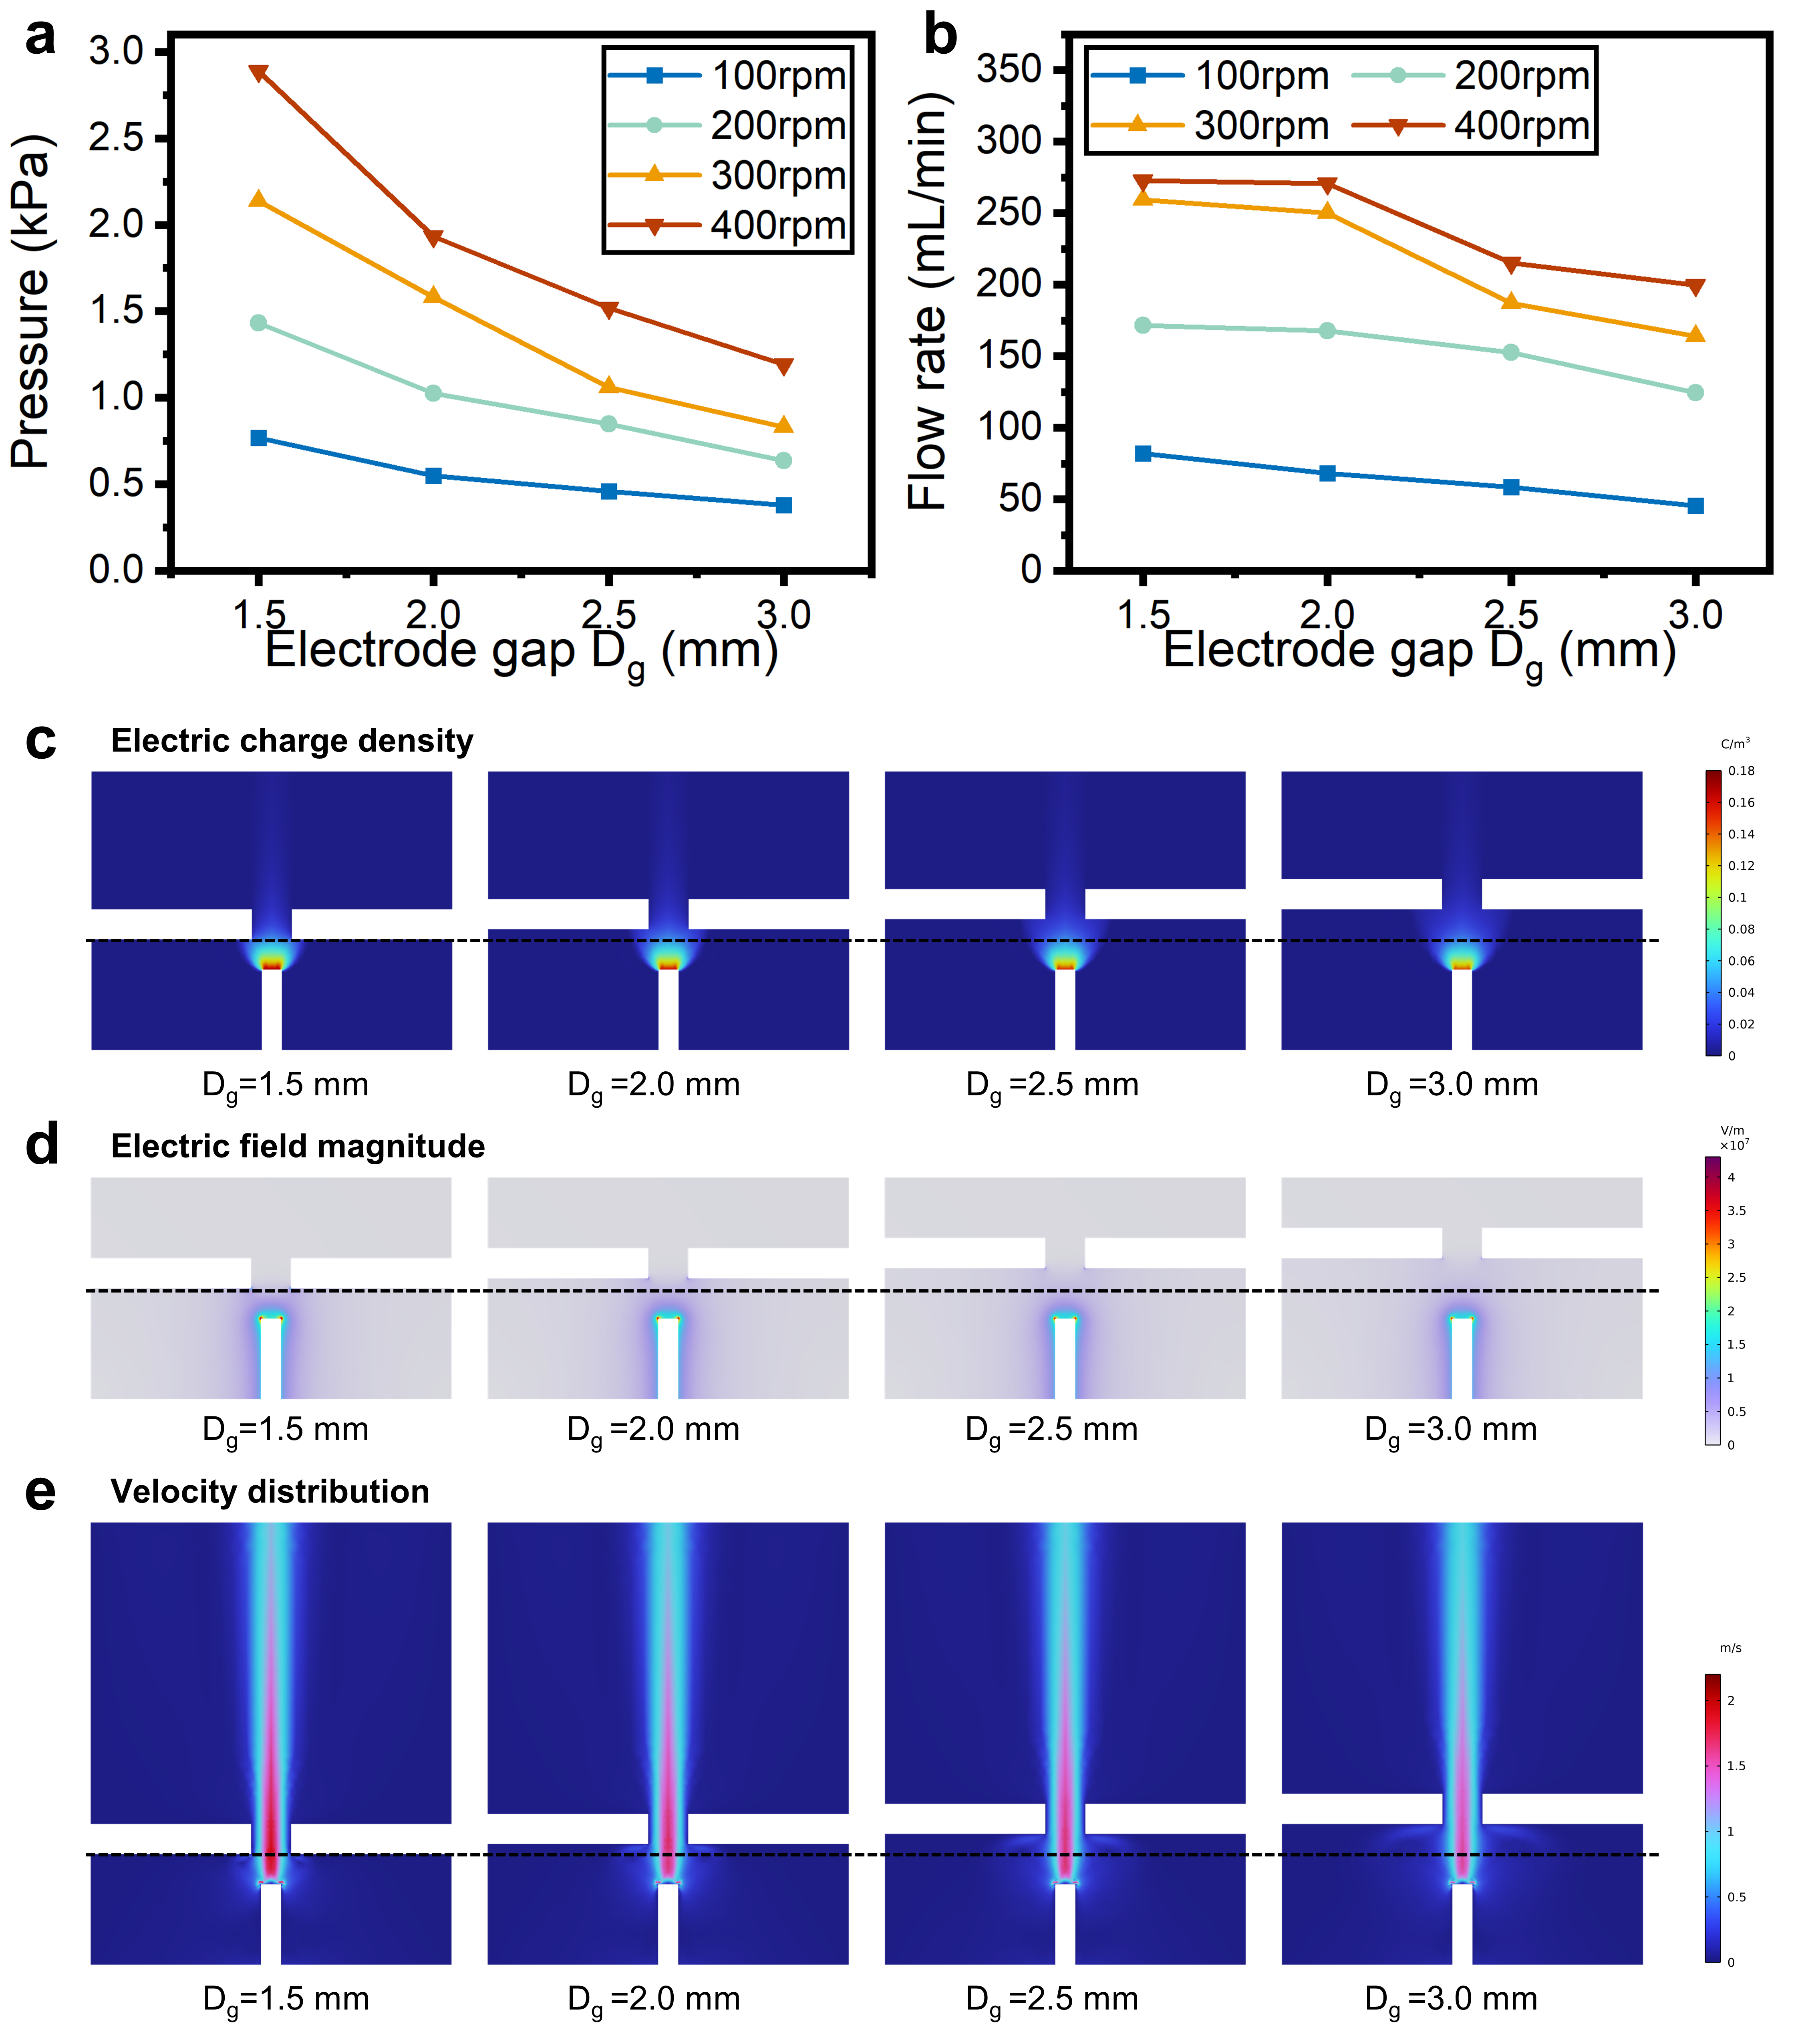
Supplementary Fig. 14 Effects of $D_{g}$ variation on the TEHD pump.
Variation of a pumping pressure and b pumping flow rate with different $D_{g}$. Simulated results of c charge density, d electric field magnitude, and e velocity with different $D_{g}$.

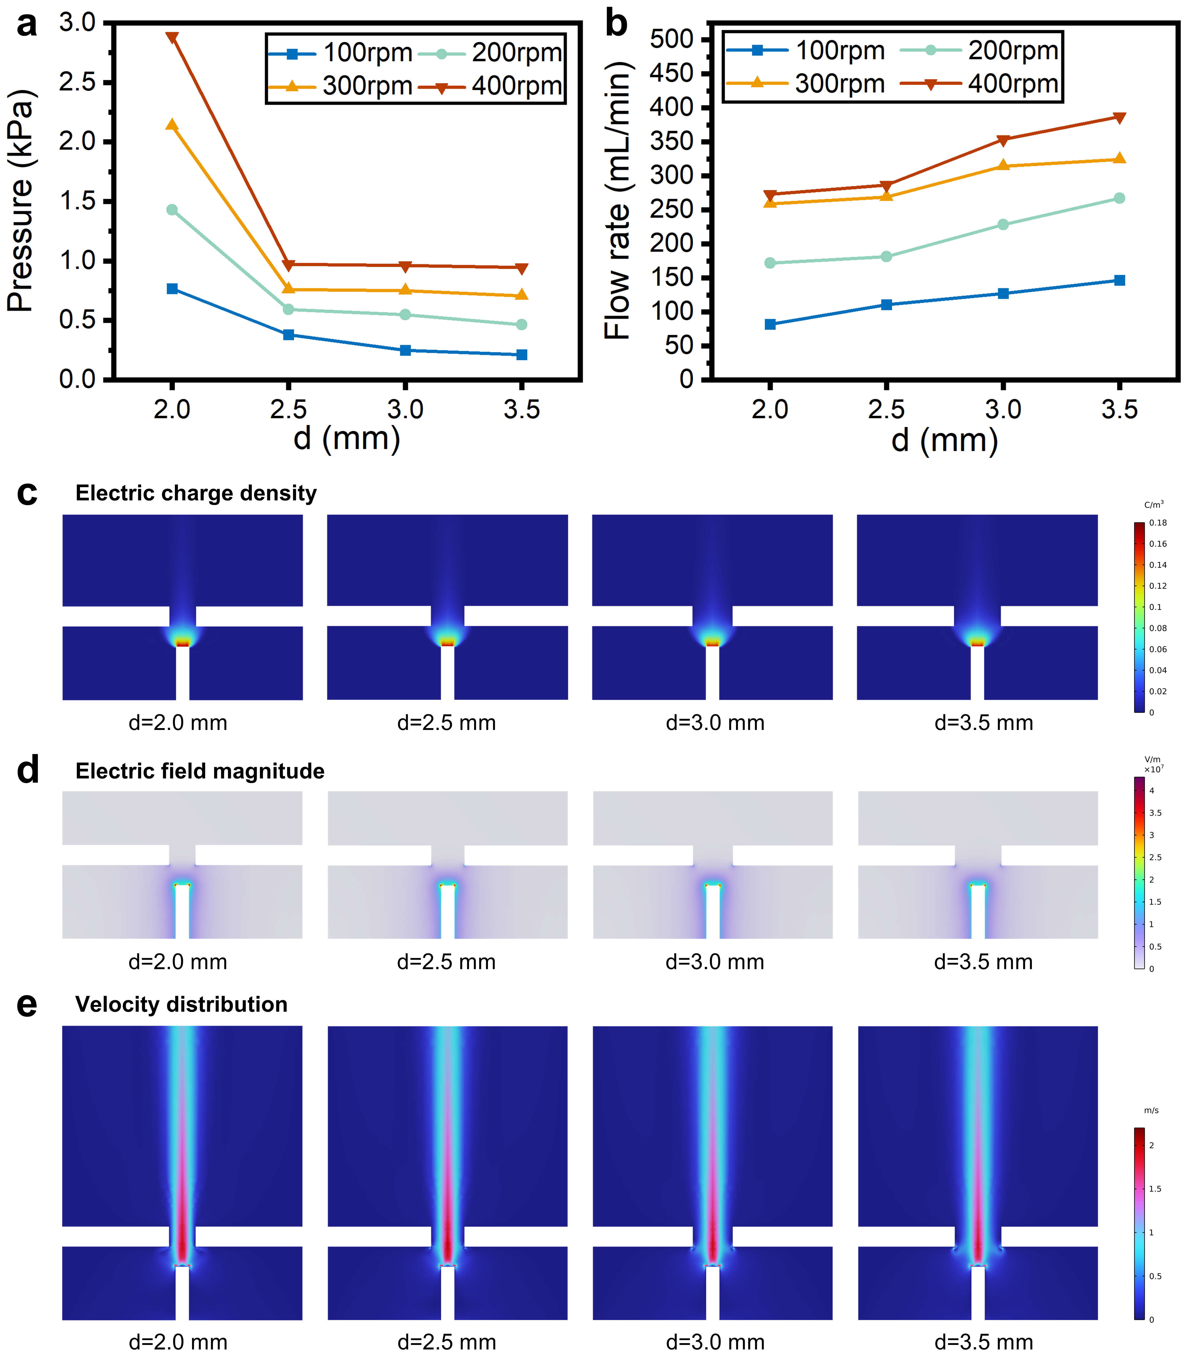
Supplementary Fig. 15 Effects of $d$ variation on the TEHD pump.
Variation of a pumping pressure and b pumping flow rate with different $d$. Simulated results of c charge density, d electric field magnitude, and e velocity with different $d$.

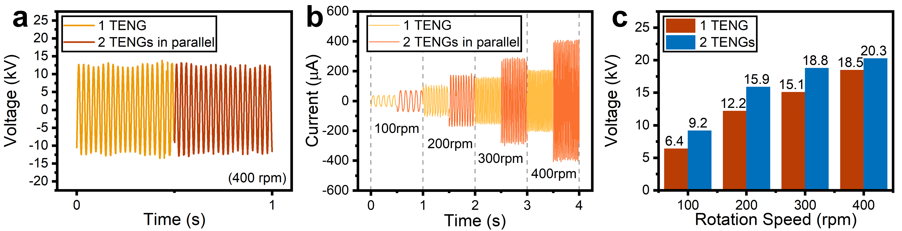
Supplementary Fig. 16 Effects of parallel connection of two FR-TENGs in phase.
a The open-circuit voltage for two TENGs connected in parallel compared with one TENG. b The short-circuit current for two TENGs connected in parallel in the same phase compared with one TENG. c Comparison of the average output voltage of a full-wave voltage doubler driven by two TENGs in parallel versus driven by one TENG.

Supplementary Movie 1. Fabrication process of a soft electrohydrodynamic (EHD) pump
Supplementary Movie 2. Application of TEHD pumping system in driving soft robotic finger
Supplementary Movie 3. Application of TEHD pumping system in pumping oil through microfluidic chips
Supplementary Movie 4. Application of TEHD pumping system for oil purification

