Supplementary information

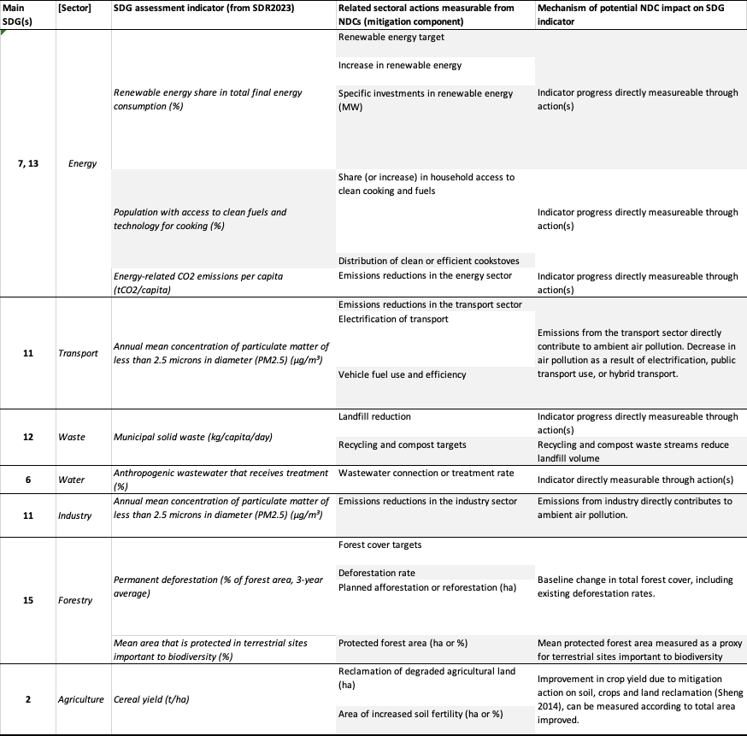
Supplementary table 1. List of NDC actions that can be directly linked to performance in an indicator from the Sustainable Development Report (Sachs et al. 2023).

