This file includes:

Figs. S1 to S24
Legends for tables S1 to S21

Other Supplementary Materials for this manuscript include the following:

Tables S1 to S21

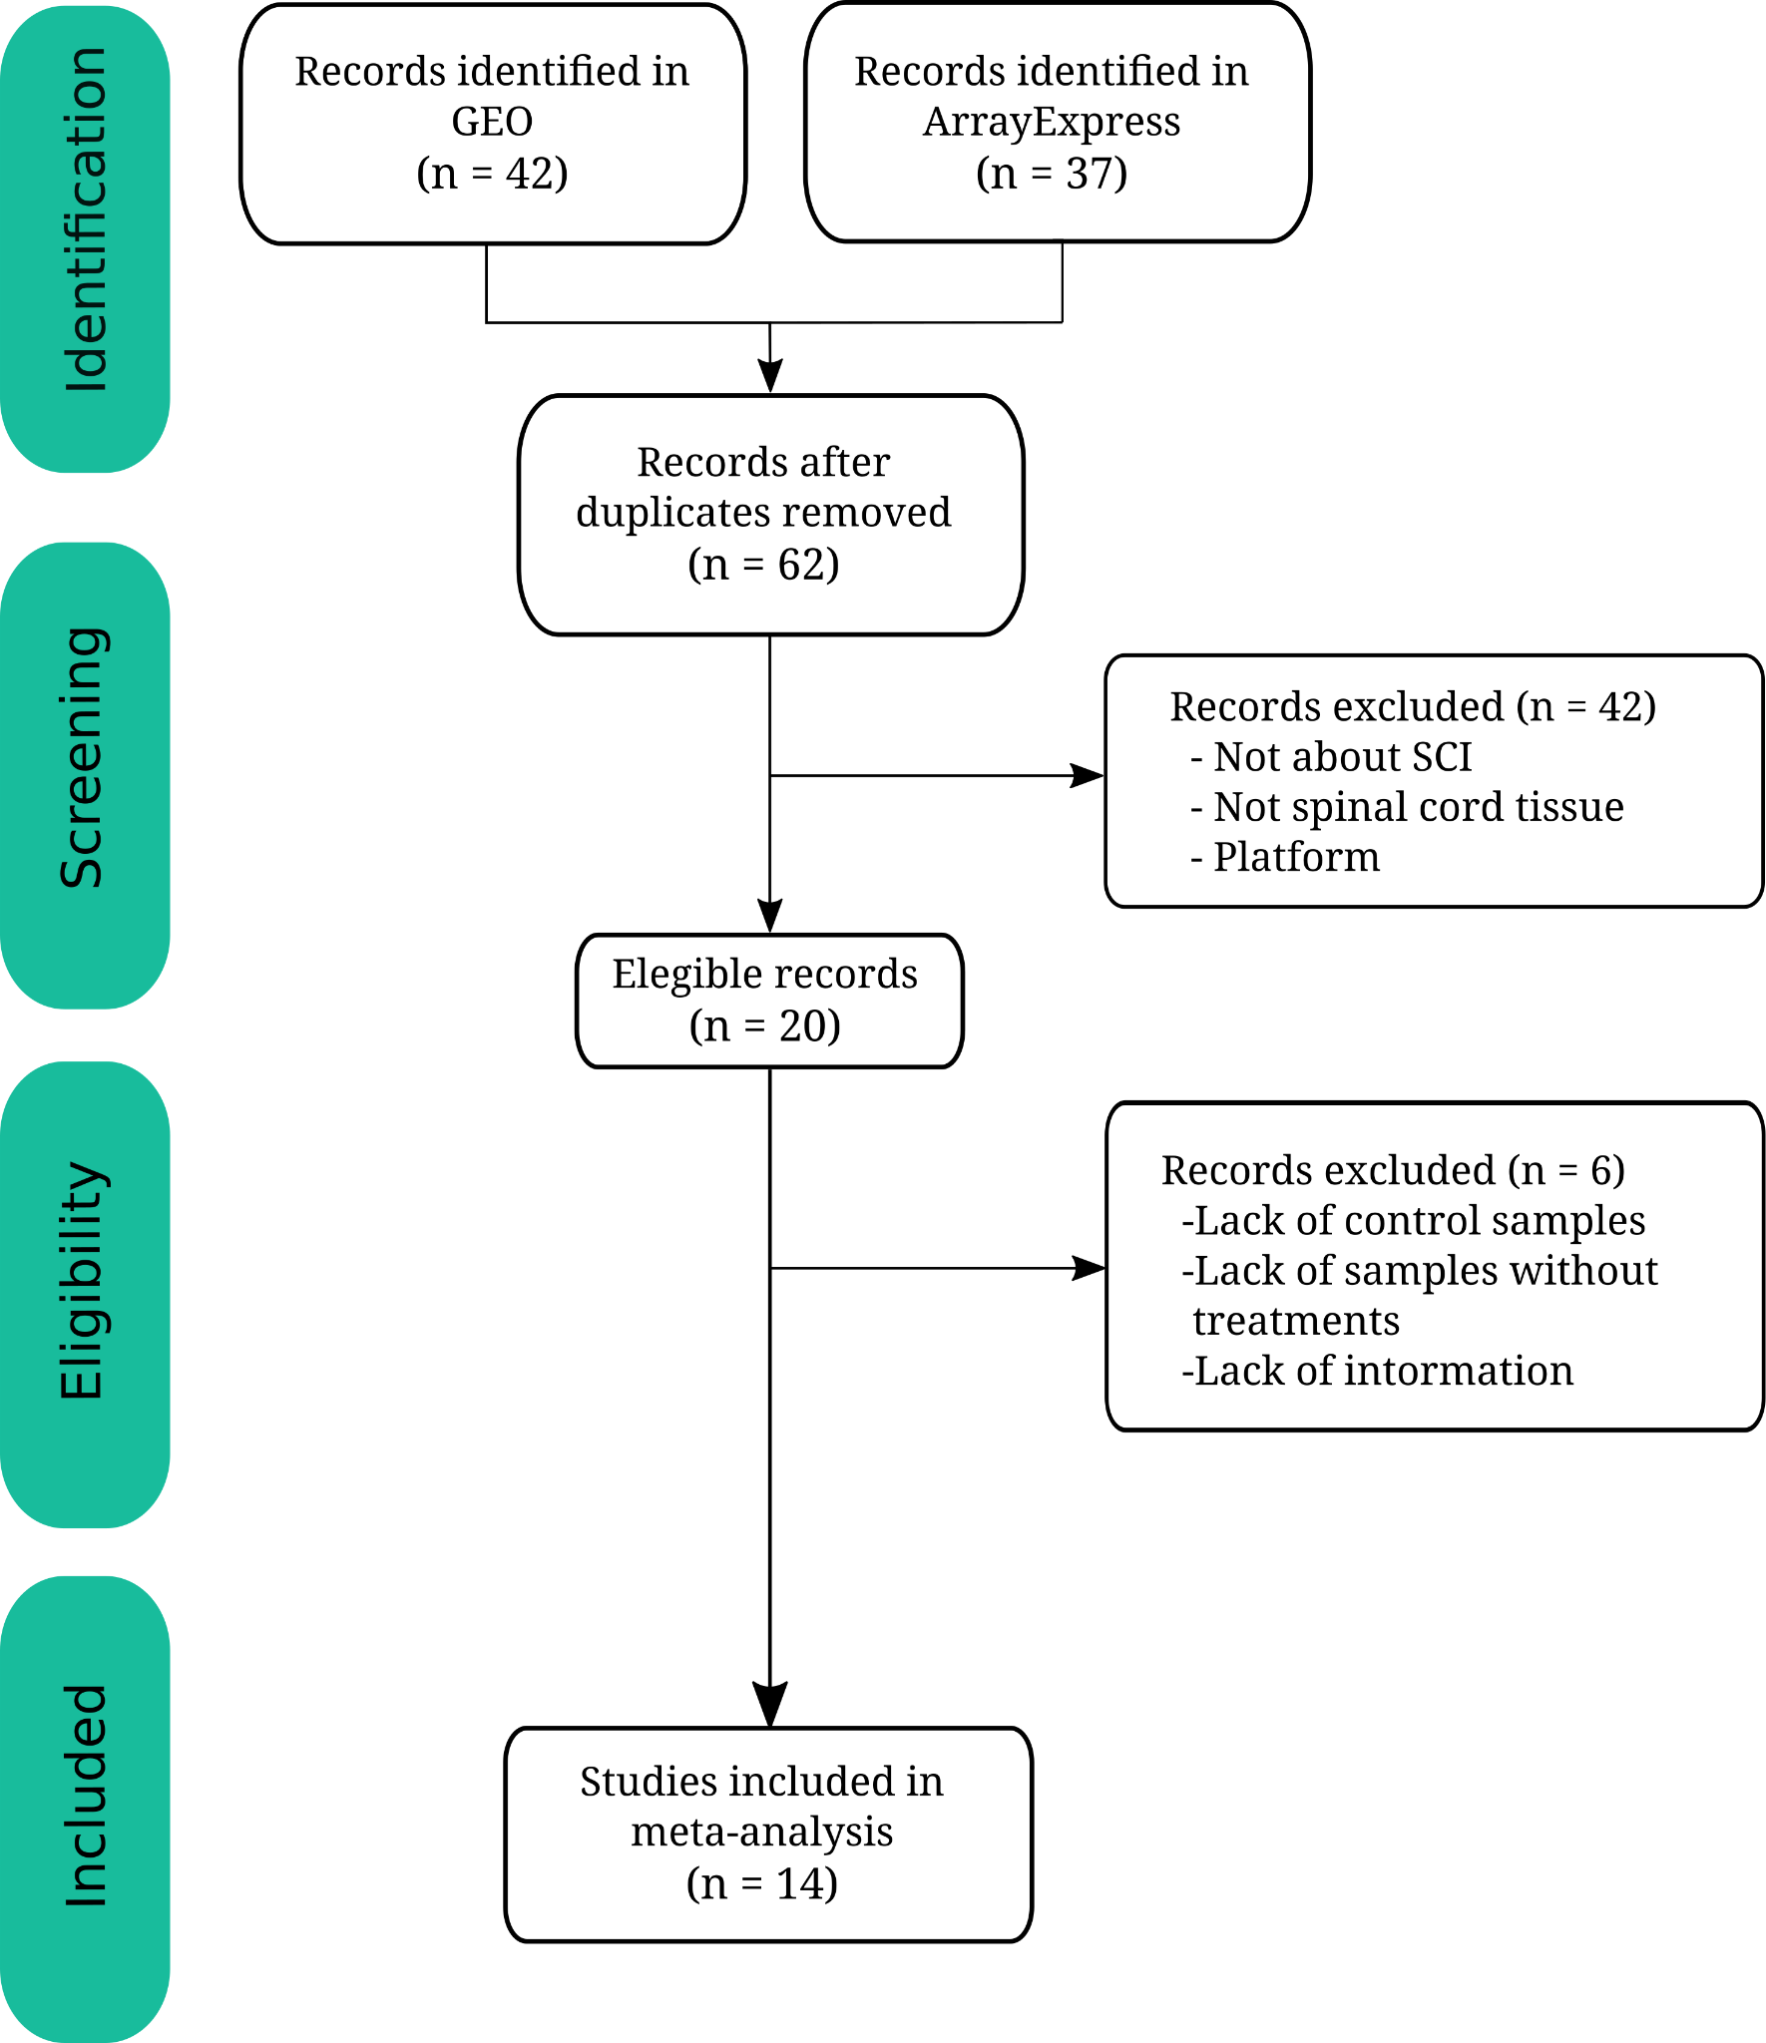
Fig. S1. Prisma diagram. Flow diagram of systematic review and selection of studies for the meta-analysis, according to the PRISMA statement guidelines.

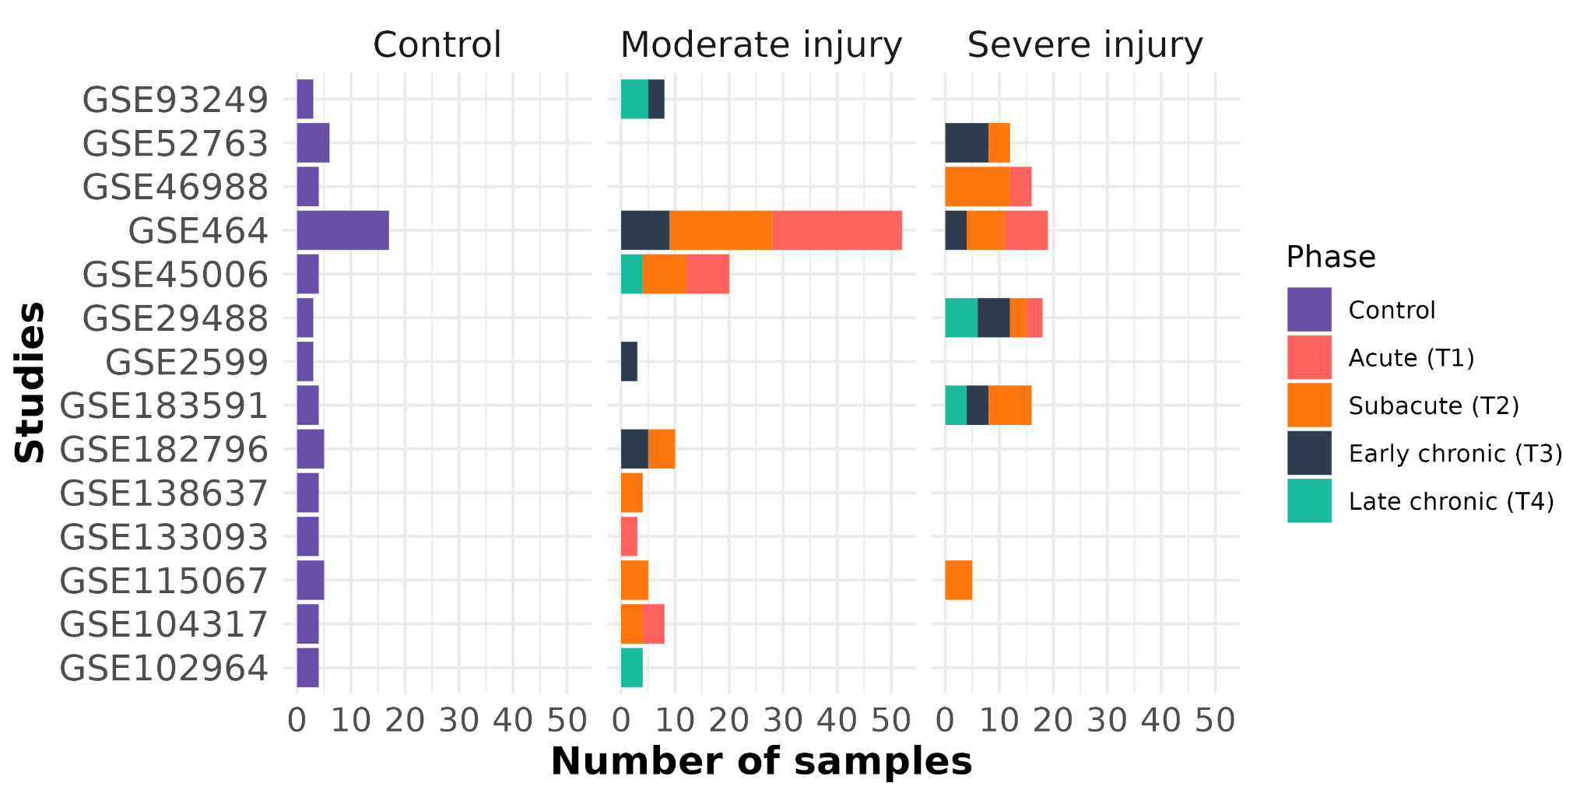
Fig. S2. Summary of sample distribution. Barplots showing the sample distribution by study, severity and phase.

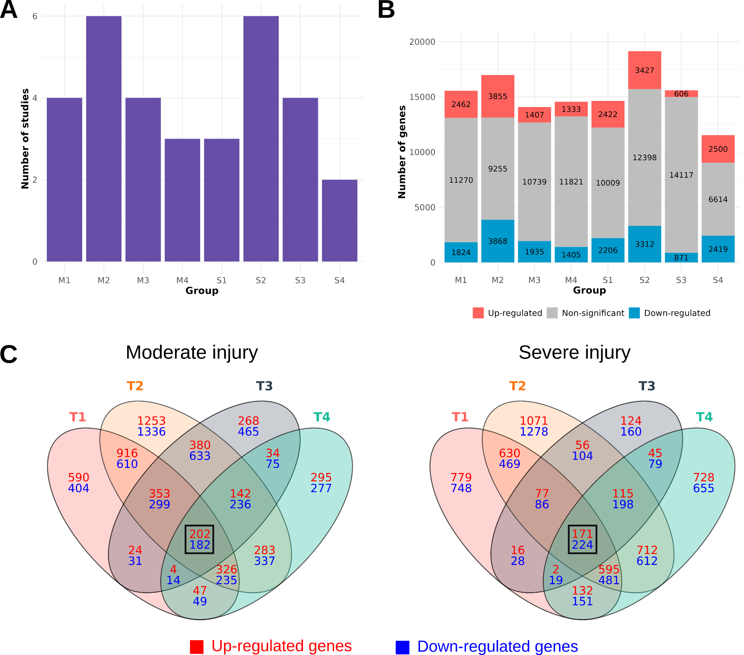
Fig. 3. Overview of gene expression meta-analysis results. (A) Barplot reporting the number of studies per group. (B) Barplot displaying the number of significantly altered genes per group, with significantly up-regulated genes in red, significantly down-regulated genes in blue, and non-significantly altered genes in gray. (C) Venn diagrams of significantly altered genes in different injury phases (T1, acute; T2, subacute; T3, early chronic; T4, late chronic) for moderate (left) and severe (right) injury. Intersecting significantly up-regulated genes are noted in red, and significantly dow-nregulated genes are noted in blue. The black square indicates the intersection of all four groups.
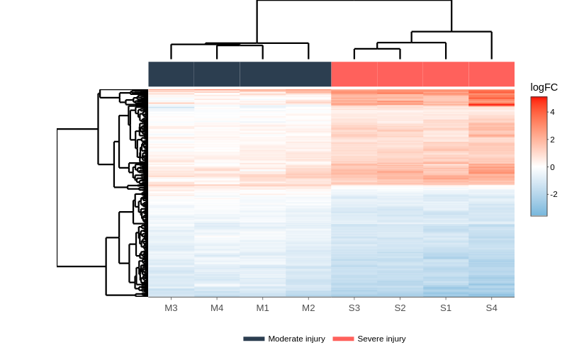
Fig. S4. Hierarchical heatmap of severity-specific biomarkers. Hierarchical heatmap revealed higher dysregulation of these genes, both up-regulated or down-regulated, in severe injuries than moderate injuries, resulting in a clear separation into two distinct branches of the heatmap based on severity.

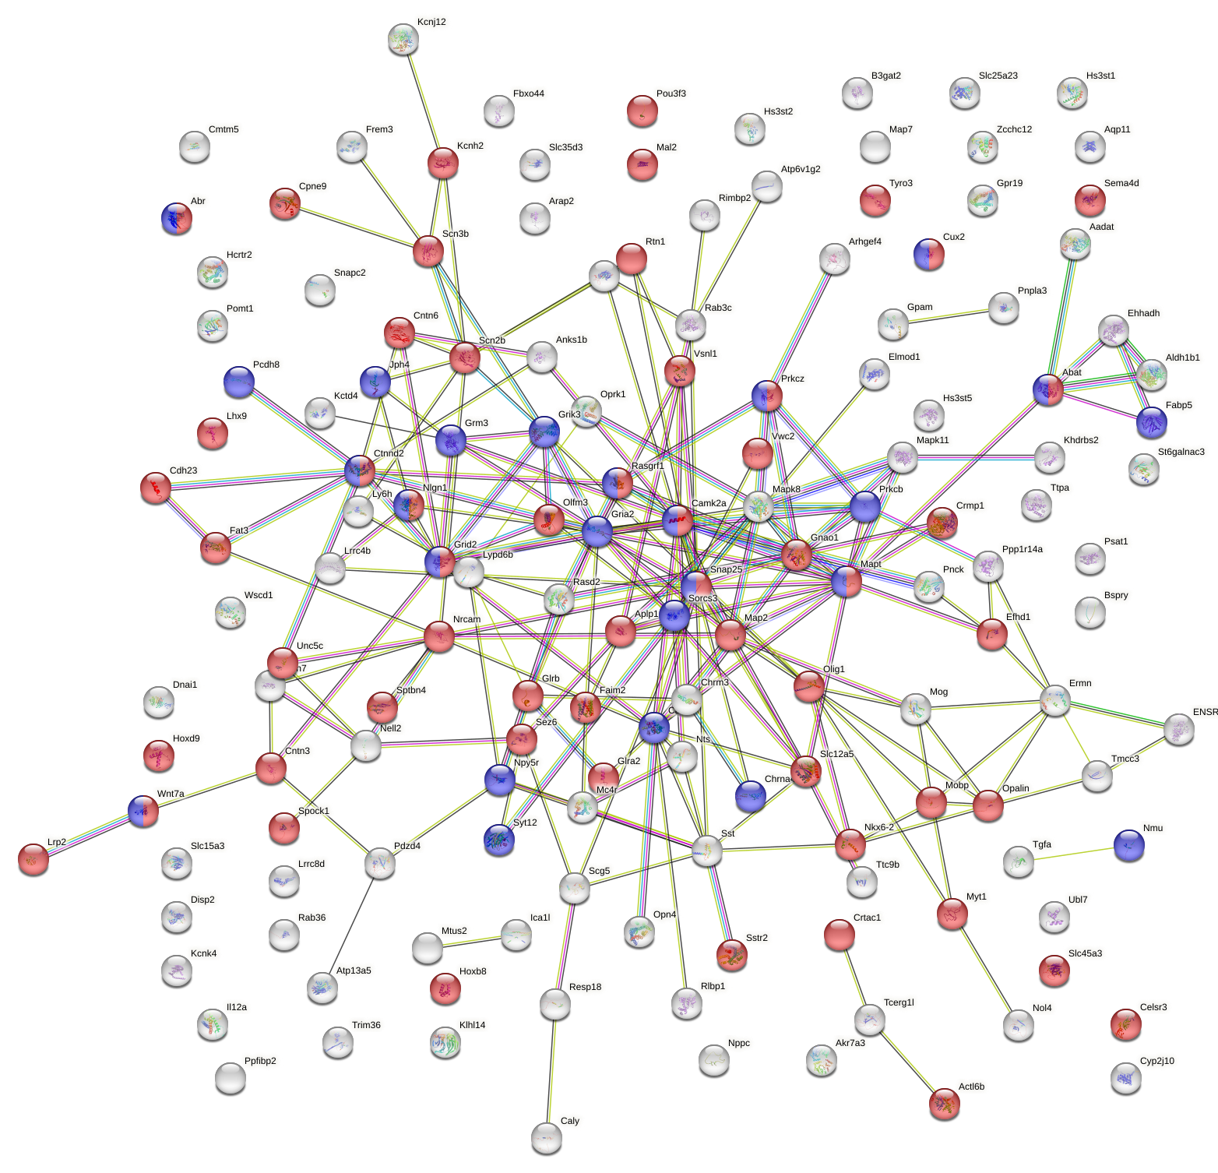

Fig. S5. PPI network for down-regulated severity-markers. Red, proteins related to nervous system development (GO:0007399). Blue, proteins related to regulation of trans-synaptic signaling (GO:0099177). Permalink: https://version-11-5.string-db.org/cgi/network?networkId=bAOGP0hyvNCg.

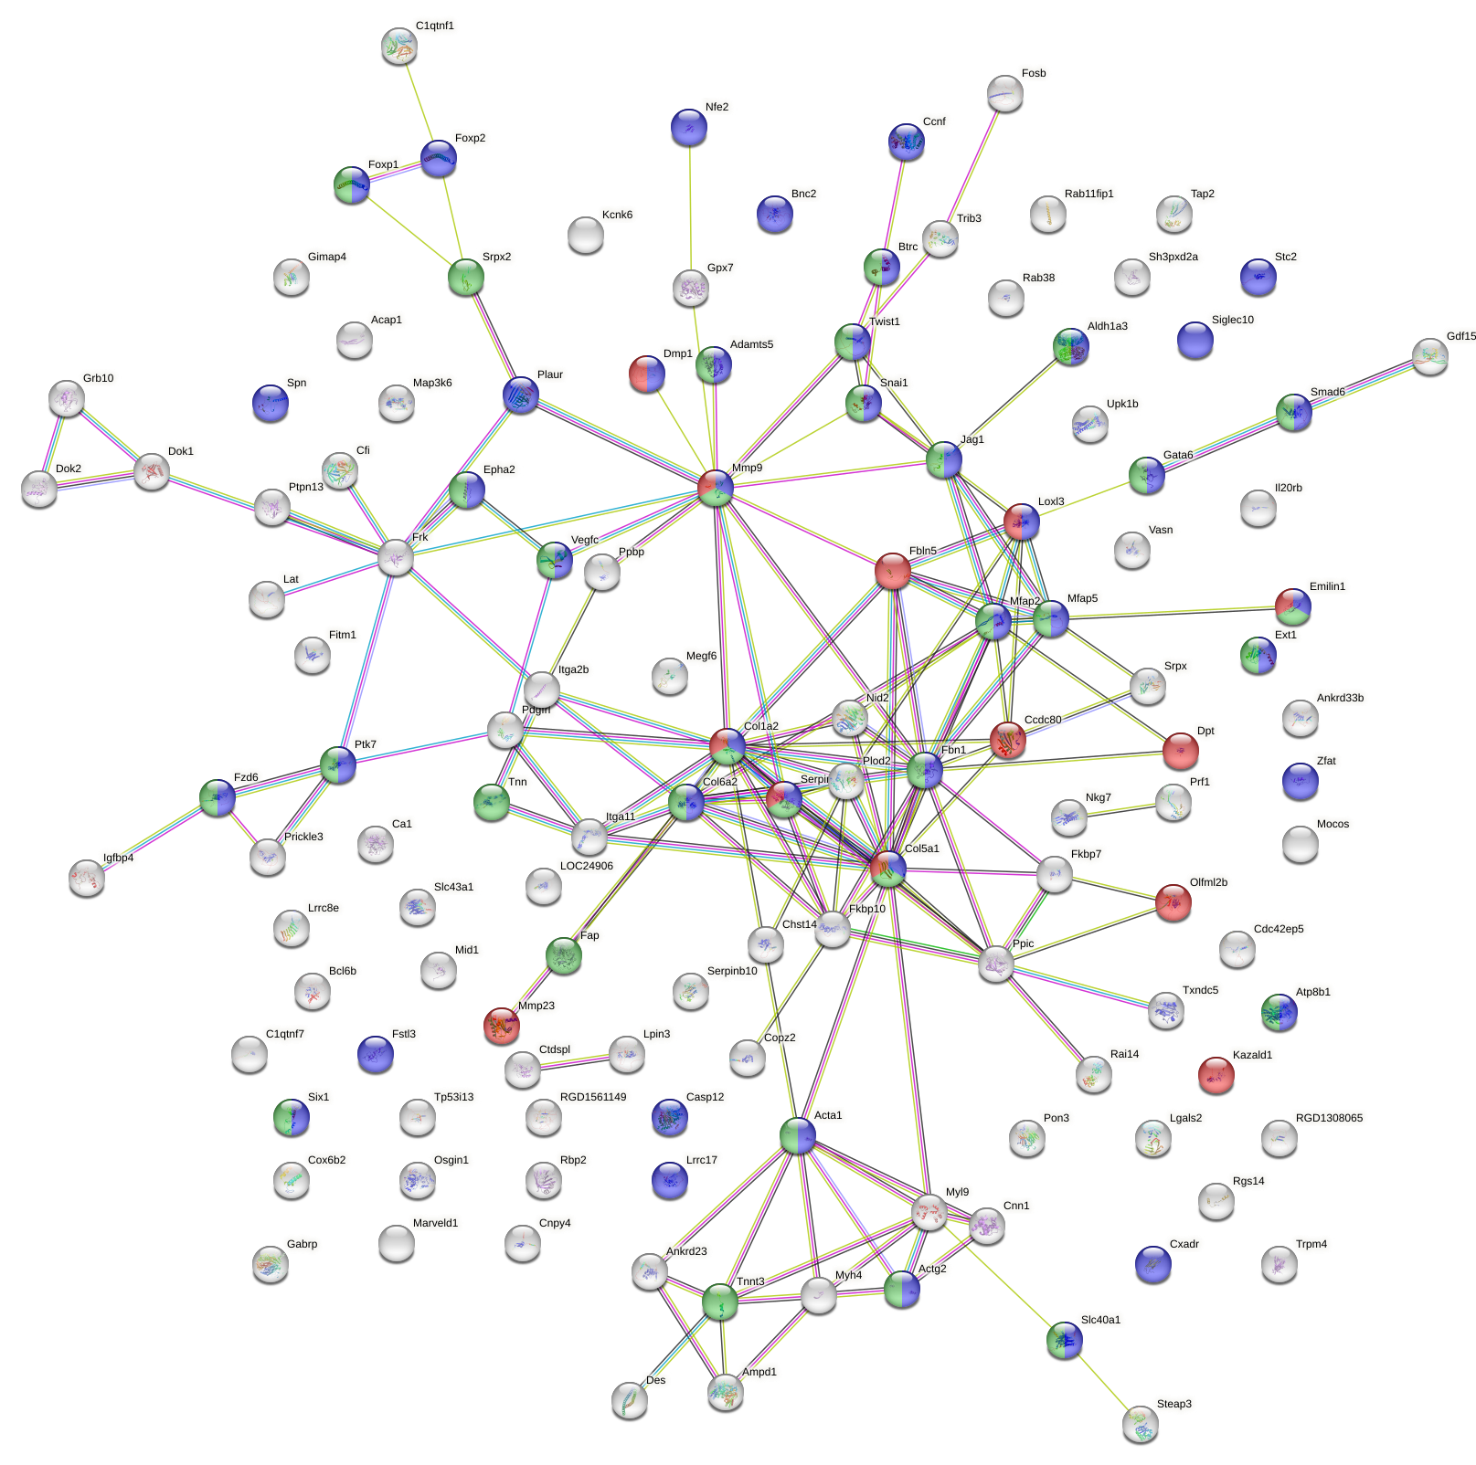

Fig. S6. PPI network for up-regulated severity-markers. Red, proteins related to extracellular matrix organization (GO:0030198). Blue, proteins related to animal organ development (GO:0048513). Green, proteins related to anatomical structure morphogenesis (GO:0009653). Permalink: https://version-11-5.string-db.org/cgi/network?networkId=bYnq68Vl7nAs.

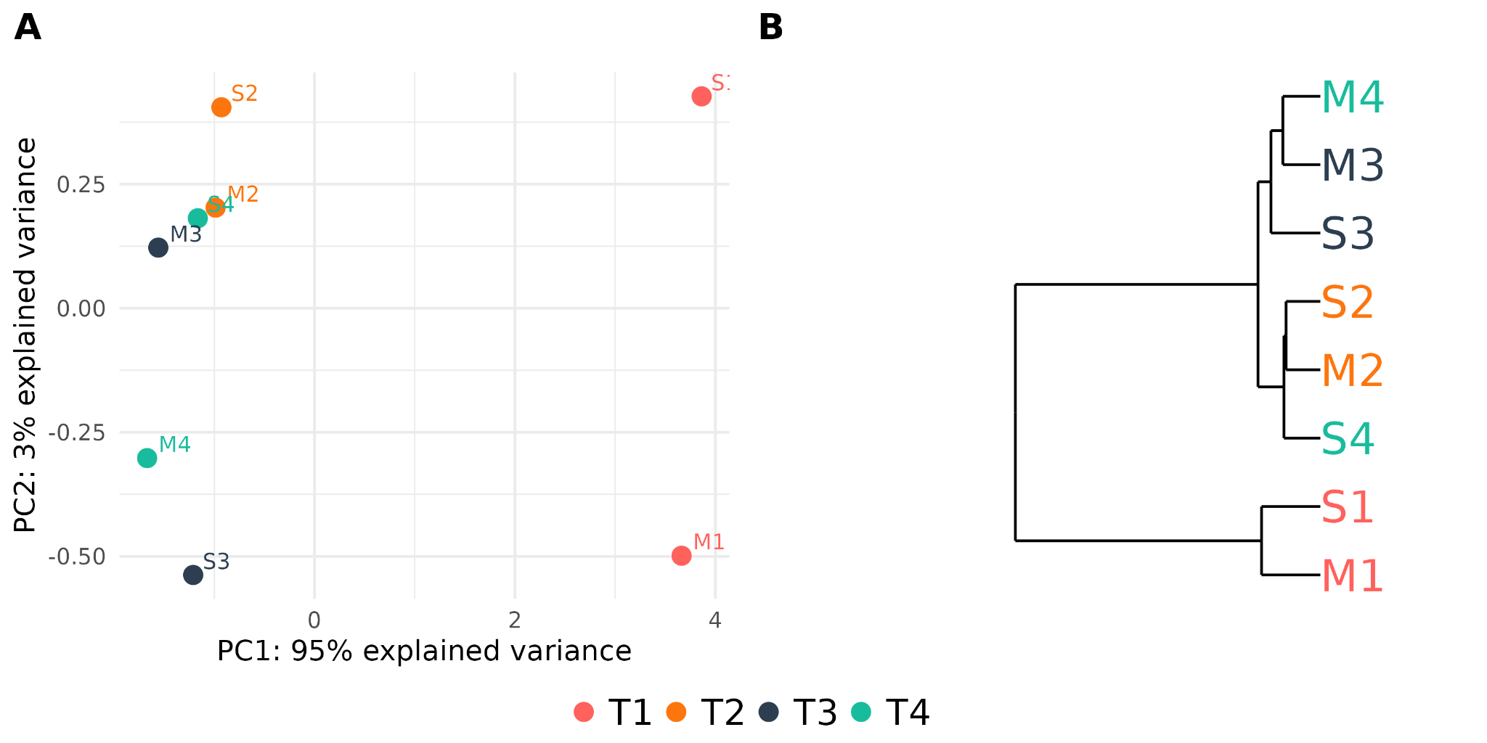
Fig. S7. Group classification using top 10 T1-specific biomarkers. (A) PCA plot and (B) hierarchical clustering using top 10 T1-specific genes (Fosl1, Il33, Vcam1, Mx2, Mdk, Ldlr, Hmgcr, Alpk3, Dusp5, Serpina3n).

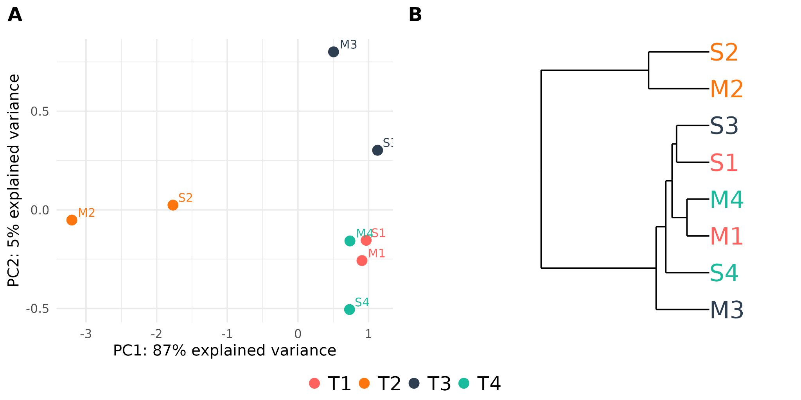
Fig. S8. Group classification using top 10 T2-specific biomarkers. (A) PCA plot and (B) hierarchical clustering using top 10 T2-specific genes (Cfp, Slc46a3, Scn8a, Ly86, Casr, C1qc, Slc2a5, Fgd2, Aif1, Slc7a7).

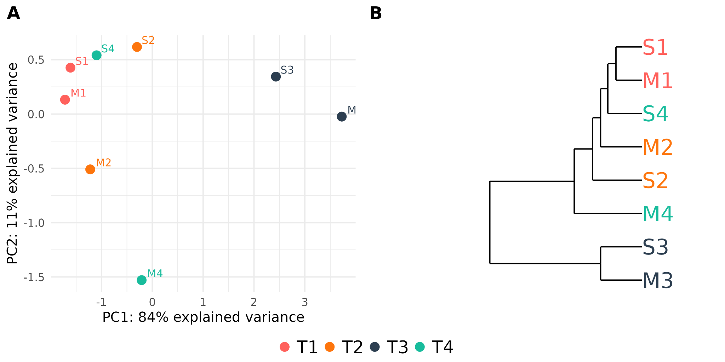
Fig. S9. Group classification using top 10 T3-specific biomarkers. (A) PCA plot and (B) hierarchical clustering using top 10 T3-specific genes (Slc28a2, Iqgap1, Cd14, Nt5dc2, Xdh, Msn, Lyve1, Tmem37, Rdh10, Enpp3).

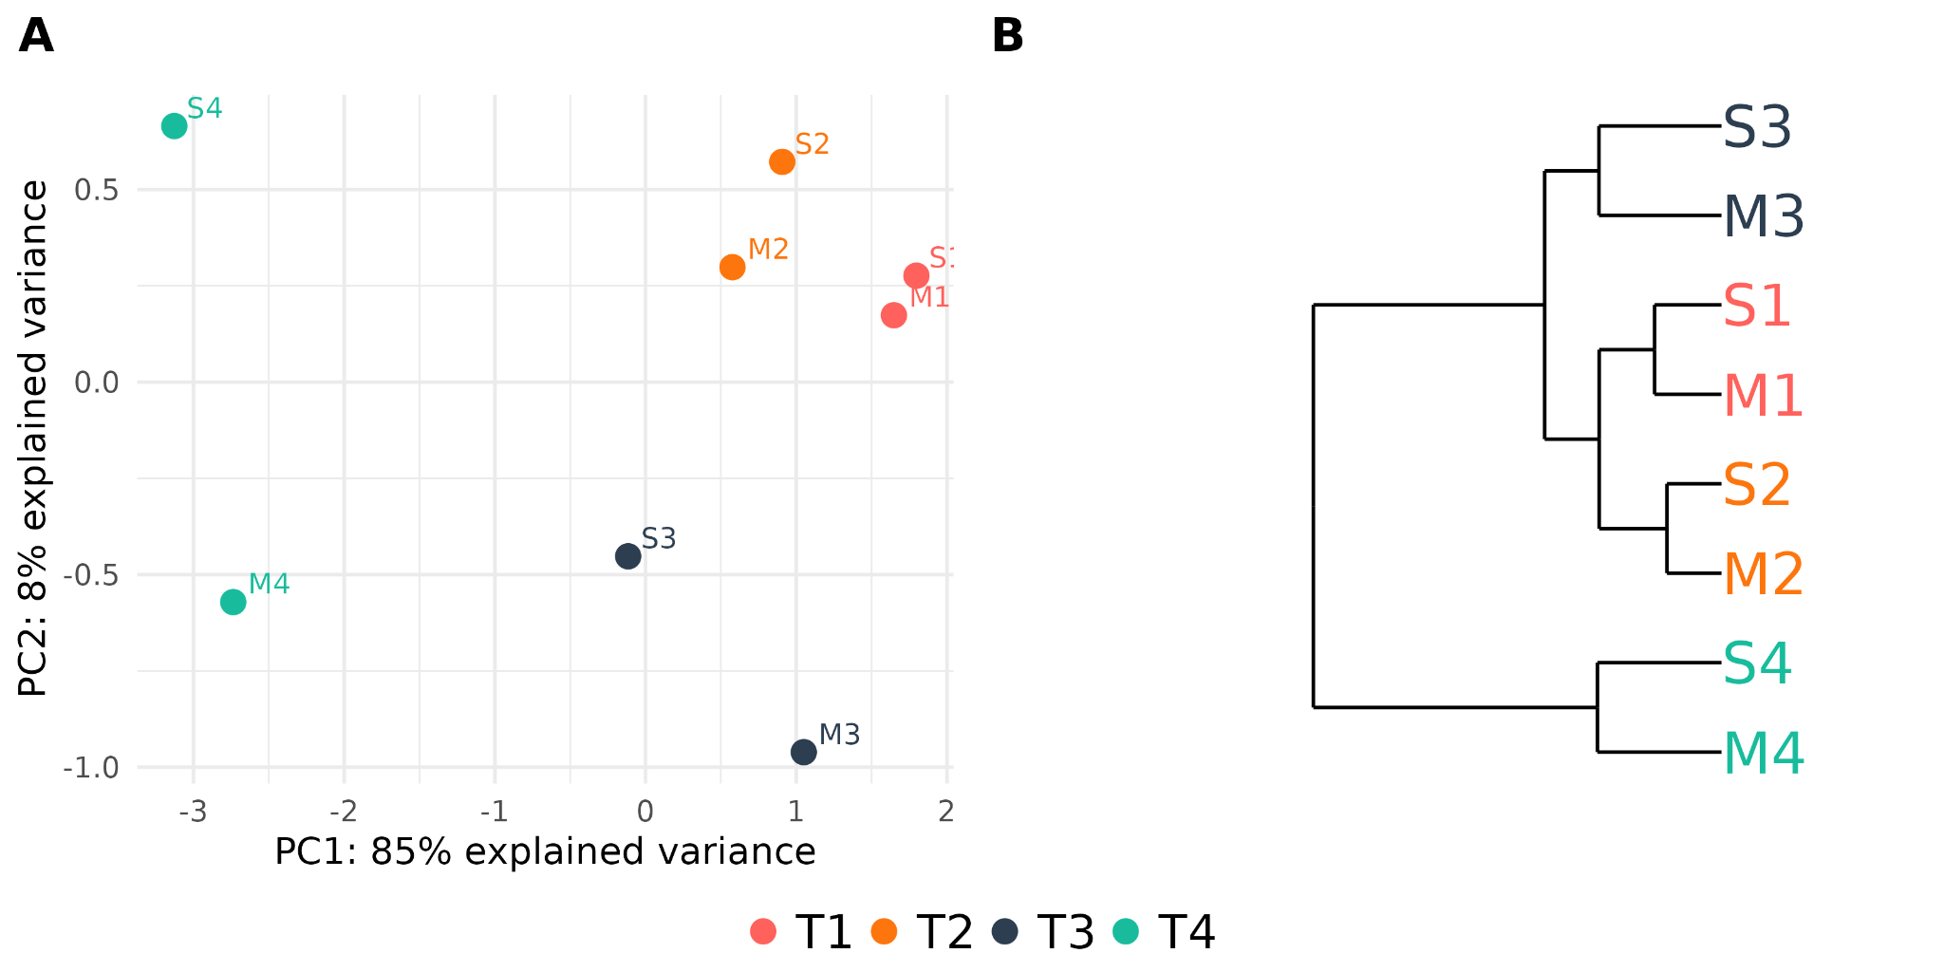
Fig. S10. Group classification using top 10 T4-specific biomarkers. (A) PCA plot and (B) hierarchical clustering using top 10 T4-specific genes (Cp, Rab27a, Rab3b, Cybrd1, Thrsp, Plcb1, Pmp22, Acot2, Cyp27a1, RT1-Db1).
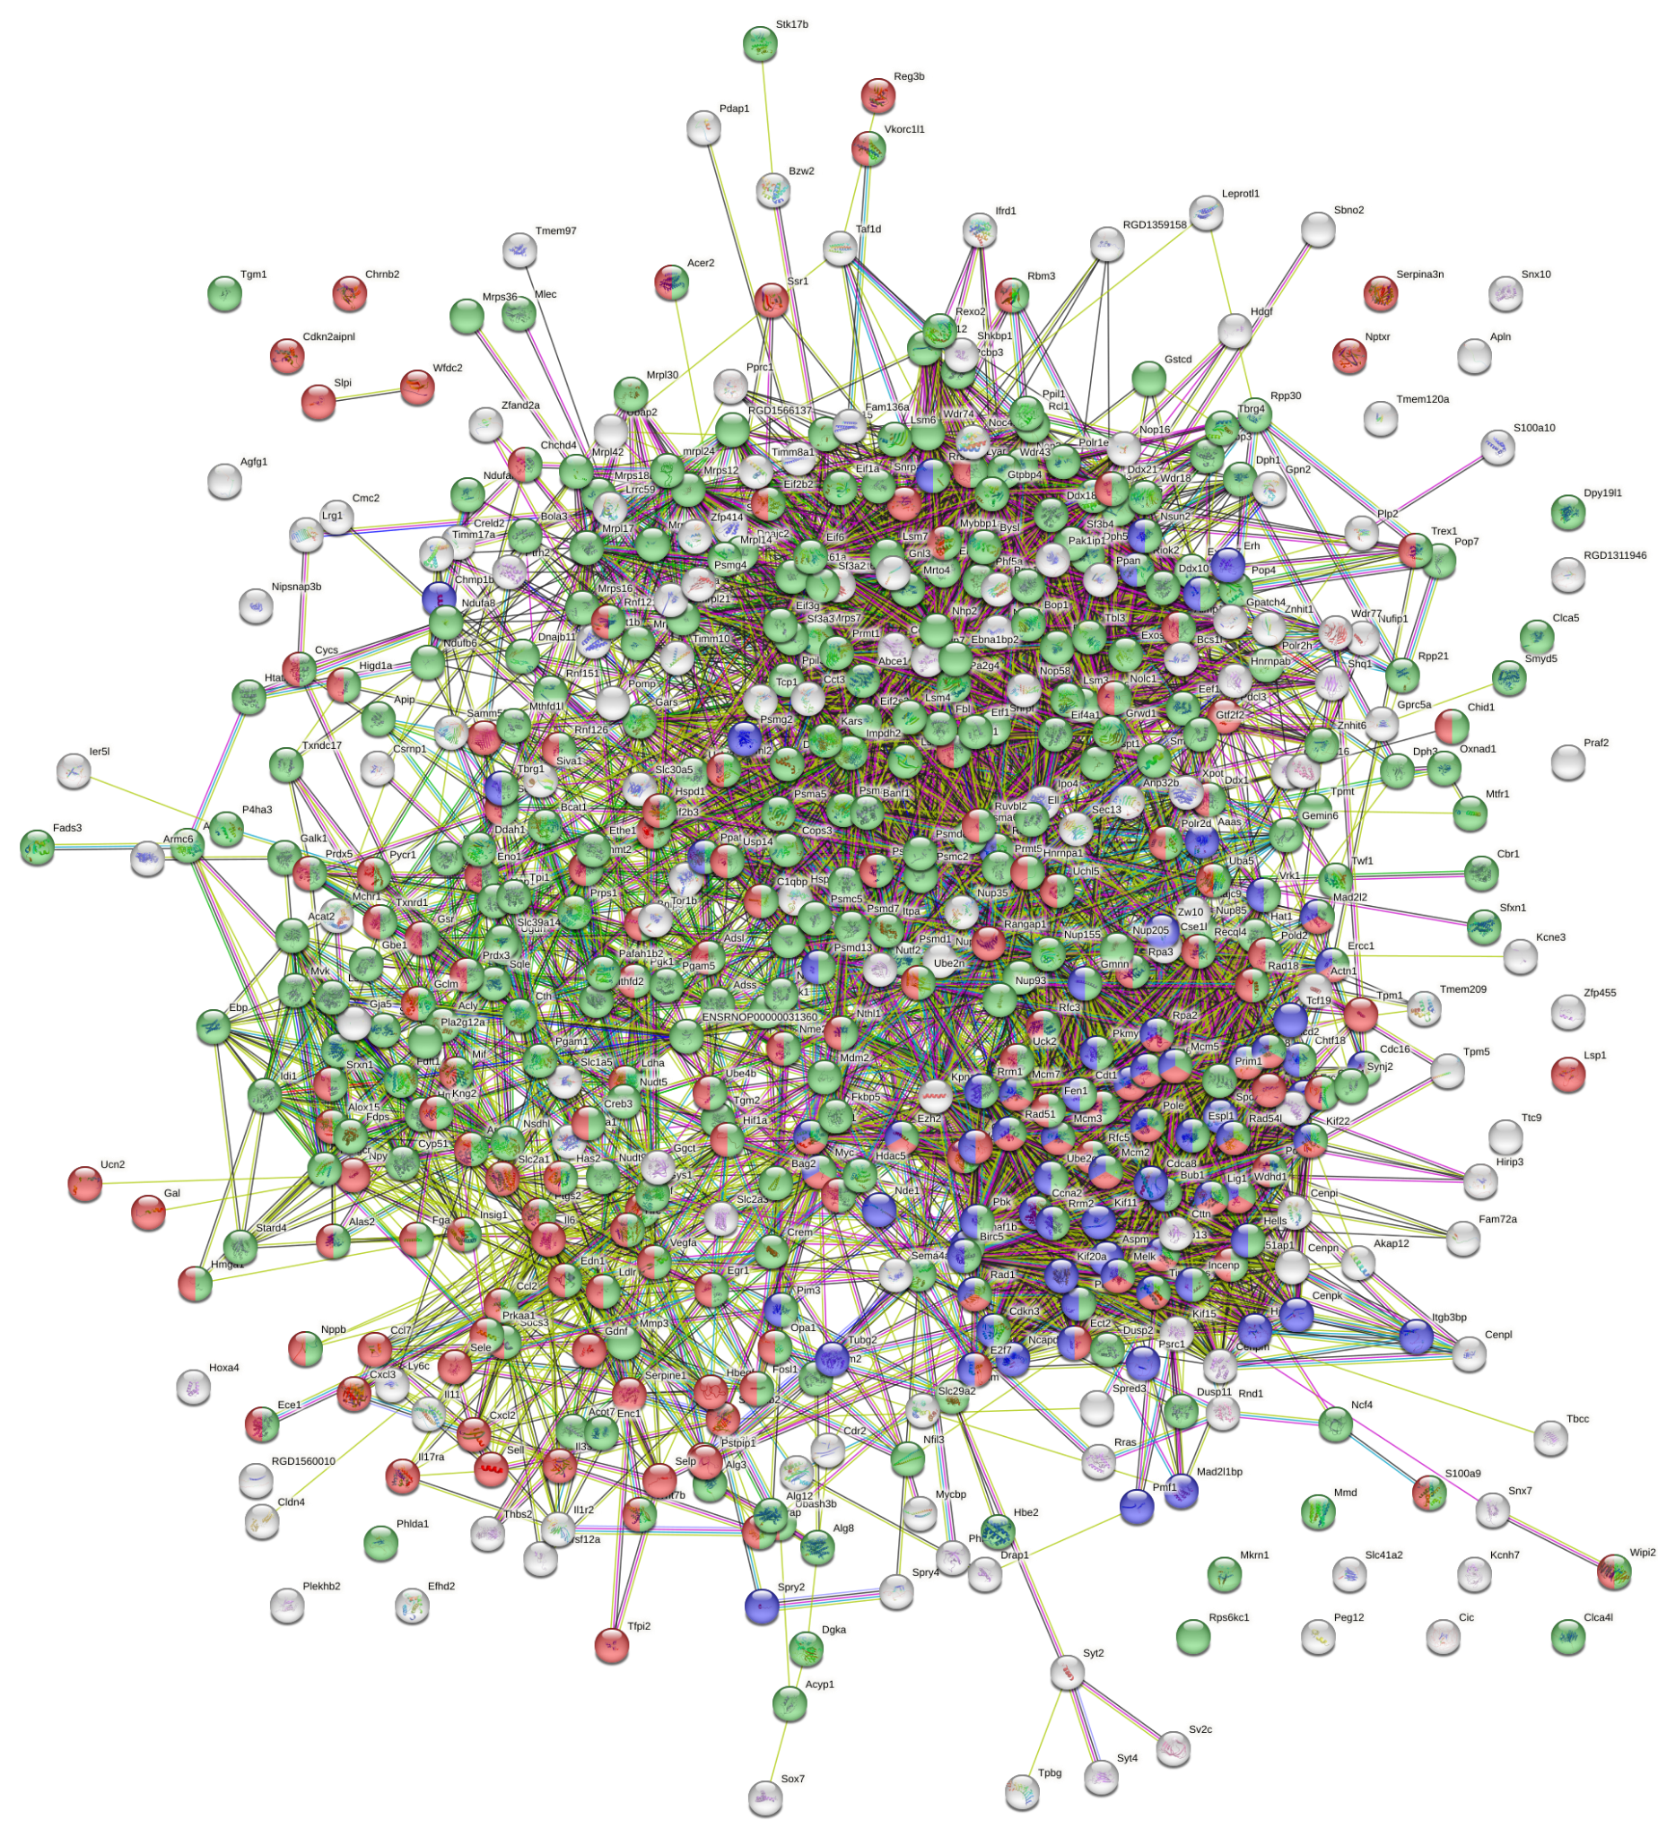
Fig. S11. PPI network for up-regulated T1-specific markers. Red, proteins related to response to stress (GO:0006950). Blue, proteins related to cell cycle (GO:0007049). Green, proteins related to metabolic process (GO:0008152). Permalink: https://version-11-5.string-db.org/cgi/network?networkId=buUPVKYpauPP.
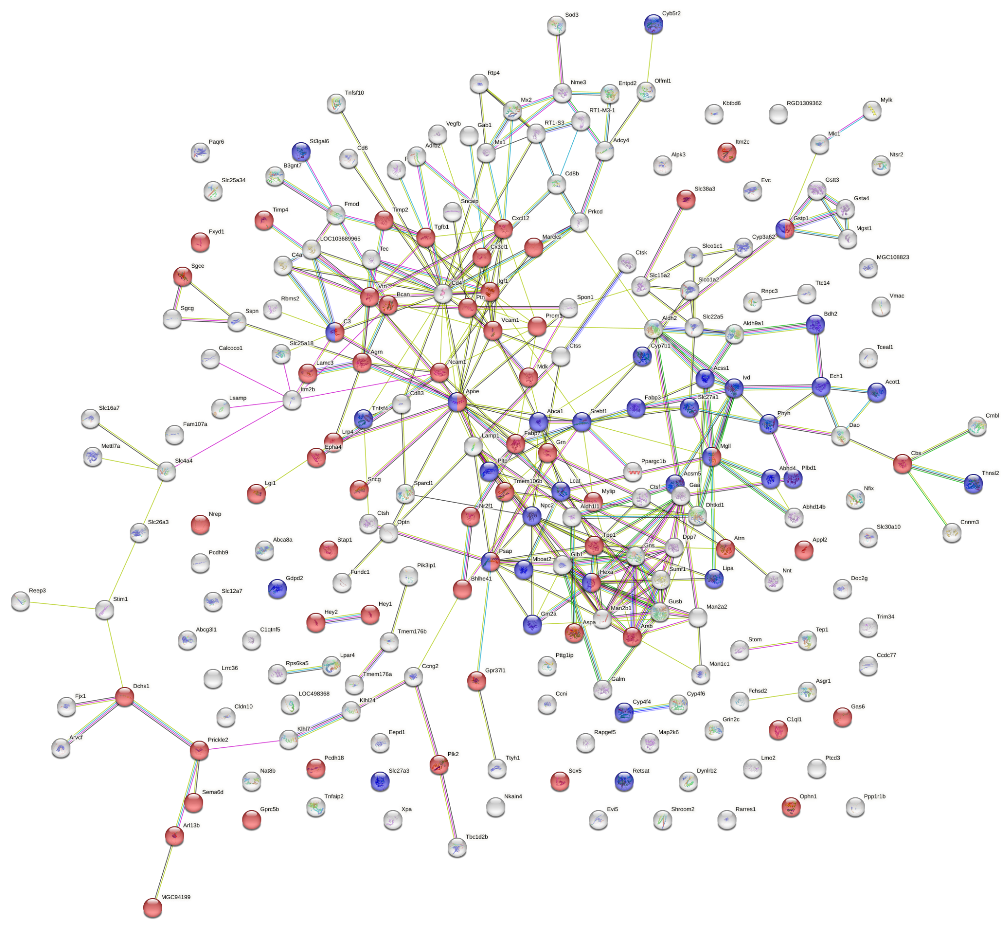
Fig. S12. PPI network for down-regulated T1-specific markers. Red, proteins related to nervous system development (GO:0007399). Blue, proteins related to lipid metabolic process (GO:0006629). Permalink:
https://version-11-5.string-db.org/cgi/network?networkId=bSj43bKYgYVn.

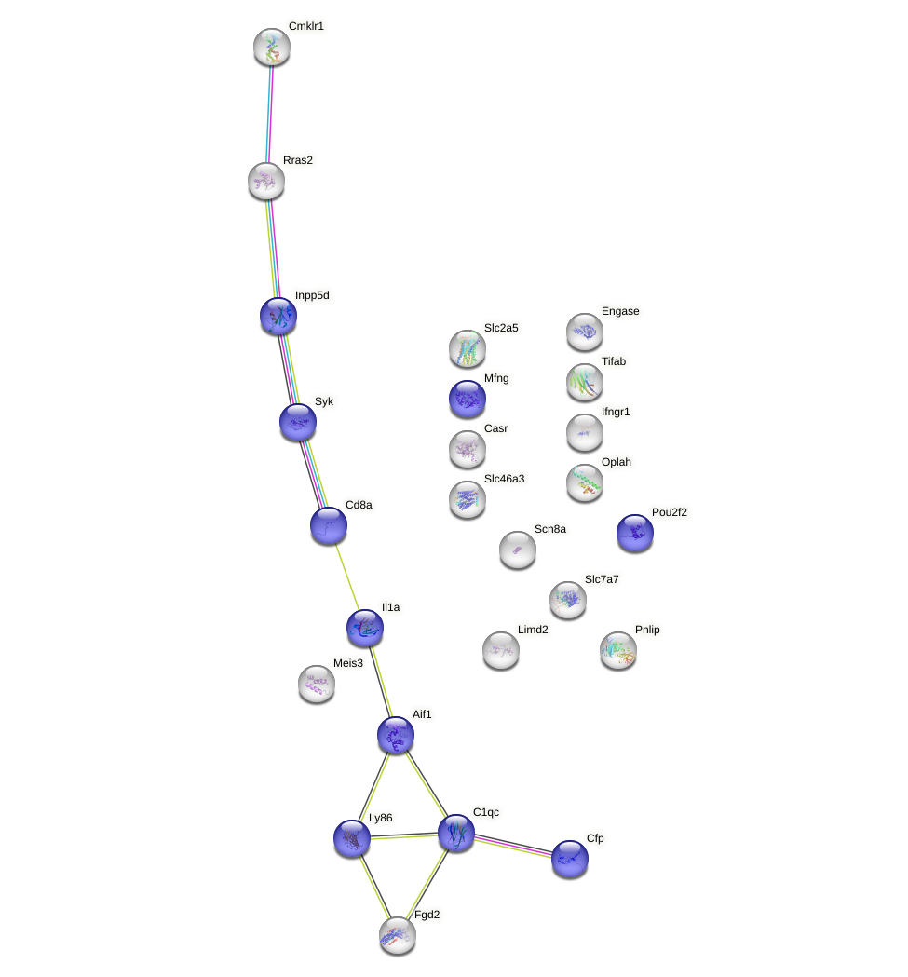
Fig. S13. PPI network for down-regulated T2-specific markers. Blue, proteins related to immune response (GO:0006955). Permalink: https://version-11-5.string-db.org/cgi/network?networkId=bc5iq1DKBY2M.

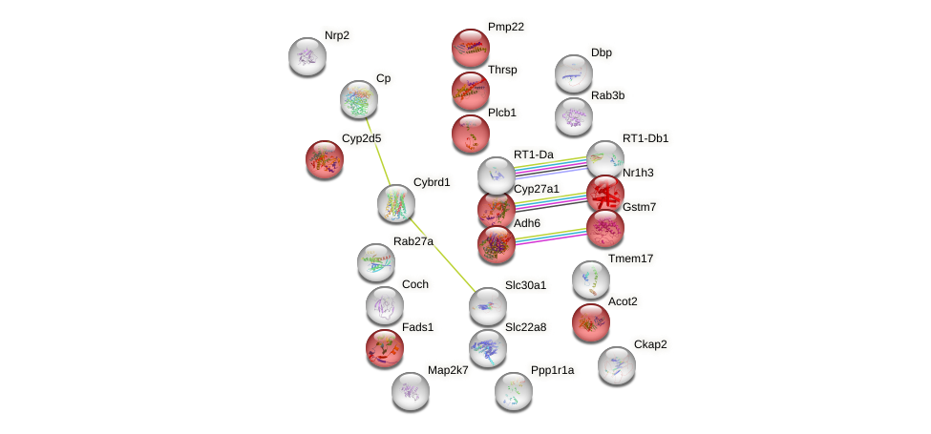
Fig. S14. PPI network T4-specific markers. Red, proteins related to lipid metabolic process (GO:0006629). Permalink:
https://version-11-5.string-db.org/cgi/network?networkId=b7EQWDGipjBn.

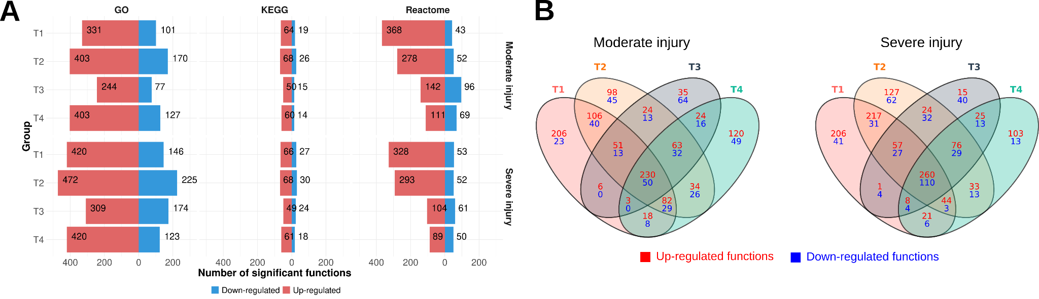

Fig. S15. Gene set analysis reveals altered functions/pathways across time and severity after injury. (A) Number of significantly altered functions for each database and experimental group. Up-regulated (red) and down-regulated (blue) refer to functions with a logarithm of the odds ratio (LOR) value greater or lower than 0, respectively. (B) Venn Diagram of significantly altered functional terms. Relationship between common and unique identified functions in different injury phases (T1, acute; T2, subacute; T3, early chronic; T4, late chronic). Venn diagrams constructed for up-regulated and down-regulated functions in moderate injury (left) and severe injury (right).

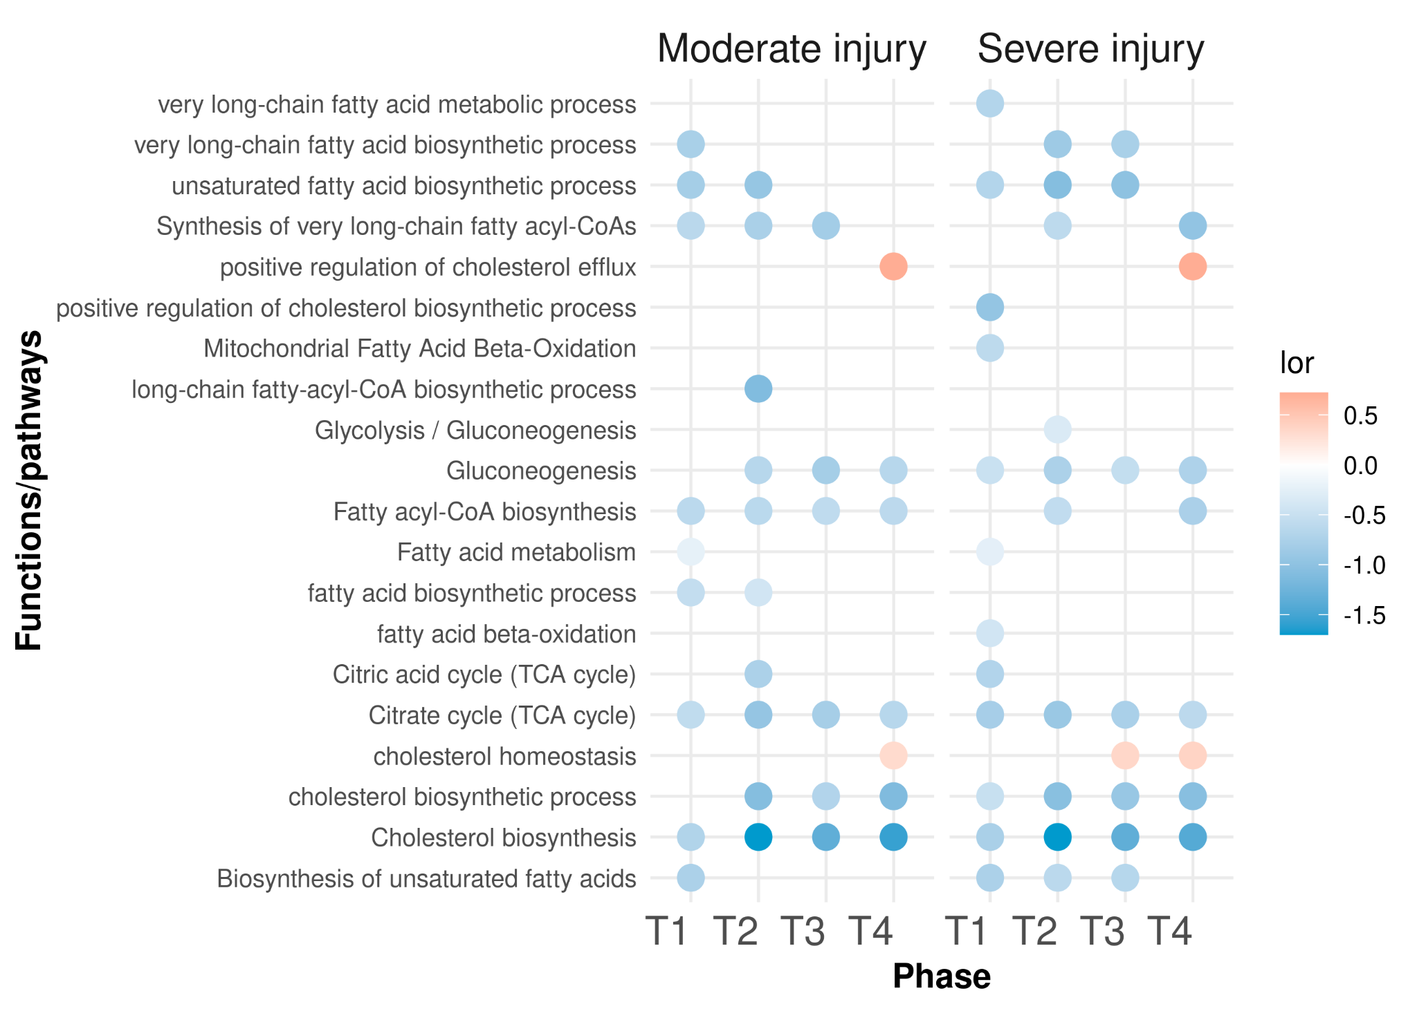
Fig. S16. Dotplot of selection of down-regulated metabolism functions.

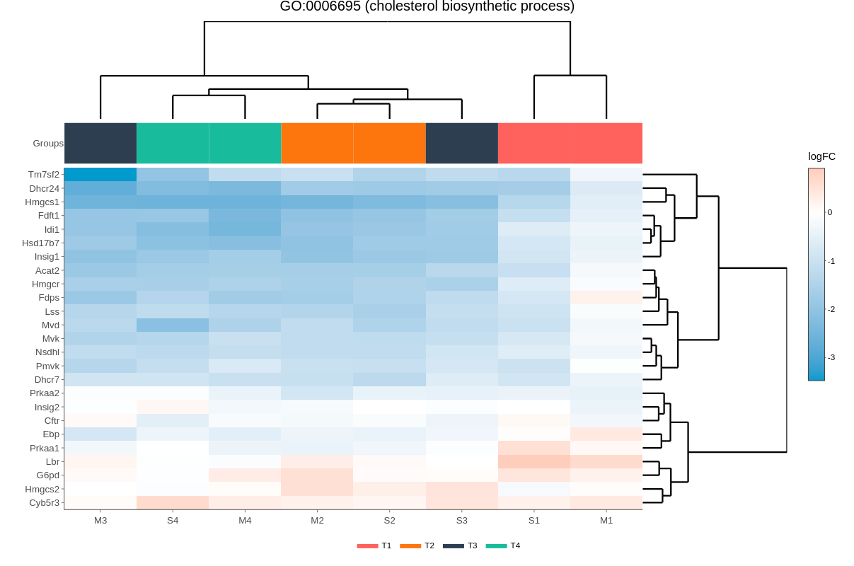
Fig. S17. Hierarchical heatmap of genes in GO term GO:0006695 (cholesterol biosynthetic process).

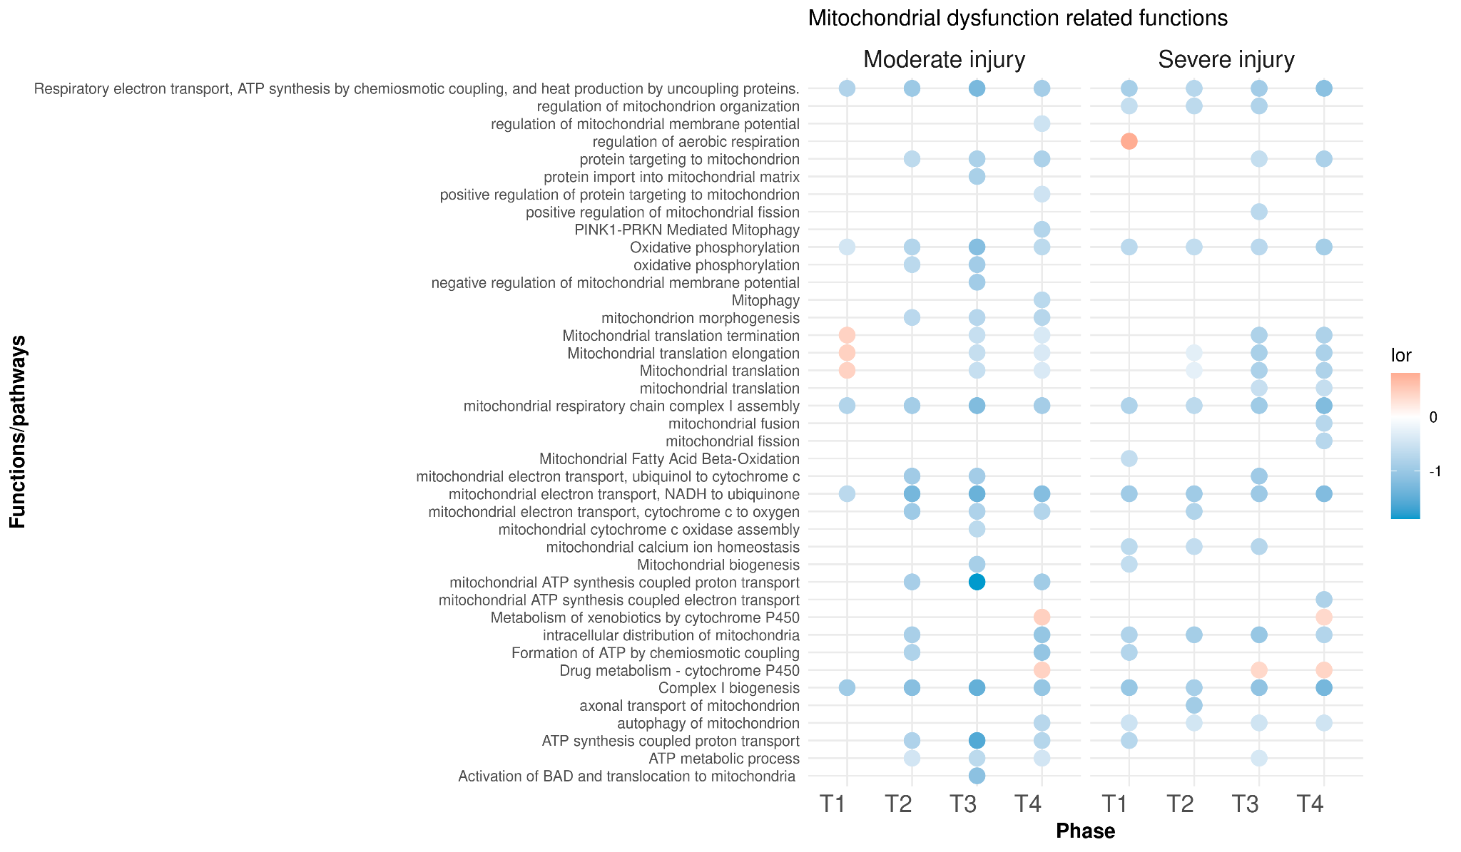
Fig. S18. Dotplot of mitochondria related functions.

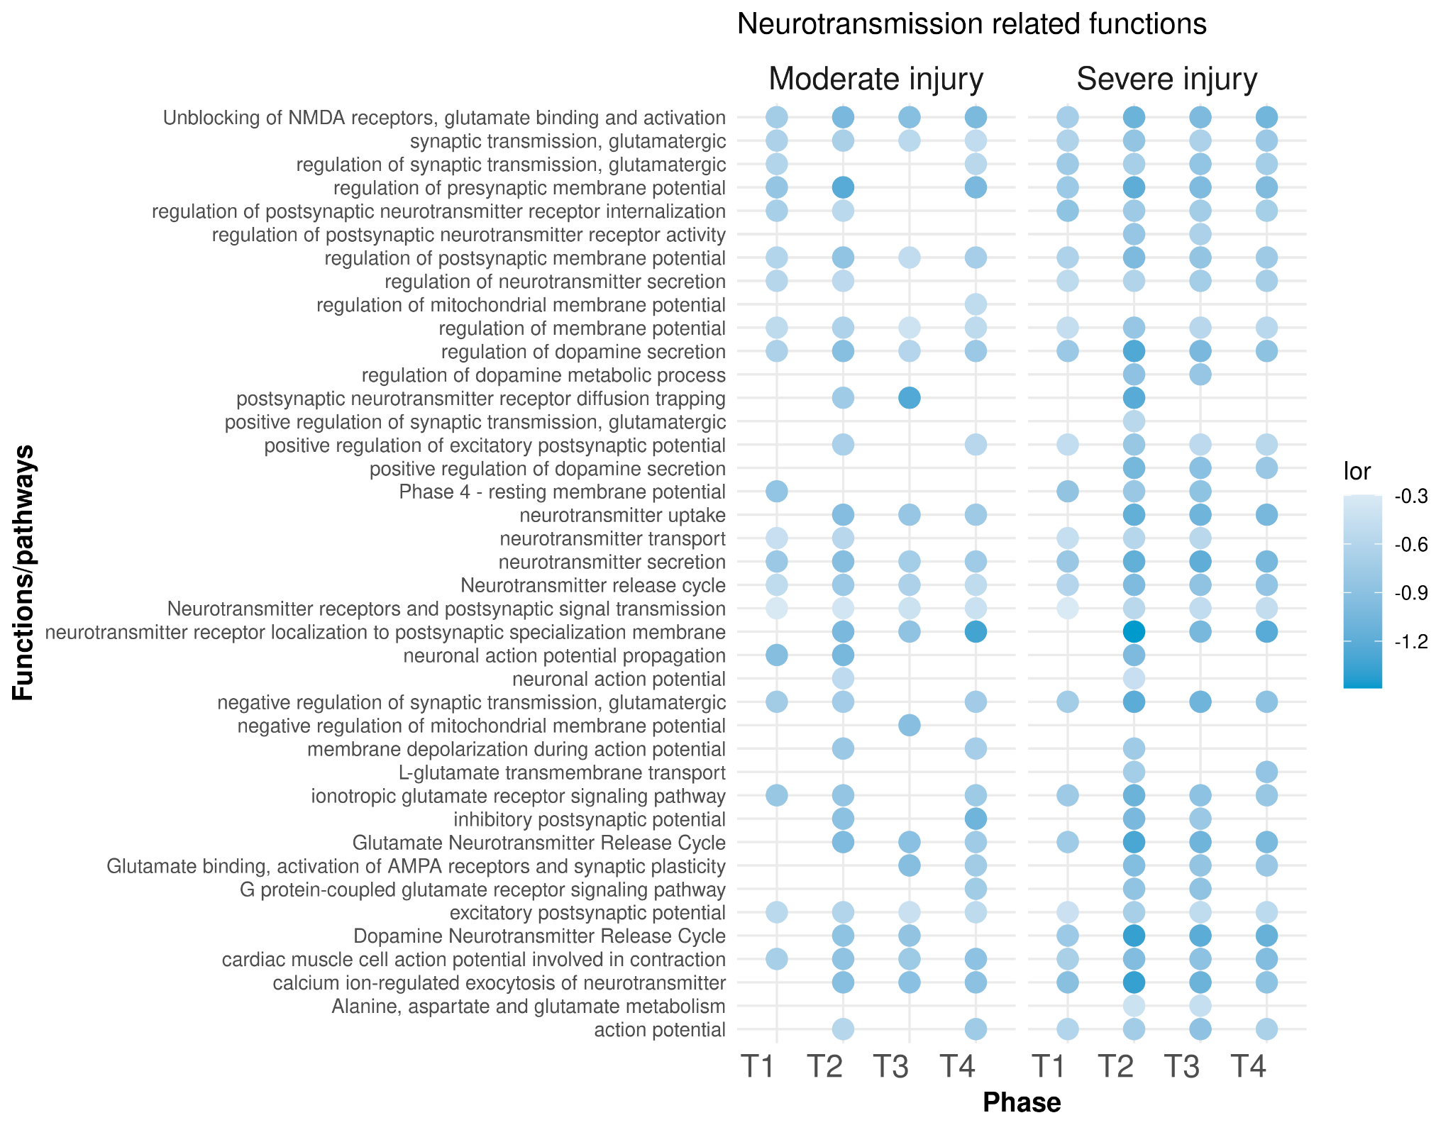
Fig. S19. Dotplot of neurotransmission related functions.

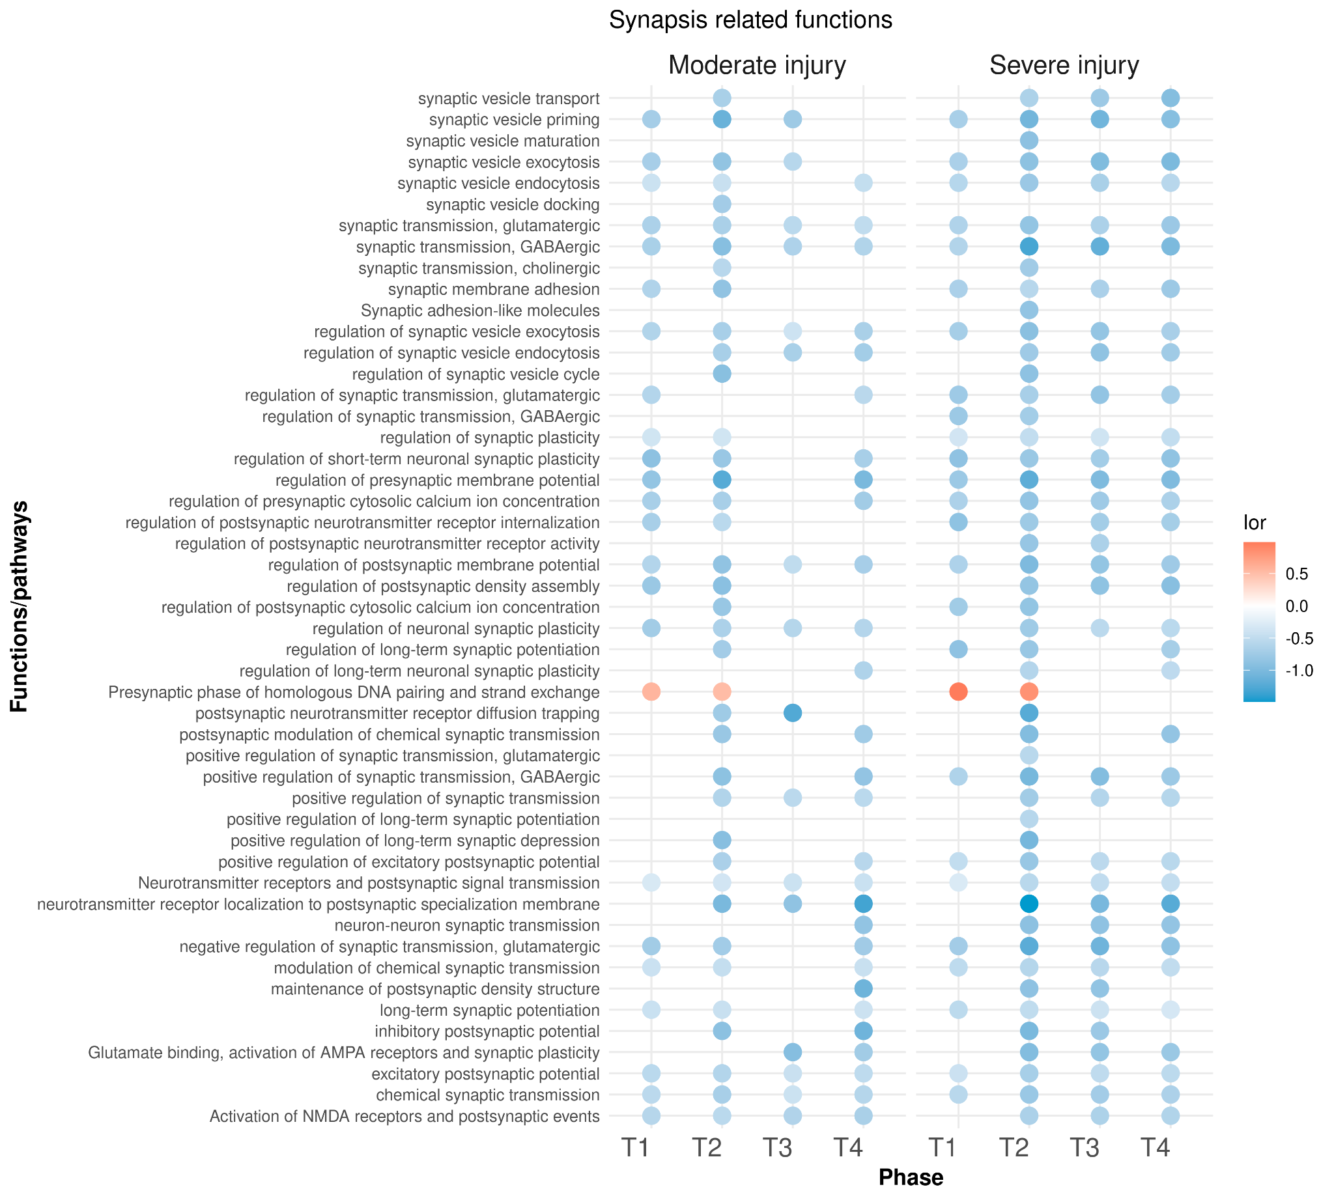
Fig. S20. Dotplot of synapsis related functions.

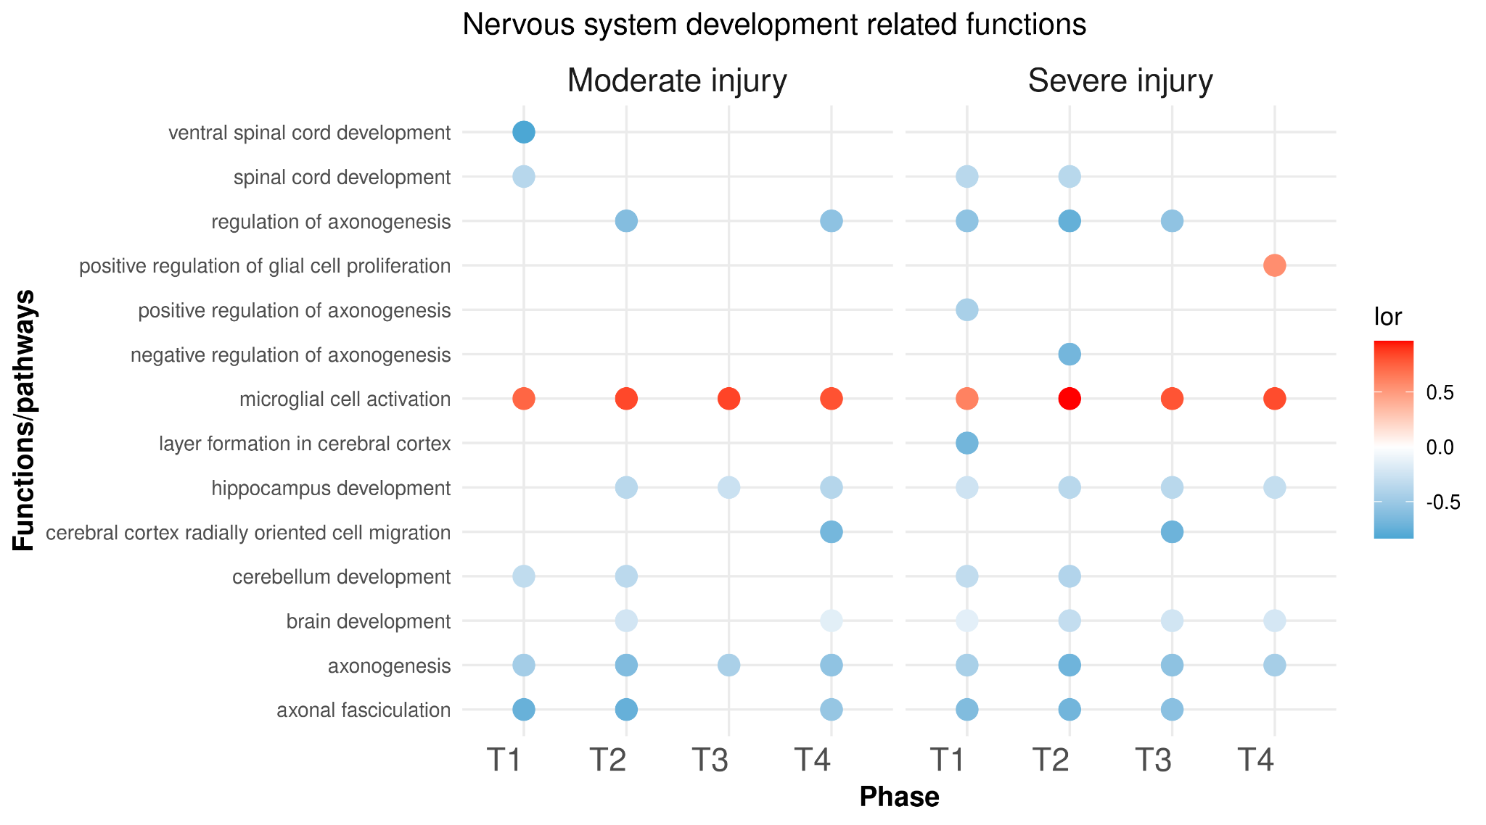
Fig. S21. Dotplot of nervous system development related functions.

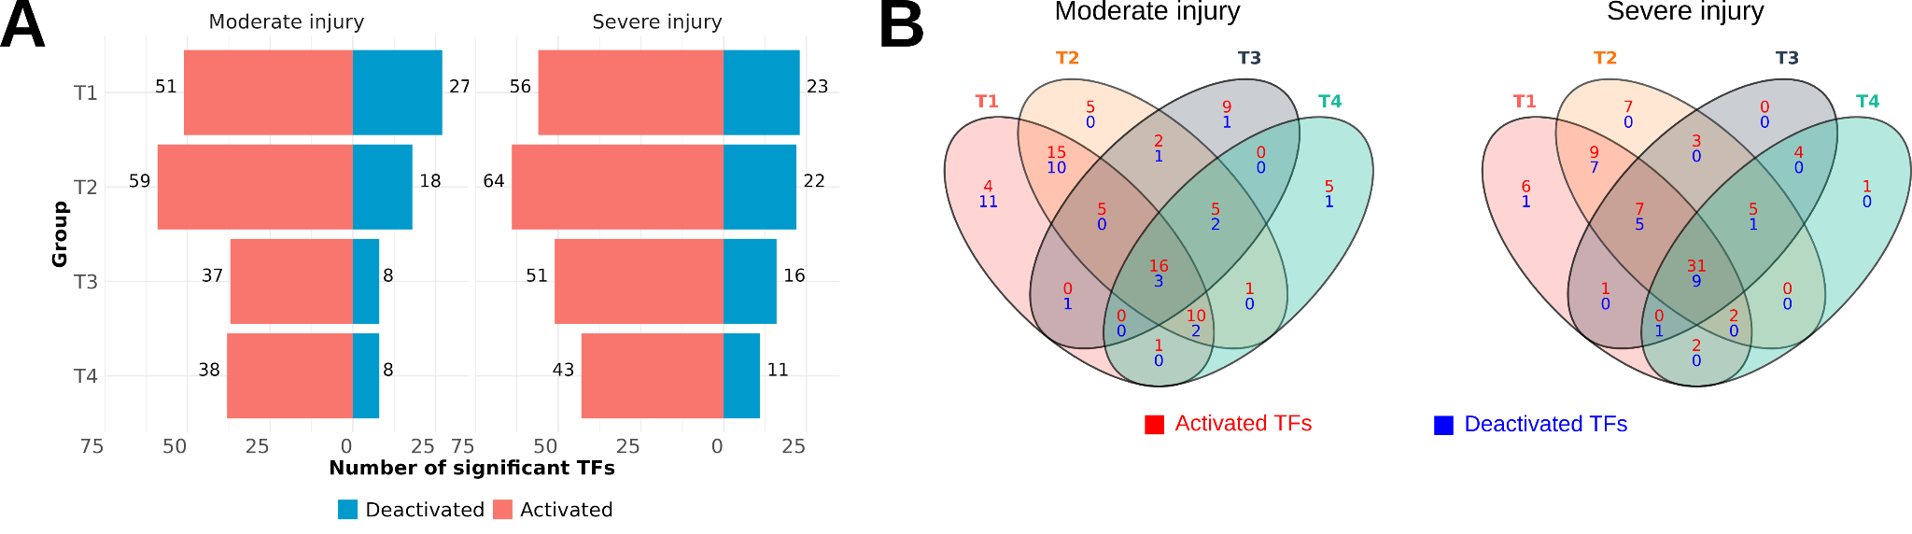
Fig. S22. Summary of transcription factor activity inference analysis. (A) Number of significantly altered TFs for each experimental group. Activated (red) and deactivated (blue) refer to TFs with a NES value greater or lower than 0, respectively. (B) Venn Diagram of significantly altered TFs. Relationship between the common and unique identified functions in different injury phases (T1, acute; T2, subacute, T3., early chronic, T4., late chronic). Venn diagrams constructed for up-regulated and down-regulated functions for moderate (left) and severe injury (right).

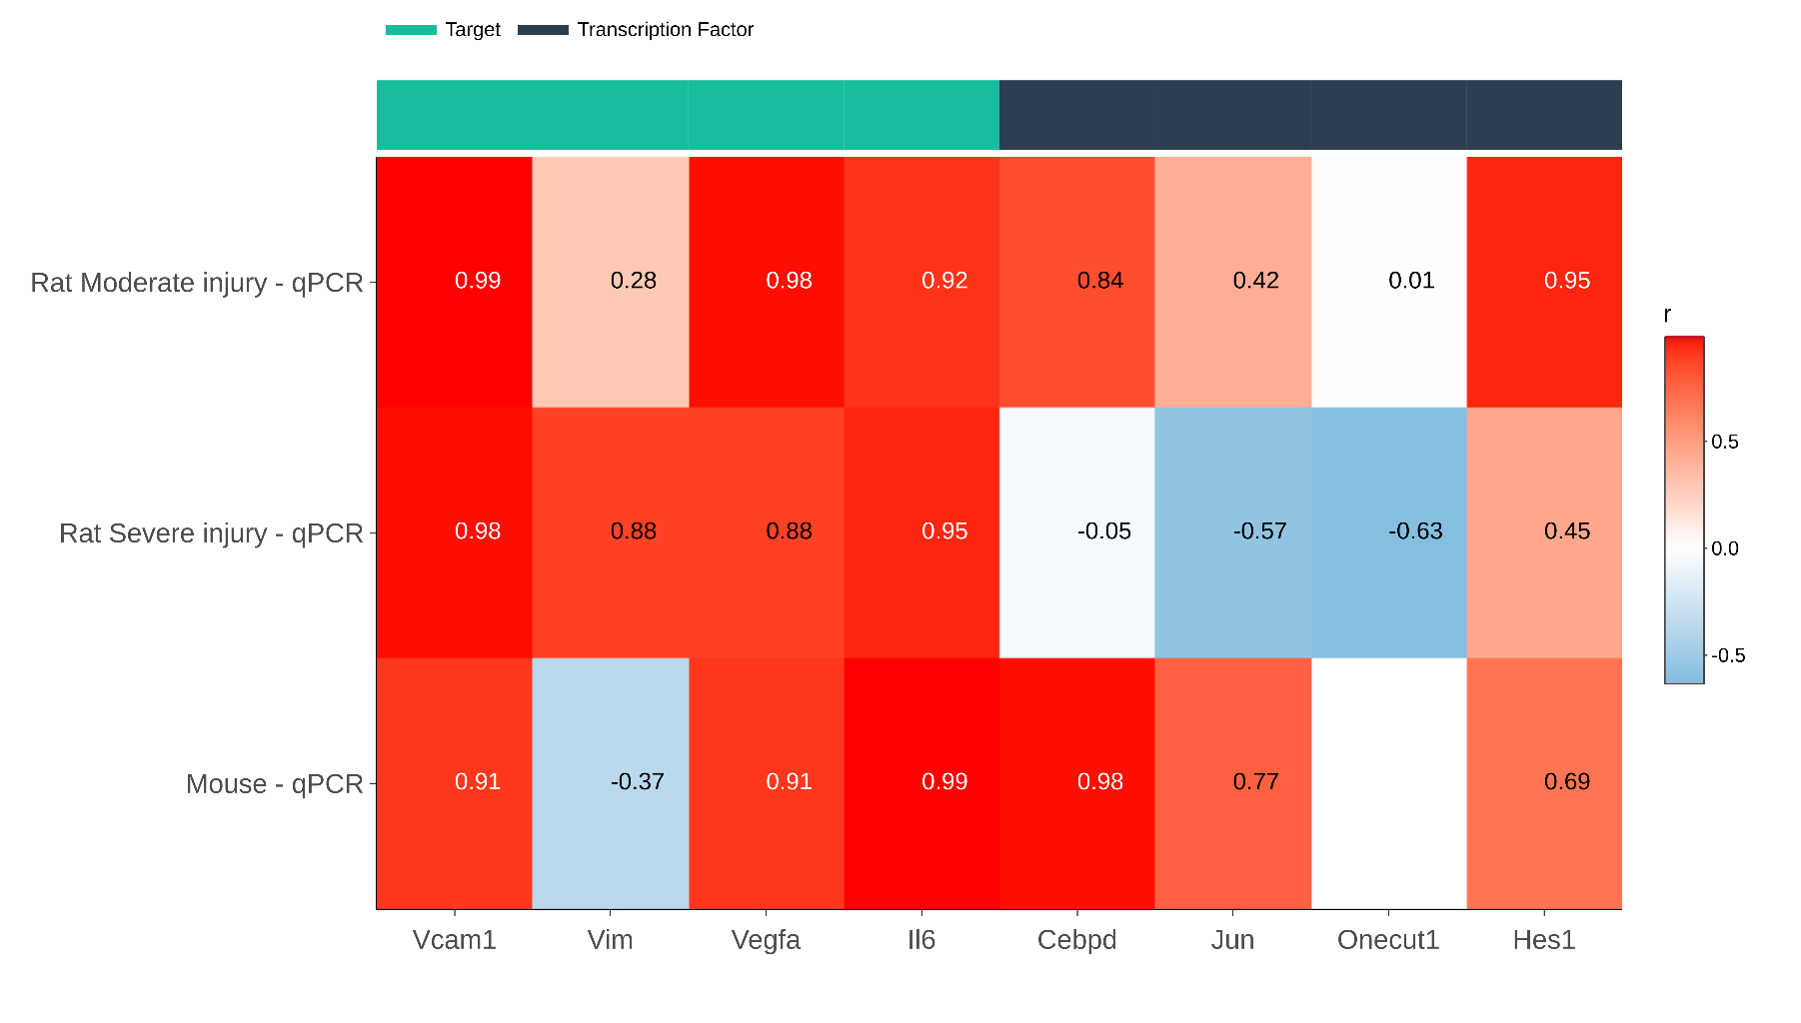
Fig. S23. Pearson correlation coefficient after comparing logFC values obtained in qPCR analysis with those from the rat meta-analysis and mouse dataset.

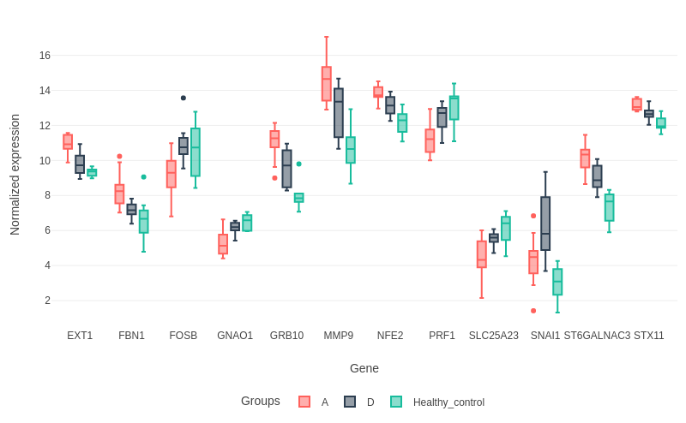
Fig. S24. Normalized expression of 12 gene severity-markers in GSE151371 dataset. Red, AIS A group; black, AIS D group; green, healthy controls. These genes are characterized by an increasing dysregulation as the SCI severity increases.

Supplementary Tables S1-S21 (External Excel files)
Table S1. Studies included in meta-analysis. GEO series ID, platform, year and publications associated from selected datasets are indicated.
Table S2. Injury method for each study. GEO series ID, injury method and category assigned for meta-analysis.
Table S3. Sample annotation. GEO series ID, sample Id, group, severity level, phase and time for each sample.
Table S4. Summary of sample distribution. Barplots showing the sample distribution by study, severity and phase.
Table S5. Comparisons applied for specific biomarkers identification.
Table S6. Severity-specific markers. Limma test results of comparison (S1, S2, S3, S4) vs (M1, M2, M3, M4).
Table S7. T1-specific biomarker genes. Limma test results of comparison (M1, S1) vs (M2, M3, M4, S2, S3, S4).
Table S8. T2-specific biomarker genes. Limma test results of comparison (M2, S2) vs (M1, M3, M4, S1, S3, S4).
Table S9. T3-specific biomarker genes. Limma test results of comparison (M3, S3) vs (M1, M2, M4, S1, S2, S4).
Table S10. T4-specific biomarker genes. Limma test results of comparison (M4, S4) vs (M1, M2, M3, S1, S3, S4).
Table S11. Interactions TF-target.
Table S12. Li et al., 2022 DGE analysis results (1 dpi vs control).
Table S13. Li et al., 2022 DGE analysis results (7 dpi vs control).
Table S14. Li et al., 2022 DGE analysis results (28 dpi vs control).
Table S15. Li et al., 2022 DGE analysis results (42 dpi vs control).
Table S16. Mouse gene expression patterns matrix.
Table S17. Correlation analysis.
Table S18. GSE151371 DEG analysis results (AIS A vs AIS D).
Table S19. Li et al., 2022 mouse dataset sample information.
Table S20. GSE151371 dataset sample information.
Table S21. Primer sequences.

