Supplementary Information for a paper published in “Urban Ecosystems”

Urban woods in a small Mediterranean city: are native vs alien woods lonely together?

Marco Varricchione^{1,3}, Maria L. Carranza^{1,3}, Chiara D’Angeli^{1,2}, Maria C. de Francesco^{1,3,*}, Michele Innangi¹, Lucia A. Santoianni¹, Angela Stanisci^{1,3}

¹EnviXLab, Department of Biosciences and Territory, University of Molise, Contrada Fonte Lappone, I-86090 Pesche, IS, Italy.
²Italian Institute for Environmental Protection and Research, ISPRA, Roma (RM), Italy.
³National Biodiversity Future Center (NBFC), I-90133 Palermo, PA, Italy.

*Corresponding: maria.defrancesco@unimol.it

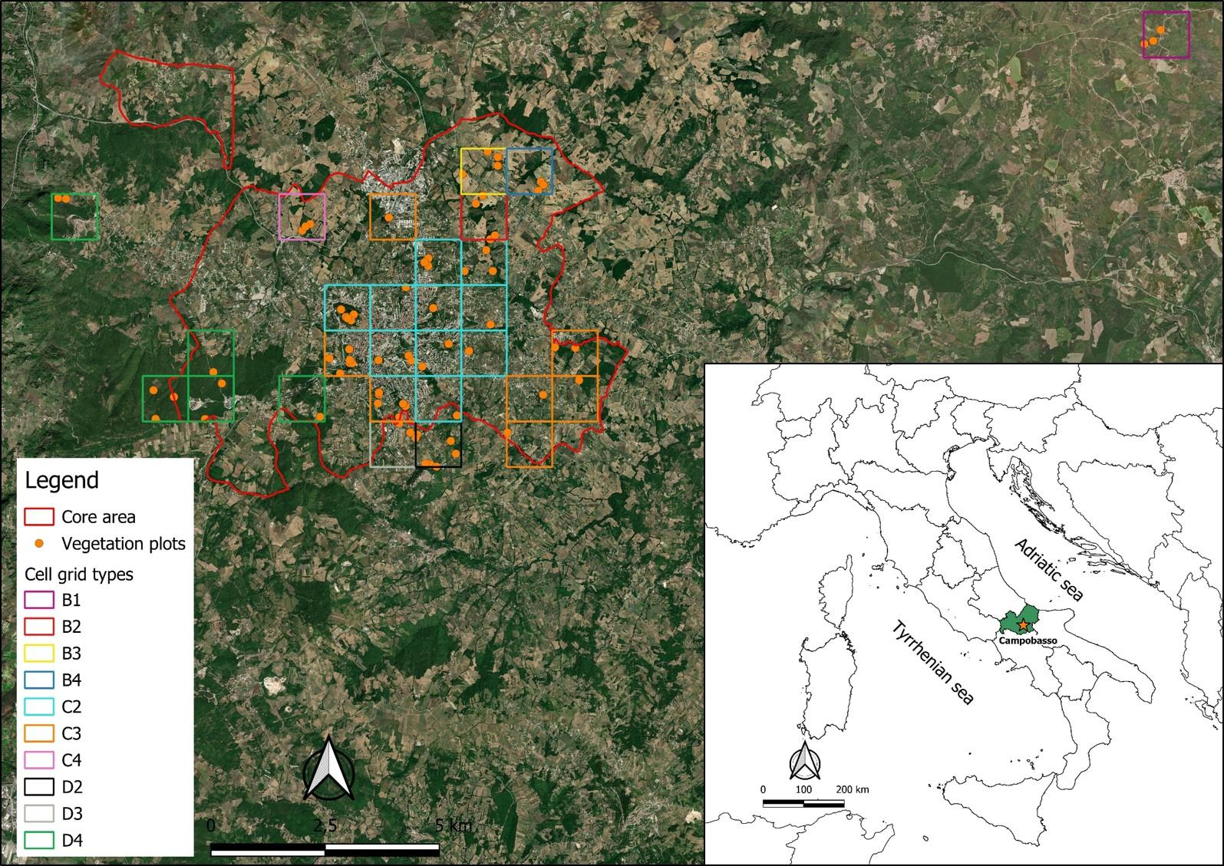
Fig S1 Study area along with the 10 cell grid types and the distribution of 74 vegetation plots

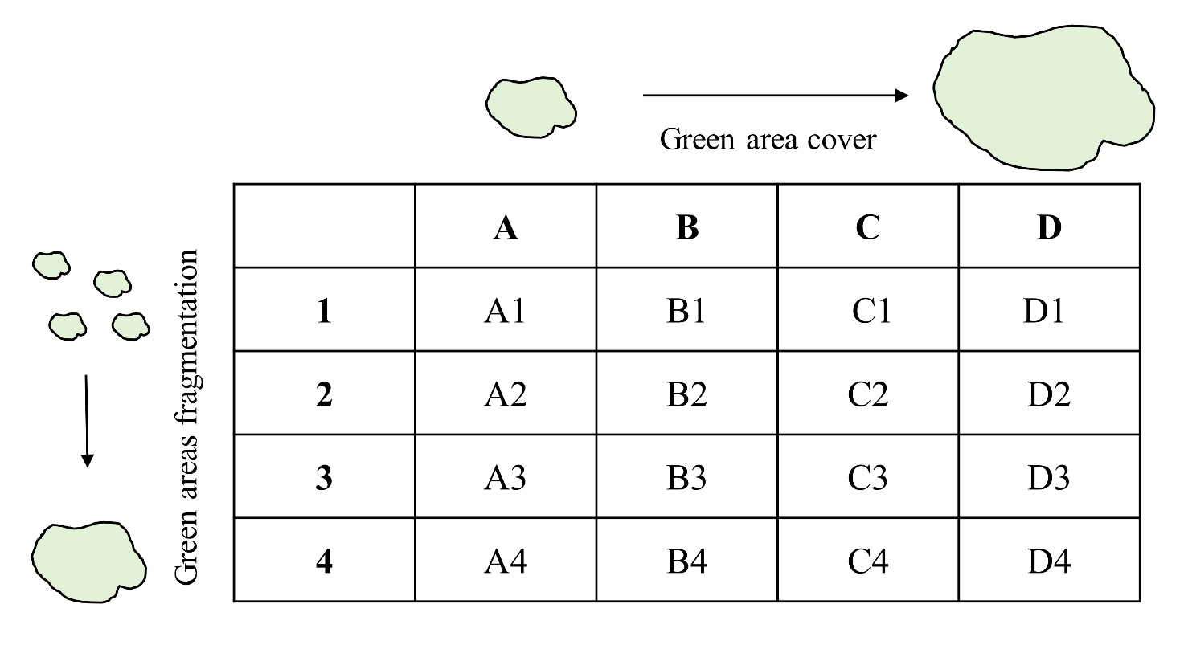
Fig S2 Summary description of the gradient of green areas cover and fragmentation used for the cell grid types classification, according to the Italian National Biodiversity Future Center (NBFC) methodological protocol for studying the urban biodiversity in Italian cities (Sabelli 2023).

Table S1 Species list found in Campobasso city along with their Status, Plant Growth Habit and species Frequency % per plot in each wood type and in total. Nomenclature follows Pignatti et al. (2017)
 |  |  | Frequency (%) in
Species | Status | Plant Growth Habit | T1932 - Quercus pubescens | T19511 - Quercus cerris | T19512 - Quercus frainetto | T142 - Salix alba | T1J - Robinia pseudoacacia | T3 - Pinus nigra | Total Frequency (%)
Acer campestre | Native | Tree | 82.35 | 83.33 | 52.94 | 16.67 | 25 | 30 | 54.05
Acer monspessulanum | Native | Tree | 5.88 | 0 | 0 | 0 | 0 | 0 | 1.35
Acer opalus | Native | Tree | 0 | 8.33 | 0 | 0 | 0 | 10 | 2.70
Acer platanoides | Native | Tree | 0 | 0 | 0 | 0 | 0 | 10 | 1.35
Acer pseudoplatanus | Native | Tree | 5.88 | 0 | 0 | 0 | 8.33 | 10 | 4.05
Aesculus hippocastanum | Alien | Tree | 0 | 8.33 | 0 | 0 | 0 | 10 | 2.70
Ailanthus altissima | Alien | Tree | 5.88 | 0 | 0 | 0 | 8.33 | 30 | 6.76
Asparagus acutifolius | Native | Shrub | 64.71 | 33.33 | 35.29 | 0 | 0 | 30 | 32.43
Carpinus orientalis | Native | Tree | 17.65 | 41.67 | 47.06 | 0 | 0 | 0 | 21.62
Castanea sativa | Native | Tree | 0 | 0 | 5.88 | 0 | 0 | 0 | 1.35
Cedrus libani | Alien | Tree | 0 | 0 | 0 | 0 | 0 | 20 | 2.70
Cercis siliquastrum | Native | Tree | 0 | 0 | 0 | 0 | 0 | 10 | 1.35
Cistus salvifolius | Native | Tree | 0 | 0 | 5.88 | 0 | 0 | 0 | 1.35
Clematis vitalba | Native | Climbing | 52.94 | 33.33 | 35.29 | 66.67 | 66.67 | 60 | 50.00
Cornus mas | Native | Tree | 5.88 | 0 | 0 | 16.67 | 0 | 0 | 2.70
Cornus sanguinea | Native | Tree | 82.35 | 83.33 | 70.59 | 33.33 | 33.33 | 0 | 56.76
Corylus avellana | Native | Tree | 0 | 0 | 0 | 16.67 | 0 | 0 | 1.35
Crataegus laevigata | Native | Tree | 5.88 | 0 | 5.88 | 16.67 | 0 | 0 | 4.05
Crataegus monogyna | Native | Tree | 88.24 | 100 | 64.71 | 33.33 | 41.67 | 60 | 68.92
Cupressus arizonica | Alien | Tree | 0 | 8.33 | 0 | 0 | 0 | 30 | 5.41
Cupressus sempervirens | Alien | Tree | 0 | 0 | 0 | 0 | 0 | 40 | 5.41
Cytisus villosus | Native | Shrub | 5.88 | 8.33 | 17.65 | 0 | 0 | 0 | 6.76
Daphne laureola | Native | Shrub | 0 | 8.33 | 0 | 0 | 0 | 0 | 1.35
Emerus major subsp. emeroides | Native | Tree | 41.18 | 16.67 | 11.76 | 0 | 0 | 10 | 16.22
Euonymus europaeus | Native | Tree | 17.65 | 16.67 | 23.53 | 33.33 | 25 | 30 | 22.97
Ficus carica | Native | Tree | 11.76 | 0 | 5.88 | 0 | 16.67 | 0 | 6.76
Fraxinus excelsior | Native | Tree | 17.65 | 0 | 0 | 0 | 0 | 10 | 5.41
Fraxinus ornus | Native | Tree | 58.82 | 33.33 | 41.18 | 0 | 8.33 | 70 | 39.19
Fraxinus oxycarpa | Native | Tree | 0 | 0 | 5.88 | 0 | 0 | 0 | 1.35
Genista tinctoria | Native | Shrub | 0 | 8.33 | 5.88 | 0 | 0 | 0 | 2.70
Hedera helix | Native | Climbing | 64.71 | 91.67 | 94.12 | 50 | 25 | 50 | 66.22
Juglans regia | Native | Tree | 0 | 0 | 0 | 0 | 8.33 | 30 | 5.41
Laurus nobilis | Native | Tree | 5.88 | 16.67 | 23.53 | 0 | 0 | 20 | 12.16
Ligustrum japonicum | Alien | Shrub | 0 | 0 | 0 | 0 | 8.33 | 0 | 1.35
Ligustrum vulgare | Native | Shrub | 82.35 | 91.67 | 88.24 | 16.67 | 8.33 | 0 | 56.76
Lonicera caprifolium | Native | Climbing | 70.59 | 58.33 | 88.24 | 16.67 | 16.67 | 10 | 51.35
Lonicera implexa | Native | Climbing | 0 | 0 | 11.76 | 0 | 0 | 0 | 2.70
Malus sylvestris | Native | Tree | 5.88 | 0 | 0 | 16.67 | 0 | 0 | 2.70
Olea europaea | Native | Tree | 0 | 0 | 5.88 | 0 | 8.33 | 20 | 5.41
Ostrya carpinifolia | Native | Tree | 5.88 | 8.33 | 11.76 | 0 | 0 | 0 | 5.41
Osyris alba | Native | Shrub | 11.76 | 0 | 0 | 0 | 0 | 0 | 2.70
Phyllirea latifolia | Native | Tree | 11.76 | 0 | 0 | 0 | 0 | 0 | 2.70
Picea abies | Native | Tree | 0 | 0 | 0 | 0 | 0 | 10 | 1.35
Pinus nigra | Native | Tree | 0 | 0 | 0 | 0 | 0 | 70 | 9.46
Populus alba | Native | Tree | 0 | 0 | 0 | 0 | 8.33 | 0 | 1.35
Populus nigra | Native | Tree | 0 | 0 | 0 | 50 | 16.67 | 0 | 6.76
Populus tremula | Native | Tree | 0 | 0 | 5.88 | 0 | 8.33 | 0 | 2.70
Prunus avium | Native | Tree | 29.41 | 33.33 | 47.06 | 0 | 16.67 | 20 | 28.38
Prunus cerasifera | Native | Tree | 0 | 0 | 0 | 0 | 8.33 | 0 | 1.35
Prunus domestica | Native | Tree | 0 | 0 | 0 | 0 | 0 | 10 | 1.35
Prunus dulcis | Native | Tree | 0 | 0 | 0 | 0 | 8.33 | 0 | 1.35
Prunus spinosa | Native | Tree | 76.47 | 75 | 64.71 | 33.33 | 8.33 | 40 | 54.05
Pyrus communis | Native | Tree | 11.76 | 0 | 0 | 0 | 0 | 10 | 4.05
Pyrus cordata | Native | Tree | 17.65 | 8.33 | 0 | 16.67 | 0 | 0 | 6.76
Pyrus pyraster | Native | Tree | 0 | 8.33 | 0 | 0 | 0 | 20 | 4.05
Quercus cerris | Native | Tree | 64.71 | 100 | 94.12 | 33.33 | 8.33 | 40 | 62.16
Quercus frainetto | Native | Tree | 0 | 8.33 | 100 | 16.67 | 0 | 0 | 25.68
Quercus ilex | Native | Tree | 11.76 | 8.33 | 23.53 | 0 | 0 | 80 | 20.27
Quercus pubescens | Native | Tree | 94.12 | 0 | 0 | 0 | 0 | 30 | 25.68
Quercus robur | Native | Tree | 0 | 0 | 5.88 | 0 | 0 | 0 | 1.35
Quercus virgiliana | Native | Tree | 5.88 | 8.33 | 0 | 0 | 0 | 0 | 2.70
Rhamnus cathartica | Native | Tree | 5.88 | 0 | 0 | 16.67 | 0 | 10 | 4.05
Rhamnus saxatilis | Native | Shrub | 0 | 0 | 0 | 0 | 0 | 10 | 1.35
Robinia pseudoacacia | Alien | Tree | 5.88 | 16.67 | 23.53 | 0 | 100 | 0 | 25.68
Rosa agrestis | Native | Shrub | 5.88 | 8.33 | 0 | 0 | 0 | 0 | 2.70
Rosa arvensis | Native | Shrub | 29.41 | 25 | 23.53 | 0 | 8.33 | 0 | 17.57
Rosa canina | Native | Shrub | 5.88 | 8.33 | 17.65 | 16.67 | 0 | 0 | 8.11
Rosa micrantha | Native | Shrub | 5.88 | 0 | 0 | 0 | 0 | 0 | 1.35
Rosa sempervirens | Native | Shrub | 23.53 | 16.67 | 17.65 | 16.67 | 8.33 | 0 | 14.86
Rosa sp. | Native | Shrub | 5.88 | 8.33 | 29.41 | 16.67 | 8.33 | 20 | 14.86
Rubus hirtus | Native | Shrub | 17.65 | 25 | 47.06 | 16.67 | 25 | 20 | 27.03
Rubus ulmifolius | Native | Shrub | 88.24 | 50 | 41.18 | 100 | 75 | 30 | 62.16
Ruscus aculeatus | Native | Shrub | 35.29 | 58.33 | 76.47 | 16.67 | 8.33 | 0 | 37.84
Salix alba | Native | Tree | 0 | 0 | 0 | 66.67 | 8.33 | 0 | 6.76
Salix appendiculata | Native | Tree | 0 | 0 | 0 | 16.67 | 0 | 0 | 1.35
Salix pentandra | Native | Tree | 0 | 0 | 0 | 0 | 0 | 10 | 1.35
Sambucus ebulus | Native | Shrub | 0 | 0 | 0 | 0 | 8.33 | 0 | 1.35
Sambucus nigra | Native | Tree | 0 | 0 | 0 | 16.67 | 41.67 | 20 | 10.81
Smilax aspera | Native | Climbing | 5.88 | 0 | 0 | 0 | 0 | 0 | 1.35
Sorbus aucuparia | Native | Tree | 0 | 8.33 | 0 | 0 | 0 | 0 | 1.35
Sorbus domestica | Native | Tree | 23.53 | 33.33 | 29.41 | 0 | 0 | 20 | 20.27
Sorbus torminalis | Native | Tree | 23.53 | 50 | 47.06 | 0 | 0 | 0 | 24.32
Spartium junceum | Native | Tree | 23.53 | 0 | 5.88 | 16.67 | 0 | 10 | 9.46
Tamus communis | Native | Climbing | 58.82 | 41.67 | 64.71 | 16.67 | 66.67 | 20 | 50.00
Taxus baccata | Native | Tree | 11.76 | 0 | 0 | 0 | 0 | 0 | 2.70
Teucrium chamaedrys | Native | Shrub | 5.88 | 0 | 0 | 0 | 0 | 0 | 1.35
Tilia cordata | Native | Tree | 0 | 0 | 0 | 0 | 0 | 10 | 1.35
Trachycarpus fortunei | Alien | Tree | 5.88 | 0 | 0 | 0 | 0 | 0 | 1.35
Ulmus minor | Native | Tree | 47.06 | 33.33 | 11.76 | 50 | 41.67 | 40 | 35.14
Viburnum tinus | Native | Tree | 5.88 | 0 | 0 | 0 | 0 | 30 | 5.41

Table S2 List of most abundant woody species (cover > 80%) of the three layers (Tree, Shrub and Climbing) in each wood type along with EUNIS habitat name and code. Bold form highlights alien species (Galasso et al. 2018). Nomenclature follows Pignatti et al. (2017)

EUNIS Habitat |  |  | Most abundant species (Cover > 80%)
Code | Name | Abbreviation | Tree | Shrub | Climbing
T1932 | Italo-Sicilian Quercus pubescens forests | Quercus pubescens | Quercus pubescens, Crataegus monogyna, Prunus spinosa, Quercus cerris, Cornus sanguinea, Fraxinus ornus, Acer campestre, Ulmus minor, Emeros major subsp. emeroides | Ligustrum vulgare, Rubus ulmifolius, Asparagus acutifolius, Ruscus aculeatus | Hedera helix, Lonicera caprifolium, Tamus communis, Clematis vitalba
T19511 | Southern Italic Quercus cerris forests | Quercus cerris | Quercus cerris, Crataegus monogyna, Acer campestre, Cornus sanguinea, Prunus spinosa, Carpinus orientalis, Sorbus torminalis, Fraxinus ornus | Ligustrum vulgare, Rubus ulmifolius, Ruscus aculeatus | Hedera helix, Lonicera caprifolium, Tamus communis, Clematis vitalba
T19512 | Southern Italic Quercus frainetto forests | Quercus frainetto | Quercus frainetto, Quercus cerris, Cornus sanguinea, Prunus spinosa, Prunus avium, Acer campestre, Crataegus monogyna, Sorbus torminalis, Carpinus orientalis, Fraxinus ornus | Ligustrum vulgare, Ruscus aculeatus, Rubus ulmifolius, Rubus hirtus, Asparagus acutifolius | Hedera helix, Lonicera caprifolium, Tamus communis,
T142 | Mediterranea riparian Populus forest | Salix alba | Salix alba, Populus nigra, Ulmus minor, Prunus spinosa, Euonymus europaeus, Cornus sanguinea, Crataegus monogyna, Quercus cerris | Rubus ulmifolius, Rubus hirtus, Ruscus aculeatus, Rosa sempervirens, Rosa sp. | Clematis vitalba, Hedera helix
T1J | Deciduous self sown forest of non site-native trees | Robinia pseudoacacia | Robinia pseudoacacia, Ulmus minor, Cornus sanguinea, Sambucus nigra, Crataegus monogyna, Euonymus aeuropaeus, Prunus avium | Rubus ulmifolius, Rubus hirtus | Tamus communis, Clematis vitalba, Hedera helix
T3 | Coniferous forest | Pinus nigra | Fraxinus ornus, Quercus ilex, Pinus nigra, Crataegus monogyna, Quercus cerris, Cupressus arizonica, Prunus spinosa, Quercus pubscens, Cupressus sempervirens, Ulmus minor, Ailanthus altissima, Viburnum tinus, Cedrus libani, Juglans regia, Prunus avium, Sambucum nigra | Rubus ulmifolius, Asparagus acutifolius, Rubus hirtus | Clematis vitalba, Hedera helix, Tamus communis

Table S3 Results from the Poisson model between plot counts and the interaction between each wood type and Patch Quality Index. CI stands for confidence interval

 | Counts
Predictors | Incidence Rate Ratios | CI
Q. pubescens ×  Quality Index Low | 0.00 | 0.00 – Inf
Q. cerris ×  Quality Index Low | 0.00 | 0.00 – Inf
Q. frainetto ×  Quality Index Low | 2.00 | 0.50 – 8.00
S. alba ×  Quality Index Low | 2.00 | 0.50 – 8.00
R. pseudoacacia ×  Quality Index Low | 3.00 | 0.97 – 9.30
P. nigra ×  Quality Index Low | 0.00 | 0.00 – Inf
Q. pubescens ×  Quality Index Medium Low | 2.00 | 0.50 – 8.00
Q. cerris ×  Quality Index Medium Low | 0.00 | 0.00 – Inf
Q. frainetto ×  Quality Index Medium Low | 0.00 | 0.00 – Inf
S. alba ×  Quality Index Medium Low | 1.00 | 0.14 – 7.10
R. pseudoacacia ×  Quality Index Medium Low | 3.00 | 0.97 – 9.30
P. nigra ×  Quality Index Medium Low | 1.00 | 0.14 – 7.10
Q. pubescens ×  Quality Index Medium High | 8.00 *** | 4.00 – 16.00
Q. cerris ×  Quality Index Medium High | 4.00 ** | 1.50 – 10.66
Q. frainetto ×  Quality Index Medium High | 3.00 | 0.97 – 9.30
S. alba ×  Quality Index Medium High | 2.00 | 0.50 – 8.00
R. pseudoacacia ×  Quality Index Medium High | 2.00 | 0.50 – 8.00
P. nigra ×  Quality Index Medium High | 8.00 *** | 4.00 – 16.00
Q. pubescens ×  Quality Index High | 7.00 *** | 3.34 – 14.68
Q. cerris ×  Quality Index High | 8.00 *** | 4.00 – 16.00
Q. frainetto ×  Quality Index High | 12.00 *** | 6.81 – 21.13
S. alba ×  Quality Index High | 1.00 | 0.14 – 7.10
R. pseudoacacia ×  Quality Index High | 4.00 ** | 1.50 – 10.66
P. nigra ×  Quality Index High | 1.00 | 0.14 – 7.10
Observations | 24
R² Nagelkerke | 1.000
* p<0.05 ** p<0.01 *** p<0.001

References

Galasso G, Conti F, Peruzzi L, et al (2018) An updated checklist of the vascular flora alien to Italy. Plant Biosyst 152:556–592. https://doi.org/10.1080/11263504.2018.1441197
Pignatti S, Guarino R, La Rosa M (2017) Flora d’Italia. Edagricole, Bologna, Italy
Sabelli C (2023) Reaping the benefits of Italy’s biodiversity. Nat Italy. https://doi.org/https://doi.org/10.1038/d43978-023-00133-5

