Supplementary Information

Sanghyeok Im¹, Peyman Asghari-Rad¹, Kelly Elizabeth Varnell¹, Alex T. Vai², Jianyi Cui², Rachael Howland², David Bradwell², Hojong Kim^{1*}
¹Materials Science and Engineering, The Pennsylvania State University, 419 Steidle Building, University Park, PA 16802, United States
²Ambri Incorporated, Marlborough, MA 01752, United States
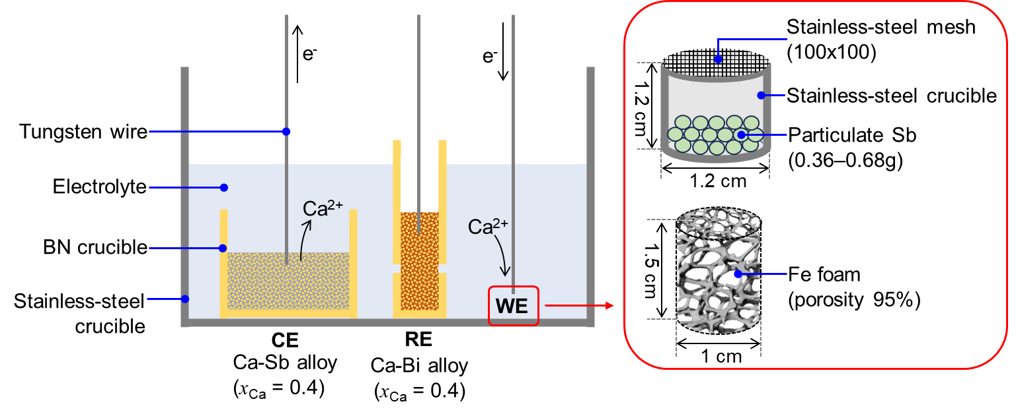
Figure S1. A 3-electrode cell configuration consisting of a Ca-Sb alloy (x_{Ca} = 0.40) as the counter electrode (CE) and a Ca-Bi alloy (x_{Ca} = 0.40) as the reference electrode (RE) to measure electrochemical performance of working electrode (WE) materials in a eutectic CaCl₂-LiCl electrolyte at 520 °C.

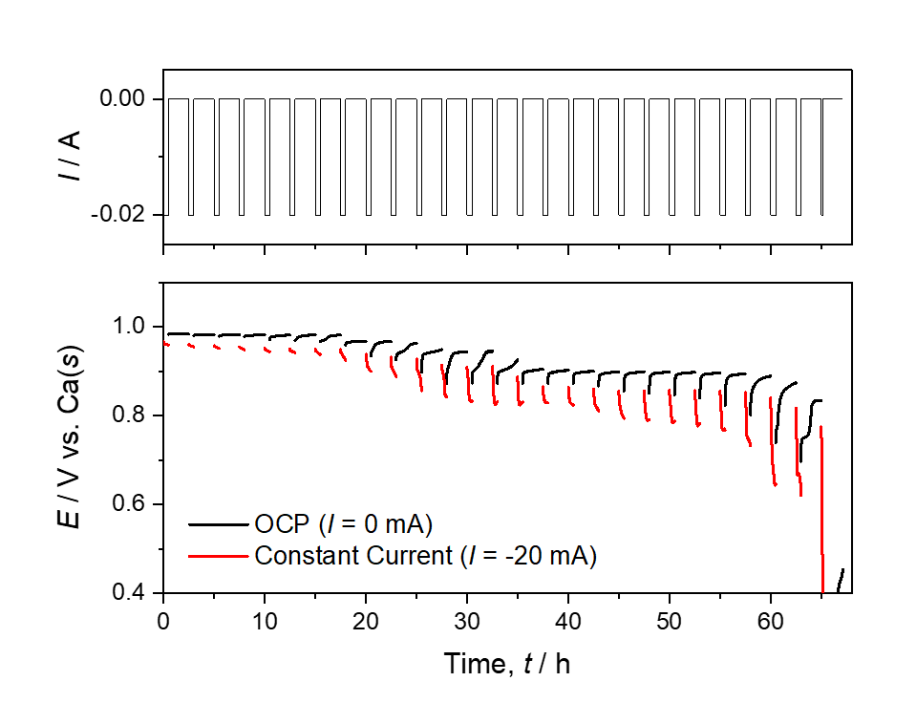
Figure S2. Sequential coulometric titration of an Sb electrode subjected to -20 mA for 0.5 h, after which OCP was monitored for 2 h to determine the equilibrium potential (E_{eq}) as a function of discharge capacity, as reported in Figure 1d.

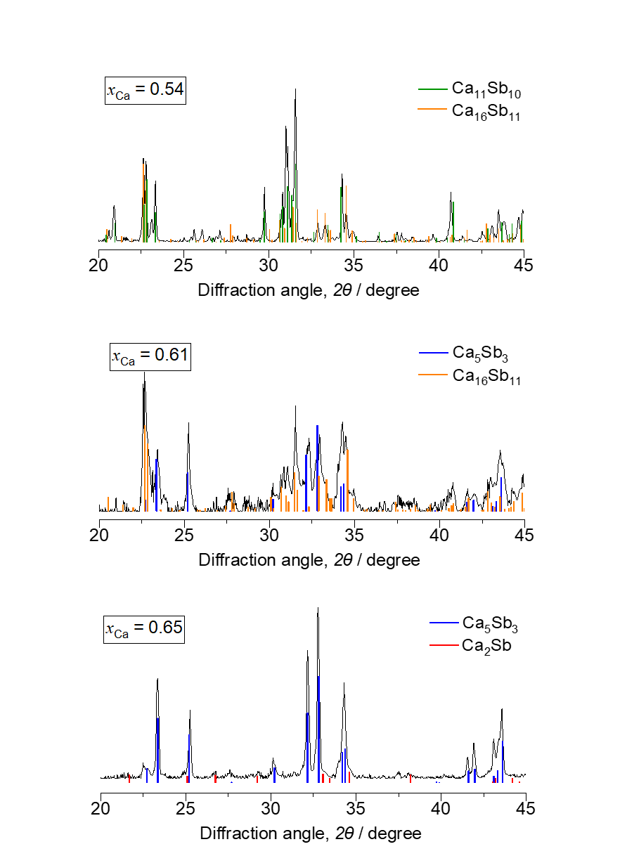
Figure S3. XRD patterns of Ca-Sb alloys (x_{Ca} = 0.54–0.65) used for emf measurements in Figure 1e, confirming the equilibrium phases present.

Table S1. Description of each electrode fabricated for 3-electrode cell testing and its role, composition, dimensions, and related figures in the main text (Figure S1).
Electrode Composition |  |  | Electrode Holder |  | Corresponding Figure(s)
Type | Material | Mass | Material | Dimension | Corresponding Figure(s)
RE | Ca-Bi alloy  (x_{Ca} = 0.4) | 2.0 g | BN | 8 mm ID, 12 mm OD, 25 mm Height  (two capillary holes) | Figure 1,2,4
CE | Ca-Sb alloy  (x_{Ca} = 0.4) | 15.0 g | BN | 21 mm ID, 25 mm OD, 12 mm Height | Figure 1,2,4
WE | Monolithic Sb | 1.0 g | BN | 8 mm ID, 12 mm OD, 12 mm Height | Figure 1a–b
 | Particulate Sb | 0.36 g | SS | 8 mm ID, 12 mm OD, 12 mm Height  (SS mesh cover) | Figure 1d
 | Ca-Sb alloys  (x_{Ca}=0.54–65) | 2.0 g | BN | 8 mm ID, 12 mm OD, 25 mm Height  (with capillary holes) | Figure 1e
 | Particulate Sb | 0.68 g | SS | 8 mm ID, 12 mm OD, 12 mm Height  (SS mesh cover) | Figure 2a
 | Particulate Sb | 0.41 g | SS | 8 mm/12 mm, 12 mm  (SS mesh cover) | Figure 2b
 | Ca-Li  (Deposited in-situ) | - | Fe foam | 10 mm D,  15 mm Height  (95% porosity) | Figure 4d

Table S2. Cell component and the dimensions of electrode holder for the Ca||Sb(s) battery and its components.
Component |  |  | Cell #1 (Figure 3) | Cell #2 (Figure 5)
Cathode |  | Mass | 0.70 g Sb | 7.0 g Sb
 |  | Current collector | 300-series SS mesh  (mesh size: 40×40) | 300-series SS mesh  (mesh size: 80×700)
Anode |  | Mass | 0.70 g Ca | 3.3 g Ca
 |  | Current collector | Fe foam (porosity 95%)  (1.0 cm D, 1.5 cm H) | 300-series SS mesh stack (6 layers of 2.7 cm H × 7.3 cm W, 35×35 mesh)
 | Electrolyte | Mass | 120 g | 602 g
 | Electrolyte | Interelectrode distance | 0.5 cm | 1.3 cm
 | Crucible | Material | 300-series SS | 300-series SS
 | Crucible | Dimensions | 6.8 cm D | 9.5 cm L × 9.5 cm W × 6.0 cm H

Table S3. Estimation of electrode cost based on the performance of the Ca | CaCl₂-LiCl | Sb(s) battery presented in Figure 3.
 | Ca | Sb | Total
mass, m / g | 0.7 | 0.7 | 1.4
Commodity bulk price, P / $/kg | 4.0 | 9.7
Average discharge capacity, Q / mAh | 500
Average discharge energy, E_{D} / kWh | 0.62E-03
Electrode cost, C / $/kWh | 15.5
Energy density / Wh/kg | 620

Table S4. Specific capacity per mass of cathode used and calculated electrode cost for the Ca||Sb(s) cell (Figure 3), compared to previously reported liquid metal batteries.
Electrode  couple | Operating  temperature (°C) | Specific  capacity  (mAh g⁻¹) | Electrode  cost ($/kWh) | Reference
Ca||Sb(s) | 520 | 715 | 15.5 | This work
Ca||Sb(l) | 700 | 136 | 90 | doi 10.1149/2.0801412jes
Ca-Mg||Bi(l) | 550 | 90 | 144 | doi: 10.1038/ncomms10999
Li||Sb-Pb(l) | 450 | 121 | 68 | doi:10.1038/nature13700
Li||Sb-Pb(l) | 500 | 171 | 65 | doi:10.1038/nature13700
Li||Bi(l) | 550 | 293 | 169 | doi.org/10.1016/j.jpowsour.2014.10.173
Li||Sb-Sn(l) | 500 | 259 | 73 | doi.org/10.1021/acsami.6b02576
Li||Te-Sn(l) | 500 | 368 | 143 | doi.org/10.1016/j.ensm.2018.04.017
Mg||Sb(l) | 700 | 147 | 276 | doi.org/10.1021/ja209759s

