Supporting Information

Siphon-Like Effect in Chemical Reactions: Kinetic Basis of Bifunctional OX-ZEO Catalyst for Selective Syngas Conversion to Light Olefins
Zhuangzhuang Lai^{†1}, Danfeng Xiong^{†1}, Peijun Hu†‡, Jianfu Chen†*, and Haifeng Wang†*
† State Key Laboratory of Green Chemical Engineering and Industrial Catalysis, Centre for Computational Chemistry and Research Institute of Industrial Catalysis, East China University of Science and Technology, Shanghai 200237, China
‡ School of Chemistry and Chemical Engineering, The Queen’s University of Belfast, Belfast, BT9 5AG, UK
¹ Contributed equally to this work
*Corresponding Author(s): jfchen@ecust.edu.cn (J. F. Chen); hfwang@ecust.edu.cn (H. F. Wang)

Supplementary Information S1. Description of the diffusion process in the proximity of ZnCrO_{x} and MOR
In our reactor model, it is important to emphasize that the diffusion mainly occurs in the interstitial spaces between the oxide and zeolite particles. This diffusion process involves the transport of the main products, CH₂CO and CH₄, from the ZnCrO_{x} surface to the MOR inlet. Given the relatively small molecular diameters of the CH₂CO (3.04 Å) and CH₄ (2.19 Å) molecules compared to the larger interstitial spaces (>30 nm), the diffusion of these species falls within the domain of molecular diffusion, as supported by the literature,¹ and illustrated in the following Figure. This supports the applicability of Fick's law in describing this diffusion process.
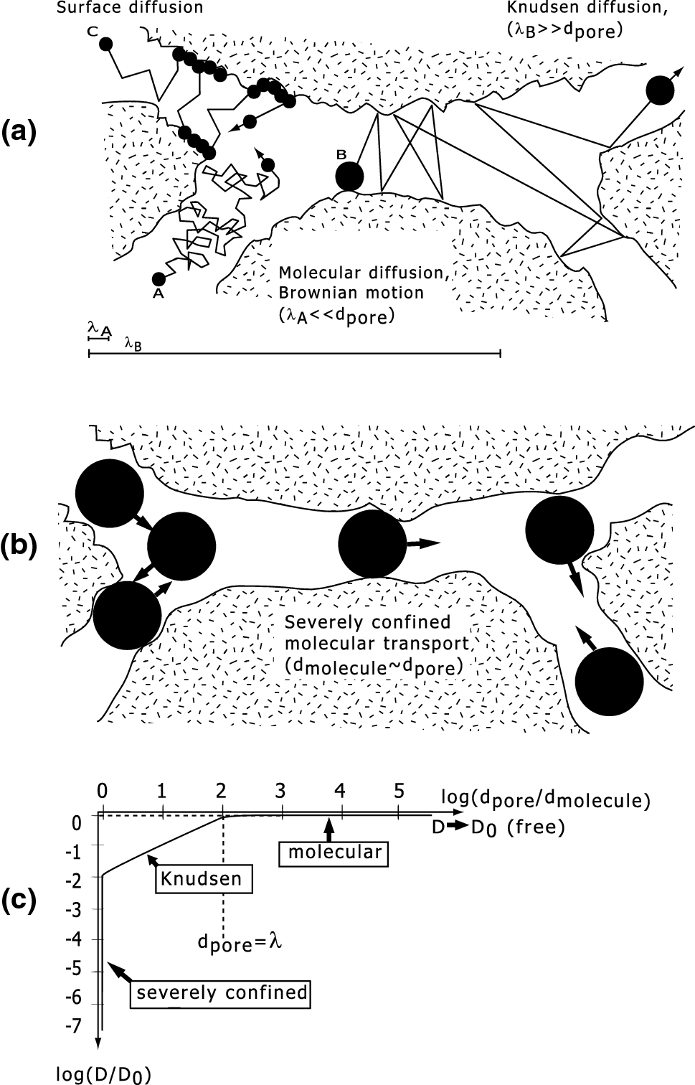
Figure. Schematic representation of the different diffusion mechanisms in a porous medium: (a) molecular diffusion, Knudsen diffusion, and surface diffusion, all relevant in mesoporous materials; (b) configurational diffusion, which is typical in zeolites, but could also occur for larger probe molecules in mesoporous materials; (c) diffusivities in different diffusion regimes. Adapted with permission from Ref. 1, Copyright (2021) SPRINGER LINK.

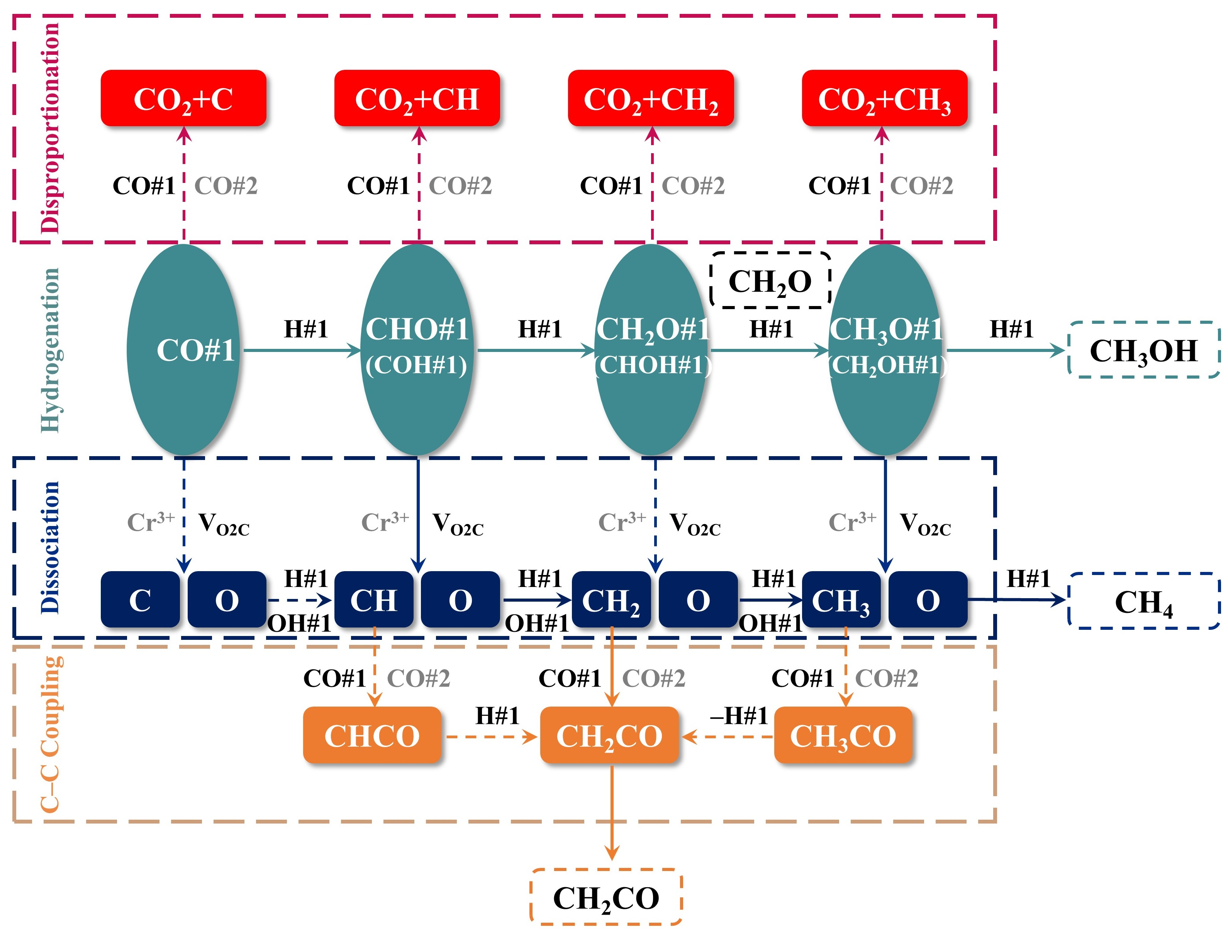
Figure S1. Diagram of syngas conversion reaction network on the reduced ZnCr₂O₄(110) surface, where #1 and #2 represent the vacancy site of two-coordinated oxygen (V_{O2C}) and four-coordinated Cr³⁺ site over ZnCrO_{x}.²

Supplementary Information S2. Reaction mechanism for ketene conversion within the MOR
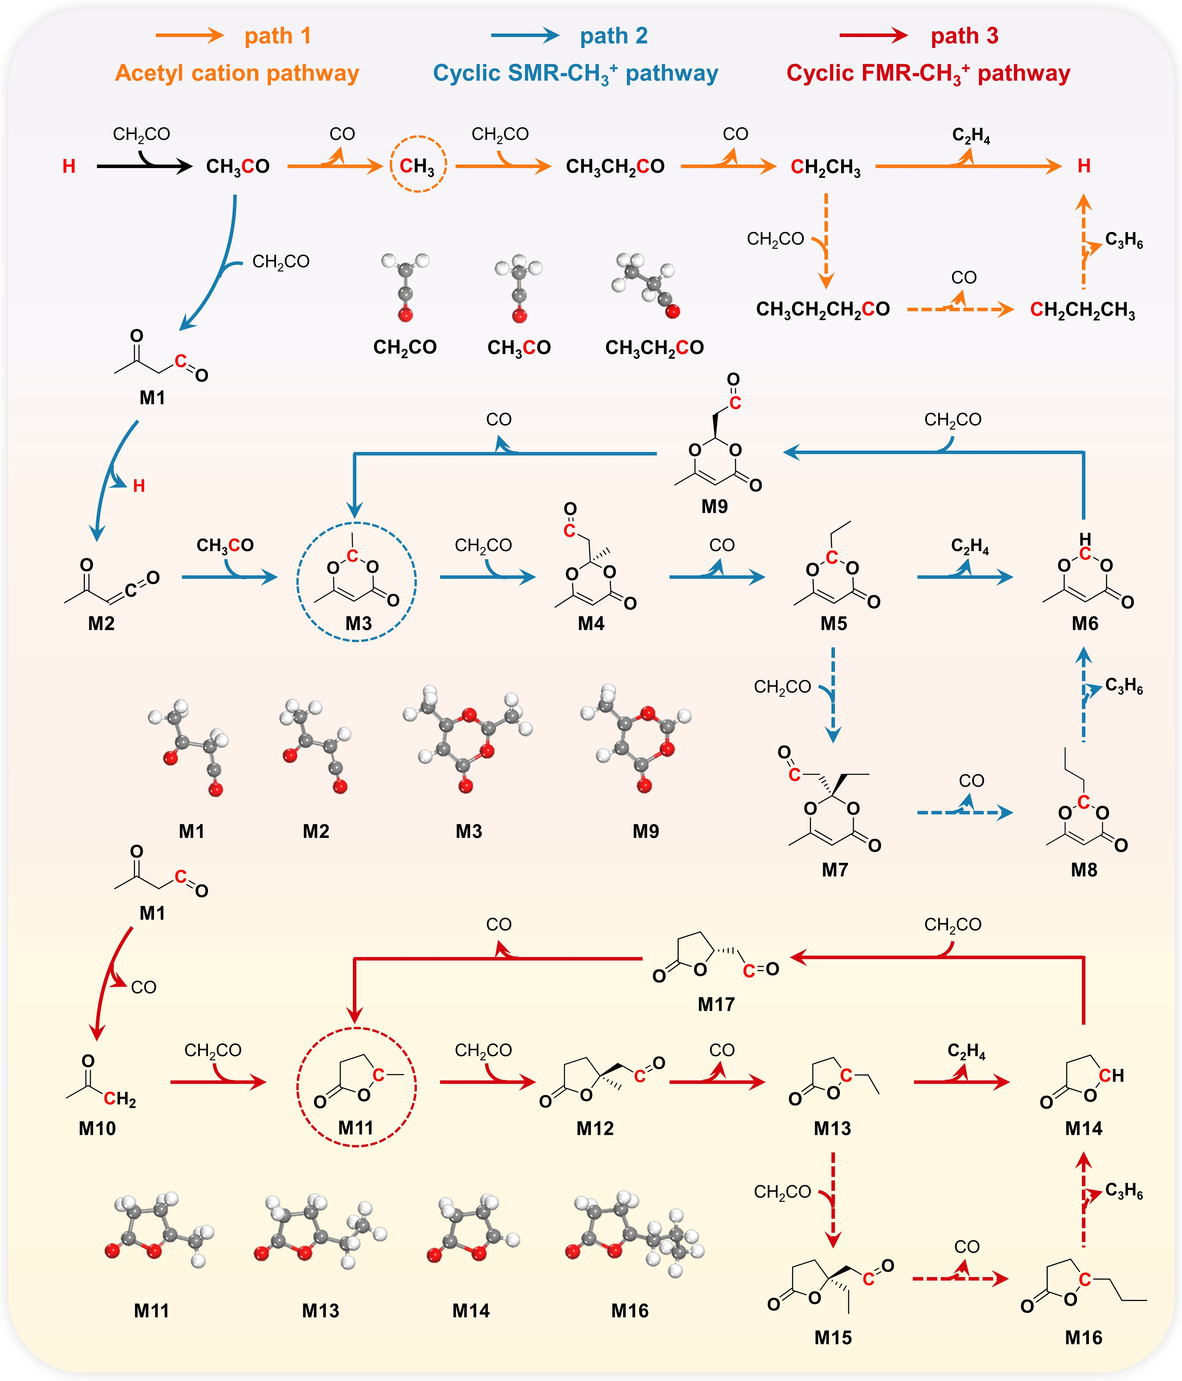
Figure S2. Paths 1, 2 and 3 for ketene conversion to ethylene (solid line) and propylene (dashed line) within MOR as well as the structures of some typical intermediates. The H and C marked in red denote the B-acid site and carbocation, respectively.
In fact, have thoroughly investigated the potential pathways of ketene conversion within the MOR’s 8-membered-ring side pockets (8MR) and 12-membered-ring (12MR) channels.³ As shown in Figure S2, the energetics of the three paths involved in both reported and unreported studies in the literature ³⁻⁶ have been calculated by DFT and the slow-growth method within the framework of ab initio molecular dynamics (AIMD) simulations. The quantitative kinetic analysis confirms the experimental results that the 8MR is the real active site and follows the path 1 to form the light olefins.^{3, 7} Given the complexity and importance of the ketene conversion mechanism within MOR, we have prepared a separate manuscript focusing on this topic and included it in the submission.³ Thus, in the main manuscript, we have selectively included the optimal reaction channel of ketene conversion within the MOR, coupling it with the reaction network on the ZnCrO_{x} surface to maintain a clear focus on the central research objectives. It should be noted that in this process, the diffusion of CH₂CO into the MOR is described as occurring from the 12MR inlet to its interior, corresponding to step R68 in Table S1. This is grounded on the experimental results that revealed the 12MR as the diffusion channel.⁷ Once inside, the ketene diffuses into the 8MR and adsorbs onto the Brønsted-acid site with a Gibbs free energy of -0.06 eV, encountering a Gibbs free energy barrier of 0.14 eV, as detailed in step R69 in Table S1.
Additionally, in our research,³ we have indeed found some key intermediates similar to the hydrocarbon pool species mentioned in Refs. 5 and 6, such as CH₃, M3 and M11 formed in path 1, path 2 and path 3, respectively. The quantitative kinetic analysis revealed that ketene conversion within MOR follows a typical autocatalytic process, divided into the generation of reactive intermediates (CH₃, M3 and M11) and their subsequent catalysis, conforming the essence of the hydrocarbon pool mechanism within the zeolite.
We further investigated the impact of the Brønsted-acid within the 12MR on ketene adsorption and conversion. Our calculations indicate that the Brønsted-acid within the 12MR preferentially facilitates ketene adsorption with a Gibbs free energy of -0.14 eV; however, the subsequent diffusion into the 8MR requires overcoming a Gibbs free energy barrier of 0.25 eV, as shown in Figure S2-1. Further microkinetic analysis reveals that the activity remains largely unaffected, reflecting the minimal influence of the Brønsted-acid within the 12MR on the ketene conversion activity. This observation is consistent with the fact that the catalytic capability of ZnCrO_{x} is the rate-limiting step in the conversion of syngas to light olefins over the ZnCrO_{x} coupled MOR catalytic system (Table S1-2), indicating that the activity is independent of the catalytic capability within the MOR.
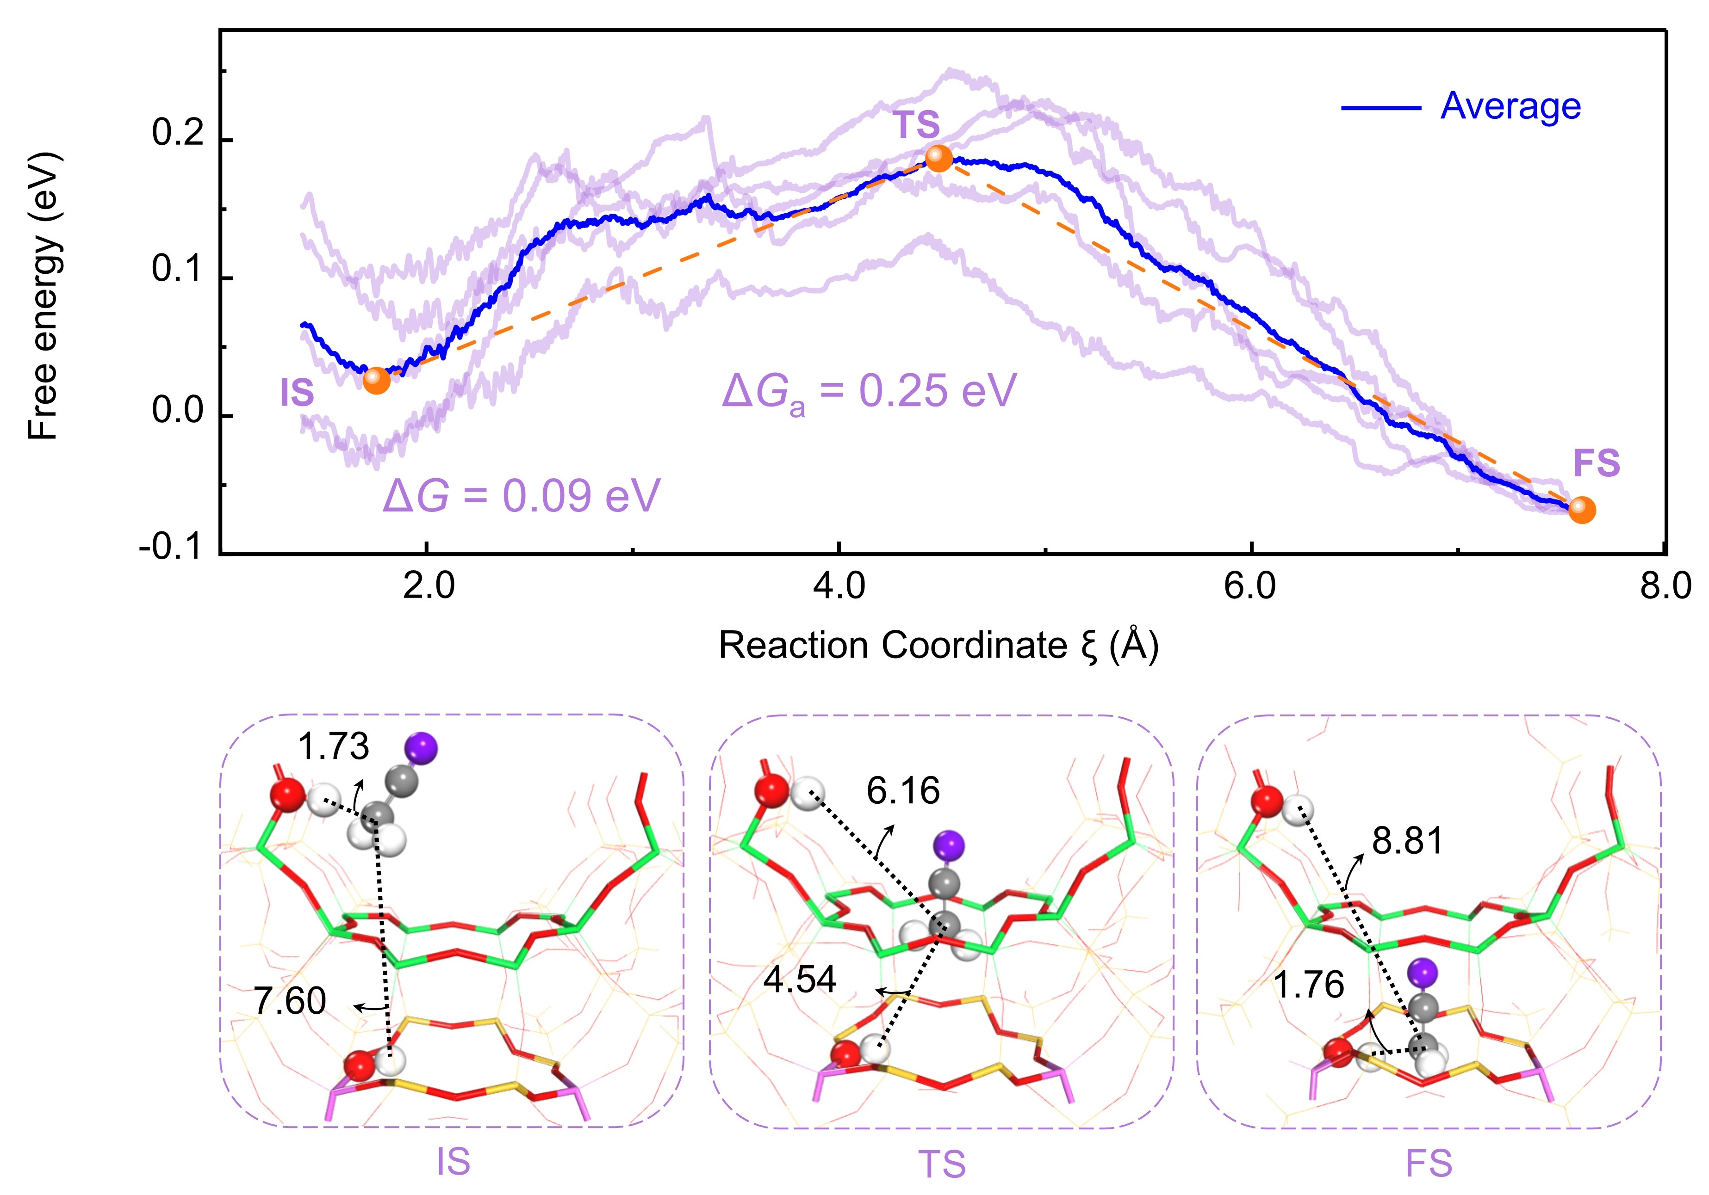
Figure S2-1. Free energy profiles of the CH₂CO diffusion adsorbed on the Brønsted-acid from the 12MR to the 8MR using the slow-growth method. The blue line represents the average free energy profile.

Table S1. Kinetic data, E_{a} (Gibbs free energy barrier), ∆G (Gibbs free energy change), Z_{i} (reversibility of step i), and r_{i} (reaction rate of step i), for elementary reactions in all possible pathway of syngas conversion over ZnCrO_{x} coupled MOR catalyst and ZnCrO_{x} catalyst, respectively, obtained from microkinetic using DFT data. #1, #2 and H#3 represent V_{O2C}, Cr³⁺ site over ZnCrO_{x} and B-acid site over MOR, respectively. Note that species_in represents that species is in the pore of MOR. p_{1_CH2CO} and p_{1_CH4} represent the partial pressures of CH₂CO and CH₄ on ZnCrO_{x} surface, respectively. p_{2_CH2CO} and p_{2_CH4} represent the partial pressures of CH₂CO and CH₄ at the MOR inlet, respectively. p_{_CH2CH2} and p_{_CH4} represent the partial pressures of CH₂CH₂ and CH₄ at the MOR outlet, respectively.
 |  |  |  | ZnCrO_{x}/MOR |  | ZnCrO_{x}
 | Rtep i | E_{a} | ∆G | Z_{i} | r_{i} /s⁻¹ | Z_{i} | r_{i} /s⁻¹
R1 | CO + #1 ⇆ CO#1 | 0.67 | 0.67 | 1.00 | 2.48×10⁻³ | 1.00 | 2.19×10⁻³
R2 | CO + #2 ⇆ CO#2 | 0.85 | 0.85 | 1.00 | 4.69×10⁻³ | 1.00 | 2.24×10⁻³
R3 | H₂ + #1 ⇆ H₂#1 | 0.91 | 0.91 | 1.00 | 2.74×10⁻³ | 1.00 | 4.32×10⁻³
R4 | H₂#1 + #2 ⇆ H#1 + H#2 | 0.43 | -0.71 | 9.99×10⁻¹ | 2.74×10⁻³ | 9.98×10⁻¹ | 4.32×10⁻³
R5 | H#2 + #1 ⇆ H#1 + #2 | 0.00 | -0.64 | 1.00 | 2.73×10⁻³ | 1.00 | 4.32×10⁻³
R6 | CO#1 + H#1 ⇆ CHO#1 + #1 | 0.62 | 0.59 | 9.75×10⁻¹ | 2.48×10⁻³ | 9.82×10⁻¹ | 2.19×10⁻³
R7 | CO#1 + H#1 ⇆ COH#1 + #1 | 2.22 | 1.94 | 3.59×10⁻¹ | 2.53×10⁻¹⁴ | 3.60×10⁻¹ | 3.15×10⁻¹⁴
R8 | CHO#1 + H#1 ⇆ CH₂O#1 + #1 | 0.29 | -0.32 | 9.99×10⁻¹ | 3.08×10⁻⁴ | 9.99×10⁻¹ | 3.51×10⁻⁴
R9 | CHO#1 + H#1 ⇆ CHOH#1 + #1 | 1.42 | 0.42 | 4.33×10⁻⁵ | 3.62×10⁻¹⁰ | 1.45×10⁻³ | 4.54×10⁻¹⁰
R10 | CH₂O#1 + H#1 ⇆ CH₃O#1 + #1 | 0.85 | -0.01 | 1.00 | 2.57×10⁻⁴ | 1.00 | 2.89×10⁻⁴
R11 | CH₂O#1 + H#1 ⇆ CH₂OH#1 + #1 | 2.71 | 1.58 | 2.06×10⁻¹⁰ | 2.42×10⁻¹⁵ | 6.32×10⁻⁸ | 3.03×10⁻¹⁵
R12 | COH#1 + H#1 ⇆ CHOH#1 + #1 | 0.55 | -0.94 | 9.84×10⁻⁵ | 2.53×10⁻¹⁴ | 3.31×10⁻³ | 3.15×10⁻¹⁴
R13 | CHOH#1 + H#1 ⇆ CH₂OH#1 + #1 | 1.66 | 0.84 | 4.76×10⁻⁶ | 2.65×10⁻¹⁷ | 4.36×10⁻⁵ | 1.11×10⁻¹⁵
R14 | CH₂OH#1 + H#1 ⇆ CH₃OH#1 + #1 | 1.04 | 0.31 | 3.98×10⁶ | -2.19×10⁻¹⁵ | 1.58×10⁴ | -3.34×10⁻¹⁵
R15 | CH₃O#1 + H#1 ⇆ CH₃OH#1 + #1 | 1.91 | 1.91 | 9.81×10⁻⁴ | 1.02×10⁻⁶ | 1.19×10⁻³ | 1.28×10⁻⁶
R16 | CH₂O#1 ⇆ CH₂O + #1 | 0.90 | 0.29 | 1.00 | 3.50×10⁻⁶ | 1.00 | 3.52×10⁻⁶
R17 | CH₃OH#1 ⇆ CH₃OH + #1 | 0.00 | -1.34 | 7.77×10⁻¹ | 1.02×10⁻⁶ | 7.96×10⁻¹ | 1.28×10⁻⁶
R18 | CHO#1 + #1 ⇆ CH#1 + O#1 | 0.22 | -0.93 | 3.39×10⁻¹ | 2.17×10⁻³ | 5.55×10⁻¹ | 1.84×10⁻³
R19 | CH₂O#1 + #1 ⇆ CH₂#1 + O#1 | 1.08 | -1.07 | 3.27×10⁻⁵ | 4.73×10⁻⁵ | 1.44×10⁻³ | 5.93×10⁻⁵
R20 | CH₂O#1 + #2 ⇆ CH₂#2 + O#1 | 2.68 | 0.29 | 5.46×10⁻⁷ | 8.49×10⁻¹⁴ | 2.43×10⁻⁵ | 9.54×10⁻¹⁴
R21 | CHOH#1 + #1 ⇆ CH#1 + OH#1 | 0.36 | -1.12 | 7.48×10⁻¹ | 3.62×10⁻¹⁰ | 9.92×10⁻¹ | 4.54×10⁻¹⁰
R22 | CH₂OH#1 + #1 ⇆ CH₂#1 + OH#1 | 1.22 | -2.42 | 1.51×10¹ | -1.41×10⁻²⁴ | 5.92×10¹ | -2.24×10⁻²¹
R23 | CH₂OH#1 + #2 ⇆ CH₂#2 + O#1 | 0.30 | -1.06 | 2.52×10⁻¹ | 4.63×10⁻¹⁵ | 9.96×10⁻¹ | 7.48×10⁻¹⁵
R24 | CH₃O#1 + #1 ⇆ CH₃#1 + O#1 | 1.83 | -0.54 | 3.73×10⁻⁹ | 1.92×10⁻⁸ | 4.48×10⁻⁶ | 2.41×10⁻⁸
R25 | CH₃O#1 + #2 ⇆ CH₃#2 + O#1 | 1.77 | -0.53 | 2.84×10⁻⁹ | 2.56×10⁻⁴ | 2.16×10⁻¹⁰ | 2.87×10⁻⁴
R26 | CH₃OH#1 + #1 ⇆ CH₃#1 + OH#1 | 0.53 | -2.22 | 3.63×10⁻¹⁰ | 7.79×10⁻¹⁴ | 9.72×10⁻⁶ | 1.19×10⁻¹³
R27 | CH₃OH#1 + #2 ⇆ CH₃#2 + OH#1 | 0.74 | -2.21 | 2.76×10⁻¹⁰ | 8.37×10⁻¹² | 4.69×10⁻¹⁰ | 1.14×10⁻¹¹
R28 | CH#1 + H#1 ⇆ CH₂#1 + #1 | 0.94 | -0.46 | 9.63×10⁻⁵ | 2.42×10⁻³ | 2.60×10⁻³ | 5.62×10⁻³
R29 | CH#1 + OH#1 ⇆ CH₂#1 + O#1 | 0.53 | -0.69 | 1.01 | -2.48×10⁻⁴ | 1.00 | -3.78×10⁻³
R30 | CH₂#1 + H#1 ⇆ CH₃#1 + #1 | 1.57 | 0.51 | 9.54×10⁻⁵ | 2.48×10⁻⁶ | 2.59×10⁻³ | 1.55×10⁻⁴
R31 | CH₂#2 + H#1 ⇆ CH₃#2 + #1 | 0.55 | -0.84 | 4.34×10⁻³ | 4.35×10⁻⁷ | 7.43×10⁻⁶ | 2.48×10⁻⁵
R32 | CH₂#2 + OH#1 ⇆ CH₃#2 + O#1 | 0.74 | -1.07 | 4.55×10¹ | -4.47×10⁻⁹ | 2.87×10⁻³ | 1.36×10⁻⁷
R33 | CH₂#1 + OH#1 ⇆ CH₃#1 + O#1 | 0.87 | 0.28 | 1.00 | -2.48×10⁻⁶ | 1.00 | 1.63×10⁻³
R34 | CH₃#2 + H#2 ⇆ CH₄ (p_{1_CH4}) + #2 + #2 | 1.15 | -1.64 | 4.43×10⁻⁶ | 1.52×10⁻⁶ | 1.27×10⁻³ | 1.32×10⁻⁷
R35 | CH₃#2 + OH#1 ⇆ CH₄(p_{1_CH4})+ #2 + O#1 | 0.75 | -1.23 | 4.64×10⁻² | 2.51×10⁻⁴ | 4.91×10⁻¹ | 3.12×10⁻⁴
R36 | CH₃#2 + H#1 ⇆ CH₄ (p_{1_CH4}) + #2 + #1 | 1.27 | -1.00 | 4.43×10⁻⁶ | 3.59×10⁻⁶ | 1.27×10⁻³ | 3.47×10⁻⁷
R37 | CH₃#1 + H#2 ⇆ CH₄ (p_{1_CH4}) + #1 + #2 | 1.11 | -1.63 | 3.36×10⁻⁶ | 1.07×10⁻⁹ | 6.14×10⁻⁸ | 1.63×10⁻⁶
R38 | CH₃#1 + H#1 ⇆ CH₄ (p_{1_CH4}) + #1 + #1 | 1.68 | -0.99 | 3.36×10⁻⁶ | 8.19×10⁻¹³ | 6.14×10⁻⁸ | 1.40×10⁻⁹
R39 | CH₃#1 + OH#1 ⇆ CH₄ (p_{1_CH4}) + #1 + #1 | 0.79 | -1.22 | 3.53×10⁻² | 4.29×10⁻⁸ | 2.37×10⁻⁵ | 1.82×10⁻³
R40 | CHO#1 + CO#1 ⇆ CH#1 + CO₂#1 | 1.14 | -0.63 | 3.39×10⁻¹ | 7.15×10⁻¹⁵ | 5.55×10⁻¹ | 6.07×10⁻¹⁵
R41 | CH₂O#1 + CO#1 ⇆ CH₂#1 + CO₂#1 | 1.93 | -0.78 | 2.74×10⁻⁵ | 5.44×10⁻¹⁶ | 1.21×10⁻³ | 6.83×10⁻¹⁶
R42 | CH₃O#1 + CO#1 ⇆ CH₃#1 + CO₂#1 | 2.59 | -0.25 | 3.12×10⁻⁹ | 1.10×10⁻¹⁸ | 3.75×10⁻⁶ | 1.38×10⁻¹⁸
R43 | CHO#1 + CO#2 ⇆ CH#1 + CO₂#2 | 2.35 | 0.31 | 3.39×10⁻¹ | 5.45×10⁻²² | 5.55×10⁻¹ | 4.14×10⁻²²
R44 | CH₂O#1 + CO#2 ⇆ CH₂#1 + CO₂#2 | 2.55 | 0.17 | 3.27×10⁻⁵ | 1.56×10⁻¹⁸ | 1.44×10⁻³ | 1.75×10⁻¹⁸
R45 | CH₃O#1 + CO#2 ⇆ CH₃#1 + CO₂#2 | 3.32 | 0.70 | 3.73×10⁻⁹ | 4.42×10⁻²² | 4.48×10⁻⁶ | 4.97×10⁻²²
R46 | CH₂#1 + CO#2 ⇆ CH₂CO#1 + #2 | 0.50 | 0.28 | 8.78×10⁻¹ | 2.22×10⁻³ | 1.00 | 1.15×10⁻⁴
R47 | CH₂#1 + CO#1 ⇆ CH₂CO#1 + #1 | 0.88 | 0.46 | 8.78×10⁻¹ | 1.37×10⁻⁸ | 1.00 | 7.88×10⁻¹⁰
R48 | CH₂#2 + CO#2 ⇆ CH₂CO#2 + #2 | 0.20 | -0.63 | 5.25×10¹ | -4.31×10⁻⁷ | 5.94×10¹ | -2.49×10⁻⁵
R49 | CH₃#1 + CO#2 ⇆ CH₃CO#1 + #2 | 0.62 | 0.50 | 4.81 | -1.91×10⁻⁸ | 5.41 | -3.39×10⁻⁵
R50 | CH₃#1 + CO#1 ⇆ CH₃CO#1 + #1 | 0.97 | 0.67 | 4.02 | -1.60×10⁻¹³ | 4.53 | -3.19×10⁻¹⁰
R51 | CH₃#2 + CO#2 ⇆ CH₃CO#2 + #2 | 0.53 | -0.10 | 1.00 | -3.91×10⁻¹⁴ | 1.00 | -2.52×10⁻¹²
R52 | CH₃CO#1 + #1 ⇆ CH₂CO#1 + H#1 | 0.21 | -0.73 | 1.91×10³ | -2.03×10⁻⁹ | 7.13×10¹ | -1.43×10⁻⁷
R53 | CH₃CO#1 + O#1 ⇆ CH₂CO#1 + OH#1 | 0.00 | -0.40 | 1.09 | -1.71×10⁻⁸ | 1.10 | -3.37×10⁻⁵
R54 | CH₃CO#2 + #1 ⇆ CH₂CO#2 + H#1 | 1.89 | 0.32 | 1.44×10⁴ | -3.91×10⁻¹⁴ | 9.56×10⁶ | -2.51×10⁻¹²
R55 | CH₃CO#2 + O#1 ⇆ CH₂CO#2 + OH#1 | 2.31 | 0.54 | 1.15 | -9.88×10⁻¹⁹ | 2.07×10⁴ | -1.16×10⁻¹⁴
R56 | CH₂CO#1 ⇆ CHCO (p_{1_CH2CO}) + #1 | 0.00 | -0.64 | 9.97×10⁻¹ | 2.22×10⁻³ | 1.00 | 8.06×10⁻⁵
R57 | CH₂CO#2 ⇆ CH₂CO (p_{1_CH2CO}) + #2 | 0.00 | -1.09 | 1.00 | -4.31×10⁻⁷ | 1.00 | -2.49×10⁻⁵
R58 | CO#2 + O#1 ⇆ CO₂#1 + #2 | 0.15 | 0.12 | 1.00 | 2.47×10⁻³ | 1.00 | 2.19×10⁻³
R59 | CO#2 + OH#1 ⇆ COOH#2 + #1 | 1.78 | 1.48 | 1.00 | 9.89×10⁻¹⁷ | 1.00 | 2.37×10⁻¹⁵
R60 | COOH#2 + O#1 ⇆ CO₂#2 + OH#1 | 0.28 | -0.24 | 1.00 | 9.89×10⁻¹⁷ | 1.00 | 2.37×10⁻¹⁵
R61 | COOH#2 + #1 ⇆ CO₂#2 + H#1 | 3.73 | -0.47 | 1.05×10⁴ | -3.39×10⁻³³ | 3.86×10² | -3.33×10⁻³³
R62 | H#1 + OH#1 ⇆ H₂O#1 + #1 | 1.89 | 1.89 | 3.70×10⁻⁴ | 4.82×10⁻⁷ | 3.97×10⁻³ | 1.43×10⁻⁵
R63 | OH#1 + OH#1 ⇆ H₂O#1 + O#1 | 1.64 | 1.64 | 2.71 | -4.89×10⁻⁷ | 1.07 | -1.45×10⁻⁵
R64 | H#2 + OH#1 ⇆ H₂O#1 + #2 | 1.96 | 1.23 | 2.59×10⁻⁴ | 6.87×10⁻⁹ | 2.78×10⁻³ | 1.83×10⁻⁷
R65 | CO₂#1 ⇆ CO₂ + #1 | 0.38 | -0.24 | 1.00 | 2.47×10⁻³ | 1.00 | 2.19×10⁻³
R66 | CO₂#2 ⇆ CO₂ + #2 | 0.00 | -1.36 | 1.00 | 1.00×10⁻¹⁶ | 1.00 | 2.37×10⁻¹⁵
R67 | H₂O#1 ⇆ H₂O + #1 | 0.00 | -0.78 | 1.00 | 1.14×10⁻¹¹ | 1.00 | 2.93×10⁻⁹
R68 | Mass transfer process of CH₂CO  (p_{1_CH2CO} → p_{2_CH2CO}) | 1.22 | 0.00 | 1.00 | 2.22×10⁻³
R69 | Mass transfer process of CH₄  (p_{1_CH4} → p_{2_CH4}) | 1.37 | 0.00 | 1.00 | 1.71×10⁻⁴
R70 | CH₂CO diffusion to the pore of MOR  (p_{2_CH2CO} → p_{_CH2CO_in}) | 0.12 | 0.10 | 1.00 | 2.22×10⁻³
R71 | CH₂CO_in + H#3 ⇆ CH₂CO···H#3 | 0.14 | -0.06 | 1.00 | 1.10×10⁻³
R72 | CH₂CO···H#3 ⇆ CH₃CO⁺#3 | 0.07 | -0.46 | 1.00 | 1.10×10⁻³
R73 | CH₃CO⁺#3 ⇆ CH₃#3 + CO_in | 1.82 | 0.85 | 7.50×10⁻¹ | 1.10×10⁻³
R74 | CH₃#3 + CH₂CO_in ⇆ CH₃CH₂CO⁺#3 | 1.04 | -0.73 | 2.04×10⁻³ | 1.10×10⁻³
R75 | CH₃CH₂CO⁺#3 ⇆ CH₃CH₂#3 + CO_in | 1.36 | 0.20 | 6.76×10⁻¹ | 1.10×10⁻³
R76 | CH₃CH₂#3 ⇆ CH₂CH₂_in + H#3 | 1.23 | 0.67 | 1.00 | 1.09×10⁻³
R77 | CH₃CH₂#3 + CH₂CO_in ⇆ CH₃CH₂CH₂CO⁺#3 | 1.45 | -0.21 | 9.99×10⁻⁵ | 1.51×10⁻⁵
R78 | CH₃CH₂CH₂CO⁺#3 ⇆ CH₃CH₂CH₂#3 + CO_in | 1.11 | -0.01 | 4.56×10⁻¹ | 1.51×10⁻⁵
R79 | CH₃CH₂CH₂#3 ⇆ CH₃CHCH₂_in + H#3 | 1.81 | 0.55 | 1.70×10⁻² | 1.51×10⁻⁵
R80 | CO_in ⇆ CO | 0.00 | -0.81 | 1.00 | 2.22×10⁻³
R81 | CH₂CH₂_in ⇆ CH₂CH₂  (p_{CH2CH2_in} → p_{_CH2CH2}) | 0.00 | -0.64 | 1.00 | 1.08×10⁻³
R82 | CH₃CHCH₂_in ⇆ CH₃CHCH₂ | 0.00 | -0.84 | 1.00 | 1.51×10⁻⁵
R83 | CH₄ diffusion to the outlet of MOR  (p_{2_CH4} → p_{_CH4}) | 1.45 | 0.00 | 1.00 | 8.54×10⁻⁵

Table S1-1. Coverage (θ) over ZnCrO_{x} coupled MOR catalyst.
θ_{CH#1} | 7.15×10⁻⁸ | θ_{CH2#1} | 5.63×10⁻⁶ | θ_{CH2CO#1} | 6.00×10⁻¹⁴ | θ_{CH2O#1} | 3.78×10⁻⁶
θ_{CH2OH#1} | 9.72×10⁻²⁶ | θ_{CH3#1} | 1.32×10⁻¹¹ | θ_{CH3CO#1} | 1.52×10⁻²⁰ | θ_{CH3O#1} | 1.00×10⁻³
θ_{CH3OH#1} | 3.38×10⁻¹⁹ | θ_{CHO#1} | 5.64×10⁻¹¹ | θ_{CHOH#1} | 3.00×10⁻¹⁶ | θ_{CO#1} | 9.78×10⁻⁹
θ_{CO2#1} | 2.01×10⁻⁷ | θ_{COH#1} | 7.07×10⁻²² | θ_{H#1} | 4.85×10⁻² | θ_{H2#1} | 3.67×10⁻¹⁰
θ_{H2O#1} | 6.01×10⁻²⁰ | θ_{O#1} | 9.50×10⁻¹ | θ_{OH#1} | 3.31×10⁻⁴ | θ_{#1} | 2.19×10⁻⁴
θ_{CH2#2} | 1.22×10⁻¹⁴ | θ_{CH2CO#2} | 8.86×10⁻¹⁴ | θ_{CH3#2} | 3.84×10⁻⁸ | θ_{CH3CO#2} | 4.12×10⁻¹³
θ_{CO#2} | 1.80×10⁻⁶ | θ_{CO2#2} | 1.90×10⁻¹² | θ_{COOH#2} | 9.10×10⁻¹⁸ | θ_{H#2} | 2.41×10⁻³
θ_{#2} | 9.98×10⁻¹ | θ_{CH2CO···H#3} | 1.14×10⁻⁵ | θ_{CH3#3} | 2.20×10⁻³ | θ_{CH3CH2#3} | 4.54×10⁻²
θ_{CH3CH2CH2#3} | 1.23×10⁻⁴ | θ_{CH3CH2CH2CO#3} | 8.27×10⁻¹⁰ | θ_{CH3CH2CO#3} | 8.79×10⁻⁶ | θ_{CH3CO#3} | 4.20×10⁻²
θ_{H#3} | 9.10×10⁻¹

Table S1-2. Degree of kinetic rate control (X_{RC,i}) of some important elementary reaction steps for products (C₂H₄, CH₃OH, CH₄) in the syngas conversion over the ZnCrO_{x}/MOR coupling system.
Step i | X_{RC,i}
Step i | C₂H₄ | CH₃OH | CH₄
CH₃O#1 + H#1 ⇆ CH₃OH#1 + #1 | 0.00 | 1.00 | −0.00
CHO#1 + #1 ⇆ CH#1 + O#1 | 0.22 | ‒0.37 | −0.20
CH#1 + H#1 ⇆ CH₂#1 + #1 | 0.11 | ‒0.19 | −0.10
CH₃O#1 + #2 ⇆ CH₃#2 + O#1 | ‒0.09 | ‒0.05 | 0.97

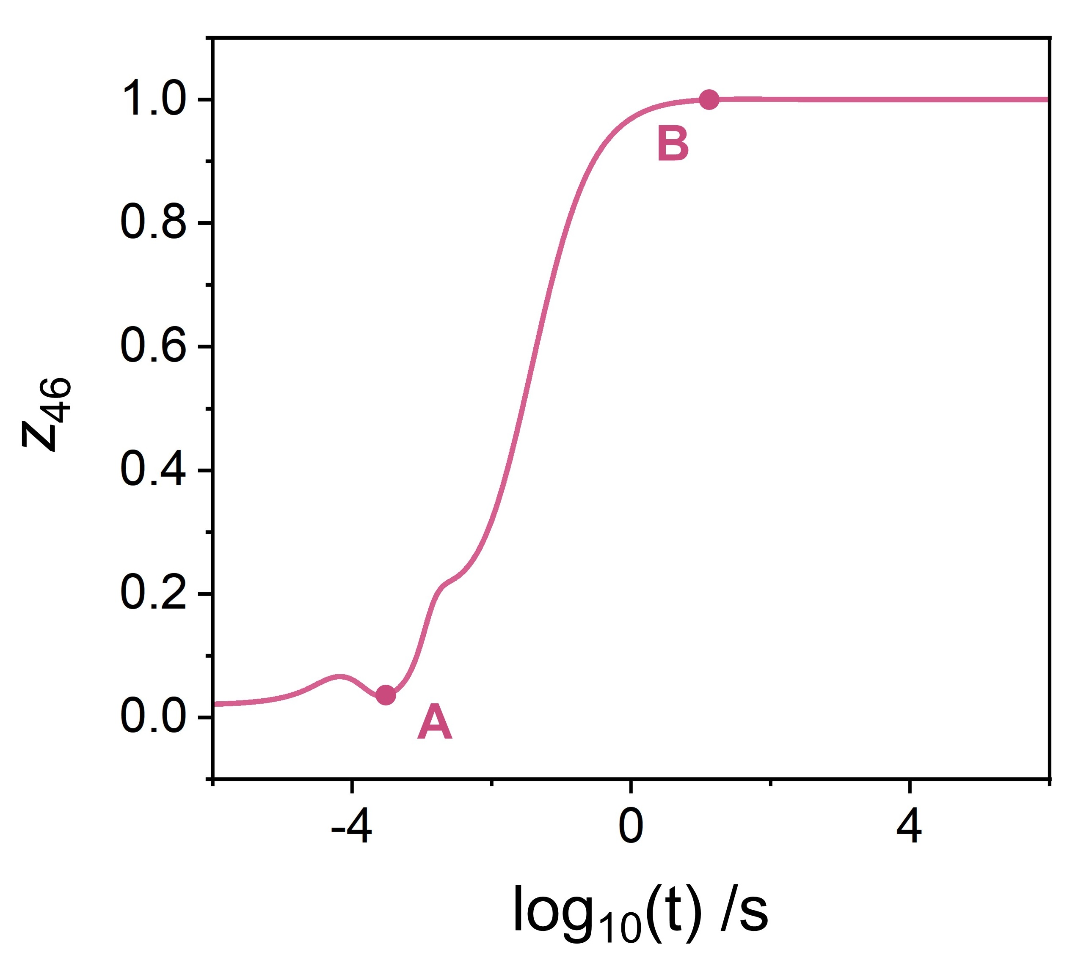
Figure S3. The dynamic evolution of the reversibility of step R46 (CH₂#1 + CO#2 ⇆ CH₂CO#1 + #2) in Table S1 over ZnCrO_{x}/MOR catalytic system.
Supplementary Information S3. Reaction rate equations and ordinary differential equations
Based on the law of mass action, the reaction rate of each elementary step in Table S1 can be expressed as follows.
r_{R1} = k_{R1f}*p_{CO}*θ_{#1} − k_{R1r}*θ_{CO#1}
r_{R2} = k_{R2f}*p_{CO}*θ_{#2} − k_{R2r}*θ_{CO#2}
r_{R3} = k_{R3f}*p_{H2}*θ_{#1} – k_{R3r}*θ_{H2#1}
r_{R4} = k_{R4f}*θ_{H2#1}*θ_{#2} − k_{R4r}*θ_{H#1}*θ_{H#2}
r_{R5} = k_{R5f}*θ_{H#2}*θ_{#1} − k_{R5r}*θ_{H#1}*θ_{#2}
r_{R6} = k_{R6f}*θ_{H#1}*θ_{CO#1} − k_{R6r}*θ_{#1}*θ_{CHO#1}
r_{R7} = k_{R7f}*θ_{H#1}*θ_{CO#1} − k_{R7r}*θ_{#1}*θ_{COH#1}
r_{R8} = k_{R8f}*θ_{H#1}*θ_{CHO#1} − k_{R8r}*θ_{#1}*θ_{CH2O#1}
r_{R9} = k_{R9f}*θ_{H#1}*θ_{CHO#1} − k_{R9r}*θ_{#1}*θ_{CHOH#1}
r_{R10} = k_{R10f}*θ_{H#1}*θ_{CH2O#1} − k_{R10r}*θ_{#1}*θ_{CH3O#1}
r_{R11} = k_{R11f}*θ_{H#1}*θ_{CH2O#1} − k_{R11r}*θ_{#1}*θ_{CH2OH#1}
r_{R12} = k_{R12f}*θ_{H#1}*θ_{COH#1} − k_{R12r}*θ_{#1}*θ_{CHOH#1}
r_{R13} = k_{R13f}*θ_{H#1}*θ_{CHOH#1} − k_{R13r}*θ_{#1}*θ_{CH2OH#1}
r_{R14} = k_{R14f}*θ_{H#1}*θ_{CH2OH#1} − k_{R14r}*θ_{#1}*θ_{CH3OH#1}
r_{R15} = k_{R15f}*θ_{H#1}*θ_{CH3O#1} − k_{R15r}*θ_{#1}*θ_{CH3OH#1}
r_{R16} = k_{R16f}*θ_{CH2O#1} − k_{R16r}*p_{CH2O}*θ_{#1}
r_{R17} = k_{R17f}*θ_{CH3OH#1} − k_{R17r}*p_{CH3OH}*θ_{#1}
r_{R18} = k_{R18f}*θ_{#1}*θ_{CHO#1} − k_{R18r}*θ_{O#1}*θ_{CH#1}
r_{R19} = k_{R19f}*θ_{#1}*θ_{CH2O#1} − k_{R19r}*θ_{O#1}*θ_{CH2#1}
r_{R20} = k_{R20f}*θ_{#2}*θ_{CH2O#1} − k_{R20r}*θ_{O#1}*θ_{CH2#2}
r_{R21} = k_{R21f}*θ_{#1}*θ_{CHOH#1} − k_{R21r}*θ_{CH#1}*θ_{OH#1}
r_{R22} = k_{R22f}*θ_{#1}*θ_{CH2OH#1} − k_{R22r}*θ_{CH2#1}*θ_{OH#1}
r_{R23} = k_{R23f}*θ_{#2}*θ_{CH2OH#1} − k_{R23r}*θ_{CH2#2}*θ_{OH#1}
r_{R24} = k_{R24f}*θ_{#1}*θ_{CH3O#1} − k_{R24r}*θ_{CH3#1}*θ_{O#1}
r_{R25} = k_{R25f}*θ_{#2}*θ_{CH3O#1} − k_{R25r}*θ_{CH3#2}*θ_{O#1}
r_{R26} = k_{R26f}*θ_{#1}*θ_{CH3OH#1} − k_{R26r}*θ_{CH3#1}*θ_{OH#1}
r_{R27} = k_{R27f}*θ_{#2}*θ_{CH3OH#1} − k_{R27r}*θ_{CH3#2}*θ_{OH#1}
r_{R28} = k_{R28f}*θ_{H#1}*θ_{CH#1} − k_{R28r}*θ_{#1}*θ_{CH2#1}
r_{R29} = k_{R29f}*θ_{CH#1}*θ_{OH#1} − k_{R29r}*θ_{O#1}*θ_{CH2#1}
r_{R30} = k_{R30f}*θ_{H#1}*θ_{CH2#1} − k_{R30r}*θ_{#1}*θ_{CH3#1}
r_{R31} = k_{R31f}*θ_{H#1}*θ_{CH2#2} − k_{R31r}*θ_{#1}*θ_{CH3#2}
r_{R32} = k_{R32f}*θ_{OH#1}*θ_{CH2#2} − k_{R32r}*θ_{O#1}*θ_{CH3#2}
r_{R33} = k_{R33f}*θ_{CH2#1}*θ_{OH#1} − k_{R33r}*θ_{O#1}*θ_{CH3#1}
r_{R34} = k_{R34f}*θ_{H#2}*θ_{CH3#2} − k_{R34r}*p_{CH4}*θ_{#2}²
r_{R35} = k_{R35f}*θ_{OH#1}*θ_{CH3#2} − k_{R35r}*p_{CH4}*θ_{O#1}*θ_{#2}
r_{R36} = k_{R36f}*θ_{H#1}*θ_{CH3#2} − k_{R36r}*p_{CH4}*θ_{#1}*θ_{#2}
r_{R37} = k_{R37f}*θ_{H#2}*θ_{CH3#1} − k_{R37r}*p_{CH4}*θ_{#1}*θ_{#2}
r_{R38} = k_{R38f}*θ_{H#1}*θ_{CH3#1} − k_{R38r}*p_{CH4}*θ_{#1}²
r_{R39} = k_{R39f}*θ_{OH#1}*θ_{CH3#1} − k_{R39r}*p_{CH4}*θ_{O#1}*θ_{#1}
r_{R40} = k_{R40f}*θ_{CO#1}*θ_{CHO#1} − k_{R40r}*θ_{CH#1}*θ_{CO2#1}
r_{R41} = k_{R41f}*θ_{CO#1}*θ_{CH2O#1} − k_{R41r}*θ_{CH2#1}*θ_{CO2#1}
r_{R42} = k_{R42f}*θ_{CO#1}*θ_{CH3O#1} − k_{R42r}*θ_{CH3#1}*θ_{CO2#1}
r_{R43} = k_{R43f}*θ_{CO#2}*θ_{CHO#1} − k_{R43r}*θ_{CH#1}*θ_{CO2#2}
r_{R44} = k_{R44f}*θ_{CO#2}*θ_{CH2O#1} − k_{R44r}*θ_{CH2#1}*θ_{CO2#2}
r_{R45} = k_{R45f}*θ_{CO#2}*θ_{CH3O#1} − k_{R45r}*θ_{CH3#1}*θ_{CO2#2}
r_{R46} = k_{R46f}*θ_{CO#2}*θ_{CH2#1} − k_{R46r}*θ_{#2}*θ_{CH2CO#1}
r_{R47} = k_{R47f}*θ_{CO#1}*θ_{CH2#1} − k_{R47r}*θ_{#1}*θ_{CH2CO#1}
r_{R48} = k_{R48f}*θ_{CO#2}*θ_{CH2#2} − k_{R48r}*θ_{#2}*θ_{CH2CO#2}
r_{R49} = k_{R49f}*θ_{CO#2}*θ_{CH3#1} − k_{R49r}*θ_{#2}*θ_{CH3CO#1}
r_{R50} = k_{R50f}*θ_{CO#1}*θ_{CH3#1} − k_{R50r}*θ_{#1}*θ_{CH3CO#1}
r_{R51} = k_{R51f}*θ_{CO#2}*θ_{CH3#2} − k_{R51r}*θ_{#2}*θ_{CH3CO#2}
r_{R52} = k_{R52f}*θ_{#1}*θ_{CH3CO#1} − k_{R52r}*θ_{H#1}*θ_{CH2CO#1}
r_{R53} = k_{R53f}*θ_{O#1}*θ_{CH3CO#1} – k_{R53r}*θ_{OH#1}*θ_{CH2CO#1}
r_{R54} = k_{R54f}*θ_{#1}*θ_{CH3CO#2} − k_{R54r}*θ_{H#1}*θ_{CH2CO#2}
r_{R55} = k_{R55f}*θ_{O#1}*θ_{CH3CO#2} – k_{R55r}*θ_{OH#1}*θ_{CH2CO#2}
r_{R56} = k_{R56f}*θ_{CH2CO#1} − k_{R56r}*p_{CH2CO_1}*θ_{#1}
r_{R57} = k_{R57f}*θ_{CH2CO#2} − k_{R57r}*p_{CH2CO_1}*θ_{#2}
r_{R58} = k_{R58f}*θ_{O#1}*θ_{CO#2} − k_{R58r}*θ_{#2}*θ_{CO2#1}
r_{R59} = k_{R59f}*θ_{CO#2}*θ_{OH#1} − k_{R59r}*θ_{#1}*θ_{COOH#2}
r_{R60} = k_{R60f}*θ_{O#1}*θ_{COOH#2} − k_{R60r}*θ_{OH#1}*θ_{CO2#2}
r_{R61} = θ_{#1}*θ_{COOH#2}*k_{R61f} − θ_{H#1}*θ_{CO2#2}*k_{R61r}
r_{R62} = k_{R62f}*θ_{H#1}*θ_{OH#1} − k_{R62r}*θ_{#1}*θ_{H2O#1}
r_{R63} = k_{R63f}*θ_{OH#1}² − k_{R63r}*θ_{O#1}*θ_{H2O#1}
r_{R64} = k_{R64f}*θ_{H#2}*θ_{OH#1} − k_{R64r}*θ_{#2}*θ_{H2O#1}
r_{R65} = k_{R65f}*θ_{CO2#1} − k_{R65r}*p_{CO2}*θ_{#1}
r_{R66} = k_{R66f}*θ_{CO2#2} − k_{R66r}*p_{CO2}*θ_{#2}
r_{R67} = k_{R67f}*θ_{H2O#1} – k_{R67r}*p_{H2O}*θ_{#1}
r_{R68} = D_{CH2CO}*A*N_{A}*p◦/(R*T*∆l)*(p_{1_CH2CO} – p_{2_CH2CO})
r_{R69} = D_{CH4}*A*N_{A}*p◦/(R*T*∆l)*(p_{1_CH4} – p_{2_CH4})
r_{R70} = k_{R70f}*p_{2_CH2CO} − k_{R70r}*p_{CH2CO_in}
r_{R71} = k_{R71f}*p_{CH2CO_in}*θ_{H#3} − k_{R71r}*θ_{CH2CO‧‧‧H#3}
r_{R72} = k_{R72f}*θ_{CH2CO‧‧‧H#3} − k_{R72r}*θ_{CH3CO+#3}
r_{R73} = k_{R73f}*θ_{CH3CO+#3} − k_{R73r}*p_{CO_in}*θ_{CH3#3}
r_{R74} = k_{R74f}*p_{CH2CO_in}*θ_{CH3#3} − k_{R74r}*θ_{CH3CH2CO+#3}
r_{R75} = k_{R75f}*θ_{CH3CH2CO+#3} − k_{R75r}*p_{CO_in}*θ_{CH3CH2#3}
r_{R76} = k_{R76f}*θ_{CH3CH2#3} − k_{R76r}*p_{CH2CH2_in}*θ_{H#3}
r_{R77} = k_{R77f}*p_{CH2CO_in}*θ_{CH3CH2#3} − k_{R77r}*θ_{CH3CH2CH2CO+#3}
r_{R78} = k_{R78f}*θ_{CH3CH2CH2CO+#3} − k_{R78r}*p_{CO_in}*θ_{CH3CH2CH2#3}
r_{R79} = k_{R79f}*θ_{CH3CH2CH2#3} − k_{R79r}*p_{CH3CH2CH2_in}*θ_{H#3}
r_{R80} = k_{R80f}*p_{CO_in} − k_{R80r}*p_{CO}
r_{R81} = k_{R81f}*p_{CH2CH2_in} − k_{R81r}*p_{CH2CH2}
r_{R82} = k_{R82f}*p_{CH3CH2CH2_in} − k_{R82r}*p_{CH3CH2CH2}
r_{R83} = D_{CH4}*A*N_{A}*p◦/(R*T*∆l)*(p_{2_CH4} – p_{CH4})
r_{D1} = −(F*p◦*(p_{CH2CH2} − p_{o}__{CH2CH2}))/(N_{A}*T*k_{B})
r_{D2} = −(F*p◦*(p_{CH2CH2_in} − p_{o}__{CH2CH2_in}))/(N_{A}*T*k_{B})
r_{D3} = −(F*p◦*(p_{CH2CHCH3} − p_{o}__{CH2CHCH3}))/(N_{A}*T*k_{B})
r_{D4} = −(F*p₀*(p_{CH2CHCH3_in} − p_{o}__{CH2CHCH3_in}))/(N_{A}*T*k_{B})
r_{D5} = −(F*p◦*(p_{1_CH2CO} − p_{o_1}__{CH2CO}))/(N_{A}*T*k_{B})
r_{D6} = −(F*p◦*(p_{2_CH2CO} − p_{o_2}__{CH2CO}))/(N_{A}*T*k_{B})
r_{D7} = −(F*p◦*(p_{CH2CO_in} − p_{o}__{CH2CO_in}))/(N_{A}*T*k_{B})
r_{D8} = −(F*p◦*(p_{CH2O} − p_{o}__{CH2O}))/(N_{A}*T*k_{B})
r_{D9} = −(F*p◦*(p_{CH3OH} − p_{o}__{CH3OH}))/(N_{A}*T*k_{B})
r_{D10} = −(F*p◦*(p_{1_CH4} − p_{o_1}__{CH4}))/(N_{A}*T*k_{B})
r_{D11} = −(F*p◦*(p_{2_CH4} − p_{o_2}__{CH4}))/(N_{A}*T*k_{B})
r_{D12} = −(F*p◦*(p_{CH4} − p_{o}__{CH4}))/(N_{A}*T*k_{B})
r_{D13} = −(F*p◦*(p_{CO} − p_{o}__{CO}))/(N_{A}*T*k_{B})
r_{D14} = −(F*p◦*(p_{CO2} − p_{o}__{CO2}))/(N_{A}*T*k_{B})
r_{D15} = −(F*p◦*(p_{CO_in} − p_{o}__{CO_in}))/(N_{A}*T*k_{B})
r_{D16} = −(F*p◦*(p_{H2} − p_{o}__{H2}))/(N_{A}*T*k_{B})
r_{D17} = −(F*p◦*(p_{H2O} − p_{o}__{H2O}))/(N_{A}*T*k_{B})
where r_{Ri} and r_{Di} represent the reaction rate equations of elementary steps i and the diffusion rate equations of gas species, respectively. $k_{Rif}$ and $k_{Rir}$ stand for the forward and reverse reaction rate constants of steps i, respectively. $p_{i}$ is the partial pressure of species i. $θ_{i\#j}$ represents the coverage of intermediate i on site j (j = 1, 2, 3) and $θ_{\#j}$ is the free site. F is the space velocity and p◦ is the standard atmospheric pressure. N_{A}, D, ∆l and A are the Avogadro constant, the diffusion coefficient, the proximity of ZnCrO_{x}/MOR and and the cross-section area, respectively.
Further, we can formulate the ordinary differential equations at the steady state as follows.
dθ_{CH#1}/dt = r_{R18} + r_{R21} − r_{R28} − r_{R29} + r_{R40} + r_{R43}
dθ_{CH2#1}/dt = r_{R19} + r_{R22} + r_{R28} + r_{R29} − r_{R30} − r_{R33} + r_{R41} + r_{R44} − r_{R46} − r_{R47}
dθ_{CH2CO#1}/dt = r_{R46} + r_{R47} + r_{R52} + r_{R53} − r_{R56}
dθ_{CH2O#1}/dt = r_{R8} − r_{R10} − r_{R11} − r_{R16} − r_{R19} − r_{R20} − r_{R41} − r_{R44}
dθ_{CH2OH#1}/dt = r_{R11} + r_{R13} − r_{R14} − r_{R22} − r_{R23}
dθ_{CH3#1}/dt = r_{R24} + r_{R26} + r_{R30} + r_{R33} − r_{R37} − r_{R38} − r_{R39} + r_{R42} + r_{R45} − r_{R49} − r_{R50}
dθ_{CH3CO#1}/dt = r_{R49} + r_{R50} − r_{R52} − r_{R53}
dθ_{CH3O#1}/dt = r_{R10} − r_{R15} − r_{R24} − r_{R25} − r_{R42} − r_{R45}
dθ_{CH3OH#1}/dt = r_{R14} + r_{R15} − r_{R17} − r_{R26} − r_{R27}
dθ_{CHO#1}/dt = r_{R6} − r_{R8} − r_{R9} − r_{R18} − r_{R40} − r_{R43}
dθ_{CHOH#1}/dt = r_{R9} + r_{R12} − r_{R13} − r_{R21}
dθ_{CO#1}/dt = r_{R1} − r_{R6} − r_{R7} − r_{R40} − r_{R41} − r_{R42} − r_{R47} − r_{R50}
dθ_{CO2#1}/dt = r_{R40} + r_{R41} + r_{R42} + r_{R58} − r_{R65}
dθ_{COH#1}/dt = r_{R7} − r_{R12}
dθ_{H#1}/dt = r_{R4} + r_{R5} − r_{R6} − r_{R7} − r_{R8} − r_{R9} − r_{R10} − r_{R11} − r_{R12} − r_{R13} − r_{R14} − r_{R15} − r_{R28} − r_{R30} − r_{R31} − r_{R36} − r_{R38} + r_{R52} + r_{R54} + r_{R61} − r_{R62}
dθ_{H2#1}/dt = r_{R3} − r_{R4}
dθ_{H2O#1}/dt = r_{R62} + r_{R63} + r_{R64} − r_{R67}
dθ_{O#1}/dt = r_{R18} + r_{R19} + r_{R20} + r_{R24} + r_{R25} + r_{R29} + r_{R32} + r_{R33} + r_{R35} + r_{R39} − r_{R53} − r_{R55} − r_{R58} − r_{R60} + r_{R63}
dθ_{OH#1}/dt = r_{R21} + r_{R22} + r_{R23} + r_{R26} + r_{R27} − r_{R29} − r_{R32} − r_{R33} − r_{R35} − r_{R39} + r_{R53} + r_{R55} − r_{R59} + r_{R60} − r_{R62} − 2*r_{R63} − r_{R64}
dθ_{#1}/dt = r_{R6} − r_{R3} − r_{R5} − r_{R1} + r_{R7} + r_{R8} + r_{R9} + r_{R10} + r_{R11} + r_{R12} + r_{R13} + r_{R14} + r_{R15} + r_{R16} + r_{R17} − r_{R18} − r_{R19} − r_{R21} − r_{R22} − r_{R24} − r_{R26} + r_{R28} + r_{R30} + r_{R31} + r_{R36} + r_{R37} + 2*r_{R38} + r_{R39} + r_{R47} + r_{R50} − r_{R52} − r_{R54} + r_{R56} + r_{R59} − r_{R61} + r_{R62} + r_{R65} + r_{R67}
dθ_{CH2#2}/dt = r_{R20} + r_{R23} − r_{R31} − r_{R32} − r_{R48}
dθ_{CH2CO#2}/dt = r_{R48} + r_{R54} + r_{R55} − r_{R57}
dθ_{CH3#2}/dt = r_{R25} + r_{R27} + r_{R31} + r_{R32} − r_{R34} − r_{R35} − r_{R36} − r_{R51}
dθ_{CH3CO#2}/dt = r_{R51} − r_{R54} − r_{R55}
dθ_{CO#2}/dt = r_{R2} − r_{R43} − r_{R44} − r_{R45} − r_{R46} − r_{R48} − r_{R49} − r_{R51} − r_{R58} − r_{R59}
dθ_{CO2#2}/dt = r_{R43} + r_{R44} + r_{R45} + r_{R60} + r_{R61} − r_{R66}
dθ_{COOH#2}/dt = r_{R59} − r_{R60} − r_{R61}
dθ_{H#2}/dt = r_{R4} − r_{R5} − r_{R34} − r_{R37} − r_{R64}
dθ_{#2}/dt = r_{R5} − r_{R4} − r_{R2} − r_{R20} − r_{R23} − r_{R25} − r_{R27} + 2*r_{R34} + r_{R35} + r_{R36} + r_{R37} + r_{R46} + r_{R48} + r_{R49} + r_{R51} + r_{R57} + r_{R58} + r_{R64} + r_{R66}
dθ_{CH2CO‧‧‧H#3}/dt = r_{R71} − r_{R72}
dθ_{CH3#3}/dt = r_{R73} − r_{R74}
dθ_{CH3CH2#3}/dt = r_{R75} − r_{R76} − r_{R77}
dθ_{CH3CH2CH2#3}/dt = r_{R78} − r_{R79}
dθ_{CH3CH2CH2CO#3}/dt = r_{R77} − r_{R78}
dθ_{CH3CH2CO#3}/dt = r_{R74} − r_{R75}
dθ_{CH3CO#3}/dt = r_{R72} − r_{R73}
dθ_{#3}/dt = r_{R76} − r_{R71} + r_{R79}
dp_{CH2CH2}/dt = Pn*(r_{R81} + r_{D1})
dp_{CH2CH2_in}/dt = Pn*(r_{R76} − r_{R81} + r_{D2})
dp_{CH2CHCH3}/dt = Pn*(r_{R82} + r_{D3})
dp_{CH2CHCH3_in}/dt = Pn*(r_{R79} − r_{R82} + r_{D4})
dp_{1_CH2CO}/dt = Pn*(r_{R56} + r_{R57} − r_{R68} + r_{D5})
dp_{2_CH2CO}/dt = Pn*(r_{R68} − r_{R70} + r_{D6})
dp_{CH2CO_in}/dt = −Pn*(r_{R71} − r_{R70} + r_{R74} + r_{R77} − r_{D7})
dp_{CH2O}/dt = Pn*(r_{R16} + r_{D8})
dp_{CH3OH}/dt = Pn*(r_{R17} + r_{D9})
dp_{1_CH4}/dt = Pn*(r_{R34} + r_{R35} + r_{R36} + r_{R37} + r_{R38} + r_{R39} − r_{R69} + r_{D10})
dp_{2_CH4}/dt = Pn*(r_{R69} − r_{R83} + r_{D11})
dp_{CH4}/dt = Pn*(r_{R83} + r_{D12})
dp_{CO}/dt = −Pn*(r_{R1} + r_{R2} − r_{R80} − r_{D13})
dp_{CO2}/dt = Pn*(r_{R65} + r_{R66} + r_{D14})
dp_{CO_in}/dt = Pn*(r_{R73} + r_{R75} + r_{R78} − r_{R80} + r_{D15})
dp_{H2}/dt = −Pn*(r_{R3} − r_{D16})
dp_{H2O}/dt = Pn*(r_{R67} + r_{D17})
where Pn is the normalized total relative pressure of gas.

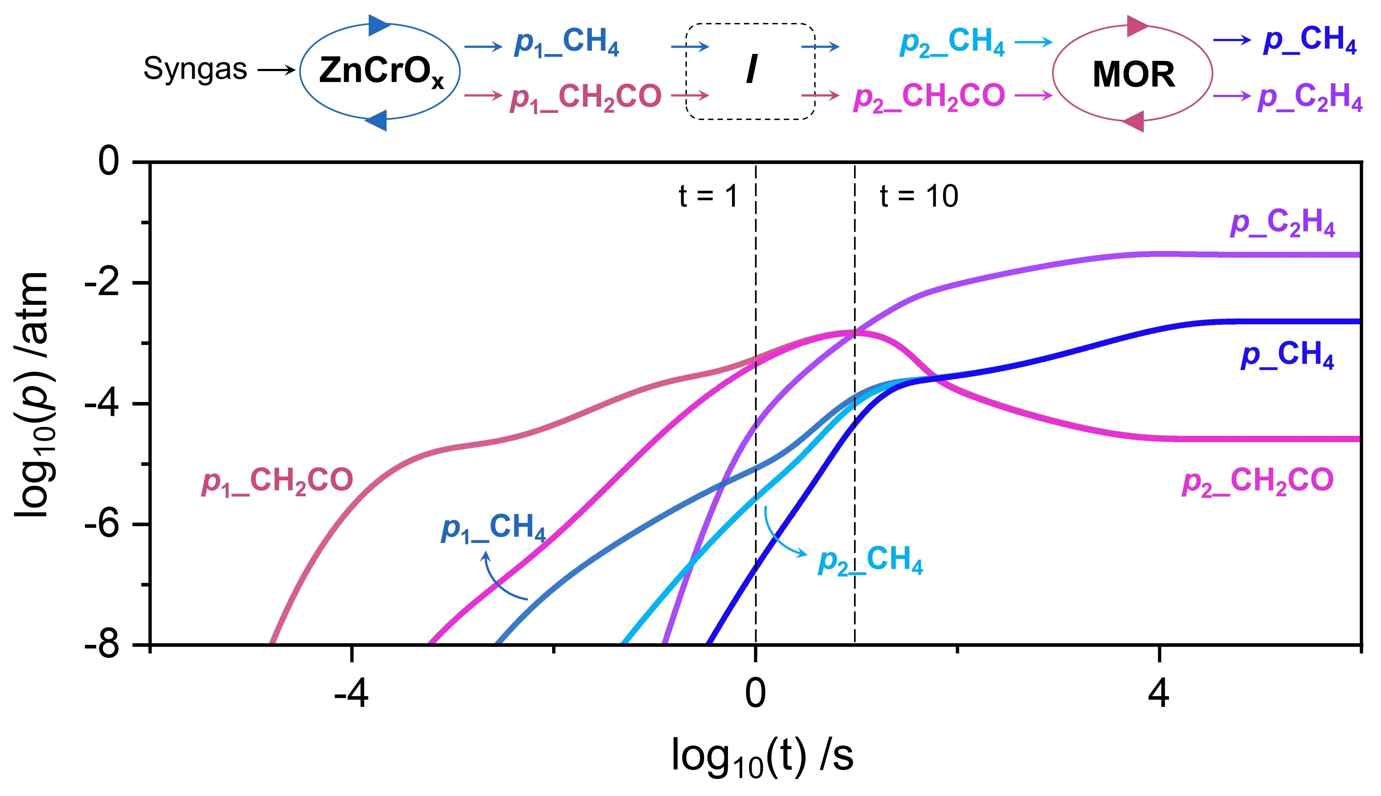
Figure S4. The dynamic evolution of gas species concentration over ZnCrO_{x}/MOR catalytic system, including CH₄ (p₁_CH₄) and CH₂CO (p₁_CH₂CO) on ZnCrO_{x}, CH₄ (p₂_CH₄) and CH₂CO (p₂_CH₂CO) at the MOR inlet, C₂H₄ (p_C₂H₄) and CH₄ (p_CH₄) at the MOR outlet.

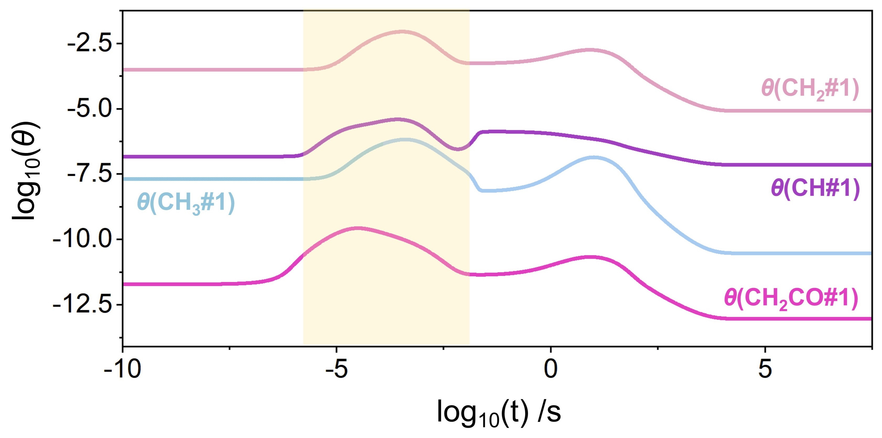
Figure S5. The dynamic evolution of the coverages of key intermediates by coupling MOR with the ZnCrO_{x} surface under the steady state condition.

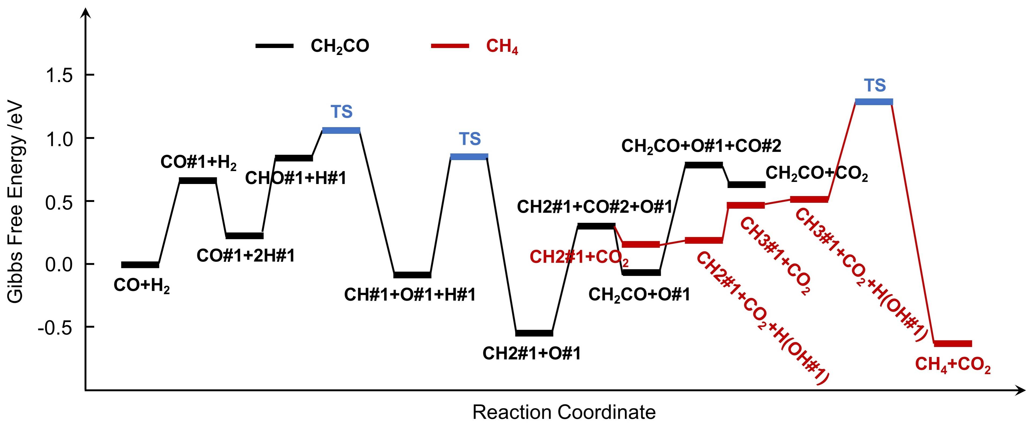
Figure S6. The Gibbs free energy profiles of selective syngas conversion to CH₂CO and CH₄ over ZnCrO_{x} surface. Notaby, the blue horizontal bars represent the transition state where the corresponding reaction step is irreversible. The remaining steps arrive the equilibrium.

Supplementary Information S4. Derivation of the overall reaction rate
Based on the kinetic data at steady state condition in Table S1, we can see that CO can easily react with dissociated H to form CHO due to their kinetic quasi-equilibrium (Z_{i} ≈ 1, i = 1, 3–6) and the dissociation of CHO is the rate-limiting step of C₂H₄ formation over ZnCrO_{x}/MOR (Z₁₈ ≈ 3.39×10⁻¹), verified by the X_{RC,i} in Table S1-2. Thus, the formation rate of C₂H₄ can be expressed as:
$r_{C2H4}=k_{R18f}θ_{CHO\#1}θ_{\#1}$ (S1)
Because the processes of H₂ adsorption and dissociation (Z_{i} ≈ 1, i = 3–5), CO adsorption and hydrogenation (Z_{i} ≈ 1, i = 1, 6) have achieved the quasi-equilibrium, we can obtain:
$k_{R3f}p_{H2}θ_{\#1}=k_{R3r}θ_{H2\#1}$ (S2)
$k_{R4f}θ_{H2\#1}θ_{\#2}=k_{R4r}θ_{H\#1}θ_{H\#2}$ (S3)
$k_{R5f}θ_{H\#2}θ_{\#1}=k_{R5r}θ_{H\#1}θ_{\#2}$ (S4)
$k_{R1f}p_{CO}θ_{\#1}=k_{R1r}θ_{CO\#1}$ (S5)
$k_{R6f}θ_{CO\#1}θ_{H\#1}=k_{R6r}θ_{CHO\#1}θ_{\#1}$ (S6)
where $k_{Rif}$ and $k_{Rir}$ stand for the forward and reverse reaction rate constants of steps i, respectively. $p_{i}$ is the partial pressure of species i. $θ_{i\#j}$ represents the coverage of intermediate i on site j (j = 1, 2) and $θ_{\#j}$ is the free site. Substituting equations (S2)-(S6) into (S1), r_{C2H4} can be written as:
$r_{C2H4}=K_{eqR1}{\left(K_{eqR3}K_{eqR4}K_{eqR5}\right)}^{1/2}K_{eqR6}k_{R18f}p_{CO}p_{H2}^{1/2}θ_{\#1}^{2}=k_{C2H4}p_{CO}p_{H2}^{1/2}$ (S7)
where $K_{eqRi}$ represents the equilibrium constant of steps i. $k_{C2H4}$ is defined as the effective energy barrier of C₂H₄ formation and expressed as $K_{eqR1}{\left(K_{eqR3}K_{eqR4}K_{eqR5}\right)}^{1/2}K_{eqR6}k_{R18f}θ_{\#1}^{2}$.
Similarly, the effective energy barrier of CH₄ formation on ZnCrO_{x}/MOR catalytic system can be derived. From Table S1-2, one can see that the rate-limiting step of CH₄ formation is the dissociation of CH₃O#1 on ZnCrO_{x}. Thus, the formation rate of CH₄ can be expressed as:
$r_{CH4}=k_{R25f}θ_{CH3O\#1}θ_{\#2}$ (S8)
Because the processes of CHO#1 hydrogenation to CH₃O#1 (Z_{i} ≈ 1, i = 8, 10) have achieved the quasi-equilibrium, we can obtain:
$k_{R8f}θ_{CHO\#1}θ_{H\#1}=k_{R8r}θ_{CH2O\#1}θ_{\#1}$ (S9)
$k_{R10f}θ_{CH2O\#1}θ_{H\#1}=k_{R10r}θ_{CH3O\#1}θ_{\#1}$ (S10)
Substituting equations (S2)-(S6) and (S9)-(S10) into (S8), r_{CH4} can be expressed as:
$r_{CH4}=K_{eqR1}{\left(K_{eqR3}K_{eqR4}K_{eqR5}\right)}^{3/2}K_{eqR6}{K_{eqR8}K_{eqR10}k}_{R25f}p_{CO}p_{H2}^{3/2}θ_{\#1}θ_{\#2}=k_{CH4}p_{CO}p_{H2}^{3/2}$ (S11)
where $k_{CH4}$ is defined as the effective energy barrier of CH₄ formation and expressed as $K_{eqR1}{\left(K_{eqR3}K_{eqR4}K_{eqR5}\right)}^{3/2}K_{eqR6}{K_{eqR8}K_{eqR10}k}_{R25f}θ_{\#1}θ_{\#2}$.
According to the transition state theory, $K_{eqRi}$ and $k_{Rif}$ can be formulated as:
$K_{eqRi}=e^{{∆G_{i}}/{RT}}$ (S12)
$k_{Rif}=e^{{-∆G_{i}^{≠,°}}/{RT}}$ (S13)
where $∆G_{i}$ and $∆G_{i}^{≠,°}$ represent the Gibbs free energy and Gibbs free energy barrier of steps i, respectively. Thus, under the steady state, substituting the energetics (Table S1) of the corresponding elementary and the coverage $θ_{\#1}$ and $θ_{\#2}$ (Table S1-1) into equations (7) and (11), the effective energy barriers of C₂H₄ and CH₄ formation can be obtained, which is approximately 2.20 eV and 2.50 eV, respectively.

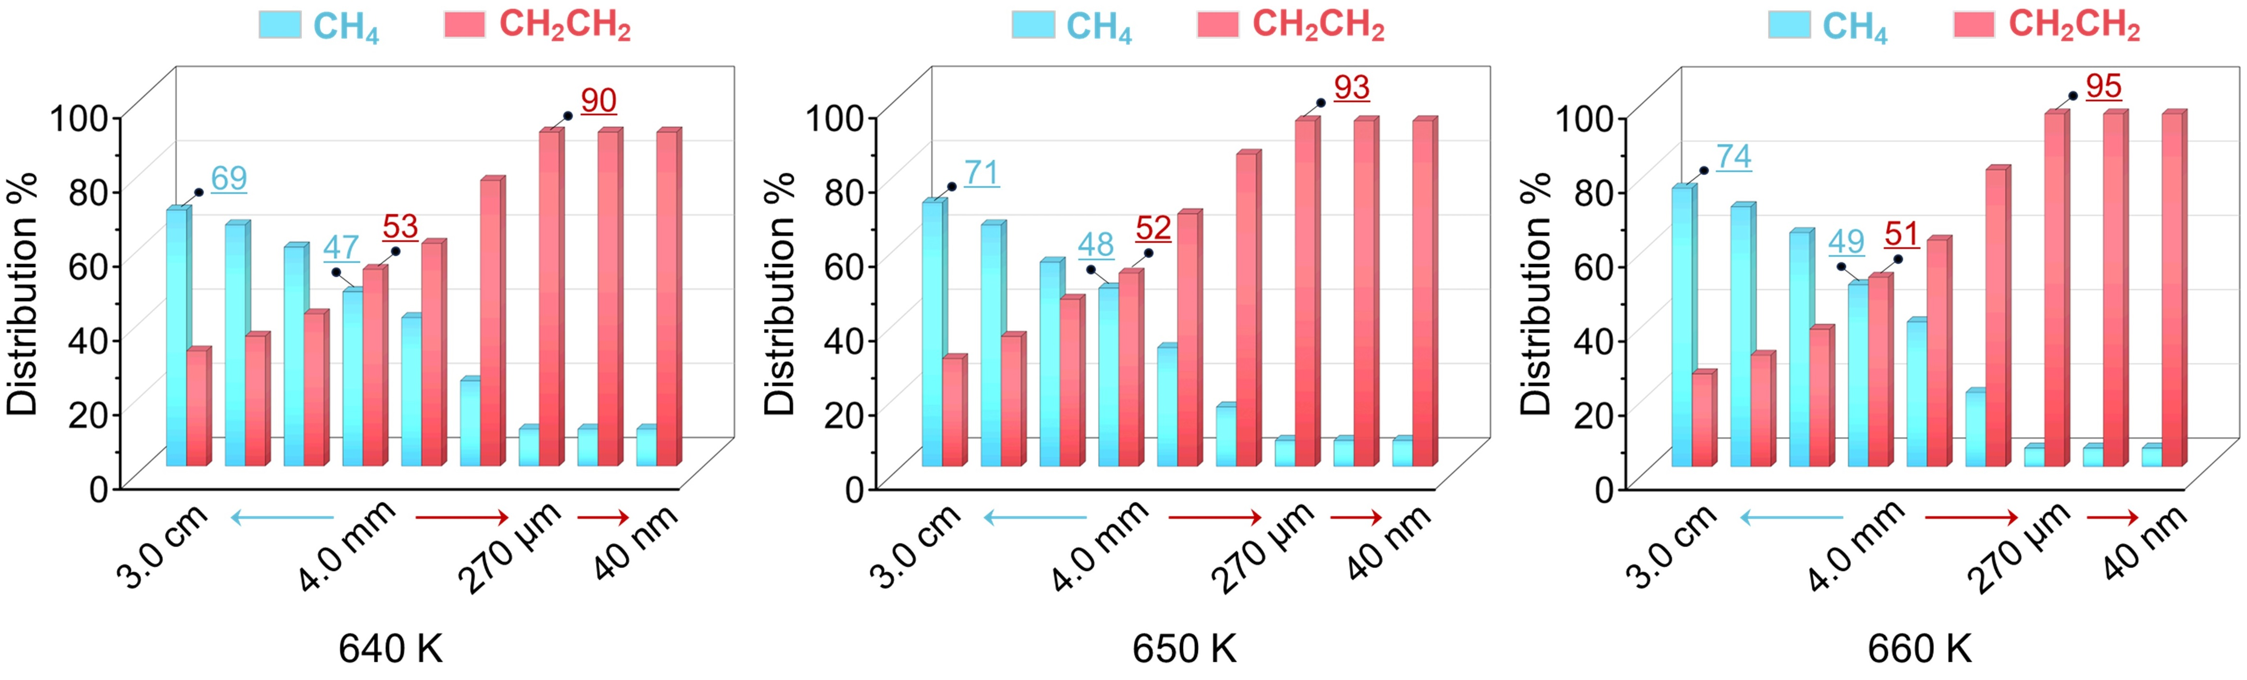
Figure S7. Distributions of the products (C₂H₄ versus CH₄) as a function of l of ZnCrO_{x} and MOR at different temperatures.

Supplementary Information S5. Evaluation of the diffusivities, derivation of the diffusion barrier for diffusion process of gas species at proximity of oxide and zeolite, and the reaction phase diagram calculations of different Zn species migrations
1. Diffusivities of gas phase species
Experimental and theoretical researchers have evaluated the diffusivities of many gas species on the zeolite, such as CH₄, C₂H₄, C₃H₆ and C₃H₈.⁸⁻¹³ Moreover, they found that the diffusivities (D) is closely related with the number of carbon, indicating that the gas molecules with the same carbon atoms behave the similar diffusivities.^{10, 13} Thus, based on the reported data in the literature,^{8, 13} we obtain the diffusivities of CH₄ (1.77×10⁻¹¹), which can be corrected to the experimental conditions of T = 650 K by following the equation (S14) (i.e., 8.42×10⁻¹¹), while the diffusivities of CH₃OH and CH₂CO at 650 K can be approximately replaced with that of ethylene (3.52×10⁻¹⁰).
$D=\frac{D_{298K}}{{(\frac{298}{T})}^{2}\left(\frac{p}{101.325}\right)}$ (S14)
2. Derivation of the diffusion barrier for diffusion process of gas species at proximity of oxide and zeolite
In this work, the widely used Fick’s law is applied to describe the realistic diffusion process of intermediate species at the proximity of ZnCrO_{x}/MOR bifunctional catalyst, which is a macroscopic law describing the phenomenon of gas diffusion and can be expressed as:
$J={dn}/{(A*dt)}=-D*{dC}/{dl}$ (S15)
where J, n, D, A, C and l are the diffusion flux, the number of the moles of gas, the diffusion coefficient, the cross-section area, the volume concentration, and the diffusion distance, respectively. Furthermore, we can derive the diffusion flux of each molecule according to equation (S15).
${dN}/{dt}=-D*A*N_{A}*{dC}/{dl}$ (S16)
where N and N_{A} represent the number of molecules and the Avogadro constant. Together with the “Ideal Gas Law” pV = nRT, equation (S16) can be written as:
$\frac{dN}{dt}=-\frac{D*A*N_{A}}{RTdl}dp=\frac{D*A*N_{A}}{RT∆l}\left(\frac{p_{1}}{p^{°}}-\frac{p_{2}}{p^{°}}\right)=\frac{D*A*N_{A}p^{°}}{RT∆l}\left(p_{1}-p_{2}\right)$ (S17)
where p₁ and p₂ stand for the pressure of initial and final states. As equation (S17) shows, it can be physically understood by a gas-phase reaction step with different pressures at both ends and its free energy change is zero. Accordingly, ${(D*A*N_{A}p^{°})}/{(RT∆l)}$ is the reaction rate constant of this reaction step. Thus, based on the form of the transition state theory, we can obtain the relations between the l and the energy barrier of the gas-reaction step as follows.
$E_{a}=RT*ln\left(\frac{k_{B}T}{h}*\frac{RTl}{DN_{A}Ap^{°}}\right)$ (S18)
Experimental researchers have demonstrated that the ketene generated from oxides preferentially diffuses into the 12-membered ring of MOR and then enters the 8-membered ring side pocket of MOR to trigger the formation of light olefins.⁷ Thus, the cross-section area A is approximately evaluated with the area of the 12-membered ring aperture (66.9 Å²).
We have also compared the predictions of molecular volume (V) between van der Waals equation of state and ideal gas law under reaction conditions (p = 2.5 MPa, T = 650 K). As shown in the table below, these differences are almost negligible, indicating the applicability of idea gas law.
 | van der Waals equation | ideal gas law
CH₄ | 2.163*10⁻³ | 2.162*10⁻³
CH₃OH | 2.049*10⁻³ | 2.162*10⁻³
CH₂CH₂ | 2.144*10⁻³ | 2.162*10⁻³
CH₃CHCH₂ | 2.089*10⁻³ | 2.162*10⁻³
3. Reaction phase diagram calculations of different Zn species migrations
To evaluate the possibility of Zn species migration, the reaction phase diagram of different Zn species migration from ZnCrO_{x} to MOR was calculated by following the equations (S19)-(S22):
Zn²⁺: Zn₁₆Cr₃₂O₆₀ + H₂Al₂/MOR → H₂Zn₁₅Cr₃₂O₆₀ + Zn-Al₂/MOR ∆G = 2.33 eV (S19)
ZnO: Zn₁₆Cr₃₂O₆₀ + H₂Al₂/MOR + H₂O → H₂Zn₁₅Cr₃₂O₆₀ + ZnO-H₂Al₂/MOR ∆G = 3.31 − ∆μ(H₂O) (S20)
Zn[OH]⁺: Zn₁₆Cr₃₂O₆₀ + H₂Al₂/MOR + H₂O → H₂Zn₁₅Cr₃₂O₆₀ + ZnOH-HAl₂/MOR ∆G = −0.76 − ∆μ(H₂O) (S21)
Zn(OH)₂: Zn₁₆Cr₃₂O₆₀ + H₂Al₂/MOR + 2H₂O → H₂Zn₁₅Cr₃₂O₆₀ + Zn(OH)₂H₂Al₂/MOR ∆G = 0.55 − 2∆μ(H₂O) (S22)
where Zn₁₆Cr₃₂O₆₀ and H₂Al₂/MOR represent the calculation models of ZnCrO_{x}(110) and MOR (H₂Al₂Si₄₆O₉₆), respectively. Notably, H₂Zn₁₅Cr₃₂O₆₀ is the model with the addition of H to balance the charge of the system after Zn species migration. As can be seen from equations (S19)-(S22), the Gibbs free energy of the reaction phase by Zn²⁺ species migration remains unchanged, while those of the other three species migrations are determined by the potential of H₂O. Thus, by varying the partial pressure of H₂O (10⁻⁷ to 1 atm), we can obtain their reaction phase diagram at the experimental conditions of 650 K, shown in Figure 3e in the main text.
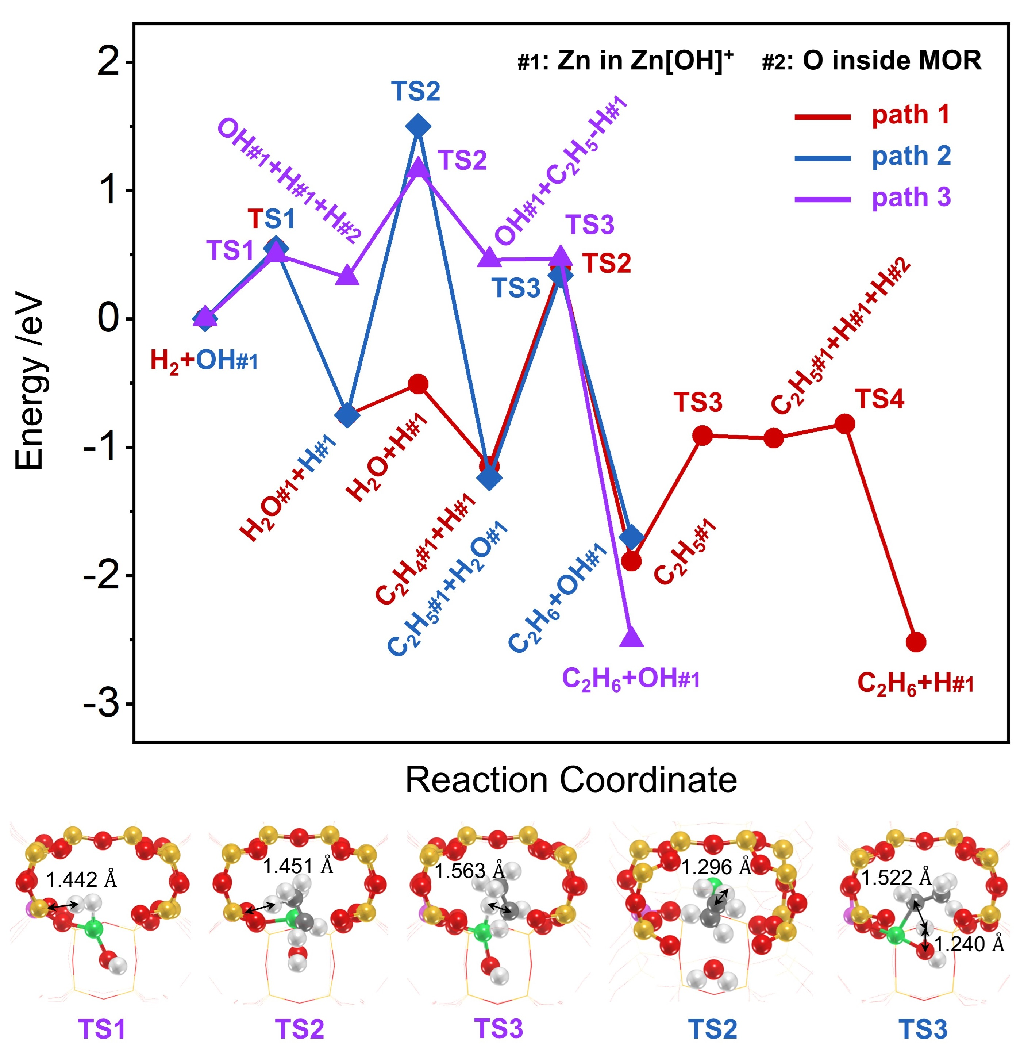
Figure S8. The energy profiles of the C₂H₄ hydrogenation on the [ZnOH]⁺ site over MOR.

Supplementary Information S6. Derivation of the overall reaction rate and the optimal space velocity on the generalized reaction-diffusion coupling kinetic model
To shed light on the principles for determining the optimal combination between oxide and zeolite components, we abstracted a generalized reaction-diffusion coupling kinetic model under the condition of the optimal proximity, which can be described by CH₂CO-mediated syngas conversion to light olefins on OX-ZEO (R → I → P) as follows.
Oxide: CO + H₂ (R) → CH₂CO (I) (R1)
OX-ZEO: CO + H₂ (R) → CH₂CO (I) → C₂H₄ (P) (R2)
With the framework of law of mass action, we first obtained the reaction rate of each elementary step.
Oxide: $r_{oxide-(I)}=k_{1f}p_{R}-k_{1r}p_{I}$ (S23)
OX-ZEO: $r_{OX-ZEO-(R)}=k_{1f}p_{R}-k_{1r}p_{I}$ (S24)
OX-ZEO: $r_{OX-ZEO-(P)}=k_{2f}p_{I}-k_{2r}p_{P}$ (S25)
where k_{1f} (k_{1r}) and k_{2f} (k_{2r}) represent the forward (reverse) rate constants on oxide and zeolite, respectively. p_{i} (i = R, I, P) is the pressure of gas species i. Based on the steady state approximation at the condition of space velocity (F):
Oxide: $\frac{dI}{dt}=r_{oxide-(I)}-F^{'}*p_{I}=0$ (S26)
OX-ZEO: $\frac{dI}{dt}=r_{OX-ZEO-(R)}-r_{OX-ZEO-\left(P\right)}-F^{'}*p_{I}=0$ (S27)
OX-ZEO: $\frac{dP}{dt}=r_{OX-ZEO-\left(P\right)}-F^{'}*p_{P}=0$ (S28)
F' represents the F in the unit of s⁻¹. We can obtain:
Oxide: $p_{oxide-(I)}=\frac{k_{1f}p_{R}}{k_{1r}+F^{'}}$ (S29)
OX-ZEO: $p_{OX-ZEO-(I)}=\frac{k_{1f}p_{R}(F^{'}+k_{2r})}{k_{2r}F^{'}+k_{1r}F^{'}+k_{2r}F^{'}+k_{1r}k_{2r}+{F^{'}}^{2}}$ (S30)
OX-ZEO: $p_{OX-ZEO-(P)}=\frac{k_{1f}k_{2f}p_{R}}{k_{2r}F^{'}+k_{1r}F^{'}+k_{2r}F^{'}+k_{1r}k_{2r}+{F^{'}}^{2}}$ (S31)
Subsituting equation (S29) and equations (S30)-(S31) to equation (S26) and equations (S27)-(S29), respectively, the formation rate of I on oxide and I and P on OX-ZEO can be derived:
Oxide: $r_{oxide-(I)}={F^{'}*p_{R}*k_{1f}}/{\left(F^{'}+k_{1r}\right)}$ (S32)
OX-ZEO: $r_{OX-ZEO-(I)}={F^{'}*p_{R}*k_{1f}*(k_{2f}+k_{2r}+F^{'})}/{\left({F^{'}}^{2}+F^{'}\left(k_{1r}+k_{2f}+k_{2r}\right)+k_{1r}*k_{2r}\right)}$ (S33)
OX-ZEO: $r_{OX-ZEO-(P)}={F^{'}*p_{R}*k_{1f}*k_{2f}}/{\left({F^{'}}^{2}+F^{'}\left(k_{1r}+k_{2f}+k_{2r}\right)+k_{1r}*k_{2r}\right)}$ (S34)
where r_{oxide-(I)} and r_{OX-ZEO-(P)} are simply denoted as r_{I} and r_{P}, respectively. To reveal the optimal velocity F', the partial differential of the formation rate of I on oxide and P on OX-ZEO against F' is first taken:
Oxide: $\frac{dr_{I}}{dF^{'}}=\frac{p_{R}*k_{1f}*k_{1r}}{{\left(F^{'}+k_{1r}\right)}^{2}}>0$ (S35)
OX-ZEO: $\frac{dr_{P}}{dF^{'}}=\frac{p_{R}*k_{1f}*k_{2f}(-{F^{'}}^{2}+k_{1r}*k_{2r})}{{\left({F^{'}}^{2}+F^{'}\left(k_{1r}+k_{2f}+k_{2r}\right)+k_{1r}*k_{2r}\right)}^{2}}$ (S36)
The above results clearly indicate that r_{I} increases with the increase of F' because their partial differentials exceed 0, while r_{P} first increases and then decreases with the increase of F', leading to the maximum at F'=(k_{1r}*k_{2r})^{1/2}, i.e., the optimal F' for the formation of P on OX-ZEO should satisfy the condition of (k_{1r}*k_{2r})^{1/2}.
To quantitatively evaluate the quality of the combination of oxide and zeolite, we provide the enhancement factors λ, presenting the enhancement effect of zeolite on the selectivity of light olefines (P), which can be expressed as:
$λ=\frac{r_{P}}{r_{I}}=\frac{k_{2f}*(F^{'}+k_{1r})}{{F^{'}}^{2}+F^{'}\left(k_{1r}+k_{2f}+k_{2r}\right)+k_{1r}*k_{2r}}$ (S37)
It is clear from equation (S37) that λ is closely related to F' in addition to the intrinsic catalytic ability (k) of oxide and zeolite. Thus, the influence of F' and k on λ is first analyzed. Experiments have shown that the formation of CH₂CO on oxide is an endothermic process while its conversion on zeolite is the exothermic under typical conditions of H₂/CO = 1.5, p = 2.5 MPa, T = 650 K, which implies k_{1f} < k_{1r} and k_{2f} > k_{2r} kinetically. Based on this, all possibilities are discussed among F' and k of oxide and zeolite as follows.
- When F' > k_{1r} and F' >(or <) k_{2f}, λ ≈ k_{2f} /( F' + k_{2f}) < 1 by combining equation (S37), suggesting that the introduction of zeolite can not improve the selectivity of light olefins.
- When F' < k_{1r} and F' > k_{2f}, λ ≈ k_{2f} / F' < 1 by substituting it into equation (S37). This also indicates that the introduction of zeolite can not enhance the selectivity of light olefins.
- When F' < k_{1r} and F' < k_{2f}, λ ≈ k_{2f} * k_{1r} /(( k_{2f} + k_{1r}) * F' + k_{1r} * k_{2r}) > 1 by substituting it into equation (S37), implying that the selectivity of light olefins can be greatly promoted by coupling zeolite.

To facilitate the comparison with the energy barrier of the elementary reactions, F' can be quantified in the form of energy (E_{a}) as follows:
$F^{'}=\frac{Fp^{°}}{N_{A}k_{B}T}=\frac{k_{B}T}{h}e^{{-E_{a}}/{RT}}$ (S38)
Expanding equation (S38) and collecting terms, we get:
$E_{a}=RT*(\ln\left(\frac{k_{B}T}{h}\right)-\ln\left(\frac{Fp^{°}}{N_{A}k_{B}T}\right))$ (S39)
where R, T, k_{B}, h, N_{A} and p。 represent the gas constant, the reaction temperature, the Boltzmann constant, the Planck constant, the Avogadro constant and the standard atmospheric pressure, respectively. Notably, the unit of the F is m³/(mol*s).

Table S2. Degree of kinetic rate control (X_{RC,i}) of some important elementary reaction steps for CH₂CO formation on ZnCrO_{x} in the syngas conversion and C₂H₄ formation on MOR in the CH₂CO conversion.
ZnCrO_{x} |  | MOR
Step i | CH₂CO | Step i | C₂H₄
Step i | X_{RC,i} | Step i | X_{RC,i}
CHO#1 + #1 ⇆ CH#1 + O#1 | 0.32 | CH₃CO⁺#3 ⇆ CH₃#3 + CO_in | 0.62
CH#1 + H#1 ⇆ CH₂#1 + #1 | −0.25
CH₃#1 + OH#1 ⇆ CH₄ + #1 + O#1 | −0.32
CH₃O#1 + #2 ⇆ CH₃#2 + O#1 | ‒0.03

Supplementary Information S7. Analysis of the optimal l
The optimal l was analyzed by separating the diffusion process from our reaction-diffusion kinetic model (i.e., the kinetic model changes from two to three steps), with the corresponding Gibbs free energy profile depicted in Figure S9. For clarity and ease of comprehension, we first used the ZnCrO_{x}-coupled zeolite as an illustrative example. The corresponding diffusion-bridged coupling kinetic model is illustrated in Figure S9a. For the case of k_{1r} < F'×K_{eq2} at the experimental F' for ZnCrO_{x} (Figure S9a), we have revealed in the main text that k_{2f} > k_{1r} is the optimal condition for zeolite design, where the catalytic ability of ZnCrO_{x} becomes the limiting factors for the light olefin formation. Consequently, according to our previous theoretical work identifying the rate-limiting step of the overall reaction,¹⁴ we can determine that k_{d} > k_{1r} is the requirement for the diffusion process not to limit the light olefin selectivity.
Similarly, for the condition where k_{1r} > F'×K_{eq2}, the critical kinetic constraint for zeolite optimization is k_{2f} = F'×K_{eq2} (Figure S9b). Under this condition, the optimal combination of oxide and zeolite is independent of the diffusion process when the diffusion process satisfies the condition k_{d} > F'×K_{eq2}.
Combining these two situations, we can determine the critical condition of the diffusion process, which requires k_{d} > F'×K_{eq2}. Together with the optimal F’ derived for OX-ZEO catalyst design in the main text (F’ = (k_{1r}k_{2r})^{1/2}), we can obtain k_{d} > (k_{1r} / k_{2r})^{1/2}×k_{2f}, and thus the optimal l should satisfy $l≤{(D*A*N_{A}p^{°})}/{(RT{\left(k_{1r}/k_{2r}\right)}^{1/2}k_{2f})}$ based on equation (S18). This quantitative formula provides a framework for selecting the appropriate distance when designing OX-ZEO bifunctional catalysts.
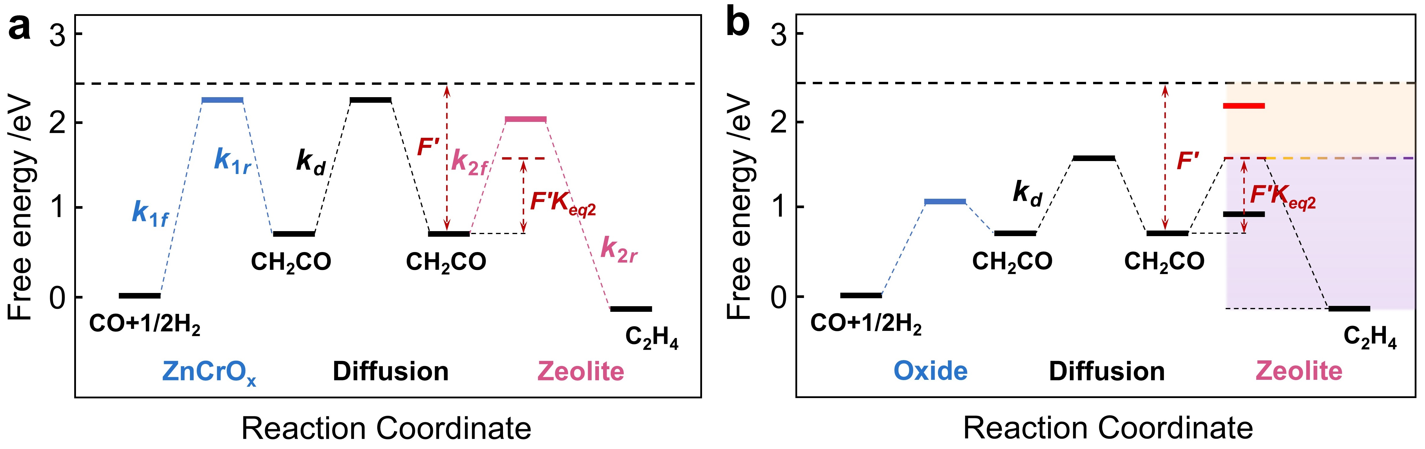
Figure S9. (a) Schematic of the relations among F', k_{2f}, k_{1r}, k_{d}, and F' × K_{eq2} on zeolite-ZnCrO_{x} system. (b) The effective energy profile of syngas conversion to light olefins on the bifuctional catalysts of oxide combined zeolite, wherein the orange and purple labels correspond to the kineitic and thermodynamic control zones in Figure 5d of the main text, respectively.
Figure S10. Optimal transition state structures for CH₃CO⁺ decarbonylation within the HSAPO-34, MOR, Ga-doped MOR and Sc-doped MOR, as well as the CHO dissociation on highly reduced MnO (110), ZnCr₂O₄(100), ZnGa₂O₄(110), ZnRh₂O₄(110), ZnFe₂O₄(110), and ZnV₂O₄(110), respectively.

References
1. Bukowski, B. C.; Keil, F. J.; Ravikovitch, P. I.; Sastre, G.; Snurr, R. Q.; Coppens, M.-O. Connecting Theory and Simulation with Experiment for the Study of Diffusion in Nanoporous Solids. Adsorption 2021, 27, 683-760.
2. Lai, Z. Z.; Sun, N. L.; Jin, J. M.; Chen, J. F.; Wang, H. F.; Hu, P. Resolving the Intricate Mechanism and Selectivity of Syngas Conversion on Reduced ZnCr₂O_{x}: A Quantitative Study from DFT and Microkinetic Simulations. ACS Catal., 2021, 11, 12977-12988.
3. Xiong, D. F.; Lai, Z. Z.; Yuan, H. Y.; Chen, J. F.; Wang, H. F. Ketene Conversion Chemistry within Mordenite Zeolite: Pore-Size Dependent Reaction Mechanism, Product Selectivity and Catalytic Activity. JACS, 2024, Resubmitted.
4. Ji, Y.; Gao, P.; Zhao, Z. C.; Xiao, D.; Han, Q.; Chen, H. Y.; Gong, K.; Chen, K. Z.; Han, X. W.; Bao, X. H.; Hou, G. J. Oxygenate-Based Routes Regulate Syngas Conversion over Oxide-Zeolite Bifunctional Catalysts. Nat. Catal. 2022, 5, 594-604.
5. Wang, C. M.; Wang, Y. D.; Xie, Z. K. Methylation of Olefins with Ketene in Zeotypes and Its Implications for the Direct Conversion of Syngas to Light Olefins: A Periodic DFT Study. Catal. Sci. Technol. 2016, 6, 6644-6649.
6. Yan, H.; Feng, X.; Liu, Y. B.; Yang, C. H.; Shan, H. H. Catalytic Cracking of Acetic Acid and its Ketene Intermediate over HZSM-5 Catalyst: A Density Functional Theory Study. Mol. Catal. 2017, 437, 11-17.
7. Jiao, F.; Pan, X. L.; Gong, K.; Chen, Y. X.; Li, G.; Bao, X. H. Shape-Selective Zeolites Promote Ethylene Formation from Syngas via a Ketene Intermediate. Angew. Chem., Int. Ed. 2018, 57, 4692-4696.
8. Chen, L. H.; Deng, Y. W.; Han, W.; E., J. Q.; Wang, C. H.; Han, D. D.; Feng, C. L. Effects of Zeolite Molecular Sieve on the Hydrocarbon Adsorbent and Diffusion Performance of Gasoline Engine during Cold Start. Fuel, 2022, 310, 122427.
9. Yang, G.; Wang, C. M.; Li, Y.; Du, Y. J.; Wang, Y. D.; Xie, Z. K. Simple Structure Descriptors Quantifying the Diffusion of Ethene in Small-Pore Zeolites: Insights from Molecular Dynamic Simulations. Inorg. Chem. Front., 2022, 9, 1590-1602.
10. Jobic, H. Diffusion of Linear and Branched Alkanes in ZSM-5. A Quasi-elastic Neutron Scattering Study. J. Mol. Catal. A. Chem., 2000, 158, 135-142.
11. Smit, B.; Maesen, T. L. M. Molecular Simulations of Zeolites: Adsorption, Diffusion, and Shape Selectivity. Chem. Rev., 2008, 108, 4125-4184.
12. Yuan, J.; Liu, Z.; Wu, Y.; Han, J.; Tang, X.; Li, C.; Chen, W.; Yi, X.; Zhou, J.; Krishna, R.; Sastre, G.; Zheng, A. Thermal Resistance Effect on Anomalous Diffusion of Molecules under Confinement. Proc. Natl. Acad. Sci. U.S.A. 2021, 118, e2102097118.
13. Jiang, H. J.; Hou, Z. H.; Luo, Y. A Kinetic View on Proximity-dependent Selectivity of Carbon Dioxide Reduction on Bifunctional Catalysts. ACS Catal., 2020, 10, 13518-13523.
14. Lai, Z. Z.; Chen, J. F.; Jia, M. L.; Hu, P.; Wang, H. F. Universal Skeleton Feature of the Three-Dimensional Volcano Surface and the Thermodynamic Rule in Locating the Catalyst in Heterogeneous Catalysis. ACS Catal. 2022, 12, 247-258.

