Supplementary Information

Structural Impacts of Two Disease-linked ADAR1 Mutants:
A Molecular Dynamics Study

Wen-Chieh Huang^{1†}, Chia-Hung Hsu^{2†}, Titus Albu,³ Chia-Ning Yang^{*1}
1 Institute of Precision Medicine, National Sun Yat-sen University, Kaohsiung, Taiwan
2 Department of Internal Medicine, Zuoying Armed Forces General Hospital, Kaohsiung, Taiwan
3 Department of Chemistry, University of Tennessee, Chattanooga, Tennessee, USA
†Wen-Chieh Huang and Chia-Hung Hsu are co-first authors.

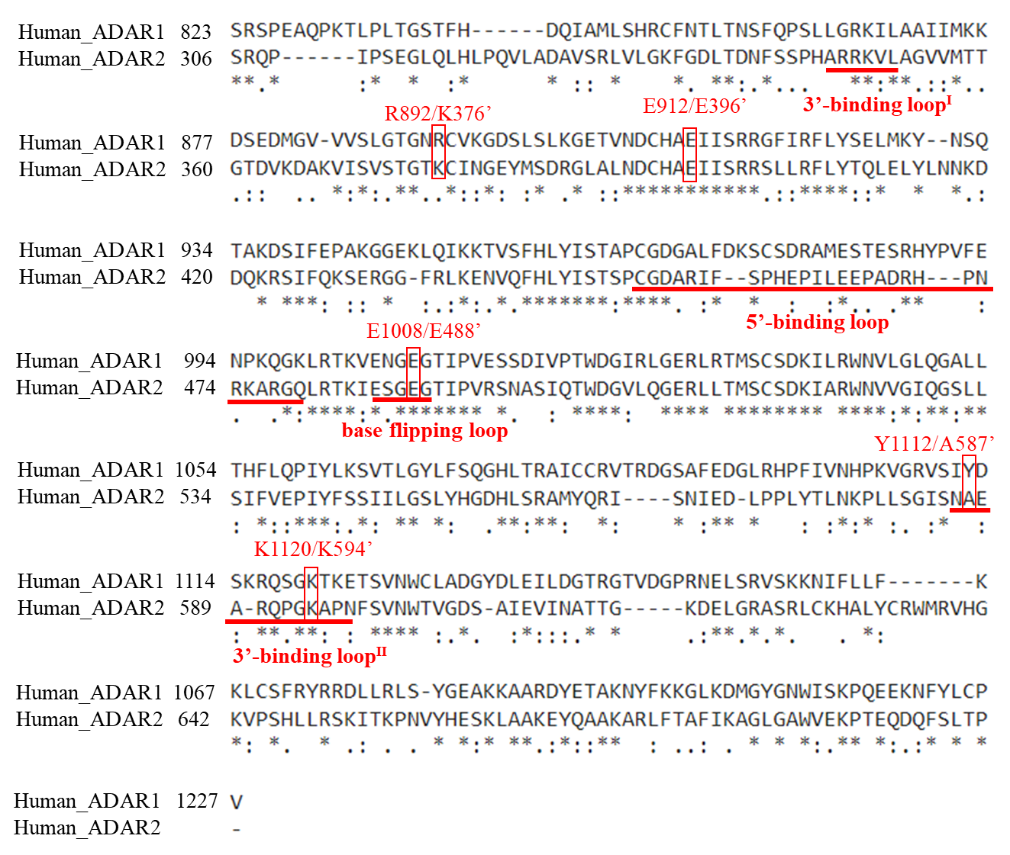

Figure S1 Sequence alignment of human ADAR1 (S823-V1227) and ADAR2 (S306-P741) deaminase domains. Sequence identity (marked as *) and similarity (marked as • for non-conservative variation and ⁚ for conservative variation). The loops are referred to as the base-flipping loop, the 5'-binding loop, the 3'-binding loop^{I}, and the 3’binding loop^{II} are underlined. The three key residues (E912, E1008, and K1120) to interact with the substrate RNA and two mutation points (R892 and Y1112) are also specified in both ADAR1 and ADAR2 for comprison.

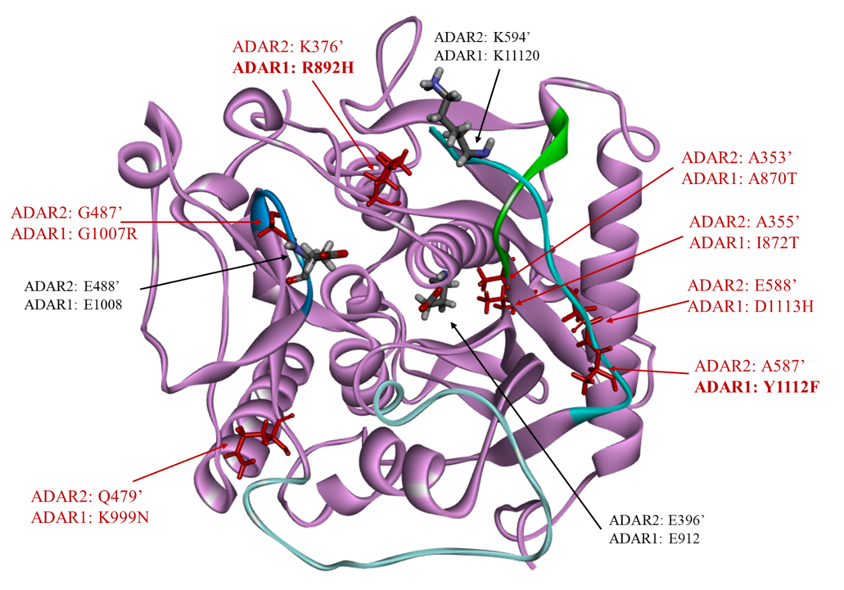
Figure S2 Mutation sites (marked in red) in ADAR1 deaminase domain mapped onto the X-ray crystallography solved structure of ADAR2-RNA complex where the dsRNA substrate was removed for clarity.

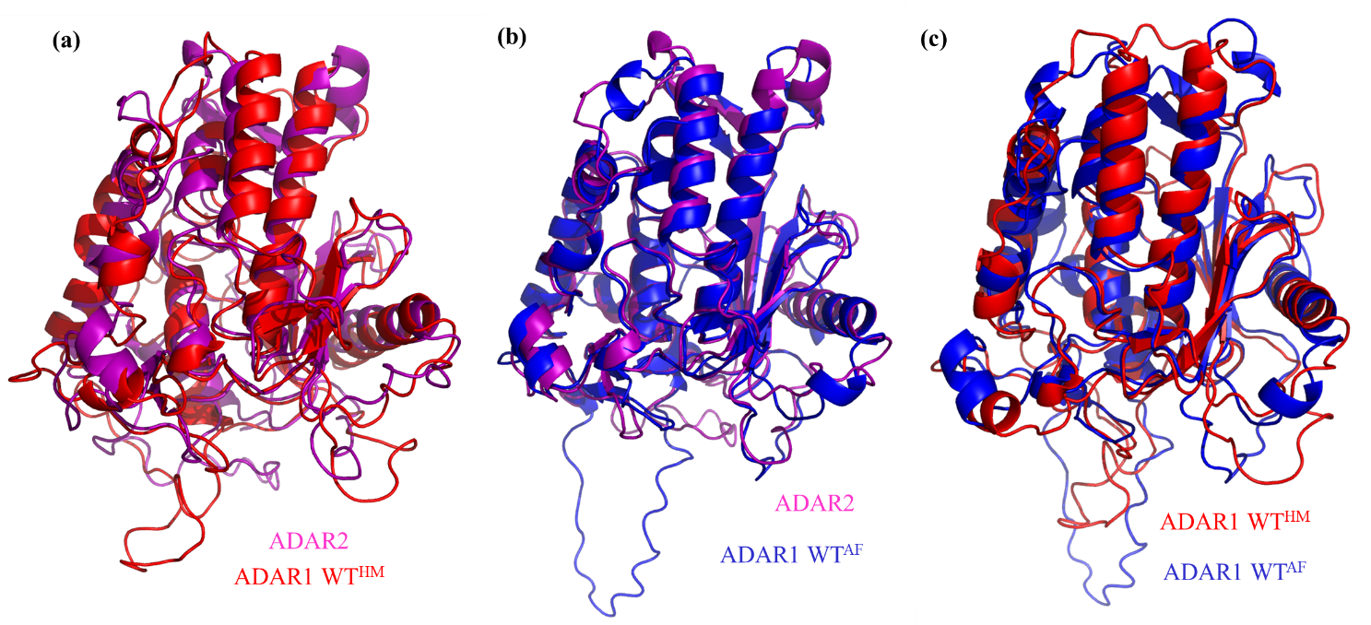

Figure S3 Superimpose of ADAR1 WT modeled structures and experimentally solved ADAR2 structure to show minute structure variances. (a) ADAR1 WT built by homology modeling vs. ADAR2. (b) ADAR1 WT built by AlphaFold2 vs. ADAR2. (c) ADAR1 WT built by homology modeling vs. ADAR1 WT built by AlphaFold2. All the variations come from the loops. Note the 5’-binding loop is not shown in the apo ADAR2.

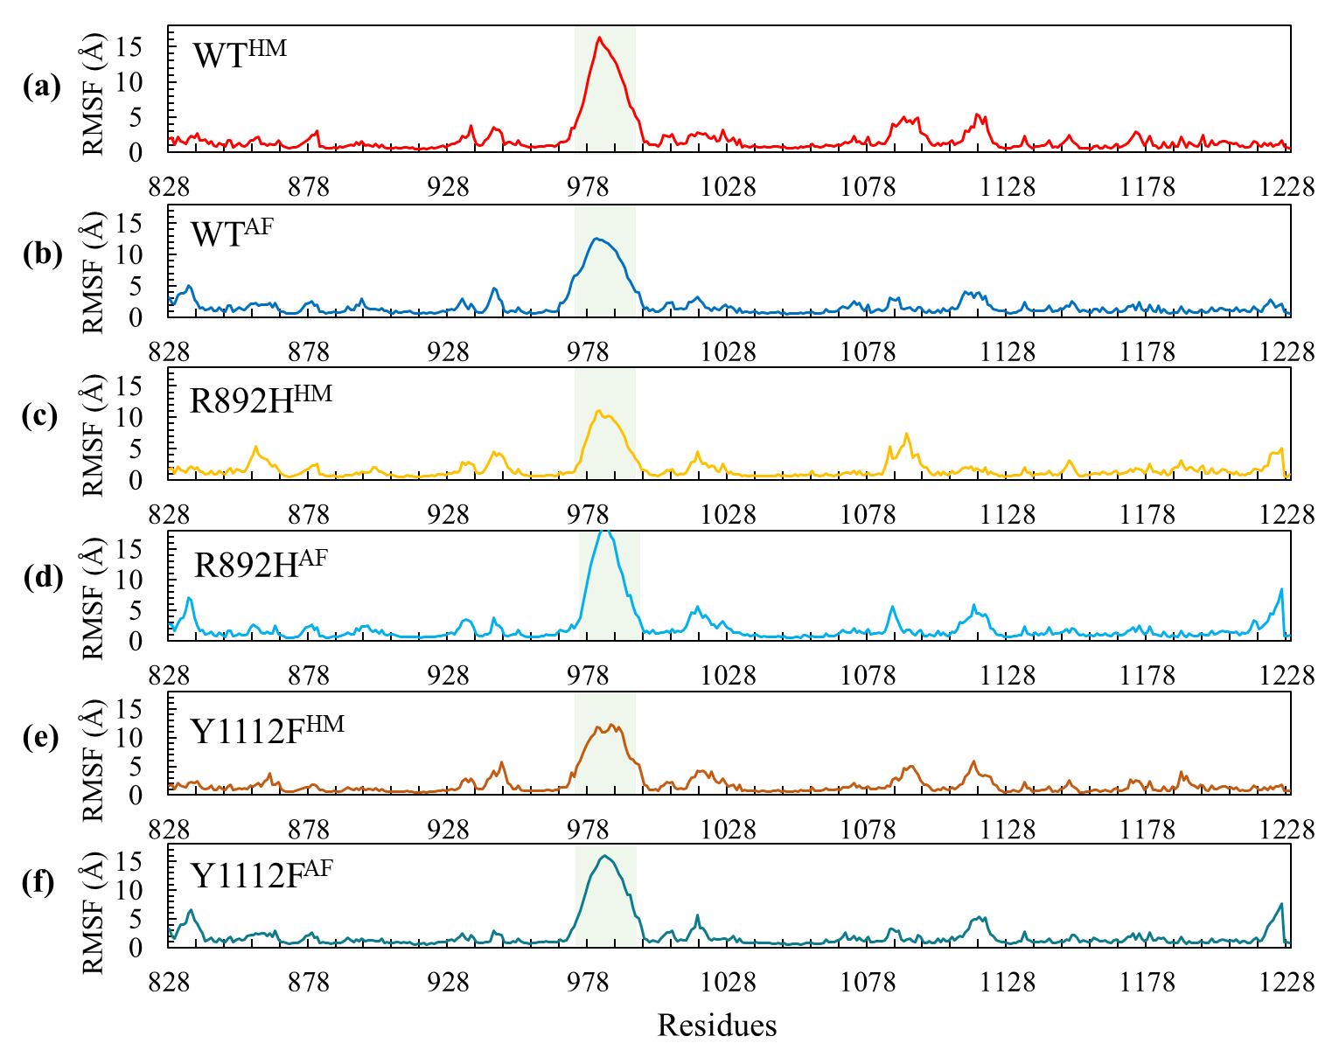
Figure S4 RMSF of six modeled structures in their trajectories between 1000 and 2000 ns. (a) WT by homology, (b) WT by AlphaFold2, (c) R892H by homology, (d) R892H by AlphaFold2, (e) Y1112F by homology, and (f) Y1112F by AlphaFold2. The shaded region in each plot specifies the flexible 5’-bindng loop (residues 972-995 replaced by a sequence of alanine) showing high RMSF values.

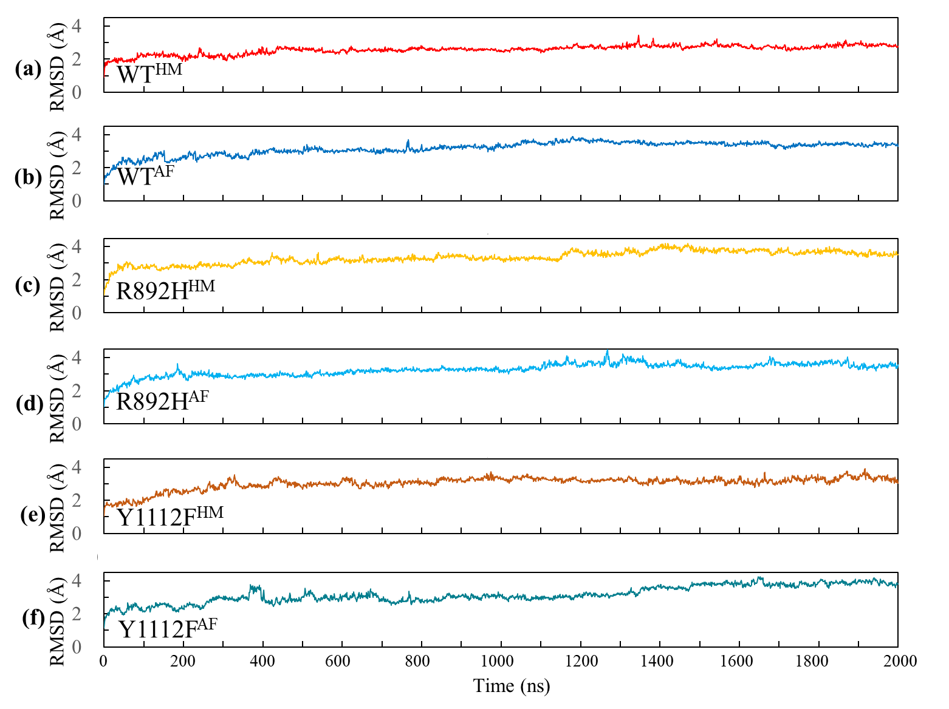
Figure S5 RMSD of six modeled structures throughout the entire 2 μs: (a) WT by homology, (b) WT by AlphaFold2, (c) R892H by homology, (d) R892H by AlphaFold2, (e) Y1112F by homology, and (f) Y1112F by AlphaFold2.

